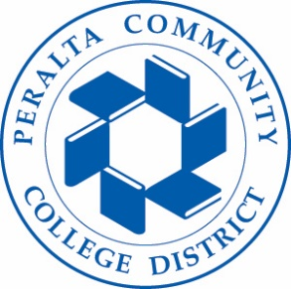

Accident Insurance Program for Students
Peralta Community College District provides accident insurance, at no cost, to enrolled students that have been injured during an athletic activity, in the classroom or on campus.
- Please fill out the attached “Accident Claim Form” and send to: claims@studentinsuranceusa.com
- Once received, a Student Insurance Account Manager will contact you.
- Please review Step 1. Depending on your current insurance status, the insurance will be used as primary or excess coverage.
- Risk Management Office is not involved with overseeing the processing of the forms or medical care.

*Students may receive medical health services through campus and community partners. Please check your campus website under “Health Services.”

