PERALTA COMMUNITY COLLEGE DISTRICT

[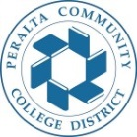](http://web.peralta.edu/)

**COUNCIL ON INSTRUCTION, PLANNING, AND DEVELOPMENT (CIPD)**

**CIPD Agenda, Monday, Sept 13, 2021, 1:30pm-3:30pm, via zoom**

Co-Chair: Siri Brown, VC of Academic Affairs

Co-Chair: Heather Sisneros, Laney Curriculum Co-chair

Note Taker: Frank Nguyen

**ACT 1: General Training Session: (1pm-1:45pm)**

**What is Credit for Prior Learning (CPL)? How can my department be involved? How can CPL bring new students to my department? What role does Student Services play?**

**Palomar College is the state leader for this state initiative and *Candace Rose* serves as the Coordinator with a wealth of information to share**

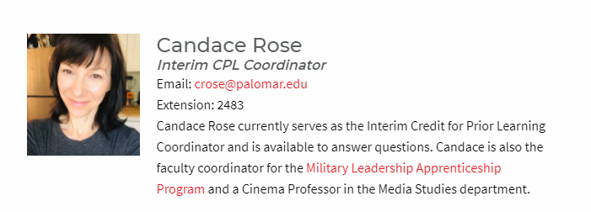

**ACT 2: Curriculum proposals for review and approval (1:40pm-2:20pm)**

* Merritt College
* Berkeley City College
* College of Alameda
* Laney College

**ACT 3: Pressing Curriculum Topics**

* CIPD: Welcoming respectful tone
* ACCJC revision: Policy on Credit hour, Clock Hour, and Academic Year (previously titled Policy on Institutional degree and Credits)

<https://accjc.org/wp-content/uploads/6.b.v.-Policy-on-Institutional-Degrees-and-Credits_tracked.pdf>

* Update on Online Course catalog
* Update on 2021-22 UC TCA
* Update on District wide change Process/Faculty involvement
* District wide plan of adding the new discipline CS/Computer Science
* Pending District Wide proposals:

1- ART 7: Changing description; course also at MC

2- BIOL 201: Changing description; course also at COA and MC (as HLTOC)

3- BIOL 202: Changing description; course also at COA (as HLTOC)

4- MATH 201: all offering colleges: CoA, LC and MC to bring to Oct CIPD

5- Districtwide change to Mathematics AS to bring to Oct CIPD

5- SOC 120: TABLED at CIPD Oct 20; removed MATH 13; course at all 4 campuses

6- ART 21: Update course description, MC is ready and waiting for Laney