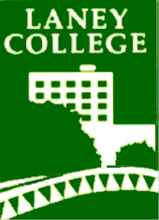

Laney College
Institutional Learning Outcomes

Communication
Students will effectively express and exchange ideas through various modes of communication.

Critical Thinking and Problem Solving
Students will be able to think critically and solve problems by identifying relevant information, evaluating alternatives, synthesizing findings and implementing effective solutions.

Career Technical Education
Students will demonstrate technical skills in keeping with the demands of their field of study.

Global Awareness, Ethics and Civic Responsibility
Students will be prepared to practice community engagement that addresses one or more of the following: environmental responsibility, social justice and cultural diversity.

Personal and Professional Development
Students will develop their knowledge, skills and abilities for personal and/or professional growth, health and well being.

