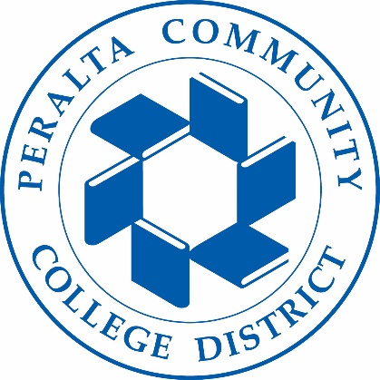
Holistic Safety & Wellness Advisory Committee
04/27/2023
Meeting Agenda

To: Holistic Safety & Wellness Advisory Committee
From: Tim Thomas-Director Public Safety
Subject: Holistic Safety Security & Wellness Advisory Committee Town Hall.
- Opening Remarks Chancellor Jackson

2. Breakout Session (review scenario questions)

3. Review discussion from breakout session
4. Next Meeting 5/11/23 11:00am

