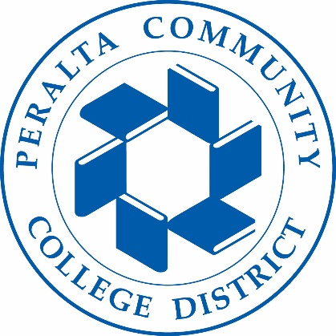
Holistic Safety & Wellness Advisory Committee
03/23/2023
Meeting Agenda

To: Holistic Safety & Wellness Advisory Committee
From: Tim Thomas-Director Public Safety

Subject: Update & Action Items:
1.Campus Reports

2.Continue to review and edit Behavioral Health Staff Guide Doc 30 mins.

3. Change time of regular HSWAC meeting
3. Mission Statement/Name HSWAC
4. Next Meeting 4/13/23 11:00am (Safety Program at Laney Dr. King).

