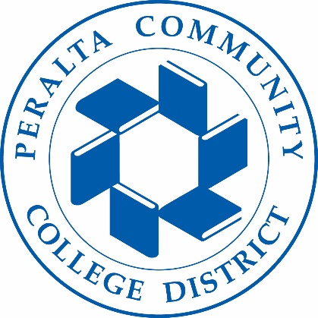
Holistic Safety & Wellness Advisory Committee
04/13/2023
Meeting Agenda

To: Holistic Safety & Wellness Advisory Committee
From: Tim Thomas-Director Public Safety

Subject: Update & Action Items:
- Campus Reports

2. Cleary Report/Training Calendar Questions

3. Kimberly King Safety Program
4. Name and Time change for HSWAC
5. Mission Statement
6. Next Meeting 4/27/23 11:00am

