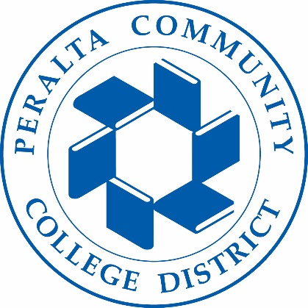
Holistic Safety & Wellness Advisory Committee
05/11/2023
Meeting Agenda

To: Holistic Safety & Wellness Advisory Committee
From: Tim Thomas-Director Public Safety
Subject: Holistic Safety Security & Wellness Advisory Committee Meeting
- Summer Meetings
- Training
- Change meeting time for Fall
- Holistic Wellness Advisory Mission Statement

