To take vacation, sick leave, or floating holiday time, employees must complete both steps:  
  
1. Submit a Pre-Authorization for Leave form for manager approval before taking leave.  
2. Submit your timesheet in HCM to record the leave hours taken.  
  
These steps are required even if your time off was pre-approved. Not submitting both may result in incorrect leave balances or pay delays.

## Step 1: Log In

Go to https://hcm.peralta.edu  
Use your Peralta credentials to log in.

## Step 2: Submit a Pre-Authorization for Leave Form

## From the HCM Employee Self-Service main menu, click the Pre-Authorization tile.

To create a new request:

• Select 'Create New Request’  
• Choose 'Leave Pre-Authorization Form' as the Request Type  
• Enter the dates and hours for the time off request  
 - Use either specific Workday Dates & Hours, or enter an Expected Start and End Date  
• Add a brief note in the Employee Comments box (e.g., Vacation, Floating Holiday)  
• Click 'Submit' to send the request to your Approving Manager for review

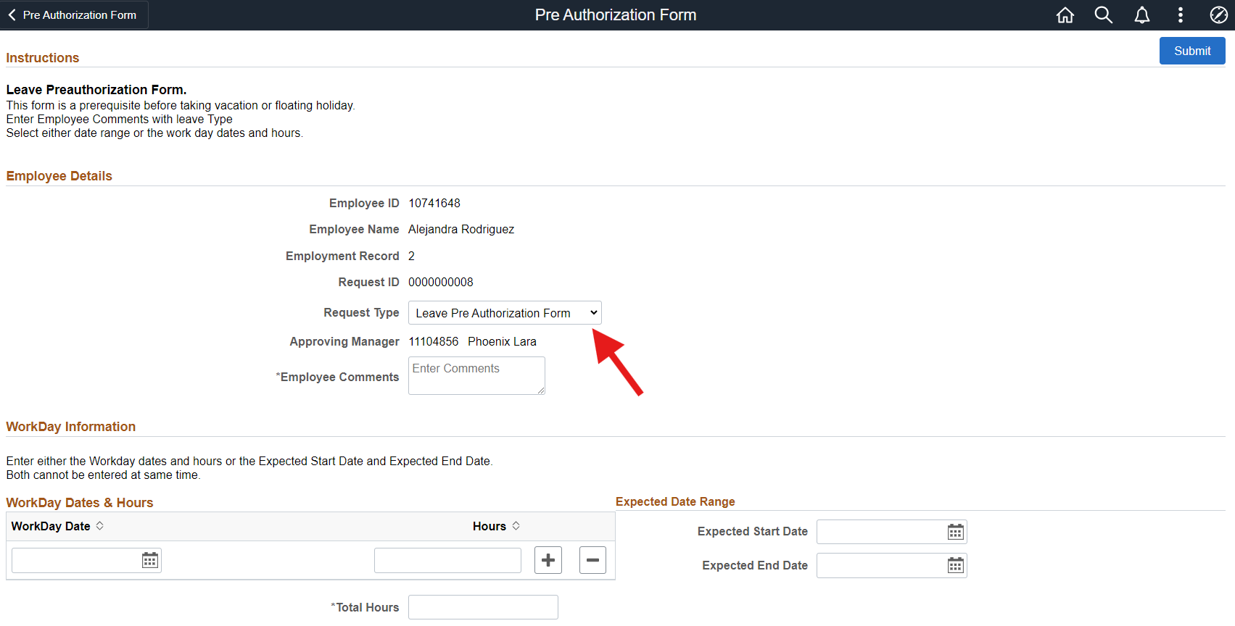

## Step 3: Navigate to Your Timesheet

From the main menu:  
Main Menu > Employee Self-Service > Time > Enter Time

## Step 4: Choose Your Time Entry View

In the upper-right corner, use the “View By” drop-down and select Period to enter time for the entire month.  
Use the left and right arrows or the calendar icon to select the correct month.  
  
🗓 Example: If you are entering hours for April, select the date range April 1 – April 30.

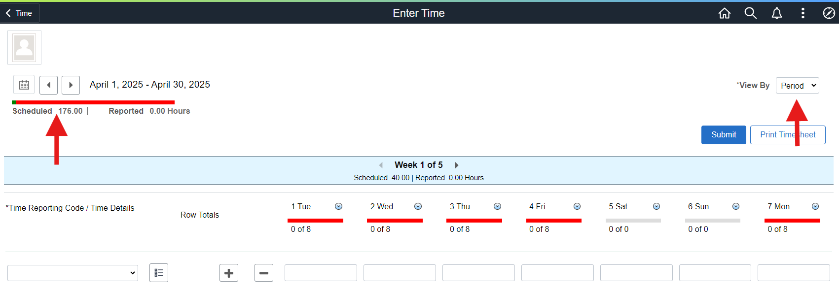

## Step 5: Enter Your Time

Select your Time Reporting Code (TRC) from the dropdown menu.  
(Examples: REG = Regular (for hourly employees), SCK = Sick Leave, VAC = Vacation, FHL = Floating Holiday). Regular full-time employees and part-time faculty do not need to enter their timesheet for hours worked.  
  
TRC tells the system what kind of hours you're reporting — work time or a type of leave.  
  
Under each date, enter the number of hours worked or leave taken.  
✅ Tip: If you're entering a full 8-hour day off (e.g., vacation), enter 8 under that day.  
  
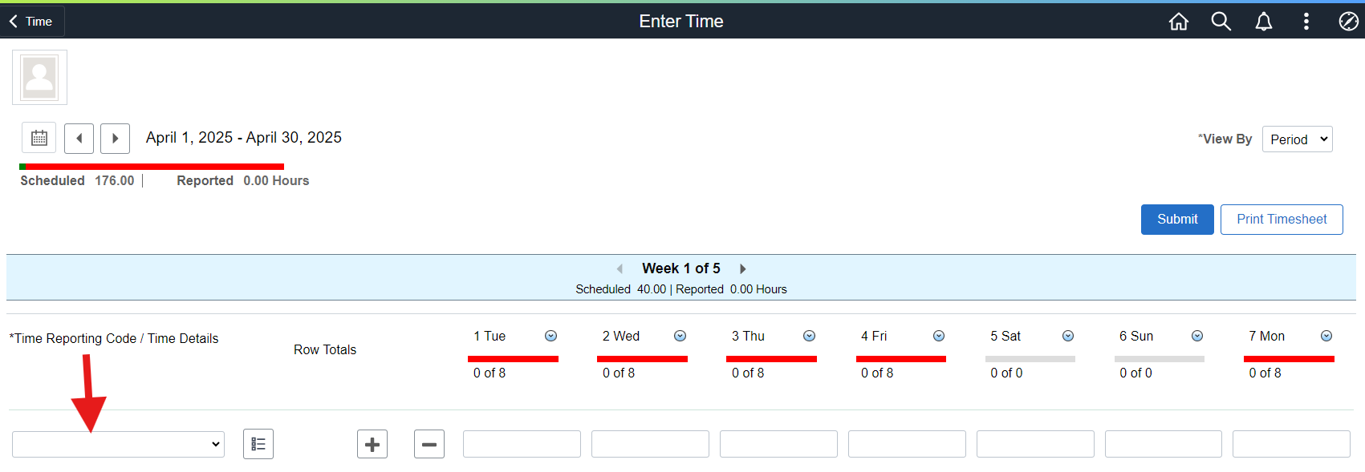

## Step 6: Edit or Remove Rows

• To add another type of leave, click the plus (+) icon to insert a new row.  
• To remove a row, click the minus (–) icon.  
  
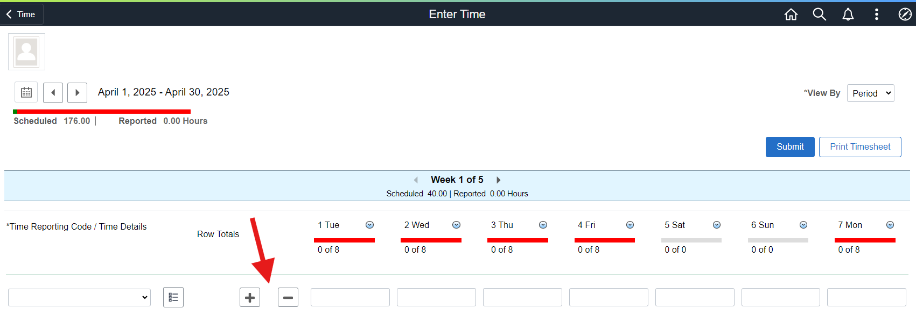

## Step 7: Submit or Save

Click the Submit button when you're done.  
Or click Print Timesheet to download a PDF copy for your records.  
  
Note: 'Reported' means the hours you enter and submit. Hours are processed after the month ends, so your ‘Reported’ hours may not appear immediately in your paycheck.  
  
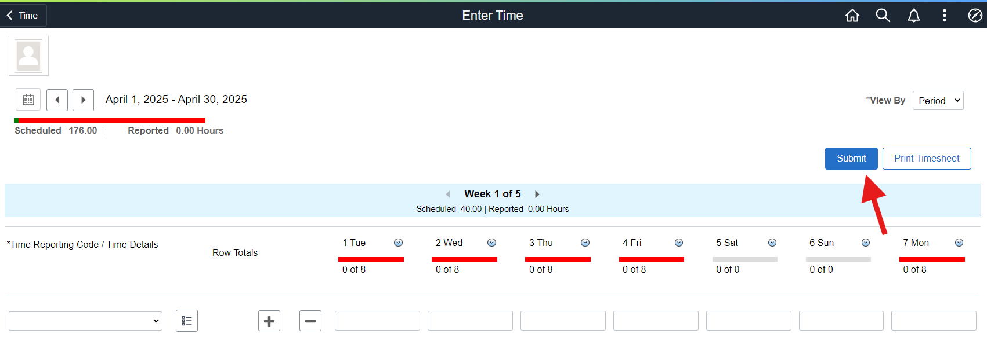

## Common Issues & Fixes

|  |  |
| --- | --- |
| Problem | Solution |
| Hours are not showing in balances | Double-check that the timesheet was submitted correctly. |
| Wrong Time Code used | Use the dropdown to select the correct Time Reporting Code. |
| Need to add more time types | Click the plus (+) icon to insert a new row for each time code. |

## Need Help?

If you're unsure which code to use or run into issues, contact:  
• Your Supervisor – for time approval questions  
• The Benefits Leaves Analyst, Alejandra Rodriguez, via email at alejandrarodriguez@peralta.edu – for leave eligibility and balance questions