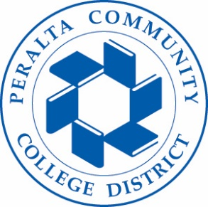

General Liability Claim Process
A General Liability Claim is a claim for damages filed by a third party (student or visitor) for bodily injury or property damages to the claimant resulting from the premises or operations of the Peralta Community College District and its Colleges.
- It is essential that claims be reported to the Office of Risk Management within 24 hours of the Colleges’ knowledge of an injury or damages, regardless of the severity of the claim.
- If the injury or damage is the result of an identified hazard, take photographs of the area.
- In the event of a serious incident at the College, please contact the Office of Risk Management immediately. If the incident occurs after normal working hours, please contact Peralta Public Safety, and request they contact Office of Risk Management.
- For all incidents, complete an “Accident Reporting and Claim Form” (See attachment) and forward to the Office of Risk Management for processing.
- If there has been a bodily injury, complete a “Medical Incident Report” (See attachment) immediately and forward to the Office of Risk Management.
- Liability Claims are investigated and managed by an outside claim’s administrator, ASCIP. If you are contacted by an adjustor from ASCIP, please respond promptly with any requested information.
- For questions regarding General Liability Claims, please contact Office of Risk Management at 510-466-7240 or by email at riskmanagement@peralta.edu
Peralta Vehicle Accident
If you have been involved in an accident with a Peralta vehicle or are a driver of a Peralta vehicle who has been involved in an automobile accident.
- Contact:
  - If there is an Injury: Call local police and 911 if life threatening.
  - Non-Injury: Exchange insurance information and file a Police Report online.
- If an employee is in an accident, please notify your supervisor immediately.
- Take photos of the accident.
- Fill out Vehicle Accident Report located in your vehicle.
- Forward Vehicle Accident Report, photos, and Police Report to the Office of Risk Management for processing.
Peralta Property Damage, or Theft
- If there has been damage/loss to a building or property or theft in your department, contact the department supervisor, Peralta Public Safety, and police department to generate a report as soon as possible.
- Take photos.
- Generate a list of property damaged or stolen with itemized cost.
- Submit Peralta Public Safety Report, Police Report, photos and list of equipment or damages to the Office of Risk Management for processing.

