ACCOUNT PAYABLES
POLICY AND PROCEDURES

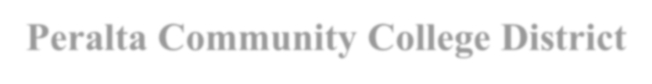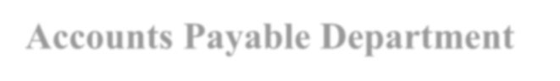

Peralta Community College District

Accounts Payable Department

Compilation of Policies and Procedures

Based on the Board Policies
and Best For Use by
Accounts Payable Department

As Compiled by: Accounts Payable Staff

Adil Ahmed, Budget Director

Nicholas Shere, AP Specialist II

Earvin Robinson, AP Specialist I

Tina Du, AP Specialist I

Kemal Idrisov, AP Specialist I

Amina Omer, AP Specialist I

Table of Contents

Staff 4
AP Schedule 5
General AP Information 6
Invoice Requirements 7
Order Types 9
AP Table of Requirements 13
Job Aids 16
Invoice Review & Payment Procedure 17
AP Check Cycle & Disbursement 22
Following Up on Payments 24
Vendor Files 26
Contracts 27
Travel 28
Transportation Report 28
Fiscal Year Closing 29
AP Staff Contact Info 30
Additional Documentation 31

Staff

Budget Director
Adil Ahmed

AP Specialist II: Nicholas Shere
- DGS and Capital Projects
- Query Authoring

AP Specialist I: Earvin Robinson
- Merritt College
- Staples

AP Specialist I: Tina Du
- Laney College
- Payroll
- Staledates/Escheatments

AP Specialist I: Kemal Idrisov
- College of Alameda
- District

AP Specialist I: Amina Omer
- Berkeley City College
- Benefits

AP Schedule

Check Runs
Checks are run every Tuesday and Thursday. The following day (Wednesday and Friday, respectively), checks are mailed, returned to the campus, or held for pickup at the district. Hold or campus delivery requests should be printed on the invoice near the PO number. Near holidays, at the end of the fiscal year, and at other times, the AP schedule may be adjusted to accommodate the District calendar, the payroll schedule, etc.

AP Cutoff
Every year, the Vice Chancellor for Finance and Administration will issue a memorandum detailing the deadlines and cutoffs related to fiscal year closing. The cutoff to submit invoices to accounts payable is typically in early July. Invoices must be submitted to AP by 5:00 on the day of the cutoff in a ready-to-pay state. (POs must be dispatched, all related documents must be correct, etc.)

Staledates/Escheatments
The escheatment process on staledated checks is run monthly, based on statements provided by Alameda County.

Sales and Use Tax Reporting
AP staff are responsible for verifying sales and use tax when entering vouchers. The Budget Director or Director of Fiscal Services submits the Sales and Use Tax report to the State Board of Equalization.

1099 Reporting
AP staff review 1099 summary reports for accuracy and provide information on corrections to the Budget Director or Director of Fiscal Services, who transmits the 1099 data to the Internal Revenue Service. AP staff mail 1099 forms to vendors. AP staff assist the Purchasing Department in identifying vendor files which must be updated or corrected with regard to 1099 reporting settings.

General AP Information

Payment Terms
Peralta’s payment terms are Net 30. (This means payment is due within thirty days of the receipt of valid invoice and goods, or valid invoice and services performed.) This is contingent upon the invoice and/or related documentation being submitted in a timely fashion.

Consistency and Completeness of Documentation
AP can only make payments based on complete and consistent documentation. The specific requirements vary from different types of payment. For more information on completeness and consistency, please see following sections on regular PO and open account invoices.

Travel
Reimbursement of employee travel expenses must be in accordance with Board Policy and Administrative Procedure 7400—Travel as approved by the Peralta Board of Trustees. For more information, please see the section on travel payments.

Food and Refreshments
Payments for food and refreshments served at meetings are governed by Administrative Procedure 6385.

Invoice Requirements
Invoices must provide the following information and meet the following criteria:
- Vendor Name
- Vendor Address
- Invoice Number
- Invoice Date
- Purchase Order Number (Vendors must have a dispatched PO before providing goods or services)
- Detailed Itemization
- Correct line prices, price per quantity, tax, and total
- Invoice must balance (add up)
- Invoice must be addressed to Peralta Community College District
- Invoice cannot be modified or fabricated by Peralta staff
- For services performed: invoice must show the dates of service

Supporting Documentation
For some types of transaction, there is required supporting documentation, including:
- Contract, where required for services as specified by District Administrative Procedure and Purchasing SOP. Also required may be:
  - Notice to Proceed, where the NTP determines the start and end date of the contract
  - Addenda or amendments to the contract, if any
  - Cover memo specifying budget coding and requisition number, if these are not included in the body of the contract
- Measure A Form, for order of equipment/furniture/etc. using Measure A funds
- Meeting agenda and other documents related to meals purchases
These documents are to be attached electronically to the Purchase Order. The requester can attach them when creating the requisition, and the system will copy them to the PO when it is sourced, or the Buyer may attach them directly to the PO.

Verbal Orders / Pay-To Requisitions

Effective April 9th, 2018, verbal orders are discontinued.
Any transactions that were previously handled using "pay-to" requisitions should now be processed on open account (blanket PO) or regular PO orders. These must be dispatched by Purchasing before the vendor begins work or delivers goods.
No vendor should perform work or deliver goods unless they have received a copy of the signed Purchase Order from Purchasing.

Administrative Procedure 6330—Purchasing

I.A. The authority to contract for goods and/or services is vested in the Board of Trustees. Authority to purchase supplies, materials, apparatus, equipment and services is annually delegated by Board action to designated District officers. The purchase of goods and services shall be made through the Purchasing Department following authorized procedures in accordance with established policies and laws. Any purchase made by an employee without proper authorization will be considered an obligation and liability of the employee and not the Peralta Community College District.

I.C.1 Except for small purchases from petty cash, all purchases or commitments to buy are made through the use of a purchase order. Purchase orders will be issued by the Purchasing Department only upon receipt of a properly authorized purchase requisition.

Order Types

There are two main types of orders: "Regular PO" orders and "Open Account" or blanket PO orders. Regular PO orders are itemized and paid based on warehouse receipts. Open Account orders encumber a lump sum in advance to order against based on approvals by the managers designated in the approval workflow for the cost center.

Origins
Every requisition and purchase order should have a three-letter "origin" code. The first letter of the origin code indicates the location from which the order originated, and the other two letters indicate what kind of transaction the order is.
Location | Prefix | Order Type | Suffix
District Office | D | Regular PO | PO
College of Alameda | A | Open Account | OA
Laney | L | Pay-To | IN (Discontinued)
Merritt | M | Travel | TV
Berkeley City College | V or B | Petty Cash | PC
So, an open account from one of the departments at the District would have origin DOA, while a regular PO from Laney would have origin LPO. Because Berkeley City College's name was changed (from Vista) before the introduction of the open account suffix, a BCC travel is a VTV, but a BCC open account is a BOA.
The procurement process for each of the origin suffixes is different. The two main differences are the order of operations and whether we pay based on signatures or based on warehouse receipt status.
Equipment should be ordered on a regular PO. Supplies may be ordered on a regular PO (if the specific itemization is known in advance) or on an open account (if the specific items to be ordered have to be identified on short notice). Services should be ordered on Open Accounts.

Regular PO Lifecycle

- The end-user creates a requisition for the items they wish to order
- The requisition is approved by their manager(s)
- The requisition is sourced to a purchase order automatically
- The buyer reviews the PO, approves it, dispatches it, and submits it to the vendor
- The vendor ships the order to the warehouse and sends an invoice with the PO number to AP
- The warehouse marks received items in
- AP reviews and vouchers the invoice in PeopleSoft, where it is matched against the PO and receipts
- If voucher passes matching and budget checking, a payment is generated

Receiving Goods
All goods should be delivered to the warehouse, with the exception of perishable or hazardous materials, or materials requiring installation by the vendor or a third-party installer.
Delivery of orders to the requested location must be approved in advance by Purchasing.
If goods have been delivered directly to the requested location, the requester MUST notify the warehouse promptly by email. The requester is responsible for following up on receiving issues related to their orders.
Otherwise, payment may be delayed, or it may be impossible to pay the order.

Discrepancies on Regular POs
If the invoice is inconsistent with the PO, AP staff will follow up with the vendor and/or the requester. The requester may need to take action to resolve the situation in order for the invoice to be paid.
If the invoice significantly differs from the PO, a Change Order may need to be submitted to the buyer, or the warehouse may need to be notified of the receipt of unmarked items.
If the requester asks the vendor to modify the order, or if he or she approves a modification proposed by the vendor, the requester must contact the buyer to determine whether a change order is required. If this is not done promptly, it may create significant delays in payment.

For either regular PO or Open Account invoices, if AP identifies missing or inconsistent documentation or issues with the transaction, they will contact the end user, the vendor, and/or Purchasing to resolve the situation.

Open Account Lifecycle

- The end-user creates a requisition to encumber a lump sum against which to place orders
- The requisition is approved by their manager(s)
- The requisition is sourced to a purchase order automatically
- The buyer reviews the PO, approves it and dispatches it
- The end-user orders their goods or services from the vendor on an ongoing basis, referencing the PO number. The end-user is responsible for verifying the available balance on the open account before ordering.
- The vendor fulfills the orders and submits invoices with the PO number to AP
- AP reviews and vouchers the invoice in PeopleSoft
- The voucher is approved by managers designated for that cost center and location. If others need to review the invoice for accuracy, they can be added as "ad hoc" approvers, giving them the ability to approve or deny that invoice.
- Once the voucher is approved and passes budget checking, a payment is generated
- If the open account is about to be exhausted but more orders will need to be placed, the requester is responsible for submitting a Change Order form to the buyer.
- After the last invoice for the fiscal year has been placed, the requester should notify AP to finalize the last payment made, liquidating the remaining balance to the budget.

Open Account Setup

Each year, the requester and cost center manager should review past expenditures and plans for the coming year, then create open accounts as necessary to encumber funds for all contracts, as well as for copiers, water coolers, annual memberships, subscriptions, and other recurring costs.
To assist in reviewing past spending, AP has created a query to review expenses by vendor and budget year over year. The current version of this query is AP_DEPT_EXP_HIST_B.
Please see How to Use the Department Expense History Query for more information.
An open account may be set up on one or multiple lines, as needed.
- If the invoices will contain both taxable and non-taxable items (e.g., parts and labor), then the PO should be set up with taxable and non-taxable lines
- If the PO is to be paid from multiple budget strings, then the PO may be set up on multiple lines or on a single line with multiple distributions
  - If all transactions are equally shared between the different budgets, use one PO line with multiple distributions. The split should be the same for every payment
  - If the budget split will vary from one invoice to the next (for example, when a consultant works multiple projects for varying hours every month), then the PO should be set up on multiple lines with one budget per line. The invoice and PO must be set up in such a way that the AP Specialist can identify what invoice line corresponds to what PO line
- For contract services, the open account and contract must be consistent in terms of budget and scope of work

AP Table of Requirements

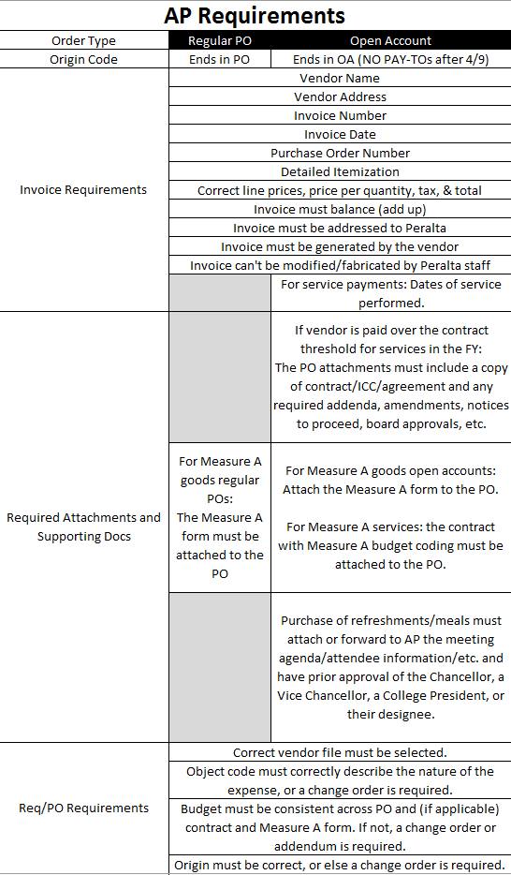
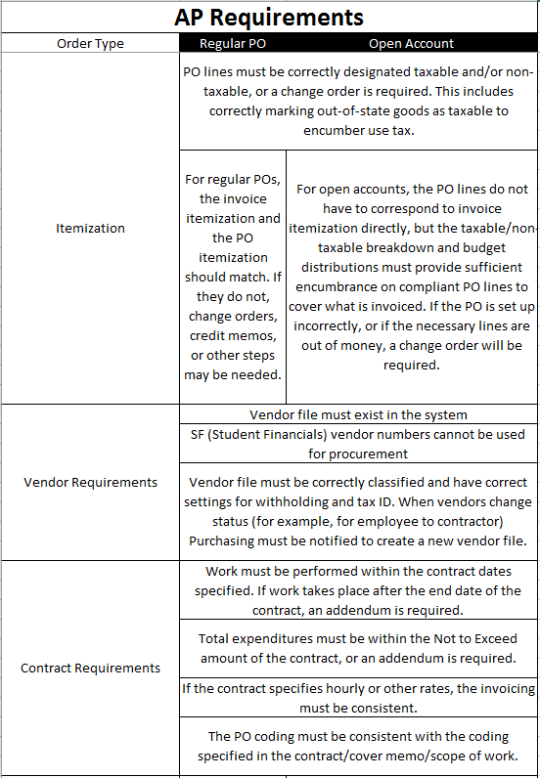

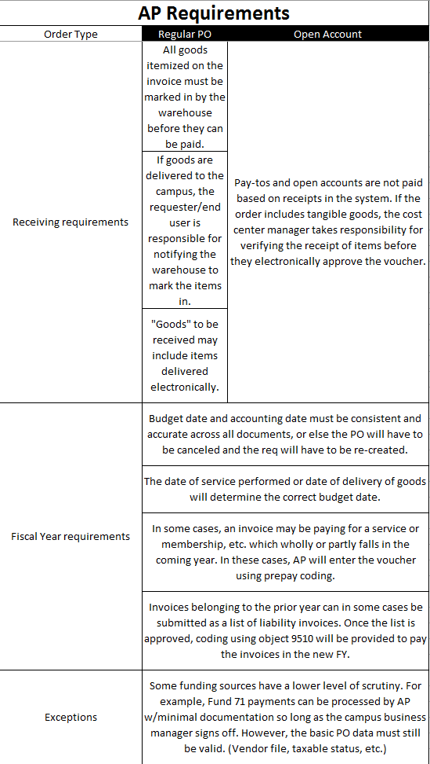

Job Aids

For technical guidance on using PeopleSoft / ONEPeralta, see training and job aids at http://web.peralta.edu/oneperalta/training-materials/. There you will find detailed guidance on how to operate the screens related to Accounts Payable, Purchasing, and other Finance Module functions.

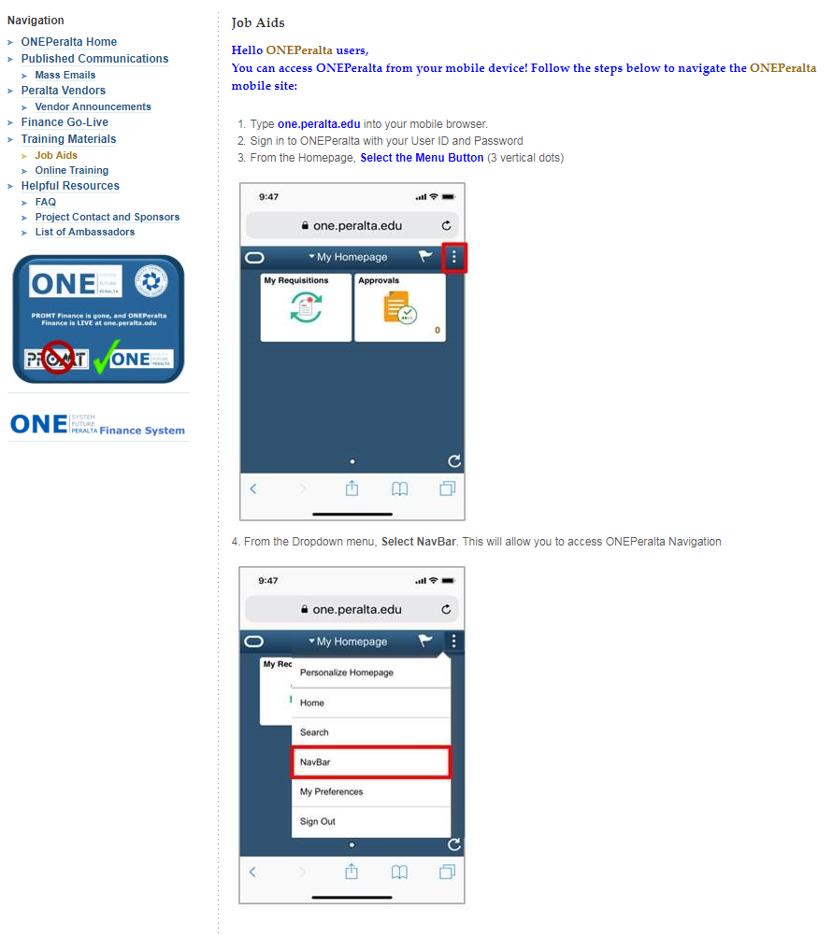

Invoice Review & Payment Procedure

Invoice Receipt
Invoices are received electronically by email to accountspayable@peralta.edu or by mail to 333 East 8th St., Oakland, CA, 94606, Attn: Accounts Payable.
Paper invoices are scanned by AP. Scanned invoices and invoices received electronically are sorted into folders by origin under “W:\Departments\finbudg\AP\AP Incoming Invoices.” The AP Specialists will review and process invoices in the folders based on their assignments on a first-come, first-served basis.
The invoice is reviewed together with the Purchase Order and associated documentation attached to the Purchase Order, such as contract, Measure A form, etc.
Invoices to be paid must meet criteria including:
- Dispatched PO
- Valid budget coding
- Complete and consistent documentation

Budget Coding
Regardless of the type of the payment, all payments should have budget coding which correctly describes the expense, and which is consistent across all necessary documentation.

Structure of the Budget String
The budget string consists of 23 numbers:
Field | Digits | Example | Meaning
Location | 1 (X) | 6 | Merritt
Fund | 2 (XX) | 11 | Gen. Restricted Fund
Cost Center | 3 (XXX) | 642 | Merritt Student Svcs.
Object Code | 4 (XXXX) | 4304 | Non-Instructional Supplies
Program | 1 (X) | 1 | General Operations
Activity Suffix | 6 (XXXXXX) | 643000 | EOPS
Project | 4 (XXXX) | 1010 | EOPS
Accounting Line | 2 (XX) | 02 | N/A (Arbitrary)
Of these, AP is particularly concerned with the object code and project number.

Object Code
The object code defines the nature of the expense. For more information about how the codes are used, see:
- PCCD Object Code Guidelines
- The State Budget and Accounting Manual (BAM)
To see a listing of the codes and their descriptions as defined in the system, use query OBJECT_CODES or search within Budget Details using the magnifying glass.
Some common object code problems include:
- Confusing supplies and equipment
- Confusing software purchases and internet service subscriptions
- Using a catch-all miscellaneous category when a more specific code applies

Project Number
AP does not usually have to determine the validity of the project number, but the project number used to pay an invoice has to be checked against any contracts or Measure A forms to make sure they are consistent. If funding has been identified for a specific purpose, then those funds should not be used for a different purpose without a budget transfer.

Consistency & Completeness
of Documentation

Consistency
Information must be consistent between all documents, including:
- Invoice
- Purchase Order and Requisition
- Contract
- Receiving
- Vendor File
If information is not consistent, the inconsistency must be resolved before payment can be made.
The types of information that must be consistent include:
- Vendor name, Peralta vendor number, and Tax ID/SSN
- Dollar amounts
- Items paid for
- Taxable and/or non-taxable line items
- Party billed (must be Peralta)

Examples of Inconsistent Documentation
Here are some common types of inconsistent documentation:
- Invoiced price and PO price do not match
- Taxable lines are not marked taxable on req/PO
- The wrong vendor number is chosen when creating the requisition
- Invoice bills for goods which were not ordered
- Invoice bills for goods which have already been paid for on another invoice
- Vendor or Tax ID is different on contract and invoice
- Invoice is billed to an individual or a partner agency rather than to Peralta
- Invoice is for work in excess of the contract Not To Exceed amount

Completeness
The specific requirements which must be met in order for documentation to be consistent will vary depending on payment type and in some cases based on funding source.

Regular PO
Documentation to pay an invoice based on a regular PO is typically:
- Dispatched PO
- Valid invoice
- Items received by the warehouse during the correct fiscal year
- Measure A Form (if applicable)

Open Account
Documentation to pay an invoice based on an open account is typically:
- Dispatched PO
- Valid invoice
- Contract (if applicable based on Administrative Procedure and Purchasing SOP)
  - Statement of work (if separate from contract)
  - Notice to Proceed (if required to determine start and end date)
  - Addenda/Amendments to the contract (if required to extend dates, amounts, or to update budget)
- Measure A form (if applicable)

Item and Amount Accuracy
Invoice lines must be compared to PO lines to ensure that the goods which we are paying for match what we ordered. Substitution of obviously equivalent items or small deviations in pricing can usually still be paid as is.
Significant changes or substitutions to the items ordered, as well as significant price increases, have to be recorded on the PO. In these cases, the requester must submit a change order to the buyer, so that the alterations are properly approved and documented. Requesters should initiate this process as soon as they are aware of substitutions or changes, and should not verbally authorize the vendor to make changes without also contacting Purchasing.

Sales and Use Tax

It is important that our sales tax be correctly recorded on POs and vouchers, so that our reporting to the state will be accurate. The following should be true for all invoices:
- Lines which are taxable (goods) on the invoice are taxable on the PO
- Lines which are not taxable (labor) on the invoice are not taxable on the PO
- The same tax rate is used on the invoice and on the PO
  - For all orders delivered to our campuses or the district, the vendor should invoice for our sales tax jurisdiction
  - If we pick up an order from the vendor at their location, their tax jurisdiction will apply. If it differs, then the PO lines should be set to a corresponding Ship-To location code. Examples:
    - SNL: San Leandro
    - SFO: San Francisco
    - ALB: Albany
- The invoice is prepared correctly in accordance with state regulations
When creating open accounts for service that may include both parts and labor, the requisition and PO must contain both taxable and non-taxable lines. The requester is responsible for separating those lines on the requisitions and marking them correctly. The tax amount must not be included as a line item, however. The system will calculate the tax automatically. If the system’s calculation is not correct, the AP technician will make the necessary adjustment at the voucher stage.
For orders shipped from out of state, the vendor may not collect sales tax in California. If that is the case, PO lines for tangible goods must still be marked taxable. We will record the tax as use tax on the voucher, and Peralta will remit the use tax to the state directly.

Measure A
For Measure A orders, either a Measure A Form or a contract with Measure A coding must be attached to the Purchase Order. The AP Specialist can open the attached documents on the PO to review when vouchering the invoice.
The invoice must be consistent with the coding and amount limits on the Measure A form or contract, as well as with the scope of work on contracts.

AP Check Cycle & Disbursement

Check Cycle
For each check run, one AP Specialist will run the check cycle process. The cycle must be approved by a designated approver other than the AP Specialists who have entered vouchers. The approver will upload the Positive Pay data file to Alameda County and forward the payment register PDF file.

Disbursing Payments
The day following the check run, checks will be disbursed. The checks are divided between the AP Specialists.
- Checks marked with handling code RE / "Regular Payment" are mailed
- Checks marked with handling code HL / "Hold for Pickup" are held at AP
- Checks marked with a numerical handling code are sent via district mail to the corresponding campus business office

Hold Checks

- If the check is made out to an individual, that individual can pick up their check
- If the check is made out to a company, then representatives from the vendor must be authorized in advance by Peralta Staff from the initiating department. Email authorized names to Nick Shere
- AP will maintain a list of names of authorized representatives for vendor check pickup

Direct Pays and Express Checks
Note: Neither direct pays nor express checks are normally used for procurement purposes.
Direct pays and express checks are two methods of creating a payment that can be used in special circumstances. These two terms are not interchangeable. “Direct pay” refers to a voucher created by the AP technician without copying lines from a PO. “Express check” refers to a check which is run by itself and not as part of a regular check cycle. An express check may be a direct pay or it may be from a normal voucher. A direct pay may be run as an express check, or it may be run as part of a regular cycle.
Direct Pays
- Direct Pays should be used only when a requisition cannot be processed.
- Direct pays do not show up under document status. They are directly deducted from the budget.
- To determine whether a direct pay has been processed, check the “voucher inquiry” screen or review available budget.
- Direct Pays are normally used only for Payroll and Benefits transactions
Express Checks
- Express checks are checks which are not run as part of a regular AP weekly cycle.
- The approval process for express checks is no different from checks cut during the regular cycle. All the usual requirements remain in place.
- Express checks are virtually never required, since AP runs twice a week.

Following Up on Payments

Each requester is responsible for checking their orders to make sure they have been completed. If an order has been received but not paid after 30 days, the requester should follow up with the AP tech. This is especially critical when approaching the end of the fiscal year and for funds which are not carried over to the next year.

Tracking Payments in PeopleSoft/ONEPeralta
In most cases, the document status page shows whether a payment has been made. However, if a direct pay has been used, document status will not show it. To track a direct payment, use Voucher Inquiry, check the budget directly, or look up payments by vendor.
If the requester does not have security access to these screens, they should contact the IT helpdesk.
Standardize on working from the PO number rather than the req number, because the req will not reflect change orders.

Interpreting Document Status

- Payment: If there is a payment line, a check has been cut on the indicated date.
- Voucher: If there is a voucher line, but no payment line, the invoice has been keyed in. The voucher may be pending receipts or approvals. The "voucher date" which displays in Document Status screens is in the invoice date, not the date the voucher was keyed in.
- If neither voucher nor payment lines exist, the AP tech has not keyed in a payment based on the PO in question.
If the PO has not yet been dispatched, the vendor should not perform any work or deliver any goods. AP cannot process any invoices. Concerns regarding PO dispatch should be addressed to Purchasing.
If the requisition has been both approved and budget checked but is not sourced to a PO after a period of days, it has become “stuck in cyberspace” and the requester should contact the helpdesk.

Interpreting PO Activity Summary
For POs with multiple lines which may be shipped in several shipments, billed on several invoices and paid with several checks over a period of time, the PO Activity Summary screen is the quickest way to tell what has been received and what has been paid.
To reach the screen, use the following navigation: Purchasing>Purchase Orders>Review PO Information>Activity Summary.
- The Receipt tab, Qty Received column shows how many of each item have been received.
- The Invoice tab, Quantity Invoiced column shows how many of each item we have paid for.

Researching with Queries
Some important queries that can assist in following up on invoices include:
- PCC_OPEN_ENC_NEW, the Open Encumbrance report. See How to Use the Open Encumbrance Query.
- IS_IT_PAID, query to review paid and unpaid vouchers. See Running the IS_IT_PAID query

Vendor Files
The requester is responsible for selecting the correct vendor number when creating a requisition. This includes checking not only the vendor name but also the remittance address, and ensuring that if multiple vendor numbers exist for a given vendor name, the correct vendor number is chosen. In some cases, it may be necessary to create a new vendor file.
It is not sufficient merely to confirm that the vendor name is similar to the name on the invoice. Special care should be taken with vendors who have multiple files, such as Ricoh or Pitney Bowes, and vendors with similar names.
A mistake in vendor selection can easily lead to the wrong vendor being paid, lost checks, or payments credited incorrectly.
Vendor numbers beginning with SF must never be used to create requisitions. Those files are for students who receive refunds or financial aid awards. A separate file must be created if they are to be paid as a note-taker, art model, etc.
For questions regarding vendor files, please contact Purchasing.

Payment Alternate Name
Please note that what prints on the check is not the "Vendor Name" field but the "Payment Alt Name" field. This may not be visible to requesters. To verify what name is used as the payment alternate name, contact Purchasing or your AP Specialist.

Contracts
For contract thresholds and requirements, please see Administrative Procedure 6340 and Purchasing SOP 10. Questions regarding when a contract should be prepared should be addressed to John Hiebert at Purchasing.
Under current policy, only the following are allowed to execute contracts:
- Chancellor
- Vice Chancellor, Finance and Administration
- College Presidents, only for contracts up to $5,000.
No other employees or managers are currently authorized to sign agreements on Peralta's behalf.
Contracts are routed through Purchasing, Finance, and Legal for review before execution.
No vendor may begin work until the contract has been executed and a Purchase Order has been dispatched. Once the contract is in place, work should be completed within the time period stated. Total payments for work under the contract should be within the Not to Exceed amount.
The requester and the manager approving the work are responsible for tracking total payments under each contract. If the vendor works beyond the coverage date of the contract, or amount billed exceeds the limit of the contract, an amendment is required.
Invoices for work performed within the terms of the contract can be paid in any fiscal period. For example, if a vendor completes work in June prior to the contract end date and within the terms of the contract, but does not invoice for that work until the next fiscal year, the invoice can be paid in the new fiscal year. Vendor invoices should contain sufficient detail to show when work was performed.
In such cases, the manager approving work on the contract is responsible for ensuring that the remaining balance of the prior-year PO is accrued as a liability.

Travel
All requisitions for expenditures relating to non-local travel must be accompanied by a Travel Authorization Form signed by the Chancellor.
Employees may request an advance up to 80% of their Not to Exceed amount (less registration or other costs payable directly to the conference, and less any payments made using district Cal Cards). Advance requests must be submitted no later than 15 days before the travel.
Registration should be paid separately to the conference. A new vendor file may be required in some cases. If so, the requester must arrange head of time for the vendor to complete the vendor applications.
Advances must be liquidated/finalized within 30 days of completion of travel. The traveler must submit the completed, signed travel form itemizing all expenses and attaching relevant receipts. Travelers who do not submit their final travel documentation within 30 days lose eligibility for future advances.
- Hotel receipts must be itemized
- No liquor expenses can be reimbursed
- Up to $50 in meals per day can be claimed without receipts
- Up to $25 in incidental costs per day can be claimed without receipts
- Only submit meal expenses incurred by the traveler themselves, not other diners
- If taking leave before/after a conference, only those days on which the employee is doing work for the district are reimbursable
- 60 miles round-trip is the threshold for differentiating local travel from non-local travel. All non-local travel requires a travel form.
For full information, please see Administrative Procedure 7400.

Transportation Report
Employees authorized to use a personal vehicle in the performance of their assigned workday duties are eligible for reimbursement for mileage and parking fees incurred while on District business. All expense claims requested for reimbursement shall be substantiated and submitted on the District’s approved form. Employees receiving a monthly travel stipend shall not be eligible for mileage, tolls, and parking reimbursement of travel expenses for distances up to 30 miles one way or 60 miles round-trip
Transportation reports (mileage, bridge and parking expenses) are to be submitted to the AP Technician at the end of each calendar month. No accumulation. Reports should be submitted to AP for payment no later than the 15th day of the following month.

Fiscal Year Closing

Prior to the end of the fiscal year, requesters should check outstanding orders, and managers should check their budgets, to make sure all transactions are complete. All requesters now have the ability to run the open encumbrance query PCC_OPEN_ENC_NEW. Do not use the older version of the open encumbrance query. Open encumbrances should be reviewed monthly or quarterly throughout the year, but are especially important as the end of the fiscal year approaches.
When researching open encumbrances, it is important to differentiate between funds left over after paying an order, and orders which have not been paid. It is equally important to differentiate between orders for which there is a valid liability in the closing fiscal year, and those which are not yet received, and which must be paid out of the fiscal year in which they are received.
It is imperative that all documents which are to be paid by AP out of the prior fiscal year’s budget period be received at Accounts Payable before the announced AP invoice cutoff.

AP Staff Contact Info

Nick Shere
Phone: 10-466-7241
Fax: 510-835-4078
nshere@peralta.edu

Earvin Robinson
Phone: 510-466-7226
Fax: 510-835-4078
erobinson@peralta.edu

Tina Du
Phone: 510-587-7872
Fax: 510-835-4078
tdu@peralta.edu

Kemal Idrisov
Phone: 510-466-7253
Fax: 510-835-4078
kidrisov@peralta.edu

Amina Omer
Phone: 510-587-7853
Fax: 510-835-4078
aomer@peralta.edu

Additional Documentation

How to Use the Open Encumbrance Query:
PCCD Object Code Guidelines:
Running the IS_IT_PAID query:
How to Use the Department Expense History Query:
AP Process Overview for ONEPeralta:

