  - Creating/Deactivating Accounting [Budget] Strings

Procedure Type: Fiscal Services

Procedure Name: Creating/Deactivating Accounting [Budget] Strings

Procedure Owner: Associate Vice Chancellor of Finance and Administration

Secondary Owner: Executive Director of Business & Administrative Operations

Cross-Functional Divisions:
Finance and Administration Division – Accounting, Budget
College – Business Services Office

Category: Chart of Accounts

Procedure Purpose:
The purpose of this procedure is to guide fiscal staff through the process for adding and deactivating funds.
This procedure should be used in conjunction with
- CCC - Budget and Accounting Manual (BAM)
- BP 6300 Fiscal Management and Accounting (peralta.edu)
- AP 6300 General Accounting (peralta.edu)

Procedure Summary:
Districtwide financial resources are allocated to and accounted for using the PCCD’s Accounting Code System, which is comprised of 23 digits, based on the purposes for which they are to be spent and controlled.
Each accounting/budget string (combo code) accounts for designated assets, deferred outflows of resources, liabilities, deferred inflows of resources and account balance/net position. A new accounting/budget string should only be established and maintained as required by law and sound financial administration. Only the minimum number of combo codes consistent with legal and operating requirements should be established.

PCCD’s Accounting Code System comprises of 23 digits.

Field Length (characters) | Location | Fund | Cost Center | Object Code | Program | Activity Suffix | Project | Account Line
 | 1 | 2 | 3 | 4 | 1 | 6 | 4 | 2

According to AP 6300 General Accounting [Section A – Function], it is the responsibility of the District Accounting Office to:
- Provide central functions for all district funds.
- Maintenance of accounting data on the District's data processing system.

The AVC of Finance and Administration is responsible for ensuring district-wide accounting practices are consistent amongst all colleges and the district. The AVC of Finance and Administration [or designee] must coordinate with each colleges’ vice presidents of administrative services to reinforce the practice of working with the district budget and accounting team in accordance with AP 6300 General Accounting.

Procedures Summary:
Obtaining the Chart of Accounts

- Log into PeopleSoft Financial Management: https://fm.peralta.edu
- Steps to run a Budget Overview:
  - Open the NavBar Reporting Tools Query Query Viewer
  - Search for the Query: CHART_OF_ACCOUNTS​
  - Run the Query to Excel.​
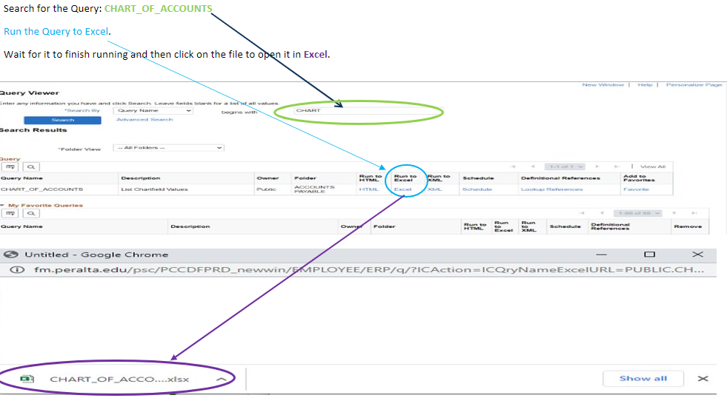
  - An Excel spreadsheet will be created.

Project Number Set-Up

- Upon the receipt of a new executed grant award/contract the Project Manager will work with their college VPAS [or designee] to submit an email request (and supporting grant award/contract documents) for a new accounting/budget string to the District Budget Director and Principal Budget & Finance Analyst (PBFA).

- The PBFA:
  - Reviews the approved grant award/contract documents.
  - Creates a Project Numbers in PeopleSoft [Chart Field Page]. Refer to Appendix A^{[i]}.
    - Assigns project numbers in chronological order based on funding agencies:
      - 1XXX – Federal
      - 2XXX – State
      - 3XXX – Local

  - Completes a Project Management Information Sheet.
  - Sends the Project Management Information Sheet and notifies the Project Manager, VPAS (BSO), AVC of Finance and Administration, Budget Director, PBFA, and Principal Accounting Technician of the new approved grant Project Number.

- The PBFA:
  - Reviews the Project Number in PeopleSoft [Chart Field Page]
  - Adds the new grant to the master list.
  - Maintain a master list of all grants district-wide.

- The District Budget Director [Level 2 approval] reviews and approves the Project Number Setup in PeopleSoft upon notification.
  - Review to ensure documents are complete.

- The AVC of Finance and Administration [Level 3 approval] reviews and approves the Project Number Setup in PeopleSoft upon notification.
  - Review proper approval have been obtained.

Deactivating a Project Number

- The Project Manager notifies their college VPAS when a grant award/contract ends within a month after the project closes.

- The VPAS emails the Budget Director and PBFA, one month before fiscal year-end (May 30), requesting for the deactivation of the project number.
  - The following information is included:
    - Project number
    - Contract End Date
    - Evidence of submission (either email or proof of transmission) of the final report to the grantor.

- The Budget Director will work with the PBFA and VPAS and take the following steps to close the a project number.
    - Verifies that all expenditures (i.e. payroll, services, and supplies) have been paid.
    - Verifies that all billing has been invoiced and receivables have been collected.

- The PBFA deactivates the project number in PeopleSoft.

- The PBFA notifies the VPAS and Project Manager that the project number has been closed.

Glossary:

Chart of Account is PCCD’s Accounting Code System comprises of 23 digits. The chart of account is also referred to as:
- Accounting string
- Burget string
- Combo code

Related Policies:
- BP 6300 Fiscal Management and Accounting (peralta.edu)
- AP 6300 General Accounting (peralta.edu)
- Peralta Community College District Grant Manual

Related Forms and Information:
- Project Management Information Sheet
- Master list of all grants.

History:
New Procedure

^{[i]} Appendix A - Instructions on how to create a new Project Number

Step 1- Click Chatfield Values
Step 2 - Next click on Project

Step 3 – [Existing Value tab]

Enter [SetID]: equals PCCD1
Click the magnifying glass [Project] and to get a list of all project numbers. 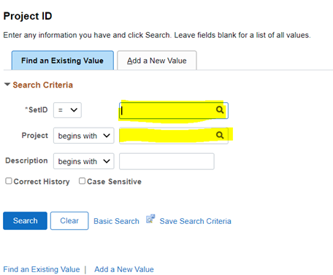

Step 4 – Look Up Project numbers that are available.
- 1000 – 1999 range for Federal
- 2000 – 2999 range for State
- 3000 – 3999 range for Local

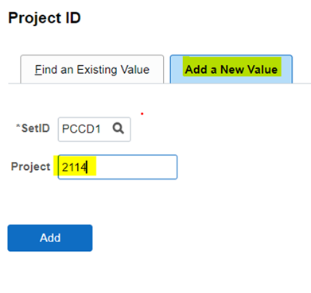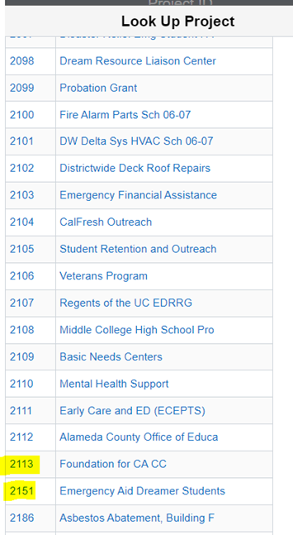
Step 5: Assign a project number [Add a New Value tab] in chronological order based on funding source..
- Federal projects: 1XXX
- State projects: 2XXX
- Local projects: 3XXXl
Step 6: Complete the following fields:
Project Tab
- Description
- Start Date
- End Date
- Project Manager – Effective Date
- Project Manager – Manager Name
- Project Status – Open

Description Tab
- Description: Name, FY, and amount of award

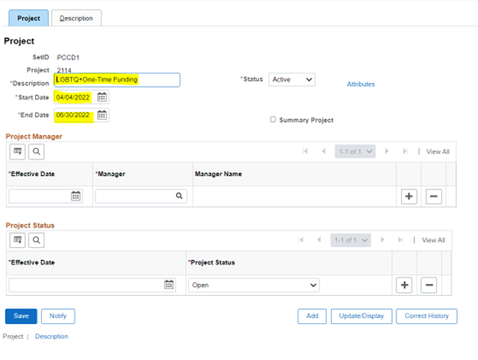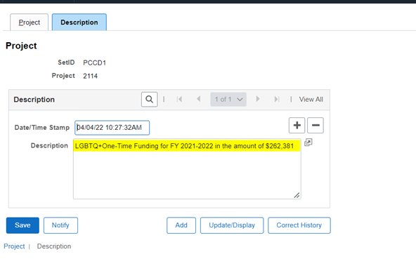
Step 7 – Click Save

