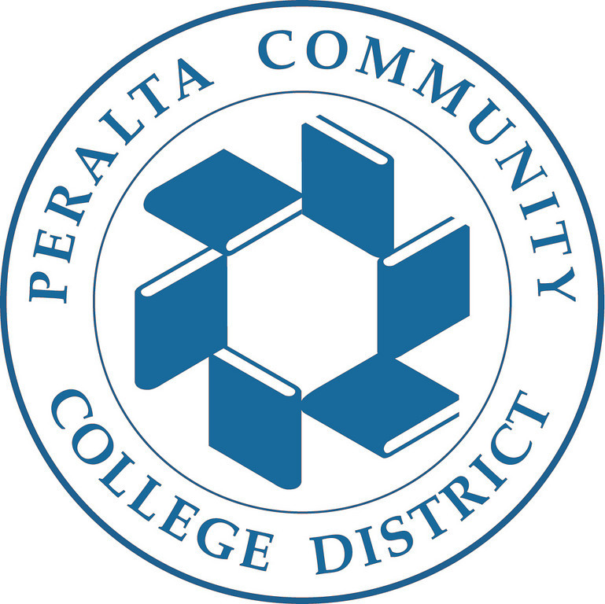
Audit Resolution Meeting
Friday, January 23, 2015
HR Conference Room

Attendees: Adela Esquivel-Swinson, Amany Elmasry, Calvin Madlock, Charlotte Smith, Dave Nguyen, Dominique Benavides, Joyce Brown-Willis, Michael Orkin, Michael Dioquino, Ranell Holmes, Roderick Fajarda, Thomas Wong.

Meeting convened at 10:41 am

Update on reporting timely and accurate data to the NSLDS.

The issue with majors missing the CIP code for the fall 2014 report has been fixed. All IM majors have been fixed as well. Dominique ran the report this morning and there were no issues with the CIP codes for the Fall 2014 report.

There are about 12500 plans that need to be updated. The temporary solution for this issue consists of running a SQL to update all the required fields for the Fall 2014 report, except for the CIP codes because those have been manually updated.

Although some certificates take less than two years to be completed, for the purpose of this solution, they will be using the assumption that all the IM programs are for two years.
There are about four fields that need to be updated in the report:
- Report to NSC: it has to be changed to yes)
- Classification: AA degree
- Value: 68
- Type: weeks

The permanent solution is to update the students’ major in their record.
All students need to have a correct major, if they are not fixed, they cannot be reported.

Students are asked to complete the survey in PASSPORT so they can have a correct active major. However, students who visit the front counter to enroll for classes might not even complete the survey.
Additionally, there are students who select a valid major but do not select the correct campus and A&R staff do not have information concerning which campus the student is receiving Financial Aid.

They need to take into account that there are IM majors that still active and if those are removed it will cause major tuition calculations. Old returning students are the ones who have the problem with IM majors because they are not updating their majors.

It was suggested to have the survey come up every time A&R staff goes to quick enroll a student.
However, this page would require a customization. Additionally, it will require more time to serve students and the admissions and record office already have really long lines. The original request was to add a row to the program plan with the specified criteria. A customization is not really necessary. What is needed is a technical fix that takes place behind the scenes to update students’ program plan.

The National Student Clearinghouse (NSC) is a third party data warehouse that collects the enrollment information from PeopleSoft. Peralta is not really required to use it, but they are using it because in order to report to NSLDS, every student would require PeopleSoft customization to do that. NSC provides all the required fields and these are sent to PeopleSoft, but PeopleSoft has not really function very well with NSC.

As long as the Peralta Colleges offer title IV aid, all students need to be reported, not only financial aid students.
If students want to defer their loan, the only way to deferred it is if they are enrolled in 6 units. That is why every student needs to be reported because the loan might not even be from Peralta; it could be from any other college.

The NSC report is pulling 23 thousand students, but there are 17 thousand students that need the additional fields.
If the SQL is run by IT, then all information will pull out correctly and they will be able to report that. When a report is run it connects to the previous report and it updates any changes. However, they need to take into account that there are also the data issues that need to be cleaned up.

The inaccurate data issues are being addressed by the 3 tickets that were submitted.
Whoever runs the report would have to work with A&R to resolve any additional issues every single month so they can report timely and accurate data to NSLDS. It is hesitant to resolve the data issues; otherwise they will keep experiencing issues for future audits.

It was decided that IT will run the SQL. Amani will work with Ranell on running the SQL and they will provide an update by Wednesday, January 28.

Three tickets update from Joyce:

• Joyce is testing one instructor to make sure that the dates are showing correctly. The rosters for them supposed to appear 7 days before the due date for regular session classes, 3 days for classes that are longer than 2 weeks and 2 days for classes that are shorter than 2 weeks. Joyce’s goal is to complete this testing by the end of today.

• There was a customization with permission numbers; therefore, there were some issues.
One of the encountered issues is that they showed and incorrect reason code, - Kyu had the issue fixed. Joyce is currently testing the fix to ensure that it worked.

• Students being dropped from the roster immediately- The permission number issue was preventing Joyce to log in as an instructor and drop the student. She is currently doing some testing to ensure that the permission numbers issue is no longer a problem.

Having a fix for all these three tickets will also help with the withdraw dates issue.
The incorrect enrollment status issue might be related to the date the roster was due. If they can make the roster available 7 days prior the due date, it will record the correct date rather than back dating.

The rosters for instructors will be available Monday or Tuesday of next week.

TD Client

There is progress on getting the log ins from TD Client only. Dave and Michael might have the logins by Monday evening. These are logins to access a mailbox where all Peralta files are located. Therefore, they need to get approval from all the College Presidents. They can start testing the program once they get the logins for all four colleges. Mike can take the document to the cabinet on Tuesday and have the presidents sign it.
Dave and Michael will provide a project status update by Wednesday, January 28.

Adjournment
Next meeting will be Friday, January 30 at 3:00 pm.
Meeting adjourned at 11:33pm

