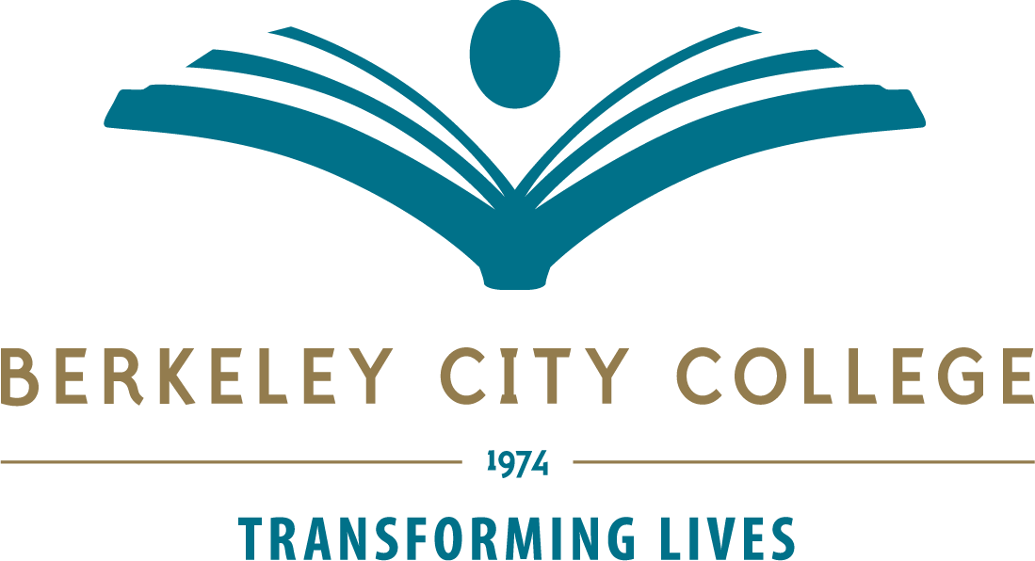

Technology Committee Agenda and Minutes

November 14, 2024, 12:30 – 1:20 p.m.
Conference Room 451B and Zoom (https://peralta-edu.zoom.us/j/84266180036)
Tri-Chairs: Nghiem Thai, Erika Yeh, and Thomas Rizza
Meeting Recording:

Time | Agenda Topic | Leader | Minutes
12:30 p.m. | Approval of Agenda | Thai | Agenda approved.
12:35 p.m. | Approval of 10/10/2024 Minutes | Thai | Postponed
12:40 p.m. | Approval of (Semi-)Annual Goals  - Review and revise committee charge.  - Complete classroom AV refresh by July 1.  - Plan AV/IT purchasing for new building.  - Explore ways to sustain Chromebook loan program. | Thai | Clarke-Miller moved  Rizza seconded  Passed unanimously
1:00 p.m. | Standing Items  Bond & Refresh Plan  Classroom Technology (inc. new building)  District Tech Committee Report  Website | Koo  Bay  Bay  Rizza/Leonian | MMART Mac lab refresh will be delayed by spring release of new Mac Studio. However, due to the long lead time for delivery, it was unlikely that the product would be available by the end of the fiscal year. Mary expressed concerns about the slow startup times of the current computers, impacting student learning and scheduling.  Joe discussed the progress of the AV and classroom tech project, including a piggybacked contract from UC Berkeley and bids for the new building's classroom technology. Joe expressed concern about the high bids and the need to ensure the equipment meets specifications.  Joe provided an update on various district projects, including the funding of Peoplesoft by the State, the vendor list refresh, and the short-term vendor agreement. He also mentioned the completion of the security camera project and the district's assistance to COA due to staffing issues.  Tom is meeting with Laura Ruberto, Chair of Chairs, to discuss concerns about missing departmental pages and contact information.
1:15 p.m. | Announcements
 | Next Meeting 12/12/ 2024

Tech Committee Members
Nghiem Thai (Admin Tri-chair), Erika Yeh (Faculty Tri-chair), Thomas Rizza (Classified Tri-chair), Mary Clarke-Miller, Matt Freeman, Phoumy Sayavong, Joe Bay, Vincent Koo, Jeejun Bertuso, Joshua Boatright, Elissa Jaw (Disability Services), Tania Leonian, Chris Bernard (Distance Ed), Paramsothy Thananjeyan (CIS), Luis Angel Soberanis-Pacheco (Student Rep)

Tech Committee meetings are open to the college community.

Mission
Berkeley City College’s mission is to promote student success, to provide our diverse community with educational opportunities, and to transform lives. The College achieves its mission through instruction, student support and learning resources which enable its enrolled students to earn associate degrees and certificates, and to attain college competency, careers, transfer, and skills for lifelong success.

