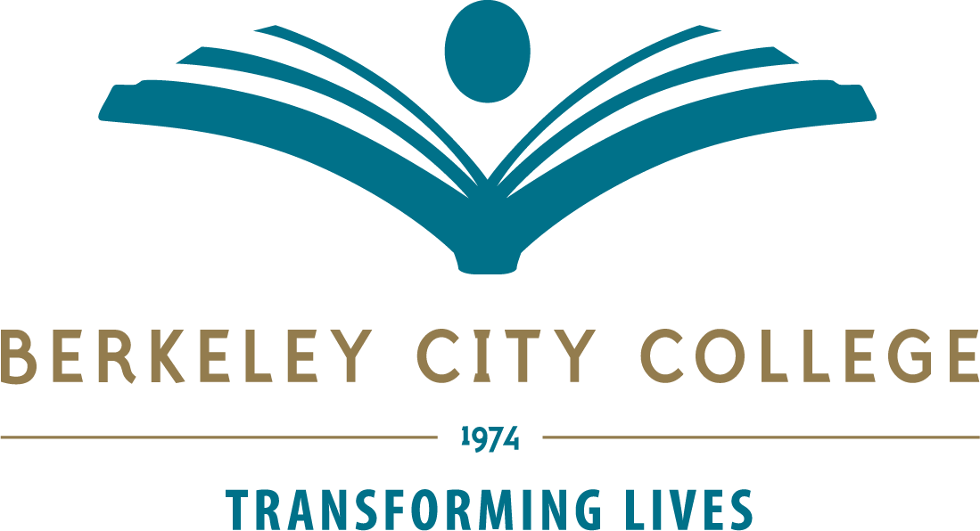

Technology Committee Agenda –Nov. 3rd 2022
Location Zoom Time: 12:30p.m.-1:20p.m.
Co-Chairs: Administrator: Christopher Lewis; Faculty: Mary Clarke-Miller

Mission: Berkeley City College’s mission is to promote student success, to provide our diverse community with educational opportunities, and to transform lives. The College achieves its mission through instruction, student support and learning resources which enable its enrolled students to earn associate degrees and certificates, and to attain college competency, careers, transfer, and skills for lifelong success.

TIME | AGENDA TOPIC | LEADER | DESIRED OUTCOME
12:30-12:35 | Review Agenda – any additions | Chris Lewis/  Mary Clarke-Miller
12:35-12:45pm | Welcome Tom Rizza | Tom
12.45-1.20pm | Open Lab First Floor – update?  Standing items  Updates on Refresh Plan – Purchase update – Roll out dates  Updates on Classroom updates  Website update  Status of District Technology Plan, network. | Chris  Vincent/Joe  Joe and Willis  Tania  Vincent
 | Next Meeting Dec 1st
Tech Committee Members:
Chris Lewis, Mary Clarke-Miller, Matt Freeman, Christopher Bernard, John Nguyen, Brenda Johnson, Phoumy Sayavong, Joe Bay, Vincent Koo, Jeejun Bertuso, Randy Yang, Joshua Boatright, Elissa Jaw, Ben Allen, Tania Leonian , Mazin Saeed
Vision: Berkeley City College is a premier, diverse, student-centered learning community, dedicated to academic excellence, collaboration, innovation, and transformation.

Tech Committee meetings are open to the college community.

