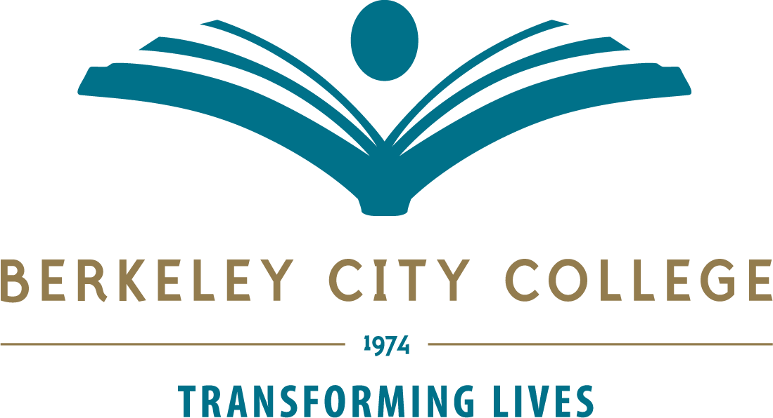

Technology Committee Agenda – Feb 2nd 2023
Location Zoom Time: 12:30p.m.-1:20p.m.
Co-Chairs: Administrator: Christopher Lewis; Faculty: Mary Clarke-Miller

Mission: Berkeley City College’s mission is to promote student success, to provide our diverse community with educational opportunities, and to transform lives. The College achieves its mission through instruction, student support and learning resources which enable its enrolled students to earn associate degrees and certificates, and to attain college competency, careers, transfer, and skills for lifelong success.

TIME | AGENDA TOPIC | LEADER | DESIRED OUTCOME
12:30-12:40 | Review Agenda – any additions  Approval of last minutes | Chris Lewis/  Mary Clarke-Miller
12:40-12:45 | Open Lab First Floor – info – LRC update – 10 Macs – 25 refurbished pc laptops ready to deploy – 3 gamer pc laptops on way | Mary/Chris
12.45-1.20pm | Standing items - Bond?  Updates on Refresh Plan November link– Purchase update – Roll out dates - new update?  Updates on Classroom updates – (Spreadsheet needed to include in with instructional plan )  Website update – any updates on the new website moving forward? Helpdesk set up?  Status of District Technology Plan, network. | Chris  Vincent  Joe  Tania/Tom  Vincent
 | Next Meeting March 2nd 2023
Tech Committee Members:
Chris Lewis, Mary Clarke-Miller, Matt Freeman, Christopher Bernard, John Nguyen, Phoumy Sayavong, Joe Bay, Vincent Koo, Jeejun Bertuso, Randy Yang, Joshua Boatright, Elissa Jaw, Tania Leonian , Student Rep vacant, Tom Rizza
Vision: Berkeley City College is a premier, diverse, student-centered learning community, dedicated to academic excellence, collaboration, innovation, and transformation.

Tech Committee meetings are open to the college community.

