Berkeley City College’s mission is to provide our diverse community with
educational opportunities, promote student success, and to transform lives.

Introduction and Directions

The Peralta Community College District has an institutional effectiveness process which consists of the following components: a District-wide Strategic Plan which is updated every six years; Comprehensive Program Reviews which are completed every three years; and Annual Program Updates (APUs) which are completed in non-program review years.

The Program Review 2021-22 timeline has been developed for each program and services to guide through the semester. Please review and work with your Deans, Managers, Department Chairs and/or Supervisors to complete this Program Review.

The Program Review is intended to primarily focus upon planning for the subsequent two years and institutional effectiveness. The Program Review process directly leads to the institutional resource allocation process and budget planning for the following academic year (2022-23). This is an opportunity for each administrative unit, support service program, and department to reflect on progress made and identify areas of program improvements to achieve equitable student success and elimination of achievement gaps. In this process of making continuous quality improvement, there is an opportunity for each program, student services, and department to request resources that support achieving the stated goals.

If you have questions regarding other material in the Program Review, please contact your Dean or Manager. If you have questions regarding data, please contact Dr. Phoumy Sayavong, Senior Researcher and Planning Analyst (psayavong@peralta.edu).

Please email the completed Program Review to your Dean by November 30, 2021.

Program Reviews, click here.
To view prior Annual Program Updates, click here.
COLLEGE PROFILE
Click here to view the Berkeley City College Student Demographics Dashboard.
This 2-page dashboard will provide information on the characteristics of our student body from the past two years such as headcount, ethnicity, enrollment status, age group, educational goals, and majors.
College Outcomes | 2017-2018 | 2018-2019 | 2019-2020 | 2020-21
Full Time Equivalent Students (FTES) | 4,140 | 3,864 | 3,696 | 3,290
Efficiency  (Productivity; avg faculty-student ratio) | 13.4 | 13 | 13.2 | 14.3
Success Rate (%) | 67% | 69% | 67%* | 74%
Degrees + Certificates Awarded (#) | 1,021 | 948 | 1,106 | 1,014
*Excludes “EW” grades

To view prior Program Reviews, click here. To view prior Annual Program Updates, click here.

- DEPARTMENT DESCRIPTION
Please verify the mission statement for your department. If your program has not created a mission statement, provide details on how your department supports and contributes to the College’s mission.
The mission of the sociology discipline at Berkeley City College is to support students in degree completion and transfer. By providing a course of study that examines the systematic study of human social institutions and social relationships, sociology courses provide both a general education in the social sciences as well as preparation for the sociology major. Students taking sociology courses will study the role of social theory, sociological research methods, social organization and structure, social stratification and hierarchies, dynamics of social change, family structures, social deviance and control, and applications to the study of specific social groups, social institutions, and social problems.
Name(s) of member(s) completing this Program Review | Department/Program | Completion Date
Mark Swiencicki  Linda McAllister | Sociology | November 2021.
List faculty names and/or staff with assignments in fall 2021.
Full Time | Part Time
Mark Swiencicki  Linda McAllister | Darrol Hughes  Dustin Mabry  Breanne Harris

II. STUDENT EQUITY & SUCCESS
Using the data dashboards provided below, review and reflect upon the outcome trends for your department. You may use data from other sources if available.

Click here if you would like to view BCC’s Planning Documents (Education Master Plan, College Strategic Goals, Student Equity Plan, District Strategic Goals, Vision for Success, Guided Pathways, Technology Plan, Facilities Plan)

For assistance with data dashboards, contact Phoumy Sayavong at psayavong@peralta.edu

3A. Enrollment Trend and Productivity Dashboard
*Note that completion and retention rates are presented with the inclusion and exclusion of excused withdrawals (EW) and military withdrawals.
What are your enrollment trends in the past three years?
Enrollment Trends: According to the data from the “Enrollment Trend and Productivity Dashboard” above, From 2017 – 2020 Sociology (abbreviated as “Soc” from here on) enrollments slowly dropped from 1221 to 1051, then took a bigger downward jump to 873 in the 2020-2021 AY. We assume this unusual decline was largely caused by the Covid shutdown, since numerous students weren’t prepared to jump from F2F to remote classes mid semester. Also, since our drop closely mirrors the serious general national decline in 2-year public college enrollments for the past 10 years (see below blue arrows), the data suggests this is more of a national demographic and covid related problem than a BCC sociology problem.

BCC Sociology Enrollment & Productivity vs. College Averages:

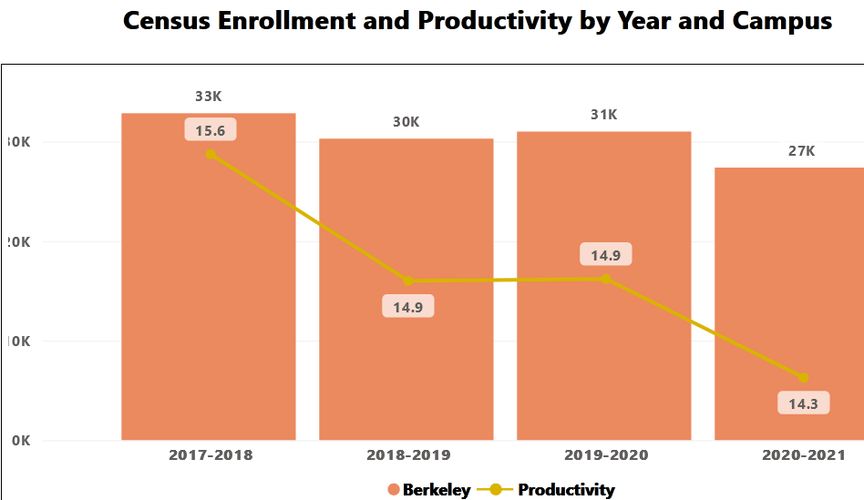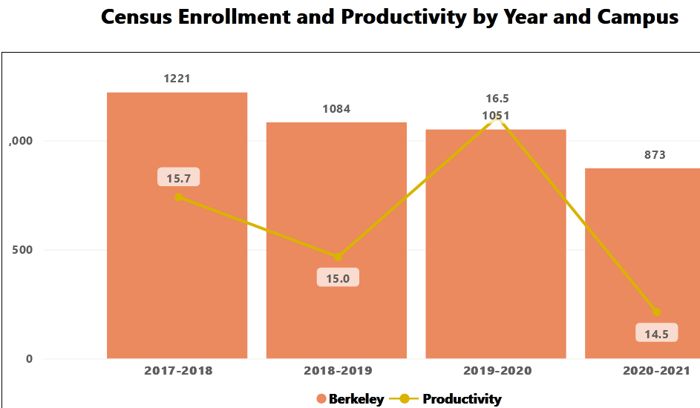
BCC Average Enromment & Productivity for all Depts, 2017-21 BCC Sociology Enrollment & Productivity, 2017-21
Although BI would not allow us to compare BCC Sociology numbers to BCC “Liberal Arts & Social Science Division” numbers, the good news is that BCC Sociology productivity averages moderately exceeded the college wide averages for every calendar year.
Drilling into the numbers on day vs. evening classes, we noticed our day classes had a 78% fill rate and a productivity of 15.3, whereas our evening classes had a 66% fill rate and a 11.9 productivity rate. Essentially our day classes are doing about 18% better than our evening classes. Unfortuantely the BI tool would not allow us to generate such data for F2F vs. online classes.

Below you will find all the data for how our classes are doing by time of day. As you can see, our Sociology student prefer day classes to night classes by a margin of about an 18% fill rate.
BCC Sociology Numbers by Time of Day, 2017-21:
Time of Day: | Fill Rate: | Productivity:
Day | 78% | 15.3
Evening | 66% | 11.9

Below you will find the data for how our classes are doing by modality type. To place things in perspective, college wide, hybrid/blended classes have the highest fill rates - especially “> 51% online” which is the pick of the litter.
All BCC Numbers by Modality, 2017-21:
Class Modality: | Fill Rate: | Productivity:
F2F | 80% | 15.1
< 50% online | 85% | 13.6
> 51% online | 99% | 15.1
100% online | 84% | 14.9

For BCC Sociology, we can’t reliably look at hybrid/blended classes since (in the current BI dataset) only 1 of them was offered in F18. However, the data suggests that our students moderately prefer online classes to F2F classes, by a fill rate difference of about 16%. And since hybrid/blended classes do the best at BCC college wide, it makes sense to offer multiple hybrid sociology classes in the future. We currently are offering blended sociology classes, but they do not yet appear in the BI data. However, in S21 both of the 2 newly offered blended 50/50 Soc 1 classes reached max cap size. However, because the Dept feels that some level of F2f is helpful for non-traditional students, we plan to offer hybrid instead of blended classes whenever possible in the future.
BCC Sociology Numbers by Modality, 2017-21:
Class Modality: | Fill Rate: | Productivity:
F2F | 75% | 14.61
< 50% online | Only 1 class in F18 | Only 1 class in F18
> 51% online | no data | no data
100% online | 87% | 16.3

When the data for your department are disaggregated by student ethnic groups, what trends do you observe and how do plan to address them over the next three years?

Results: According to the Power BI data, when comparing the data for the last pre-Covid year (2018/19) to the most recent data (2021/22), it’s striking to see that White and Asian students have switched places. (see below) White students go from having the highest to the lowest Completion rates for all “races” (from 78.6% to 53.3% completion rates), and Asian students go from a 68.2% to a 78.9% completion rate, the highest. I assume the greater economic resources of white students allowed them to take time off from college, or get a high enough paying job to leave college.

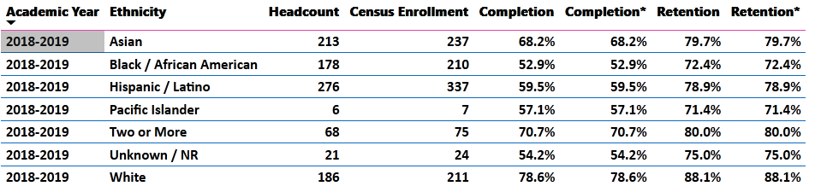
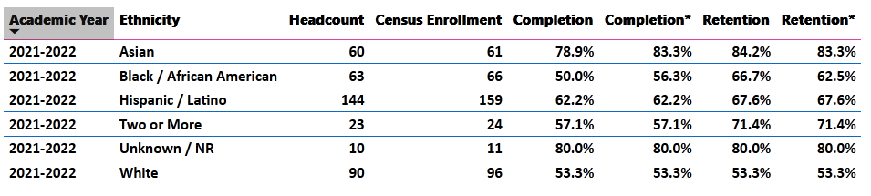
Oddly there was only a minor drop for Black students of 3.4 percentage points, but Hispanic completion rates actually went up 2.7 percentage points. This suggests that in the immediate post-Covid period we need to focus primarily on Black student success (their completion rate is the lowest, at 50%, whereas Hispanics are at 62.6%, higher than white students. Note, overall Black completion rates for all of BCC were 49.7% only marginally lower than for the Sociology dept, so this is more if a college wide issue than a Sociology problem.
One reason for this huge gap could be the poor attendance rates of many Black students. In Swiencicki’s classes a large share of the students who never show up, or who have very poor attendance, seem to be African American. One possible way to close this gap would be for the college to help create, or connect with pro-Black support groups like UMOJA to raise Black completion rates by creating a more supportive and empowering community for Black students. We plan to work with student services to see if we can get them to promote programs like UMOJA to help inspire our Black sociology students.
Another solution is to encourage failing students to make greater use of EOPS and dedicated sociology tutors, which we plan to do.
Finally, because Hispanic completion rates are about 15% lower than the college average we plan to work with student services to encourage the use of programs like Puente and Excelencia in Education to promote Hispanic completion rates.

Year 1 (2021-22) | Year 2 (2022-23) | Year 3 (2023-24)
1) Work with student services to get them to promote groups like UMOJA to help inspire our Black sociology students.  2) Work with student services to get them to promote groups like Puente & Excelencia in Eduation to promote Hispanic completion rates.  3) Make greater use of EOPS, CareBCC and dedicated sociology tutors. | 1) Refine process of working with student services in promoting groups like UMOJA to help inspire Black sociology students.  2) Refine process of working with student services in promoting groups like Puente & Excelencia in Eduation to promote Hispanic completion rates.  3) Review success of greater use of EOPS, CareBCC, and dedicated sociology tutors. | 1) Assess process of working with student services in promoting groups like UMOJA to help inspire Black sociology students.  2) Assess process of working with student services in promoting groups like Puente & Excelencia in Eduation to promote Hispanic completion rates.  3) Assess success of greater use of EOPS, CareBCC, and dedicated sociology tutors.
What would you recommend that we do to increase student enrollment in your department?
. The SOC Dept. has concentrated on initiatives to improve completion and retention across the student body with particular attention to students from traditionally marginalized communities. The SOC Dept. will continue to strategize, develop initiatives, and pursue programs that the pay particular heed to the unique circumstances of the Black/African American and Latinx communities at BCC. SOC faculty will likewise continue to support identified student groups such as EOPS, CalWorks, Umoja, CareBCC, Veterans Affairs, etc. The completion and retention rates for special student groups, on average, run close to the college norm.

3B. Course Completion and Retention Rates Dashboard – Instruction
*Note that completion and retention rates are presented with the inclusion and exclusion of excused withdrawals (EW) and military withdrawals.

If you need more guidance with this item, click here for additional support. Click here for additional guidance for how to view and use equity data. If you would like to view BCC’s Equity Plan, click here.
On page 3 of the “Course Completion and Retention Rates by Subject” dashboard, what are the completion and retention trends by gender, age, ethnicity in your department?
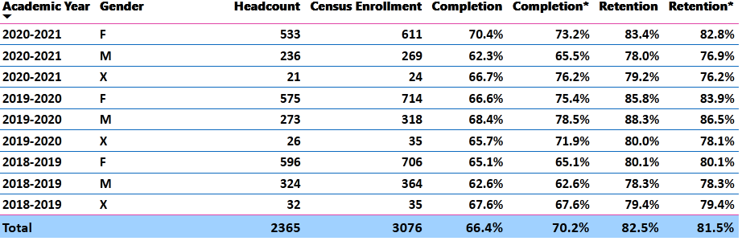
Note: the completion rates by gender fluctuate over time in an apparently random fashion.

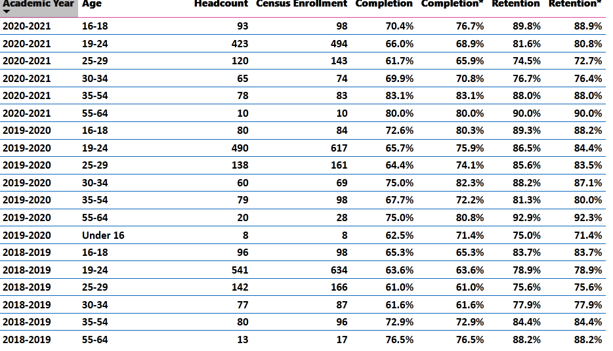
The age effect is that there is a U-curve in which the highest completion rates occur among our youngest and oldest students (i.e., HS students and 35+). It would appear that these two groups have the highest motivation levels, which is unfortunate since most of our students are between 19-29.

Results: According to the Power BI data, when comparing the data for the last pre-Covid year (2018/19) to the most recent data (2021/22), it’s striking to see that White and Asian students have switched places. (see below) White students go from having the highest to the lowest Completion rates for all “races” (from 78.6% to 53.3% completion rates), and Asian students go from a 68.2% to a 78.9% completion rate, the highest. I assume the greater economic resources of white students allowed them to take time off from college, or get a high enough paying job to leave college.

Ethnic Disparities: Oddly there was only a minor drop for Black students of 3.4 percentage points, but Hispanic completion rates actually went up 2.7 percentage points. This suggests that in the immediate post-Covid period we need to focus primarily on Black student success (their completion rate is the lowest, at 50%, whereas Hispanics are at 62.6%, higher than white students. Note, overall Black completion rates for all of BCC were 49.7% only marginally lower than for the Sociology dept, so this is more if a college wide issue than a Sociology problem.
One reason for this huge gap could be the poor attendance rates of many Black students. In Swiencicki’s classes a large share of the students who never show up, or who have very poor attendance, seem to be African American. One possible way to close this gap would be for the college to help create, or connect with pro-Black support groups like UMOJA to raise Black completion rates by creating a more supportive and empowering community for Black students. We plan to work with student services to see if we can get them to promote programs like UMOJA to help inspire our Black sociology students.
Another solution is to encourage failing students to make greater use of EOPS and dedicated sociology tutors, which we plan to do.
Finally, because Hispanic completion rates are about 15% lower than the college average we plan to work with student services to encourage the use of programs like Puente and Excelencia in Education to promote Hispanic completion rates.
What disproportionately impacted (DI) population(s) showed outcomes gains in your program area and which need more support?
DI GAINS: As noted in my analysis in the past section, when comparing the data for the last pre-Covid year (2018/19) to the most recent data (2021/22), Hispanic completion rates actually went up 2.7 percentage points (from 59.5 – 62.6%). Assuming this is not a random fluctuation, we believe this is the result of the fact that each year more young Hispanics are born second generation Americans rather than foreign born immigrants, so as Hispanic youth become more Americanized and acculturated their educational performance starts to mirror that of the dominant group. Incidentally, this is also occurring with Hispanic birth rates. However, since the college wide completion rate is 74% (excluding EWs and MWs), more work needs to be done to raise Hispanic completion rates.
DI LOSSES: As noted in my analysis in the past section, when comparing the data for the last pre-Covid year (2018/19) to the most recent data (2021/22), completion rates for Black students dropped from 52.9 – 50% (a 5.4% drop). This is especially problematic, because the college wide completion rate for this period is 74% (excluding EWs and MWs)

How do these outcome trends compare to the college average?
-Hispanics 62.6% vs. 74% college wide completion rates (-15.4.%).
-Black Students: 50% vs. 74% college wide completion rates (-32.4%).
Note: the college wide completion rate of 74% excludes EWs and MWs, but the data for Hispanic and Black students does not.
What questions do you have about the trends?
I’m unsure why the college wide completion rate of 74% excludes EWs and MWs, but the data for Hispanic and Black students does not.
Based on input you’ve received from students, what have they expressed as their need (s) to complete and succeed in your courses? (support your recommendations with examples) e.g., offer diff modalities; timing of day).
1) Continued access to loaner laptops.
2) Subsidized broadband internet coverage. Most students are just using their cell phones.
3) Access to dedicated sociology tutors.
How will these outcome trends you identified in this section affect your department goals and plans for the next three years?
Year 1 (2021-22) | Year 2 (2022-23) | Year 3 (2023-24)
1) We will need more money for dedicated sociology tutors.  2) We will ask college to survey our students as to what things are causing them to drop or fail classes. | 1) We will need more money for dedicated sociology tutors.  2) We will analyze the requested college survey on what things are causing them to drop or fail classes. | 1) We will need more money for dedicated sociology tutors.  2) We will use the results of our analysis of the requested college survey to craft new solutions to the DI disparities.

3C. Degrees and Certificates Dashboard
On page 1 of the “Degrees and Certificate Awards Trends” Dashboard, what are the award trends for your department (overall, by gender, age, and ethnicity).
Between 2018/19 – 2020/21, the Sociology AA awards steadily rose from 35-54. In 2021 the SOC ADT had the highest total number of completers out of all of the ADTs that BCC offers.
Gender: most of the awards went to females (females: 40, males: 11)
Age: most of the awards went to youngish students: 19-24: 39, 25-29: 17, 16-18: 14, 30-34: 10.
Ethnicity: in descending order of awards: Hispanics: 21, Whites: 15, Asians: 9, Blacks 5. The Hispanic numbers are remarkable since they only made up about 25% of our students.
On page 4, what DI population(s) award trends showed gains in your program area and which populations need more support?
GAIN: from 2017/18 – 2020/21 Hispanics went from between 8 – 11 to 21. Impressive gain indeed!
DROP: from 2017/18 – 2020/21 Black awards dropped from 7 or 8 to 5. Black students did not fare well during the Covid period.
How do these outcome trends compare to the college average?
From 2017/18 – 2020/21 the college average for all subjects wavered between 948 and 1109, but largely stayed flat.
Based on input you’ve received from students, what have they expressed as their need (s) to complete their degrees and/or certificates? (support your recommendations with examples)
1) Continued access to loaner laptops (numerous students have told me they only have a cell phone).
2) Subsidized broadband internet coverage. Most students are just using their cell phones.
3) Access to dedicated sociology tutors.
How will these outcome trends you identified in this section affect your department goals and plans for the next three years?
Year 1 (2021-22) | Year 2 (2022-23) | Year 3 (2023-24)
1) We will need more money for dedicated sociology tutors.  2) We will ask college to survey our students as to what things are causing them to drop or fail classes. | 1) We will need more money for dedicated sociology tutors.  2) We will analyze the requested college survey on what things are causing them to drop or fail classes. | 1) We will need more money for dedicated sociology tutors.  2) We will use the results of our analysis of the requested college survey to craft new solutions to the DI disparities.

3D. Transfer Dashboard
This dashboard does not provide data by subject. Reflect on what you can do to affect student transfer. How may your department help to support BCC student transfer? (e.g., serve on panels, strengthen GP in your dept, change curriculum, increase number of AD-Ts, etc.)
. The SOC Dept. has concentrated on initiatives to improve completion and retention across the student body with particular attention to students from traditionally marginalized communities. The SOC Dept. will continue to strategize, develop initiatives, and pursue programs that pay particular heed to the unique circumstances of the Black/African American and Latinx communities at BCC. SOC faculty will likewise continue to support identified student groups such as EOPS, CalWorks, Umoja, CareBCC, Veterans Affairs, etc. The completion and retention rates for special student groups, on average, run close to the college norm.

3E. Curriculum
View the department’s curriculum through the lens of student equity outcomes. BCC outcome data suggests that disproportionately impacted groups of students experience low rates of success.
How do you plan to adjust the curriculum to advance student equity and address DI student outcome gaps?
Examples include: making adjustments to lesson plans based on student assessment outcomes; review pedagogy and revise assignments for culturally relevant content; simplify student processes and make service areas student-centered; manage class discussions and student participation; review best practices, etc.).

In the boxes below, add improvement actions that are directly related to Student Equity & Success. If there are no improvement actions in this area, leave blank. If you have more than one Improvement Plan, add more by copying and pasting the table below.
IMPROVEMENT ACTIONS
Department/Discipline:
Action Name:
Description:
Completion timeline:
Responsible person:

III. PROGRAM GOALS
- List your current Department Goals.
Goal 1. Curriculum:
1: Update ADT to reflect curricular changes (underway)
2: Evaluate adopting COAs Statistics for Social Sciences course (underway)
3: Have 100% online courses go through the POCR process and be listed on the CVC (underway)
4: Map SOC program under Guided Pathways model (beginning)

Goal 2. Assessment:
1: Complete identified assessment activities for the discipline in the Social Sciences three year assessment schedule (underway)

Goal 3. Instruction:
1: Continue to schedule sociology courses across the schedule and across delivery methods (ongoing).
2: Develop a discipline specific tutor training program

Goal 4. Student Success:
1: Increase Student Success and Retention in face-to-face classes (ongoing), particularly for disproportionally impacted groups
2: Increase Student Success and Retention in online and hybrid classes (ongoing), particularly for disproportionately impacted groups.
3: Increase Students’ completion of Sociology ADT (ongoing), particularly for disproportionately impacted groups.
- How do the goals align with the College goals? If so, which ones?
Berkeley City College Goals
- GOAL I: Strengthen Resilience: Strengthen BCC students’ abilities to become self-directed, focused and engaged in the pursuit of transformative, life-long learning experiences that result in personal and academic success.
- GOAL II: Raise College Competence: Raise student skills and competencies, and expand their learning experiences, so that they can successfully complete their college program.
- GOAL III: Enhance Career-Technical Education Certificates and Degrees: Enhance BCC’s 1- and 2-year career and technical education programs so that they provide current and transferable skills and competencies to earn a living wage in our area, and to maintain competency for advancement in one’s career.
- GOAL IV: Increase Transfer and Transfer Degrees: Ensure that all of BCC’s programs of study and transfer pathways for degrees prepare students, in a timely manner, for multiple transfer options.
- GOAL V: Ensure Institutional Sustainability: Increase BCC’s impact in education through innovation, internal and external collaboration and partnerships, and sufficient resources, both short-term and long-term.
- Our goal 1.1 of updating our SOC ADT is proposed to align with BCC Goal IV
- Our goal 1.2 of adopting Statistics for Sociology aligns with BCC GOAL IV of “Increase Transfer and Transfer Degrees”
- Our goal 1.3 and 1.4 aligns with college goals I and V
- Our goal 2.1 aligns with college goal II
- Our goal 3.1 aligns with college goal V
- Our goal 3.2 of fostering of specific discipline tutors is designed to align with BCC GOAL II to "raise student skills and competencies…so they can complete the program”
- Our goals 4.1 – 4.3 align with colleges goal IV

- Assess your facilities utilization (including labs, support for online learning, and other spaces) and for each year, indicate if the space is insufficient. If so, what are the needs and why? *Note that facility needs and planning are addressed in the Facility Master Plan for the college, including the planning for new buildings.
Year 1 (2021-22) | Year 2 (2022-23) | Year 3 (2023-24)
Sociology faculty members mostly utilize the larger classrooms at 2050 Center St. (rooms 421-424), Room 322, Room 218, and numerous rooms located in the basement of the main campus. Occasionally a section is taught in the auxiliary building. Classrooms with working AV projectors and audio are a necessity. However, many classrooms in 2050 Center Street do not have usable whiteboard space if the projector/screen is in use - which impacts our delivery of instruction. Social science faculty meets frequently with students in small groups and need a space to hold these meetings. This space is extremely limited at 2050 Center Street. Office space for part-time instructors is constrained by the number of instructors who share a single workspace.  Faculty need:  1) More AV classrooms with useable whiteboard is needed.  2) Online proctoring software for online exam taking.  3) Faculty need semi-professional usb microphones, webcams, and external SSDs for creating online lectures. | 1) More AV classrooms with useable whiteboard is needed.  2) Online proctoring software is needed for online exam taking.  3) Faculty need semi-professional usb microphones, webcams, and external SSDs for creating online lectures. | 1) Sufficient AV classrooms with useable whiteboard is needed.  2) Online proctoring software is needed for online exam taking.  3) Faculty need semi-professional usb microphones, webcams, and external SSDs for creating online lectures.
- What are the essential functions of your department, any unique characteristics or trends? Provide specific examples.
To provide a forum/space for students to critically analyze society using different perspectives and methods. We seem to get a high level of GE students in our Intro and Soc 5 course which takes a little more work to get them to start thinking sociologically.

- Describe how external factors (if applicable), such as State and Federal laws, advisory board recommendations, district and college governance have an impact on the support services your department provides. (e.g., partnered with dual enrollment and contract Ed programs at K-12 districts and high schools; support staff at high schools have access to Canvas to follow along and support students; allow tutors into the classes; Guided Pathways, AB 705, etc.)
Since our student body is so ethnically diverse, and often low income, many of our students’ only access to a computer is their cell phone. This hurts students who are taking online or blended classes. BCC should continue to fund the free loaner Chromebook program, and to consider subsidizing Broadband for low income students.
We are increasingly seeing demand in dual-enrollment and contract ed programs for SOC 13. These courses might benefit from having embedded BCC tutors.

Based on your responses to questions 4-8, are there areas that need improvements? If so, add improvement actions below. If there are no improvement actions in this area, leave blank. If you have more than one Improvement Plan, add more by copying and pasting the table below.
IMPROVEMENT ACTIONS
Department/Discipline:
Action Name:
Description:
Completion timeline:
Responsible person:

- ASSESSMENT
Berkeley City College is committed to a culture of assessment to improve instruction, services, and institutional planning. Findings from SLO, PLO, ALO assessments, and program review data are used to direct resources for areas that are institutional priorities that are articulated in the Educational Master Plan and BCC Strategic Plan. Due to the critical role that course and program assessments play in our institutional planning and to be in compliance with the Accreditation requirements, the Program Review resource allocation requests require the completion of assessment in order to qualify.
9A. List and describe the department/program’s progress and reflection on Student Learning Outcomes (SLOs), Program Learning Outcomes (PLOs), and/or Service Area Outcomes (SAOs). If your department/program offers a degree or certificate, please describe the department’s progress on Program Learning Outcomes (PLOs).
The SLOS for all Sociology courses were all assessed between F19 and F20 (and all but one of those in F20).

Results and reflections:
Soc 1:
-SLO1: about 79% of Soc 1 students exceeded our expected goal of 70%. The students that did struggle struggled with understanding and applying sociological perspectives and certain concepts, so to fix this we generated more real world examples, and used more breakout discussion time to apply these to real world examples.
-SLO2: about 79% of Soc 1 students exceeded our expected goal of 70% for both SLOS. The students that did struggle struggled with writing the paper on “how identities such as race, class, gender, age, sexual orientation, religion and nationality contribute to a range of social experiences and social perspectives” mostly failed because they turned in papers that were way too short. To remedy this we added a section to the assignment that reminds them that a paper that turns in only half or 2/3 of the assigned pages will be severely marked down.
Soc 2:
-SLO1: about 73% of Soc 2 students exceeded our expected goal of 70%. The students that did struggle struggled with applying theoretical perspectives to news articles. To remedy this we introduced a group assignment that makes them explain why each of 3 quotes is an example of a particular perspective.
-SLO2: about 75% of Soc 2 students exceeded our expected goal of 70%. To help the students that did struggle to ”explain how a selected social problem is caused by cultural, structural, and economic factors” did suboptimal either due to plagiarism, or because the assignment was asking too much of them. To fix the 1st issue we added an article in the assignment module on the difference between plagiarizing and paraphrasing, and to fix the latter I changed the assignment to an earlier one that we’ve had more success with.
Soc 5:
-SLO1: only about 66% of our Soc 5 students were able to “correctly apply the sociological concepts and theories learned in the course to written text or multi-media content.”.
exceeded our expected goal of 70%. To remedy this we introduced an assignment that requires them to get into groups and apply these terms to real life statements found in the media.
-SLO2: over 77% of our Soc 5 students were able to “Analyze how the life experiences and outcomes of a minority group (or an American who is a member of a minority group) have been impacted by their minority status.” However, to help those that couldn’t we created and uploaded to Canvas a video on how to do the paper.
Soc 7:
SLO 1 – 85% of students were successful. Students did very well in their description of sociological concepts and in their application of these concepts through a process of content analysis. Students need help in the area of writing and need explicit instruction to refrain from personal reflection and broad generalization. Some would jump from a description of a concept to something in their own life and then back to the content analysis process without making strong, persuasive, connections between these modes of reference and methodologies of assessment.
SLO 2 -85% of students were successful. Students were able to apply sociological concepts to forms of media, in this case images representing paintings and photographs, impressively. They had done so in response to readings and video clips across our semester and seemed well-prepared for this sort of sociological analysis/work.
Soc 8:
SLO 1 - Students in both sections struggled to understand the work of Michel Foucault and the sociological paradigm controlology that is developed from his body of work. While students scored in the "ideal" range on core ideas for most concepts and theories (some of which they may have encountered in earlier sociology classes), they struggled with the more advanced or specialized components of these theories (notably labeling theory and feminist paradigms) as applied by the focus of this course. Students at BCC are fluent in the sociological perspectives that lean heavily into conflict or critical theory. This may be due to the focus of their introduction to sociology courses but also because these theories are more reflective of their lived experience and confirming of their world views. Theories and concepts outside of the critical/conflict tradition, that rely on a more positivistic relationship, shows more of a learning gap. Theories that centralize power but go beyond material resources as the conceptualization of power were also spaces students could get more support exploring.
SLO 2 - Students are doing well identifying how constructions of deviance and criminality are tied to other social identities without having to be directly asked to make this connection. Only 2 students in one section (8%) and 3 students in the other (15%) did not directly connect a deviant or criminal label to other constructed social identities. The combined results from the two sections (45 students total) were (percentages rounded): Students scoring a 4 (excellent): 10 (22%), Students scoring a 3 (good): 11 (24%), Students scoring a 2 (satisfactory): 15 (33%), Students scoring a 1 (needs improvement): 4 (9%), Students scoring a 0 (insufficient): 5 (11%)
Soc: 13:
SLO 1 - Students did well when asked to connect course assigned readings to a small research project they completed and then incorporate these works in a reflection on an area of major social change (sexuality and gender identity) in relation to institutional or organizational response (toy production). The acceptable target of 70% of students meeting a score of 2 was met: 77% of students scored a 2 or higher. The two students who scored a one would have met the ideal target for this SLO had they completed the research project required for the paper. The five students who scored a zero struggled with different issues: not completing/citing the reading, not completing the research project, not connecting the social change with the institutional response, not understanding some key course terms or writing more of a personal reflection rather than meeting the expectations of the prompt.
SLO 2 Students are doing reasonably well analyzing the dynamics of gender socialization, micro and macro dynamics and incorporating course resources into their written work but this assessment fell just short of acceptable targets. 3 students did not score any points on the rubric and four more didn't get beyond a very introductory engagement with the course concepts. The acceptable target of 70% of students meeting a score of 2 fell just short with 67% or higher meeting this target. The assessment fell just short of meeting the acceptable target of 70% of students scoring an average of 2 (satisfactory) or higher. Two of the students that scored a 1 did so because they misapplied two key terms. One more student was not present for the group discussion and didn't have access to the article so making use of at least two resources as a requirement to get a two impacted this response
Soc: 18:
SLO 1 I gave a pre-test to 36 students before starting a four-week unit that would end in an exam. Each question covered a core concept for each of the four lectures leading up to an end-of-unit exam. Qx 1: Students already met the acceptable target on the pretest and the ideal target was met in the post-test. Qx 2: While there was a big jump in students getting this correct on the post-test, it still fell below the established acceptable target. Qx 3: While there was a slight improvement here, students still missed the acceptable target by a significant margin Qx 4: Students not only met the acceptable target in the post-test, but they also exceeded the ideal target. Students struggled somewhat to recognize a legislative term from their text that was not developed in lecture Students really struggled to link a common thread across disparate death mythologies.
SLO 2 28 out of 30 students scored 3.5 or higher on this section of the essay (95%) meeting the target (and exceeding) the acceptable target. This also exceeded the ideal target. Students could earn 3.5 out of five points if they did a particularly good job only explaining one theoretical paradigm. If I looked at only those scoring 4.5 or higher as "acceptable" (which was only possible if two or more paradigms were discussed) then only 60% would have met the target. I may have set the "satisfactory" standard on the rubric too low for this assessment.
Soc 120:
SLO 1 83% of students were successful in pointing to the relationship between a researcher's theoretical perspective, concern, or problematic and their methodological choices. That is, students seemed to know quite immediately that a researcher would need to develop a methodology as informed by the kinds of questions and the kinds of data needed to answer a particular research question. While students were quick to pick up on the general relationship between theoretical perspective and research methodology, they became a bit distracted in the fascinating details of the case used as an example (an ethnography on fashion modeling). While most students satisfied the basic assessment outcomes, their replies also evidenced a need to have them learn more about social theory and general problematics of sociology before replying to this discussion so that they could further articulate the relationship between theory and method.
SLO 2 76% of students were successful. Students developed fascinating and mostly feasible research projects. They were able to identify and satisfy challenges associated with qualitative, ethnographic, research methods. These challenges included: Making sense of qualitative data through coding and theme-making; Addressing ethical implications of working closely with research subjects, some of whom meet the qualification of a "vulnerable population;" and proposing the outcome of their project with audience and stakeholders in mind. Like most students of research methods, students proposed projects that were more so driven by personal interest or passion than by a clear research question or puzzle. This means some of them would encounter challenges while pursuing the actual projects and delivering sociological material for a sociological audience.
9B. What improvement plans did your department identify upon the assessment of each program? How has your department used the results of assessment to improve student learning outcomes and/or curriculum? Please be as detailed as possible.
We have no yet completed a program level assessment.

9C. Describe how the program has made use of information from the data it has from program and student learning outcomes in Round 4 (last cycle of the last 3 years) for continuous improvement. Include the three most significant plans for improvements as a result of the assessment process with timelines. Click here to view your Assessment Calendar
9D. How does your department, program, or unit ensure that students are aware of learning or service area outcomes?
The course SLOS are posted in all class syllabi, and they are listed in our department website. In our 100% online asynchronous classes SLOs are also listed on assessments that measure that SLO.

9E. Besides your syllabi, where are the service area and/or program level outcomes published? If on a website, please specify the URL.
https://www.berkeleycitycollege.edu/sociology/files/2020/06/BCC-2020-2021-SOCIOLOGY-AA-T.pdf

In the boxes below, add improvement actions that are directly related to Assessment. If there are no improvement actions in this area, leave blank. If you have more than one Improvement Plan, add more by copying and pasting the table below.
IMPROVEMENT ACTIONS
Department/Discipline:
Action Name:
Description:
Completion Timeline
Responsible person:

- ENGAGEMENT
10A. Discuss how faculty and staff have engaged in institutional efforts such as committees, presentations, and departmental activities. Please list the committees that full-time faculty/staff/admin participate in.
Swiencicki has sat on the DTC committee for the past 8 years (with 1 semester off due to a scheduling conflict), and sat on a TRC until 2019. He also taught an hour class to BCC faculty on how to create and edit professional quality course lectures in Camtasia (S21).
McAllister is serving on Faculty Senate (as the social sciences senator), DE committee (through Sp ’21), POCR committee (as a course reviewer), Curriculum Committee (social sciences rep), Honor Council Advisory Group, Senate rep for District CIPD, TRC member (CIS faculty), co-faculty Liaison for Guided Pathways, and TLC advisory board.
10B. Discuss how faculty and staff have engaged in community activities, partnerships and/or collaborations.
The two FT sociology instructors meet periodically to review and update the SLOs. In term of the data
analysis, the courses are divided between the 2 FT instructors depending upon which courses they
primarily teach. The two FT faculty also meet periodically to review the courses offered, best times to offer them, and what to change or add for the future. McAllister will be a FDIP mentor in Spring ’22. McAllister submitted a pilot test course to the OEI/CVC state level review as part of BCC’s application to get listed on the exchange as a home college. McAllister has been attending the Praxis and Pedagogy discussion group at BCC.
10C. Discuss how adjunct faculty members are included in departmental training, discussions, and decision-making.
Adjunct faculty are invited to, and usually attend the department meetings. Adjunct faculty have also assisted in doing SLOs.
- 10D. Discuss the relationship and engagement with other support services, programs, departments, or administrative units and how these relationships support your area to meet its goals.
McAllister has been involved with the tutor training stakeholders meetings. McAllister served as the interim Curriculum Committee Chair in Sp. 21 (March – June) and worked with the Office of Instruction reviewing departmental curriculum plans. McAllister participated in the online accessibility training program offered through the District in F ’21.

In the boxes below, add improvement actions that are directly related to Engagement. If there are no improvement actions in this area, leave blank. If you have more than one Improvement Plan, add more by copying and pasting the table below.
IMPROVEMENT ACTIONS
Discipline:
Action Name:
Description:
Completion Timeline
Responsible person:

VI. Prioritized Resource Requests
In the boxes below, add a 3-year resource requests for your department/program that have not been funded by existing funding sources. Work with your supervisor to estimate costs. If there are no resource requested, leave the boxes blank.

Click here to view the Resource Request Process and Timeline

Resource Category | Description/Justification | Estimated Annual Salary Costs | Estimated Annual Benefits Costs | Total  Estimated  Cost | Overall  Priority Ranking (1=Most important)
Personnel
Classified Staff | Fulltime Electronic Media Administrator/Manager (Webmaster) | N/A | N/A | N/A | 2
Student Worker | Tutors (2) | 6,000 | 0 | 6,000 | 1
Part Time Faculty
Professional Development | Description/Justification |  |  | Estimated Cost
Department wide PD needed | Increased training on accessibility; even offering a service to make PDF material accessible for faculty. Many contract services exist who offer at a pay-per-page rate for converting PDF material to accessible documents. Many OER projects already funded to make textbook costs free for students could use assistance to make these materials accessibility to screen readers. |  |  | $10,000 for the Social Science Department | 3
Personal/Individual PD needed
Supplies | Description/Justification |  |  | Estimated Cost
Software (for whom or role?) | Continued licensing of Snagit and Camtasia to enable hybrid and online course video lectures.  Continued support for Canvas Studio for closed caption services and the archiving of multimedia material.  Continued subscription to other software such as Turnitin and other LTIs commonly used by faculty. |  |  | N/A | 4
Books, Magazines, and/or Periodicals | Continue subscription to New York Times online.
Instructional Supplies | Two 64 gb USB 3.2 Flash drives (to transport slides and presentations to classroom pcs) |  |  | $80
Non-Instructional Supplies
Technology & Equipment | Description/Justification  Before you list your technology request, click here to view the latest Technology Refresh Plan to verify whether it has already included. |  |  | Estimated Cost
New
Replacement
Facilities | Description/Justification |  |  | Estimated Cost
Classrooms
Offices
Labs
Other
Library | Description/Justification |  |  | Estimated Cost
Library materials (including streamline media needs)
Library collections
OER
Other | Description/Justification |  |  | Estimated Cost
OTHER Description | All of below are for instructors to create, store & post video lectures to Canvas:
Blue Yeti USB Microphone | Semi-professional USB microphone needed to create high quality audio for video lectures. |  |  | 129.99 | $129.99
j5create USB™ HD Webcam | Semi-professional USB webcam needed to create decent quality video for video lectures. |  |  | $59.99 | $59.99
Samsung Portable SSD T7 MU-PC500T/AM 500GB | Good, relatively fast external SSD hard drive needed to frequently back up/store edited projects and video lectures. |  |  | $109.99 | $109.99
Thank you for your time and effort in completing the Program Review!
Please email the completed Program Review to your Dean by November 30, 2021.

