Berkeley City College’s mission is to provide our diverse community with
educational opportunities, promote student success, and to transform lives.

Introduction and Directions

The Peralta Community College District has an institutional effectiveness process which consists of the following components: a District-wide Strategic Plan which is updated every six years; Comprehensive Program Reviews which are completed every three years; and Annual Program Updates (APUs) which are completed in non-program review years.

The Program Review 2021-22 timeline has been developed for each program and services to guide through the semester. Please review and work with your Deans, Managers, Department Chairs and/or Supervisors to complete this Program Review.

The Program Review is intended to primarily focus upon planning for the subsequent two years and institutional effectiveness. The Program Review process directly leads to the institutional resource allocation process and budget planning for the following academic year (2022-23). This is an opportunity for each administrative unit, support service program, and department to reflect on progress made and identify areas of program improvements to achieve equitable student success and elimination of achievement gaps. In this process of making continuous quality improvement, there is an opportunity for each program, student services, and department to request resources that support achieving the stated goals.

If you have questions regarding other material in the Program Review, please contact your Dean or Manager. If you have questions regarding data, please contact Dr. Phoumy Sayavong, Senior Researcher and Planning Analyst (psayavong@peralta.edu).

Please email the completed Program Review to your Dean by November 30, 2021.

COLLEGE PROFILE
Click here to view the Berkeley City College Student Demographics Dashboard.
This 2-page dashboard will provide information on the characteristics of our student body from the past two years such as headcount, ethnicity, enrollment status, age group, educational goals, and majors.
College Outcomes | 2017-2018 | 2018-2019 | 2019-2020 | 2020-21
Full Time Equivalent Students (FTES) | 4,140 | 3,864 | 3,696 | 3,290
Efficiency  (Productivity; avg faculty-student ratio) | 13.4 | 13 | 13.2 | 14.3
Success Rate (%) | 67% | 69% | 67%* | 74%
Degrees + Certificates Awarded (#) | 1,021 | 948 | 1,106 | 1,014
*Excludes “EW” grades

To view prior Program Reviews, click here. To view prior Annual Program Updates, click here.

- DEPARTMENT DESCRIPTION
Please verify the mission statement for your department. If your program has not created a mission statement, provide details on how your department supports and contributes to the College’s mission.
In addition to the college mission, the focus of the Psychology discipline is three fold, to support critical thinking, analysis and application of major psychological theories and concepts, and prepare students planning to successfully transfer into the psychology major.

Our psychology courses engage in the scientific study of human behavior and mental processes. Psychology students study the nature of consciousness, the development of the individual, basic processes of perception, learning, memory, cognition and motivation; the relationship of behavior to physiology and health; and the nature of psychological disorders and how psychologists attempt to improve the quality of people’s lives.

In addition, to supporting increased understanding of the human condition, our own behavior as well as that of others, our Psychology courses fulfill general education requirements in area D (social sciences) and in area E (Lifelong Learning) at California State Universities. We have an AA-T in Psychology and our Psychology 1 class has consistently been included as a Learning Community core course.

Ultimately, our courses support the College Mission in promoting student success and transfer.

Name(s) of member(s) completing this Program Review | Department/Program | Completion Date
Melina Bersamin | Social Science/Psychology | 10/22/21
List faculty names and/or staff with assignments in fall 2021.
Full Time | Part Time
Melina Bersamin | Christopher Gade, Jennifer Yu, Gerald Williams, Rima Najm-Briscoe

II. STUDENT EQUITY & SUCCESS
Using the data dashboards provided below, review and reflect upon the outcome trends for your department. You may use data from other sources if available.

Click here if you would like to view BCC’s Planning Documents (Education Master Plan, College Strategic Goals, Student Equity Plan, District Strategic Goals, Vision for Success, Guided Pathways, Technology Plan, Facilities Plan)

For assistance with data dashboards, contact Phoumy Sayavong at psayavong@peralta.edu

3A. Enrollment Trend and Productivity Dashboard
*Note that completion and retention rates are presented with the inclusion and exclusion of excused withdrawals (EW) and military withdrawals.
What are your enrollment trends in the past three years?
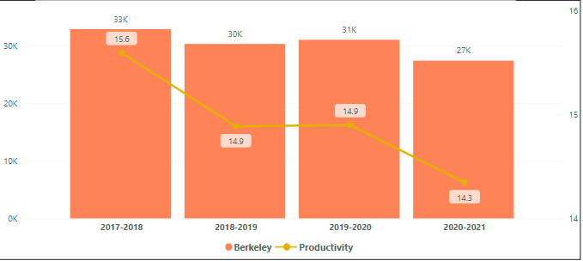Figure 1. Berkeley City College Enrollment and Productivity

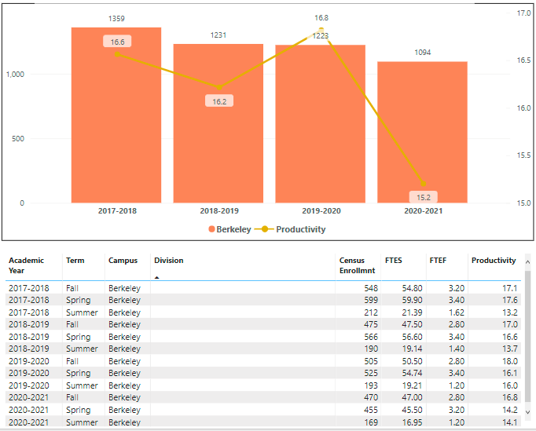Figure 2. All Psychology courses at Berkeley City College, Census Enrollment Productivity.

Enrollment Trends: As noted in Figure 1, there has been a decline in enrollment over the past three years. Within psychology, the highest levels of enrollment were for the 2017/18 academic year with 1359 students. The 2018/19 and 2019/20 school year were relatively stable with regards to enrollment with 1231 and 1223 students respectively. This dropped to 1094 for the 2020/21 school year. This is not surprising given the pandemic and the associated uncertainty. Productivity rates also dropped from 16.8 to 15.2. The largest decline was from 16.8 in 2018/2019 to 15.2 in 2019/2020. That being said, across all years, our productivity rates remain higher than those of the overall college rates.

Moving forward it will be important to track what type of classes fill and fill first: in-person, asynchronous, and/or hybrid. This information will help us develop a schedule that best meets student need.

When the data for your department are disaggregated by student ethnic groups, what trends do you observe and how do plan to address them over the next three years?
Year 1 (2021-22) | Year 2 (2022-23) | Year 3 (2023-24)
Data has not been disaggregated by ethnic groups at the department level. | NA | NA
What would you recommend that we do to increase student enrollment in your department?
- I recommend that we not cut sections until the first week of classes. Instructors are reluctant to add students to their already full sections and then we lose students to other colleges that don’t cut their classes.
- Creating a class waitlist so that students are automatically enrolled once someone drops until the last day to add. Students who are interested are often lost or hard to track down when a space opens up.
- Offer clear guidance on how this degree can support a variety of different educational tracts as well as career options.
- Advertise and promote courses at UCB, CSU EB, and SFSU
- Market on-line classes to non-traditional college populations thinking about a second career
- Create a library textbook lending/selling program and/or increase OER use within classes

3B. Course Completion and Retention Rates Dashboard – Instruction
*Note that completion and retention rates are presented with the inclusion and exclusion of excused withdrawals (EW) and military withdrawals.

If you need more guidance with this item, click here for additional support. Click here for additional guidance for how to view and use equity data. If you would like to view BCC’s Equity Plan, click here.
On page 3 of the “Course Completion and Retention Rates by Subject” dashboard, what are the completion and retention trends by gender, age, ethnicity in your department?
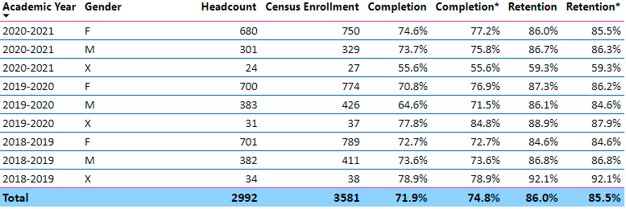
Figure 3. Psychology Department Enrollment/Completion/Retention by Gender

Focusing on data that excludes EWs and MWs we see that there is some variation across years with regards to differences in completion by gender with no clear patterns emerging. For example, in 2020/21 the completion rate was 77.2% and 75.8% respectively for females and males. However, non-binary individuals while previously having some of the higher completion and retention rates, in 2020/21 had some of the lowest rates -about 20 percentage points lower. This is concerning, and a data point to pay attention to in the future. Is this a function of teaching practices specific to psychology or a function of a subgroup that may need additional resources, particularly during a pandemic and politically divisive period in our history.

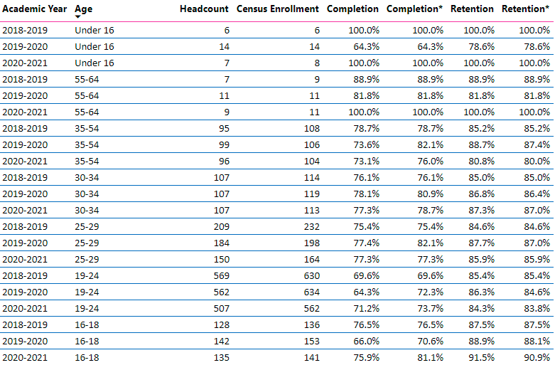 Figure 5. Department Enrollment/Completion/Retention by Age
Enrollment rates are highest among the traditional college age group (19-24). Looking across all three years, this is also the group with some of the lowest completion rates. I would suggest that this is not due to classroom pedagogy but rather scheduling. Completion rates might improve by ensuring classes offered fit typical employment schedules. Additionally, supporting conversations between students and counseling to develop a schedule that meets the demands of short-term demands (work) and long-term planning (e.g. transfer goals) may also increase competition rates. On the other hand, 16 and under and 55-64 have some of the lowest enrollment rates yet highest completion rates. This remained true when there was a transition to on-line learning. Focusing specifically on completion rates, there is an increase in completion rates among 16 and under, 16-18 year olds, 30-34 year olds, 55-64 year olds. Other groups had rates that oscillated across years with no consistent patterns. The most meaningful data from this chart is that there is some evidence that our older students, who have been stigmatized as being technologically challenged, succeeded in our on-line classes.
.7%, 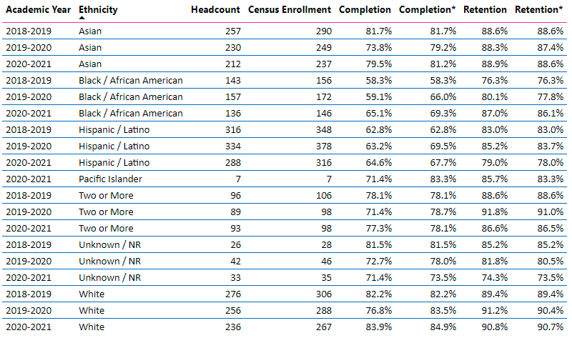
Figure 6. Department Enrollment/Completion/Retention by Ethnicity

Across all three years, Whites and Asians typically have the highest completion rates. For example, in 2020/21 84.9%, 81.2%, respectively, whereas for the same year African American and Latinx students have some of the lowest (65.1% and 64.6%, respectively). There was, however, a noticeable increase among Black/African Americans in completion (58.3, 59.1, 65.1). Nonetheless, student groups with lower completion rates might benefit from additional supports including: how to 1) provide in-class supports for students (embedded tutoring), 2) train faculty on how to identify students early and provide support, 3) incentivize going to office hours 4) training for faculty for how to successfully approach students, and 5) developing relationships with clubs (e.g. Latinx, BSU) and 6) developing mentoring programs to support minority student success. Additionally, it may be worthwhile to conduct interviews with students to identify areas of need. More importantly, continued professional development is needed to ensure faculty are interacting with students free from stereotypes and when possible incorporate curriculum that highlights assets of underrepresented groups.

There is some fluctuation across different groups when focusing on retention rates. Among Asians, the rate is relatively consistent from 2018 to 2021 (88.6, 87.4, 88.6). This is also true of those who identified as White (89.4, 90.4, 90.4). There was a noticeable increase among Black/African Americans (76.3, 77.8, 86.1). There was a decline in retention rates from 83% to 78% among Hispanic/Latino students. More importantly, it is unclear why these rates appear only among psychology students as the overall retention rates at the college increased slightly. A consultation and collaboration with the Puente program may help improve retention rates among this group. Additionally, as the college implements initiatives associated with our role as an HSI, it will be important to track change among this group.
What disproportionately impacted (DI) population(s) showed outcomes gains in your program area and which need more support?
If you focus on Black/African Americans you will see that there has been an increase in completion and retention across the past three years. From 58% to 69% for completion rates and 76% to 87% for retention over three years. As noted above, more investigation is needed to assess why non-binary and LatinX students are not succeeding at the same rate.
How do these outcome trends compare to the college average?
The rates for gender are very similar to the college wide averages, albeit slightly higher: 74.7% vs. 77% and 73.8% vs. 75% for females and males respectively. However, the completion rate for non-binary in 2020/21 college wide was higher 75.1% than at BCC at 55%. Looking at ethnicity we see a similar pattern where Asians and Whites have some of the highest completion and retention rates whereas Latinx and African Americans have some of the lowest rates.

What questions do you have about the trends?
- Do completion and retention rates differ by modality at the discipline and department level?

Based on input you’ve received from students, what have they expressed as their need (s) to complete and succeed in your courses? (support your recommendations with examples) e.g., offer diff modalities; timing of day).
Students report needing assistance with writing and getting tutoring in order to complete the course. And while these resources are available, there are issues with early identification of resources and scheduling times for tutoring. Students also have indicated issues with time management. A more systematic needs assessment of students would help inform department goals and objectives.
How will these outcome trends you identified in this section affect your department goals and plans for the next three years?
Year 1 (2021-22) | Year 2 (2022-23) | Year 3 (2023-24)
Identify students to provide tutoring for psychology 1A. | Intentionally share out and incentivize resources (extra credit) at key points during the semester. | Conduct a needs assessment among students who drop to ascertain key factors that influence their decision.

3C. Degrees and Certificates Dashboard
On page 1 of the “Degrees and Certificate Awards Trends” Dashboard, what are the award trends for your department (overall, by gender, age, and ethnicity).
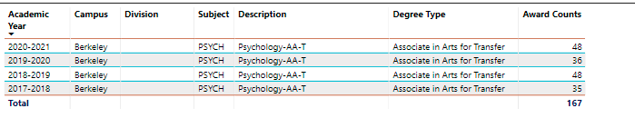
Table . Psychology Degrees awarded at BCC

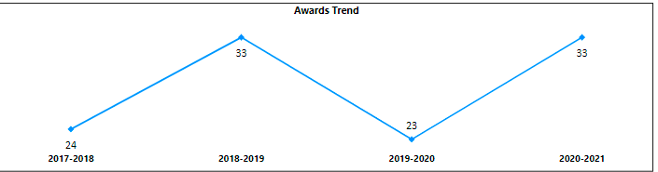
Table . Psychology Degree Awarded, gender (F)

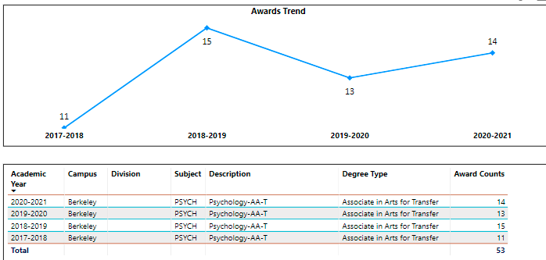
Table . Psychology Degrees Awarded, Male

As noted in the above tables, there appears to be a cyclical pattern to the number of degrees awarded. This is true among both males and females, though the difference is much smaller as significantly more females received a psychology degree than males. This trend occurs across all majors.

The data for age group appears to be incorrect and therefore it is unclear what the trends are. For example, the total number of degrees awarded in 2017/18 was 35. However, if you disaggregate my age group and add up the numbers the total number of degrees is 46. Some students appear to be double counted.

Across time, the number of degrees awarded by various groups does not follow any specific patterns.

On page 4, what DI population(s) award trends showed gains in your program area and which populations need more support?
Degrees awarded by ethnicity:
2019/2020 = 36
Asian: 8%
Black: 19%
LatinX: 36%
White: 25%

I am not sure we have the data to determine what populations need the most support. Looking at a cohort that began at the same time and examining what percent of each ethnic group were conferred a degree in the same period of time would provide us with more relevant data. The data above would suggest that Asians need the most support as they have the lowest representation in degrees awarded for the 2019/2020 school year. Trends across time differ by ethnic group and the numbers are relatively small to draw any real conclusions. The more compelling question is to ascertain how to increase the numbers of degrees awarded among one of the more popular majors.

How do these outcome trends compare to the college average?
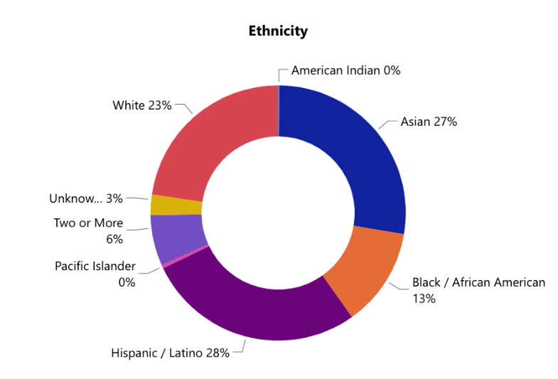
Figure : Degrees Awarded – BCC – Ethnicity
BCC Degrees Awarded by Ethnicity:
Hispanic/Latinx: 28%
Asian: 27%
White: 23%
Black/African American: 13%
Two or More: 9%
Unknown: 3%

The trends for the most recent year 2019/2020 compared to the total degrees awarded do not match the general college rates among Asians (27% vs. 8%). The rates among Black/African Americans are slightly higher among for psychology (19% vs. 13%).

Based on input you’ve received from students, what have they expressed as their need (s) to complete their degrees and/or certificates? (support your recommendations with examples)
Students often are unclear about available resources and specific requirements for the major. One of my best students, who eventually transferred to UCB, ended up changing her major to Liberal Arts. This was done in order to avoid a last-minute requirement that she was unaware of associated with Bio1A. If she had known about the prerequisites earlier in the semester, she would have been able to complete the necessary prerequisite courses on time. Another student was assisting on a Guided Pathway activity and didn’t realize he could double count some of the classes he was taking, making it possible to graduate early. My institutional recommendation is to require a first-year experience class that introduces students to counseling, the transfer process, career options, as well as organizational strategies, resources and canvas. Last but not least, student work on Guided Pathways made them aware of resources (jobs, internships, and scholarships). This highlights the need for more effective communication of resources that will help students transfer on time.

How will these outcome trends you identified in this section affect your department goals and plans for the next three years?
Year 1 (2021-22) | Year 2 (2022-23) | Year 3 (2023-24)
- Evaluate the feasibility of a department wide FYE  - Reach out to Puente | - Identify effective communication strategies to increase awareness of student resources

3D. Transfer Dashboard
This dashboard does not provide data by subject. Reflect on what you can do to affect student transfer. How may your department help to support BCC student transfer? (e.g., serve on panels, strengthen GP in your dept, change curriculum, increase number of AD-Ts, etc.)
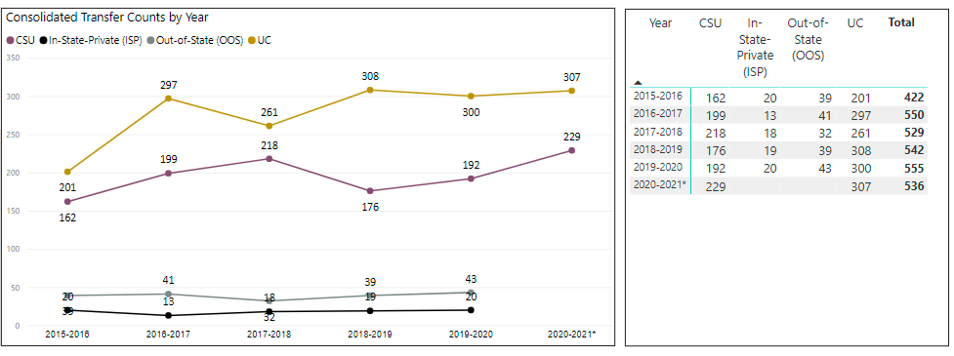Without knowing how many students were eligible for transfer or tracking transfer rates of a cohort (having a denominator), it is challenging to interpret these numbers and identify whether these numbers reflect gains or losses. That being said, through more effective communication with students about requirements, informational panels with counselors, and increased awareness of academic-related resources (e.g. access to chrome books, hot spots, streamlined tutoring) will facilitate student success. Through Guided Pathway support we aim to continue to develop the necessary tools to increase awareness of resources and requirements for graduation. As noted below, through the GP process we identified a potential bottleneck and have created a new course and made adjustments to the psychology AD-T to eliminate this obstacle.

3E. Curriculum
View the department’s curriculum through the lens of student equity outcomes. BCC outcome data suggests that disproportionately impacted groups of students experience low rates of success.
How do you plan to adjust the curriculum to advance student equity and address DI student outcome gaps?
Examples include: making adjustments to lesson plans based on student assessment outcomes; review pedagogy and revise assignments for culturally relevant content; simplify student processes and make service areas student-centered; manage class discussions and student participation; review best practices, etc.).
- As noted above, work across all psychology faculty to include culturally relevant content
- Continue working with counseling to introduce psychology success maps to students in order to provide proactive student-centered support
- Increase opportunities for class discussions and collaboration
- Create opportunities for school and class connectedness to increase student engagement

In the boxes below, add improvement actions that are directly related to Student Equity & Success. If there are no improvement actions in this area, leave blank. If you have more than one Improvement Plan, add more by copying and pasting the table below.
IMPROVEMENT ACTIONS
Department/Discipline: | Psychology/Social Science
Action Name: | Student Equity and Success School Connectedness
Description: | Build the psychology club and tutoring program in order to create opportunities for increased student connection and engagement within the psychology program
Completion timeline: | Fall 2023
Responsible person: | Melina Bersamin

III. PROGRAM GOALS
- List your current Department Goals.
Goal 1. Curriculum:
- Add an introduction to biological psychology class to the curriculum to make reduce the number of prerequisites needed to transfer.
- Increase the number of classes using zero or low-cost textbooks
- Utilize available data to create a schedule that fits student demand
Goal 2. Assessment
- To standardize assessment across all psychology courses
- To include part-time faculty in the assessment process
- To evaluate practices and support professional growth and development
Goal 3: Collaboration
- To work closely with alumni to identify areas of growth for the department and mentorship opportunities.
- To work with UCB to develop internship opportunities, counseling presentations, and introductions to professors.
- Through Guided Pathways continue collaborations with counseling faculty to develop student communication, student success maps, to facilitate the transfer process. Continue piloting informational counseling visits to Psych 1A classrooms.
- Identify opportunities for all psychology faculty to collaborate on assessment, curriculum, and check-ins

- How do the goals align with the College goals? If so, which ones?
Berkeley City College Goals
- GOAL I: Strengthen Resilience: Strengthen BCC students’ abilities to become self-directed, focused and engaged in the pursuit of transformative, life-long learning experiences that result in personal and academic success.
- GOAL II: Raise College Competence: Raise student skills and competencies, and expand their learning experiences, so that they can successfully complete their college program.
- GOAL III: Enhance Career-Technical Education Certificates and Degrees: Enhance BCC’s 1- and 2-year career and technical education programs so that they provide current and transferable skills and competencies to earn a living wage in our area, and to maintain competency for advancement in one’s career.
- GOAL IV: Increase Transfer and Transfer Degrees: Ensure that all of BCC’s programs of study and transfer pathways for degrees prepare students, in a timely manner, for multiple transfer options.
- GOAL V: Ensure Institutional Sustainability: Increase BCC’s impact in education through innovation, internal and external collaboration and partnerships, and sufficient resources, both short-term and long-term.
Goals 1&2: Through evaluation and assessments we aim to ensure high quality instruction that increases student focus, motivation and success
Goal 3: Through collaboration with UCB and local partners we hope to create internship opportunities to provide students with work experience
Goal 4: Through the development of student success maps and piloting informational counseling sessions in Psych 1A, we will provide students with concrete steps and resources that will support transfer. Additionally, alumni mentoring would support this process.
- Assess your facilities utilization (including labs, support for online learning, and other spaces) and for each year, indicate if the space is insufficient. If so, what are the needs and why? *Note that facility needs and planning are addressed in the Facility Master Plan for the college, including the planning for new buildings.
Year 1 (2021-22) | Year 2 (2022-23) | Year 3 (2023-24)
Explore the role of a proctoring room. This would support students and faculty and provide opportunities for taking make-up exams in an adequate test taking environment. Often times faculty must put students in environments that are not conducive to test taking given our lack of space. |  | NA
- What are the essential functions of your department, any unique characteristics or trends? Provide specific examples.
The Psychology Department aims to provide quality instruction to students interested in learning about the human condition and provide the necessary instruction to prepare students for transfer to four-year program. The trend that is most concerning is the sudden drop in completion and retention rates among non-binary students.
- Describe how external factors (if applicable), such as State and Federal laws, advisory board recommendations, district and college governance have an impact on the support services your department provides. (e.g., partnered with dual enrollment and contract Ed programs at K-12 districts and high schools; support staff at high schools have access to Canvas to follow along and support students; allow tutors into the classes; Guided Pathways, AB 705, etc.)
Guided Pathways has led to two significant changes. First, through close collaboration with counseling and curriculum, a course was identified that would meet the biological science requirements for several UC schools without the need for two prerequisites which is what students currently need in order to take Bio 1A. To that end, Psych 61, Introduction to Biological Psychology, was developed in order to remove those obstacles. Second, we are in the process of developing student success maps for the Psychology program. They were reviewed in 3 psychology 1A classes and received positive feedback.

Based on your responses to questions 4-8, are there areas that need improvements? If so, add improvement actions below. If there are no improvement actions in this area, leave blank. If you have more than one Improvement Plan, add more by copying and pasting the table below.
IMPROVEMENT ACTIONS
Department/Discipline: | Psychology/Social Sciences
Action Name: | Assessment
Description: | Identify a process to increase part-time faculty participation in assessment activities, including incorporating findings into one’s practices
Completion timeline: | Close of next assessment period (2024)
Responsible person: | Melina Bersamin

- ASSESSMENT
Berkeley City College is committed to a culture of assessment to improve instruction, services, and institutional planning. Findings from SLO, PLO, ALO assessments, and program review data are used to direct resources for areas that are institutional priorities that are articulated in the Educational Master Plan and BCC Strategic Plan. Due to the critical role that course and program assessments play in our institutional planning and to be in compliance with the Accreditation requirements, the Program Review resource allocation requests require the completion of assessment in order to qualify.
9A. List and describe the department/program’s progress and reflection on Student Learning Outcomes (SLOs), Program Learning Outcomes (PLOs), and/or Service Area Outcomes (SAOs). If your department/program offers a degree or certificate, please describe the department’s progress on Program Learning Outcomes (PLOs).
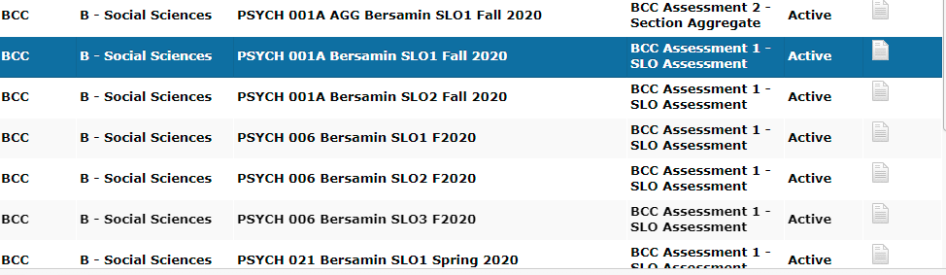
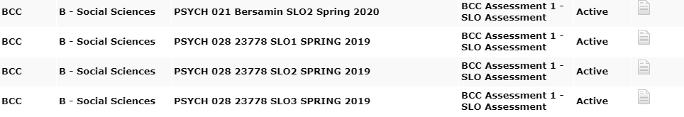
SLOs for all four psychology programs were completed in Fall of 2020. A majority of part-time instructors participated some or all of the process. The first round of SLOs were completed as a section aggregate.

Assessment plan for the next cycle:
spring 22 | fall 22 | spring 23 | fall 2023
Psych 21 | X | Psych 1 | X
Psych 28 | X | Psych 6 | X

9B. What improvement plans did your department identify upon the assessment of each program? How has your department used the results of assessment to improve student learning outcomes and/or curriculum? Please be as detailed as possible.
- Assessment is not a department wide activity. Participation by part-timers is inconsistent. There are few opportunities to collaborate on assessment and work as a unit and this is an area of need in order to collectively improve our courses.
- This activity highlighted discrepancies in what information was presented on the syllabi in terms of SLOs. I aim to send what information needs to be included in the syllabus each semester to all instructors
- Across all courses, a key take-away was to provide more opportunities for students to discuss and reflect on concepts to ensure understanding.
9C. Describe how the program has made use of information from the data it has from program and student learning outcomes in Round 4 (last cycle of the last 3 years) for continuous improvement. Include the three most significant plans for improvements as a result of the assessment process with timelines. Click here to view your Assessment Calendar
Results from the Social Psychology assessment found that it may be worthwhile to identify assessment questions that address more nuanced aspects of social psychology. Additionally, across all classes there is a subset of students who struggle with explaining key concepts and theories. Early identification of these students through low-stakes assessment may lead to adjusting teaching methods to better reach all students. A specific plans for improvement entails developing a set of in-class assignments and on-line discussions that directly speak to the goals and objectives of the course. This will provide students with an opportunity to practice defining key terms and applying them to human behavior. These questions will be designed to encourage key competencies. Another plan will be to identify strategies to increase participation in assessment and improve outcomes.

9D. How does your department, program, or unit ensure that students are aware of learning or service area outcomes?
Learning outcomes are posted on every syllabus and associated canvas pages.
9E. Besides your syllabi, where are the service area and/or program level outcomes published? If on a website, please specify the URL.
We do not currently have the PLOs listed on our department webpage. This would be a good addition.

In the boxes below, add improvement actions that are directly related to Assessment. If there are no improvement actions in this area, leave blank. If you have more than one Improvement Plan, add more by copying and pasting the table below.
IMPROVEMENT ACTIONS
Department/Discipline: | Psychology
Action Name: | Assessment Collaboration
Description: | Identify a process by which part-time instructors can participate in the assessment process. Including collecting data, evaluating results, and creating action plans.
Completion Timeline | Fall 2023 *This is not possible without incentivizing this process for part-time faculty. I am unclear if this is currently part of their contracted position or not. If not, how can stipends be made available to support this process?
Responsible person: | Melina Bersamin

- ENGAGEMENT
10A. Discuss how faculty and staff have engaged in institutional efforts such as committees, presentations, and departmental activities. Please list the committees that full-time faculty/staff/admin participate in.
Melina Bersamin: Distance Education Committee, Guided Pathways
10B. Discuss how faculty and staff have engaged in community activities, partnerships and/or collaborations.
I am currently collaborating with UC Berkeley in several areas:
- Counseling: I am working with Skylar Barton and Olivia Owens to create opportunities for BCC students to effectively transfer to UCB and succeed.
- Internships: I have worked with two research labs at UC Berkeley to create space for BCC students. Last semester two students worked in a child development lab at UCB

10C. Discuss how adjunct faculty members are included in departmental training, discussions, and decision-making.
All psychology faculty are invited and encouraged to attend professional development events during flex days. Additionally, they are invited to participate in Social Science Department meetings.
- 10D. Discuss the relationship and engagement with other support services, programs, departments, or administrative units and how these relationships support your area to meet its goals.
Working closely with other Social Science Faculty supports discussions around pedagogy. Working closely with counseling and curriculum creates opportunities to create programmatic changes that remove obstacles for our students.

In the boxes below, add improvement actions that are directly related to Engagement. If there are no improvement actions in this area, leave blank. If you have more than one Improvement Plan, add more by copying and pasting the table below.
IMPROVEMENT ACTIONS
Discipline:
Action Name:
Description:
Completion Timeline
Responsible person:

VI. Prioritized Resource Requests
In the boxes below, add a 3-year resource requests for your department/program that have not been funded by existing funding sources. Work with your supervisor to estimate costs. If there are no resource requested, leave the boxes blank.

Click here to view the Resource Request Process and Timeline

Resource Category | Description/Justification | Estimated Annual Salary Costs | Estimated Annual Benefits Costs | Total  Estimated  Cost | Overall  Priority Ranking (1=Most important)
Personnel
Classified Staff | Fulltime Electronic Media Administrator/Manager (Webmaster) | N/A | N/A | N/A | 1
Student Worker
Part Time Faculty
Professional Development | Description/Justification |  |  | Estimated Cost
Department wide PD needed | In order to engage adjunct faculty in the assessment process it is necessary to build in PD that supports the process of assessment, implementation and re-evaluation. More importantly, adjunct faculty need to be paid for their time.  Training on making courses accessible.  Increased training on accessibility even offering a service to make PDF material accessible for faculty. Many contract services exist who offer at a pay-per-page rate for converting PDF material to accessible documents. Many OER projects already funded to make textbook costs free for students could use assistance to make these materials accessibility to screen readers. |  |  | $8000  $? | 2  3
Personal/Individual PD needed | Training on making courses accessible. |  |  | $?
Supplies | Description/Justification |  |  | Estimated Cost
Software (for whom or role?) | Respondus lock-down or other software to prevent cheating.  Continued licensing of Snagit and Camtasia to enable hybrid and online course video lectures.  Continued support for Canvas Studio for closed caption services and the archiving of multimedia material.  Continued subscription to other software such as Turnitin and other LTIs commonly used by faculty. |  |  | $2795  $?  $?  $?
Books, Magazines, and/or Periodicals
Instructional Supplies | Microphones to support teaching in masks for all psych faculty (5) |  |  | $400
Non-Instructional Supplies
Technology & Equipment | Description/Justification  Before you list your technology request, click here to view the latest Technology Refresh Plan to verify whether it has already included. |  |  | Estimated Cost
New
Replacement | Continued refresh of full-time faculty computers at regular intervals.
Facilities | Description/Justification |  |  | Estimated Cost
Classrooms | Addition of hyflex capabilities in all BCC classrooms.
Offices
Labs
Other
Library | Description/Justification |  |  | Estimated Cost
Library materials (including streamline media needs) | Kanopy streaming is an essential multimedia platform for our instructional needs.
Library collections | NYT subscription
OER | Continue support for OER and Affordable Learning Materials program.
Other | Description/Justification |  |  | Estimated Cost
OTHER Description | Support for POCR (Peer Online Course) reviewers and those having their courses reviewed.  Accessible materials support.

Thank you for your time and effort in completing the Program Review!
Please email the completed Program Review to your Dean by November 30, 2021.

