Berkeley City College’s mission is to provide our diverse community with
educational opportunities, promote student success, and to transform lives.

Introduction and Directions

The Peralta Community College District has an institutional effectiveness process which consists of the following components: a District-wide Strategic Plan which is updated every six years; Comprehensive Program Reviews which are completed every three years; and Annual Program Updates (APUs) which are completed in non-program review years.

The Program Review 2021-22 timeline has been developed for each program and services to guide through the semester. Please review and work with your Deans, Managers, Department Chairs and/or Supervisors to complete this Program Review.

The Program Review is intended to primarily focus upon planning for the subsequent two years and institutional effectiveness. The Program Review process directly leads to the institutional resource allocation process and budget planning for the following academic year (2022-23). This is an opportunity for each administrative unit, support service program, and department to reflect on progress made and identify areas of program improvements to achieve equitable student success and elimination of achievement gaps. In this process of making continuous quality improvement, there is an opportunity for each program, student services, and department to request resources that support achieving the stated goals.

If you have questions regarding other material in the Program Review, please contact your Dean or Manager. If you have questions regarding data, please contact Dr. Phoumy Sayavong, Senior Researcher and Planning Analyst (psayavong@peralta.edu).

Please email the completed Program Review to your Dean by November 30, 2021.

COLLEGE PROFILE
Click here to view the Berkeley City College Student Demographics Dashboard.
This 2-page dashboard will provide information on the characteristics of our student body from the past two years such as headcount, ethnicity, enrollment status, age group, educational goals, and majors.
College Outcomes | 2017-2018 | 2018-2019 | 2019-2020 | 2020-21
Full Time Equivalent Students (FTES) | 4,140 | 3,864 | 3,696 | 3,290
Efficiency  (Productivity; avg faculty-student ratio) | 13.4 | 13 | 13.2 | 14.3
Success Rate (%) | 67% | 69% | 67%* | 74%
Degrees + Certificates Awarded (#) | 1,021 | 948 | 1,106 | 1,014
*Excludes “EW” grades

To view prior Program Reviews, click here. To view prior Annual Program Updates, click here.

- DEPARTMENT DESCRIPTION
Please verify the mission statement for your department. If your program has not created a mission statement, provide details on how your department supports and contributes to the College’s mission.
In addition to the mission of the Social Sciences Department, the mission of the Political Science program at Berkeley City College is to prepare students to transfer into a university-level political science major. Additionally, the program seeks to instill a sense of civic responsibility in students and empower them to become informed citizens and lifelong activists through a critical dialogue concerning classical and contemporary issues in local, national, international, and global politics. The Political Science program, through its course offerings and contribution towards degree completion and transfer, supports the college mission in promoting student success, providing our diverse community with educational opportunities, and transforming lives.

Name(s) of member(s) completing this Program Review | Department/Program | Completion Date
Charlotte Lee  Matthew Freeman | Political Science | November 4, 2021
List faculty names and/or staff with assignments in fall 2021.
Full Time | Part Time
Matthew Freeman  Charlotte Lee | Marjorie Haskell  Blake Respini

II. STUDENT EQUITY & SUCCESS
Using the data dashboards provided below, review and reflect upon the outcome trends for your department. You may use data from other sources if available.

Click here if you would like to view BCC’s Planning Documents (Education Master Plan, College Strategic Goals, Student Equity Plan, District Strategic Goals, Vision for Success, Guided Pathways, Technology Plan, Facilities Plan)

For assistance with data dashboards, contact Phoumy Sayavong at psayavong@peralta.edu

3A. Enrollment Trend and Productivity Dashboard
*Note that completion and retention rates are presented with the inclusion and exclusion of excused withdrawals (EW) and military withdrawals.
What are your enrollment trends in the past three years?
Over the past three years, enrollment in POSCI courses has been falling: from 1,307 FTES in 2017-18 to 875 in 2020-21 (Fig. 3A.1). This trend is consistent with falling enrollment at the district level and statewide in the CCC system.

Figure 3A.1: BCC POSCI enrollment and productivity, 2017-2021
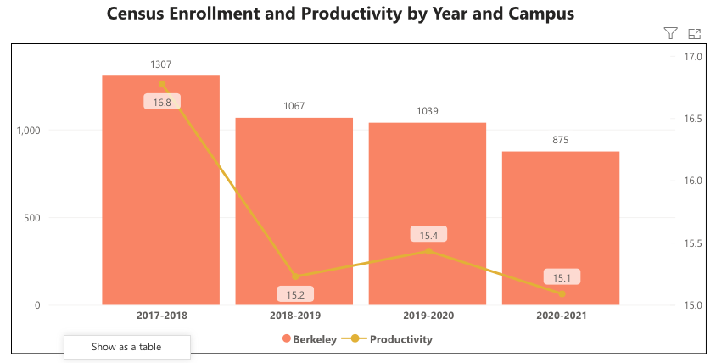

Productivity in POSCI has been above-average compared to the district average (Fig. 3A.2). Productivity for all POSCI courses in 2017-18 was 16.8, compared to 16.6 across all POSCI programs in PCCD (Fig. 3A.3) and 15.3 for all programs in the district. In 2020-21, these numbers were: 15.1 for BCC POSCI, 14.7 for PCCD POSCI programs, and 13.7 for all PCCD programs.

Figure 3A.2: PCCD enrollment and productivity, 2017-2021
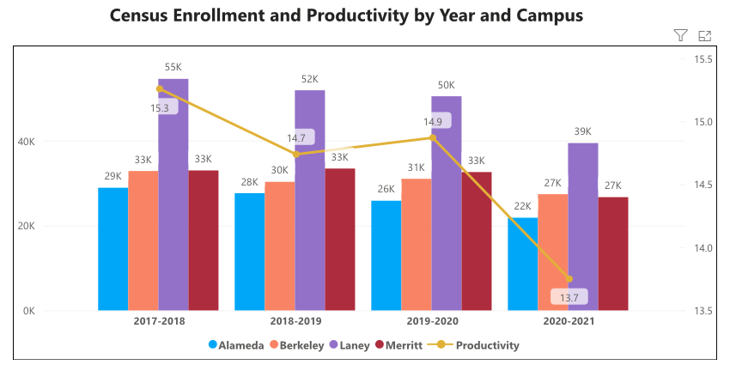

Figure 3A.3: PCCD POSCI Enrollment and productivity, 2017-2021
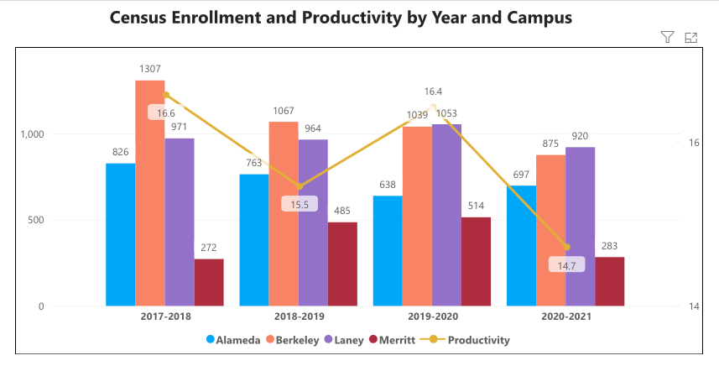

With respect to modality, productivity appears to be higher in online courses compared to face-to-face, a trend which was accelerated in 2019-2020 and 2020-2021 due to the covid-19 pandemic. The table below summarizes enrollment levels by modality:

Table 3A.1: POSCI Enrollment by modality, 2017-2021
 | 2017-2018 | 2018-2019 | 2019-2020 | 2020-2021
Face to face | 15.8 | 13.9 | 14.1 | n/a
Fully online | 18.2 | 17.6 | 17.7 | 15.1
All modalities | 16.8 | 15.2 | 15.4 | 15.1

When the data for your department are disaggregated by student ethnic groups, what trends do you observe and how do plan to address them over the next three years?

Enrollment trends by race and ethnicity are summarized in Table 3A.2 below. Enrollment of Asian and black/African American students fell over the 2018-2021 period. Enrollment of Latinx and white students increased. Students who identified as two or more races/ethnicities remained relatively flat.

Table 3A.2: POSCI enrollment by student ethnicity, 2018-2021
 | 2018-19 | Percent | 2019-20 | Percent | 2020-21 | Percent
Asian | 296 | 27.7 | 271 | 26.8 | 214 | 25.3
Black | 150 | 14.0 | 134 | 13.2 | 87 | 10.3
Latinx | 306 | 28.6 | 308 | 30.4 | 267 | 31.6
Two or more | 88 | 8.2 | 73 | 7.2 | 74 | 8.8
White | 230 | 21.5 | 227 | 22.4 | 203 | 24.0
Total | 1070 | 100.0 | 1013 | 100.0 | 845 | 100.0

Year 1 (2021-22) | Year 2 (2022-23) | Year 3 (2023-24)
Discuss with academic counselors and Society of Scholars coordinators to identify student needs, especially those of Asian and Black students, that POSCI instructors might address in course offerings. | Discuss with academic counselors and Society of Scholars coordinators to identify student needs, especially those of Asian and Black students, that POSCI instructors might address in course offerings. | Devise plan for implementing changes in consultation with counseling and student services.
What would you recommend that we do to increase student enrollment in your department?
Student enrollment might be increased through outreach to current and past POSCI students to encourage them to recommend BCC POSCI to friends, family, and acquaintances.

3B. Course Completion and Retention Rates Dashboard – Instruction
*Note that completion and retention rates are presented with the inclusion and exclusion of excused withdrawals (EW) and military withdrawals.

If you need more guidance with this item, click here for additional support. Click here for additional guidance for how to view and use equity data. If you would like to view BCC’s Equity Plan, click here.
On page 3 of the “Course Completion and Retention Rates by Subject” dashboard, what are the completion and retention trends by gender, age, ethnicity in your department?
Figure 3B.1 below summarizes completion and retention rates by gender. There are no significant differences between male and female students in terms of completion and retention rates over the period 2018-2021.

Figure 3B.1: Completion and retention trends by gender
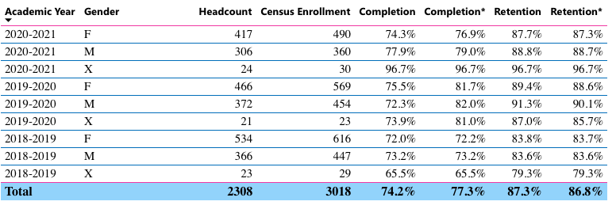

The bulk of POSCI students who enrolled during the period 2018-2021 were in the 19-24 age group (Fig. 3B.2). These students saw an increase in their course completion rate, from 72.2% in 2018-19 to 79% in 2020-21. The next-largest age group, 25-29 year olds, saw essentially flat completion rates over the same period, from 68.6% to 65.7%.

Figure 3B.2: Completion and retention trends by age
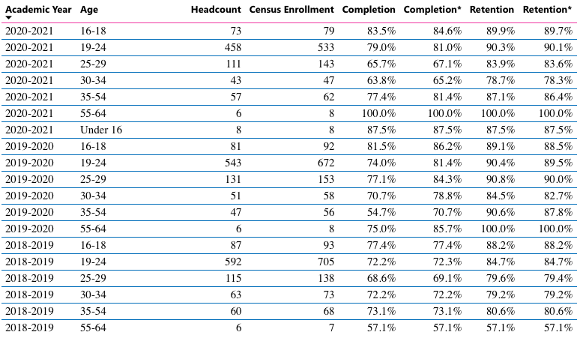

Completion and retention rates varied by ethnicity (Fig. 3B.3). Three groups saw completion rates increase over the period 2018-2021: black, Asian, and white students. Black students saw a rise in completion rates from 66.2% in 2018-19 to 73.6% in 2020-21. Completion rates for white and Asian students improved over the period 2018-19 to 2020-21, increasing from 75.7% to 87.3% (Asian) and 77.3% to 85.5% (white students). This implies that those students in these three groups who opted to remain in online courses during the covid-19 emergency online teaching period were completing courses at relatively high rates.

Other groups experienced drops in completion rates: Mixed race students’ completion rates dropped dramatically over this period, from 75% to 59.5%. Latinx students’ completion rates remained relatively steady at 66%.

Figure 3B.3: Completion and retention trends by ethnicity
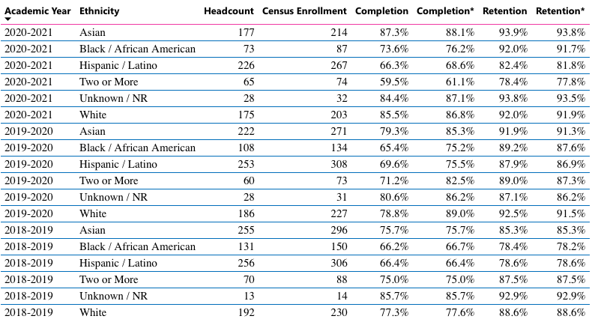

What disproportionately impacted (DI) population(s) showed outcomes gains in your program area and which need more support?
While we do not have program-level student data for all DI populations, it appears that Black/African American students had increases in their completion rates and retention rates over the period 2018-2021.

Hispanic/Latino students had a flat trendline in their completion rates and slight gains in their retention rates.

Students of two or more races/ethnicities saw decreases in their retention rates and completion rates. This may indicate that this student population would benefit from more support in our program.

Information at the program-level was unavailable for other DI populations such as foster youth, students with disabilities, and low-income students.

How do these outcome trends compare to the college average?
These trends appear consistent with overall college trends.

What questions do you have about the trends?
Based on input you’ve received from students, what have they expressed as their need (s) to complete and succeed in your courses? (support your recommendations with examples) e.g., offer diff modalities; timing of day).
BCC POSCI students have expressed a variety of needs. One need that has been consistently communicated across semesters and academic years, and which has been especially affected by covid-19, is the need for student mental health support and services. Students would benefit greatly from more mental health services.

How will these outcome trends you identified in this section affect your department goals and plans for the next three years?
Year 1 (2021-22) | Year 2 (2022-23) | Year 3 (2023-24)
Discuss with academic counselors and Society of Scholars coordinators to identify student needs, especially those of mixed race students, that POSCI instructors might address in course offerings. | Discuss with academic counselors and Society of Scholars coordinators to identify student needs, especially those of mixed race students, that POSCI instructors might address in course offerings. | Devise plan for implementing changes in consultation with counseling and student services.

3C. Degrees and Certificates Dashboard
On page 1 of the “Degrees and Certificate Awards Trends” Dashboard, what are the award trends for your department (overall, by gender, age, and ethnicity).
Overall, the POSCI program has awarded 103 degrees over the period 2017-21. The trendline has been uneven over time (Fig. 3C.1), with an increase during the 2019-2020 year and decrease in 2020-21. Degree trends by gender and age match overall trends. Most ethnicities saw a decrease in degrees awarded in 2020-21, with the exception of Asians.

Figure 3C.1
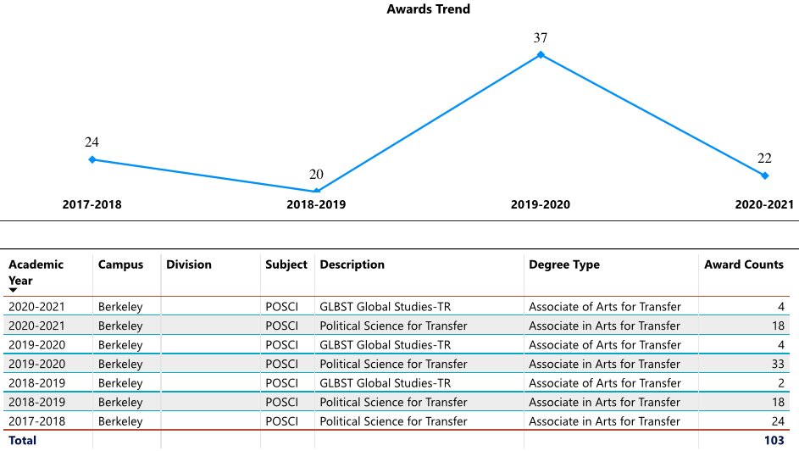

On page 4, what DI population(s) award trends showed gains in your program area and which populations need more support?
While we do not have program-level student data for all DI populations, it appears that the degree trends for male and female students were similar.

A total of 4 degrees were awarded to Black/African American students in 2017-2018 and 2018-2019, and this increased to 5 in 2019-2020, then decreased to 3 in 2020-2021.

Only one degree was awarded to a Pacific Islander in 2018-2019.

Hispanic/Latino students had an uneven trendline, over 10 degrees awarded in 2017-18 and 2019-2020 but 5 or fewer degrees awarded in 2018-19 and 2020-21.

Students of two or more races/ethnicities had only 1 or 2 degrees awarded during each of the AY from 2017-2020.

Information at the program-level was unavailable for other DI populations such as foster youth, students with disabilities, and low-income students.

How do these outcome trends compare to the college average?
When broken down into sub-populations, the number of degrees awarded are small for POSCI and it is difficult to draw any firm conclusions.
Based on input you’ve received from students, what have they expressed as their need (s) to complete their degrees and/or certificates? (support your recommendations with examples)
None noted.

How will these outcome trends you identified in this section affect your department goals and plans for the next three years?
Year 1 (2021-22) | Year 2 (2022-23) | Year 3 (2023-24)
Continue to focus on faculty advising in order to encourage degree completion among all student groups.  Build program and degree maps as part of Guided Pathways at BCC | Continue to focus on faculty advising in order to encourage degree completion among all student groups.  Refine/revise program and degree maps as part of GP at BCC | Continue to focus on faculty advising in order to encourage degree completion among all student groups.  Utilize program and degree maps to support student transfer

3D. Transfer Dashboard
This dashboard does not provide data by subject. Reflect on what you can do to affect student transfer. How may your department help to support BCC student transfer? (e.g., serve on panels, strengthen GP in your dept, change curriculum, increase number of AD-Ts, etc.)
POSCI faculty have been engaged in Guided Pathways projects, including the testing of alumni outreach efforts and creation of pathways maps for students. These efforts will support student transfer.

POSCI faculty have also been engaged in partnerships with student-led CC transfer groups such as Global CC Transfers (https://www.globalcctransfers.org) to provide BCC students with access to resources related to transfer and careers in political science.

3E. Curriculum
View the department’s curriculum through the lens of student equity outcomes. BCC outcome data suggests that disproportionately impacted groups of students experience low rates of success.
How do you plan to adjust the curriculum to advance student equity and address DI student outcome gaps?
Examples include: making adjustments to lesson plans based on student assessment outcomes; review pedagogy and revise assignments for culturally relevant content; simplify student processes and make service areas student-centered; manage class discussions and student participation; review best practices, etc.).
POSCI faculty have created Zero Textbook Cost (ZTC) courses and Open Educational Resources (OER) in efforts to advance student equity and address DI student outcome gaps. At present, four POSCI courses are available as ZTC: POSCI 1, POSCI 3, POSCI 19, and POSCI 20. An additional course, POSCI 2, will be converted to ZTC during 2022-2023.

In the boxes below, add improvement actions that are directly related to Student Equity & Success. If there are no improvement actions in this area, leave blank. If you have more than one Improvement Plan, add more by copying and pasting the table below.
IMPROVEMENT ACTIONS
Department/Discipline: | POSCI
Action Name: | Converting courses to Zero Textbook Cost
Description: | Convert POSCI 2: Comparative Government to ZTC
Completion timeline: | Build/adopt course materials during 2021-2022  Launch ZTC version of course in 2022-2023
Responsible person: | Charlotte Lee
IMPROVEMENT ACTIONS
Department/Discipline: | POSCI
Action Name: | Explore offering fully online POSCI degree
Description: | Explore feasibility and structure of a fully online POSCI degree offering
Completion timeline: | Exploratory only – open-ended timeline
Responsible person: | All POSCI faculty
IMPROVEMENT ACTIONS
Department/Discipline: | POSCI
Action Name: | Explore offering fully ZTC pathway to a POSCI degree
Description: | Explore feasibility and structure of a zero textbook cost POSCI degree offering
Completion timeline: | Exploratory only – open-ended timeline
Responsible person: | All POSCI faculty

III. PROGRAM GOALS
- List your current Department Goals.
One department goal relates to Goal IV, increase transfer and transfer degrees. POSCI faculty are currently working on a draft Guided Pathways program map for POSCI and Global Studies in order to increase student understanding of and success in transfer and careers in related fields.

Another department goal relates to Goal V, increasing internal and external partnerships and collaboration. POSCI faculty are currently collaborating with a cross-campus team on Guided Pathways implementation. POSCI faculty are also engaged in partnerships with staff, faculty, and administrators at UC Berkeley in programs such as UCB Global Studies and the Institute of European Studies.

- How do the goals align with the College goals? If so, which ones?
Berkeley City College Goals
- GOAL I: Strengthen Resilience: Strengthen BCC students’ abilities to become self-directed, focused and engaged in the pursuit of transformative, life-long learning experiences that result in personal and academic success.
- GOAL II: Raise College Competence: Raise student skills and competencies, and expand their learning experiences, so that they can successfully complete their college program.
- GOAL III: Enhance Career-Technical Education Certificates and Degrees: Enhance BCC’s 1- and 2-year career and technical education programs so that they provide current and transferable skills and competencies to earn a living wage in our area, and to maintain competency for advancement in one’s career.
- GOAL IV: Increase Transfer and Transfer Degrees: Ensure that all of BCC’s programs of study and transfer pathways for degrees prepare students, in a timely manner, for multiple transfer options.
- GOAL V: Ensure Institutional Sustainability: Increase BCC’s impact in education through innovation, internal and external collaboration and partnerships, and sufficient resources, both short-term and long-term.
One department goal relates to Goal IV, increase transfer and transfer degrees. POSCI faculty are currently working on a draft Guided Pathways program map for POSCI and Global Studies in order to increase student understanding of and success in transfer and careers in related fields.

Another department goal relates to Goal V, increasing internal and external partnerships and collaboration. POSCI faculty are currently collaborating with a cross-campus team on Guided Pathways implementation. POSCI faculty are also engaged in partnerships with staff, faculty, and administrators at UC Berkeley in programs such as UCB Global Studies and the Institute of European Studies.

- Assess your facilities utilization (including labs, support for online learning, and other spaces) and for each year, indicate if the space is insufficient. If so, what are the needs and why? *Note that facility needs and planning are addressed in the Facility Master Plan for the college, including the planning for new buildings.
Year 1 (2021-22) | Year 2 (2022-23) | Year 3 (2023-24)
Space is sufficient | Space is sufficient | Space is sufficient
- What are the essential functions of your department, any unique characteristics or trends? Provide specific examples.
n/a

- Describe how external factors (if applicable), such as State and Federal laws, advisory board recommendations, district and college governance have an impact on the support services your department provides. (e.g., partnered with dual enrollment and contract Ed programs at K-12 districts and high schools; support staff at high schools have access to Canvas to follow along and support students; allow tutors into the classes; Guided Pathways, AB 705, etc.)
POSCI faculty are engaged in Guided Pathways implementation at BCC. This has included pilot projects as part of a “transformative project” on alumni outreach and program mapping of POSCI and Global Studies degree programs.

Based on your responses to questions 4-8, are there areas that need improvements? If so, add improvement actions below. If there are no improvement actions in this area, leave blank. If you have more than one Improvement Plan, add more by copying and pasting the table below.
IMPROVEMENT ACTIONS
Department/Discipline: | POSCI
Action Name: | Guided Pathways Program Mapping
Description: | Draft program maps for POSCI and Global Studies
Completion timeline: | Draft maps Fall 2021  Test and revise maps thereafter  Update as needed -- ongoing
Responsible person: | Charlotte Lee

- ASSESSMENT
Berkeley City College is committed to a culture of assessment to improve instruction, services, and institutional planning. Findings from SLO, PLO, ALO assessments, and program review data are used to direct resources for areas that are institutional priorities that are articulated in the Educational Master Plan and BCC Strategic Plan. Due to the critical role that course and program assessments play in our institutional planning and to be in compliance with the Accreditation requirements, the Program Review resource allocation requests require the completion of assessment in order to qualify.
9A. List and describe the department/program’s progress and reflection on Student Learning Outcomes (SLOs), Program Learning Outcomes (PLOs), and/or Service Area Outcomes (SAOs). If your department/program offers a degree or certificate, please describe the department’s progress on Program Learning Outcomes (PLOs).
SLO assessment of all POSCI courses was completed during the most recent cycle from 2018-2021. Students are meeting SLOs at acceptable or higher levels in all POSCI courses.

9B. What improvement plans did your department identify upon the assessment of each program? How has your department used the results of assessment to improve student learning outcomes and/or curriculum? Please be as detailed as possible.
Improvement plans that were identified in SLO assessment include:
POSCI 1: Students need more resources exploring "Social Media" or "New Media" influence in democratic learning and civic engagement.
POSCI 2: Increase guidance for students as they work on assignments, especially milestone assignments that lead toward a final research paper at the conclusion of the course.
POSCI 3: Because of some student learning gaps with respect to the authority and responsibilities of international organizations such as the UN, include a clearer discussion in the course of such international organizations.
POSCI 6: Instructor may facilitate and also organize more peer learning activities.
POSCI 19: Integrate more student reflection and engagement into the unit on the history of globalization.
POSCI 20: Revise the assessment tool. The rubric for scoring the assessment item does not match the prompt on the assessment. Hence students did not answer the prompt to the depth required by the rubric.

9C. Describe how the program has made use of information from the data it has from program and student learning outcomes in Round 4 (last cycle of the last 3 years) for continuous improvement. Include the three most significant plans for improvements as a result of the assessment process with timelines. Click here to view your Assessment Calendar
The three most significant plans for improvements include 1) continually improving and updating course content to remain up-to-date in engaging students with events in politics, domestic and international, 2) providing support to students on course assignments as needed, and 3) revising courses to improve student outcomes, especially with respect to equity and DI groups.

9D. How does your department, program, or unit ensure that students are aware of learning or service area outcomes?
All SLOs are included on every course syllabi in the POSCI program.

9E. Besides your syllabi, where are the service area and/or program level outcomes published? If on a website, please specify the URL.
Program level outcomes are published in the college catalog.

In the boxes below, add improvement actions that are directly related to Assessment. If there are no improvement actions in this area, leave blank. If you have more than one Improvement Plan, add more by copying and pasting the table below.
IMPROVEMENT ACTIONS
Department/Discipline: | POSCI
Action Name: | Updating course content
Description: | Continuously updating course content to reflect changes in the study of US and international politics
Completion Timeline | Ongoing
Responsible person: | All POSCI faculty

- ENGAGEMENT
10A. Discuss how faculty and staff have engaged in institutional efforts such as committees, presentations, and departmental activities. Please list the committees that full-time faculty/staff/admin participate in.
Academic Senate President – Matt Freeman
Assessment Committee – Charlotte Lee
Facilities and Health & Safety Committee – Charlotte Lee
Faculty Accreditation Liaison Officer – Charlotte Lee
Guided Pathways Design Team – Charlotte Lee
Milvia Building User Group – Charlotte Lee

10B. Discuss how faculty and staff have engaged in community activities, partnerships and/or collaborations.
In 2019, POSCI faculty Charlotte Lee presented on the BCC Global Studies Program at the Western Political Science Association annual conference.

From 2019 through the present, Charlotte Lee has participated in three ASCCC-funded OER projects to build textbooks and textbook-equivalents that align with CCC standards for courses in comparative politics, international relations, and political science methods. In each of these projects, she collaborated with CCC and other CC faculty to create content. OER created through these projects are available on opolisci.com and OER Commons. Charlotte was the lead faculty for the OER project for international relations. In Fall 2021, Charlotte was appointed the Political Science OER Liaison for the ASCCC OER Initiative.

Charlotte Lee has been a CORE reviewer for POSCI courses in the CCC system since Fall 2021.

In partnership with adjunct faculty at UC Berkeley, POSCI faculty Charlotte Lee secured a modest grant from the UCB Institute of European Studies to host an event on new research in international studies. Now scheduled for Spring 2022, participants for this event will include faculty from UCB, USF, and the University of Washington.

To promote student success in transfer and international careers, Charlotte Lee has collaborated with local organizations including Global CC Transfers, Citizens’ Climate Lobby, and the US Department of State Diplomat-in-Residence.

10C. Discuss how adjunct faculty members are included in departmental training, discussions, and decision-making.
Faculty members attend department meetings during Flex Days each semester and are consulted in SLO assessment activities.
- 10D. Discuss the relationship and engagement with other support services, programs, departments, or administrative units and how these relationships support your area to meet its goals.
POSCI faculty have built cross-campus and -district dialogue on many college initiatives and priorities as leadership in the BCC Academic Senate. Faculty are part of cross-campus teams as part of BCC’s Guided Pathways initiative. All of these serve to support student success, equity, and transfer.

In the boxes below, add improvement actions that are directly related to Engagement. If there are no improvement actions in this area, leave blank. If you have more than one Improvement Plan, add more by copying and pasting the table below.
IMPROVEMENT ACTIONS
Discipline: | POSCI
Action Name: | Partnership with GCCT and UCB Global Studies
Description: | Explore building a “hub” with Global CC Transfers (a student-led non-profit dedicated to supporting CC transfers interested in international careers) and the UC Berkeley Global Studies program
Completion Timeline | Ongoing
Responsible person: | Charlotte Lee

VI. Prioritized Resource Requests
In the boxes below, add a 3-year resource requests for your department/program that have not been funded by existing funding sources. Work with your supervisor to estimate costs. If there are no resource requested, leave the boxes blank.

Click here to view the Resource Request Process and Timeline

Resource Category | Description/Justification | Estimated Annual Salary Costs | Estimated Annual Benefits Costs | Total  Estimated  Cost | Overall  Priority Ranking (1=Most important)
Personnel
Classified Staff | Fulltime webmaster | N/A | N/A | N/A
Student Worker
Part Time Faculty
Professional Development | Description/Justification |  |  | Estimated Cost
Department wide PD needed | Increased training on accessibility, including provision of a service to make PDF material accessible on course Canvas pages. Many contract services exist that offer a pay-per-page rate for converting PDF material to accessible documents. This would be especially useful in tandem with Open Educational Resources (OER) projects, which reduce textbook costs for students, but many OER textbooks would benefit from assistance in making these materials accessible to screen readers.
Personal/Individual PD needed
Supplies | Description/Justification |  |  | Estimated Cost
Software (for whom or role?) | Continued licensing of Snagit and Camtasia to enable hybrid and online course video lectures.  Continued support for Canvas Studio for closed caption services and the archiving of multimedia material.  Continued subscription to other software such as Turnitin and other LTIs commonly used by faculty. |  |  | N/A
Books, Magazines, and/or Periodicals | Continue subscription to New York Times online. |  |  | N/A
Instructional Supplies
Non-Instructional Supplies
Technology & Equipment | Description/Justification  Before you list your technology request, click here to view the latest Technology Refresh Plan to verify whether it has already included. |  |  | Estimated Cost
New
Replacement
Facilities | Description/Justification |  |  | Estimated Cost
Classrooms | Addition of hyflex capabilities in all BCC classrooms.
Offices
Labs
Other
Library | Description/Justification |  |  | Estimated Cost
Library materials (including streamline media needs) | Kanopy streaming is an essential multimedia platform for our instructional needs.
Library collections
OER | Continue support for OER and Affordable Learning Materials program.
Other | Description/Justification |  |  | Estimated Cost
OTHER Description | Support for POCR (Peer Online Course) reviewers and those having their courses reviewed.

Thank you for your time and effort in completing the Program Review!
Please email the completed Program Review to your Dean by November 30, 2021.

