Berkeley City College’s mission is to provide our diverse community with
educational opportunities, promote student success, and to transform lives.

Introduction and Directions

The Peralta Community College District has an institutional effectiveness process which consists of the following components: a District-wide Strategic Plan which is updated every six years; Comprehensive Program Reviews which are completed every three years; and Annual Program Updates (APUs) which are completed in non-program review years.

The Program Review 2021-22 timeline has been developed for each program and services to guide through the semester. Please review and work with your Deans, Managers, Department Chairs and/or Supervisors to complete this Program Review.

The Program Review is intended to primarily focus upon planning for the subsequent two years and institutional effectiveness. The Program Review process directly leads to the institutional resource allocation process and budget planning for the following academic year (2022-23). This is an opportunity for each administrative unit, support service program, and department to reflect on progress made and identify areas of program improvements to achieve equitable student success and elimination of achievement gaps. In this process of making continuous quality improvement, there is an opportunity for each program, student services, and department to request resources that support achieving the stated goals.

If you have questions regarding other material in the Program Review, please contact your Dean or Manager. If you have questions regarding data, please contact Dr. Phoumy Sayavong, Senior Researcher and Planning Analyst (psayavong@peralta.edu).

Please email the completed Program Review to your Dean by November 30, 2021.

COLLEGE PROFILE
Click here to view the Berkeley City College Student Demographics Dashboard.
This 2-page dashboard will provide information on the characteristics of our student body from the past two years such as headcount, ethnicity, enrollment status, age group, educational goals, and majors.
College Outcomes | 2017-2018 | 2018-2019 | 2019-2020 | 2020-21
Full Time Equivalent Students (FTES) | 4,140 | 3,864 | 3,696 | 3,290
Efficiency  (Productivity; avg faculty-student ratio) | 13.4 | 13 | 13.2 | 14.3
Success Rate (%) | 67% | 69% | 67%* | 74%
Degrees + Certificates Awarded (#) | 1,021 | 948 | 1,106 | 1,014
*Excludes “EW” grades

To view prior Program Reviews, click here. To view prior Annual Program Updates, click here.

- DEPARTMENT DESCRIPTION
Please verify the mission statement for your department. If your program has not created a mission statement, provide details on how your department supports and contributes to the College’s mission.
Name(s) of member(s) completing this Program Review | Department/Program | Completion Date
Heather Dodge | Library | Library
List faculty names and/or staff with assignments in fall 2021.
Full Time | Part Time
Heather Dodge (FT), Joshua Boatright (FT), Jenny Yap (FT), Principal Library Tech, Vacant (FT) | Annemarie Meyer (PT Lib), Suzanne Allison (PT Lib), Jordan Yee (PT Lib), Linda Jolivet (PT Lib), Allison Greene (PT Lib Tech)

II. STUDENT EQUITY & SUCCESS
Using the data dashboards provided below, review and reflect upon the outcome trends for your department. You may use data from other sources if available.

Click here if you would like to view BCC’s Planning Documents (Education Master Plan, College Strategic Goals, Student Equity Plan, District Strategic Goals, Vision for Success, Guided Pathways, Technology Plan, Facilities Plan)

For assistance with data dashboards, contact Phoumy Sayavong at psayavong@peralta.edu

3A. Enrollment Trend and Productivity Dashboard
*Note that completion and retention rates are presented with the inclusion and exclusion of excused withdrawals (EW) and military withdrawals.
What are your enrollment trends in the past three years?
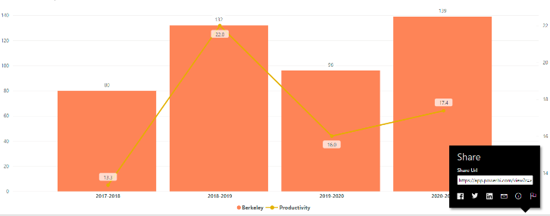
Enrollment is high again in our LIS 85 class after a dip in 2019-20 and our fill rate averages 85%. Online, async classes continue to be very popular and our partnership with the learning communities continues to bolster student success in research and increase our enrollment.

When the data for your department are disaggregated by student ethnic groups, what trends do you observe and how do plan to address them over the next three years?
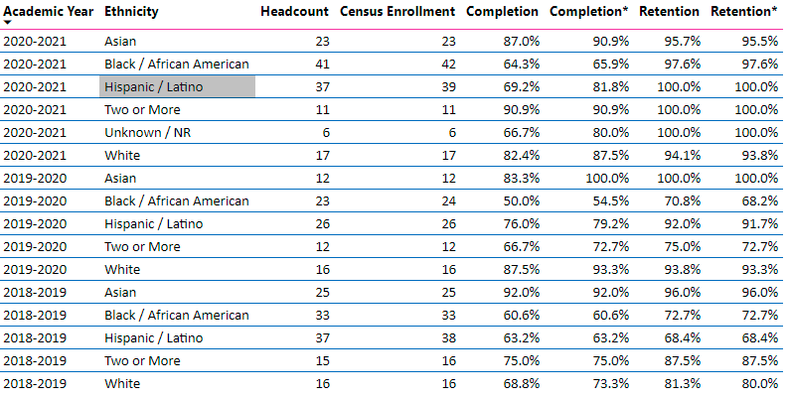
Overall, we can see the impact of the pandemic in 19-20 with black and Latino students falling to their lowest rates of completion and retention. These student groups rebounded a bit this year, but we need to put attention toward improving outcomes for these students. Below are some different ideas on improving those outcomes.

Year 1 (2021-22) | Year 2 (2022-23) | Year 3 (2023-24)
-work closely with counselors to provide a syllabus for LIS 85 so students know expectations of the class  -provide weekly Zoom group sessions for students to complete work (not office hours)  -pilot non-credit LIS 511-513 series to address learning gaps for students | -work closely with Umoja and HIS counselors to ensure AfAm and Latinx students have additional out of class supports for LIS 85  -design class projects that incorporate IDEA framework (inclusion, diversity, equity, accountability)  -provide more alerts to students when they are in danger of failing/not completing the course | -assess and refine strategies from year one and two
What would you recommend that we do to increase student enrollment in your department?
Continue to partner with the learning communities and pilot non-credit series (LIS 511-513)

3B. Course Completion and Retention Rates Dashboard – Instruction
*Note that completion and retention rates are presented with the inclusion and exclusion of excused withdrawals (EW) and military withdrawals.

If you need more guidance with this item, click here for additional support. Click here for additional guidance for how to view and use equity data. If you would like to view BCC’s Equity Plan, click here.
On page 3 of the “Course Completion and Retention Rates by Subject” dashboard, what are the completion and retention trends by gender, age, ethnicity in your department?
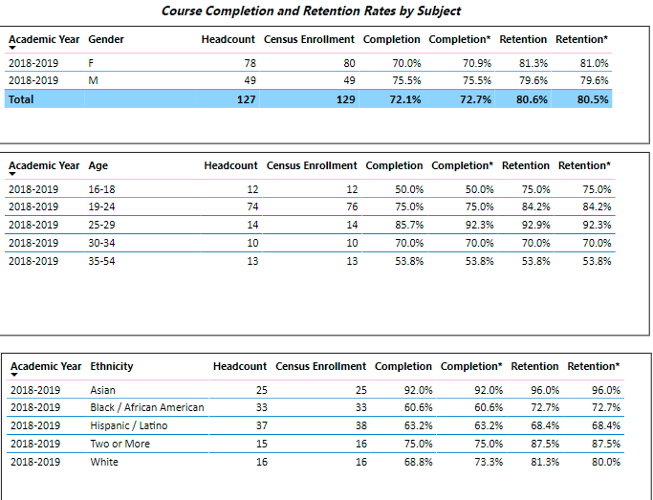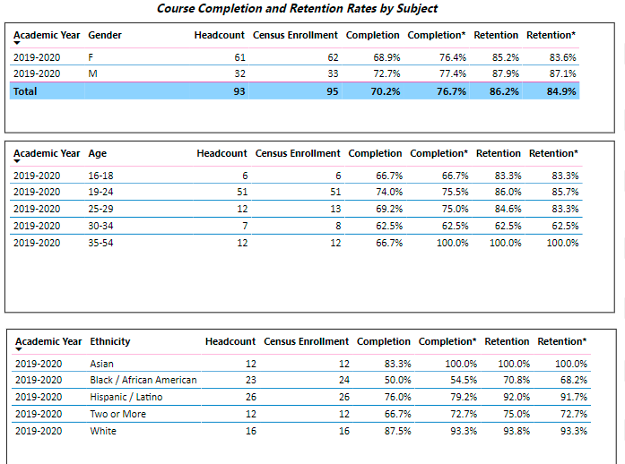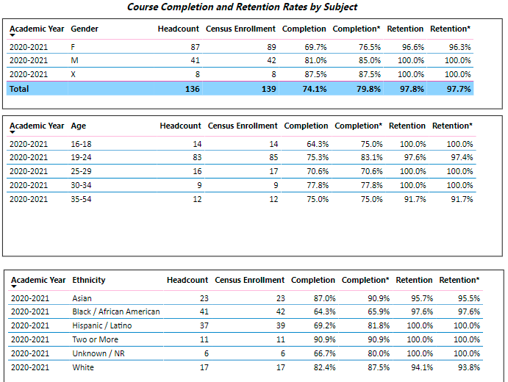

What disproportionately impacted (DI) population(s) showed outcomes gains in your program area and which need more support?
-AfrAm: after a dip during 19-20 (pandemic related, likely) students are completing at a higher rate than 18-19
-Latinx: students continue to complete the course at better rates
Although these students are making improvements, our department would like to see them completing the course at 75% or higher so we still have supports to provide to make these changes.

How do these outcome trends compare to the college average?
-trends are similar to the college average.

What questions do you have about the trends?
N/A

Based on input you’ve received from students, what have they expressed as their need (s) to complete and succeed in your courses? (support your recommendations with examples) e.g., offer diff modalities; timing of day).
-some students would prefer a synchronous online course or a f2f course. These students are typically students of color.
-using a FlipGrid “roses and thorns” exit interview in Heather Dodge’s LIS 85 sections, students provided feedback about the course and named ONE improvement they would like to make. Students typically suggested more f2f time or a drop-in lab to help with assignment completion. Students mentioned that the instructor’s communication style and amount of communication from the instructor was greatly part of their success.

How will these outcome trends you identified in this section affect your department goals and plans for the next three years?
Year 1 (2021-22) | Year 2 (2022-23) | Year 3 (2023-24)
-investigate the possibility of a f2f or hybrid LIS 85 targeting the Puente and Umoja students | -pilot LIS 511-513 series to provide additional support to students  -work closely with Puente and Umoja counselors to ensure students understand the expectations of LIS 85 | -review and assess year one and two strategies

3C. Degrees and Certificates Dashboard
On page 1 of the “Degrees and Certificate Awards Trends” Dashboard, what are the award trends for your department (overall, by gender, age, and ethnicity).
NA

On page 4, what DI population(s) award trends showed gains in your program area and which populations need more support?
NA

How do these outcome trends compare to the college average?
NA
Based on input you’ve received from students, what have they expressed as their need (s) to complete their degrees and/or certificates? (support your recommendations with examples)
NA

How will these outcome trends you identified in this section affect your department goals and plans for the next three years?
Year 1 (2021-22) | Year 2 (2022-23) | Year 3 (2023-24)

3D. Transfer Dashboard
This dashboard does not provide data by subject. Reflect on what you can do to affect student transfer. How may your department help to support BCC student transfer? (e.g., serve on panels, strengthen GP in your dept, change curriculum, increase number of AD-Ts, etc.)
NA

3E. Curriculum
View the department’s curriculum through the lens of student equity outcomes. BCC outcome data suggests that disproportionately impacted groups of students experience low rates of success.
How do you plan to adjust the curriculum to advance student equity and address DI student outcome gaps?
Examples include: making adjustments to lesson plans based on student assessment outcomes; review pedagogy and revise assignments for culturally relevant content; simplify student processes and make service areas student-centered; manage class discussions and student participation; review best practices, etc.).
CREDIT/NON-CREDIT COURSES: updating and providing culturally relevant content based on the IDEA framework; providing additional support either via Zoom or in person to students who need it, revise pedagogies to align better with the ACRL information literacy framework, devise a better early alert system for dynamically-dated classes. Update non-credit courses to allow for open entry/exit and promote these courses as ‘just in time learning’ for students struggling with research.

LIBRARY ORIENTATIONS: provide informational workshops to students enrolled in PSSD, EOPS, Umoja, Puente, Veterans programs, and other support programs on campus.

In the boxes below, add improvement actions that are directly related to Student Equity & Success. If there are no improvement actions in this area, leave blank. If you have more than one Improvement Plan, add more by copying and pasting the table below.
IMPROVEMENT ACTIONS
Department/Discipline: | LIS 85
Action Name: | Update curriculum to include the IDEA framework
Description: | Update curriculum, create projects and assignments that reflect IDEA and ACRL standards
Completion timeline: | Spring 23
Responsible person: | Heather Dodge, Jenny Yap
Department/Discipline: | LIS 85
Action Name: | Alert System for LIS 85 short-term classes
Description: | Set-up a separate recommended alter calendar for instructors who teach LIS 85 to ensure students understand the expectations
Completion timeline: | Spring 23
Responsible person: | Heather Dodge
Department/Discipline: | LIS 511-513
Action Name: | Update LIS 511-513 CORs
Description: | Update CORS to be open entry/exit, increase hours, and remove prereqs
Completion timeline: | Fall 22
Responsible person: | Heather Dodge, Jenny Yap
Department/Discipline: | Library Orientations
Action Name: | Workshops to Special Programs
Description: | Provide short, informative library workshops to special program groups to increase student and support staff awareness about library services and resources
Completion timeline: | SP 22
Responsible person: | Library staff

III. PROGRAM GOALS
- List your current Department Goals.
- Expand the library’s physical footprint to accommodate different modes of studying—increase study rooms, improve facilities to accommodate personal devices (electrical outlets, wifi, etc) (BCC Goals I, V)
- Expand staffing to include an additional FT librarian who supports equity and inclusion activities. (BCC Goals II, V)
- Expand staffing to include an additional FT Senior Library Technician to support our existing library facility and the expanded library footprint (BCC Goal V)
- Stabilize and expand the library’s budget for databases, books/e-books, and technology accessing all available resources to the library (Fund 1, lottery funds, Measure G, and Higher Education Emergency Relief Funds) (BCC Goal I, II, V)

- How do the goals align with the College goals? If so, which ones?
Berkeley City College Goals
- GOAL I: Strengthen Resilience: Strengthen BCC students’ abilities to become self-directed, focused and engaged in the pursuit of transformative, life-long learning experiences that result in personal and academic success.
- GOAL II: Raise College Competence: Raise student skills and competencies, and expand their learning experiences, so that they can successfully complete their college program.
- GOAL III: Enhance Career-Technical Education Certificates and Degrees: Enhance BCC’s 1- and 2-year career and technical education programs so that they provide current and transferable skills and competencies to earn a living wage in our area, and to maintain competency for advancement in one’s career.
- GOAL IV: Increase Transfer and Transfer Degrees: Ensure that all of BCC’s programs of study and transfer pathways for degrees prepare students, in a timely manner, for multiple transfer options.
- GOAL V: Ensure Institutional Sustainability: Increase BCC’s impact in education through innovation, internal and external collaboration and partnerships, and sufficient resources, both short-term and long-term.
- Assess your facilities utilization (including labs, support for online learning, and other spaces) and for each year, indicate if the space is insufficient. If so, what are the needs and why? *Note that facility needs and planning are addressed in the Facility Master Plan for the college, including the planning for new buildings.
If we look at data from the last time we evaluated our space needs, you will see that demands on the library’s space have increased year over year. COVID 19 has changed how students see the campus and therefore our space needs may change to include more study spaces for downtime between classes, more quiet spaces for taking Zoom classes, and an emphasis on technology lending and technology-ready spaces.
 | AY 16/17 | AY 17/18
Gate Count (Fall) | 66973 | 69248
Reserve textbook checkouts | 28193 | 21962
Reference transactions | 1183 | 1350
Circulating books checkouts | 2727 | 4854
Research workshops | 100 | 126
Students in workshops/orientations | 3025 | 3654

Year 1 (2021-22) | Year 2 (2022-23) | Year 3 (2023-24)
-Space not sufficient: work with the BUG to establish the plan for expanding the library once the new building is open  -increase access to personal computing devices by lending a chromebook to any student who wants one (and hot spot)  -improve printing by upgrading to wireless printing (students can send print jobs remotely and pick-up at the library) | -continue to advocate for increased footprint at 2050 Center and work with architects to reconfigure the library’s space  -increase funding for the library’s databases, e-books, and reserves collection to keep pace with expanded need | -finalize plans for increased library footprint and secure funding to make necessary changes  -increase funding for the library’s databases, e-books, and reserves to keep pace with expanded need
- What are the essential functions of your department, any unique characteristics or trends? Provide specific examples.
Provide a welcoming space and appropriate resources to support the curricular needs of BCC students and faculty. Collect, curate, and provide access to a library collection (both digital and physical) that supports the curricular needs of our students. Provide reference and instruction services (both in person and online) that support the curricular needs of our students.

Trends: there are three trends in our library:
- A steady increase in circulation of materials over the last year.

- A steady demand for authentic and tailored library instruction and orientations with our stand-alone orientations and semester-long embedded librarian program.

Year | Orients/Embeds
18-19 | 98
19-20 | 84
20-21 | 78

- A change in how and where students are receiving reference support. See the decrease in our reference desk transactions due to the pandemic and students accessing the library exclusively online.

Academic Year | # of Reference transactions
18-19 | 2,681 (online/in person)
19-20 | 1,872 (online/in person)
20-21 | 1,034 (online only)

A unique trend is the increased need for databases, e-books, and streaming media. A specific example: our use of Kanopy, a streaming media database, has increased exponentially this year and required additional funding, in addition, departments such as English, which have typically relied on print books have made requests for online databases like Digital Theatre + and e-books through Over Drive. The library needs to have funds to ensure we can meet these needs.

- Describe how external factors (if applicable), such as State and Federal laws, advisory board recommendations, district and college governance have an impact on the support services your department provides. (e.g., partnered with dual enrollment and contract Ed programs at K-12 districts and high schools; support staff at high schools have access to Canvas to follow along and support students; allow tutors into the classes; Guided Pathways, AB 705, etc.)
n/a

Based on your responses to questions 4-8, are there areas that need improvements? If so, add improvement actions below. If there are no improvement actions in this area, leave blank. If you have more than one Improvement Plan, add more by copying and pasting the table below.
IMPROVEMENT ACTIONS
Department/Discipline: | Library
Action Name: | Increase F/T library technician staff
Description: | Due to our increased circulation and the demands for study space and space management in the library we request (and have requested for years) the addition of one more f/t classified Senior Library Technician. This individual would be responsible for managing the day to day operations of the circulation desk, schedule and train student workers, manage aspects of our reserve textbook collection, oversee room and computer reservations, and assist with all circulation activities.
Completion timeline: | Spring 2023
Responsible person: | Heather Dodge in conjunction with VP Hay
IMPROVEMENT ACTIONS
Department/Discipline: | Library
Action Name: | Hire F/T IDEA Librarian (Inclusion, Diversity, Equity, Access)
Description: | In order to reach and serve BCC’s growing and diverse population (UMOJA, HSI, dual-enrollment, Puente, exc.) the library requests the addition of another f/t librarian who will be focused on outreach, instruction, and assessment of services related to inclusion, diversity, equity, and access. This person will work to engage marginalized populations, develop instruction models with instructional faculty tailored specifically to these groups, and work to ensure these groups are represented in our instruction and our collection.
Completion timeline: | Spring 2024
Responsible person: | Heather Dodge in conjunction with VP Hay
IMPROVEMENT ACTIONS
Department/Discipline: | Library
Action Name: | Increase databases, ebook, and streaming media library funding
Description: | In order to meet the demand of online courses (hugely increased since the pandemic) and the number of students working from off-site, the library needs additional funds for purchasing multi-user and single user e-books, article databases, and streaming media. Costs for these services continue to increase and our library’s regular budget for databases ($40,000) has not increased for over 10 years.
Completion timeline: | Spring 2023
Responsible person: | Heather Dodge in conjunction with VP Hay
IMPROVEMENT ACTIONS
Department/Discipline: | Library
Action Name: | Plan the library’s expansion into the LRC
Description: | With the new building on Milvia street, the library has an opportunity to expand it’s footprint across the first floor into the LRC. We would like to meet with the BUG and the architectural firm to ensure that we advocate for advantageous use of the space and an upgrade in furniture and technology to ensure we are planning for a library that will address the needs of students and faculty.
Completion timeline: | Spring 2022
Responsible person: | Heather Dodge in conjunction with VP Hay

- ASSESSMENT
Berkeley City College is committed to a culture of assessment to improve instruction, services, and institutional planning. Findings from SLO, PLO, ALO assessments, and program review data are used to direct resources for areas that are institutional priorities that are articulated in the Educational Master Plan and BCC Strategic Plan. Due to the critical role that course and program assessments play in our institutional planning and to be in compliance with the Accreditation requirements, the Program Review resource allocation requests require the completion of assessment in order to qualify.
9A. List and describe the department/program’s progress and reflection on Student Learning Outcomes (SLOs), Program Learning Outcomes (PLOs), and/or Service Area Outcomes (SAOs). If your department/program offers a degree or certificate, please describe the department’s progress on Program Learning Outcomes (PLOs).
SAO Assessment (2020-21): https://peralta4-my.sharepoint.com/:w:/g/personal/hdodge_peralta_edu/EcIvZvkAJ8pGmoJt9xcqXh0BOAUV9QvAocKrPR48oMQESg?e=OPl2Zt

9B. What improvement plans did your department identify upon the assessment of each program? How has your department used the results of assessment to improve student learning outcomes and/or curriculum? Please be as detailed as possible.
SAO action plan is here:
SLO action plan is here:

9C. Describe how the program has made use of information from the data it has from program and student learning outcomes in Round 4 (last cycle of the last 3 years) for continuous improvement. Include the three most significant plans for improvements as a result of the assessment process with timelines. Click here to view your Assessment Calendar
-we have met to determine how to improve our web presence
-we have reached out to and scheduled presentations with special programs and departments where information about the library is needed (EOPS, Learning Communities, Veterans Resource Center, NextUp, etc)
-we plan to request additional database funds to provide culturally relevant databases such as Ebsco’s robust Ethnic Studies database and access to streaming media

9D. How does your department, program, or unit ensure that students are aware of learning or service area outcomes?
-SLOs for orientations are integrated into planning with instructors and learning goals are stated to students during orientations
-SAOs are published on our website: https://www.berkeleycitycollege.edu/library/stafffaculty/library-documents/

9E. Besides your syllabi, where are the service area and/or program level outcomes published? If on a website, please specify the URL.
https://www.berkeleycitycollege.edu/library/stafffaculty/library-documents/

In the boxes below, add improvement actions that are directly related to Assessment. If there are no improvement actions in this area, leave blank. If you have more than one Improvement Plan, add more by copying and pasting the table below.
IMPROVEMENT ACTIONS
Department/Discipline: | Library
Action Name: | Website Audit/Improvement
Description: | Audit the library’s website for usability and make improvements in search
Completion Timeline | Spring 2022
Responsible person: | Librarians: Heather Dodge, Jenny Yap, Joshua Boatright
IMPROVEMENT ACTIONS
Department/Discipline: | Library
Action Name: | Implement OneSearch
Description: | Simplify student searching by implementing Primo OneSearch—a federated search that searches across selected databases and our ebooks and book catalog
Completion Timeline | Spring 2023
Responsible person: | Librarians: Heather Dodge, Jenny Yap, Joshua Boatright
IMPROVEMENT ACTIONS
Department/Discipline: | Library
Action Name: | Provide targeted outreach presentations
Description: | Provide targeted library outreach to departments that serve disproportionately impacted students.
Completion Timeline | Spring 2022
Responsible person: | Librarians: Heather Dodge, Jenny Yap, Joshua Boatright

- ENGAGEMENT
10A. Discuss how faculty and staff have engaged in institutional efforts such as committees, presentations, and departmental activities. Please list the committees that full-time faculty/staff/admin participate in.
Librarians participate in the following committees: Academic Senate (Jenny Yap), Integrated Planning (Heather Dodge), Assessment (Heather Dodge), Technology (Joshua Boatright), Curriculum Committee (Jenny Yap), Distance Education (Heather Dodge), Department Chairs Council (Heather Dodge), Facilities Committee (Joshua Boatright), Racial Justice Task Force (Jenny Dodge), TLC Advisory Board (Heather Dodge) Affordable Learning Materials Committee (Jenny Yap and Heather Dodge)
10B. Discuss how faculty and staff have engaged in community activities, partnerships and/or collaborations.
Joshua Boatright: actively participates in our District and our state’s Library Service Platform project.
Jenny Yap: participates in CCLI (California Conference for Library Instruction) planning
Heather Dodge: acts as a regional lead for the ASCCC OERI and collaborates state-wide on OER projects.
Heather Dodge and Jenny Yap: developed and implemented BCC’s Affordable Learning Materials Committee
10C. Discuss how adjunct faculty members are included in departmental training, discussions, and decision-making.
PT faculty members regularly participate in Flex Day activities and twice a semester department meetings. They provide input on SAOs and action plans, give input on how we gather statistics and participate in training related to Alma and Primo (our library management system). P/T librarians have been or are involved in TLC projects and piloting programs in the library.
- 10D. Discuss the relationship and engagement with other support services, programs, departments, or administrative units and how these relationships support your area to meet its goals.
The library routinely provides training on OER, our services, and research to other departments and disciplines based on requests.

In the boxes below, add improvement actions that are directly related to Engagement. If there are no improvement actions in this area, leave blank. If you have more than one Improvement Plan, add more by copying and pasting the table below.
IMPROVEMENT ACTIONS
Discipline: | Library
Action Name: | Develop an engagement calendar
Description: | Coordinate with other departments and areas that provide services to students to regularly provide short service-oriented orientations to staff and the students they serve.
Completion Timeline | Spring 2022
Responsible person: | All librarians

VI. Prioritized Resource Requests
In the boxes below, add a 3-year resource requests for your department/program that have not been funded by existing funding sources. Work with your supervisor to estimate costs. If there are no resource requested, leave the boxes blank.

Click here to view the Resource Request Process and Timeline

Resource Category | Description/Justification | Estimated Annual Salary Costs | Estimated Annual Benefits Costs | Total  Estimated  Cost | Overall  Priority Ranking (1=Most important)
Personnel
Classified Staff | FT Senior Library Tech: needed to ensure smooth operations at the library (all other Peralta colleges have 2 f/t classified professionals). Previously requested on numerous APUs/CPRs. | $47,000 | 16,000 | 63,000 | 1
Student Worker | 1.75 Student workers: to meet the additional safety needs put on us by COVID 19 | $37,000 | N/A | $37,000 | 3
Part Time Faculty | 1 f/t librarian: needed to act as our IDEA librarian and assist with our equity gaps | 64,000 | 16,000 | 80,000 | 2
Professional Development | Description/Justification |  |  | Estimated Cost
Department wide PD needed | -Conference/training to support new library services platform (Ex Libris Knowledge Days) $1,000 x two personnel |  |  | 2,000 | 15
Personal/Individual PD needed
Supplies | Description/Justification |  |  | Estimated Cost
Software (for whom or role?) | $60,000 yr for additional databases, including eBooks, that would support STEM, CTE, and streaming media areas (Science Direct, Web of Knowledge, Diversity+, Swank, Kanopy) |  |  | 60,000 | 4
Books, Magazines, and/or Periodicals | 20,000 stable book purchasing budget to ensure the currency of the digital and physical library collection |  |  | 20,000 | 5
Instructional Supplies | 7 laptop carts to supplement our current carts and address the influx of Chromebooks on campus |  |  | 7,000 | 7
Non-Instructional Supplies | Furniture refresh needed in the library to replace stained upholstery  Increased budget for book processing supplies: book tape, bar codes, to match our increase in technology lending  Additional funds for color printing to promote library services |  |  | 20,000  1500  600 | 11-14
Technology & Equipment | Description/Justification  Before you list your technology request, click here to view the latest Technology Refresh Plan to verify whether it has already included. |  |  | Estimated Cost
New | 7 laptop carts to supplement our current carts and address the influx of Chrombooks on campus |  |  | 7,000 | 7
Replacement | Library desktop refresh for student computers (six). These computers have not been updated for over five years.  Print card machine: Replace our print card machine with a credit-card enabled machine and a machine which can dispense change. This will enable students to use debit/credit cards to pay for printing on campus (currently they need exact change).  Replacement for our two OLD AS DIRT library security gates.  Funding to transition to wireless printing. Initial fees are ($5,000) and then ongoing is $4,000 |  |  | 10,000  5,000  15,000  9,000 | 8  9  10  6
Facilities | Description/Justification |  |  | Estimated Cost
Classrooms
Offices | Additional Office for FT Senior Lib Tech |  |  | 20,000
Labs
Other
Library | Description/Justification |  |  | Estimated Cost
Library materials (including streamline media needs) | See above
Library collections
OER | .2 release time for f/t librarian to chair the Affordable Learning Materials Committee and spearhead textbook affordability and OER efforts at BCC |  |  | 15,000 | 6
Other | Description/Justification |  |  | Estimated Cost
OTHER Description

Thank you for your time and effort in completing the Program Review!
Please email the completed Program Review to your Dean by November 30, 2021.

