Berkeley City College’s mission is to provide our diverse community with
educational opportunities, promote student success, and to transform lives.

Introduction and Directions

The Peralta Community College District has an institutional effectiveness process which consists of the following components: a District-wide Strategic Plan which is updated every six years; Comprehensive Program Reviews which are completed every three years; and Annual Program Updates (APUs) which are completed in non-program review years.

The Program Review 2021-22 timeline has been developed for each program and services to guide through the semester. Please review and work with your Deans, Managers, Department Chairs and/or Supervisors to complete this Program Review.

The Program Review is intended to primarily focus upon planning for the subsequent two years and institutional effectiveness. The Program Review process directly leads to the institutional resource allocation process and budget planning for the following academic year (2022-23). This is an opportunity for each administrative unit, support service program, and department to reflect on progress made and identify areas of program improvements to achieve equitable student success and elimination of achievement gaps. In this process of making continuous quality improvement, there is an opportunity for each program, student services, and department to request resources that support achieving the stated goals.

If you have questions regarding other material in the Program Review, please contact your Dean or Manager. If you have questions regarding data, please contact Dr. Phoumy Sayavong, Senior Researcher and Planning Analyst (psayavong@peralta.edu).

Please email the completed Program Review to your Dean by November 30, 2021.

COLLEGE PROFILE
Click here to view the Berkeley City College Student Demographics Dashboard.
This 2-page dashboard will provide information on the characteristics of our student body from the past two years such as headcount, ethnicity, enrollment status, age group, educational goals, and majors.
College Outcomes | 2017-2018 | 2018-2019 | 2019-2020 | 2020-21
Full Time Equivalent Students (FTES) | 4,140 | 3,864 | 3,696 | 3,290
Efficiency  (Productivity; avg faculty-student ratio) | 13.4 | 13 | 13.2 | 14.3
Success Rate (%) | 67% | 69% | 67%* | 74%
Degrees + Certificates Awarded (#) | 1,021 | 948 | 1,106 | 1,014
*Excludes “EW” grades

To view prior Program Reviews, click here. To view prior Annual Program Updates, click here.

- DEPARTMENT DESCRIPTION
Please verify the mission statement for your department. If your program has not created a mission statement, provide details on how your department supports and contributes to the College’s mission.
In addition to the mission of the Social Sciences Department, the mission of the History
discipline at Berkeley City College is for students to think critically and deeply about the
historical processes that have shaped, and continue to shape, the world we live in.

Through Berkeley City College history courses, we undertake a critical analysis of our selves
and society through examinations of the historical forces that create change over time and
define the contemporary moment. Our field of inquiry goes beyond the facts of history, to
encompass questions of identity, knowledge, consciousness, “truth,” and meaning. At the
same time, we provide students with critical thinking, reading, and writing skills that have
applications well beyond the discipline.

History courses at Berkeley City College fulfill general education requirements, as well as the
American Cultures requirement at UC and the United States History, Constitution, and
American Ideals requirement at California State Universities. History classes meet both
transfer and degree completion requirements. We have an AA-T in History and our classes are
requirements in several Learning Communities, and support the AD-T degrees in Elementary
Teacher Education and Political Science, as well as the AA degree in Global Studies. The
BCC History program is well known for being incredibly diverse in the classes it offers and
has one of the largest catalogs of History classes in the Peralta District.

The History discipline, through its course offerings and contribution towards degree
completion and transfer, supports the College Mission in promoting student success, providing
our diverse community with educational opportunities and transforming lives.

Name(s) of member(s) completing this Program Review | Department/Program | Completion Date
Tim Rose | History | November 5, 2021
List faculty names and/or staff with assignments in fall 2021.
Full Time | Part Time
Tim Rose | Richard Kim  Robert Michael Noonan  Susan Khan  Jennifer Helton

II. STUDENT EQUITY & SUCCESS
Using the data dashboards provided below, review and reflect upon the outcome trends for your department. You may use data from other sources if available.

Click here if you would like to view BCC’s Planning Documents (Education Master Plan, College Strategic Goals, Student Equity Plan, District Strategic Goals, Vision for Success, Guided Pathways, Technology Plan, Facilities Plan)

For assistance with data dashboards, contact Phoumy Sayavong at psayavong@peralta.edu

3A. Enrollment Trend and Productivity Dashboard
*Note that completion and retention rates are presented with the inclusion and exclusion of excused withdrawals (EW) and military withdrawals.
What are your enrollment trends in the past three years?
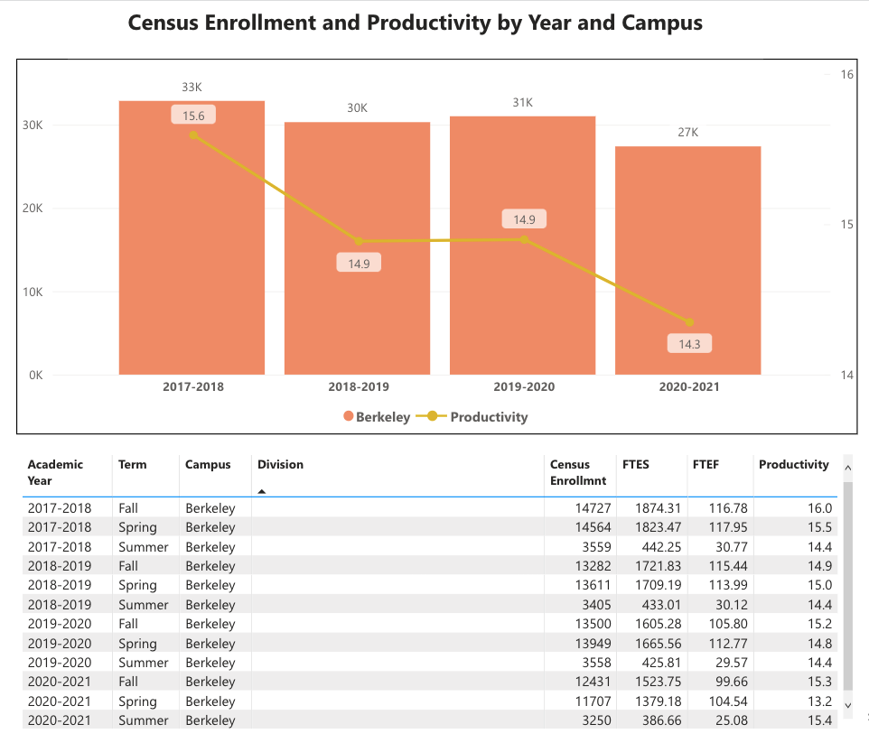
Figure 1: Berkeley City College Enrollment and Productivity

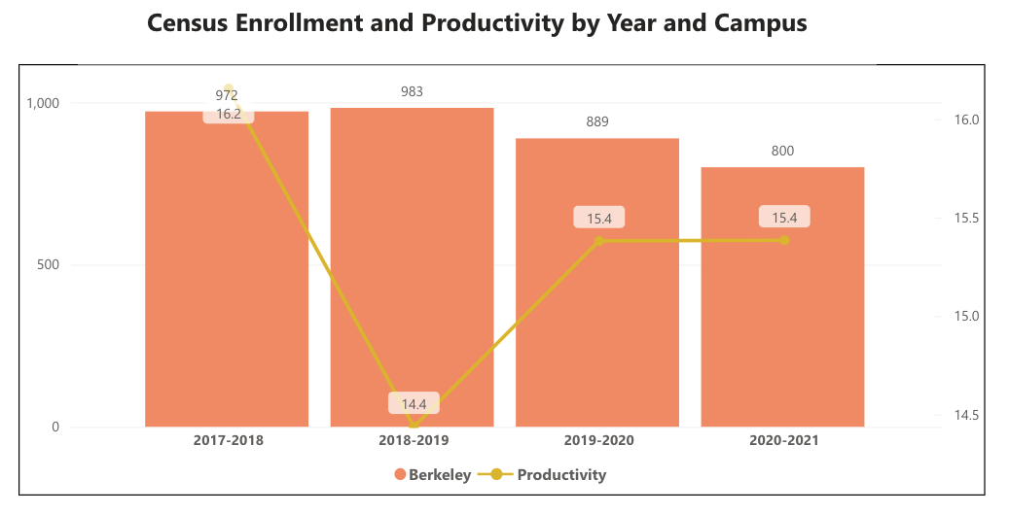
Figure 2: All History Courses at Berkeley City College, Census Enrollment and Productivity

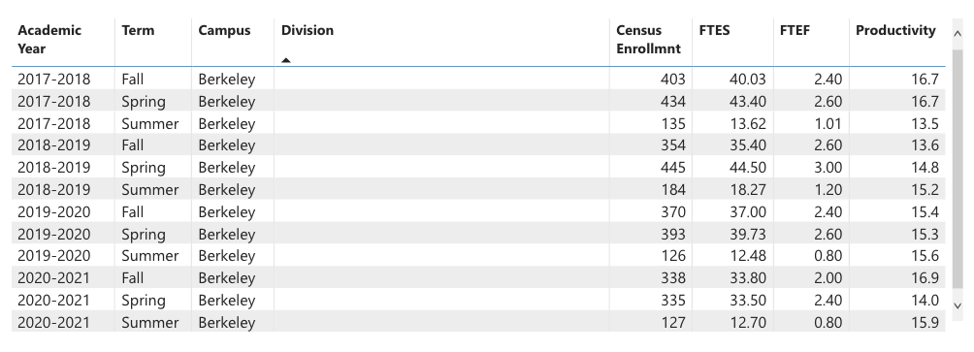
Figure 3: All History Courses at Berkeley City College, Census Enrollment and Productivity

Enrollment Trends:
General enrollment in history courses shows a modest declining over the past three years. In 2018-2019 total enrollment stood at 983; 2019-2022 at 889; and 2020-2021 at 800. While the enrollment dropped, productivity increased during the three-year period from 14.4 in 2018-2019 to 15.4 in 2019-2020 and remained steady at 15.4 through 2020-2021. So, the decline in overall enrollment could very easily be a product of fewer history sections offered in 2019-2020 and then again in 2020-2021 compared to those offered in 2018-2019 rather than less popularity of history offerings during this three-year period. In the academic year 2018-2019, the college offered 34 history sections; in the academic year 2019-2020, the college offered 28 history sections; in the academic year 2020-2021, the college offered 26 sections. The consistency in productivity suggests that 26 to 28 sections each academic year suits student demand, but coming out of the pandemic, it will be important to build out a schedule that will account for the shifting landscape of modality preferences and a likely expansion in overall college enrollment.

The history department’s productivity numbers remain above the overall college rates. Due to the conditions of the pandemic, it is impossible to discern patterns for different modalities in this year’s Program Review. Productivity had dipped for online sections from 2018-2019 to 2019-2020. But the move to one-hundred percent online for five consecutive semesters, including summers 2020 and 2021, pretty well obliterated any observable trends regarding the relationship between enrollment/productivity and modality. The History Department will track the fill-rates and enrollment figures in the coming spring and fall semesters to evaluate the immediate late-pandemic/post-pandemic academic environment.

When the data for your department are disaggregated by student ethnic groups, what trends do you observe and how do plan to address them over the next three years?
Year 1 (2021-22) | Year 2 (2022-23) | Year 3 (2023-24)
Survey all students to assess needs and concerns during the return to campus in spring 2022. Locate sources to address concerns and needs, such as technologies and learning materials. | Build into all history classes, if possible, the use of free or affordable learning materials. | Grow opportunities for Society of Scholars cohorts in history classes.
What would you recommend that we do to increase student enrollment in your department?
- Continue to build the Guided Pathways project to maintain enrollment.
- Promote dual enrollment at OUSD, BUSD, Albany High, El Cerrito High.
- Increase contract education offerings at BYMCA and other local institutions.
- Improve/increase advertising of the college in Berkeley, Albany, Kensington, El Cerrito.
- Promote BCC courses at UC Berkeley.
- Expand the summer schedule where possible.
- College to hire a fulltime electronic media/website administrator to work with history instructors in building and maintaining attractive, current, and detailed departmental and faculty webpages.

3B. Course Completion and Retention Rates Dashboard – Instruction
*Note that completion and retention rates are presented with the inclusion and exclusion of excused withdrawals (EW) and military withdrawals.

If you need more guidance with this item, click here for additional support. Click here for additional guidance for how to view and use equity data. If you would like to view BCC’s Equity Plan, click here.
On page 3 of the “Course Completion and Retention Rates by Subject” dashboard, what are the completion and retention trends by gender, age, ethnicity in your department?
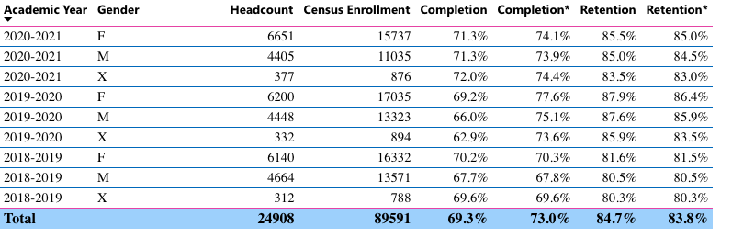 Figure 4: College-wide Enrollment/Completion/Retention (a) General and by (b) Gender

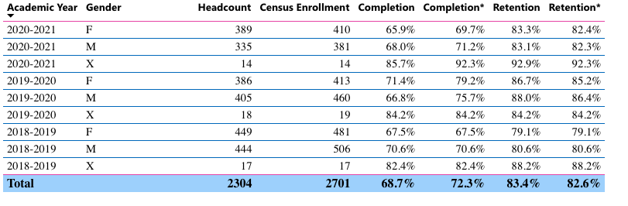
Figure 5: History Department Enrollment/Completion/Retention (a) General and by (b) Gender
Completion and Retention General Trend:
Retention rate has been holding steady at roughly the same proportion as the college- wide retention rate. The History Department has seen a slight increase in retention between the academic year 2018-2019 (80%) and the academic year 2020-2020 (83%) with the highwater mark coming in the academic year 2019-2020 (86%). Completion rate has followed the same pattern: trending slightly upward between the academic year 2018-2019 (69%) and the academic year 2020-2021 (71%) with the highwater mark coming in the academic year 2019-2020 (76%) and holding steady at roughly the same proportion as the college-wide completion rate (overall for the college 83% retention and 73% completion). Both the retention rate and completion rate showed upward trends leading through spring 2020. The slight dip in the academic year 2020-2021may be attributed to the disruption caused by the pandemic. Considering the challenges of the period spring 2020 to spring 2021, the History Department managed fairly well in meeting student needs and supporting students through its courses.

Completion and Retention by Gender:
Completion rates across genders is relatively even and fairly steady for the period 2018-2021. By year: female completion rate: 68%; 79%; 70% - male completion rate: 71%; 75%; 71% - non-binary completion rate 82%; 84%; 92%. For retention during the same period: female retention rate 79%; 85%; 82% - male retention rate: 81%; 86%; 82% - non-binary retention rate 88%; 86%; 92%. Trends for female and male students in History classes followed the same trajectory: a slight uptick in completion and retention from 2018-2019 into 2019-2020 and then slightly downward in 2020-2021. For non-binary students the trend consistently, if modestly, moved up, with overall good numbers for completion and retention. Non-binary students, however, compose a rather small proportion of enrollment in History sections: out of 2701 students enrolled in History sections during the period 2018-2019 to 2020-2021, only 50 identify as non-binary. No significant gap between genders exists for completion and retention. The year-to-year trends follow the same pattern for female, male, and non-binary students. Rates for all genders typically remained within a few percentage points, none showing a significant weakness with regard to any one gender.

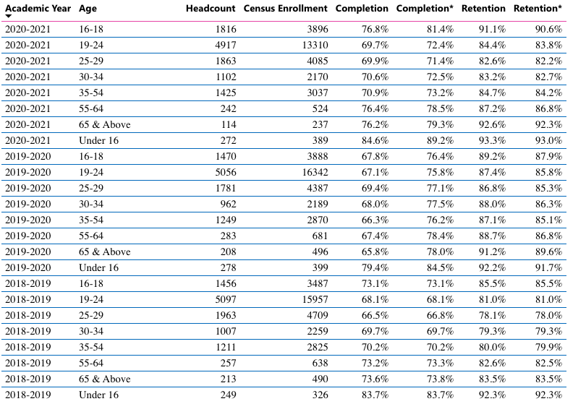
Figure 6: College-wide Enrollment/Completion/Retention by Age
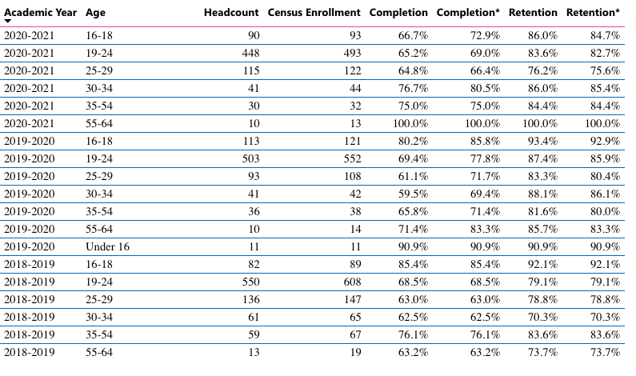
Figure 7: History Department Enrollment/Completion/Retention by Age
Completion and Retention by Age:
No surprise that the majority, far and away, of students in history sections are between the ages 19 to 24. Roughly equal numbers of students in the age group 16-18 and 25-29 comprise the next most significant statistical groups; with the age groups 30-34, 35-54, and 55-64 in descending order for enrollment figures. Data show a fairly even spread of completion and retention across age groups. Considering the largest number of students taking history classes fit into the 19-24-age range, in order to bolster completion rates as a whole, the particular needs of this age group might be better attended to. This might be accomplished through more robust counseling and scheduling that fits demand (to accommodate for employment schedules, perhaps more hybrid or 100% online). Students in the 55-64 age range managed surprisingly well on the completion and retention metrics; in light of the pandemic and shift to 100% remote learning in spring 2020, the 55-64 age group preformed proportionately well—albeit in far fewer numbers than any other age group. Prior to 2020, History sections were not doing well for completion and retention of students in the age groups 25-29 and 30-34. In 2020-2021, students in the 30-34 age range completed 81% of the time. Likewise, the 25-29 age group completed at a slightly higher rate in 2020-2021 than in 2018-2019. Coming out of the pandemic, the History Department may consider offering more hybrid and 100% online classes (either synchronous or asynchronous) to see if completion and retention.

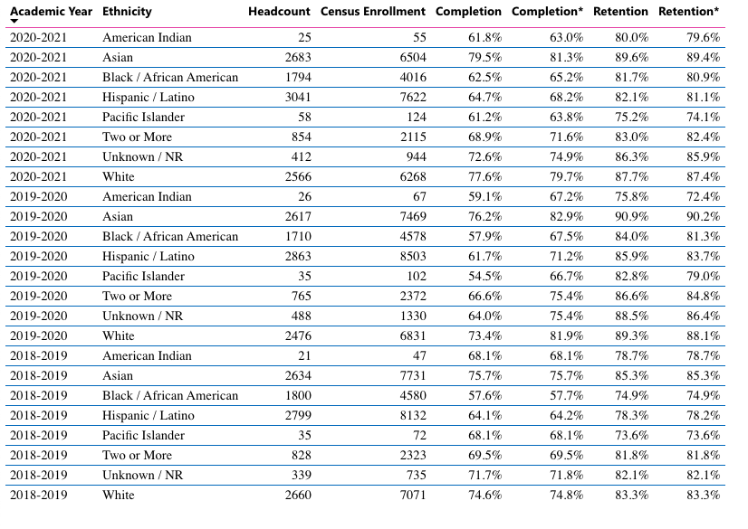
Figure 8: College-wide Enrollment/Completion/Retention by Ethnicity

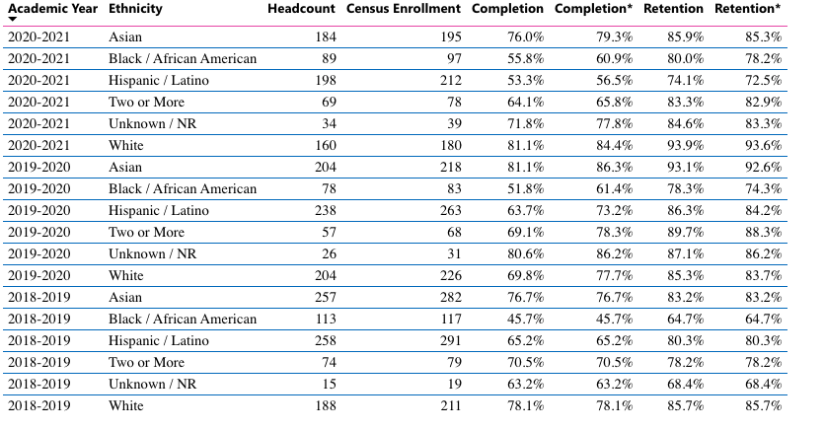
Figure 9: History Department Enrollment/Completion/Retention by Ethnicity
What disproportionately impacted (DI) population(s) showed outcomes gains in your program area and which need more support?
The most noticeable trend regarding completion and retention by ethnicity shows up in the relatively poor numbers for Black/African America students: only 46% of Black/African America completed and 64% retained in 2018-2019; in 2019-2020 the rates improved to 61% completion and 74% retention; the completion rate remained steady then in 2020-2021 at 61% and continued to climb, slightly for retention at 78%. At least in a small way, considering the collaboration between the History Department and the Society of Scholar program (Puente) in regularly offering a learning community HIST 7B, some ground will be made in attending to the unique conditions of the group. In the grander scheme, however, more attention needs to be paid to the success of Black/African America and Hispanic/Latinx students who enroll in history section. The enrollment figures of both groups are consistent with the enrollment of the groups college-wide. So, the issue is not in attracting Black/African America and Hispanic/Latinx students to History section, the issue is making sure the outcome is successful.

How do these outcome trends compare to the college average?
While the rates generally mirror the overall rates of the college, the History Department must take strides to bolster completion and retention for this student group. History sections likewise did relatively poorly in guiding Hispanic/Latinx students to course completion. In general, Hispanic/Latinx student completion and retention rates in History sections concur with the college-wide rates of the group, but History sections did not fair well in terms of completion and retention in 2020-2021. During this academic year, obviously affected by the pandemic, completion and retention of Hispanic/Latinx sagged dramatically. This trend is particularly troubling in light of the fact that more Hispanic/Latinx students enroll in History sections than any other ethnic group.
What questions do you have about the trends?
One question moving forward will be how to best schedule sections in terms of modalities to meet student demand and account for various learning styles.

Based on input you’ve received from students, what have they expressed as their need (s) to complete and succeed in your courses? (support your recommendations with examples) e.g., offer diff modalities; timing of day).
The History Department has yet to conduct surveys regarding student needs. This is something that the Department will begin to regularly employ. Coming out of the pandemic, after students have had more exposure to online instruction, the surveys may show more informed feedback than in the pre-pandemic years.

How will these outcome trends you identified in this section affect your department goals and plans for the next three years?
Year 1 (2021-22) | Year 2 (2022-23) | Year 3 (2023-24)
Create survey and take appropriate actions. | Collaborate among history faculty to address negative trends. | Assess success of changes in scheduling and teaching strategies.

3C. Degrees and Certificates Dashboard
On page 1 of the “Degrees and Certificate Awards Trends” Dashboard, what are the award trends for your department (overall, by gender, age, and ethnicity).
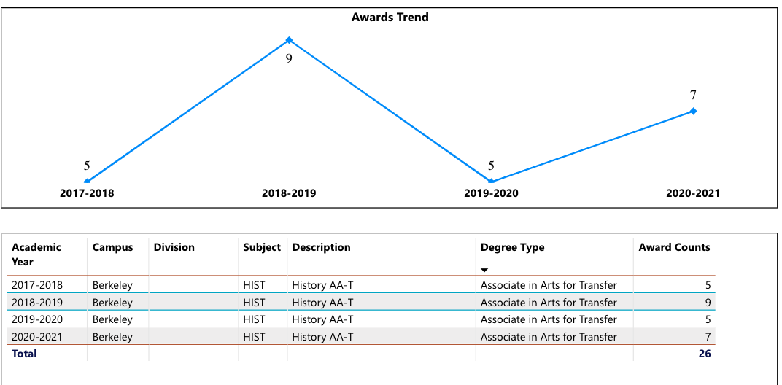
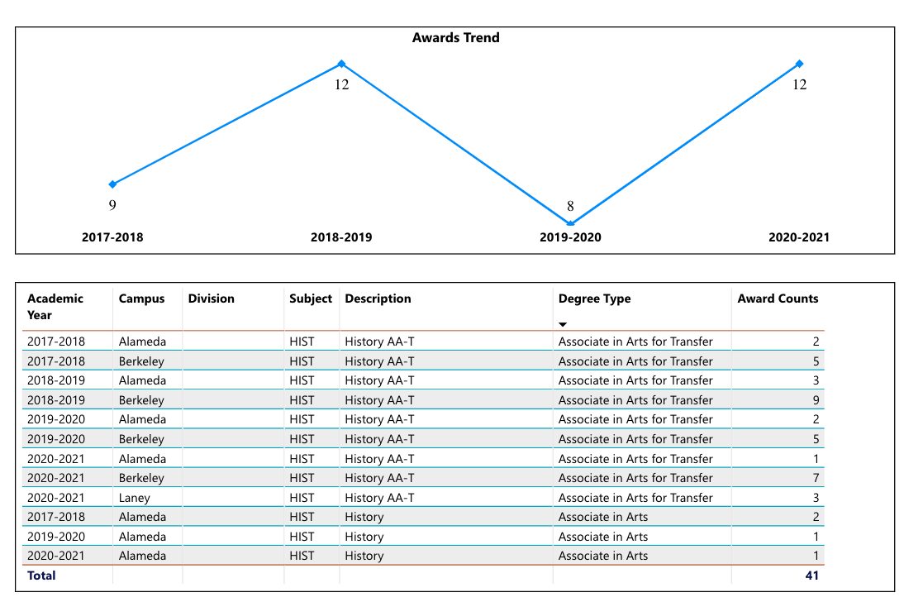
Figure 10 & 11: Overall Degrees and Certificates Awarded – HIST – BCC & Overall Degrees Awarded – HIST – PCCD
In the period 2017-2018 to 2020-2021, the History Department awarded a twenty-six AA-Ts. Degrees awarded each academic year have remained relatively steady, between nine as a high and five as a low. While twenty-six degrees awarded in four years is not much to brag about, it should be noted that BCC accounts for 63% of all History AA-Ts awarded in the Peralta District (Merritt College does not have a HIST AA-T. CoA offers both an AA and an AA-T ). Each semester, College of Alameda offers more history sections than BCC and Laney offers roughly the same number as BCC. So, with the same amount of exposure to students, BCC’s History Department attracts a greater number of students into the history degree pathway.

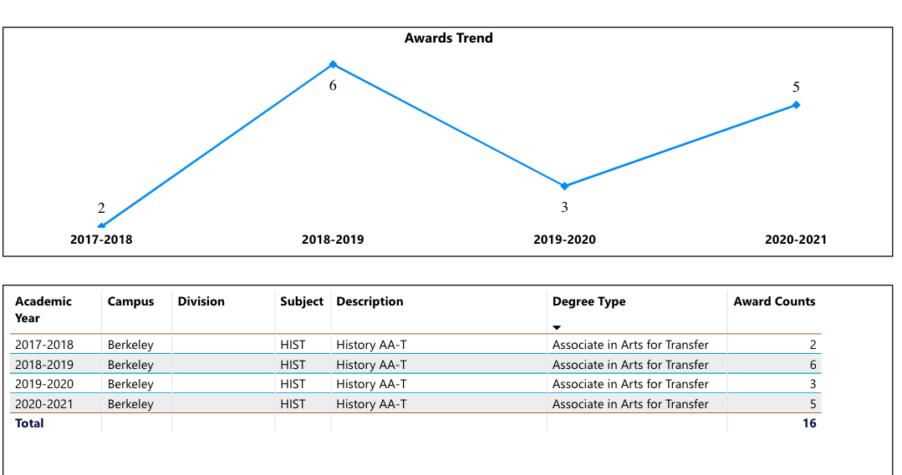
Figure 12: HIST AA-Ts Conferred – Male Students
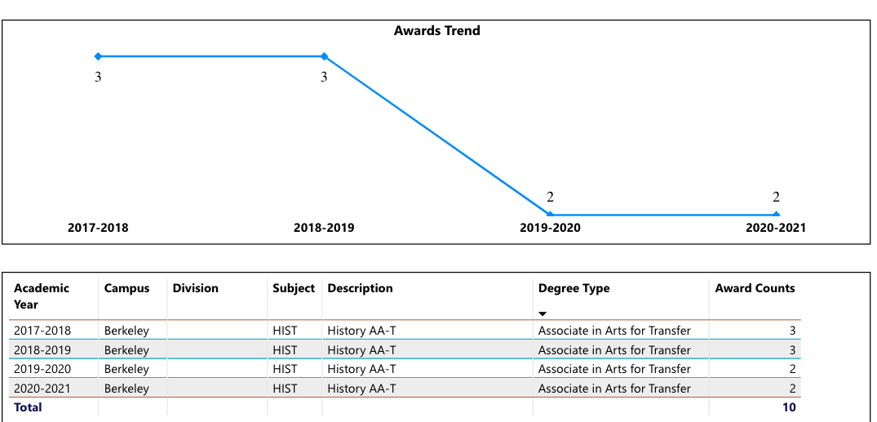
Figure 13: HIST AA-Ts Conferred – Female Students

More male students than female students have successfully pursued the History AA-T. Overall, roughly twice as many male students than female students receive a History AA-T. But considering the relatively low number of History degrees conferred, in terms of numbers the gender gap is not particularly wide. Nevertheless, History Department faculty will do more outreach to bolster the roster of History majors and degree completers. Simple steps, such as participating in degree pathway advising and distributing degree-oriented information in history classes, would no doubt help in attracting more students to the program and degree. No History degrees were awarded to students identifying as non-binary.

Degrees conferred by age spread across all categories; the age range 19-24, however, accounted for somewhere between roughly half of all degrees awarded each year and nearly all the degrees awarded each year. This trend aligns with the degree trend of the college overall. Some of the data appears to be inaccurate. The tables show that 4 of the degrees awarded in 2020-2021 went to the 16-18 age group. Yet that number seems to be in the 19-24 group instead.
On page 4, what DI population(s) award trends showed gains in your program area and which populations need more support?
History Degrees Awarded by Ethnicity:
White: 30%
Hispanic/Latinx: 23%
Asian: 12%
Black/African American: 12%
Unknown: 12%
Two or More: <1%
Pacific Islander: <1%
American Indian: <1%

How do these outcome trends compare to the college average?
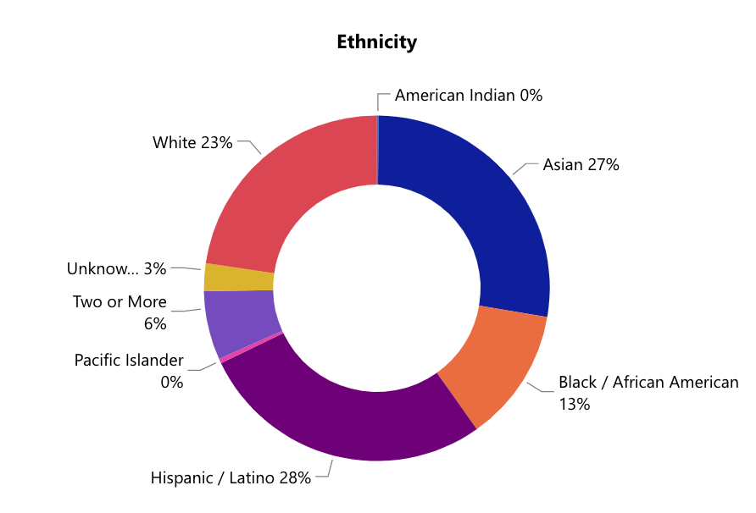
Figure 14: Degrees Awarded – BCC – Ethnicity
BCC Degrees Awarded by Ethnicity:
Hispanic/Latinx: 28%
Asian: 27%
White: 23%
Black/African American: 13%
Two or More: 9%
Unknown: 3%

Proportion of History degrees awarded by ethnicity roughly coincide with college-wide trends. History degrees are higher for Whites and substantially lower for Asians, but ,otherwise, for Hispanic/Latinx and Black/African Americans the percentages of overall degrees align with the figures posted by the college. The number of degrees for each ethnicity tend to stay fairly static year to year. While the relative consistency of degrees awarded by ethnicity does not show a particular trend affecting disproportionately impacted groups, the decline in degrees awarded to Hispanic/Latinx from a high of three in 2019 to zero in 2021 should be given attention. Trends in the post-pandemic period will be watched for new directional shifts, reorientations, or returns to pre-pandemic tendencies--such as greater demand for online or hybrid instruction to fit schedules and pathways--for enrollment and degree conferrals.

Based on input you’ve received from students, what have they expressed as their need (s) to complete their degrees and/or certificates? (support your recommendations with examples)
The History Department has not solicited input from students regarding pathways to degree completion. Doing so, however, will be a priority of the Department moving forward.

How will these outcome trends you identified in this section affect your department goals and plans for the next three years?
Year 1 (2021-22) | Year 2 (2022-23) | Year 3 (2023-24)
- Develop greater awareness of HIST AA-T by distribution of information in HIST all HIST sections  - Utilize faculty advising channels to encourage and guide students toward degree completion  - Participate in events at the college to attract history majors  - Enlist the support of the Guided Pathways program  - Confer with Counseling Department Social Sciences liaison  - Employ data and surveys to develop class schedules that meet demand | - Develop greater awareness of HIST AA-T by distribution of information in HIST all HIST sections  - Utilize faculty advising channels to encourage and guide students toward degree completion  - Participate in events at the college to attract history majors  - Enlist the support of the Guided Pathways program  - Confer with Counseling Department Social Sciences liaison  - Employ data and surveys to develop class schedules that meet demand | - Develop greater awareness of HIST AA-T by distribution of information in HIST all HIST sections  - Utilize faculty advising channels to encourage and guide students toward degree completion  - Participate in events at the college to attract history majors  - Enlist the support of the Guided Pathways program  - Confer with Counseling Department Social Sciences liaison  - Employ data and surveys to develop class schedules that meet demand

3D. Transfer Dashboard
This dashboard does not provide data by subject. Reflect on what you can do to affect student transfer. How may your department help to support BCC student transfer? (e.g., serve on panels, strengthen GP in your dept, change curriculum, increase number of AD-Ts, etc.)
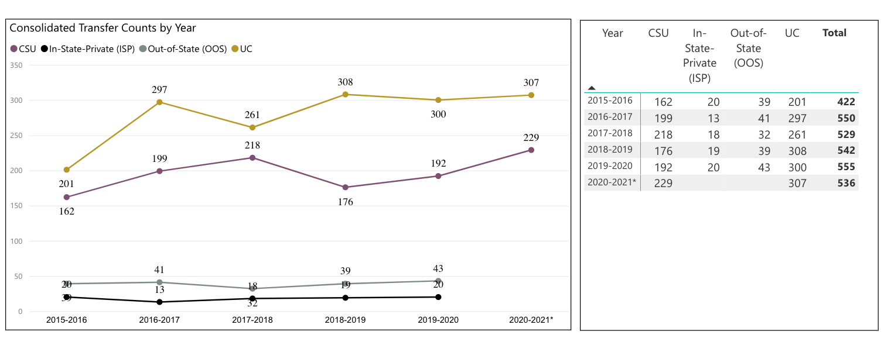
Figure 15: Consolidated Transfer Counts by Year – BCC
The History Department does not track student transfers. In order to bolster student transfer overall and particularly pay attention to the transfer goals of history majors, the Department will initiate the strategies identified above in the three-year plan.

3E. Curriculum
View the department’s curriculum through the lens of student equity outcomes. BCC outcome data suggests that disproportionately impacted groups of students experience low rates of success.
How do you plan to adjust the curriculum to advance student equity and address DI student outcome gaps?
Examples include: making adjustments to lesson plans based on student assessment outcomes; review pedagogy and revise assignments for culturally relevant content; simplify student processes and make service areas student-centered; manage class discussions and student participation; review best practices, etc.).
In the period 2018-2021, the History Department has reduced the number of courses in its catalog. Some of the deactivations eliminated courses that focused on regions within the global south, yet had not offered by the Department in years, such as HIST 8 and HIST 10. The History Department struggled to find part-time instructors who would teach either the HIST 8 or HIST 10 courses once per academic year—enrollment did not warrant more than that enrollment for the two courses. College of Alameda offers the Latin American history survey course that BCC deactivated. BCC’s History Department will consider offering HIST 12: History and Culture of East Asia in the coming academic year. Such a course would bolster the regional diversity of BCC’s History course offerings and may appeal to Asian/Asian American students—one of the student groups that registered below the college-wide average in degrees awarded for history (see above section 3C). One deactivation eliminated a course that tended to have low enrollment, HIST 32. Two deactivations, HIST 1 and HIST 33, came about due to the retirement of Nola Hadley Torres. An instructor expert in American Indian history is required for HIST 1 and HIST 33. The History Department regularly searches for an instructor for these courses; each of which was a unique and integral component of the department’s curriculum. Building HIST 1 and HIST 33 back into the schedule would contribute to addressing the interests and concerns of disproportionately impacted groups, as both classes were popular among those students.

History instructors use the assessment process to consider pedagogical reorientation and assignment revisions. In the coming three years, initiatives toward assuring instruction aligns with best practices within the discipline will be collectively undertaken. Moving courses through the POCR process and aligning with the CVC-OEI will no doubt contribute to stronger and more consistent online instruction. All history faculty participated in professional development for online instruction as a result of the pandemic. The strengthening of online teaching will no doubt carry over into the classroom as well.

Professional development, course assessment, and instructor evaluations provide opportunities for history faculty to consult on and consider culturally relevant content. Such effort will continue in the next three years.

In the boxes below, add improvement actions that are directly related to Student Equity & Success. If there are no improvement actions in this area, leave blank. If you have more than one Improvement Plan, add more by copying and pasting the table below.
IMPROVEMENT ACTIONS
Department/Discipline: | History
Action Name: | CVC-OEI Participation
Description: | Align multiple classes with the CVC-OEI rubric; get at least four courses “badged”
Completion timeline: | By the end of the Program Review three-year cycle
Responsible person: | Tim Rose (discipline lead)

III. PROGRAM GOALS
- List your current Department Goals.
- Move at least four classes (HIST 7A; HIST 7B; HIST 21; and one more from HIST 2s or HIST 31) onto the CVC-OEI platform.
- Work with Guided Pathways program to build degree completion.
- Collaborate with the Counseling Department to attract more history majors and guide students toward degree completion.
- Develop materials to share in history sections to attract more history majors and provide prospective majors or potentially interested students with ideas on career options associated with the discipline.
- Maintain up-to-date curriculum in Curriqunet and consider curriculum growth as warranted.
- Assess all active courses through the section aggregate stage of the process.
- Develop a post-pandemic schedule that takes into account new trends for student demand.
- Through the faculty new-hire prioritization process, request an additional full-time history instructor.
- Bring the current history instructors together more frequently for check-in meetings.
- Use course assessment, instructor evaluation, and collaborative process among history faculty to ensure high quality instruction.
- How do the goals align with the College goals? If so, which ones?
Berkeley City College Goals
- GOAL I: Strengthen Resilience: Strengthen BCC students’ abilities to become self-directed, focused and engaged in the pursuit of transformative, life-long learning experiences that result in personal and academic success.
- GOAL II: Raise College Competence: Raise student skills and competencies, and expand their learning experiences, so that they can successfully complete their college program.
- GOAL III: Enhance Career-Technical Education Certificates and Degrees: Enhance BCC’s 1- and 2-year career and technical education programs so that they provide current and transferable skills and competencies to earn a living wage in our area, and to maintain competency for advancement in one’s career.
- GOAL IV: Increase Transfer and Transfer Degrees: Ensure that all of BCC’s programs of study and transfer pathways for degrees prepare students, in a timely manner, for multiple transfer options.
- GOAL V: Ensure Institutional Sustainability: Increase BCC’s impact in education through innovation, internal and external collaboration and partnerships, and sufficient resources, both short-term and long-term.
GOAL I: Strengthen Resilience:
- Use course assessment, instructor evaluation, and collaborative process among history faculty to ensure high quality instruction.
GOAL II: Raise College Competence:
- Move at least four classes (HIST 7A; HIST 7B; HIST 21; and one more from HIST 2s or HIST 31) onto the CVC-OEI platform.
- Through the faculty new-hire prioritization process, request an additional full-time history instructor.
- Bring the current history instructors together more frequently for check-in meetings.
- Assess all active courses through the section aggregate stage of the process.
GOAL IV: Increase Transfer and Transfer Degrees:
- Work with Guided Pathways program to build degree completion.
- Collaborate with the Counseling Department to attract more history majors and guide students toward degree completion.
- Develop materials to share in history sections to attract more history majors and provide prospective majors or potentially interested students with ideas on career options associated with the discipline.
- Assess your facilities utilization (including labs, support for online learning, and other spaces) and for each year, indicate if the space is insufficient. If so, what are the needs and why? *Note that facility needs and planning are addressed in the Facility Master Plan for the college, including the planning for new buildings.
Year 1 (2021-22) | Year 2 (2022-23) | Year 3 (2023-24)
N/A | N/A | N/A
- What are the essential functions of your department, any unique characteristics or trends? Provide specific examples.
The essential function of the History Department is to provide quality, lower division, undergraduate education for students on the transfer track to a four-year college/university and contribute to the community writ large with life-long learning opportunities.
- Describe how external factors (if applicable), such as State and Federal laws, advisory board recommendations, district and college governance have an impact on the support services your department provides. (e.g., partnered with dual enrollment and contract Ed programs at K-12 districts and high schools; support staff at high schools have access to Canvas to follow along and support students; allow tutors into the classes; Guided Pathways, AB 705, etc.)
N/A

Based on your responses to questions 4-8, are there areas that need improvements? If so, add improvement actions below. If there are no improvement actions in this area, leave blank. If you have more than one Improvement Plan, add more by copying and pasting the table below.
IMPROVEMENT ACTIONS
Department/Discipline: | History
Action Name: | History faculty collaboration
Description: | Bring history faculty together more regularly for assessment, curriculum, student success, pedagogical innovation
Completion timeline: | Each academic year
Responsible person: | Tim Rose (discipline lead)

- ASSESSMENT
Berkeley City College is committed to a culture of assessment to improve instruction, services, and institutional planning. Findings from SLO, PLO, ALO assessments, and program review data are used to direct resources for areas that are institutional priorities that are articulated in the Educational Master Plan and BCC Strategic Plan. Due to the critical role that course and program assessments play in our institutional planning and to be in compliance with the Accreditation requirements, the Program Review resource allocation requests require the completion of assessment in order to qualify.
9A. List and describe the department/program’s progress and reflection on Student Learning Outcomes (SLOs), Program Learning Outcomes (PLOs), and/or Service Area Outcomes (SAOs). If your department/program offers a degree or certificate, please describe the department’s progress on Program Learning Outcomes (PLOs).
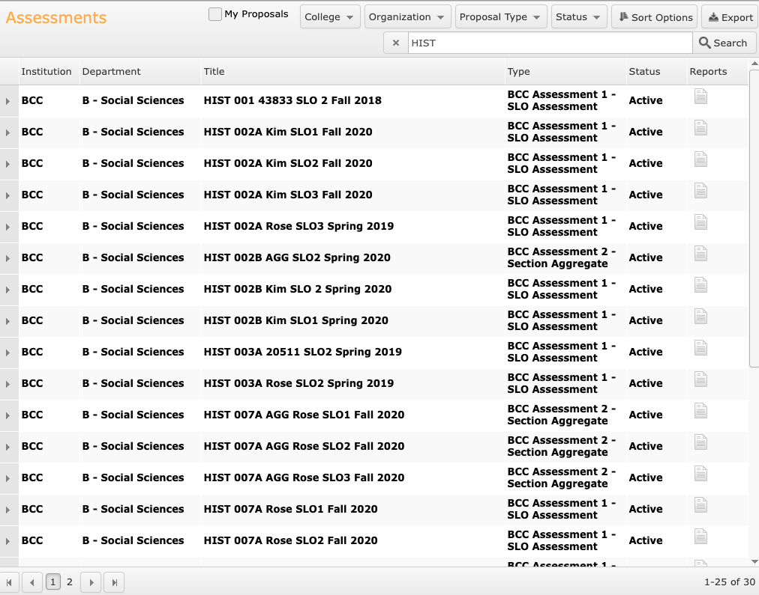
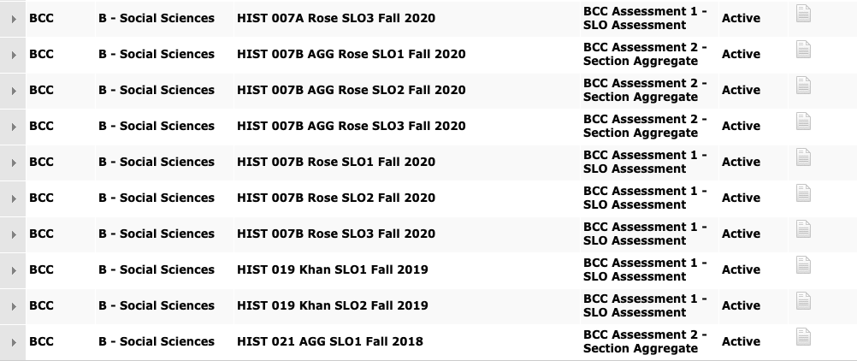
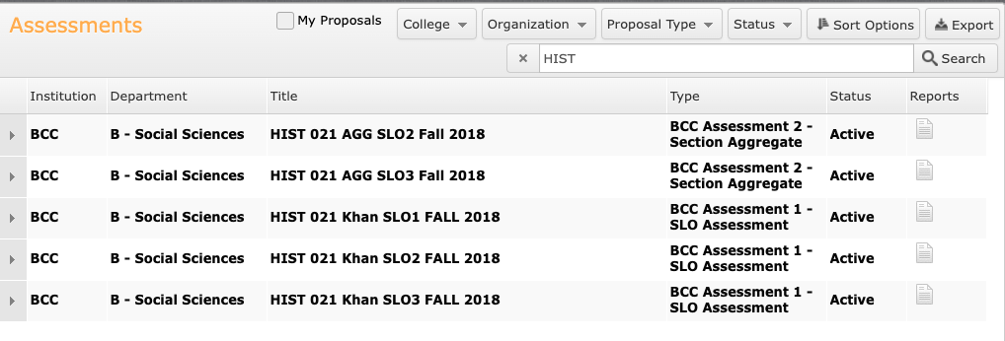

Completed SLO Assessment Round 4 – Through Level 2 (Section Aggregate):
HIST 2A
HIST 2B
HIST 7A
HIST 7B
HIST 21

Partially Completed SLO Assessment Round 4 – Through Level 1 (SLOs):
HIST 19

Assessment Plan Fall 2021 – Fall 2023

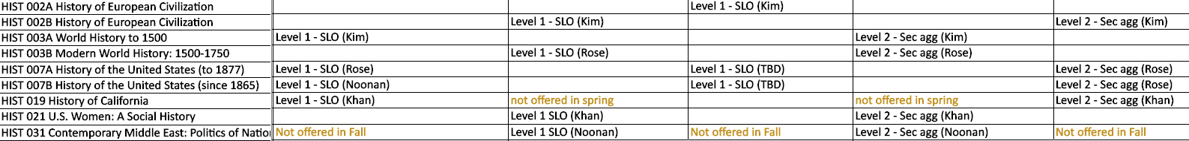

9B. What improvement plans did your department identify upon the assessment of each program? How has your department used the results of assessment to improve student learning outcomes and/or curriculum? Please be as detailed as possible.
In the period 2018-2021, identified as Round 4 of assessment at BCC, the History Department did well in assessing almost all of its regularly offered courses up to the section aggregate stage. Over the past three years a number of faculty members worked to create rubrics for assessing particular course SLOs. We will need to organize the department to do likewise for Program Outcomes. As of yet, the Department has not taken significant measures to collectively work through assessment. Program Outcomes will be assessed in the coming cycle.

9C. Describe how the program has made use of information from the data it has from program and student learning outcomes in Round 4 (last cycle of the last 3 years) for continuous improvement. Include the three most significant plans for improvements as a result of the assessment process with timelines. Click here to view your Assessment Calendar
Upon successful completion of this program, students will be able to:
- Demonstrate knowledge of the historical process within particular fields of history and effectively link historical cause and effect.
- Apply historical methodology and critical thinking in order to analyze primary and secondary sources and historical arguments.
- Interpret the diverse historical forces which have shaped the past and inform the content of the present.
All section aggregates included the following actions:
- State goals or objective of assignments/activities more explicitly
- Revise content of assignment/activities/readings
- Increase guidance for students as they work on assignments
9D. How does your department, program, or unit ensure that students are aware of learning or service area outcomes?
Learning outcomes are posted on every syllabus; all Canvas pages associated with history classes; and the department’s webpage.

9E. Besides your syllabi, where are the service area and/or program level outcomes published? If on a website, please specify the URL.
History Department PLOs are published on the department’s webpage
https://www.berkeleycitycollege.edu/history/

In the boxes below, add improvement actions that are directly related to Assessment. If there are no improvement actions in this area, leave blank. If you have more than one Improvement Plan, add more by copying and pasting the table below.
IMPROVEMENT ACTIONS
Department/Discipline: | History
Action Name: | Collaborate on Program Outcomes Assessment
Description: | Work with all history faculty to develop a program outcome assessment plan and follow through with assessment goal.
Completion Timeline | Plan completed by December 2022; program assessment completed by end of the Round 5 assessment cycle.
Responsible person: | Tim Rose (discipline lead)

- ENGAGEMENT
10A. Discuss how faculty and staff have engaged in institutional efforts such as committees, presentations, and departmental activities. Please list the committees that full-time faculty/staff/admin participate in.
Tim Rose:
- Chair of Chairs Council
- Department Chair – Social Sciences
- Lead Faculty – History
- Roundtable for Planning and Budgeting
- Integrated Planning Committee
- Academic Senate (non-voting member)
- HUSV Leadership Team
- Tenure Review Facilitator
- Career Education Committee
- Tutoring Stakeholders Taskforce
- Website Revisions Taskforce
- Standard IV ISER Contributor
- Participatory Governance Retreat
- PGM update taskforce
- Faculty New-Hire Prioritization Taskforce
- IPC Governance Charge Revision Taskforce
- Program Review Revision Taskforce

Susan Khan (Part-time Faculty Member)
- Chair/Co-Chair Professional Development Committee (this is my 3rd year)
- Assessment Liaison & voting member of Assessment Committee (this year)
- POCR group (this is my 2nd year. I do reviews of other faculty members' courses, and my History 21 has just been submitted as one of our 1st 3 courses to the CCC Online Consortium)
- Race and Equity Task Force (2nd year)
- voting member Facilities Committee (2 years, 2018-2020)
- Instructional Design consultant
- OER grant awardee for developing History 21 cost-free materials.
- Legendary Cohort instructor (also a stipend position)
10B. Discuss how faculty and staff have engaged in community activities, partnerships and/or collaborations.
Tim Rose has participated in the HUSV Advisory Board meetings.

10C. Discuss how adjunct faculty members are included in departmental training, discussions, and decision-making.
All history department adjuncts are encouraged to attend professional development events during flex days. All adjuncts participate in Social Science Department meetings. Susan Khan and Richard Kim have contributed to assessing courses that fell in the recent course assessment cycle. Susan Khan has taken on leadership positions with college DARTs and FIGs. Presently Susan Khan is serving as the Chair of the Professional Development Committee and History Department assessment liaison.
- 10D. Discuss the relationship and engagement with other support services, programs, departments, or administrative units and how these relationships support your area to meet its goals.
The History Department collaborates with other disciplines within the Social Sciences in terms of curriculum and scheduling (frequently) and pedagogy (occasionally). The Department coordinates goals with the Counseling Department as well as the Society of Scholars Program, library, Student Accessibility Services, BCC’s Transfer Center, and Veterans Affairs.

In the boxes below, add improvement actions that are directly related to Engagement. If there are no improvement actions in this area, leave blank. If you have more than one Improvement Plan, add more by copying and pasting the table below.
IMPROVEMENT ACTIONS
Discipline: | History
Action Name: | Building Community Bridges
Description: | Fulltime history instructor contacts and builds relationships with local high schools
Completion Timeline | Once duties as Lead Department Chair and Social Sciences Department Chair are passed on to someone else. Most likely 2023-2024
Responsible person: | Tim Rose (discipline lead)

VI. Prioritized Resource Requests
In the boxes below, add a 3-year resource requests for your department/program that have not been funded by existing funding sources. Work with your supervisor to estimate costs. If there are no resource requested, leave the boxes blank.

Click here to view the Resource Request Process and Timeline

Resource Category | Description/Justification | Estimated Annual Salary Costs | Estimated Annual Benefits Costs | Total  Estimated  Cost | Overall  Priority Ranking (1=Most important)
Personnel
Classified Staff | Fulltime Electronic Media Administrator/Manager (Webmaster) | N/A | N/A | N/A | 1
Student Worker
Part Time Faculty
Professional Development | Description/Justification |  |  | Estimated Cost
Department wide PD needed | Increased training on accessibility; even offering a service to make PDF material accessible for faculty. Many contract services exist who offer at a pay-per-page rate for converting PDF material to accessible documents. Many OER projects already funded to make textbook costs free for students could use assistance to make these materials accessibility to screen readers. |  |  | $10,000 for the Social Science Department | 2
Personal/Individual PD needed
Supplies | Description/Justification |  |  | Estimated Cost
Software (for whom or role?) | Continued licensing of Snagit and Camtasia to enable hybrid and online course video lectures.  Continued support for Canvas Studio for closed caption services and the archiving of multimedia material.  Continued subscription to other software such as Turnitin and other LTIs commonly used by faculty. |  |  | N/A | 3
Books, Magazines, and/or Periodicals | Continue subscription to New York Times online. |  |  | N/A
Instructional Supplies
Non-Instructional Supplies
Technology & Equipment | Description/Justification  Before you list your technology request, click here to view the latest Technology Refresh Plan to verify whether it has already included. |  |  | Estimated Cost
New
Replacement | Continued refresh of full-time faculty computers at regular intervals. |  |  | N/A
Facilities | Description/Justification |  |  | Estimated Cost
Classrooms | Addition of hyflex capabilities in all BCC classrooms. |  |  | N/A
Offices
Labs
Other
Library | Description/Justification |  |  | Estimated Cost
Library materials (including streamline media needs) | Kanopy streaming is an essential multimedia platform for our instructional needs. |  |  | N/A
Library collections
OER | Continue support for OER and Affordable Learning Materials program. |  |  | N/A
Other | Description/Justification |  |  | Estimated Cost
OTHER Description | Support for POCR (Peer Online Course) reviewers and those having their courses reviewed.  Accessible materials support. |  |  | N/A

Thank you for your time and effort in completing the Program Review!
Please email the completed Program Review to your Dean by November 30, 2021.

