Berkeley City College’s mission is to provide our diverse community with
educational opportunities, promote student success, and to transform lives.

Introduction and Directions

The Peralta Community College District has an institutional effectiveness process which consists of the following components: a District-wide Strategic Plan which is updated every six years; Comprehensive Program Reviews which are completed every three years; and Annual Program Updates (APUs) which are completed in non-program review years.

The Program Review 2021-22 timeline has been developed for each program and services to guide through the semester. Please review and work with your Deans, Managers, Department Chairs and/or Supervisors to complete this Program Review.

The Program Review is intended to primarily focus upon planning for the subsequent two years and institutional effectiveness. The Program Review process directly leads to the institutional resource allocation process and budget planning for the following academic year (2022-23). This is an opportunity for each administrative unit, support service program, and department to reflect on progress made and identify areas of program improvements to achieve equitable student success and elimination of achievement gaps. In this process of making continuous quality improvement, there is an opportunity for each program, student services, and department to request resources that support achieving the stated goals.

If you have questions regarding other material in the Program Review, please contact your Dean or Manager. If you have questions regarding data, please contact Dr. Phoumy Sayavong, Senior Researcher and Planning Analyst (psayavong@peralta.edu).

Please email the completed Program Review to your Dean by November 30, 2021.

COLLEGE PROFILE
Click here to view the Berkeley City College Student Demographics Dashboard.
This 2-page dashboard will provide information on the characteristics of our student body from the past two years such as headcount, ethnicity, enrollment status, age group, educational goals, and majors.
College Outcomes | 2017-2018 | 2018-2019 | 2019-2020 | 2020-21
Full Time Equivalent Students (FTES) | 4,140 | 3,864 | 3,696 | 3,290
Efficiency  (Productivity; avg faculty-student ratio) | 13.4 | 13 | 13.2 | 14.3
Success Rate (%) | 67% | 69% | 67%* | 74%
Degrees + Certificates Awarded (#) | 1,021 | 948 | 1,106 | 1,014
*Excludes “EW” grades

To view prior Program Reviews, click here. To view prior Annual Program Updates, click here.

- DEPARTMENT DESCRIPTION
Please verify the mission statement for your department. If your program has not created a mission statement, provide details on how your department supports and contributes to the College’s mission.
The mission of the Social Work and Human Services is to provide a comprehensive curriculum for paraprofessionals in social work and human services. It is designed to help California meet the statewide challenges and the rapidly expanding need for health, public, and human service/social worker paraprofessionals. Students’ training will allow them to become well-rounded employees who are able to participate as team members in health and human service agencies and social work settings. The program is also designed to align with various transfer programs for students who wish to continue to an Associate of Arts Degree in Liberal Arts with an emphasis in Social and Behavioral Sciences or the Associate Degrees for Transfer in either Psychology or Sociology.
Name(s) of member(s) completing this Program Review | Department/Program | Completion Date
Melina Winterton and Tim Rose | Social Sciences/HUSV-HLTED
List faculty names and/or staff with assignments in fall 2021.
Full Time | Part Time
None | Melina Winterton (Program Coordinator)  Yamini Bhatnagar  Sonja Herbert  Christina Tam

II. STUDENT EQUITY & SUCCESS
Using the data dashboards provided below, review and reflect upon the outcome trends for your department. You may use data from other sources if available.

Click here if you would like to view BCC’s Planning Documents (Education Master Plan, College Strategic Goals, Student Equity Plan, District Strategic Goals, Vision for Success, Guided Pathways, Technology Plan, Facilities Plan)

For assistance with data dashboards, contact Phoumy Sayavong at psayavong@peralta.edu

3A. Enrollment Trend and Productivity Dashboard
*Note that completion and retention rates are presented with the inclusion and exclusion of excused withdrawals (EW) and military withdrawals.
What are your enrollment trends in the past three years?
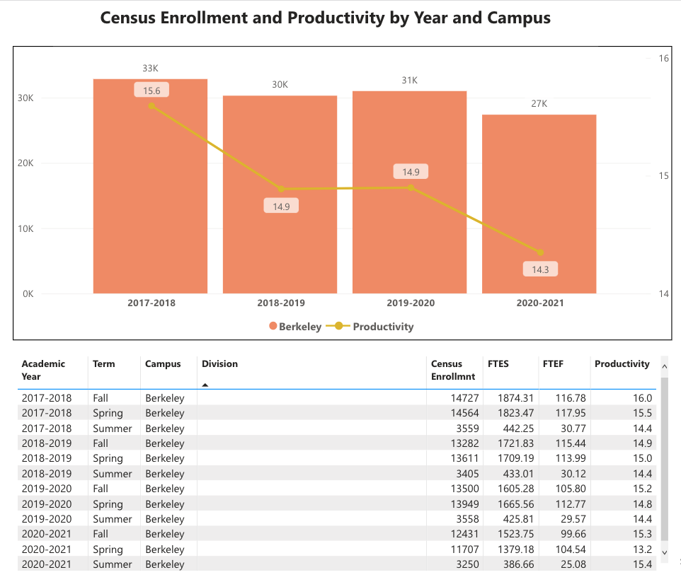
Figure 1: Berkeley City College Enrollment and Productivity
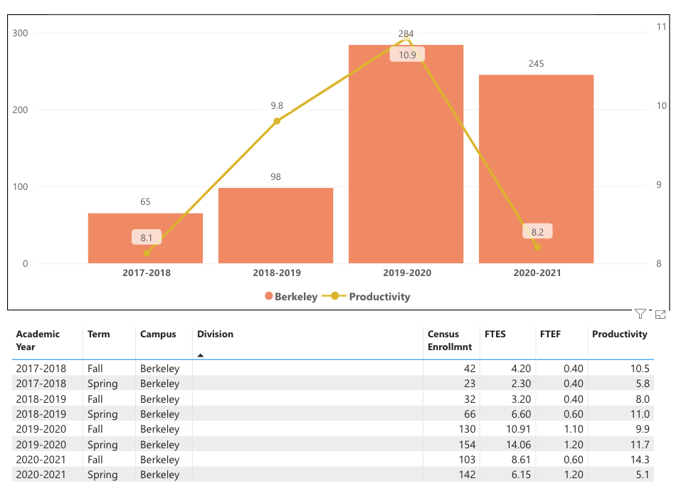
Figure 2: HUSV Enrollment and Productivity
Enrollment Trends:
General enrollment in HUSV courses shows a strong upswing each successive academic year between 2017-2018 and 2020-20221, with a nearly four-fold increase over that period. The most dramatic gains took place from 2018-2019 into 2019-2020, when enrollment nearly tripled in a single academic year. In 2017-2018 total enrollment stood at 65; 2018-2019 at 98; 2019-2020 at 284; and 2020-2021 at 245. The modest dip in enrollment from 2019-2020 into 2020-2021 can surely be attributed to the social, economic, and scholastic disruptions of the pandemic. It can be noted that the slight decline in HUSV enrollment virtually mirrors the downward trend witnessed college-wide in so far as BCC’s overall enrollment dropped 13% from 2019-2020 to 2020-2021 and HUSV section enrollments slipped 14% from 2019-2020 to 2020-2021. Productivity followed the same trend as overall enrollment. Between 2017-2018 and 20190-2020 productivity climbed nearly three points, from 8.1 to 10.9. The pandemic year of 2020-2021 brought productivity in line with where it stood in 2017-2018. So, while the pandemic year negative affected productivity, the program remains above its productivity number at the beginning of this program review cycle. Considering the unique qualities of HUSV’s typical student (skewing higher in age than almost all programs at BCC), the decline in productivity during the pandemic year causes only limited concern. If the trajectory continues on into the academic year of 2022-2023, greater consideration will be given to the downward trend for productivity.

Overall, strong increases in enrollment figures for HUSV sections demonstrate significant achievement in attracting students to HUSV course offering and a highly constructive attention to growing the degree and certificate pathway. In particular, considering the fledgling status of the program in 2017-2018, the surge in enrollment during the subsequent years showcases the dedication and diligence of the program’s faculty and attached supporting staff and administrators.

Due to the conditions of the pandemic, it is impossible to discern patterns for different modalities in this year’s Program Review. The move to one-hundred percent online for four consecutive semesters, pretty well obliterated any observable trends regarding the relationship between enrollment/productivity and modality. HUSV program leaders will track the fill-rates and enrollment figures in the coming spring and fall semesters to evaluate the immediate late-pandemic/post-pandemic academic environment.

When the data for your department are disaggregated by student ethnic groups, what trends do you observe and how do plan to address them over the next three years?
Year 1 (2021-22) | Year 2 (2022-23) | Year 3 (2023-24)
Data has not been disaggregated by ethnic groups at the department level

What would you recommend that we do to increase student enrollment in your department?
- Continue to build the Guided Pathways project to maintain enrollment.
- Promote dual enrollment at OUSD, BUSD, Albany High, El Cerrito High.
- Improve/increase advertising of the college in Berkeley, Albany, Kensington, El Cerrito.
- Develop recruitment material templates that includes employer profiles and job info, marketing developing apprenticeships
- Update website with an eye towards recruitment
- Increase employer-partnerships. many of our students come FROM employers who want them to be better trained. if we had great marketing materials to share with employers, that would get some traction.
- Organized recruitment events at partner high schools for dual enrollment track that showcase graduates and faculty.

3B. Course Completion and Retention Rates Dashboard – Instruction
*Note that completion and retention rates are presented with the inclusion and exclusion of excused withdrawals (EW) and military withdrawals.

If you need more guidance with this item, click here for additional support. Click here for additional guidance for how to view and use equity data. If you would like to view BCC’s Equity Plan, click here.
On page 3 of the “Course Completion and Retention Rates by Subject” dashboard, what are the completion and retention trends by gender, age, ethnicity in your department?
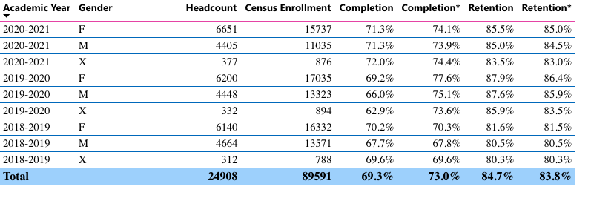
Figure 3: College-wide Enrollment/Completion/Retention (a) General and by (b) Gender
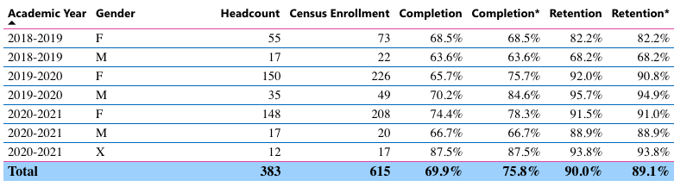
Figure 4: HUSV Enrollment/Completion/Retention (a) General and by (b) Gender

Completion and Retention General Trend:
Retention rate for HUSV has dramatically improved overall and in relation to the college-wide rate in the period 2018-2019 to 2020-2021. Over the past three years the college-wide retention rate average stands at 84%; HUSV at 89%. The HUSV program has seen a healthy increase in retention between the academic year 2018-2019 (78%) to 2019-2020 (91%) and 2020-2021 (91%). Reaching a retention rate of above 90% for two consecutive academic years is an absolutely noteworthy accomplishment. This high retention rate is due to Wrap around student supports such as: Success Incubator, warm hand-offs to BCC resources, embedded tutors, deep collaboration/referral to Wellness Center at BCC, and MOST OF ALL... truly dedicated faculty. Completion rate has followed the same pattern: trending upward between the academic year 2018-2019 (67%) and the academic year 2020-2021 (74%), with the highwater mark coming in the academic year 2019-2020 (77%). Overall, HUSV’s completion rate surpassed the college-wide rate in 2019-2020 and remains above the college-wide rate in 2020-2021. The slight dip in completion during the academic year 2020-2021 may be attributed to the disruption caused by the pandemic. Considering the challenges of the period spring 2020 to spring 2021, the HUSV program managed showed remarkable adaptability and prudence in meeting student needs and supporting students through its courses. For example, instead of an in-person internship, we partnered with Global Brigades to offer a tele-based internship. Students conduct social work and human services work, via Google Meets, to rural communities in Honduras.

Completion and Retention by Gender:
Completion rates across genders is relatively even and fairly steady for the period 2018-2021. By year: female completion rate: 69%; 75%; 78% - male completion rate: 63%; 84%; 66% - non-binary completion rate was 88% in 2020-2021, the only year for data on this group. For retention during the same period: female retention rate 82%; 91%; 91% - male retention rate: 68%; 95%; 89% - non-binary retention rate 93%. Trends for female completion mirror the year-to-year uptick in completion across the HUSV program; considering the fact that female students account for a significant majority in the HUSV program, this trend comes as no surprise. Male student completion rate increased significantly from 2018-2019 into 2019-2020 yet decline again during the pandemic-affected year of 2020-2021. In all, though, male students make up a disproportionately small percentage of overall HUSV enrollment. One noticeable trend regarding gender in HUSV sections is the decrease in ratio of male students to female students: in 2018-2019, male students accounted for 30% of enrollment; in 2029-2020, male students accounted for 21%; for the academic year 2020-2021, male students accounted for only 8.5% of students in HUSV sections. While the gender imbalance in HUSV sections coincides with the general trends in the field of professional social work, the program will nevertheless strategize on how best to attract more male students.

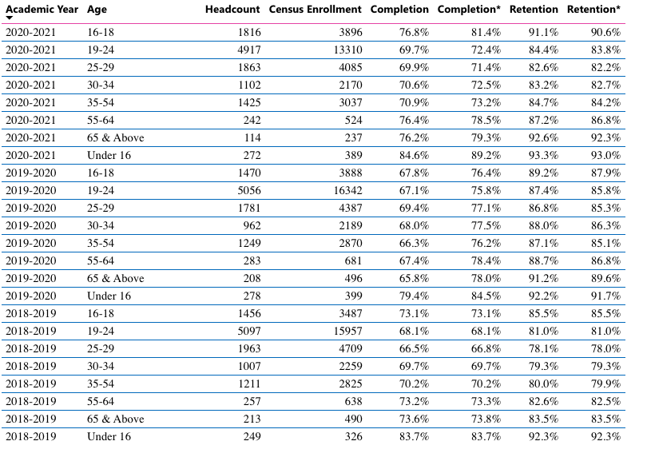
Figure 5: College-wide Enrollment/Completion/Retention by Age

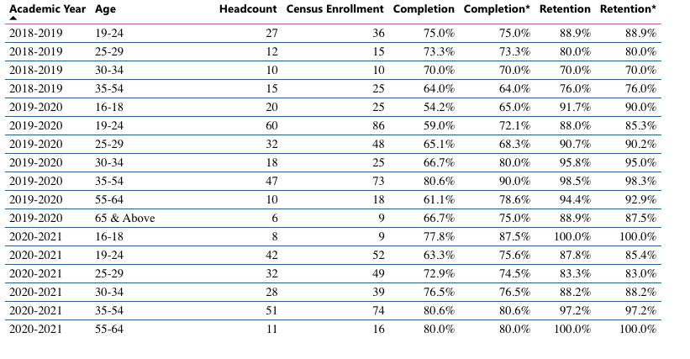
Figure 6: HUSV Enrollment/Completion/Retention by Age

Completion and Retention by Age:
Following the general college-wide trend the majority of students in HUSV sections, in the period 2018-2020, were between the ages 19 to 24. But unlike the college-wide trend, the difference between this age group and others was not so substantial. More than most programs and disciplines, students spread rather equitably across the age ranges. The greatest gains by any age group in proportion to the rest came in the 35-54 age group. In 2020-2021, in fact, the 35-54 age group had nearly one-third more enrolled students than the 19-24 age group, the group with over half of all enrolled students at BCC. The deviation from the 19-24 age group, skewing higher in age, can be attributed to the attractiveness of the HUSV certificate program for career-oriented students, professionals already in the field of social work and seeking advancement in the workplace, and the program’s attention to the unique needs of returning students.

Data show a fairly even spread of completion and retention across age groups. In relation to the college-wide figures, the HUSV program did particularly well in completion and retention for age groups 30-34 and 35-54. The strong completion and retention numbers for those groups show the HUSV program’s deftness at supporting a usually motivated but often encumbered set of students. Our program uses the lens case-management and referral. when we see a student struggling, we ask "what does this student need and how do we get it to them?" We do a LOT of resourcing students to various programs and supports both on and off campus. For dual enrollment students, we have a weekly team meeting with the HS partner, where we review each and every student's performance. Early intervention produces high persistence and completion rates.

It is worth noting, as well, that completion and retention rates across the age groups most associated with the program’s target student make-up in the academic year 2020-2021 exhibited a significant improvement over 2018-2019; demonstrating the efficacy of changes made to the program since its inception just a few years ago.

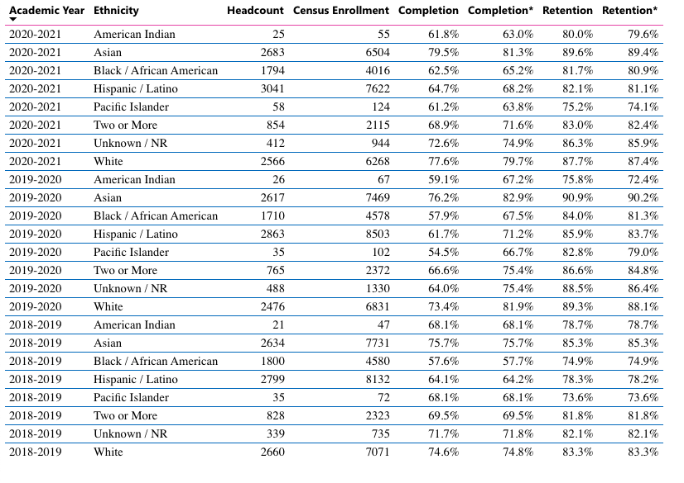
Figure 7: College-wide Enrollment/Completion/Retention by Ethnicity

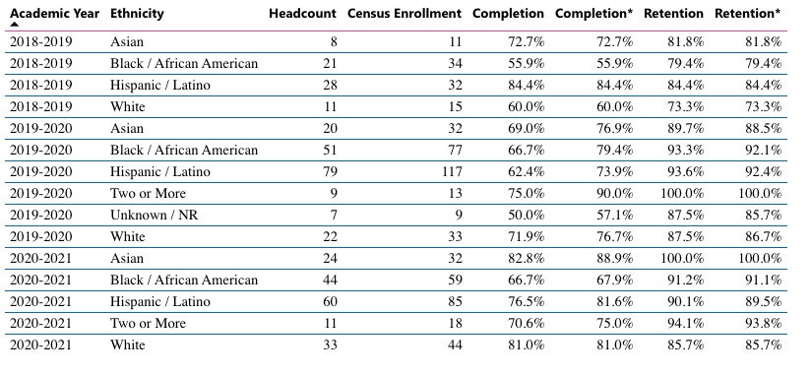
Figure 8: College-wide Enrollment/Completion/Retention by Ethnicity
What disproportionately impacted (DI) population(s) showed outcomes gains in your program area and which need more support?
The most noticeable trend regarding completion and retention for students from disproportionately impacted populations appears in the rising rates for Black/African America students. In 2018-2019 the completion rate for that group stood at 56% (roughly on par with the college-wide figure) and retention at 79% (5 points above the college-wide rate). Since 2018-2019 the rates for both metrics have improved dramatically. By 2019-2020, completion reached 79% (12 points above the college average) and retention at 92% (11 points above the college average). In the academic year 2020-2021, the completion rate for Black/African American students moved in retrograde but still remained higher than it was in 2018-2019 and higher than the college-wide average.

Likewise, the trend for Hispanic/Latinx completion and retention exceeded the college-wide average in all years under review. In the period 2018-2021, the HUSV completion rate had a mean of 80%; with a top end of 84% and low of 74%. Similarly, the retention rate in the period 2018-2021 averaged 88%; with a high of 90% and a bottom of 84%. In all, the figures for Hispanic/Latinx completion and retention are well above the college-wide rate.
How do these outcome trends compare to the college average?
In all cases, students of disproportionately impacted populations perform above the college average in HUSV sections. HUSV faculty and supporting staff create learning environments conducive to success across all student populations.

What questions do you have about the trends?
Based on input you’ve received from students, what have they expressed as their need (s) to complete and succeed in your courses? (support your recommendations with examples) e.g., offer diff modalities; timing of day).
We survey students in every HUSV class, and their stated needs are:
- better social support
- easier access to writing workshop
- accessing mental health services
- creating a plan for procrastination
- developing a mindfulness practice (stress management)

How will these outcome trends you identified in this section affect your department goals and plans for the next three years?
Year 1 (2021-22) | Year 2 (2022-23) | Year 3 (2023-24)
We need a more robust way to track who is an HUSV certificate student in the first place. We don't have a way of tracking them until AFTER they petition for the certificate, which is not helpful for persistence. | We want to be issuing 30 certificates a year, at least. | We want to be issuing 30 certificates a year, at least.

3C. Degrees and Certificates Dashboard
On page 1 of the “Degrees and Certificate Awards Trends” Dashboard, what are the award trends for your department (overall, by gender, age, and ethnicity).
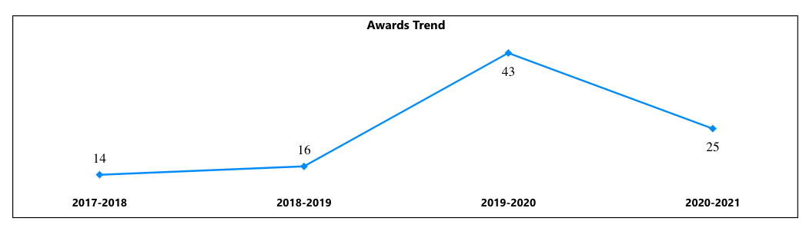
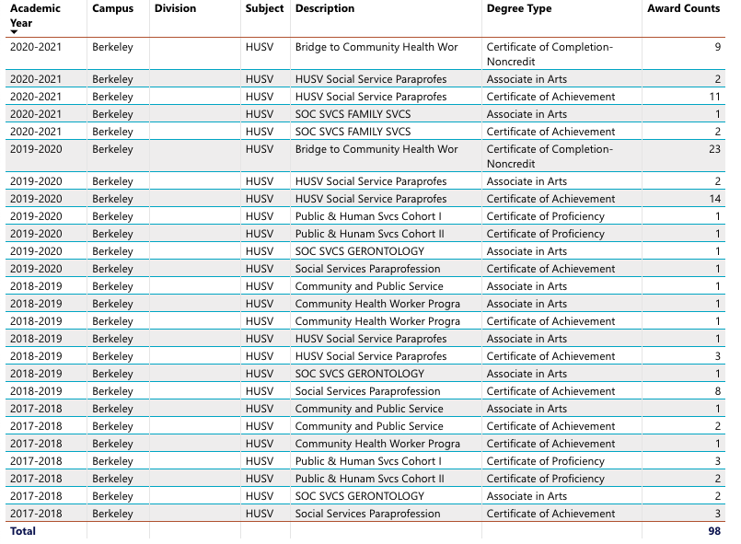
Figures 9 &10: Overall Degrees and Certificates Awarded – HUSV
In the period 2017-2018 to 2020-2021, the HUSV program awarded ninety-eight degrees and certificates. This high rate of degree obtainment demonstrates the skill and commitment of the HUSV instructors and support staff in guiding students toward completion.

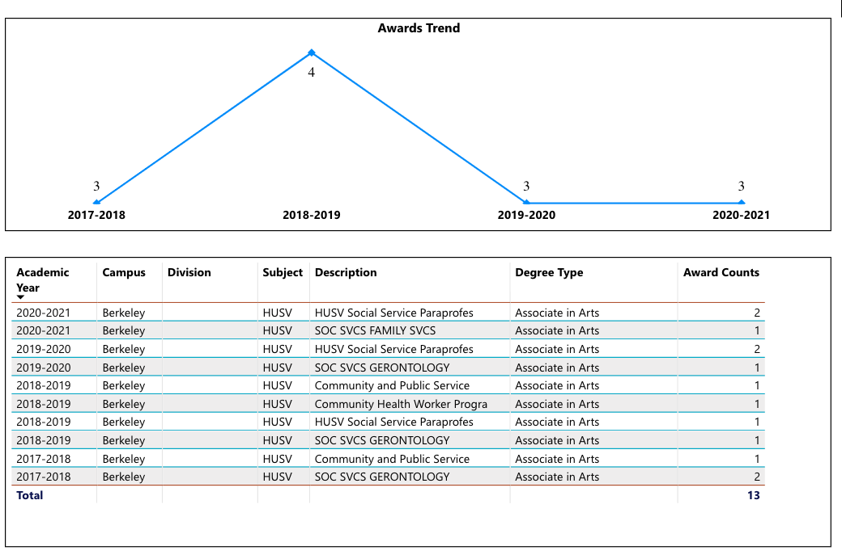
Figures 11&12: Overall Associates in Arts – HUSV
In the period 2017-2018 to 2020-2021, the HUSV program awarded thirteen AAs. Degrees awarded each academic year have remained relatively steady, between four as a high and thee as a low. The AAs awarded by HUSV (Social Services Paraprofessional; SOC SVCS Family; SOC SVCS Gerontology; Community Health Worker; and Community and Public Service) are the only such degrees within the PCCD.
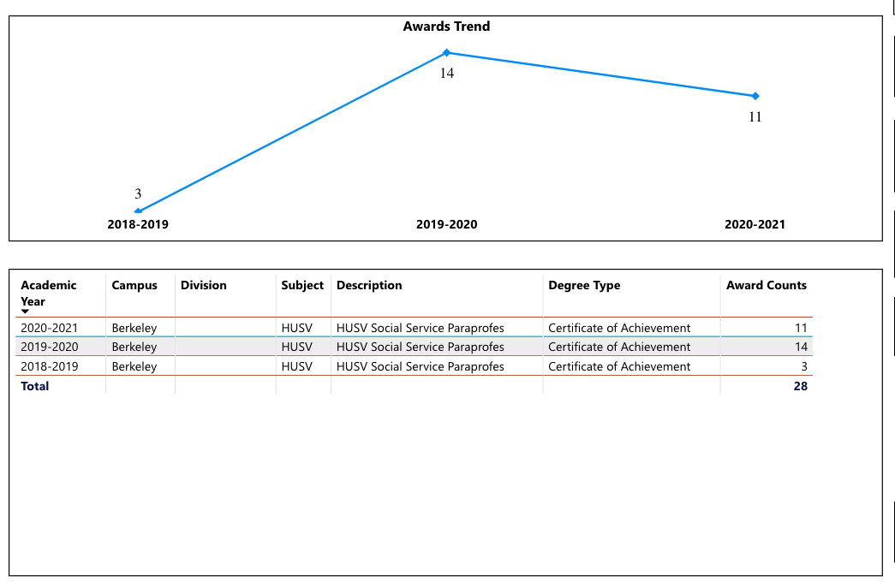
Figures 13 & 14: Overall Certificate of Achievement – HUSV
In the period 2019-2020, the HUSV program awarded 28 Certificates of Achievement for HUSV Social Service Paraprofessional.
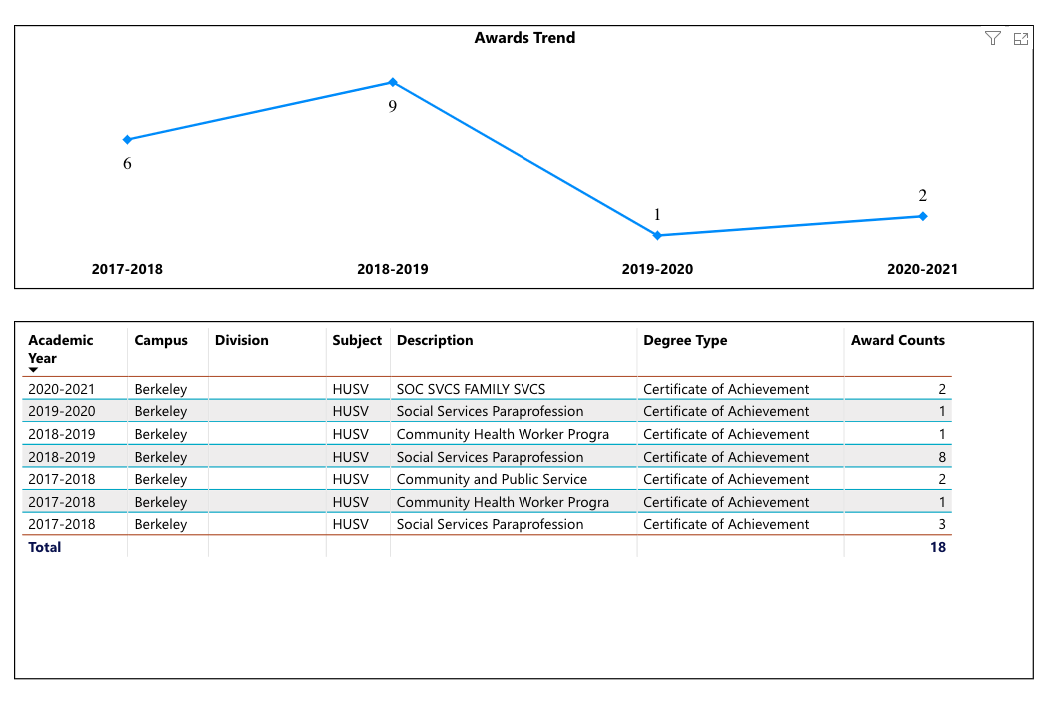
Figures 15&16: Overall Certificate of Completion for Credit– HUSV
In the period 2017-2018 to 2020-2021, the HUSV program awarded 18 Certificates of Completion for Social Services Paraprofessional; SOC SVCS Family; SOC SVCS Gerontology; Community Health Worker; and Community and Public Service.

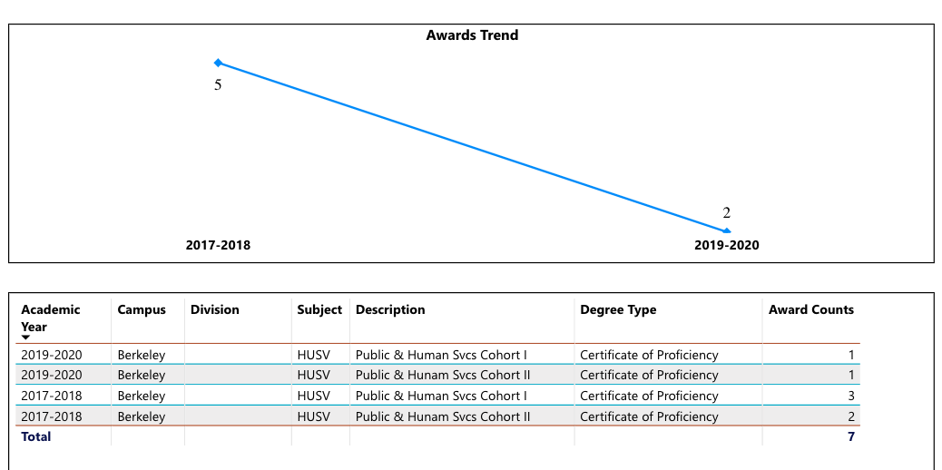
Figure 17: Overall Certificate of Proficiency for Credit– HUSV
In the period 2019-2020, the HUSV program awarded 18 Certificates of Proficiency for Public and Human Services SVCS.

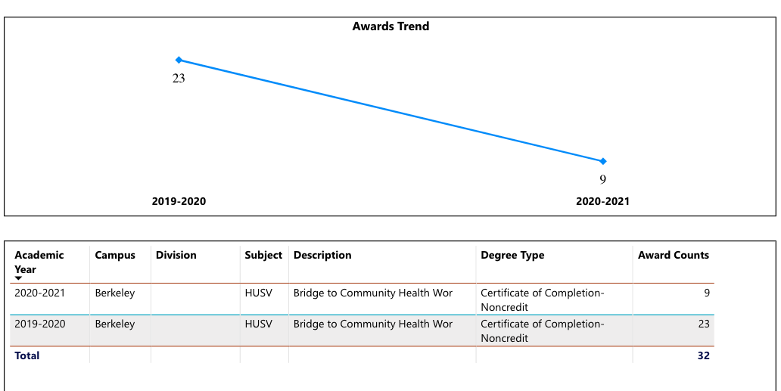
Figure 18: Overall Certificate of Completion, Non-Credit – HUSV
In the period 2019-2020, the HUSV program awarded 32 non-credit certificates of completion for Bridge to Community Health Worker.

General Trends for Degrees and Certificates:
Overall, the HUSV program has done quite well in guiding student toward degree and certificate completion. Degree and certificate completion trended upward between 2018 and 2020. In the academic year 2020-2021, the number of degrees and certificates awarded declined in proportion to the previous year, but considering the effects of the pandemic this is understandable; the entire college witnessed a decline in degrees and certificates awarded from spring 2020 to spring 2021. Ninety-eight total degrees and certificates awarded during the current program review cycle is quite strong in relation to the relatively small size of the HUSV program. The success of the program in awarding degrees and certificates demonstrates the program’s ability to meet student interest in attending to professional goals.

On page 4, what DI population(s) award trends showed gains in your program area and which populations need more support?
Figures 19 & 20: Overall Degrees and Certificates Awarded – HUSV

Degrees and Certificates: General Trend – DI Populations:
For the period 2017-2018 to 2020-2021, students of disproportionately impacted populations (Black/African American and Hispanic/Latinx) accounted for 70% of degrees and certificates awarded in the HUSV program—of the 98 degrees and certificates awarded, students of DI populations received 69. College-wide students of DI populations accounted for 39% of all degrees and certificates awarded. So, clearly, the HUSV program is serving this population well in guiding students into the program and toward completion. Students identifying as Black/African American and Hispanic/Latinx followed similar trends in relation to degrees and certificates awarded by year: between 2017-2018 and 2019-2020, the number of awards went up each year. In 2020-2021, the year most effected by the pandemic, the HUSV program saw fewer awarded degrees than the previous year, yet still remained above the 2017-2018 to 2018-2019. This trend coincides with the college-wide trend for degrees and certificates awarded.
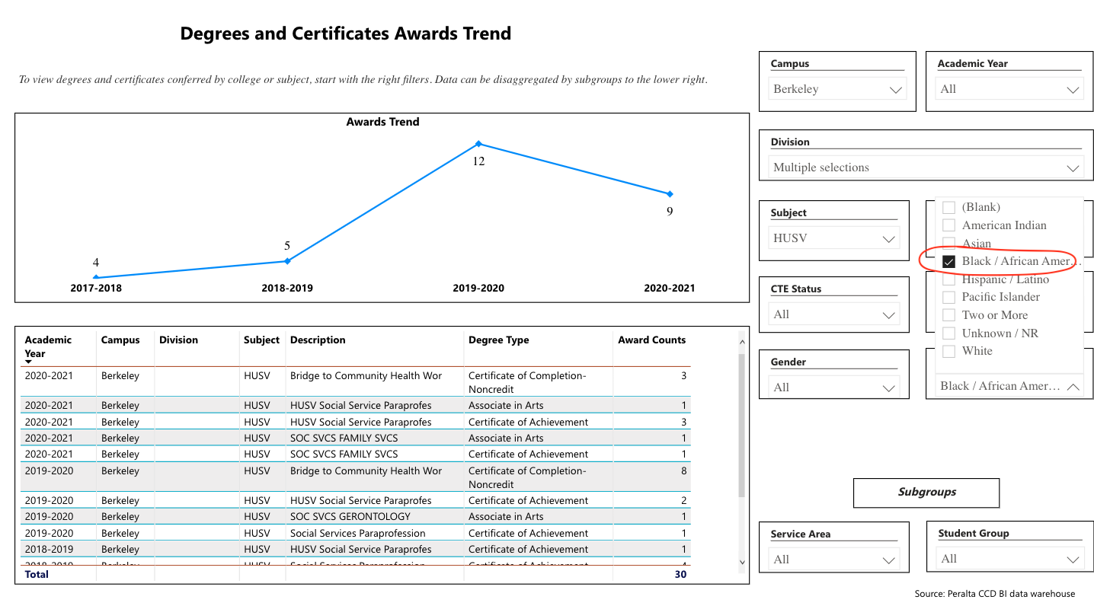

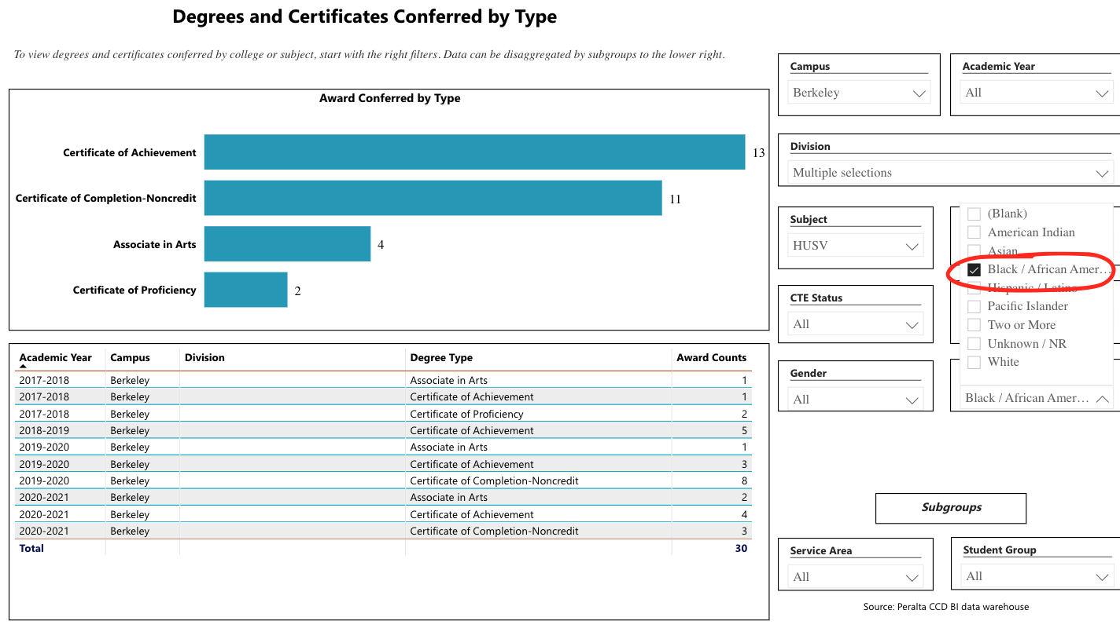

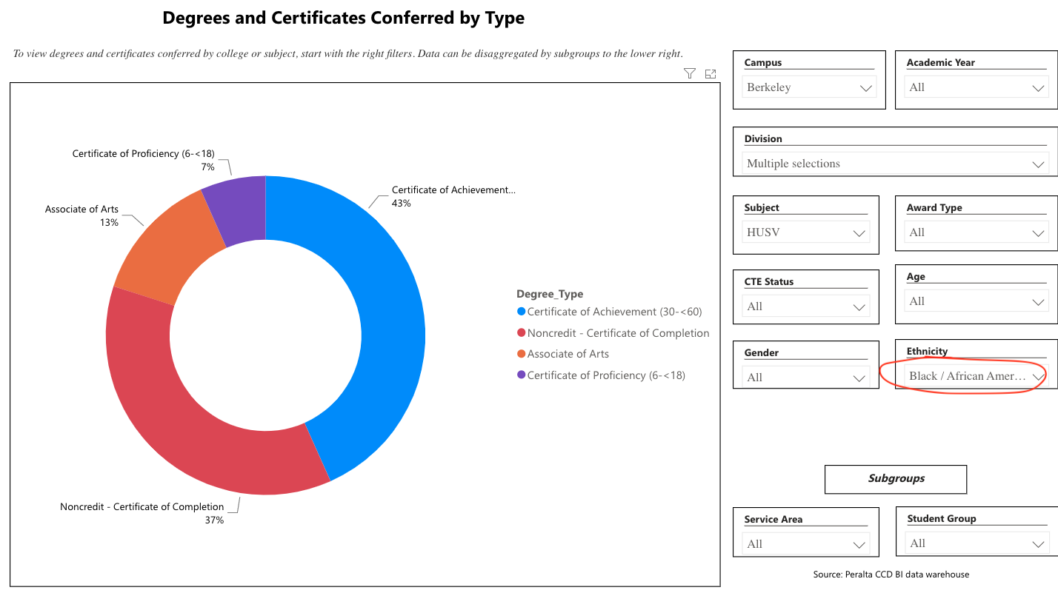
Figures 21, 22, 23: Degrees and Certificates by Type – Ethnicity – Black/African American
College-wide Black/African American students accounted for 12% of all degrees and certificates awarded. In the period 2017-2018 to 2020-2021. For the HUSV program Black/African American accounted for 31% of all degrees and certificates awarded.

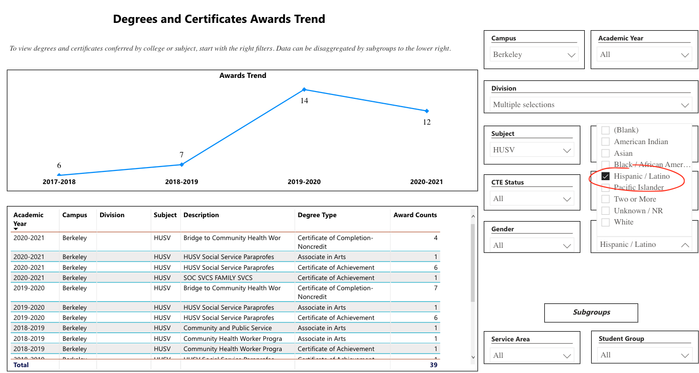

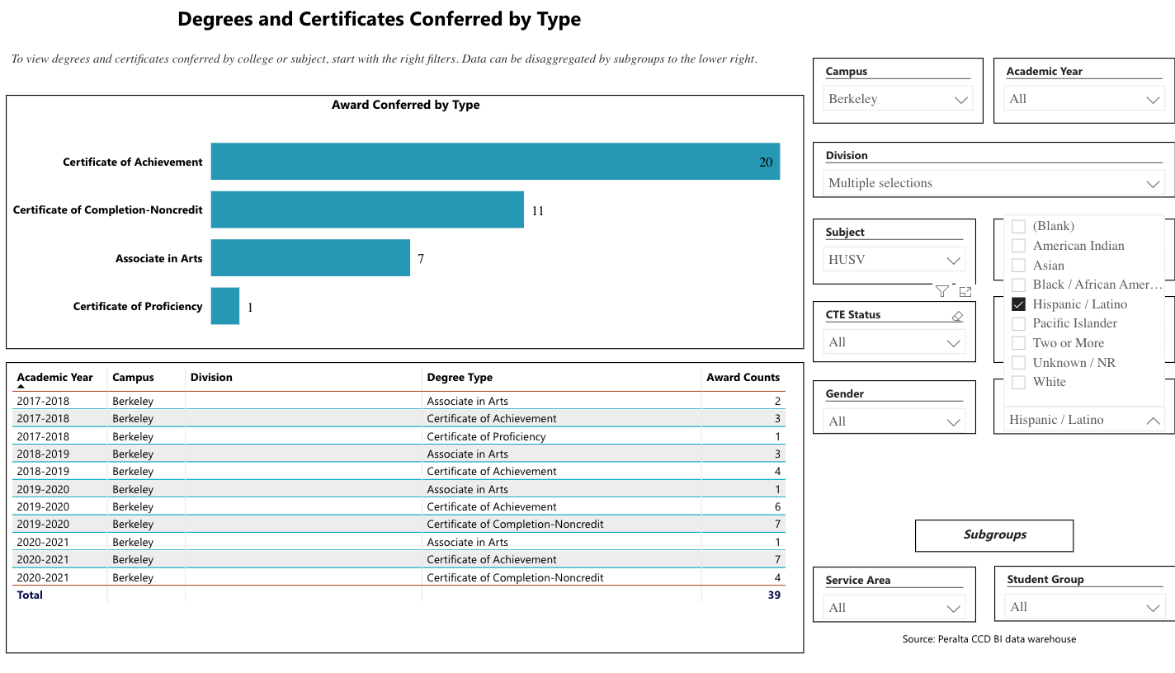

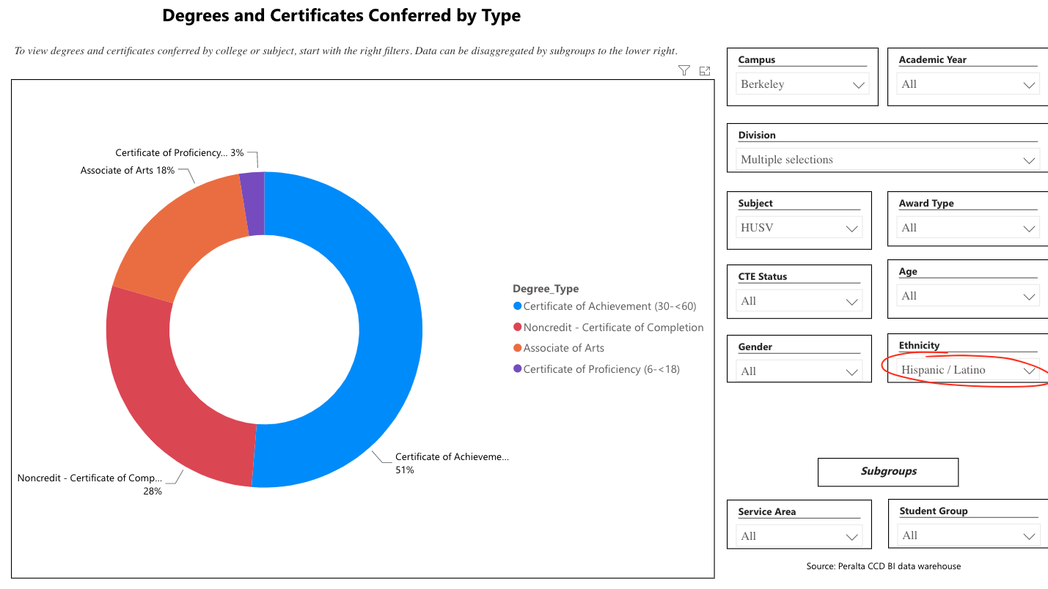
Figures 24, 25, 26: Degrees and Certificates by Type – Ethnicity – Hispanic/Latinx
College-wide Hispanic/Latinx students accounted for 27% of all degrees and certificates awarded. In the period 2017-2018 to 2020-2021. For the HUSV Hispanic/Latinx accounted for 39% of all degrees and certificates awarded.

How do these outcome trends compare to the college average?
For the period 2017-2018 to 2020-2021, students of disproportionately impacted populations (Black/African American and Hispanic/Latinx) accounted for 70% of degrees and certificates awarded in the HUSV program—of the 98 degrees and certificates awarded, students of DI populations received 69. College-wide students of DI populations accounted for 39% of all degrees and certificates awarded.
Based on input you’ve received from students, what have they expressed as their need (s) to complete their degrees and/or certificates? (support your recommendations with examples)
Curriculum designed to avoid courses that “don’t count” towards a degree. Supplementary skills-based trainings with industry recognized credentials, more case-management support for the various “life-happens” issues they are wrestling with during their course of study.

How will these outcome trends you identified in this section affect your department goals and plans for the next three years?
Year 1 (2021-22) | Year 2 (2022-23) | Year 3 (2023-24)
We are presently developing goals and plans that pertain to this section.

3D. Transfer Dashboard
This dashboard does not provide data by subject. Reflect on what you can do to affect student transfer. How may your department help to support BCC student transfer? (e.g., serve on panels, strengthen GP in your dept, change curriculum, increase number of AD-Ts, etc.)
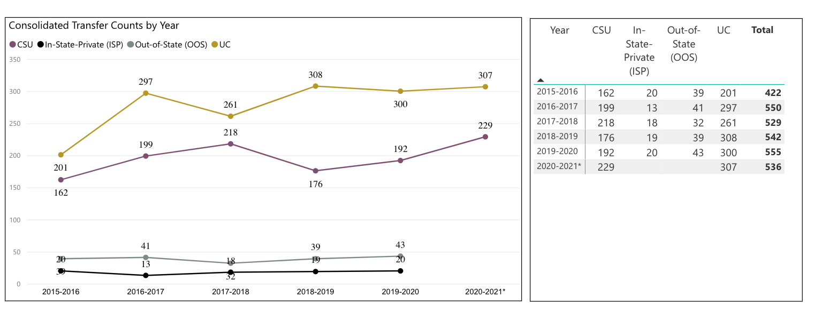
Figure 27: Consolidated Transfer Counts by Year – BCC
The HUSV program does not track student transfers. In order to bolster student transfer overall and particularly pay attention to the transfer goals of students within the program, HUSV leadership will initiate the strategies identified above in the three-year plan.

3E. Curriculum
View the department’s curriculum through the lens of student equity outcomes. BCC outcome data suggests that disproportionately impacted groups of students experience low rates of success.
How do you plan to adjust the curriculum to advance student equity and address DI student outcome gaps?
Examples include: making adjustments to lesson plans based on student assessment outcomes; review pedagogy and revise assignments for culturally relevant content; simplify student processes and make service areas student-centered; manage class discussions and student participation; review best practices, etc.).
The HUSV program is not witnessing outcome gaps for students of disproportionately impacted populations. In proportion to other student groups, students of disproportionately impacted populations are preforming well academically in HUSV sections, completion rates and success rates are significantly above college-wide levels. Students of disproportionately impacted populations likewise collectively account for more degrees and certificates (70% from 2017 to 2021) than students collectively from other groups.

In the boxes below, add improvement actions that are directly related to Student Equity & Success. If there are no improvement actions in this area, leave blank. If you have more than one Improvement Plan, add more by copying and pasting the table below.
IMPROVEMENT ACTIONS
Department/Discipline:
Action Name:
Description:
Completion timeline:
Responsible person:

III. PROGRAM GOALS
- List your current Department Goals.
1. AA T Social Work Human Services
2. CE certificate program that stack towards the AA T
3. Dual Enrollment Pathway: certificate to AA T
4. Robust offerings of work-based learning experiences
5. Registered apprenticeship in the field
6.Going forward fieldwork program will focus on tele-health experiences, WBL: in the community, and/or peer to peer support services for fellow students
Goal 1 – Transfer pathways from BCC to four-year universities
A complete revision of the program was completed in the last three years. The program is just in the process of a reboot.
Goal 2 - Collaborative work with high schools and adult schools
The program completed conversations with Berkeley Adult School (enrollment over 3,000 adult learners) on creating an onramp from adult education to the community college. There are promising opportunities to partner with the BCC ESOL faculty to contextualize courses and support more English language learners for the job prospects ahead. Occupational growth for multi-cultural, multi-lingual students is expanding in the Bay Area..
Goal 3 – Target student population
Past success with veterans and others with PTSD, has indicated a program niche for successfully working with a hard-to-serve population dealing with mental health issues. In order to better serve the student population with lived experience who also need jobs. The program is positioned to strongly succeed in this goal with additional campus supports such as full-time mental health services and peer-led support groups. Going forward fieldwork program will focus on tele-health experiences, WBL: in the community, and/or peer to peer support services for fellow students

- How do the goals align with the College goals? If so, which ones?
Berkeley City College Goals
- GOAL I: Strengthen Resilience: Strengthen BCC students’ abilities to become self-directed, focused and engaged in the pursuit of transformative, life-long learning experiences that result in personal and academic success.
- GOAL II: Raise College Competence: Raise student skills and competencies, and expand their learning experiences, so that they can successfully complete their college program.
- GOAL III: Enhance Career-Technical Education Certificates and Degrees: Enhance BCC’s 1- and 2-year career and technical education programs so that they provide current and transferable skills and competencies to earn a living wage in our area, and to maintain competency for advancement in one’s career.
- GOAL IV: Increase Transfer and Transfer Degrees: Ensure that all of BCC’s programs of study and transfer pathways for degrees prepare students, in a timely manner, for multiple transfer options.
- GOAL V: Ensure Institutional Sustainability: Increase BCC’s impact in education through innovation, internal and external collaboration and partnerships, and sufficient resources, both short-term and long-term.
- Assess your facilities utilization (including labs, support for online learning, and other spaces) and for each year, indicate if the space is insufficient. If so, what are the needs and why? *Note that facility needs and planning are addressed in the Facility Master Plan for the college, including the planning for new buildings.
Year 1 (2021-22) | Year 2 (2022-23) | Year 3 (2023-24)
- What are the essential functions of your department, any unique characteristics or trends? Provide specific examples.
The essential function of the HUSV program is to provide a comprehensive curriculum for paraprofessionals in social work and human services. It is designed to help California meet the statewide challenges and the rapidly expanding need for health, public, and human service/social worker paraprofessionals. Students’ training will allow them to become well-rounded employees who are able to participate as team members in health and human service agencies and social work settings. The program is also designed to align with various transfer programs for students who wish to continue to an Associate of Arts Degree in Liberal Arts with an emphasis in Social and Behavioral Sciences or the Associate Degrees for Transfer in either Psychology or Sociology.
- Describe how external factors (if applicable), such as State and Federal laws, advisory board recommendations, district and college governance have an impact on the support services your department provides. (e.g., partnered with dual enrollment and contract Ed programs at K-12 districts and high schools; support staff at high schools have access to Canvas to follow along and support students; allow tutors into the classes; Guided Pathways, AB 705, etc.)
Advisory Board
Partnerships
Perkins Grants
Strong Work Force Funding
Relationship to BUSD

Significant state-policy changes related to how Community Health Workers and Peer Support Specialists are reimbursed from Medical impact our program. Based on Advisory Board recommendations, we are aligning our programs with these policy changes, ensuring graduates are desirable to employers.

Additionally, Strong Work Force Funding is shifting towards the Apprenticeship Model, which allows students to earn-and-learn. This work-based model is especially important for our student population, who are disproportionately BIPOC and/or low-income. Apprenticeship means benefited, full-time work in their field (as opposed to retail or food service) while they continue their education.

We continue to strengthen and formalized our relationship with BUSD, including mapping Guided Pathways material for dual enrolled students on the Social Work and Human Services track.

Based on your responses to questions 4-8, are there areas that need improvements? If so, add improvement actions below. If there are no improvement actions in this area, leave blank. If you have more than one Improvement Plan, add more by copying and pasting the table below.
IMPROVEMENT ACTIONS
Department/Discipline: | HUSV
Action Name: | Success Inc
Description: | In-program work-based learning and associated training/supervision
Completion timeline: | 3 years
Responsible person: | Melina Winterton and Janine Greer
IMPROVEMENT ACTIONS
Department/Discipline: | HUSV
Action Name: | Work based learning expansion
Description: | Increase apprenticeships, coordinate placements, case-management for students engaged in WBL. Ideally, the hiring of a Success Coordinator.
Completion timeline: | 3 years
Responsible person: | TBD

- ASSESSMENT
Berkeley City College is committed to a culture of assessment to improve instruction, services, and institutional planning. Findings from SLO, PLO, ALO assessments, and program review data are used to direct resources for areas that are institutional priorities that are articulated in the Educational Master Plan and BCC Strategic Plan. Due to the critical role that course and program assessments play in our institutional planning and to be in compliance with the Accreditation requirements, the Program Review resource allocation requests require the completion of assessment in order to qualify.
9A. List and describe the department/program’s progress and reflection on Student Learning Outcomes (SLOs), Program Learning Outcomes (PLOs), and/or Service Area Outcomes (SAOs). If your department/program offers a degree or certificate, please describe the department’s progress on Program Learning Outcomes (PLOs).
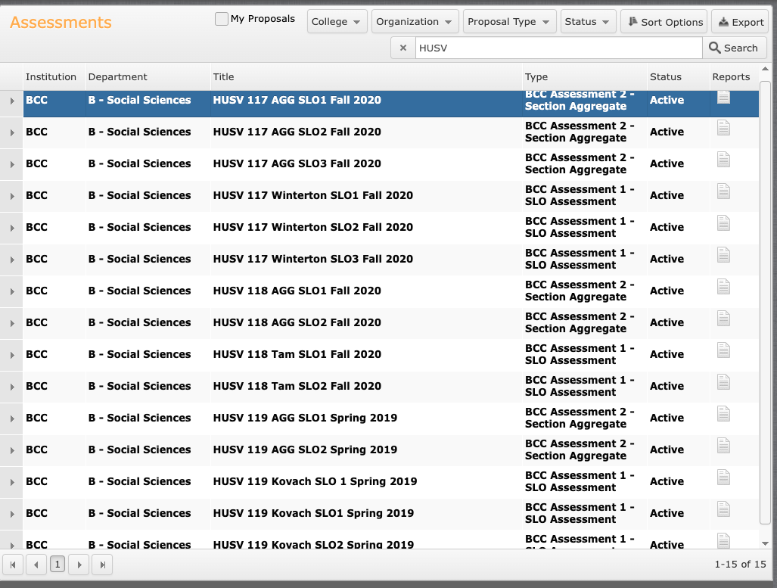
Figure: Assessment – 2019-2020

Completed SLO Assessment Round 4 – Through Level 2 (Section Aggregate):
HUSV 117
HUSV 118
HUSV 119
All for credit courses in HUSV were assessed through the section aggregate stage in round 4 of the BCC assessment cycle.

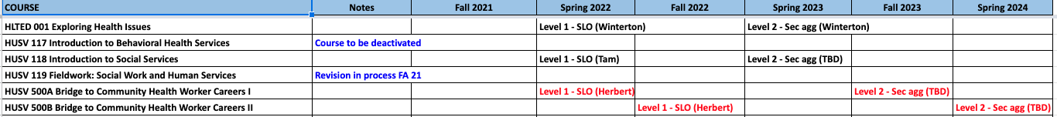
Figure: Assessment Schedule – 2021-2023

9B. What improvement plans did your department identify upon the assessment of each program? How has your department used the results of assessment to improve student learning outcomes and/or curriculum? Please be as detailed as possible.
In the period 2018-2021, identified as Round 4 of assessment at BCC, the HUSV program did well in assessing all of its for-credit courses up to the section aggregate stage. Over the past three years a number of faculty members worked to create rubrics for assessing particular course SLOs. We will need to organize the department to do likewise for Program Outcomes. HUSV Instructors are collaborating on the assessment process in fall 2021 and spring 2022; they are meeting with the BCC Assessment Coordinator to best develop an assessment and reflection plan.
9C. Describe how the program has made use of information from the data it has from program and student learning outcomes in Round 4 (last cycle of the last 3 years) for continuous improvement. Include the three most significant plans for improvements as a result of the assessment process with timelines. Click here to view your Assessment Calendar
9D. How does your department, program, or unit ensure that students are aware of learning or service area outcomes?
Learning outcomes are posted on every syllabus; all Canvas pages associated with history classes; and the program’s webpage.

9E. Besides your syllabi, where are the service area and/or program level outcomes published? If on a website, please specify the URL.
https://www.berkeleycitycollege.edu/phs/

In the boxes below, add improvement actions that are directly related to Assessment. If there are no improvement actions in this area, leave blank. If you have more than one Improvement Plan, add more by copying and pasting the table below.
IMPROVEMENT ACTIONS
Department/Discipline: | Actions
Action Name:
Description:
Completion Timeline
Responsible person:

- ENGAGEMENT
10A. Discuss how faculty and staff have engaged in institutional efforts such as committees, presentations, and departmental activities. Please list the committees that full-time faculty/staff/admin participate in.
There are no full-time instructors in the HUSV program
10B. Discuss how faculty and staff have engaged in community activities, partnerships and/or collaborations.
10C. Discuss how adjunct faculty members are included in departmental training, discussions, and decision-making.
All HUSV program decisions and discussions are done by part-time instructors.
- 10D. Discuss the relationship and engagement with other support services, programs, departments, or administrative units and how these relationships support your area to meet its goals.
The HUSV program collaborates with other disciplines within the Social Sciences in terms of curriculum and scheduling (frequently) and pedagogy (occasionally). The program coordinates goals with the Counseling Department, library, Student Accessibility Services, BCC’s Transfer Center, and Veterans Affairs.

In the boxes below, add improvement actions that are directly related to Engagement. If there are no improvement actions in this area, leave blank. If you have more than one Improvement Plan, add more by copying and pasting the table below.
IMPROVEMENT ACTIONS
Discipline:
Action Name:
Description:
Completion Timeline
Responsible person:

VI. Prioritized Resource Requests
In the boxes below, add a 3-year resource requests for your department/program that have not been funded by existing funding sources. Work with your supervisor to estimate costs. If there are no resource requested, leave the boxes blank.

Click here to view the Resource Request Process and Timeline

Resource Category | Description/Justification | Estimated Annual Salary Costs | Estimated Annual Benefits Costs | Total  Estimated  Cost | Overall  Priority Ranking (1=Most important)
Personnel
Classified Staff | Fulltime webmaster | N/A | N/A | N/A | 3
Student Worker | 5 student workers each semester (embedded tutors and Success Inc facilitators) | N/A | N/A | N/A | 2
Faculty | 1 full time faculty position | N/A | N/A | N/A | 1
Professional Development | Description/Justification |  |  | Estimated Cost
Department wide PD needed | Increased training on accessibility even offering a service to make PDF material accessible for faculty. Many contract services exist who offer at a pay-per-page rate for converting PDF material to accessible documents. Many OER projects already funded to make textbook costs free for students could use assistance to make these materials accessibility to screen readers. |  |  | N/A
Personal/Individual PD needed
Supplies | Description/Justification |  |  | Estimated Cost
Software (for whom or role?) | Continued licensing of Snagit and Camtasia to enable hybrid and online course video lectures.  Continued support for Canvas Studio for closed caption services and the archiving of multimedia material.  Continued subscription to other software such as Turnitin and other LTIs commonly used by faculty. |  |  | N/A
Books, Magazines, and/or Periodicals | Continue subscription to New York Times online.  Funds for textbook libraries when OER is not viable. |  |  | N/A
Instructional Supplies
Non-Instructional Supplies
Technology & Equipment | Description/Justification  Before you list your technology request, click here to view the latest Technology Refresh Plan to verify whether it has already included. |  |  | Estimated Cost
New
Replacement | Continued refresh of full-time faculty computers at regular intervals. |  |  | N/A
Facilities | Description/Justification |  |  | Estimated Cost
Classrooms | Addition of hyflex capabilities in all BCC classrooms. |  |  | N/A
Offices
Labs
Other
Library | Description/Justification |  |  | Estimated Cost
Library materials (including streamline media needs) | Kanopy streaming is an essential multimedia platform for our instructional needs. |  |  | N/A
Library collections
OER | Continue support for OER and Affordable Learning Materials program. |  |  | N/A
Other | Description/Justification |  |  | Estimated Cost
OTHER Description | Support for POCR (Peer Online Course) reviewers and those having their courses reviewed.  Accessible materials support. |  |  | N/A

Thank you for your time and effort in completing the Program Review!
Please email the completed Program Review to your Dean by November 30, 2021.

