Berkeley City College’s mission is to provide our diverse community with
educational opportunities, promote student success, and to transform lives.

Introduction and Directions

The Peralta Community College District has an institutional effectiveness process which consists of the following components: a District-wide Strategic Plan which is updated every six years; Comprehensive Program Reviews which are completed every three years; and Annual Program Updates (APUs) which are completed in non-program review years.

The Program Review 2021-22 timeline has been developed for each program and services to guide through the semester. Please review and work with your Deans, Managers, Department Chairs and/or Supervisors to complete this Program Review.

The Program Review is intended to primarily focus upon planning for the subsequent two years and institutional effectiveness. The Program Review process directly leads to the institutional resource allocation process and budget planning for the following academic year (2022-23). This is an opportunity for each administrative unit, support service program, and department to reflect on progress made and identify areas of program improvements to achieve equitable student success and elimination of achievement gaps. In this process of making continuous quality improvement, there is an opportunity for each program, student services, and department to request resources that support achieving the stated goals.

If you have questions regarding other material in the Program Review, please contact your Dean or Manager. If you have questions regarding data, please contact Dr. Phoumy Sayavong, Senior Researcher and Planning Analyst (psayavong@peralta.edu).

Please email the completed Program Review to your Dean by November 30, 2021.

COLLEGE PROFILE
Click here to view the Berkeley City College Student Demographics Dashboard.
This 2-page dashboard will provide information on the characteristics of our student body from the past two years such as headcount, ethnicity, enrollment status, age group, educational goals, and majors.
College Outcomes | 2017-2018 | 2018-2019 | 2019-2020 | 2020-21
Full Time Equivalent Students (FTES) | 4,140 | 3,864 | 3,696 | 3,290
Efficiency  (Productivity; avg faculty-student ratio) | 13.4 | 13 | 13.2 | 14.3
Success Rate (%) | 67% | 69% | 67%* | 74%
Degrees + Certificates Awarded (#) | 1,021 | 948 | 1,106 | 1,014
*Excludes “EW” grades

To view prior Program Reviews, click here. To view prior Annual Program Updates, click here.

- DEPARTMENT DESCRIPTION
Please verify the mission statement for your department. If your program has not created a mission statement, provide details on how your department supports and contributes to the College’s mission.
Berkeley City College’s Program in Ethnic Studies and its related strands (African American Studies, Asian American and Pacific Islander Studies, and Mexican/Latin American Studies) at Berkeley City College offers students and the community a dynamic and interdisciplinary understanding of race and ethnicity, with an emphasis on intersectional, decolonial, and relational approaches to the field. Our classes provide learners with a critical understanding of the historical and contemporary experiences and cultural expressions of diverse groups that can be used in the workplace, as well as provide a foundation for further study in the field.
The Ethnic Studies program offers courses in African American Studies, Asian American Studies, and Mexican and Latin American Studies that can be taken separately or in conjunction with Ethnic Studies. Similar to other disciplines in the social sciences, students of ethnic studies can complete coursework for IGETC general education Area 4 in the social sciences including (AFRAM 1, AFRAM 30, and ETHST 1 and 2). Furthermore, we allow students to complete coursework for IGETC Area 3 Arts and Humanities (ASAME 30 and MLAT 30a/30b). Finally, with the passage of AB 1460, requiring ethnic studies for graduation from a California State University, and the establishment of CSU’s Area F, creating a lower-division ethnic studies requirement, Berkeley City College’s program in Ethnic Studies has updated and submitted courses for transfer approval. At the present time, ETHST 1 meets these transfer requirements.

The Ethnic Studies discipline, through its course offerings and contribution towards degree completion and transfer, supports the College Mission in promoting student success, providing our diverse community with educational opportunities and transforming lives.

Name(s) of member(s) completing this Program Review | Department/Program | Completion Date
Alejandro Wolbert Pérez | Social Science/ Ethnic Studies | 11/30/2021
List faculty names and/or staff with assignments in fall 2021.
Full Time | Part Time
Jimmy Cruitson
Ismael Lara III
Abhijeet Paul
Betania Santos
Marisa Villegas

II. STUDENT EQUITY & SUCCESS
Using the data dashboards provided below, review and reflect upon the outcome trends for your department. You may use data from other sources if available.

Click here if you would like to view BCC’s Planning Documents (Education Master Plan, College Strategic Goals, Student Equity Plan, District Strategic Goals, Vision for Success, Guided Pathways, Technology Plan, Facilities Plan)

For assistance with data dashboards, contact Phoumy Sayavong at psayavong@peralta.edu

3A. Enrollment Trend and Productivity Dashboard
*Note that completion and retention rates are presented with the inclusion and exclusion of excused withdrawals (EW) and military withdrawals.
What are your enrollment trends in the past three years?
From F2018 to S2021 enrollment and productivity in Ethnic Studies and the affiliated strands decreased slightly overall, from 15.7 to 15.2. Academic year 2019-2020 hit a low of 14.5

Within the individual strands, however, we see an increase in enrollment in AFRAM from 98 in F18S19 to 162 F20S21, although a nearly identical productivity score (16.3, 16.2). In contrast, ASAME dips, from 109 enrolled, productivity 18.2 to 80 enrolled, productivity 13.3 over the same time. MLAT’s productivity climbs, from 11.0 in F18S19 to 15.0 in F20S21, while the enrollment dropped by over 50%, from 66 to 30 during that time period. Finally, ETHST went from 136 enrolled, productivity of 17, to 185 enrolled, but a productivity of 15.4

When the data for your department are disaggregated by student ethnic groups, what trends do you observe and how do plan to address them over the next three years?

When enrollment across ES and the strands is disaggregated by race and ethnicity we find completion and retention rates that are consistent, if slightly lower, with the rates of groups across Berkeley City College. For example, the Hispanic/Latino group—the largest reported group—had a completion rate of 60.7% during the most recent academic year, vs. 64.7% for the college overall. This trend is consistent among the strands as well (i.e. Black/African American student completion and retention specifically in AFRAM classes and Hispanic/Latinx student completion and retention in MLAT courses) where students from the group comprise the majority enrolled.

While underscoring the need and importance of support for students and the continual development of a responsive, culturally-aware instructional body, it is also important to note that we are still in a global pandemic, one that has impacted our students and community in innumerable ways. Rather than utilize a ‘deficiency-model’-type focus on individual student or instructional failings, we encourage the college to continue to support students holistically, including and beyond the classroom.

Year 1 (2021-22) | Year 2 (2022-23) | Year 3 (2023-24)
What would you recommend that we do to increase student enrollment in your department?
As program lead, I would like nothing more than to see a robust program in Ethnic Studies. I believe that the recent passage of AB 1460 and Area F graduation requirements will boost enrollment along with interest in the program. Along with this, and perhaps more importantly, a growing Ethnic Studies+ program will need to offer an expanded course of study to be seen as a viable academic course of study. Finally, the presence of ES online, such as through social media, can be increased in order to raise awareness of the program, its offerings, and the various events, speakers, or similar that take place throughout the year.

3B. Course Completion and Retention Rates Dashboard – Instruction
*Note that completion and retention rates are presented with the inclusion and exclusion of excused withdrawals (EW) and military withdrawals.

If you need more guidance with this item, click here for additional support. Click here for additional guidance for how to view and use equity data. If you would like to view BCC’s Equity Plan, click here.
On page 3 of the “Course Completion and Retention Rates by Subject” dashboard, what are the completion and retention trends by gender, age, ethnicity in your department?
Microsoft Power BI

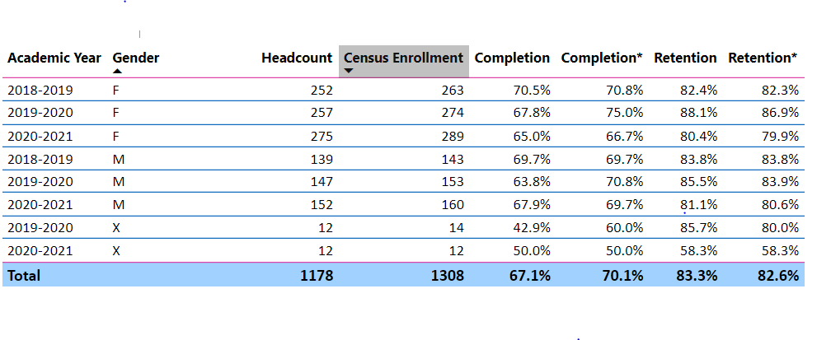

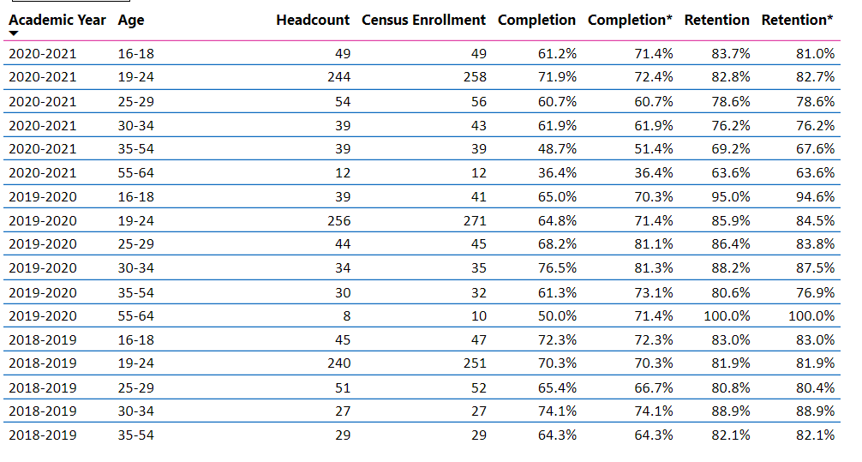

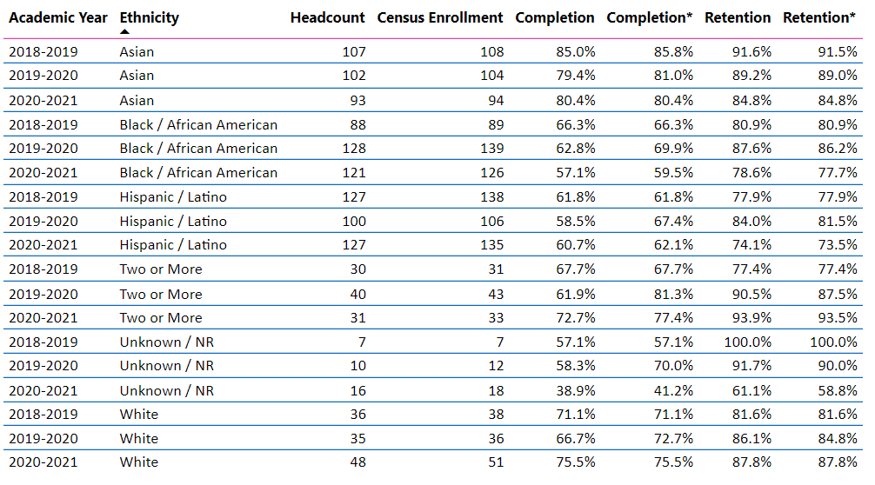

What disproportionately impacted (DI) population(s) showed outcomes gains in your program area and which need more support?
As previously noted, when enrollment across ES and the strands is disaggregated by race and ethnicity we find completion and retention rates that are consistent, if slightly lower, with the rates of groups across Berkeley City College. For example, the Hispanic/Latino group—the largest reported group—had a completion rate of 60.7% during the most recent academic year, vs. 64.7% for the college overall. This trend is consistent among the strands as well (i.e. Black/African American student completion and retention specifically in AFRAM classes and Hispanic/Latinx student completion and retention in MLAT courses) where students from the group comprise the majority enrolled.

While underscoring the need and importance of support for students and the continual development of a responsive, culturally-aware instructional body, it is also important to note that we are still in a global pandemic, one that has impacted our students and community in innumerable ways. Rather than utilize a ‘deficiency-model’-type focus on individual student or instructional failings, we encourage the college to continue to support students holistically, including and beyond the classroom.

How do these outcome trends compare to the college average?
As noted, outcome trends appear to follow just slightly below the college average.

What questions do you have about the trends?
In contrast to my expectations, the impact of COVID does not appear to be as significant a factor, at least from the enrollment data. Although all groups decreased overall, Black/African American completion and retention appears to show the biggest change from 2018-2019 to 2020-2021 figures. Curiously, although not a DI group, white students saw an increase in completion and retention over the same time period. I posit that these outcomes reflect the profound inequities in society, and the disproportionate impact COVID has had on the respective communities.

Based on input you’ve received from students, what have they expressed as their need (s) to complete and succeed in your courses? (support your recommendations with examples) e.g., offer diff modalities; timing of day).
Related to the above, students presently are experiencing and demonstrating burn out. This has materialized in a lack or decrease of interest, enthusiasm, and participation. Instructors noted an observable degree of disengagement overall, as we continue to meet remotely and online. The more effective courses have adjusted expectations and assessments, such as moving to a more open structure (i.e. no requirement for cameras, participation across different modalities such as chat or message boards), or a more forgiving deadline for assignments. Student (and instructor) exhausting is palatable, however.

How will these outcome trends you identified in this section affect your department goals and plans for the next three years?
Year 1 (2021-22) | Year 2 (2022-23) | Year 3 (2023-24)
Expectations must remain flexible and fluid as the pandemic continues and instruction remains online. However, this also presents an opportunity for instructors to innovate and experiment with new approaches to teaching. | As society hopefully continues to emerge and enter a post-pandemic world, the program, department, and college must continue to support students across the board. Instructional faculty should feel comfortable adjusting their pedagogy, and exploring new or alternative approaches. | Some things to consider are the continuation of a smaller cap for class size; embedded tutors; alternative assessments, such as project or practical applications; and the continual flexibility of multiple modalities.

3C. Degrees and Certificates Dashboard
On page 1 of the “Degrees and Certificate Awards Trends” Dashboard, what are the award trends for your department (overall, by gender, age, and ethnicity).
Overall, awards are up from 2018-2019, with the peak in 2019-2020. Award trends overall show an increase from the base. However, DSPS, foster youth, and veterans dropped. As Ethnic Studies is not a degree-granting program, and there are not as of yet any certificates tied to ES, I have nothing more to report here.

On page 4, what DI population(s) award trends showed gains in your program area and which populations need more support?
How do these outcome trends compare to the college average?
Based on input you’ve received from students, what have they expressed as their need (s) to complete their degrees and/or certificates? (support your recommendations with examples)
How will these outcome trends you identified in this section affect your department goals and plans for the next three years?
Year 1 (2021-22) | Year 2 (2022-23) | Year 3 (2023-24)

3D. Transfer Dashboard
This dashboard does not provide data by subject. Reflect on what you can do to affect student transfer. How may your department help to support BCC student transfer? (e.g., serve on panels, strengthen GP in your dept, change curriculum, increase number of AD-Ts, etc.)
The impact of AB 1460 should only lead to an increase in students transferring with at least one course in Ethnic Studies. While Berkeley City College has an advantage due to proximity in terms of being positioned as a college where students may transfer to UC Berkeley, when the student transfer population is broken down by race and ethnicity white students disproportionately make up the largest amount—with the exception of the most recent year’s reporting data. While the numbers alone tell a story, when placed in the context of their respective populations at BCC this becomes even more extreme. Social Science as a department, and Ethnic Studies as a program, are well poised to support students interested in transferring as part of a larger roadmap towards college completion, through mentorship, directed outreach (i.e. inviting recruiters to visit specific classes, not just the campus), and, in the case of ES, continuing to build the program.

3E. Curriculum
View the department’s curriculum through the lens of student equity outcomes. BCC outcome data suggests that disproportionately impacted groups of students experience low rates of success.
How do you plan to adjust the curriculum to advance student equity and address DI student outcome gaps?
Examples include: making adjustments to lesson plans based on student assessment outcomes; review pedagogy and revise assignments for culturally relevant content; simplify student processes and make service areas student-centered; manage class discussions and student participation; review best practices, etc.).
Curriculum and instruction in Ethnic Studies will continue to reflect the populations the program serves. From a pedagogical stance, ES can do more to model approaches to teaching in line with the discipline. These include flipped instruction; a move away from ‘high stakes’ assessments; experiential learning, and applied demonstrations of knowledge, to name a few examples. As importantly, Ethnic Studies can model an anti-racist approach to curriculum design rooted in non-white, non-western epistemologies.

In the boxes below, add improvement actions that are directly related to Student Equity & Success. If there are no improvement actions in this area, leave blank. If you have more than one Improvement Plan, add more by copying and pasting the table below.
IMPROVEMENT ACTIONS
Department/Discipline:
Action Name:
Description:
Completion timeline:
Responsible person:

III. PROGRAM GOALS
- List your current Department Goals.
Current program goals include the continual expansion of core and strand course offerings, with the approval of select courses to meet Area F transfer requirements. This aligns with BCC goal V, ensure institutional sustainability.

- How do the goals align with the College goals? If so, which ones?
Berkeley City College Goals
- GOAL I: Strengthen Resilience: Strengthen BCC students’ abilities to become self-directed, focused and engaged in the pursuit of transformative, life-long learning experiences that result in personal and academic success.
- GOAL II: Raise College Competence: Raise student skills and competencies, and expand their learning experiences, so that they can successfully complete their college program.
- GOAL III: Enhance Career-Technical Education Certificates and Degrees: Enhance BCC’s 1- and 2-year career and technical education programs so that they provide current and transferable skills and competencies to earn a living wage in our area, and to maintain competency for advancement in one’s career.
- GOAL IV: Increase Transfer and Transfer Degrees: Ensure that all of BCC’s programs of study and transfer pathways for degrees prepare students, in a timely manner, for multiple transfer options.
- GOAL V: Ensure Institutional Sustainability: Increase BCC’s impact in education through innovation, internal and external collaboration and partnerships, and sufficient resources, both short-term and long-term.
- Assess your facilities utilization (including labs, support for online learning, and other spaces) and for each year, indicate if the space is insufficient. If so, what are the needs and why? *Note that facility needs and planning are addressed in the Facility Master Plan for the college, including the planning for new buildings.
Year 1 (2021-22) | Year 2 (2022-23) | Year 3 (2023-24)
As BCC prepares or anticipates a post-pandemic environment, classrooms and physical spaces will become a site of instructional experimentation. So, too, will in-person office usage, such as for office hours. Even online, students will need support in accessing classes through zoom and with laptops. Instructional support will require flexible floor plans and designs, along with amplification for in-person facilitation. Online, instructors will need functional computers, and could benefit from additional hardware (microphone, camera, lighting), as well as additional support for instructional design.
- What are the essential functions of your department, any unique characteristics or trends? Provide specific examples.
As program lead in Ethnic Studies, I feel that beyond the instructional role for students I can use my training to facilitate ethnic studies-type discussions among faculty.

- Describe how external factors (if applicable), such as State and Federal laws, advisory board recommendations, district and college governance have an impact on the support services your department provides. (e.g., partnered with dual enrollment and contract Ed programs at K-12 districts and high schools; support staff at high schools have access to Canvas to follow along and support students; allow tutors into the classes; Guided Pathways, AB 705, etc.)
Dual Enrollment is an area of growth that remains untapped.

Based on your responses to questions 4-8, are there areas that need improvements? If so, add improvement actions below. If there are no improvement actions in this area, leave blank. If you have more than one Improvement Plan, add more by copying and pasting the table below.
IMPROVEMENT ACTIONS
Department/Discipline:
Action Name:
Description:
Completion timeline:
Responsible person:

- ASSESSMENT
Berkeley City College is committed to a culture of assessment to improve instruction, services, and institutional planning. Findings from SLO, PLO, ALO assessments, and program review data are used to direct resources for areas that are institutional priorities that are articulated in the Educational Master Plan and BCC Strategic Plan. Due to the critical role that course and program assessments play in our institutional planning and to be in compliance with the Accreditation requirements, the Program Review resource allocation requests require the completion of assessment in order to qualify.
9A. List and describe the department/program’s progress and reflection on Student Learning Outcomes (SLOs), Program Learning Outcomes (PLOs), and/or Service Area Outcomes (SAOs). If your department/program offers a degree or certificate, please describe the department’s progress on Program Learning Outcomes (PLOs).
Ethnic Studies has assessed Ethnic Studies 001 and 002, as of Spring 2020. These are the first courses to be assessed during the current three-year cycle. Remaining courses will be assessed as scheduled.

9B. What improvement plans did your department identify upon the assessment of each program? How has your department used the results of assessment to improve student learning outcomes and/or curriculum? Please be as detailed as possible.
Assessment made based upon student responses to discussion prompts reflective of course materials, to provide in effect a pre- and post-test. Student demonstrated growth and improvement in SLO3, in the context of the assessment, and were able to make relational comparisons by the end of the course.

9C. Describe how the program has made use of information from the data it has from program and student learning outcomes in Round 4 (last cycle of the last 3 years) for continuous improvement. Include the three most significant plans for improvements as a result of the assessment process with timelines. Click here to view your Assessment Calendar
While the assessment cycle remains an ‘open-loop,’ through the collection and reviewing of academic materials to be submitted we found and addressed a number of things based upon the previous (2019) program review.
- Course syllabi: We have made an effort to ensure that course syllabi includes SLOs across the discipline, and continue to encourage instructors to be as comprehensive as possible in doing so.
- Although nested within the Social Science department, ETHST (+ strands) is a truly interdisciplinary field. The courses as well as the course work reflects this interdisciplinarity, and we expect it to continue to do so.
- Along these same lines, the assessment methods for these courses will not necessarily be tidy or easily contained by something akin to a multiple choice questionnaire or the like.

9D. How does your department, program, or unit ensure that students are aware of learning or service area outcomes?
SLOs appear on the syllabi for every class. Instructors may in some instances link or note the specific SLO upon an assessment.

9E. Besides your syllabi, where are the service area and/or program level outcomes published? If on a website, please specify the URL.
Along with the syllabi, some instructors provide SLOs on their Canvas pages.

In the boxes below, add improvement actions that are directly related to Assessment. If there are no improvement actions in this area, leave blank. If you have more than one Improvement Plan, add more by copying and pasting the table below.
IMPROVEMENT ACTIONS
Department/Discipline: | Ethnic Studies
Action Name: | Use methods of questioning that encourage the competencies you measured
Description: | Assessment of SLO as initially planned involved pre-/post- group demonstration of competencies. Support for discussions around relational constructs of race can come earlier in the course.
Completion Timeline | Within three years
Responsible person: | Ethnic Studies program lead

- ENGAGEMENT
10A. Discuss how faculty and staff have engaged in institutional efforts such as committees, presentations, and departmental activities. Please list the committees that full-time faculty/staff/admin participate in.
Part-time faculty in Ethnic Studies have played important roles in supporting programs such as UMOJA, as well as serving as campus-community liaisons, such as through their connections and involvement with Oakland Unified School District, and representing the college in academic and community spaces.
The full time faculty in Ethnic Studies presently holds a .5 appointment as Coordinator of the district’s Faculty Diversity Internship Program. He is a member of the President’s Task Force on Equity & Racial Justice, the external member on the Art Department Tenure Review Committee, serves upon multiple scholarship review committees with the district, and belonged to the Academic Senate’s Equity Working Group.

10B. Discuss how faculty and staff have engaged in community activities, partnerships and/or collaborations.
Faculty engaged in community activities, partnerships, and collaborations across the ethnic studies program and strands. These include participating in academic and community spaces, facilitating speaking engagements and presentations, and mentoring students as well as prospective faculty. Beyond the campus, faculty have participated in statewide planning discussions around Ethnic Studies in the California community college system, to name another example.

10C. Discuss how adjunct faculty members are included in departmental training, discussions, and decision-making.
Part-time faculty members are encouraged to participate in all program and department trainings, discussions, and decision-making that is open and impacts them and/or their students. Communication takes place primarily through email messages, for example such as in assessment, soliciting feedback for program review, and in certification for online (DE) instruction.
- 10D. Discuss the relationship and engagement with other support services, programs, departments, or administrative units and how these relationships support your area to meet its goals.
Ethnic Studies is involved with the Social Science department, other departments through proximity (via the 5th floor offices, when in-person) and shared goals or common interests, along with the library and counseling department through committee work, and especially around Xicanx/Latinx issues. These relationships support the goals of the program in facilitating outreach and support for students.

In the boxes below, add improvement actions that are directly related to Engagement. If there are no improvement actions in this area, leave blank. If you have more than one Improvement Plan, add more by copying and pasting the table below.
IMPROVEMENT ACTIONS
Discipline:
Action Name:
Description:
Completion Timeline
Responsible person:

VI. Prioritized Resource Requests
In the boxes below, add a 3-year resource requests for your department/program that have not been funded by existing funding sources. Work with your supervisor to estimate costs. If there are no resource requested, leave the boxes blank.

Click here to view the Resource Request Process and Timeline

Resource Category | Description/Justification | Estimated Annual Salary Costs | Estimated Annual Benefits Costs | Total  Estimated  Cost | Overall  Priority Ranking (1=Most important)
Personnel
Classified Staff
Student Worker
Part Time Faculty | PT faculty are needed to teach expanded course offerings
Professional Development | Description/Justification |  |  | Estimated Cost
Department wide PD needed | Increased training on accessibility even offering a service to make PDF material accessible for faculty. Many contract services exist who offer at a pay-per-page rate for converting PDF material to accessible documents. Many OER projects already funded to make textbook costs free for students could use assistance to make these materials accessibility to screen readers.
Personal/Individual PD needed
Supplies | Description/Justification |  |  | Estimated Cost
Software (for whom or role?)
Books, Magazines, and/or Periodicals
Instructional Supplies
Non-Instructional Supplies
Technology & Equipment | Description/Justification  Before you list your technology request, click here to view the latest Technology Refresh Plan to verify whether it has already included. |  |  | Estimated Cost
New
Replacement
Facilities | Description/Justification |  |  | Estimated Cost
Classrooms
Offices
Labs
Other
Library | Description/Justification |  |  | Estimated Cost
Library materials (including streamline media needs) | Continued support for streaming services and conversion/accessibility for film and multimedia use; increased database offerings in ethnic studies journals and databases.
Library collections
OER
Other | Description/Justification |  |  | Estimated Cost
OTHER Description

Thank you for your time and effort in completing the Program Review!
Please email the completed Program Review to your Dean by November 30, 2021.

