Berkeley City College’s mission is to provide our diverse community with
educational opportunities, promote student success, and to transform lives.

Introduction and Directions

The Peralta Community College District has an institutional effectiveness process which consists of the following components: a District-wide Strategic Plan which is updated every six years; Comprehensive Program Reviews which are completed every three years; and Annual Program Updates (APUs) which are completed in non-program review years.

The Program Review 2021-22 timeline has been developed for each program and services to guide through the semester. Please review and work with your Deans, Managers, Department Chairs and/or Supervisors to complete this Program Review.

The Program Review is intended to primarily focus upon planning for the subsequent two years and institutional effectiveness. The Program Review process directly leads to the institutional resource allocation process and budget planning for the following academic year (2022-23). This is an opportunity for each administrative unit, support service program, and department to reflect on progress made and identify areas of program improvements to achieve equitable student success and elimination of achievement gaps. In this process of making continuous quality improvement, there is an opportunity for each program, student services, and department to request resources that support achieving the stated goals.

If you have questions regarding other material in the Program Review, please contact your Dean or Manager. If you have questions regarding data, please contact Dr. Phoumy Sayavong, Senior Researcher and Planning Analyst (psayavong@peralta.edu).

Please email the completed Program Review to your Dean by November 30, 2021.

COLLEGE PROFILE
Click here to view the Berkeley City College Student Demographics Dashboard.
This 2-page dashboard will provide information on the characteristics of our student body from the past two years such as headcount, ethnicity, enrollment status, age group, educational goals, and majors.
College Outcomes | 2017-2018 | 2018-2019 | 2019-2020 | 2020-21
Full Time Equivalent Students (FTES) | 4,140 | 3,864 | 3,696 | 3,290
Efficiency  (Productivity; avg faculty-student ratio) | 13.4 | 13 | 13.2 | 14.3
Success Rate (%) | 67% | 69% | 67%* | 74%
Degrees + Certificates Awarded (#) | 1,021 | 948 | 1,106 | 1,014
*Excludes “EW” grades

To view prior Program Reviews, click here. To view prior Annual Program Updates, click here.

- DEPARTMENT DESCRIPTION
Please verify the mission statement for your department. If your program has not created a mission statement, provide details on how your department supports and contributes to the College’s mission.
The mission of the English Department at Berkeley City College is to provide all students with strong, college-level skills in reading, writing, research, and critical thinking. English courses at the college tend to fall into four broad categories: Reading and composition, reading and composition support, literature, and creative writing. The English discipline provides students with strong skills in reading and writing, critical thinking, and research skills (primary institutional learning objectives) and aids in preparing students for transfer, CTE, or other goals. In addition to communication, courses in English address the following institutional learning outcomes: Critical thinking, information competency, and global perspectives and valuing diversity. Through its English 1A and support courses especially, but also through its general education courses and A.A. degrees, the department addresses the advancement of student access, equity, and success.

The mission of the English AA-T is to provide students with strong, college-level skills in reading, writing, and literary analysis. This program prepares students for transfer to the English Department at CSU or UC campuses or at private four-year schools.
Name(s) of member(s) completing this Program Review | Department/Program | Completion Date
Jenny Lowood, Adán Olmedo | English | 11/30/21
List faculty names and/or staff with assignments in fall 2021.
Full Time | Part Time
Jenny Lowood  Adán Olmedo  Scott Hoshida  Nima Najafi Kianfar  Tomas Moniz  Cleavon Smith  Sonya Wozniak | Bukola Adesokan  Sharon Coleman  Grace Ebron  Heather Fullerton  Meredith Isaksen  Linda King  Katherine Koelle  Michelle Koerner  Alvin Lebo-Planas  Julianne Leigh  Anna Mantzaris  Jessie Nguyen-Bilse  Karen Seneferu  Charis Woodward  Zoe Young  Georgie Ziff  Amy Zink

II. STUDENT EQUITY & SUCCESS
Using the data dashboards provided below, review and reflect upon the outcome trends for your department. You may use data from other sources if available.

Click here if you would like to view BCC’s Planning Documents (Education Master Plan, College Strategic Goals, Student Equity Plan, District Strategic Goals, Vision for Success, Guided Pathways, Technology Plan, Facilities Plan)

For assistance with data dashboards, contact Phoumy Sayavong at psayavong@peralta.edu

3A. Enrollment Trend and Productivity Dashboard
*Note that completion and retention rates are presented with the inclusion and exclusion of excused withdrawals (EW) and military withdrawals.
What are your enrollment trends in the past three years?
While enrollment for BCC as a whole was reduced by 20.53% from 2017-18 to 2020-21, the enrollment in the English Department was reduced by 14% from 2017-18 to 2020-21:

BCC College Outcomes | 2017-2018 | 2018-2019 | 2019-2020 | 2020-21
Full Time Equivalent Students (FTES) | 4,140 | 3,864 | 3,696 | 3,290
Efficiency | 13.4 | 13 | 13.2 | 14.3
(Productivity; avg faculty-student ratio)

English Dept. Outcomes | 2017-2018 | 2018-2019 | 2019-2020 | 2020-21
Full Time Equivalent Students (FTES) | 258 | 252 | 248 | 223
Efficiency | 12.87 | 13.2 | 12.91 | 12.82
(Productivity; avg faculty-student ratio)

Productivity rates did not increase or decrease in a statistically significant way.

When the data for your department are disaggregated by student ethnic groups, what trends do you observe and how do you plan to address them over the next three years?
Year 1 (2021-22) | Year 2 (2022-23) | Year 3 (2023-24)
Implement district-wide Guided Self-Placement to clear prerequisites and seamlessly “onboard” students into English 1A, as mandated by AB 705 | Improve advertising of English AA-T to English majors in the College and District | Use POCR process to qualify sections of our courses to be in the CVC list of courses
What would you recommend that we do to increase student enrollment in your department?
- Implement district-wide Guided Self-Placement to clear prerequisites and seamlessly “onboard” students into English 1A, as mandated by AB 705
- Use POCR process to qualify sections of our courses to be in the CVC list of courses
- Improve advertising of English AA-T to English majors in the College and District

3B. Course Completion and Retention Rates Dashboard – Instruction
*Note that completion and retention rates are presented with the inclusion and exclusion of excused withdrawals (EW) and military withdrawals.

If you need more guidance with this item, click here for additional support. Click here for additional guidance for how to view and use equity data. If you would like to view BCC’s Equity Plan, click here.
On page 3 of the “Course Completion and Retention Rates by Subject” dashboard, what are the completion and retention trends by gender, age, ethnicity in your department?
Overall Gender:
- Completion and retention as a whole, across the college, improved from Fall 2018 to Spring 2021:
- 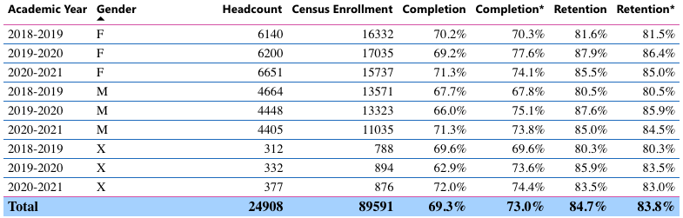
- As shown in the table, completion and retention both trended upward among the gender categories, moving from 70.3% and 81.6% up to 74.1% and 85% for females; 67.8% and 80.5% up to 73.8% and 84.5% for males, and 69.6% and 80.3% up to 74.4% and 83% for gender non-conforming. In sum, a 3-6% increase occurred across the genders in both completion and retention.

- In terms of gender, the completion and retention rates for students in BCC English classes were almost the same for females, males, and other (completion 74.7%, 73.8%, and 75.1% respectively, and retention 85.4%, 85%, and 84.6% respectively).

- Students were retained in all age groups at rates between 83.3% and 94.8%. Completion rates (excluding MW and EW grades) varied by age distribution, with the highest rates for students under 16 (88.4%), those 65 and above (80.7%), and those aged 16-18 (78.6%). Students who fared the worst were those in the largest groups, 19-24 year-olds (69.7%), and those 25-29 (70.7%); since between them, these groups comprise approximately half of the overall population, this is noteworthy.
- See the next section for disaggregation of outcomes based on ethnicity.

What disproportionately impacted (DI) population(s) showed outcomes gains in your program area and which need more support?
English Department retention rates disaggregated by ethnicity were as follows:

Retention | 18-19 | 19-20 | 20-21
Am Indian | 77.00% | 79.00% | 79.00%
Asian | 89.00% | 92.00% | 90.00%
Black/ African American | 78.00% | 83.00% | 80.00%
Hispanic/ Latino | 81.00% | 86.00% | 83.00%
Pacific Islander | 83.00% | 88.00% | 83.00%
2 or more | 81.00% | 85.00% | 83.00%
unknown | 85.00% | 85.00% | 86.00%
white | 85.00% | 88.00% | 87.00%

English Department completion rates disaggregated by ethnicity were as follows:

Completion | 18-19 | 19-20 | 20-21
Am Indian | 63.00% | 69.00% | 59.00%
Asian | 80.00% | 86.00% | 84.00%
Black/ African American | 62.00% | 70.00% | 65.00%
Hispanic/ Latino | 67.00% | 74.00% | 69.00%
Pacific Islander | 70.00% | 77.00% | 71.00%
2 or more | 69.00% | 76.00% | 71.00%
unknown | 74.00% | 75.00% | 76.00%
white | 77.00% | 83.00% | 80.00%

Retention rates increased in all ethnic groups between 2018-19 and 2020-21. Completion rates increased in all ethnic groups during that period, except for Indian Americans, representing only 66 students in 2020-21. Notably, the groups with the lowest completion rates in 2020-21 were American Indian (59%), Black/African American (65%), and Hispanic/Latino (69%).

How do these outcome trends compare to the college average?
Due to the nature of the department, it’s more meaningful to compare its success rates with those of other English Departments than it is to look at the numbers in isolation. Also, an analysis of the data on the Power BI dashboard doesn’t reflect significant progress for the English Department to the same extent as the Statewide Student Success Scorecard does because the BI tool information doesn't differentiate between success in English 1A (very significant to the department and college) and success in all other courses, many of which require the English 1A prerequisite. Data from the most recent years calculated by the Student Success Scorecard show the percent of first-time students who completed six units and attempted any English course in their first year and then completed a transfer-level course in English in their first or second year (see below); this is a critical factor for overall student success, as reflected in AB705.

The most recent data available on the Student Success Scorecard is for 2019-20. The percent of first-time students from the 2019 Student Success Scorecard who completed six units and attempted any English course in their first year and then completed a transfer-level English course in their first or second year:

English 2019-2020 (excluding MW and EW grades)
after 1 year after 2 years
all BCC 58.5% 70.8%
all Statewide 46.0% 62.2%
all COA 43.2% 55.7%
all Laney 36.2% 49.2%
all Merritt 41.5% 55.3%

African-Ame after 1 year after 2 years
BCC 50.0% 59.7%
Statewide 34.8% 50.9%
COA 29.5% 42.6%
Laney 23.6% 39.8%
Merritt 32.7% 46.2%

"Hispanic" after 1 year after 2 years
BCC 60.5% 70.4%
Statewide 41.1% 57.9%
COA 41.1% 50.5%
Laney 39.3% 49.5%
Merritt 42.9% 56.4%

The tables below show the completion and retention rates in English at BCC in 2019-2020 compared to those English departments in the other Peralta colleges:

English 2019-2020 (excluding MW and EW grades)
completion retention
Peralta 67.9% 80.4%
all BCC 70.1% 82.7%
all COA 62.8% 76.6%
all Laney 68.4% 78.5%
all Merritt 67.2% 81.8%

Because completion rates in English 1A have particular importance to the college in terms of student success and the new funding formula, we have highlighted completion and retention rates in English 1A--overall and by the two main groups designated in the equity report (African-American and "Hispanic"):

English 1A 2019-2020 (excluding MW and EW grades)
completion retention
Peralta 70.6% 83.0%
all BCC 73.5% 85.5%
all COA 65.8% 79.4%
all Laney 70.5% 80.3%
all Merritt 68.6% 84.0%

African-Ame completion retention
Peralta 60% 74%
BCC 61.0% 76.3%
COA 49.5% 70.5%
Laney 59.3% 71.0%
Merritt 65.2% 77.1%

"Hispanic" completion retention
Peralta 66.6% 78.8%
BCC 69.8% 80.7%
COA 55.9% 74.1%
Laney 65.6% 76.7%
Merritt 68.7% 80.9%

The BCC English department exceeds the district average overall and with respect to the two main groups designated in the equity report.

The completion rates in the BCC English department were slightly higher than in the previous year. In 2018-19, the completion rates in the BCC English department were 66% completion and 77% retention. In 2019-20, the rates rose to 77% completion and 86% retention. However, the rates excluded MW and EW grades, so it is difficult to interpret these results. If you look at the rates that do not exclude MW and EW, they are very similar with a slight raise in retention in 2019-20.

2019-20 completion and retention rates in English 5 were high: 77-78% completion (depending on gender), and 84-86% retention (depending on gender).

2019-20 completion and retention rates in English 1B significantly increased: 74-78% completion (depending on gender), and 86-90% retention (depending on gender).

The completion and retention rates for students completing the AAT in English at BCC is high: 83-88% completion (depending on the course taken), and 86-94% retention (depending on the course taken).

The high completion and retention rates in English 5, 1B and the courses leading to an AAT in English suggest that the English 1A courses prepare students for success in subsequent transfer-level courses in English.

What questions do you have about the trends?
N/A

Based on input you’ve received from students, what have they expressed as their need (s) to complete and succeed in your courses? (support your recommendations with examples) e.g., offer diff modalities; timing of day).
The transfer rates are high, as noted above, and students have not indicated significant concerns about what they need in order to complete and succeed in our courses. Considering changes that have occurred since the Pandemic began, it would be worthwhile to survey students concerning their preferences in relation to modality and times of offerings.

How will these outcome trends you identified in this section affect your department goals and plans for the next three years?
Year 1 (2021-22) | Year 2 (2022-23) | Year 3 (2023-24)
See page 15. | See page 15. | See page 15.

3C. Degrees and Certificates Dashboard
On page 1 of the “Degrees and Certificate Awards Trends” Dashboard, what are the award trends for your department (overall, by gender, age, and ethnicity).
The following shows the English awards (degrees and certificates) given to students from 2017-18 to 2020-21:

English Awards | 17-18 | 18-19 | 19-20 | 20-21
AA-T | 8 | 9 | 10 | 8
English Lang/Writing AA | 3 |  | 1 | 2
Fiction Wr Cert of Ach |  |  | 2 | 1
Poetry Wr Cert of Ach | 2 | 1 | 1 | 2
Playwriting Cr Wr Cert of Prof | 1 | 1
noncredit Cert Comp ACS | 64 | 63 | 115 | 88
total | 78 | 74 | 129 | 101

In In 2020-21, females received more awards than males. AA-T awards were divided among Asian students (2), Hispanic students (3), “two or more” (2), and white students (1)

On page 4, what DI population(s) award trends showed gains in your program area and which populations need more support?
The distribution of students, in terms of ethnicity, in English AA-Ts awarded is as follows:

 | 17-18 | 18-19 | 19-20 | 20-21
Am Indian
Asian | 2 |  | 2 | 2
Black/ African American | 1 |  | 1
Hispanic/ Latino | 2 | 5 | 2 | 3
Pacific Islander
2 or more | 1 |  | 1 | 2
unknown |  | 1 | 1
white | 2 | 3 | 3 | 1

How do these outcome trends compare to the college average?
The two groups not represented (American Indian and Pacific Islander) have relatively small populations at the College. It is worth noting that the group of students receiving the most AA-Ts in English is Hispanic/Latino students, one of the DI populations. They received 34.3% of the AA-Ts in English, but 22.2% of overall awards at the College. African-American and white students received a disproportionately low number of these awards.

The transfer rates are high, as noted above, and students have not indicated significant concerns about what they need in order to complete and succeed in our courses. Considering changes that have occurred since the Pandemic began, it would be worthwhile to survey students concerning their preferences in relation to modality and times of offerings.

Many matriculating English “majors” place higher value in transferring than in achieving degrees. It would benefit the department and college and would likely benefit students in the long run, if the college were to confer degrees on an “opt-out” basis, rather than an “opt-in” basis.

Based on input you’ve received from students, what have they expressed as their need (s) to complete their degrees and/or certificates? (support your recommendations with examples)
It’s worth noting that more English Language AA degrees were conferred in 2015-16 (4), 2016-17 (6), and 2017-18 (3) than in the years studied in this program review (see above). We added English 99 as a requirement in the AA degree several years ago; this course is not essential to the achievement of program outcomes and should no longer be a requirement for the AA degree.

How will these outcome trends you identified in this section affect your department goals and plans for the next three years?
Year 1 (2021-22) | Year 2 (2022-23) | Year 3 (2023-24)
See page 15. | See page 15. | See page 15.

3D. Transfer Dashboard
This dashboard does not provide data by subject. Reflect on what you can do to affect student transfer. How may your department help to support BCC student transfer? (e.g., serve on panels, strengthen GP in your dept, change curriculum, increase number of AD-Ts, etc.)
An analysis of transfer articulation with CSU and UC, using assist.org, shows that completion of the AA-T in English with a GPA of 2.0 guarantees students admission to a CSU, and completing the courses in this AA-T fulfills all transfer requirements for English majors at U.C. Berkeley, U.C.L.A., U.C. Santa Barbara, U.C. Irvine, and U.C. Santa Cruz, and meets four out of five requirements, which is sufficient for transfer, at U.C. Davis. We need to prioritize marketing these transfer opportunities for English majors.

The English Department has partnered with Counseling to offer embedded counseling services to most English 1A sections this Fall 2021. We hope that by exposing students to more academic planning and their personal support staff, they will begin to think about transferring and plan to transfer very early in their academic journey. The partnership introduces counselors into synchronous classrooms on at least two occasions at critical times in the semester, and it also introduces counselors to asynchronous classrooms. During synchronous counseling visits, students regularly pepper our counselors with an array of questions and express so much gratitude for each of their visits. They are exposed to an abundance of academic resources and, most importantly, connect with a friendly face that they can turn to. All participating English 1A sections will give their students multiple reminders and opportunities to plan their comprehensive Student Education Plans. The collaboration has already paid tangible dividends; Skyler Barton, our department liaison, has started to reach out to former 1A PLUS students to see if any students who qualified for our noncredit Certificate in Academic Composition Skills are interested in petitioning for it since they still can even though they satisfied the requirements several semesters ago. He is finding that this is increasing our certificate count. Even though this is not directly connected to transfer rate augmentation, it is reasonable to think that scholars may become more committed to degree completion and transfer when they have a physical copy of their Academic Composition Skills certificate in their hands. A majority of English 1A instructors participated in the embedded counselor pilot this Fall 2021.

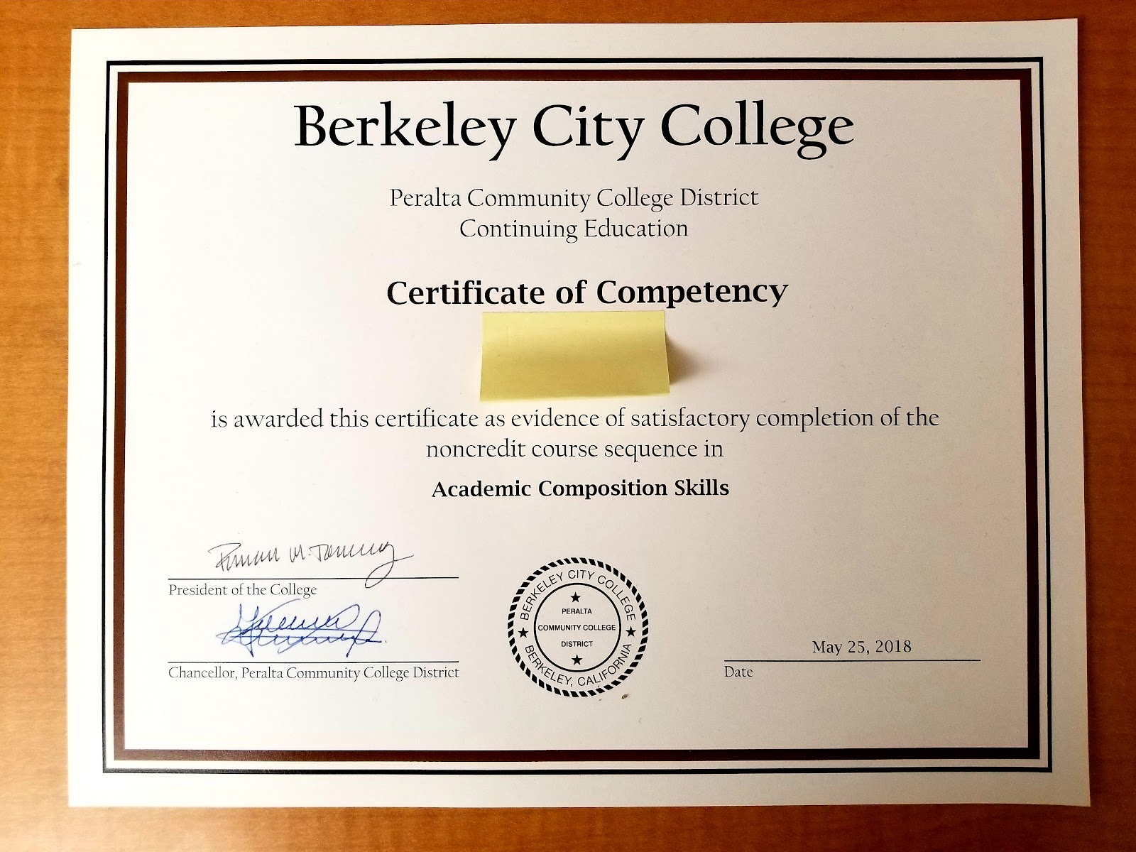

Starting in Spring 2022, a Canvas assignment template will be distributed to all English 1A instructors that would make it easy for them to give a little extra credit to their students if they submit a comprehensive Student Education Plan (SEP). It is already in play in several English 1A PLUS sections, and we know that students who plan their SEPs become more “directed,” which is one of the RP Group’s success factors.

Increasing equity at the college by recording and analyzing disaggregated SLO data to identify weaknesses will allow for more targeted and impactful action planning will ultimately improve success rates in English 1A, a transfer requirement. The English Department is committed to advancing these measures, and, in collaboration with BCC’s institutional researcher, will pilot five sections of disaggregated, Canvas-integrated, SLO assessment this Fall 2021. The department already did a soft-pilot using two English 1A sections’ Spring 2021 data—the first department in the college to do so.

It would benefit the college to discuss both CSU and UC transfer rates that are disaggregated by both student population and discipline. A look at CSU data disaggregated by subject and student demographic (provided by BCC’s Transfer and Career Center—slightly different from the dashboard) reveals that African American and Latinx transfers are paradoxically strengthening even though these two student groups traditionally have lower completion rates compared to Asian and White students; over the past three years, Latinx students had higher CSU transfer rates than white students—even increasing during the peak of the pandemic, whereas white students saw a decline in transfer rates.

2018-2019 CSU transfers:
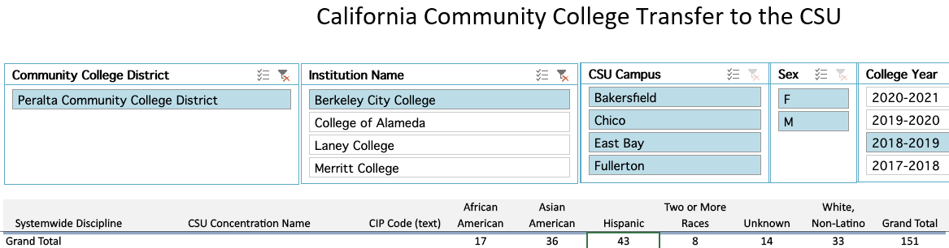

2019-2020 CSU transfers for African American and Latinx increased during the COVID pandemic, whereas white transfer rates declined.
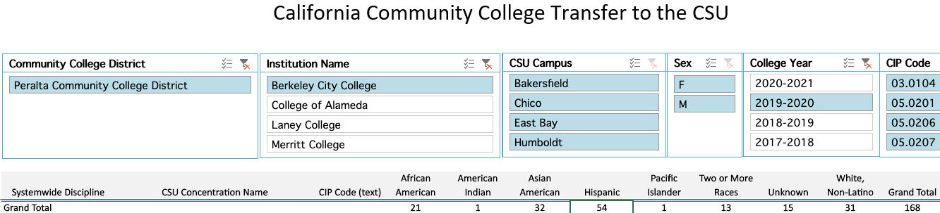

2020-2021 CSU transfers—note that 66 “Hispanic” students transferred to CSUs (26 more than White students).
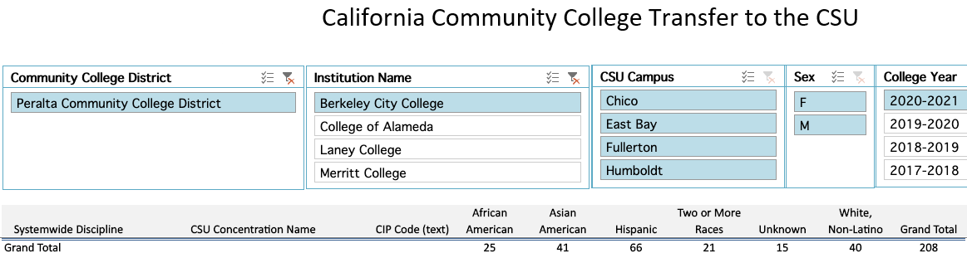
The dashboard provided in this Program Review template shows Berkeley City College is the leading transfer institution in Peralta—a total of 536 transfers in 2020-2021. The lead is more pronounced for UC transfers but still significant for CSU transfers (307 to UCs and 229 to CSUs). Laney College, a much larger college, has a total of 390 transfers (142 to UCs and 248 to CSUs), and the comparison to College of Alameda and Merritt College is even more stark: College of Alameda transferred a total of 224 transfers (69 to UCs 155 to CSUs), and Merritt College has a total of 194 transfers (only 36 to UCs and 158 to CSUs) for the same reporting period.

Additionally, the dashboard shows that the above decline in White students transferring to CSUs mirrors the decline in White students’ transferring to UCs; the increase in students of color, namely African American and Latinx students, is also present in UC transfer rates. Asian students are transferring in the highest numbers and have held steady—hardly increasing or decreasing.

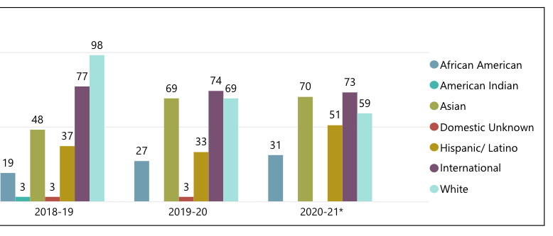
Though Laney College has more out of state transfers than BCC, about double, the quantity is not enough to change the overarching narrative: BCC is clearly the leading transfer institution in Peralta.

Based on data provided by the Transfer and Career Center, the 2018-19, 2019-20, 2020-21 BCC ENGL transfer rates to UCs are as follows:

Total: 6, 3, 10
UCB: 3, 2, 5
UCD: 1, 0, 0
UCLA: 0, 1, 0
UCR: 0, 0, 1
UCSB: 0, 0, 2
UCSC: 2, 0, 2

The 2018-19, 2019-20, 2020-21 BCC ENGL transfer rates to CSUs are as follows:
Total: 5, 3, 6

It is worth noting that the number of students enrolled in the classes required by the English AA-T -- English 85A, 85B, 85C, and 17A or B -- other than classes meeting other requirements (English 1A, 1B, and 5) has been less than 20 per class since two other colleges in the Peralta District began to offer their own English AA-T degree programs in recent years. Considering this, the overall transfer rate (combining UC and CSU) of 16 students in 2020-21 is quite high. This points to the high transfer rates of students in the program and the need to increase advertising of these classes.

3E. Curriculum
View the department’s curriculum through the lens of student equity outcomes. BCC outcome data suggests that disproportionately impacted groups of students experience low rates of success.
How do you plan to adjust the curriculum to advance student equity and address DI student outcome gaps?
Examples include: making adjustments to lesson plans based on student assessment outcomes; review pedagogy and revise assignments for culturally relevant content; simplify student processes and make service areas student-centered; manage class discussions and student participation; review best practices, etc.).
- Develop communities of practice to discuss adjusting curriculum to advance student equity
- Improve advertising for the required courses for the English Language AA degree to increase enrollment
- Reactivate courses such as African-American literature, Latino-Chicano Literature, and Women’s Literature as well as engaging literature classes such as Dramatic Literature and Film as Literature, and develop curricula for these courses that meet OEI and OER standards
- Develop a course in Queer Literature and develop curriculum for this course that meets OEI and OER standards
- Designate two sections of English 5 for students who have completed “English 1A Plus”

In the boxes below, add improvement actions that are directly related to Student Equity & Success. If there are no improvement actions in this area, leave blank. If you have more than one Improvement Plan, add more by copying and pasting the table below.
IMPROVEMENT ACTIONS
Department/Discipline: | English
Action Name: | Survey students concerning their preferences in relation to modality and times of offerings.
Description:
Completion timeline: | 2022
Responsible person: | Adán Olmedo, Phoumy Sayavong
IMPROVEMENT ACTIONS
Department/Discipline: | English
Action Name: | Implement district-wide Guided Self-Placement to clear prerequisites and seamlessly “onboard” students into English 1A, as mandated by AB 705
Description:
Completion timeline: | 2022
Responsible person: | Jenny Lowood
IMPROVEMENT ACTIONS
Department/Discipline: | English
Action Name: | Use POCR process to qualify sections of our courses to be in the CVC list of courses
Description:
Completion timeline: | 2024
Responsible person: | Jenny Lowood, Nima Najari Kianfar
IMPROVEMENT ACTIONS
Department/Discipline: | English
Action Name: | Improve advertising of English AA-T to English majors in the College and District
Description:
Completion timeline: | 2023
Responsible person: | Jenny Lowood

III. PROGRAM GOALS
- List your current Department Goals.
- Develop district-wide Guided Self-Placement, based on existing BCC GSP
- Increase advertising for English AA-T program to English majors
- Revise curriculum for English Language AA, eliminating English 99 from program requirements and adding electives that would engage a wider variety of students, while promoting diversity in the curriculum
- Revise curriculum to align courses with OEI-CVC and OER standards and develop online tools

- How do the goals align with the College goals? If so, which ones?
Berkeley City College Goals
- GOAL I: Strengthen Resilience: Strengthen BCC students’ abilities to become self-directed, focused and engaged in the pursuit of transformative, life-long learning experiences that result in personal and academic success.
- GOAL II: Raise College Competence: Raise student skills and competencies, and expand their learning experiences, so that they can successfully complete their college program.
- GOAL III: Enhance Career-Technical Education Certificates and Degrees: Enhance BCC’s 1- and 2-year career and technical education programs so that they provide current and transferable skills and competencies to earn a living wage in our area, and to maintain competency for advancement in one’s career.
- GOAL IV: Increase Transfer and Transfer Degrees: Ensure that all of BCC’s programs of study and transfer pathways for degrees prepare students, in a timely manner, for multiple transfer options.
- GOAL V: Ensure Institutional Sustainability: Increase BCC’s impact in education through innovation, internal and external collaboration and partnerships, and sufficient resources, both short-term and long-term.
- Develop district-wide Guided Self-Placement, based on existing BCC GSP (Goals 1 and 2)
- Increase advertising for English AA-T program to English majors (Goal 4)
- Revise curriculum for English Language AA, eliminating English 99 from program requirements and adding electives that would engage a wider variety of students, while promoting diversity in the curriculum (Goals 4 and 5)
- Revise curriculum to align courses with OEI-CVC and OER standards and develop online tools (Goals 2 and 5)

- Assess your facilities utilization (including labs, support for online learning, and other spaces) and for each year, indicate if the space is insufficient. If so, what are the needs and why? *Note that facility needs and planning are addressed in the Facility Master Plan for the college, including the planning for new buildings.
Due to the importance of English 1A Plus classes and support classes such as the Writing Workshop, which support student equity and success, the department needs an additional dedicated lab space.
Year 1 (2021-22) | Year 2 (2022-23) | Year 3 (2023-24)
Develop district-wide GSP | Revise English Language AA  Improve advertising of English AA and AA-T | Revise curriculum to align with OEI-CVC and OER standards
- What are the essential functions of your department, any unique characteristics or trends? Provide specific examples.
English courses at the college tend to fall into four broad categories: Reading and composition, reading and composition support, literature, and creative writing. The English discipline provides students with strong skills in reading and writing, critical thinking, and research skills (primary institutional learning objectives) and aids in preparing students for transfer, CTE, or other goals. In addition to communication, courses in English address the following institutional learning outcomes: Critical thinking, information competency, and global perspectives and valuing diversity. Through its English 1A and support courses especially, but also through its general education courses and A.A. degrees, the department addresses the advancement of student access, equity, and success.

The mission of the English AA-T is to provide students with strong, college-level skills in reading, writing, and literary analysis. This program prepares students for transfer to the English Department at CSU or UC campuses or at private four-year schools.

- Describe how external factors (if applicable), such as State and Federal laws, advisory board recommendations, district and college governance have an impact on the support services your department provides. (e.g., partnered with dual enrollment and contract Ed programs at K-12 districts and high schools; support staff at high schools have access to Canvas to follow along and support students; allow tutors into the classes; Guided Pathways, AB 705, etc.)
The English Department at BCC is in full compliance with AB 705. “English 1A Plus” classes, which offer additional support in English 1A for students who need it, include embedded tutors (“writing coaches”), and the department offers additional elective support classes (“writing workshop” classes – English 208ABCD or English 518ABCD), as well as drop-in tutoring.

Based on your responses to questions 4-8, are there areas that need improvements? If so, add improvement actions below. If there are no improvement actions in this area, leave blank. If you have more than one Improvement Plan, add more by copying and pasting the table below.
IMPROVEMENT ACTIONS (as stated above in Student Equity & Success)
Department/Discipline: | English
Action Name: | Survey students concerning their preferences in relation to modality and times of offerings.
Description:
Completion timeline: | 2022
Responsible person: | Adán Olmedo, Phoumy Sayavong
IMPROVEMENT ACTIONS
Department/Discipline: | English
Action Name: | Implement district-wide Guided Self-Placement to clear prerequisites and seamlessly “onboard” students into English 1A, as mandated by AB 705
Description:
Completion timeline: | 2022
Responsible person: | Jenny Lowood
IMPROVEMENT ACTIONS
Department/Discipline: | English
Action Name: | Use POCR process to qualify sections of our courses to be in the CVC list of courses
Description:
Completion timeline: | 2024
Responsible person: | Jenny Lowood, Nima Najari Kianfar
IMPROVEMENT ACTIONS
Department/Discipline: | English
Action Name: | Improve advertising of English AA-T to English majors in the College and District
Description:
Completion timeline: | 2023
Responsible person: | Jenny Lowood
IMPROVEMENT ACTIONS
Department/Discipline: | English
Action Name: | Automatic degree/certificate conferral
Description: | It would benefit the department and college and would likely benefit students in the long run, if the college were to confer degrees and certificates on an “opt-out” basis, rather than an “opt-in” basis.
Completion timeline: | 2023
Responsible person: | Office of Instruction and Student Services

- ASSESSMENT
Berkeley City College is committed to a culture of assessment to improve instruction, services, and institutional planning. Findings from SLO, PLO, ALO assessments, and program review data are used to direct resources for areas that are institutional priorities that are articulated in the Educational Master Plan and BCC Strategic Plan. Due to the critical role that course and program assessments play in our institutional planning and to be in compliance with the Accreditation requirements, the Program Review resource allocation requests require the completion of assessment in order to qualify.
9A. List and describe the department/program’s progress and reflection on Student Learning Outcomes (SLOs), Program Learning Outcomes (PLOs), and/or Service Area Outcomes (SAOs). If your department/program offers a degree or certificate, please describe the department’s progress on Program Learning Outcomes (PLOs).
Between Fall 2018 and Spring 2021 (“Round 4”), all English 1A faculty participated in the SLO assessment of English 1A, a process that involves a standardized assignment and rubric, norming sessions and blind scoring by at least two instructors. Among the other classes offered in the department, 20 faculty members participated in SLO assessment. 100% of faculty members who taught during Round 4 participated in SLO assessments. The department liaison facilitated a 6-year plan around assessment wherein instructors’ individual Round 4 SLOs were pooled into online documents before being manually entered into Curriqunet by the liaison, so faculty learning how to assess were not encumbered, fatigued, or otherwise overburdened by Curriqunet entry. Notably, though, one part-time instructor did input their assessments into Curriqunet on her own (Tracy Black, ChDev 51). It is also worth noting that part-time instructor Laura Zink completed 8 SLO assessments due to her role as instructor of several stand-alone Creative Writing courses. With Round 5 underway, the outlook for an even stronger assessment cycle is looking good; faculty have all the tools (rubrics and know-how) to finish all SLO assessments in a timely fashion, and assessment trainings will shift toward building instructors’ capacity to independently enter their assessment data into Curriqunet. The department’s Round 5 SLO assessment plan actually concludes at the end of Fall 2022, leaving ample time to do program level outcomes assessment.

9B. What improvement plans did your department identify upon the assessment of each program? How has your department used the results of assessment to improve student learning outcomes and/or curriculum? Please be as detailed as possible.
100% of the English degrees/certificates have their Program Outcomes mapped and have had all their aligned SLOs assessed. The flagship, the AA-T, for instance, has had each of its aligned SLOs assessed in the last assessment cycle, and the SLOs are all aggregated, but due to Curriqunet problems beyond anyone at the college’s control, their formal entry into Curriqunet is impossible. The action plans for each of the SLOs that support PLO assessment are accessible in Curriqunet, but it didn’t seem meaningful to list them all out here. By attending to these action plans in the manner described below, the department will be supporting the Program Learning Outcomes.
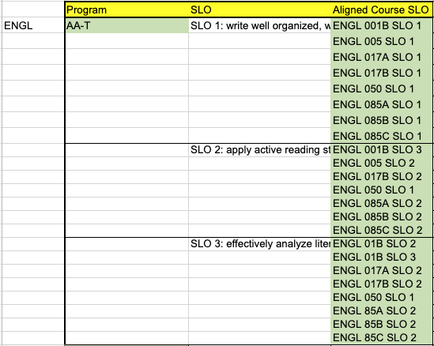

9C. Describe how the program has made use of information from the data it has from program and student learning outcomes in Round 4 (last cycle of the last 3 years) for continuous improvement. Include the three most significant plans for improvements as a result of the assessment process with timelines. Click here to view your Assessment Calendar
Round 4 English 1A, 5 and Creative Writing highlights:
- The English 1A SLO assessments revealed the need to develop stronger understanding and instruction among faculty members and students regarding 4 of the more challenging rubric categories (there are 10 in all); the department determined that the creation of meta-rubrics would improve instruction around these categories by not only making them more visible and more discussed but also by giving faculty members new material to use in their assignments. These meta-rubrics delineated in greater detail and more student-friendly language what was expected of student work in order for it to receive the highest scores. The “multiple perspectives,” "number and quality of sources,” "formatting,” and "reading comprehension” meta rubrics were completed just prior to the pandemic, so Round 5 assessments will see how effectively they contribute to improved student learning outcomes.
-English 5 faculty are currently “closing the loop” on Round 4 assessment action plans that were discussed during two Spring 2021 Flex Day department meetings. Several of the same faculty members are re-assessing their classes this Fall 2021 to see the impact of their action plans on student learning outcomes. Although there was no common assessment (no shared assignment), a shared SLO rubric was established in Round 4, indicative of a shift toward a more collaborative assessment practice. This shift is also evinced by the level 2 (aggregate) SLO action plan: a majority of the faculty members independently identified an increase in instructional consultation as one of their action plan items. In addition to the increase in collaboration, faculty members’ most common action plans included
- In summary, the goals of the assignments and activities will be more detailed and there will be more attention or “check-ins” with students--either formally, through quizzes or discussion posts or informally during office hours--such that more attention is given to the teaching of secondary source usage. Instructors may provide examples of strong student work to supplement these additional revisions to the assignment; additionally, instructors may create new modules that specifically target the use of secondary sources in the lead-up to the assignment.
- If students are using secondary sources properly (good quality) but not substantially enough (low quantity), then faculty members will look for ways of increasing the amount of secondary source usage that occurs by awarding it more points and/or creating supplemental assignments and/or quizzes.
-Meanwhile, while English 5 faculty were utilizing Flex Day department meeting time to reflect on their section aggregate results and action plans, creative writing faculty were simultaneously discussing convergent concerns and pedagogical practices in a separate breakout room. Though they are unable to use the exact same shared assessment since all of the Creative Writing classes are stand-alone sections typically taught by the same instructor, their willingness to collaborate in a looser sense is still likely to improve instructional quality and creativity given the shared commonalities among the courses. It is worth noting that part-time instructor Sharon Coleman assessed 5 courses in addition to her English 1A SLO contributions. All Creative Writing courses were assessed by part-time instructors in Round 4. The Creative Writing courses as a whole yielded specific, meaningful action plans; here is one example from English 10A, which is focused on improving students’ “plot” and “conflict” skills, which the assessment revealed to be the two most challenging rubric categories: “1) Instructor will review the course materials on plot and conflict and revise them to emphasize the need for a more complete beginning, middle, and end to the story (plot) as well as a stronger sense of the three types of conflict (internal, external, character). Instructor will also change the readings so that more of the works are short and have a traditional plot and conflict structure. 2) Increase student collaboration and/or peer review: I will organize a more structured peer review workshop session that highlights the use of plot and conflict.” Even though this is an action plan for English 10B, other Creative Writing faculty members could also implement these action plan items and would at least be stimulated by their discussion, which is the plan.

9D. How does your department, program, or unit ensure that students are aware of learning or service area outcomes?
All course syllabi are required to display the Student Learning Outcomes.

9E. Besides your syllabi, where are the service area and/or program level outcomes published? If on a website, please specify the URL.
Although they used to be listed within the English department website (within the BCC website), they are no longer there and can only be accessed by a public search unless one has Curriqunet access.

In the boxes below, add improvement actions that are directly related to Assessment. If there are no improvement actions in this area, leave blank. If you have more than one Improvement Plan, add more by copying and pasting the table below.
IMPROVEMENT ACTIONS
Department/Discipline: | English
Action Name: | Disaggregate all SLO data
Description: | All SLO data will include Student ID numbers, so the data can be disaggregated by race and ethnicity and other demographics.
Completion Timeline | Fall 2022
Responsible person: | Adán M. Olmedo
IMPROVEMENT ACTIONS
Department/Discipline: | English
Action Name: | Work with Curricunet to enable PLO data to be entered into Curricunet.
Description: | Currently Curricunet doesn’t function properly, impeding PLO data entry.
Completion Timeline | Fall 2022
Responsible person: | Adán M. Olmedo

- ENGAGEMENT
10A. Discuss how faculty and staff have engaged in institutional efforts such as committees, presentations, and departmental activities. Please list the committees that full-time faculty/staff/admin participate in.
The department led efforts to fully implement AB705.

Currently, one full-time faculty member serves as the Assessment Coordinator for the college, and Professional Development Committee Co-chair, a member of the Integrated Planning Committee as well as co-chairing the department. Another full-time faculty member serves as Faculty Tutoring Coordinator, Academic Senate representative, CRLA liaison for the college, and Curriculum Committee representative, as well as co-chairing the department. Recently, a third full-time faculty member has been the District Professional Development Officer and has been FDIP coordinator. The most recently hired full-time faculty member is the college’s representative on the POCR committee and has visited committee meetings at the College to learn about its governance structure. In addition, work groups in the department this year have included three full-time faculty members, as well as over a dozen part-time instructors.
10B. Discuss how faculty and staff have engaged in community activities, partnerships and/or collaborations.
Some classes offered by the Department are parts of apprenticeship and learning community cohorts, including, for example, courses used by the YMCA apprenticeship program.

A part-time faculty member organizes annual poetry festivals and the Milvia Street Arts and Literary Journal, which showcases work from students in BCC Art and Creative Writing classes. All BCC faculty, staff and students are invited to submit creative work.

In the past year, English Department faculty members have met with faculty and representatives from Berkeley Adult School to plan how the two schools can align courses and services to better serve students.
10C. Discuss how adjunct faculty members are included in departmental training, discussions, and decision-making
Adjunct faculty members participate in every aspect of departmental decision-marking through their participation in department meetings (two per semester), and most also participate in departmental projects, such as portfolio assessment, which is a critical endeavor within the department that normally occurs every semester.

Currently, part-timers are working on departmental projects in each of the following areas:
- development of streaming materials
- development of POCR-aligned curriculum,
- creation of a meaningful tool for assessing reading skills,
- research tech tools/LTIs to maximize student involvement and communication (How can we mimic face-to-face student interaction with new virtual tools, especially asynchronously?).
- create SLO assignment templates with rubrics within Canvas that faculty members can copy into their own Canvas shells
10D. Discuss the relationship and engagement with other support services, programs, departments, or administrative units and how these relationships support your area to meet its goals.
As mentioned above in the assessment section, The English Department has partnered with Counseling to offer embedded counseling services to most English 1A sections this Fall 2021. We hope that by exposing students to more academic planning and their personal support staff, they will begin to think about transferring and plan to transfer very early in their academic journey. The partnership introduces counselors into synchronous classrooms on at least two occasions at critical times in the semester, and it also introduces counselors to asynchronous classrooms. During synchronous counseling visits, students regularly pepper our counselors with an array of questions and express so much gratitude for each of their visits. They are exposed to an abundance of academic resources and, most importantly, connect with a friendly face that they can turn to. All participating English 1A sections will give their students multiple reminders and opportunities to plan their comprehensive Student Education Plans. The collaboration has already paid tangible dividends; Skyler Barton, our department liaison, has started to reach out to former 1A PLUS students to see if any students who qualified for our noncredit Certificate in Academic Composition Skills are interested in petitioning for it since they still can even though they satisfied the requirements several semesters ago. He is finding that this is increasing our certificate count.

In the boxes below, add improvement actions that are directly related to Engagement. If there are no improvement actions in this area, leave blank. If you have more than one Improvement Plan, add more by copying and pasting the table below.
IMPROVEMENT ACTIONS
Discipline: | English
Action Name: | English CVC/OEI and OER Project
Description: | Have at least ten English course sections POCR-badged and at least ten sections “textbook cost free.”
Completion Timeline | 11/2024
Responsible person: | Jenny Lowood, Nima Najafi Kianfar
IMPROVEMENT ACTIONS
Discipline: | English
Action Name: | Reading Skills Rubric
Description: | Complete rubric and tool for meaningful assessment of reading skills, including departmental approval
Completion Timeline | 11/2022
Responsible person: | Jenny Lowood
IMPROVEMENT ACTIONS
Discipline: | English
Action Name: | Streaming Services as Teaching Tools
Description: | Create a document to help teachers find strong streaming material and teacher tools in streaming services available through the BCC Library, including Digital Theater +, Kanopy, and others, as appropriate
Completion Timeline | 11/2022
Responsible person: | Jenny Lowood
IMPROVEMENT ACTIONS
Discipline: | English
Action Name: | Tech/LTI research
Description: | research tech tools/LTIs to maximize student involvement and communication (How can we mimic face-to-face student interaction with new virtual tools, especially asynchronously?).
Completion Timeline | Spring 2022
Responsible person: | Adán M. Olmedo, Nima Najafi Kianfar
IMPROVEMENT ACTIONS
Discipline: | English
Action Name: | Canvas SLO rubric/assignment templates
Description: | create SLO assignment templates with rubrics within Canvas that faculty members can copy into their own Canvas shells
Completion Timeline | 3-5 courses per semester until finished
Responsible person: | Adán M. Olmedo

VI. Prioritized Resource Requests
In the boxes below, add a 3-year resource requests for your department/program that have not been funded by existing funding sources. Work with your supervisor to estimate costs. If there are no resource requested, leave the boxes blank.

Click here to view the Resource Request Process and Timeline

Resource Category | Description/Justification | Estimated Annual Salary Costs | Estimated Annual Benefits Costs | Total  Estimated  Cost | Overall  Priority Ranking (1=Most important)
Personnel
Classified Staff | 0
Student Worker | 0
Part Time Faculty | 0
Professional Development | Description/Justification |  |  | Estimated Cost
Department wide PD needed
Personal/Individual PD needed | Stipends for ongoing departmental projects |  |  | $4,000
Supplies | Description/Justification |  |  | Estimated Cost
Software (for whom or role?) | LTIs, as identified in departmental projects |  |  | $5,000
Books, Magazines, and/or Periodicals
Instructional Supplies
Non-Instructional Supplies
Technology & Equipment | Description/Justification  Before you list your technology request, click here to view the latest Technology Refresh Plan to verify whether it has already included. |  |  | Estimated Cost
New
Replacement
Facilities | Description/Justification |  |  | Estimated Cost
Classrooms
Offices
Labs | Additional lab to support needs of English support classes |  |  | unknown
Other
Library | Description/Justification |  |  | Estimated Cost
Library materials (including streamline media needs) | Streaming films, as identified in departmental projects |  |  | $2,000
Library collections
OER
Other | Description/Justification |  |  | Estimated Cost
OTHER Description

Thank you for your time and effort in completing the Program Review!
Please email the completed Program Review to your Dean by November 30, 2021.

