Berkeley City College’s mission is to provide our diverse community with
educational opportunities, promote student success, and to transform lives.

Introduction and Directions

The Peralta Community College District has an institutional effectiveness process which consists of the following components: a District-wide Strategic Plan which is updated every six years; Comprehensive Program Reviews which are completed every three years; and Annual Program Updates (APUs) which are completed in non-program review years.

The Program Review 2021-22 timeline has been developed for each program and services to guide through the semester. Please review and work with your Deans, Managers, Department Chairs and/or Supervisors to complete this Program Review.

The Program Review is intended to primarily focus upon planning for the subsequent two years and institutional effectiveness. The Program Review process directly leads to the institutional resource allocation process and budget planning for the following academic year (2022-23). This is an opportunity for each administrative unit, support service program, and department to reflect on progress made and identify areas of program improvements to achieve equitable student success and elimination of achievement gaps. In this process of making continuous quality improvement, there is an opportunity for each program, student services, and department to request resources that support achieving the stated goals.

If you have questions regarding other material in the Program Review, please contact your Dean or Manager. If you have questions regarding data, please contact Dr. Phoumy Sayavong, Senior Researcher and Planning Analyst (psayavong@peralta.edu).

Please email the completed Program Review to your Dean by November 30, 2021.

COLLEGE PROFILE
Click here to view the Berkeley City College Student Demographics Dashboard.
This 2-page dashboard will provide information on the characteristics of our student body from the past two years such as headcount, ethnicity, enrollment status, age group, educational goals, and majors.
College Outcomes | 2017-2018 | 2018-2019 | 2019-2020 | 2020-21
Full Time Equivalent Students (FTES) | 4,140 | 3,864 | 3,696 | 3,290
Efficiency  (Productivity; avg faculty-student ratio) | 13.4 | 13 | 13.2 | 14.3
Success Rate (%) | 67% | 69% | 67%* | 74%
Degrees + Certificates Awarded (#) | 1,021 | 948 | 1,106 | 1,014
*Excludes “EW” grades

To view prior Program Reviews, click here. To view prior Annual Program Updates, click here.

- DEPARTMENT DESCRIPTION
Please verify the mission statement for your department. If your program has not created a mission statement, provide details on how your department supports and contributes to the College’s mission.
The ESOL Program at Berkeley City College provides foundational skills in English for a diverse community, addressing the needs of international students, immigrants who have recently arrived in the Bay area, and multilingual students who have received some previous education in the U.S. The goal of the program is to prepare students for success in transfer and vocational courses and/or immediate employment advancement and meaningful participation in American life.

Name(s) of member(s) completing this Program Review | Department/Program | Completion Date
Gabriel Winer  Laurie Brion | ESOL | November 22, 2021
List faculty names and/or staff with assignments in fall 2021.
Full Time | Part Time
Gabriel Winer  Laurie Brion | Osa Kauffman  James Seger  Liz Boner  Sepi Hosseini  Olga Lewis

II. STUDENT EQUITY & SUCCESS
Using the data dashboards provided below, review and reflect upon the outcome trends for your department. You may use data from other sources if available.

Click here if you would like to view BCC’s Planning Documents (Education Master Plan, College Strategic Goals, Student Equity Plan, District Strategic Goals, Vision for Success, Guided Pathways, Technology Plan, Facilities Plan)

For assistance with data dashboards, contact Phoumy Sayavong at psayavong@peralta.edu

3A. Enrollment Trend and Productivity Dashboard
*Note that completion and retention rates are presented with the inclusion and exclusion of excused withdrawals (EW) and military withdrawals.
What are your enrollment trends in the past three years?
Up until the pandemic, census enrollment was holding steady and even rising (684 in 2018-19 to 968 in 2019-20) despite a drop in international students (a national trend), thanks to the simultaneous implementation of the mirrored non-credit program. Like other departments, ESOL took a hit from the pandemic, both because of the remote-learning modality not being ideal for many students and by factors outside of the college. Enrollment went down to 821 in 2020-21.
When the data for your department are disaggregated by student ethnic groups, what trends do you observe and how do plan to address them over the next three years?
A very small number of students taking ESOL classes were born here, and because of AB705’s policy of placing long-term ELs (sometimes still called Generation 1.5) straight into mainstream English, we expect that that number will diminish more. This pie chart is based on our student survey from Spring 2020, the last normal enrollment time before the pandemic. There is no majority country of origin.
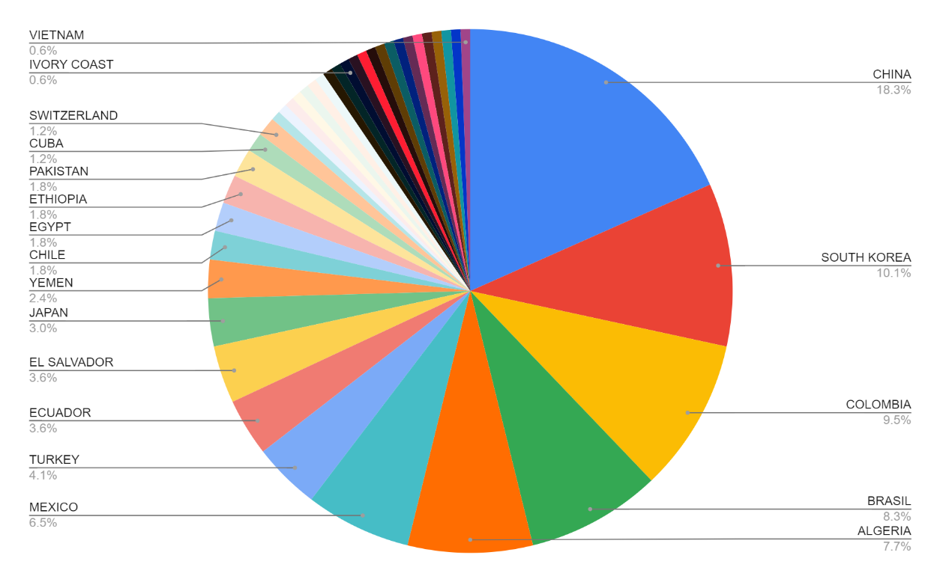

Based on the dashboard data, Asian, Latinx, and white enrollment increased and then fell slightly, while Black enrollment remained about the same.
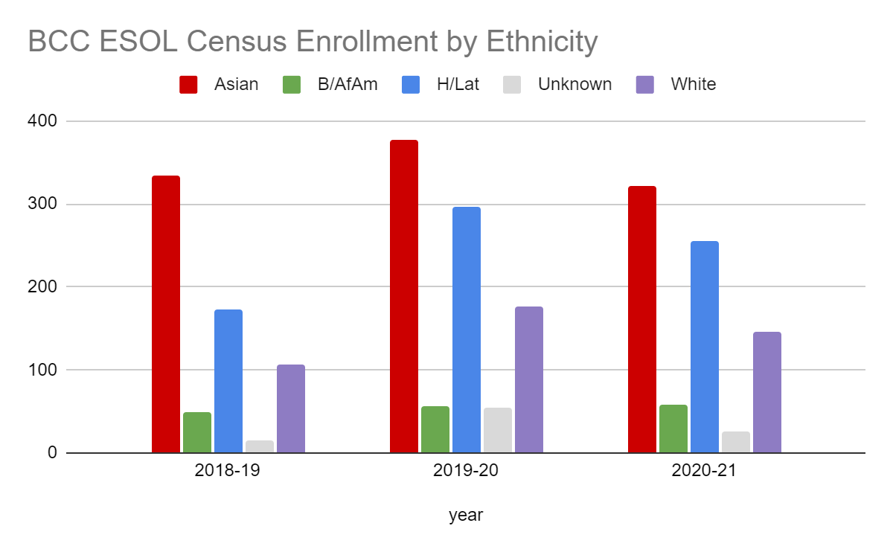
When you break down ethnicity further by residency status, it is quickly apparent how counting “Asian” or “Hispanic/Latinx” as one monolith obscures any meaningful conclusions. As the enrollment of international students dropped in 2019 (possibly based on Trump-era threat to students keeping their visas), the enrollment of local students, primarily Asian and Latinx, rose. Another population hidden in plain view in these statistics is immigrants from Middle Eastern and North African countries, who often check “white” on the demographic boxes. This is despite the fact that they often experience racism, xenophobia, and Islamophobia (whether or not they are actually Muslim) in the U.S. This gap in data collection may obscure barriers students face.

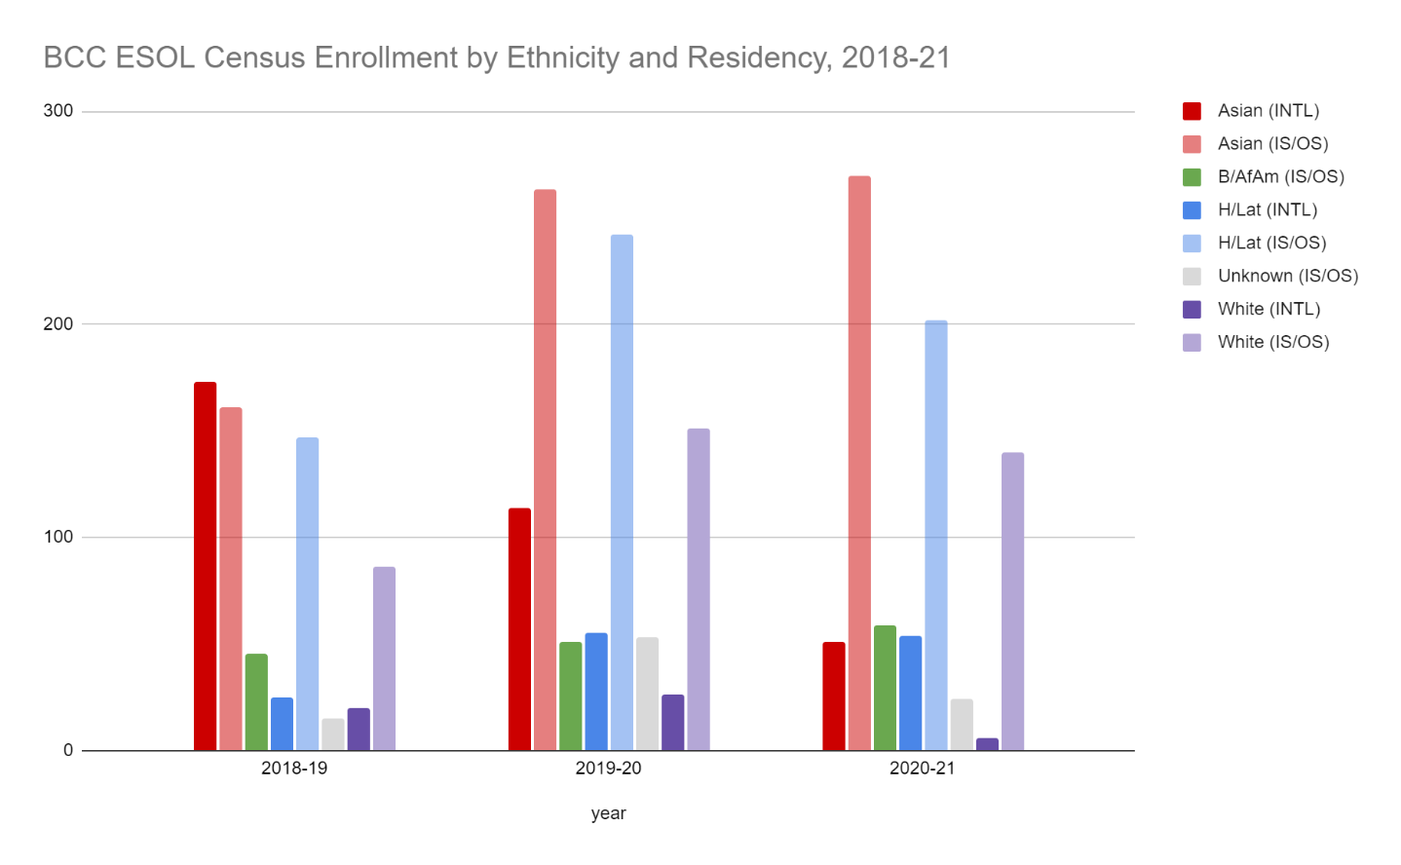
We hope to maintain and continue increasing the enrollment of local students in proportions commensurate with the demographics of English learners in Berkeley and surrounding communities, and to see the numbers of international students recover to their previous numbers.
Year 1 (2021-22) | Year 2 (2022-23) | Year 3 (2023-24)
Streamline intake process (Guided Self Placement) | Build back reading/writing sections to accommodate the return of more international students | If they have been developed, implement ESOL Momentum certificates programs
What would you recommend that we do to increase student enrollment in your department?
- Community outreach and advertising.
- Continue and build on efforts to coordinate with student services:
  - Midhun Joseph, Transitions Liaison, has helped maintain and build our enrollment by connecting with students from BAS and others as well. His role is essential.
  - The new Peralta Guided Self Placement has excellent potential to streamline intake, but will take human follow-up to implement effectively. Dean Cook will need support from Counseling, A&R, and Enrollment Services to make sure students can get from the placement step all the way into their classes without facing obstacles that inevitably have disproportionate impact.
- Repair and improve the College website.
- Support efforts to align curriculum sequences with other disciplines in addition to English. ESOL should be included as an integral part of Guided Pathways so that students entering in the ESOL department are systematically supported to accrue credits toward degree and transfer. I believe this will bring in more international students as well as an untapped number of immigrant students from the community who might be interested in attending BCC if they could see a clearly delineated pathway to future goals that begins in the ESOL classes but does not end there.
- Support collaboration among ESOL instructors to continue developing our reputation for good teaching.
- Take measures (as planned) to ensure a safe return to campus so we can offer more classes in person with confidence.

3B. Course Completion and Retention Rates Dashboard – Instruction
*Note that completion and retention rates are presented with the inclusion and exclusion of excused withdrawals (EW) and military withdrawals.

If you need more guidance with this item, click here for additional support. Click here for additional guidance for how to view and use equity data. If you would like to view BCC’s Equity Plan, click here.
On page 3 of the “Course Completion and Retention Rates by Subject” dashboard, what are the completion and retention trends by gender, age, ethnicity in your department?
Note: I focused on retention/completion without the asterisk, so I could do more apples-to-apples and include the impact of Covid on numbers.
Gender: According to the Dashboard data, women usually show slightly higher retention and completion rates, although this did not hold true in 2019-20. Not surprisingly, completion fell off for both during the pandemic. This chart shows ESOL M and F completion and retention rates for the period, with the overall BCC rates in gray for comparison. Retention rates remain comparable or higher than the college overall, but men saw a drop in completion this past year.
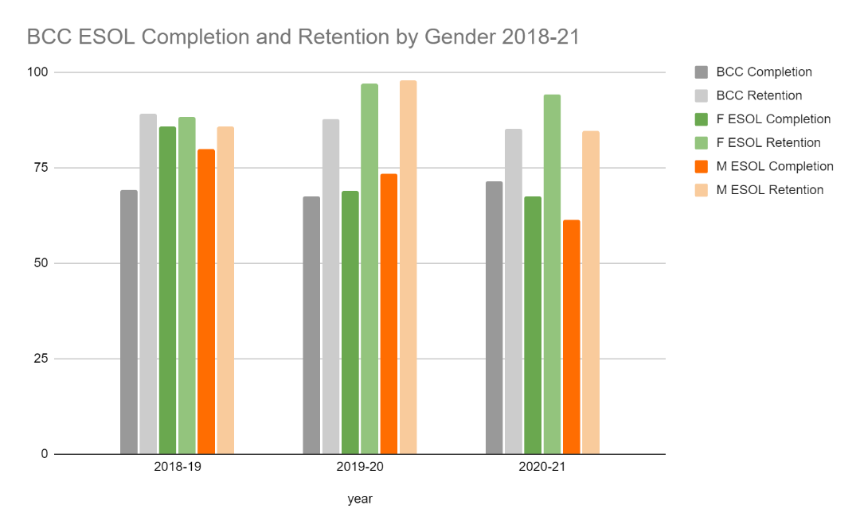
Age: Dashboard data for age shows a mixed picture. In the most recent year, the youngest (16-18) and oldest (55+) groups have the highest completion, presumably because they are less impacted by work and family obligations. These two groups also represent the smallest number of students. The other age groups had slightly lower completion than the college as a whole, which is unusual for ESOL historically. This could be attributed to the precipitous drop in international students, who overall are more highly-resourced and technologically skilled (with many exceptions, of course), combined with the disproportionate impacts of the pandemic on local immigrant students who were more likely to be working extra jobs, home-schooling children, etc.

Ethnicity: Dashboard data for ethnicity shows differences in outcomes in the pandemic year.
I focused on completion only for a clearer comparison. Typically, the completion rates of all ethnicities in ESOL are higher than the college average. What happened in 2019? That was before the pandemic.
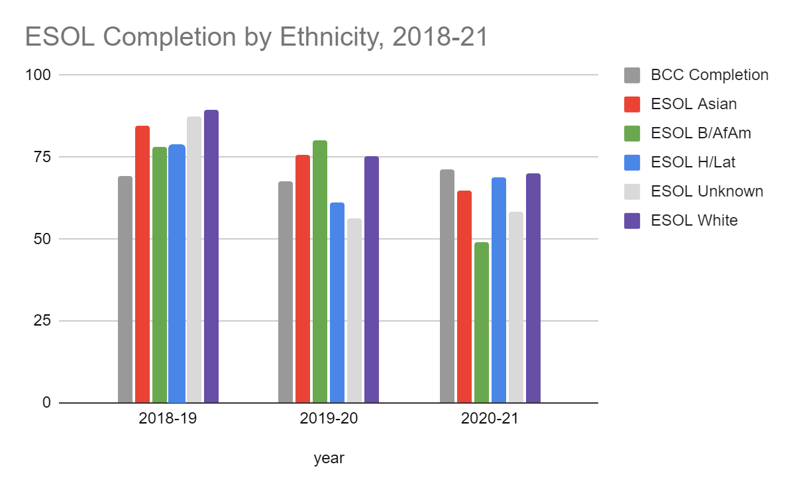
A possible answer can be revealed by disaggregating international students. When we disaggregate for residency, and keep in mind that the number of international students tanked nationwide in 2019, we see that the international vs. in state + out-of-state differences are often more salient than differences between ethnicities. (Black/African American and Unknown/NR international students were not represented in high enough numbers to be included in the dashboards).
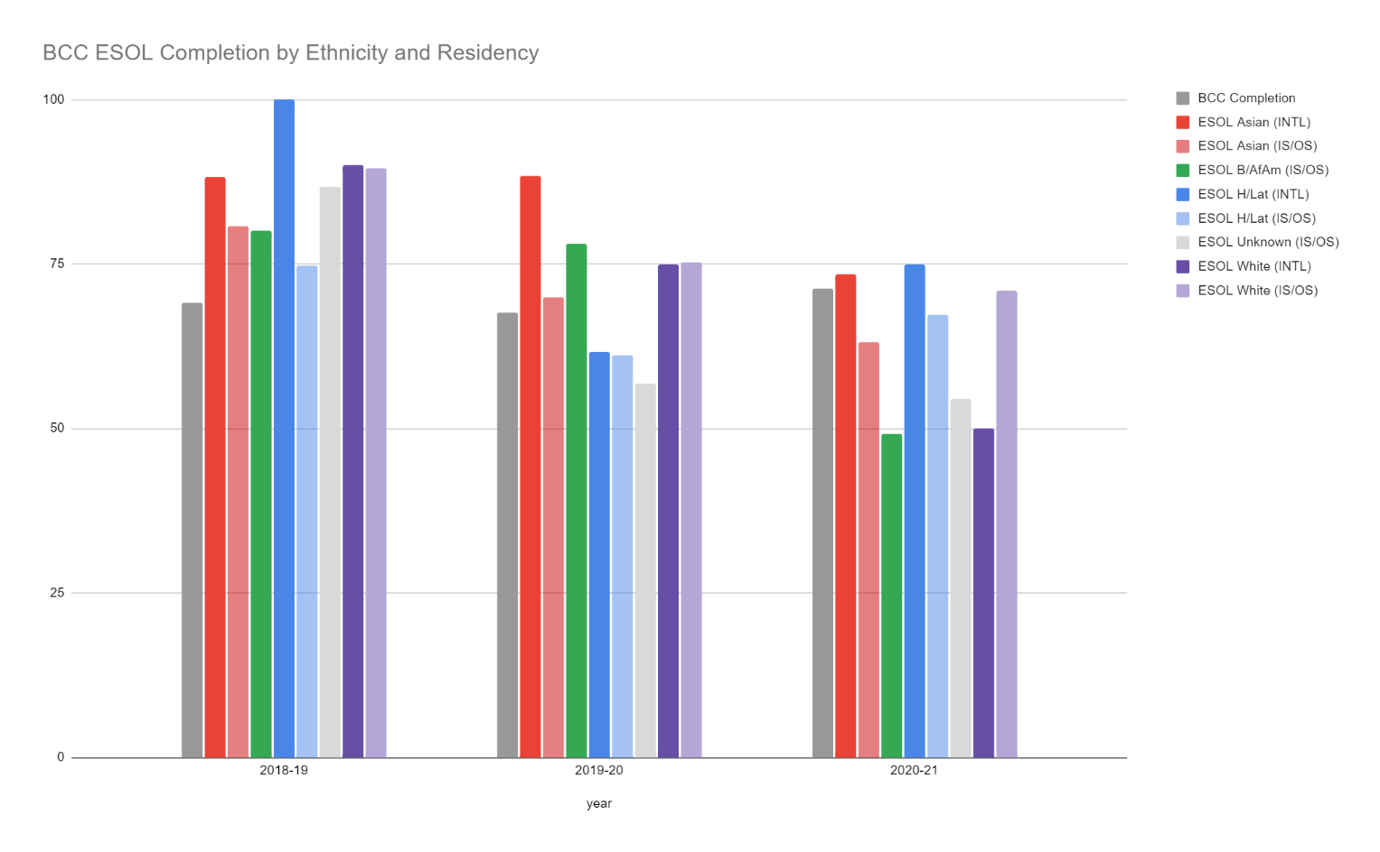
It is possible that (as discussed above) the lower numbers of comparatively well-resourced international students affect these outcomes, an effect that is hidden by combining Asian and Latinx students together by ethnicity rather than separating their statistics based on their residency. For example, completion rates for Asian international students were higher last year than the college average, while rates for local Asian students were lower. Black students may have been statistically harder hit by the pandemic, as their total completion, which had been higher in 2019-20 than local Asian student and all Latinx and white students, dropped below college averages for the first time.

What disproportionately impacted (DI) population(s) showed outcomes gains in your program area and which need more support?
Disaggregate the data and outcomes as far down as a possible then ask:
- What trends do you notice when examining course success rates for disproportionately impacted student populations? Which factors do you believe have the greatest impact (positive or negative) and cause variation between student course success rates between faculty in your department? Describe some specific methods your department/unit is planning or implementing to address these equity gaps. How will you evaluate the efficacy of these interventions?

- How has pivoting to online instruction contributed to potential reductions in student success? Provide some specific examples of practices that faculty in your department have found ineffective in the online environment.
Please review the video from the RP Group acknowledging the interrogation De Anza Community College committed to in their analysis of course completion and success rate:
  - RP project of the Year Award 2020
https://www.youtube.com/watch?v=T4wQVq5a71U&feature=youtu.be
Although the enrollment of international students has dropped to about a third of historical numbers, course completion remains high. The transition to remote learning hit the local students the hardest. However, completion by Latinx students, both international and local, actually went up last year. The pandemic had such pervasive effects on all areas of life that it is not possible to attribute causation entirely to one factor; however, the move to remote learning definitely impacted both enrollment and success for many ESOL students. It is true that some students flourished in the online environment, but for many, the lack of social, auditory, and visual context made it difficult to progress in language acquisition and development of academic skills in English. So much of the learning of an additional language is embedded in the social interactions within and outside of a class, beyond what an online class can facilitate. Students can play a game or analyze a text in a Zoom breakout room, but they cannot do it in real space, stopping to ask a question on the side or using three-dimensional space to anchor a concept. BCC ESOL teachers made great strides in personalizing and enriching the online experience for students, but for many, there is no virtual substitute for a human conversation. Because support services such as tutoring and advising were also only accessible online, students who were struggling tended to drop out rather than persist through difficult points in the semester.
That said, ESOL instructors continued to collaborate to improve our ability to foster student success; we carried out three inquiry projects throughout the pandemic: Non-credit Evaluation and Planning, Grading for Equity, and Liquid Syllabus Development. We also continued to share materials, participate in collaborative assessment, and work on various continuing department projects, including applying for Humanities IGETC credit for ESOL 52 and building a districtwide Guided Self Placement tool.
How do these outcome trends compare to the college average?
Local ESOL Black, Asian, and Latinx students all had completion rates lower than the college average in the last year. In the year before that, the rates were also lower for Latinx students, though not the other two groups.
Another important factor to disaggregate and examine is credit vs. non-credit. In the ESOL department, students take the same courses, but are enrolled as credit or non-credit in a model called “Mirrored Non-credit.” Running a snapshot of non-credit vs. credit retention and completion rates reveals that although retention is higher for non-credit students, completion is lower: 64% vs. 79%.
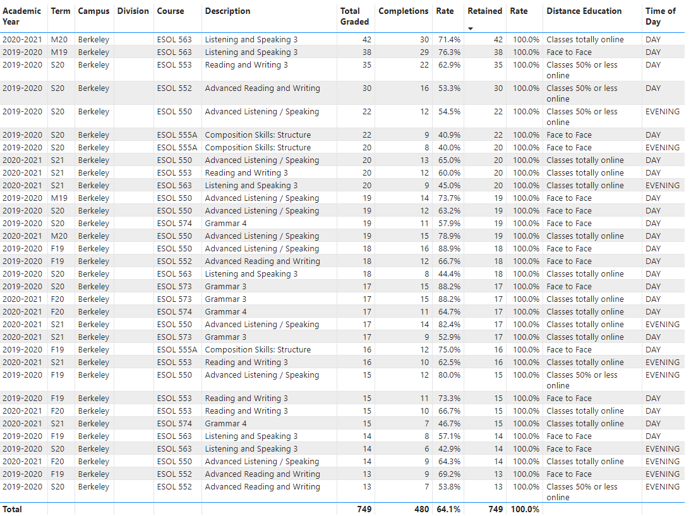
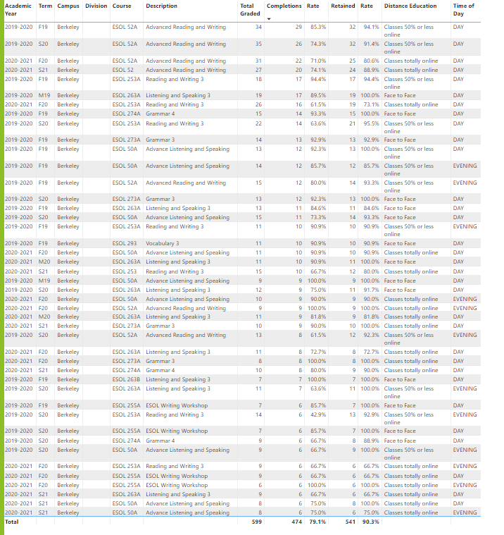

What questions do you have about the trends?
Who are we not counting?
How are au pairs counted? As international or out-of-state students?
Will the international student program rebound now that we are able to issue visas and the political climate is improving?
How can we use retention vs. completion to evaluate where students are encountering barriers to success?
How much will we retain online modalities as an option in the future?
Based on input you’ve received from students, what have they expressed as their need (s) to complete and succeed in your courses? (support your recommendations with examples) e.g., offer diff modalities; timing of day).
- A smoother intake process, (e.g. clear, friendly communication about how to access necessary student services)
- Face-to-face component (many students have expressed how difficult it is to complete assignments and stay engaged online).
- A survey we did in 2019 indicated that students were satisfied with the offerings at different times of day, but the survey by its nature could not include those who had not enrolled for that very reason. Ideally, we could restore the evening program to its former level, offering all three skill areas at both levels over the week.
How will these outcome trends you identified in this section affect your department goals and plans for the next three years?
Year 1 (2021-22) | Year 2 (2022-23) | Year 3 (2023-24)
Transition back to partial F2F classes; continue to improve placement and intake | Build back evening program including grammar and more reading/writing sections if enrollment allows; continue collaborative work on Grading for Equity; work with LRC to rebuild tutoring | Connect with Guided Pathways; work with other equity initiatives at BCC (e.g. Conocimiento Los Caminos) to support DI students

3C. Degrees and Certificates Dashboard
On page 1 of the “Degrees and Certificate Awards Trends” Dashboard, what are the award trends for your department (overall, by gender, age, and ethnicity).
The dashboard shows an overall decline in certificates of competency and proficiency (57 to 15) in the last three years. Asian students received the most certificates, Latinx students not commensurate with enrollment numbers, and Black students hardly any.

On page 4, what DI population(s) award trends showed gains in your program area and which populations need more support?
ESOL has very few students in some of the DI categories, by nature of the subject. Low income ESOL students received even fewer certificates than the college as a whole. As recommended below, an automatic or at least systematic way for students to apply for certificates will increase the numbers. Latinx enrollment exceeds any other ethnicity in the noncredit courses; reducing barriers to students applying for certificates of competency will increase the number of Latinx students receiving certificates.

How do these outcome trends compare to the college average?
Latinx and Black students in ESOL were awarded fewer certificates than the college as a whole, proportionate to enrollment and limited to type of certificate.
Based on input you’ve received from students, what have they expressed as their need (s) to complete their degrees and/or certificates? (support your recommendations with examples)
Since many students complete the requirements for the certificates but do not apply to receive them, the college needs to either 1) institute a degree-audit system to automatically award certificates to those who qualify so it is not a difficult bureaucratic opt-in hurdle, or 2) provide support for student services to systematically help students apply.
The other important improvement, if possible, will be to develop state-approved credit certificates of achievement (16 units or more) that incorporate units from other disciplines. Part of the low numbers of certificates awarded is due to students not knowing about them or finding it difficult to apply, but it is also possible that many students have less motivation to apply for an ESOL certificate or proficiency or competency that is only locally recognized and does not confer as much tangible benefit as a certificate of achievement.

How will these outcome trends you identified in this section affect your department goals and plans for the next three years?
Year 1 (2021-22) | Year 2 (2022-23) | Year 3 (2023-24)
Resume publicizing certificates and how to apply; hold workshops to assist students in applying. | If supported by the college, develop new ESOL Momentum certificates that align with Guided Pathways | Implement and publicize new certificates.

3D. Transfer Dashboard
This dashboard does not provide data by subject. Reflect on what you can do to affect student transfer. How may your department help to support BCC student transfer? (e.g., serve on panels, strengthen GP in your dept, change curriculum, increase number of AD-Ts, etc.)
The ESOL Department provides students with a foundation for other academic and vocational courses; continuing to support English learners after they leave the program is a strategy we have pursued for years by various means. One way to do this will be forging strong connections through Guided Pathways as those programs develop. Another is continuing our collaborative work to increase both academic rigor and support within the ESOL curriculum.

3E. Curriculum
View the department’s curriculum through the lens of student equity outcomes. BCC outcome data suggests that disproportionately impacted groups of students experience low rates of success.
How do you plan to adjust the curriculum to advance student equity and address DI student outcome gaps?
Examples include: making adjustments to lesson plans based on student assessment outcomes; review pedagogy and revise assignments for culturally relevant content; simplify student processes and make service areas student-centered; manage class discussions and student participation; review best practices, etc.).
The ESOL department is continuously working to address inequitable outcomes through student-centered pedagogy, culturally relevant materials, and programmatic design. Last year most of the instructors in the department participated in an inquiry group through the Teaching and Learning Center focused on Grading for Equity by Joe Feldman. Our findings were transformative. Many of us made significant changes to our grading policies based on research-informed practices to reduce equity gaps.
Some of us also revised our syllabi to be clearer and more inviting to students, and designed “liquid syllabi” to welcome students in before classes start as part of another TLC group project. Throughout the pandemic, we have shared strategies to humanize the online environment and try to replicate the classroom community virtually.
As we return to in-person classes, we will take the best of what we have learned to do in the online environment back to the classroom, and pay special attention to the affective realm during what will likely be a stressful as well as joyful transition. We will continue our collaboration as much as possible to keep improving the program.

In the boxes below, add improvement actions that are directly related to Student Equity & Success. If there are no improvement actions in this area, leave blank. If you have more than one Improvement Plan, add more by copying and pasting the table below.
IMPROVEMENT ACTIONS
Department/Discipline: | ESOL
Action Name: | Increase certificates awarded
Description: | Increase the number of certificates of proficiency and competency awarded, to at least 75% of the students who are eligible based on their course completion.
Completion timeline: | Spring 2024
Responsible person: | ESOL faculty, counseling, A&R
In the boxes below, add improvement actions that are directly related to Student Equity & Success. If there are no improvement actions in this area, leave blank. If you have more than one Improvement Plan, add more by copying and pasting the table below.
IMPROVEMENT ACTIONS
Department/Discipline: | ESOL
Action Name: | Streamline placement and enrollment of new students
Description: | Develop and implement a clear path with transparent responsibilities for welcoming new ESOL students into the college, helping them find their appropriate levels, and guiding them into their courses while reducing barriers.
Completion timeline: | Spring 2024
Responsible person: | Student Services, District offices, Office of Instruction, counseling, A&R, and Transitions Liaison, in consultation with ESOL faculty

III. PROGRAM GOALS
- List your current Department Goals.
Support faculty and students in online teaching and learning and participate in the safe return to campus. (Goal I)
Increase completion rates for Black and Latinx students.
(Goal II)
Continue to recruit and support non-credit students from the community. (Goal V)
Evaluate course and level offerings in light of current student population. (Goal II and IV)
Work toward joining ESOL with Guided Pathways. (Goal IV)

- How do the goals align with the College goals? If so, which ones?
Berkeley City College Goals
- GOAL I: Strengthen Resilience: Strengthen BCC students’ abilities to become self-directed, focused and engaged in the pursuit of transformative, life-long learning experiences that result in personal and academic success.
- GOAL II: Raise College Competence: Raise student skills and competencies, and expand their learning experiences, so that they can successfully complete their college program.
- GOAL III: Enhance Career-Technical Education Certificates and Degrees: Enhance BCC’s 1- and 2-year career and technical education programs so that they provide current and transferable skills and competencies to earn a living wage in our area, and to maintain competency for advancement in one’s career.
- GOAL IV: Increase Transfer and Transfer Degrees: Ensure that all of BCC’s programs of study and transfer pathways for degrees prepare students, in a timely manner, for multiple transfer options.
- GOAL V: Ensure Institutional Sustainability: Increase BCC’s impact in education through innovation, internal and external collaboration and partnerships, and sufficient resources, both short-term and long-term.
See above.

- Assess your facilities utilization (including labs, support for online learning, and other spaces) and for each year, indicate if the space is insufficient. If so, what are the needs and why? *Note that facility needs and planning are addressed in the Facility Master _{.0}Plan for the college, including the planning for new buildings.
Year 1 (2021-22) | Year 2 (2022-23) | Year 3 (2023-24)
Facilities are sufficient. | We would like to move to the new building and have designated classrooms. | To be determined.
- What are the essential functions of your department, any unique characteristics or trends? Provide specific examples.
BCC’s ESOL Department serves local immigrants and international students, providing non-credit and credit offerings in three skill areas (reading/writing, listening/speaking, and grammar) at the high intermediate and advanced levels.
The department has made significant progress in reducing inequities in the last ten years, as part of the broader movement to scrap traditional remedial education that works on a “deficit model” that disproportionately impacts Black, Latinx, and language minority students. Traditional remedial ESL pathways are inherently based on the obviously false but powerful idea that no matter what else a student already knows, English fluency equals intelligence. Through this pervasive and corrosive lens, remedial curriculum and course sequences view the developing English skills of multilingual students as a deficit to be corrected rather than recognizing students' inherent intelligence and the indisputable value of multilingualism. Students are required to master discrete parts of the language by taking a long sequence of basic skills courses before being allowed to participate in intellectually rigorous core curricula. Despite the good intentions of many individuals, the remedial model has had devastating effects. The structure itself devalues and demoralizes students, and accepts exponential attrition as inevitable.

Starting around 2009, BCC’s ESOL, English and math departments joined the acceleration movement. Working with colleagues across departments and the district, we have overhauled ESOL course sequences and content and transformed our placement process to maximize students’ likelihood of progressing through English 1A. Many of these efforts have been designed backward from that one course, which is indeed a crucial gateway to the rest of college. It’s apparent that our work has paid off: the following chart from the CCC’s Transfer Level Gateway Completion Dashboard, shows the increase in students who began in ESOL classes passing English 1A:

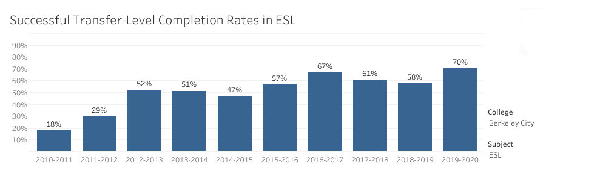
Beyond English, the ESOL Department has undertaken multiple efforts in the past to build bridges between ESOL and other disciplines, including special electives, CTE collaboration, class pairings, cross-disciplinary inquiry, and professional development for ESOL and other faculty.
- Describe how external factors (if applicable), such as State and Federal laws, advisory board recommendations, district and college governance have an impact on the support services your department provides. (e.g., partnered with dual enrollment and contract Ed programs at K-12 districts and high schools; support staff at high schools have access to Canvas to follow along and support students; allow tutors into the classes; Guided Pathways, AB 705, etc.)
AB705 has been the most significant policy driver of our progress in the last 4 years; before that, BCC’s ESOL department was working on all the same strategies promoted by AB705: placement reform, shortening pre-transfer sequences, and supporting students to complete college-level curriculum. We have also partnered with Berkeley Adult School and local high schools. We closely follow recommendations from and sometimes participate in presentations with the RP Group, TESOL, California Acceleration Project, and other organizations promoting student success and equity.

Based on your responses to questions 4-8, are there areas that need improvements? If so, add improvement actions below. If there are no improvement actions in this area, leave blank. If you have more than one Improvement Plan, add more by copying and pasting the table below.
IMPROVEMENT ACTIONS
Department/Discipline:
Action Name:
Description:
Completion timeline:
Responsible person:

- ASSESSMENT
Berkeley City College is committed to a culture of assessment to improve instruction, services, and institutional planning. Findings from SLO, PLO, ALO assessments, and program review data are used to direct resources for areas that are institutional priorities that are articulated in the Educational Master Plan and BCC Strategic Plan. Due to the critical role that course and program assessments play in our institutional planning and to be in compliance with the Accreditation requirements, the Program Review resource allocation requests require the completion of assessment in order to qualify.
9A. List and describe the department/program’s progress and reflection on Student Learning Outcomes (SLOs), Program Learning Outcomes (PLOs), and/or Service Area Outcomes (SAOs). If your department/program offers a degree or certificate, please describe the department’s progress on Program Learning Outcomes (PLOs).
The department completes SLO assessments on the core reading/writing courses (ESOL 253, 553, 52, and 552) every semester through collaborative portfolio assessment. The other courses are cycled through according to the assessment schedule. The Program Learning Outcomes are aligned directly with the primary SLOs of the reading and writing, listening and speaking, and grammar courses.
9B. What improvement plans did your department identify upon the assessment of each program? How has your department used the results of assessment to improve student learning outcomes and/or curriculum? Please be as detailed as possible.
Reading and writing:
SLO 1: Mechanics and Usage.
• Provide instruction in most frequent mechanical errors. Teach proofreading skills so students can find and correct errors in writing.
• While grammar is not a main focus of the course, instructors may provide general mechanical error feedback so that the student is aware of their trouble spots.
• Recommend grammar course for students whose grammar significantly impacts comprehensibility of writing.

SLO 1: Multiple Perspectives
• Build rationale with students for addressing multiple perspectives. Discuss how it strengthens writing and makes it more persuasive.
• Share rubric with students. Review multiple perspectives requirement.
• Analyze models of successful and unsuccessful examples multiple perspectives in writing.
• Guided activity in identifying and responding to an opposing perspective.
Listening and Speaking:
Reinforce target vocabulary through additional practice (quizzes, and other in-class and online exercises). Include more practice in the areas listed in the pronunciation section of the rubric (phonemes, word and phrasal stress, reductions, intonation, pacing, cadence and linking).
Develop materials/ exercises for pragmatics practice, particularly in the areas of “back-channeling,” follow-up questions, following a thread for an extended period and asking comprehension questions for misunderstandings.
Grammar:
Expose students to correct examples of correct writing.
Revamp the regularly used textbook and adopt the new OER.

Instructors are engaged in continuous improvement based on assessment result for each skill area.
9C. Describe how the program has made use of information from the data it has from program and student learning outcomes in Round 4 (last cycle of the last 3 years) for continuous improvement. Include the three most significant plans for improvements as a result of the assessment process with timelines. Click here to view your Assessment Calendar
Reading and writing:
SLO 1: Mechanics and Usage.
• Provide instruction in most frequent mechanical errors. Teach proofreading skills so students can find and correct errors in writing.
• While grammar is not a main focus of the course, instructors may provide general mechanical error feedback so that the student is aware of their trouble spots.
• Recommend grammar course for students whose grammar significantly impacts comprehensibility of writing.

SLO 1: Multiple Perspectives
• Build rationale with students for addressing multiple perspectives. Discuss how it strengthens writing and makes it more persuasive.
• Share rubric with students. Review multiple perspectives requirement.
• Analyze models of successful and unsuccessful examples multiple perspectives in writing.
• Guided activity in identifying and responding to an opposing perspective.
Listening and Speaking:
Reinforce target vocabulary through additional practice (quizzes, and other in-class and online exercises). Include more practice in the areas listed in the pronunciation section of the rubric (phonemes, word and phrasal stress, reductions, intonation, pacing, cadence and linking).
Develop materials/ exercises for pragmatics practice, particularly in the areas of “back-channeling,” follow-up questions, following a thread for an extended period and asking comprehension questions for misunderstandings.
Grammar:
Expose students to correct examples of correct writing.
Revamp the regularly used textbook and adopt the new OER.

Instructors are engaged in continuous improvement based on assessment result for each skill area.
9D. How does your department, program, or unit ensure that students are aware of learning or service area outcomes?
SLOs are listed on all syllabi and on the department website, and instructors reference the SLOs in class and on Canvas activities.

9E. Besides your syllabi, where are the service area and/or program level outcomes published? If on a website, please specify the URL.
https://www.berkeleycitycollege.edu/esl/

In the boxes below, add improvement actions that are directly related to Assessment. If there are no improvement actions in this area, leave blank. If you have more than one Improvement Plan, add more by copying and pasting the table below.
IMPROVEMENT ACTIONS
Department/Discipline:
Action Name:
Description:
Completion Timeline
Responsible person:

- ENGAGEMENT
10A. Discuss how faculty and staff have engaged in institutional efforts such as committees, presentations, and departmental activities. Please list the committees that full-time faculty/staff/admin participate in.
ESOL instructors continued to collaborate to improve our ability to foster student success; we carried out three inquiry projects throughout the pandemic: Non-credit Evaluation and Planning, Grading for Equity, and Liquid Syllabus Development. We also continued to share materials, participate in collaborative assessment, and work on various continuing department projects, including applying for Humanities IGETC credit for ESOL 52 and building a districtwide Guided Self Placement tool.
Full-time faculty serve on Department Chairs Council, Peralta ESOL Advisory Committee, Tenure Review Facilitator, Guided Self-Placement Task Force, serve as scholarship readers, and are working on a book for the ASCCC OERI. Adjunct faculty participate in inquiry groups, serve as liaison to Assessment Committee, and share materials as partners in collaboration.
10B. Discuss how faculty and staff have engaged in community activities, partnerships and/or collaborations.
ESOL faculty have organized a Sierra Club hiking group for students, facilitated guest speakers including formerly incarcerated artists, volunteered at the Berkeley Food Pantry as part of a BCC effort, and worked with outreach/liaisons to Berkeley Adult School.
10C. Discuss how adjunct faculty members are included in departmental training, discussions, and decision-making.
Adjunct faculty participate fully in collaborative assessments, inquiry, and planning.
- 10D. Discuss the relationship and engagement with other support services, programs, departments, or administrative units and how these relationships support your area to meet its goals.
The ESOL department works closely with the International Office, the Undocumented Community Resource Center, counseling, Transitions Liaison, the Learning Resources Center, and the Teaching and Learning Center.

In the boxes below, add improvement actions that are directly related to Engagement. If there are no improvement actions in this area, leave blank. If you have more than one Improvement Plan, add more by copying and pasting the table below.
IMPROVEMENT ACTIONS
Discipline:
Action Name:
Description:
Completion Timeline
Responsible person:

VI. Prioritized Resource Requests
In the boxes below, add a 3-year resource requests for your department/program that have not been funded by existing funding sources. Work with your supervisor to estimate costs. If there are no resource requested, leave the boxes blank.

Click here to view the Resource Request Process and Timeline

Resource Category | Description/Justification | Estimated Annual Salary Costs | Estimated Annual Benefits Costs | Total  Estimated  Cost | Overall  Priority Ranking of ALL Requests (1=Most important, 2=Second Most Important, etc.)
Personnel
Classified Staff | Yr 1= .5 outreach/advising  Yr 2=  Yr 3=
Student Worker | Yr 1=  Yr 2=  Yr 3=
Part Time Faculty | Yr 1=  Yr 2=  Yr 3=
Professional Development | Description/Justification |  |  | Estimated Cost
Department wide PD needed | Yr 1= stipends for collaborative work  Yr 2= stipends for collaborative work  Yr 3= stipends for collaborative work
Personal/Individual PD needed | Yr 1=  Yr 2=  Yr 3=
Supplies | Description/Justification |  |  | Estimated Cost
Software (for whom or role?) | - Yr 1= Adobe  - MS suite  - Quizlet subscription  - Kahoot subscription  - ESL library.com  Yr 2=  Yr 3=
Books, Magazines, and/or Periodicals | Yr 1=  Yr 2=  Yr 3=
Instructional Supplies | Yr 1=  Yr 2=  Yr 3=
Non-Instructional Supplies | Yr 1=  Yr 2=  Yr 3=
Technology & Equipment | Description/Justification  Before you list your technology request, click here to view the latest Technology Refresh Plan to verify whether it has already included. |  |  | Estimated Cost
New | Yr 1=  Yr 2=  Yr 3=
Replacement | Yr 1=  Yr 2=  Yr 3=
Facilities | Description/Justification |  |  | Estimated Cost
Classrooms
Offices
Labs
Other
Library | Description/Justification |  |  | Estimated Cost
Library materials (including streamline media needs) | Yr 1=  Yr 2=  Yr 3=
Library collections
OER
Other | Description/Justification |  |  | Estimated Cost
OTHER Description | Yr 1=  Yr 2=  Yr 3=

Thank you for your time and effort in completing the Program Review!
Please email the completed Program Review to your Dean by November 30, 2021.

