Berkeley City College’s mission is to provide our diverse community with
educational opportunities, promote student success, and to transform lives.

Introduction and Directions

The Peralta Community College District has an institutional effectiveness process which consists of the following components: a District-wide Strategic Plan which is updated every six years; Comprehensive Program Reviews which are completed every three years; and Annual Program Updates (APUs) which are completed in non-program review years.

The Program Review 2021-22 timeline has been developed for each program and services to guide through the semester. Please review and work with your Deans, Managers, Department Chairs and/or Supervisors to complete this Program Review.

The Program Review is intended to primarily focus upon planning for the subsequent two years and institutional effectiveness. The Program Review process directly leads to the institutional resource allocation process and budget planning for the following academic year (2022-23). This is an opportunity for each administrative unit, support service program, and department to reflect on progress made and identify areas of program improvements to achieve equitable student success and elimination of achievement gaps. In this process of making continuous quality improvement, there is an opportunity for each program, student services, and department to request resources that support achieving the stated goals.

If you have questions regarding other material in the Program Review, please contact your Dean or Manager. If you have questions regarding data, please contact Dr. Phoumy Sayavong, Senior Researcher and Planning Analyst (psayavong@peralta.edu).

Please email the completed Program Review to your Dean by November 30, 2021.

COLLEGE PROFILE
Click here to view the Berkeley City College Student Demographics Dashboard.
This 2-page dashboard will provide information on the characteristics of our student body from the past two years such as headcount, ethnicity, enrollment status, age group, educational goals, and majors.
College Outcomes | 2017-2018 | 2018-2019 | 2019-2020 | 2020-21
Full Time Equivalent Students (FTES) | 4,140 | 3,864 | 3,696 | 3,290
Efficiency  (Productivity; avg faculty-student ratio) | 13.4 | 13 | 13.2 | 14.3
Success Rate (%) | 67% | 69% | 67%* | 74%
Degrees + Certificates Awarded (#) | 1,021 | 948 | 1,106 | 1,014
*Excludes “EW” grades

To view prior Program Reviews, click here. To view prior Annual Program Updates, click here.

- DEPARTMENT DESCRIPTION
Please verify the mission statement for your department. If your program has not created a mission statement, provide details on how your department supports and contributes to the College’s mission.
In addition to the mission of the Social Sciences Department, the mission of the anthropology
discipline at Berkeley City College is to support student success by providing students with the
intellectual and methodological skill sets necessary to successfully transfer to a four-year institution
and/or find employment in the applied sector. The Anthropology discipline supports academic
excellence by emphasizing quality instruction and sound curriculum that will expose students to
contemporary theories, research methods, and skills used by anthropologists.

Name(s) of member(s) completing this Program Review | Department/Program | Completion Date
Thomas J. Kies | Social Sciences | 11/30/21
List faculty names and/or staff with assignments in fall 2021.
Full Time | Part Time
Thomas J. Kies, Ph.D. | Daniel Cusimano, MA.  Mather George, Ph.D.  Sheila Thomas, MA.  Nicole Wilson, Ph.D.

II. STUDENT EQUITY & SUCCESS
Using the data dashboards provided below, review and reflect upon the outcome trends for your department. You may use data from other sources if available.

Click here if you would like to view BCC’s Planning Documents (Education Master Plan, College Strategic Goals, Student Equity Plan, District Strategic Goals, Vision for Success, Guided Pathways, Technology Plan, Facilities Plan)

For assistance with data dashboards, contact Phoumy Sayavong at psayavong@peralta.edu

3A. Enrollment Trend and Productivity Dashboard
*Note that completion and retention rates are presented with the inclusion and exclusion of excused withdrawals (EW) and military withdrawals.
What are your enrollment trends in the past three years?
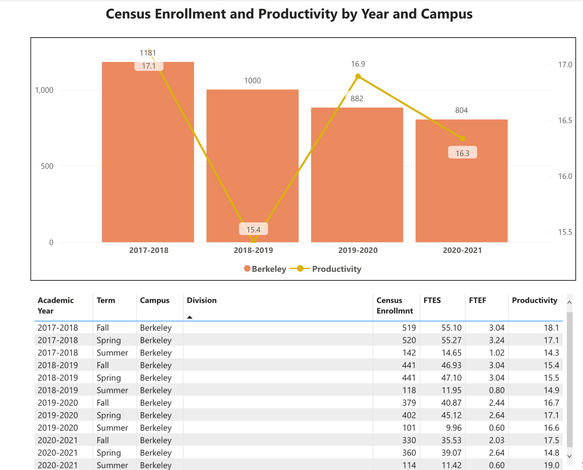
Figure 1. All Anthropology Courses at Berkeley City College, Census Enrollment and Productivity

As is apparent we are in a downward turn in terms of our enrollment over the last three years. An important aspect though is that we have kept our productivity above the college average. It is especially concerning when viewed in the light of the other anthropology programs in the Peralta District.

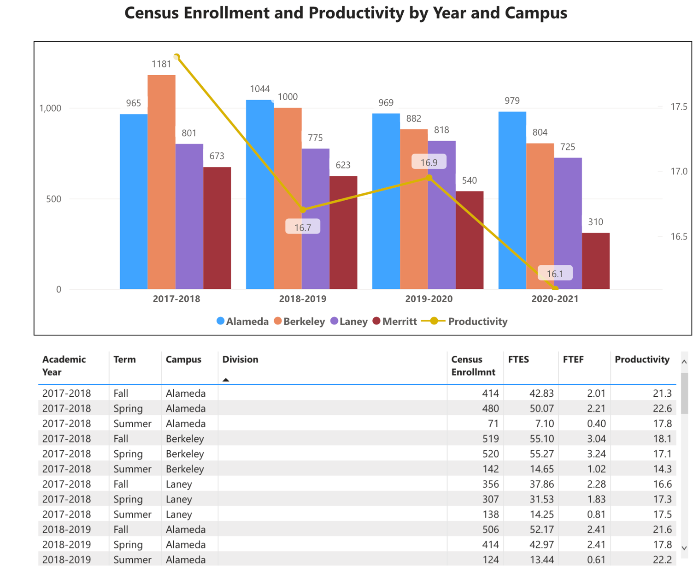
Figure 2. Anthropology Census Enrollment and Productivity, Peralta District
While concerning, the program coordinator reviewed other programs in the Social Sciences Department at Berkeley City College and there are similar declining trends at Berkeley City College in Sociology, Political Science and to a lesser degree Psychology. This is possibly a college-wide issue and undoubtedly the return to in-person instruction should see enrollments increase to levels similar to pre-pandemic levels. Not to single anyone out, but simply to show the broader trend in social science enrollments at BCC, a look at Sociology (see figure 3) shows similar reductions at play. It is interesting how in these two case studies, College of Alameda was able to be more consistent than BCC.

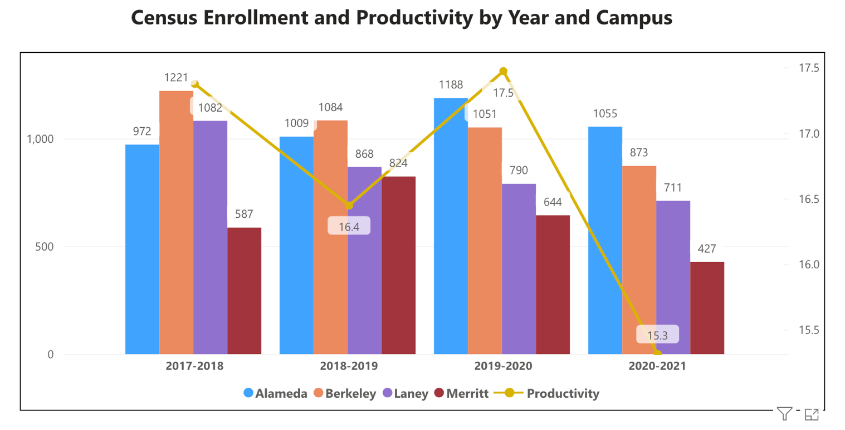
Figure 3. Sociology Census Enrollment and Productivity, Peralta District.

Anthropology Course Enrollment and Productivity—
While Sociology shows similar trends, it is important to contemplate at the course level the major courses in anthropology and also consider our peripheral sections. Under first inspection will be our major courses followed by those that are less frequently offered.

Without a doubt ANTH 1 Introduction to Physical Anthropology is our most popular course within the anthropology program. In Figure 4 you can see that the enrollment in ANTH 1 has been declining. In fact, during Fall 2021 we ended up having to cut two sections of ANTH 1 due to low enrollment. While the trends are declining, it would seem that the transition to online education due to the Covid crisis exacerbated this trend. Productivity however has continued to be strong and above the college average with this course.

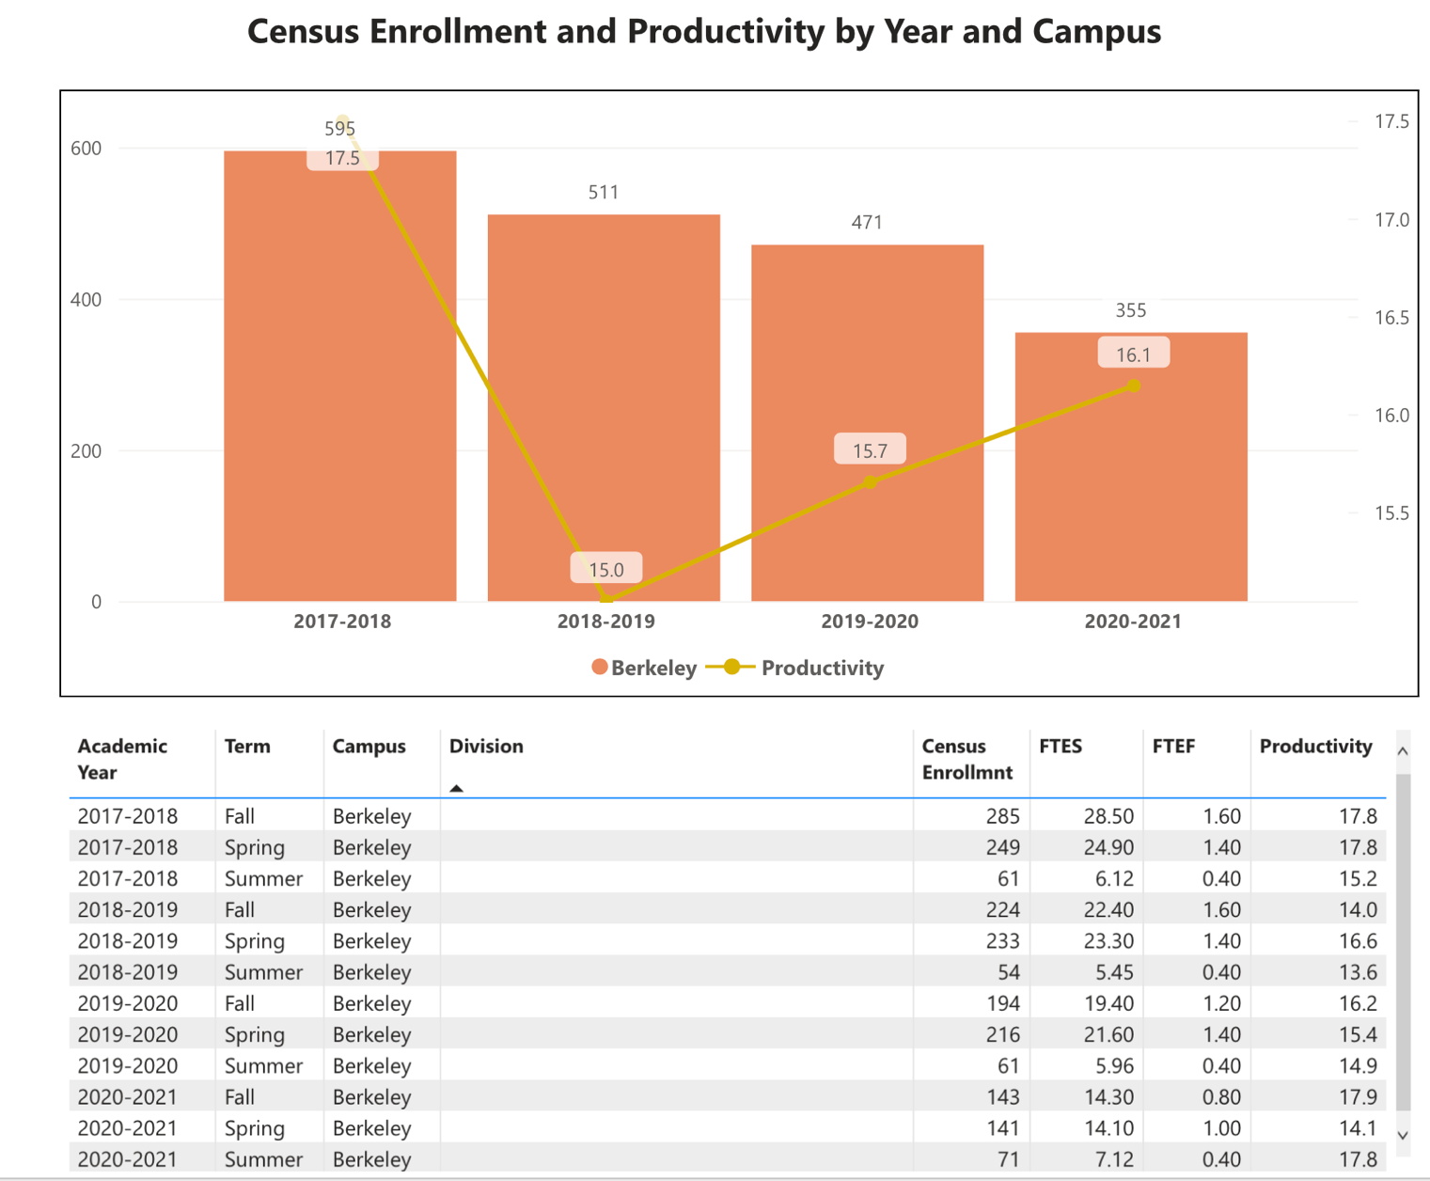
Figure 4. ANTH 1 Introduction to Physical Anthropology Census Enrollment and Productivity Berkeley City College
Associated with ANTH 1 is our ANTH 1L lab component. This is a great aspect of our program as students are not only able to get their social science general education requirements completed in anthropology but also their natural science lab + lecture requirement for transfer. We are happy to
report that BCC has continued our commitment to laboratory science learning and continue with high productivity in this course.
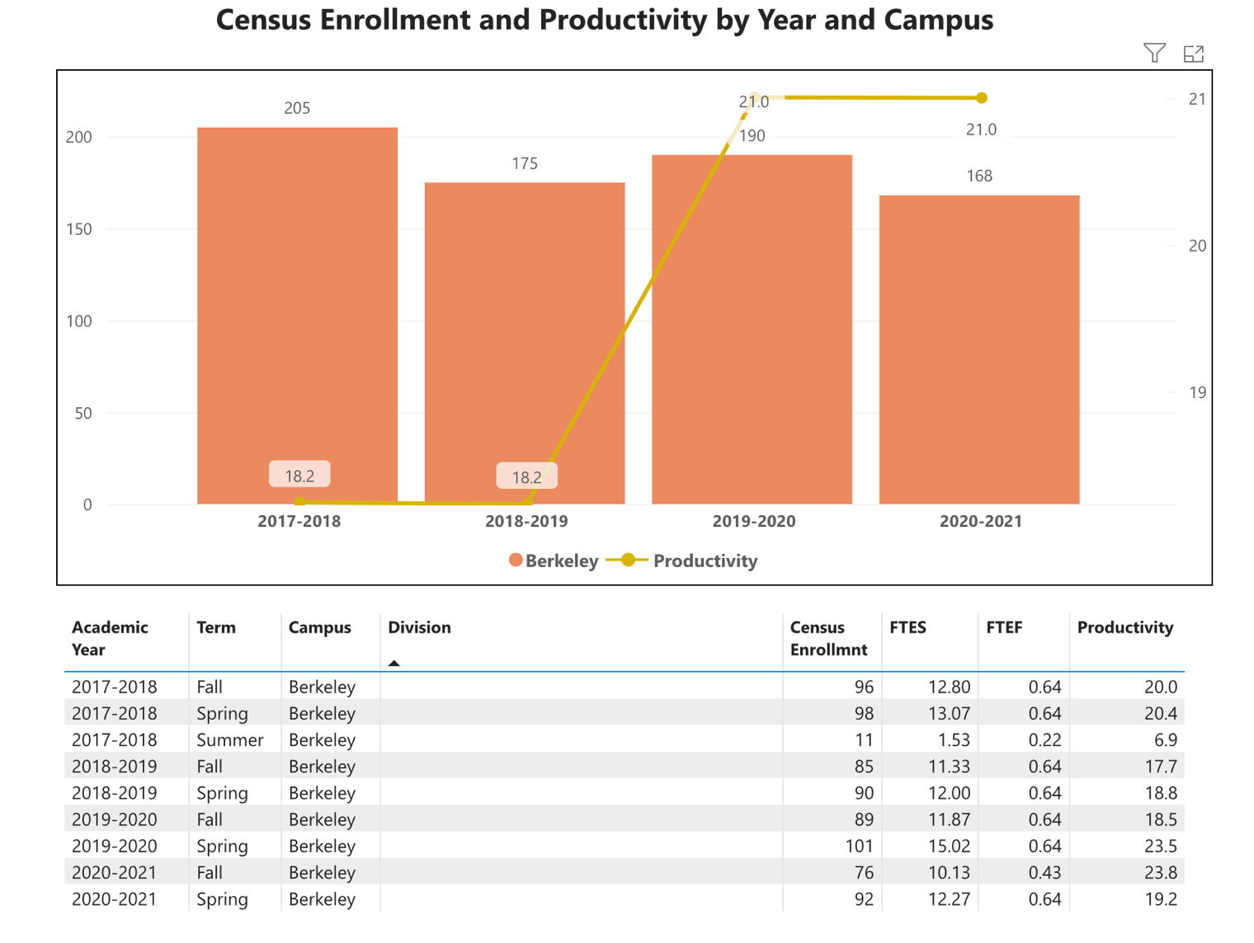
Figure 5 ANTH 1L Physical Anthropology Laboratory Census Enrollment and Productivity Berkeley City College
As noted above, our lab courses have continued to have a solid pull from students and have remained strong in terms of enrollment and productivity though we have reduced to two sections due to the Covid pandemic. Starting in 2020-2021 all lab course sections have been remote. Typically, in previous semesters we would have offered three sections each semester and all of these would have been face-to-face. With our return to campus, the anthropology program looks forward to increasing the number of in-person labs, though we did come to appreciate and plan to continue at least one online section of ANTH 1L as it has been deemed to be effective and useful for many students. Too our discussion with our faculty partners throughout the district shows attempts to try and offer ANTH 1L as a hybrid in the district. We often hear complaints from students that the 4-unit but 1-credit lab requires many in person hours for the 1-credit course. A hybrid option may be something to increase student appeal to the lab and certain aspects of the lab are well-suited to hybrid organization. Scheduling ANTH 1L will be ongoing during the next review period.
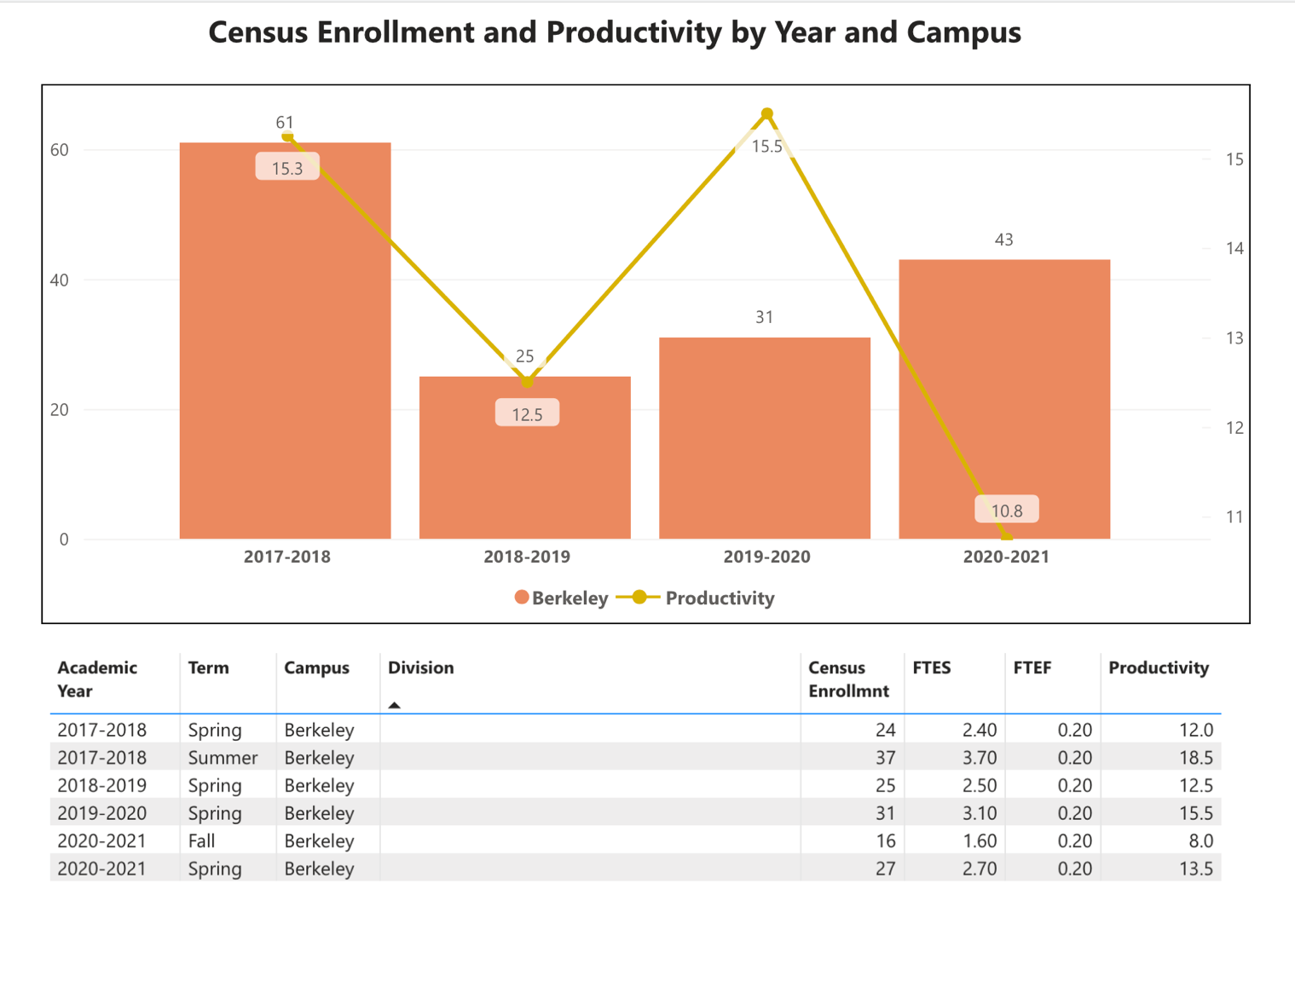
Figure 6. ANTH 2 Introduction to Archaeology Census Enrollment and Productivity Berkeley City College
Introduction to Archaeology and Prehistory is required for our anthropology majors and over the past few semesters the program coordinator has worked to try and increase the offering from a once-a-year course to every semester. Again, as with all of the courses in this survey, the transition to online instruction might be a factor with current enrollment figures. However, reviewing the data, perhaps the course should be placed back on a once-a-year cycle to improve productivity. As the return to campus continues, we will assess how the once-a-year compares to offering it every term as things progress into the next three-year review period. One of the arguments to keeping it every semester is that if a student needs the course, a fall or spring option could be the difference with a student applying for an anthropology AD-T versus applying for a Liberal Arts, Social Science AA. Some discussion of course rotation ideas with ANTH 2 discussed below within the ANTH 18 section discussion.

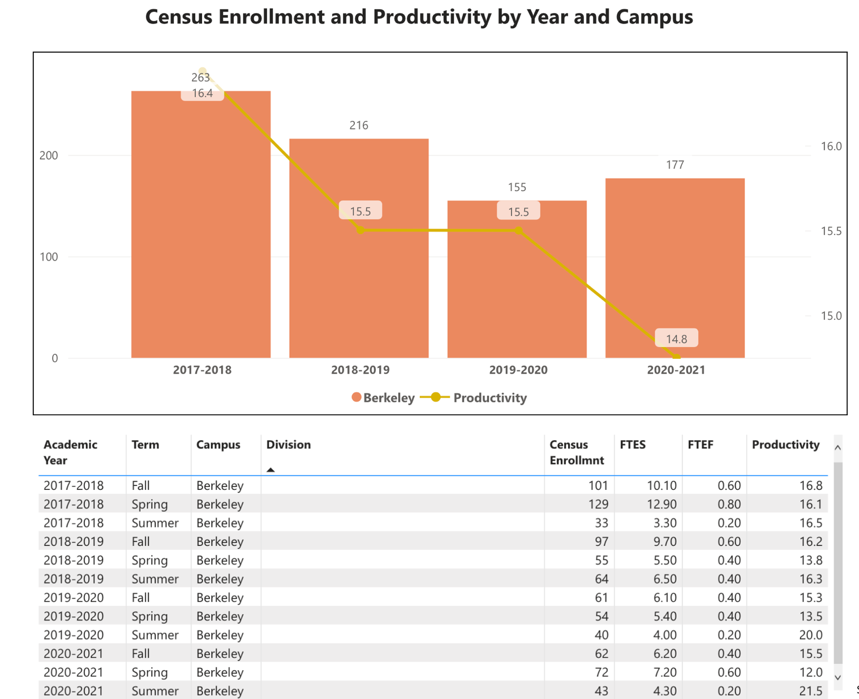
Figure 7. ANTH 3 Cultural Anthropology Census Enrollment and Productivity Berkeley City College.
Interestingly there has been a decline in the number of sections of cultural anthropology over this review time period at Berkeley City College. For years we have sustained three to four sections of ANTH 3 and now we are down to two sections within our current rotation. Interestingly this pattern is evident not only at BCC alone but also at the other Peralta colleges as well (See Figure 8). Perhaps this reduction is due to our offerings being only online and we look forward to expanding ANTH 3 offerings as we return back to in-person instruction. Future enrollments will help us assess the best modalities for the course. As we seek ways to expand offerings, perhaps ANTH 3 could be an ideal course to promote to learning communities around campus to increase the section offerings in coming semesters.
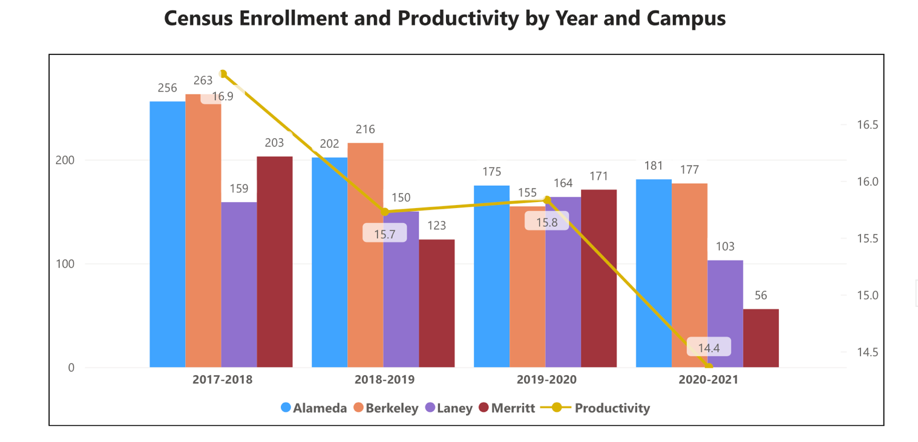
Figure 8. ANTH 3 Cultural Anthropology Census Enrollment and Productivity, Peralta District
Figure 8 merely places the discussion above into the context of the reduction of course sections across the district in cultural anthropology and also shows our productivity at Berkeley City College in a similar situation as that happening at other colleges in the district. In fact, other colleges have in fact been impacted more intensely than Berkeley City College with the shift to online education during the Covid crisis.

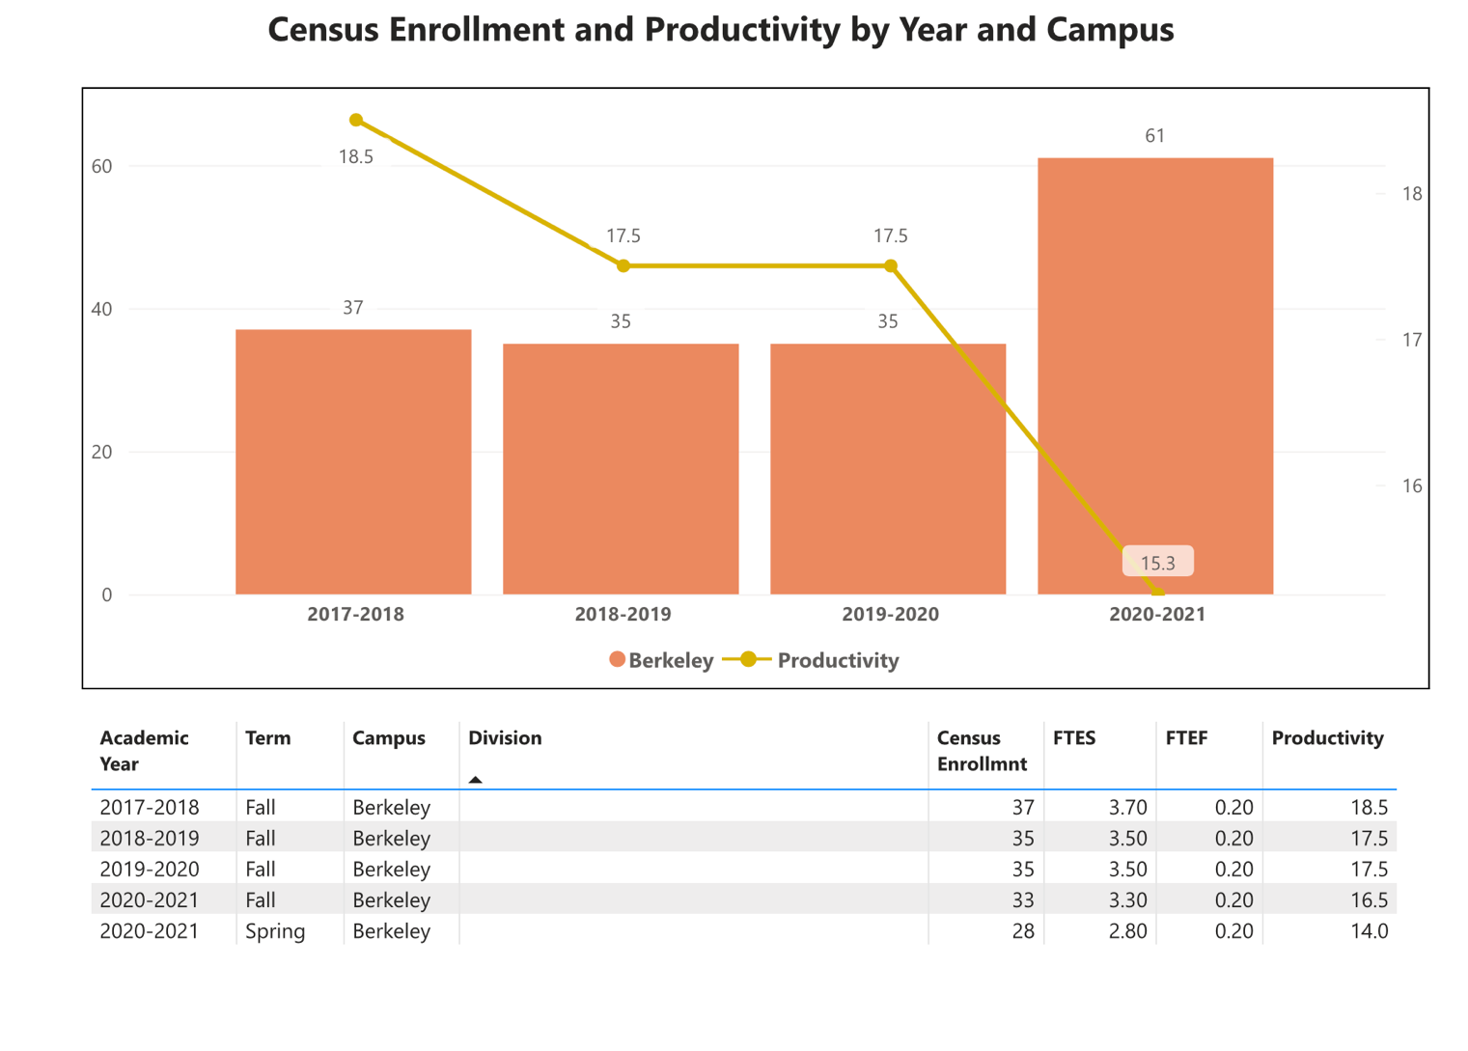
Figure 9. ANTH 18 Linguistic Anthropology Census Enrollment and Productivity Berkeley City College
What is noticeable in figure 9 is our shift from offering ANTH 18 as a once-a-year course in the fall semester each year to being offered every semester in 2020-2021. On a positive note, the total number of students has increased with this move. Conversely, we have seen our productivity slip some however, though this rate is still above the college average. We are contemplating returning ANTH 18 back to a once-a-year course sequence. Thus, this could pair well with offering ANTH 18 Linguistic Anthropology in the fall semester and ANTH 2 Archaeology in the spring. Or, another approach might be to experiment with oscillating the scheduling modalities of these two courses with ANTH 2 (online fall and face-to-face in spring semesters) and ANTH 18 (fall face-to-face with the course online in spring semesters). Discussion of the scheduling of these two courses will continue into the next three-year cycle.

We have two other courses offered at Berkeley City College including ANTH 13 Urban Anthropology and ANTH 55 Native American Cultures. These have been offered periodically and thus will be not reviewed in great detail but provide points for some discussion to conclude this section.
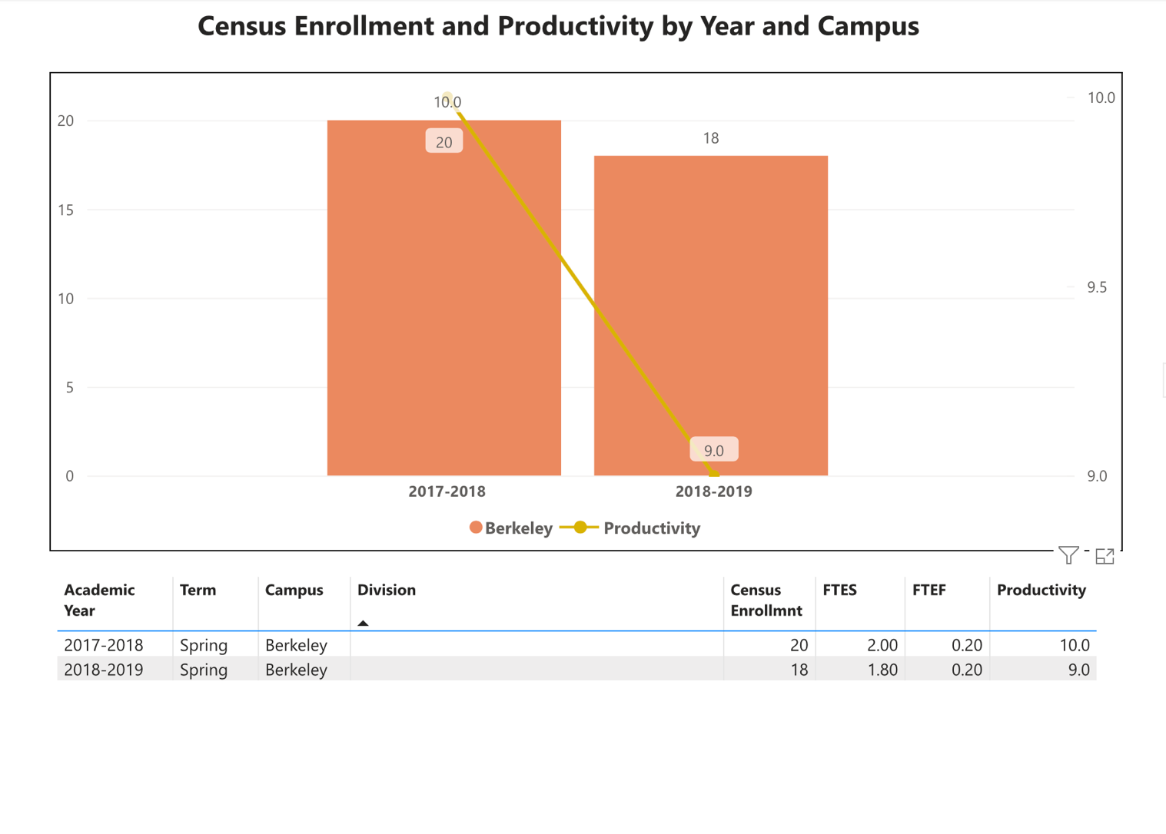
Figure 10. ANTH 55 Native American Cultures Census Enrollment and Productivity Berkeley City College

One aspect to note is that with the passing of AB1460 perhaps a Native American Studies course might better serve our students at Berkeley City College than ANTH 55. Though that said, there are many reasons why this course is important as it is within the anthropology course catalog. Anthropology will be in discussions with the department chair and colleagues about this issue. One of the issues with the productivity of this course is that it is predominately a major course. Perhaps a rotation of every other year would increase enrollment and productivity of this course. Too in the past there has been scheduling issues with Native American offerings in History that may have had a detrimental aspect with enrollment in this course. Discussions about the scheduling of this course will continue into the next three-year review period.

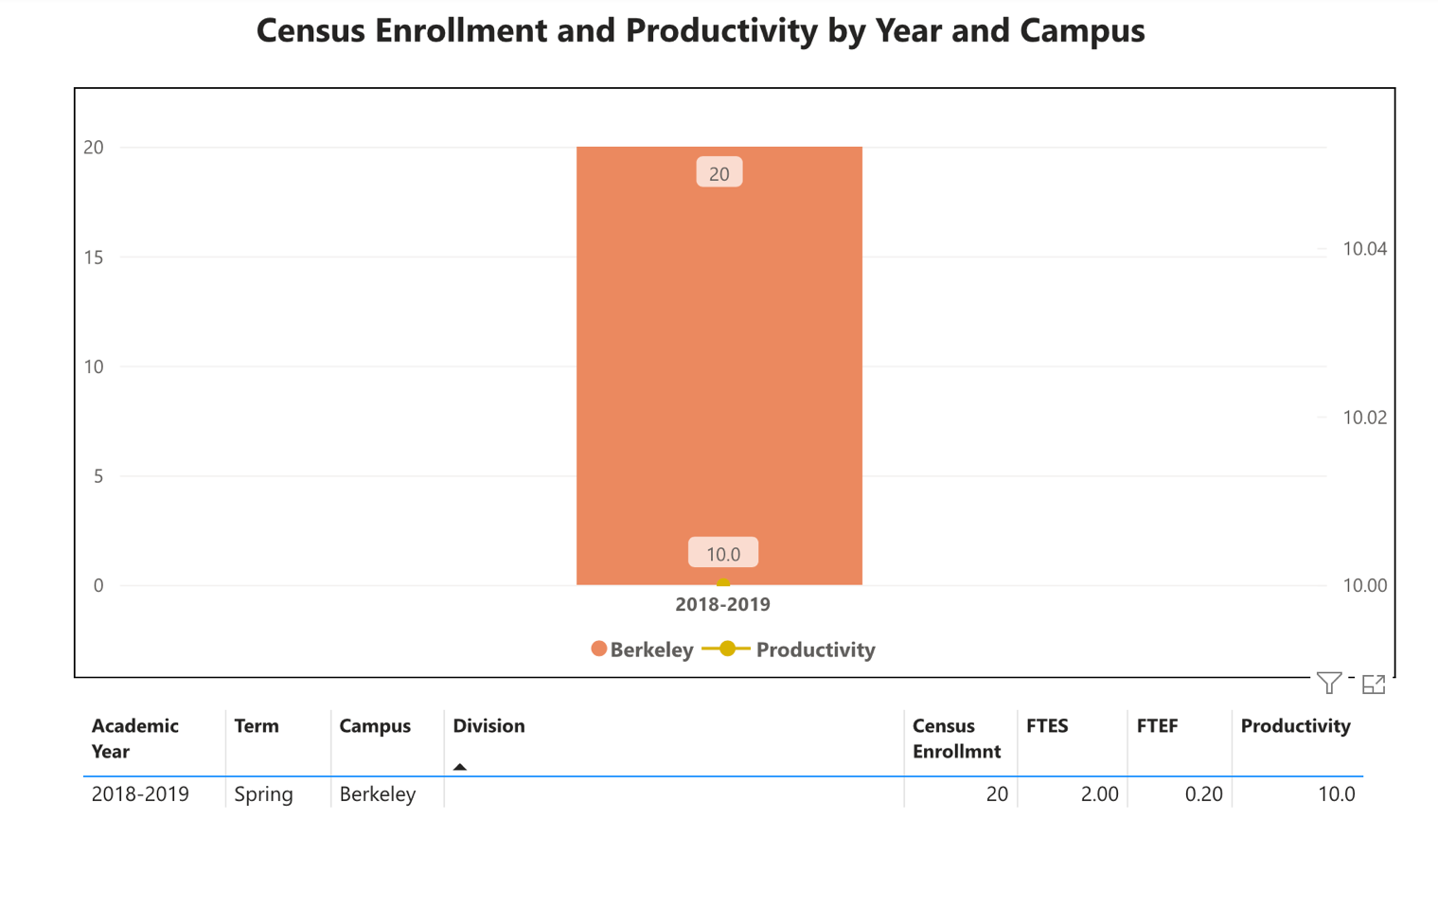
Figure 11. ANTH 13 Urban Anthropology Census Enrollment and Productivity Berkeley City College
In terms of ANTH 13, this course has been offered a few times over the last eight years and has served as a capstone for anthropology majors. It is interesting that our two major elective courses have similarly low productivity rates, see ANTH 55 above. In terms of Urban Anthropology perhaps this course could be adapted to have more appeal to the general student population especially given the importance of urban life in the modern day and age and our physical location in the Bay Area. The workload as offered in 2018-2019 was designed for student research projects and mini-ethnographic projects for anthropology majors. Making the course more accessible to general education students might be a solution to improve the productivity from the last time that the course was offered.

When the data for your department are disaggregated by student ethnic groups, what trends do you observe and how do plan to address them over the next three years?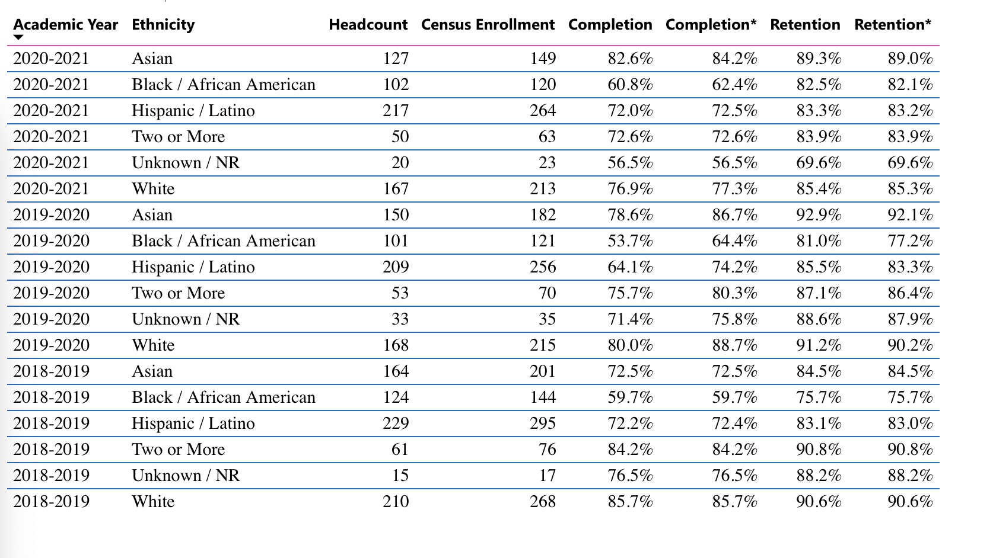
Figure 12. Headcount, Enrollment, and Retention by Ethnicity, Berkeley City College Anthropology.
While figure 12 illustrates much more than that requested in this portion of the report, enrollment will be discussed specifically. By ethnicity, we have seen a downward trend between 2018-2019 and the present for students who self-identified as Black/African American students. Whereas those who self-defined as Hispanic/Latinx and those who identified as White took a dip in 2019-2020 but rebounded in 2020-2021. Those students who identified as Asian were strong with a slight decline in 2020-2021. These enrollments will be supplemented with success and retention rates in an upcoming section.
Year 1 (2021-22) | Year 2 (2022-23) | Year 3 (2023-24)
Explore connections with college partners working on diversity and enrollment | Work with guided pathways colleagues on the flow of course requirements to degree completion | Continued adoption of the OEI rubric for clarity, accessibility, and effectiveness of anthropology courses.
What would you recommend that we do to increase student enrollment in your department?
Increased advertising of the college during peak registration periods (bus advertisements, billboards, radio, etc.).

More promotion of our courses to UC Berkeley students at the start of the semester. With many of their (UCB) face-to-face courses overflowing, our return to campus could involve an increase of marketing specifically targeting UC Berkeley students to register at BCC.

Create a dedicated teaching laboratory to better connect students with the course material and increase the tactile experience of all of our courses in anthropology.

3B. Course Completion and Retention Rates Dashboard – Instruction
*Note that completion and retention rates are presented with the inclusion and exclusion of excused withdrawals (EW) and military withdrawals.

If you need more guidance with this item, click here for additional support. Click here for additional guidance for how to view and use equity data. If you would like to view BCC’s Equity Plan, click here.
On page 3 of the “Course Completion and Retention Rates by Subject” dashboard, what are the completion and retention trends by gender, age, ethnicity in your department?
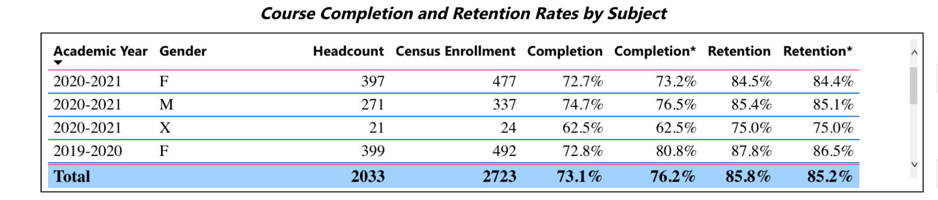
Figure 13. Course Completion and Retention by Gender, Anthropology Berkeley City College
Gender completion rates are positive with most percentages in the 70s and an overall average of 76.2%. Retention comes in quite strong with an overall average of 85.8%. So that is positive and the program coordinator has been advertising open courses for the following semester to students currently enrolled in an anthropology course each semester. These efforts may be one of the causal reasons for such a solid showing for the retaining of students currently enrolled in our coursework.

In terms of age, there are a wide array of students taking anthropology courses while the majority of the students we serve are in their late teens and twenties. The 16-18 age category does slightly better in terms of completion than the 19-24 category. This may just be a function that students in their twenties could possibly have additional responsibilities outside of the classroom and it would be interesting to cross-reference with additional demographic information to further understand that difference.

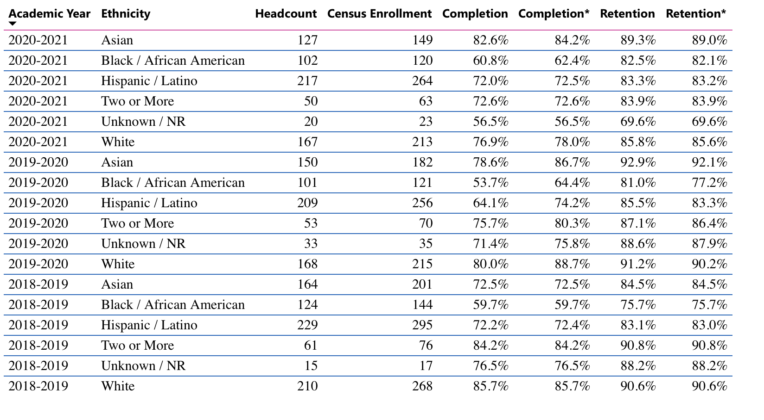
Figure 14. Course Completion and Retention by Ethnicity, Anthropology Berkeley City College
Looking at ethnicity in terms of completion and retention rates, self-defined Asian groups witnessed a positive jump (12 percentage points) between the first year in this survey and the later years under inspection. Retention too increased during this time period for this group. Self-defined Black/African American students were slightly lower hovering in the low 60s in terms of completion though retention comes in quite strong in the 80s. Self-defined Hispanic/Latinx students were consistently in the low 70s in terms of completion and the mid 80s in terms of retention. Those self-defined as White saw a slight decrease in 2020-2021 falling to the high 70s in completion. Retention of this group also dipped slightly from the 90s into the 80s during this review period.

What disproportionately impacted (DI) population(s) showed outcomes gains in your program area and which need more support?
With the transition back to campus, ideally, we will see the success rates in all of these groups improve. Too college-wide efforts, such as the newly formed Conocimientos los Caminos project, could serve to address these disparity issues across different ethnic groups. Anthropology will work to illustrate how our curriculum is ideally suited to Latinx students. Furthermore, outreach to other constituency groups at the college may assist the anthropology program’s assessment and improvement of completion rates across these groups. See below for additional discussion of Black/African American success rates in anthropology course completion as related to the college average.

How do these outcome trends compare to the college average?
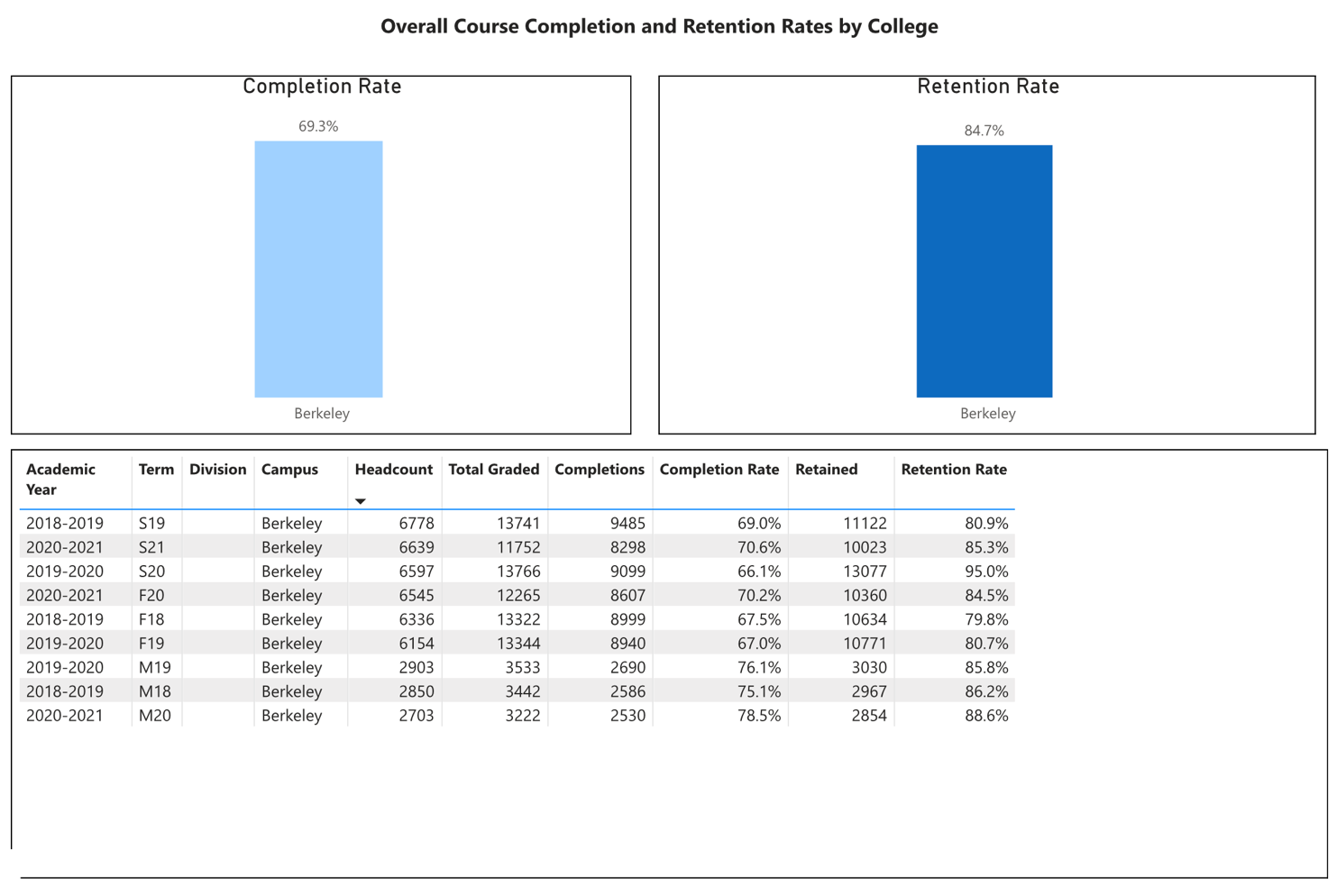
Figure 15. Berkeley City College Success and Retention Rate
Noticeable within this comparison between anthropology and the college averages are that student groups mostly are significantly above the college averages. African American success rates however averaging at 62.17% as compared to the college average of 69% is one area of concern. Thus, increased attention will be paid as we transition back to the classroom of the ways that our instructors can work to specifically improve the success rate of this group at least up to, if not above, the college average. Too with increased refinement of our teaching methods, such as some of the suggestions offered by Lasana Hotep during two professional development day presentations (such as democratizing the syllabus) in the recent past, anthropology faculty is considering how we might apply some of his suggestions to help to move the needle. From the institution to an individual classroom there is work to be done to increase the success rates of our students.

What questions do you have about the trends?
Anthropology finds it interesting that our research into students is now encompassing a move away from binary expressions of gender or single ethnic identifiers which is a positive change. One question however is with this move what are the best means to capture, analyze data on, and ultimately best serve students within the (x) category for gender and/or the two or more/unknown category of ethnicity moving forward?

Based on input you’ve received from students, what have they expressed as their need (s) to complete and succeed in your courses? (support your recommendations with examples) e.g., offer diff modalities; timing of day).
At present, a significant number of students have expressed their desire to return to face-to-face classes and coursework. Online education certainly has served a segment of our student population, but many students are not as adept/comfortable with that learning modality as in-person educational settings.
How will these outcome trends you identified in this section affect your department goals and plans for the next three years?
Year 1 (2021-22) | Year 2 (2022-23) | Year 3 (2023-24)
Return to Campus | Continued Development of Strategic Scheduling, Face-to-Face Course Expansion | Continued and Refined Faculty Advising Efforts

3C. Degrees and Certificates Dashboard
On page 1 of the “Degrees and Certificate Awards Trends” Dashboard, what are the award trends for your department (overall, by gender, age, and ethnicity).
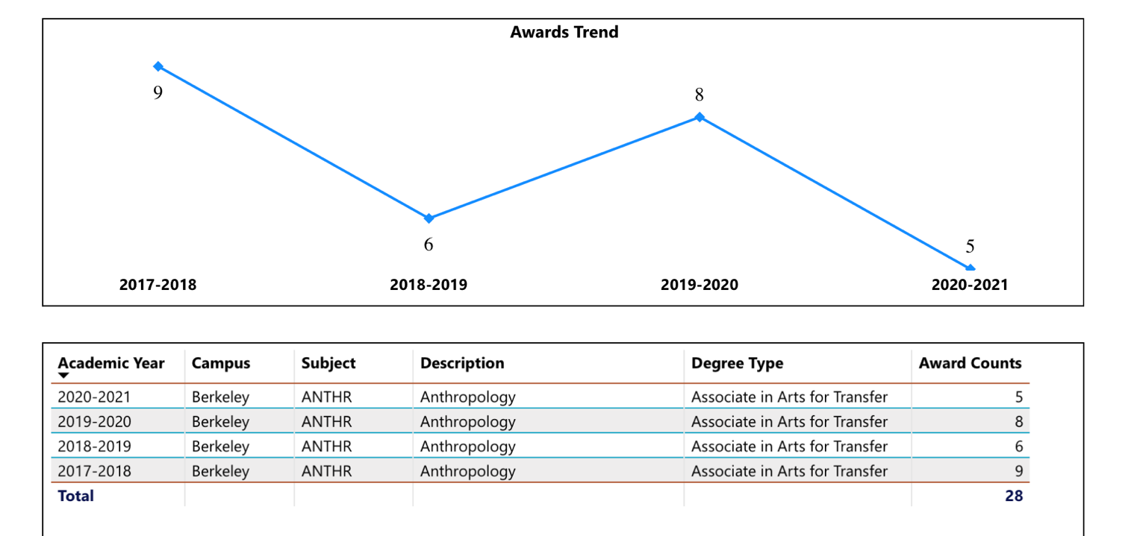
Figure 16. Anthropology ADT Conferred Berkeley City College
A total of 28 AD-T anthropology degrees have been conferred over the last four years. The makeup of our graduates by gender consists of roughly equal representation of male and female with “other” representing one individual. Most of our graduates within this review period were in the age category between 19-24. This finding is fairly consistent with college-wide data.

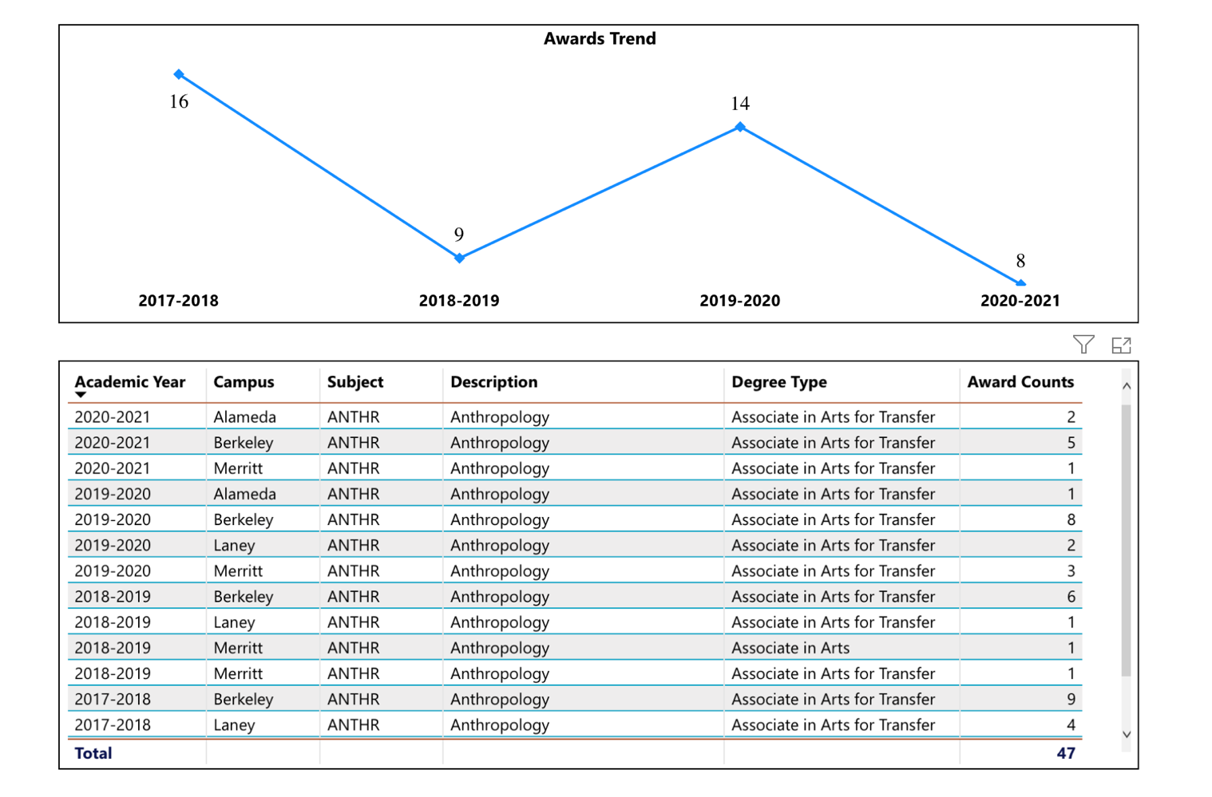
Figure 17. Anthropology ADT Conferred Peralta Colleges
When we compare the number of graduates to the other Peralta colleges, Berkeley has the largest number of Anthropology AD-T graduates in each of the four years under consideration in fact making up for 60% (28 out of 47) of the total graduates in the district during the review period. That said we would like to see the number of graduates increase to the upper threshold witnessed in earlier years.

On page 4, what DI population(s) award trends showed gains in your program area and which populations need more support?
Graduates in Anthropology at Berkeley City College by ethnicity during the review period:
Asian 4%
Black African American 8%
Hispanic/Latinx 32%
White 44%
Other 12%
How do these outcome trends compare to the college average?
Berkeley City College Graduate Averages by ethnicity during the review period:
Asian 27%
Black/African American 12%
Hispanic/Latinx 27%
White 22%
Other 12%

It is important to realize that the numbers are extremely small for the program awards (ANTH N=28/BCC N=4092). Yet comparing these data. Asian graduates of anthropology are significantly under the college average. Black/African American is also under the college average by four percentage points. Hispanic/Latinx is five percentage points above the college average and White degree recipients in anthropology are significantly higher than the college average.

Based on input you’ve received from students, what have they expressed as their need (s) to complete their degrees and/or certificates? (support your recommendations with examples)
In 2000-2021 we updated the degree to align with a University of California articulation agreement. This change was a positive step for the program as it created a clearer pathway for students to complete their anthropology degrees by adding additional coursework to the program elective requirements. It is our hope with this change, strategic scheduling, and increased faculty advising we will be able to improve the degrees awarded across the categories discussed above.
How will these outcome trends you identified in this section affect your department goals and plans for the next three years?
Year 1 (2021-22) | Year 2 (2022-23) | Year 3 (2023-24)
Increase Graduates Through Strategic Scheduling and Faculty Advising | Increase Graduates Through Strategic Scheduling and Faculty Advising | Increase Graduates Through Strategic Scheduling and Faculty Advising

3D. Transfer Dashboard
This dashboard does not provide data by subject. Reflect on what you can do to affect student transfer. How may your department help to support BCC student transfer? (e.g., serve on panels, strengthen GP in your dept, change curriculum, increase number of AD-Ts, etc.)
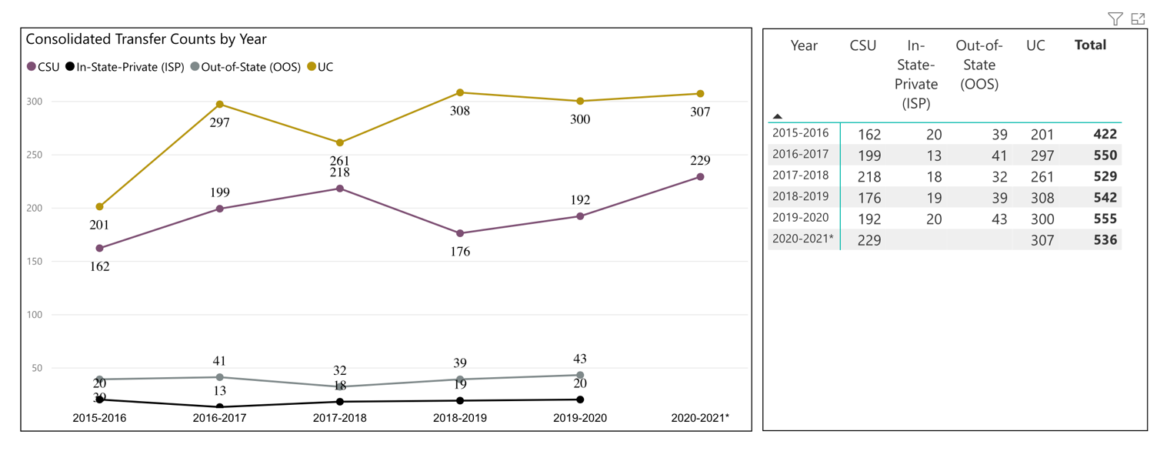
Figure 18. Berkeley City College Transfers
Anthropology graduates, according to our internally kept records have all transferred on to four-year universities. BCC Anthropology graduates are currently in residence at a variety of UCs (UC Berkeley, UC Davis, UCLA, UC Santa Cruz, etc.). BCC Anthro graduates too have successfully transferred to CSUs (CSU East Bay, SF State, Humboldt State University, etc.) and other private institutions in California and to out-of-state colleges and universities. Increased tracking of transfers is an ongoing goal for the anthropology program and a current college-wide interest.

3E. Curriculum
View the department’s curriculum through the lens of student equity outcomes. BCC outcome data suggests that disproportionately impacted groups of students experience low rates of success.
How do you plan to adjust the curriculum to advance student equity and address DI student outcome gaps?
Examples include: making adjustments to lesson plans based on student assessment outcomes; review pedagogy and revise assignments for culturally relevant content; simplify student processes and make service areas student-centered; manage class discussions and student participation; review best practices, etc.).
As mentioned above we have recently updated the curriculum and expanded the elective course offerings to include coursework in Ethnic Studies (Introduction to Ethnic Studies), Humanities (World Religions), and Sociology (Introduction to Sociology) in our section C of our degree requirements in 2020-2021. This will enable more options for students wishing to complete our degrees

With the return to campus, strategic scheduling of online, hybrid, and face-to-face coursework in anthropology is essential to best serve students. Part of this scheduling will involve an evaluation and creation of a course rotation calendar to assist student ability to complete our degree in a timely manner while simultaneously keeping enrollments and productivity high. This is step one in our process and then to reach out to other colleagues for ways anthropology can be more inclusive and bring in as diverse a student body as possible into our program and support said students from enrollment through course and program completion.

In the boxes below, add improvement actions that are directly related to Student Equity & Success. If there are no improvement actions in this area, leave blank. If you have more than one Improvement Plan, add more by copying and pasting the table below.
IMPROVEMENT ACTIONS
Department/Discipline: | Anthropology
Action Name: | Collaborate With Student Equity and Student Success Advocates
Description: | Collaborate with colleagues to determine ways the anthropology program could best align with efforts being established at Berkeley City College with for instance the HSI initiatives or other groups targeting student achievement and equity across Peralta.
Completion timeline: | Ongoing
Responsible person: | Thomas J. Kies

III. PROGRAM GOALS
- List your current Department Goals.
- Return to Campus—Transition faculty and students back to a safe, respectful, classroom experience in Spring 2022.
- New ANTH Lab—Work with the design/build team for our proposed new building to propose to shared governance a plan for a much needed (see later in this report) anthropology teaching lab space. While a general assignment classroom, this space will be a functional home for the program.
- Guided Pathways Planning and Implementation--Evaluate course offerings to determine the most efficient and effective schedule in anthropology and assess/remove barriers to student success.
- Improve online education platform—Start the process of having anthropology courses go through the POCR review process and improve the quality of online experience for students.
- Increase the lab experience and/or field studies for students—as part of a sabbatical release for the program coordinator— the feasibility of a primate field experience study abroad program will be assessed and/or the lab materials for our ANTH 1L course will be greatly expanded.
- How do the goals align with the College goals? If so, which ones?
Berkeley City College Goals
- GOAL I: Strengthen Resilience: Strengthen BCC students’ abilities to become self-directed, focused and engaged in the pursuit of transformative, life-long learning experiences that result in personal and academic success.
- GOAL II: Raise College Competence: Raise student skills and competencies, and expand their learning experiences, so that they can successfully complete their college program.
- GOAL III: Enhance Career-Technical Education Certificates and Degrees: Enhance BCC’s 1- and 2-year career and technical education programs so that they provide current and transferable skills and competencies to earn a living wage in our area, and to maintain competency for advancement in one’s career.
- GOAL IV: Increase Transfer and Transfer Degrees: Ensure that all of BCC’s programs of study and transfer pathways for degrees prepare students, in a timely manner, for multiple transfer options.
- GOAL V: Ensure Institutional Sustainability: Increase BCC’s impact in education through innovation, internal and external collaboration and partnerships, and sufficient resources, both short-term and long-term.
GOAL I: Strengthen Resilience:
New anthropology laboratory project, guided pathways, and improve online education initiatives.

GOAL II: Raise College Competence:
Return to campus, new anthropology laboratory, and increase lab effectiveness.

GOAL IV: Increase Transfer and Transfer Degrees:
Guided pathways, field experience, and improve online education

- Assess your facilities utilization (including labs, support for online learning, and other spaces) and for each year, indicate if the space is insufficient. If so, what are the needs and why? *Note that facility needs and planning are addressed in the Facility Master Plan for the college, including the planning for new buildings.
The anthropology program has long sought out a sufficient space for an anthropology teaching lab. The saga of the anthropology teaching lab is a storied tale. In 2014, the anthropology teaching lab was relocated from 422 to 032. The goal with this move was to keep the ANTH 1L section to a reasonable class capacity for a lab section. With the move to 032 the department chair ended up receiving a number of complaints— ADA issues, worker safety issues, etc. The then chair sought out alternative unused lab spaces at the college, however classroom space is tight on the campus and no agreement could be reached for several potential options.

In the ensuing years the anthropology lab has been relocated back to 422, however the lab space is far from ideal for a number of reasons and in addition that specific room is highly sought after as a general assignment classroom and by student groups during college hour.

The request for a dedicated lab space for ANTH 1L goes back nearly a decade and an anthropology teaching lab would also assist students in other anthropology classes as well. Therefor with the development of the new building, there is a grand opportunity to finally establish a space, while still a general assignment classroom, to best serve our major and non-major social and natural science students in anthropology.

Year 1 (2021-22) | Year 2 (2022-23) | Year 3 (2023-24)
Continue work with the design build team with preliminary planning for an anthropology teaching laboratory. | Finalize design of lab and contribute to college-wide discussions/fora about the new building plan and actualization. | Coordinate course schedule to allow full usage of the new lab space in 2025 and ready lab materials for moving into the new space.
- What are the essential functions of your department, any unique characteristics or trends? Provide specific examples.
Anthropology is similar to other disciplines in the social sciences, as we serve many students seeking their general education requirements. Anthropology is a bit unique in the department as our ANTH 1 and ANTH 1L serves general education students for their natural science lecture and/or lab components. As Eric Wolf once said, “Anthropology is the most scientific of the humanities and the most humanistic of the sciences.” As such anthropology has a unique vantage point as we contribute to the BCC student experience with our current and future offerings in the social and natural sciences.

- Describe how external factors (if applicable), such as State and Federal laws, advisory board recommendations, district and college governance have an impact on the support services your department provides. (e.g., partnered with dual enrollment and contract Ed programs at K-12 districts and high schools; support staff at high schools have access to Canvas to follow along and support students; allow tutors into the classes; Guided Pathways, AB 705, etc.)
In spring of 2020-21 anthropology faculty offered a contract education course at the YMCA in Emeryville tailored to Head Start teachers seeking a degree in Early Childhood Education. At that time, we offered students an asynchronous ANTH 1 Introduction to Physical Anthropology and synchronous ANTH 1L Introduction to Physical Anthropology Laboratory. Reviews from students, indicated that the workload was intense for some of the class participants and so in future semesters faculty recommend perhaps a single course followed by the lab in the following semester. While this could cause some disjuncture with lecture and lab interaction, it could make the learning more manageable for the cohort students within this program.

Based on your responses to questions 4-8, are there areas that need improvements? If so, add improvement actions below. If there are no improvement actions in this area, leave blank. If you have more than one Improvement Plan, add more by copying and pasting the table below.
IMPROVEMENT ACTIONS
Department/Discipline: | Anthropology
Action Name: | Increasingly Effectiveness of Online and In-Person Anthropology Courses and Supporting Degree Completion
Description: | Overall improvement of anthropology instruction through better labs (and associated lecture student experiences), more thorough online class evaluation/improvement, and removing barriers that inhibit students in course to program completion
Completion timeline: | Ongoing
Responsible person: | Thomas J. Kies

- ASSESSMENT
Berkeley City College is committed to a culture of assessment to improve instruction, services, and institutional planning. Findings from SLO, PLO, ALO assessments, and program review data are used to direct resources for areas that are institutional priorities that are articulated in the Educational Master Plan and BCC Strategic Plan. Due to the critical role that course and program assessments play in our institutional planning and to be in compliance with the Accreditation requirements, the Program Review resource allocation requests require the completion of assessment in order to qualify.
9A. List and describe the department/program’s progress and reflection on Student Learning Outcomes (SLOs), Program Learning Outcomes (PLOs), and/or Service Area Outcomes (SAOs). If your department/program offers a degree or certificate, please describe the department’s progress on Program Learning Outcomes (PLOs).
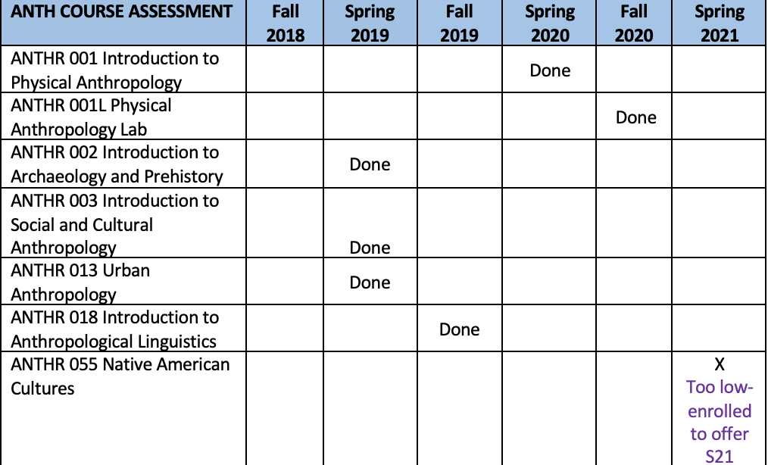
Figure 19. ANTH Course Assessment Completed During the Last Program Review Cycle
Course Student Learning Outcomes—
As is evident above, nearly all of our courses SLOs were reviewed in the last review cycle. The only exception to that statement was ANTH 55 that was scheduled to be assessed in spring of 2021 however with the shift to online learning brought on by the Covid pandemic, that specific course was not offered that semester. As such the next time that the course is offered, we will be assessing the SLOs for that course that semester.

Program Learning Outcomes—
As is evident below, the anthropology program aligns our course assessment to our program-level assessment. Unlike some of the other programs at the college, we do not have a final capstone class or project for our Associate Degree for Transfer. As such using course-level assessment measures enables an effective and efficient means for assessing the program given this constraint.

1) Explain core concepts of anthropology including: biological, archaeological, and social cultural subfields.
Assessment Methods—Standardized pre/post tests, sampled multiple-choice questions, or essays will be collected consisting of a sampling of at least one subgroup within each of the following: ANTH 1 (genetics, primatology, hominid evolution, and modern human biology), ANTH 2 (data collection, data analysis/interpretation, and knowledge of at least one cultural group), ANTH 3 (cultural relativism and the cultural expression/organization of groups from around the world).

2) Demonstrate skills in the scientific methods used by contemporary anthropologists.
Assessment Methods—A sample of the following will be means to measure this outcome: a rotating sample of lab assignments from ANTH 1L will be analyzed to assess student understanding of course material. In ANTH 2 essays will be collected in which students will describe the methods used by archaeologists in the field or students will be assessed through the collection of written responses to embedded lab activities within the class. In ANTH 3 essays on the fieldwork methods used by anthropologists will be collected or ethnographic reports prepared by students after completing fieldwork exercises will be collected and analyzed.

3) Describe an appreciation for the biological, historical, and cultural diversity of our world.
Assessment Methods—A sample of one or more of the following will serve to measure this outcome, essays or research papers will be sampled and analyzed from ANTH 1, ANTH 2, or ANTH 3 to assess student understanding of biological diversity, historical preservation, and/or issues of cultural diversity.

9B. What improvement plans did your department identify upon the assessment of each program? How has your department used the results of assessment to improve student learning outcomes and/or curriculum? Please be as detailed as possible.
During the assessing of our program in 2020-2021 it became apparent that there was a need to update our AD-T to align with the most recent version of the ANTH TMC (Transfer Curriculum Model). Thus, as a means to review the courses and program sequences, faculty used our SLO course-level assessment information to determine what aspects of the program needed revision or adaptation. One change that is currently in process one year later is to update the title of our Physical Anthropology sequence to Biological Anthropology. This name update is underway, but it also enabled us to review the course assessment methods and goals for ANTH 1 and ANTH 1L in the process of this name change in 2021.
9C. Describe how the program has made use of information from the data it has from program and student learning outcomes in Round 4 (last cycle of the last 3 years) for continuous improvement. Include the three most significant plans for improvements as a result of the assessment process with timelines. Click here to view your Assessment Calendar
As our program outcomes are aligned with our course-level assessments, we provide a sample of some of the findings from course SLO that had an influencing factor on our program offerings and future plans for assessment.

ANTH 1 Introduction to Physical Anthropology—
The program coordinator has worked to increase the part-time instructor participation to increase the sampling of our students. Further with the increased in online course offerings due to Covid, the increased analysis of online versus face-to-face comparisons are planned for future assessments.

ANTH 1L Introduction to Physical Anthropology Laboratory—
With our transition online in Fall 2020 there have been a lot of attempts to determine the best methods for student learning in online labs. Faculty used this time of transition as a means for rethinking and sharing resources among faculty at BCC to improve overall our lab experiences for students.

ANTH 2 Introduction to Archaeology and Prehistory—
There are some difficulties with the breadth of this class covering both an introduction to archaeology as well as an introduction to prehistory. The textbook chosen for the course emphasizes the arch theory and methods and additional materials are developed to emphasize the prehistory component. A forthcoming open-access textbook may be adapted to better serve students in fall 2022.

ANTH 3—Introduction to Social Cultural Anthropology—
Plagiarism continually is an issue when teaching online. Instructors have done their best to make students aware of policies via an academic integrity statement in the syllabus. Assessment could be stronger in that this specific round of assessment in this review period of a specific SLO only was examined via discussion board posts comments. Perhaps instructors could expand collection methods in upcoming assessments.

ANTH 18—Introduction to Linguistic Anthropology
While in face-to-face course the phonology SLO has had quite a bit of success in earlier assessments. The phonology section of the course became more complicated with the shift to online instruction in 2020 with the Covid pandemic. We are still in process of developing an effective means for teaching phonology in a distance or hybrid setting. Future assessment will be useful to determine if students in online are as successful as those that take the course in a face-to-face format.
9D. How does your department, program, or unit ensure that students are aware of learning or service area outcomes?
All of our course SLOs are listed at the beginning of our course syllabi. These SLOs are discussed at the start of the semester and referenced at numerous times during the course of the semester as we traverse the different thematic units of our courses.

9E. Besides your syllabi, where are the service area and/or program level outcomes published? If on a website, please specify the URL.
The program learning outcomes are located on the Anthropology Program website
https://www.berkeleycitycollege.edu/anthropology/

In the boxes below, add improvement actions that are directly related to Assessment. If there are no improvement actions in this area, leave blank. If you have more than one Improvement Plan, add more by copying and pasting the table below.
IMPROVEMENT ACTIONS
Department/Discipline: | Anthropology
Action Name: | Assessment Diversification and Program Assessment Intensification
Description: | Continue to expand the types and volume of student work that we assess during the next three-year cycle. Further make PLO more of a focus for how the course level can provide more substantive review of the program as a whole.
Completion Timeline | Ongoing
Responsible person: | Thomas J. Kies

- ENGAGEMENT
10A. Discuss how faculty and staff have engaged in institutional efforts such as committees, presentations, and departmental activities. Please list the committees that full-time faculty/staff/admin participate in.
Thomas J. Kies, Ph.D. has been a member of the following committees either currently or has served during this review cycle:
Anthropology Program Coordinator
Distance Education Committee
POCR Peer Online Course Reviewer
Facilities and Health & Safety Committee
Builder User Group
ACLS/Mellon Grant Writing Subgroup

Select Professional Development Presentations at the Teaching and Learning Center (TLC):
- ACLS/Mellon Community College Fellowship Informational Session, Fall 2020

- Is This Thing On: A Basic Screen Capture Webinar to Increase Instructor Presence and Interactivity Within Online Classes, Spring 2020

Other contributions by part- and full-time faculty available on request.
10B. Discuss how faculty and staff have engaged in community activities, partnerships and/or collaborations.
An interesting collaboration occurred with the transition to online education in the spring of 2020 with the Covid epidemic. Anthropology faculty had long discussed possibly moving our lab into a remote modality but we had not actualized an online lab. Sharing resources with ANTH 1L and other courses was a great example of the collaboration between colleagues.
In terms of collaboration between the anthropology programs at the different colleges in the district we have started the process of reviewing our tentative schedules each semester and also working together on improving our courses and programs together. Our collective agreement to all bring forth a name change of ANTH 1 to Biological Anthropology in the fall 2021 is but one example of many where we work collectively and consult on a range of issues facing all of our programs (e.g., enrollment, OER, etc.).
Anthropology at Berkeley City College will continue to develop our relationships both near and far in the UC and CSU organizations as a means to best serve our students and we look forward to resuming of in-person conferences and meetings with colleagues in our discipline and throughout higher education for future collaborations for years to come.
10C. Discuss how adjunct faculty members are included in departmental training, discussions, and decision-making.
Part-time faculty when first hired are given an orientation, provided with materials such as
course outlines and sample syllabi, and given a walking tour of the building. In the age of Covid, this would be a virtual encounter. Part-time faculty participates in assessment, department meetings and course development. Part-time faculty is included in all major decisions, discussions, and available professional development opportunities. Every effort is made to include part-time voices within the ongoing activities of the department.
- 10D. Discuss the relationship and engagement with other support services, programs, departments, or administrative units and how these relationships support your area to meet its goals.
At present we are happy to work with a wide array of programs, departments, and units across the college. We look forward to continued engagement for the betterment of the anthropology program and to best support student success at Berkeley City College. Some of these programs include, but are not limited to—The Transfer Center, BCC Library, PSSD, The Veterans Affairs Program, Media Services/IT and a host of others. It is a cliché, but it certainly does take a community and we appreciate the work of so many individuals and groups across the campus who support us and our students.

In the boxes below, add improvement actions that are directly related to Engagement. If there are no improvement actions in this area, leave blank. If you have more than one Improvement Plan, add more by copying and pasting the table below.
IMPROVEMENT ACTIONS
Discipline: | Anthropology
Action Name: | Expanding Connection to District and Transfer Partners
Description: | Continue the ongoing work that the anthropology programs have completed in scheduling, staffing, etc., and also continue the ongoing connections that we have with anthropologists at transfer institutions throughout the region.
Completion Timeline | Ongoing
Responsible person: | Thomas J. Kies

VI. Prioritized Resource Requests
In the boxes below, add a 3-year resource requests for your department/program that have not been funded by existing funding sources. Work with your supervisor to estimate costs. If there are no resource requested, leave the boxes blank.

Click here to view the Resource Request Process and Timeline

Resource Category | Description/Justification | Estimated Annual Salary Costs | Estimated Annual Benefits Costs | Total  Estimated  Cost | Overall  Priority Ranking (1=Most important)
Personnel
Classified Staff
Student Worker
Part Time Faculty | Additional FTEF allocated to anthropology as we attempt to reach pre-pandemic staffing levels.  15 courses per semester goal.  (Current offerings in ANTH are 10 course sections in fall and 12 course sections in the spring). | 5000 per course | NA | $40,000 | 2
Professional Development | Description/Justification |  |  | Estimated Cost
Department wide PD needed | Increased training on accessibility even offering a service to make PDF material accessible for faculty. Many contract services exist who offer at a pay-per-page rate for converting PDF material to accessible documents. Many OER projects already funded to make textbook costs free for students could use assistance to make these materials accessibility to screen readers. |  |  | $10,000 for the Social Science Department | 1
Personal/Individual PD needed
Supplies | Description/Justification |  |  | Estimated Cost
Software (for whom or role?) | Continued licensing of Snagit and Camtasia to enable hybrid and online course video lectures.  Continued support for Canvas Studio for closed caption services and the archiving of multimedia material.  Continued subscription to other software such as Turnitin and other LTIs commonly used by faculty. |  |  | Current market | 1
Books, Magazines, and/or Periodicals
Instructional Supplies | Continued financial support for the anthropology teaching laboratory. As we move back to face-to-face instruction our lab and tactile teaching methods will need continued support. |  |  | $1,500 per year | 1
Non-Instructional Supplies
Technology & Equipment | Description/Justification  Before you list your technology request, click here to view the latest Technology Refresh Plan to verify whether it has already included. |  |  | Estimated Cost
New
Replacement | Continued refresh of full-time faculty computers at regular intervals. |  |  |  | 2
Facilities | Description/Justification |  |  | Estimated Cost
Classrooms
Offices
Labs | Requesting an ANTH lab space in the new BCC West building. |  |  | Bid total pending | 1
Other
Library | Description/Justification |  |  | Estimated Cost
Library materials (including streamline media needs) | New York Times subscription for faculty and students is integral to anthropology instruction.  Kanopy streaming is an essential multimedia platform for our instructional needs. |  |  | Market rates | 1
Library collections
OER | Continued stipends for faculty to transition to OER texts |  |  | $10,000 | 2
Other | Description/Justification |  |  | Estimated Cost
OTHER Description | Support for POCR (Peer Online Course) reviewers and those having their courses reviewed. Cost estimate is based off of social sciences courses and $500 stipends for reviewer and the reviewed to make changes to a total of 23 course sections. |  |  | $46,000 | 1

Thank you for your time and effort in completing the Program Review!
Please email the completed Program Review to your Dean by November 30, 2021.

