Berkeley City College’s mission is to provide our diverse community with
educational opportunities, promote student success, and to transform lives.

Introduction and Directions

The Peralta Community College District has an institutional effectiveness process which consists of the following components: a District-wide Strategic Plan which is updated every six years; Comprehensive Program Reviews which are completed every three years; and Annual Program Updates (APUs) which are completed in non-program review years.

The Program Review 2021-22 timeline has been developed for each student support services to guide through the semester. Please review and work with your Deans and Managers/Supervisors to complete this Program Review.

The Program Review is intended to primarily focus upon planning for the subsequent two years and institutional effectiveness. The Program Review process directly leads to the institutional resource allocation process and budget planning for the following academic year (2022-23). This is an opportunity for each administrative unit, student support service program, and department to reflect on progress made and identify areas of program improvements to achieve equitable student success and elimination of achievement gaps. In this process of making continuous quality improvement, there is an opportunity for each program, student support services, and department to request resources that support achieving the stated goals.

If you have questions regarding other material in the Program Review, please contact your Dean or Manager. If you have questions regarding data, please contact Dr. Phoumy Sayavong, Senior Researcher and Planning Analyst (psayavong@peralta.edu).

Please email the completed Program Review to your Supervisor by November 30, 2021.

COLLEGE PROFILE
Click here to view the Berkeley City College Student Demographics Dashboard.
This 2-page dashboard will provide information on the characteristics of our student body from the past two years such as headcount, ethnicity, enrollment status, age group, educational goals, and majors.
College Outcomes | 2017-2018 | 2018-2019 | 2019-2020 | 2020-21
Full Time Equivalent Students (FTES) | 4,140 | 3,864 | 3,696 | 3,290
Efficiency  (Productivity; avg faculty-student ratio) | 13.4 | 13 | 13.2 | 14.3
Success Rate (%) | 67% | 69% | 67%* | 74%
Degrees + Certificates Awarded (#) | 1,021 | 948 | 1,106 | 1,014
*Excludes “EW” grades

To view prior Program Reviews, click here. To view prior Annual Program Updates, click here.

- PROGRAM DESCRIPTION
Please verify the mission statement for your program. If your program has not created a mission statement, provide details on how your program supports and contributes to the College’s mission.
The Admission & Records (A&R) Office serves as the first point of contact to the college for new and continuing students, as well as, the general public. Admission & Records mission is dedicated to student access and success. We ensure that students are provided with opportunity to achieve their educational goal. Students are given accurate, timely and exceptional customer service, in-person and online access, regarding admissions registration, students records, and academic policies while providing responsive respectful service to students, faculty, staff and the community.

Name(s) of member(s) completing this Program Review | Program | Completion Date
Hue Huynh | Admissions and Records | 11/30/2021
List staff and faculty names and/or staff and faculty with assignments in fall 2021.
Full Time | Part Time
Senior Admissions & Records Specialist – Hue Huynh  Admissions & Records Technician - Tam Vo  Admissions & Records Technician – Vacant  Admissions & Records Technician (Assigned to BCC as Admissions & Records Clerk) - Elinor Chin | N/A

II. STUDENT EQUITY & SUCCESS
Using the data dashboards provided below, review and reflect upon the outcome trends for your program. You may use data from other sources if available.

In our department, our Student Area Outcomes (SAO) for Admissions & Records has partnered with Assessment & Orientation, Counseling and other stakeholder groups by aligning our office hours under the Enrollment Management Plan. This will help a lot for students who are in need of our student services. We want the students to get the services that they need at the time they visit our campus or virtual support.With admissions application, students can now choose one of the four colleges and select the major on their application for financial aid purposes. Students who want to enroll in Non-credit program can also enroll in non-credit courses with just one CCCApply application. New students who wants to apply in Non-Credit program only, can also fill out the application online. Not only that, due to the update in the AB540 Affidavits, the undocumented students can now file for affidavit and do self-reporting. We are able to process them in a timely manner. The Student Equity and Achievement (SEA) program was established in July 2018 and is continuing to develop to assist the students, especially those in the Disproportionate Impacted (DI) groups. Admissions & Records staff have processed Excused Withdrawal (EW) form submissions as soon as they are received by our department for the students that have been affected by the Covid-19 pandemic and those that are struggling with it. With the funding from the HEERF Institutional funds, it will help to support students and the college as threy are impacted by the Covid-19 pandemic. Though the State Chancellor’s Office there is in the process of developing Policy, the Funding Formula, the MIS Data reporting, and the Student Education Plan, A&R staff continue to provide services to support Student Equity and achievement, and are prepared to support students to improve student success.

A&R participated in the Express Registration Enrollment Days to assist new students with enrollment issues and streamline enrollment process that aligns with the BCC’s Enrollment Management Plan. We provide priority registration to DI groups and assist undocumented students with the enrollment process. We also assist students with enrollment for non-credit classes, adult-Ed. We also provide enrollment assistance for learning communities e.g. UMOJA, Society of Scholars and FYE. To increase our contact with students due to the COVID-19 and campus closure, the A&R staff are participating in the most recent trend Webex platform to improve our communication through Google Voice for phone services and the Tawk.to - Chat feature where we can chat and answer the student's questions, concerns instantly. We are also having the zoom link for our department, so that students can drop in for questions. The students can reach out to us regarding questions about registration, how to order transcript, important dates for add/drop classes, and academic recors, etc. The students can also schedule a one-on one appointment with us on Zoom if needed.

As a result of AB 705, the English and math departments have linked support classes. A&R staff provide assistance to new students and faculty. A&R staff participated in the Student Success Day to assist high school seniors, specifically those in the DI groups, to enroll in linked math and English support classes after they meet with counselors.In order to improve on student outcomes and increase the awarding of certificates and degrees, A&R evaluators are getting trained to evaluate incoming transcripts so that students can matriculate in a timely manner. Counselors can use the information to develop SEP's that students can access. Also, A&R staff are involved with the degree audit project at the District to hopefully streamline the awarding of degrees in a timely manner. We worked close together with the counseling department to eVerify CSU ADT degrees, and the awarding of Certificate of Competency for non-credit programs in addition to the regular degree and certificate awarding process.

Admission & Records goal is to partnership with faculty and the District Office to assist students interested in the Non-Credit Education program. This program is designed to reach out to a new population of students that may not otherwise be enrolled, offering courses in Child Development, ESOL, Multi Media and many others. Non-Credit courses are offered with no tuition or fee. Admission & Records staff assist the student with submitting the non-credit applications online. Admission & Records staff has the ability to add Credit courses and Non-Credit courses to the student schedule. Because of the importance of incorporating more non-credit courses in the curriculum, and much of this workload is manual in nature and required dedicated hours for troubleshooting, the Admissions & Records office on each campus will include the request in their Program Review for more staffing to cover the enrollment of the Non-Credit Program. Non-credit courses are intended to provide students with lifelong learning, college transfer, and career preparation opportunities, but also leading to the Certificate of Competency and Certificate of Completion once they have met the requirement for the Non-Credit program they have chosen.

For the academic year 2020-2021, BCC has awarded a total 1016 degrees and certificates, including 152 AA Degrees and 9 AS Degrees, 194 AA-T Degrees, and 92 AS-T Degrees, and 440 Certificates of Achievement and 27 Certificate of Proficiency. In addition, there are 102 Certificate of Competency and Certificate of Completion for the Non-credit programs. Our goal is to increase the number of awards and help the student to complete their educational goal. Through our activities and work with counselors, we are also having an implementation of the Degree Audit tools. The evaluator in A&R are getting trained to evaluate transcripts from other CA community colleges and CA universities, to enter and post transfer credit from external institution to our system. The district transcript coordinator is also working closely with the evaluator to help evaluate the private and out of states transcripts. This process will help students and counselors to incorporate transcript credits in the development of SEP’s. Students will be able to view the transfer credits reports in their student account and track their academic progress. While the evaluators are working entering the transfer credit, the district is also doing testing and implemtenting the Audit Degree tool to help with the degree processing. Thus far, everything has been processed manually and very time consuming, A&R office will request for an additional A&R technician to assist with this process.

Click here if you would like to view BCC’s Planning Documents (Education Master Plan, College Strategic Goals, Student Equity Plan, District Strategic Goals, Vision for Success, Guided Pathways, Technology Plan, Facilities Plan)

For assistance with data dashboards, contact Phoumy Sayavong at psayavong@peralta.edu

3A. Enrollment Trend and Productivity Dashboard
*Note that completion and retention rates are presented with the inclusion and exclusion of excused withdrawals (EW) and military withdrawals.
What were your headcount trends in the past three years?
Student Demographics | 2017-2018 | 2018-2019 | 2019-2020 | 2020-2021
Annual Headcount | 11,041 | 10,903 | 10,759 | 11,433
Total Enrollment (census) | 32,850 | 30,298 | 31,007 | 27,648
Ethnicity
African-American | 15% | 16% | 15.2% | 15.3%
American Indian/Alaskan Native | 0.2% | 0.2% | 0.3% | 0.3%
Asian | 22% | 22% | 21.5% | 21.1%
Filipino | 2% | 2% | 2.4% | 2.5%
Hispanic | 24% | 25% | 25.9% | 26.4%
Multi-Ethnicity | 7% | 7% | 6.9% | 7.4%
Pacific Islander | 0.3% | 0.3% | 0.3% | 0.5%
Unknown | 4% | 3% | 5.1% | 4.1%
White Non-Hispanic | 24% | 24% | 22.5% | 22.4%
Gender
Female | 55% | 55% | 56% | 58%
Male | 43% | 42% | 41% | 39%
Unknown | 3% | 3% | 3% | 3%
Age Group
19 or Less | 27% | 29% | 30% | 32%
20 to 24 | 35% | 33% | 32% | 30%
25 to 29 | 16% | 16% | 15% | 15%
30 to 34 | 8% | 8% | 8% | 9%
35 to 39 | 4% | 4% | 4% | 5%
40 to 49 | 5% | 5% | 5% | 5%
50 + | 5% | 5% | 6% | 4%

College Outcomes | 2017-2018 | 2018-2019 | 2019-2020 | 2020-2021
Full Time Equivalent Students (FTES) | 4140 | 3864 | 3696 | 3290
Productivity (avg faculty-student ratio) | 13.4 | 13 | 13.2 | 14.3
Success Rate (%) | 67% | 69% | 67%* | 71%*
Degrees + Certificates Awarded (#) | 1,021 | 948 | 1,106 | 1016
*Excludes “EW” grades

When the data for your program are disaggregated by student ethnic groups, what issues do you notice and how do plan to address them over the next three years? What would you recommend that we do to increase student headcount in your program?
Looking at the data, it shows that the African Americans and male students are having the lower enrollment rates than any other groups. Even though we are serving all students populations, the rate is still very low for this group of students. Having multi-cultural staff from different student services, comprised of many different ethnic, and socio-economic backgrounds, to participate and engage in campus-wide events/committees will help to expand diversity across campus. The new and/or returning students will feel welcoming and want to be involved.

3B. Course Completion and Retention Rates Dashboard – Student Services
*Note that completion and retention rates are presented with the inclusion and exclusion of excused withdrawals (EW) and military withdrawals.

If you need more guidance with this item, click here for additional support. Click here for additional guidance for how to view and use equity data. If you would like to view BCC’s Equity Plan, click here.
On page 3 of the “Course Completion and Retention Rates by Subject” dashboard, what are the completion and retention trends by gender, age, ethnicity in your program?
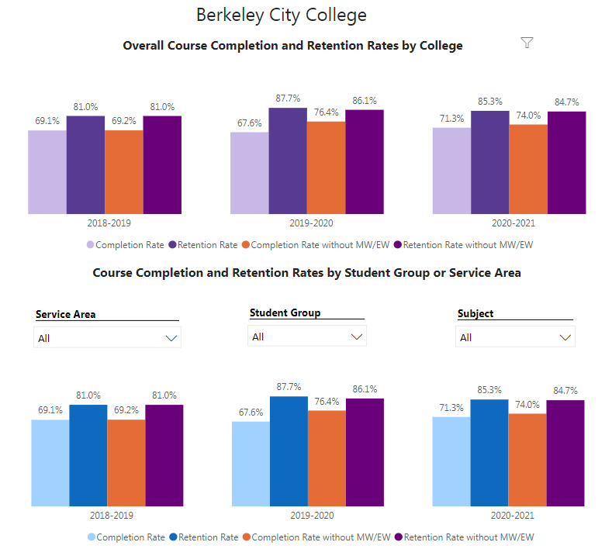

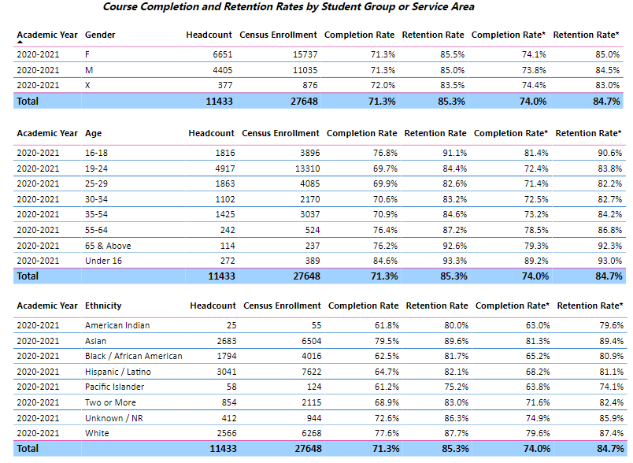

What disproportionately impacted (DI) population(s) showed gains in your program and which need more support? How do these outcomes compare to the college average? What questions do you have about the outcomes? Based on input you’ve received from students, what needs have they expressed to complete and succeed in your program? Please provide examples. How will the outcomes you identified in this section affect your department goals and plans for the next three years?
Hispanic/Latino, African American, American Indian, Pacific Islander and those students from the age of 19-24 and 25-29 have lower completion rates. These are the DI gropus which may need more support. These students may be new students or students who have just arrived from a different culture experiences/background and do not have any knowledges and will need more assistance.

These students’completion rate can be affected based on academic disadvantage, lack of technology or support from the instructional office. Many times students are having difficulty communicating or reaching out for assistance. For example, students who are having difficulty with technology and could not turn in their assignment, try to contact faculty for help but get no response. These students could have completed their work but due to no knowledge and communication, leads them to not pass their coursework. If we could have the instructional and student services work collaboratively to support the students, espciallally those in the DI groups, this process and procedures will best serve the students for their needs.

3C. Degrees and Certificates Dashboard
On page 1 of the “Degrees and Certificate Awards Trends” Dashboard, what are the award trends for your department (overall, by gender, age, and ethnicity).
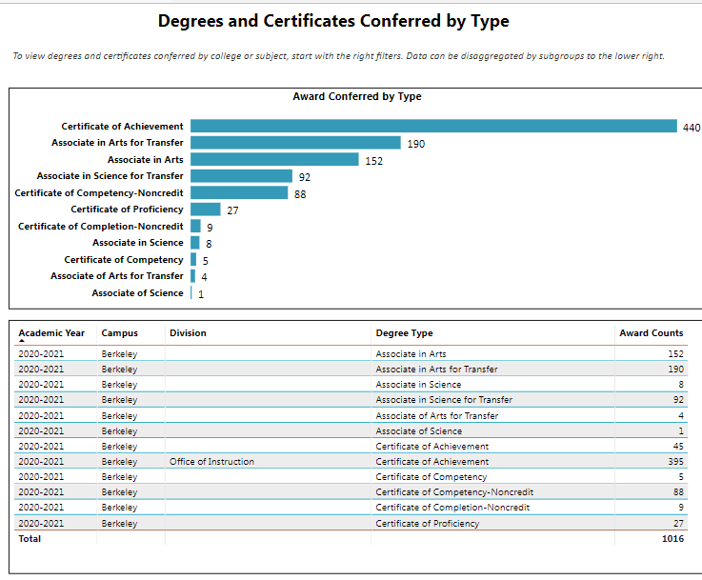
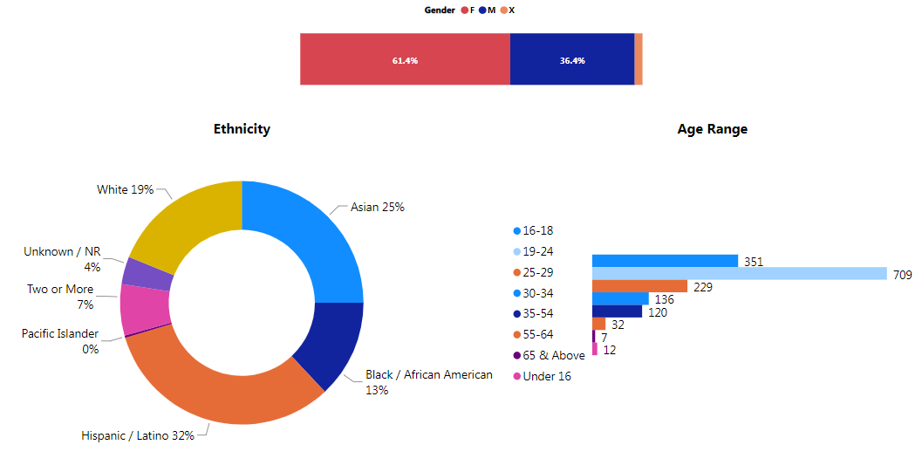

On page 4, what DI population(s) award trends showed gains in your program area and which populations need more support? How do these outcome trends compare to the college average? Based on input you’ve received from students, what do they need to complete their degrees and/or certificates? (provide examples). How will these outcome trends affect your department goals and plans for the next three years?
For the academic year 2020-2021, BCC has awarded total 1016 degrees and certificates, including 152 AA Degrees and 9 AS Degrees, 194 AA-T Degrees, and 92 AS-T Degrees, and 440 Certificates of Achievement and 27 Certificate of Proficiency. In addition, there are 102 Certificate of Competency and Certificate of Completion for the Non-credit programs. Per the data, there are the DI groups that we need to provide with more support. Our goal is to increase the number of awards and help the student to complete their educational goal. Through our activities and work with counselors, we also have implementation of a Degree Audit tool. The evaluator in A&R are getting trained to evaluate transcripts from other CA community colleges and CA universities, to enter and post transfer credit from external institution to our system. The district transcript coordinator is also working closely with the evaluator to help evaluate the private and out of states transcripts. This process will help students and counselors to incorporate transcripts credits in the development of SEP’s. Students will be able to view the transfer credits reports in their student account and track their academic progress, they will then be able to know the courses need to complete their programs. While the evaluator are working entering the transfer credit, the district is also doing testing and implemtenting the Audit Degree tool to help with degree processing. Eventually, the transcript evaluation will lead to the improvement of the Degree Audit tool that is scheduled for implementation is still on going and will be announced once it goes live, hopefully, for the next academic year.

3D. Transfer Dashboard
This dashboard does not provide data by program. Reflect on what you can do to affect student transfer. How may your program support BCC student transfer? (e.g., serve on panels, strengthen GP in your dept, strategic marketing, increase number of AD-Ts, etc.)
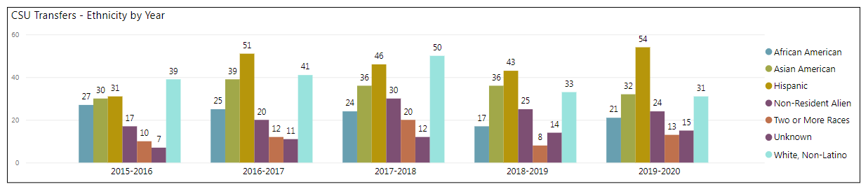
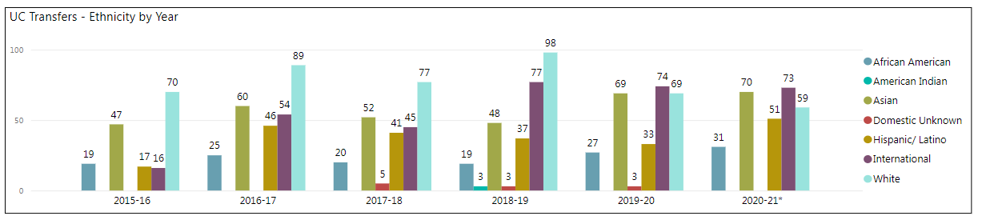
Admissions & Records office has actively supported student transfer goals by providing transcript services, enrollment verification letters (College Reports, Dean Reports, etc), evaluation students petition, as well as referring student to see a counselor or schedule an appointment with the Transfer Center.

In the boxes below, add improvement actions that are directly related to Student Equity & Success. If there are no improvement actions in this area, leave blank. If you have more than one Improvement Plan, add more by copying and pasting the table below.
IMPROVEMENT ACTIONS
Program/Discipline: | In-reach
Action Name: | A&R In-Reach
Description: | Collaborate with other student services & Office of Instructional to support students
Completion timeline: | For the next few years
Responsible person: | A&R Staff

III. PROGRAM GOALS
- List your current Program Goals.
The Admissions & Records department is part of the Enrollment Services divison. The responsibilities of the office are diverse to include the student matriculation from the registration to graduation. We are also imposed with interpreting, implementing and monitoring regulatory guidance from the state and school regualation. With student equity achievement and success, our office staff has been operating under the Enrollment Management Plans that align the student services office hours: inclduing Admissions & Records, Financial Aid, and Counseling Services which share the same hours of services, we are also including the Cashier’s office, though they are under the business management, but also student services related. The student will be able to identify their needs, determine resources and access appropriate services.

Not only that, the most recent goals of Admissions & Records is to increase the number of certificates and awards. Evalutors were trained to evaluate transcripts from other colleges and universities, this could be accomplished when the transfer credit is in placed. The A&R evaluator is currently involved in the Degree Audit project at the district office to streamline the awarding of degrees in a timely manner. What’s in progress is the BCC goal IV to increase transfer and transfer degrees, ensure that all of BCC's programs of study and transfer pathways for degree prepare students, in a timely manner, for multiple transfer options. The Admission & Records Office is located in the Student Service area and we feel these goals can be accomplished. We serve under the Dean of Student Support Services who in turn serves under the Vice President of Student Services. Our office works in collaboration with Admissions, Orientation and Placement, Counseling, Financial Aid and the Cashier’s Office. Admission & Records along with Orientation, and Counseling has teamed up to provide students with online enrollment to ensure that all needs are met prior to the beginning of each semester. Other major services Admissio & Records staff provides include evaluation of transcripts, awards degrees and certificates, determine residency and Visa Status, resolve issues for enrollment, process the excused withdrawal, help reset their student password, change student email and addresses, assist instruction with Census, Attendance Rosters and collect final Grade Rollbooks, process signed AB540 Affidavits-CA for Nonresident-Tuition Exemption students.

- How do the goals align with BCC goals? If so, which ones?
Berkeley City College Goals
- GOAL I: Strengthen Resilience: Strengthen BCC students’ abilities to become self-directed, focused and engaged in the pursuit of transformative, life-long learning experiences that result in personal and academic success.
- GOAL II: Raise College Competence: Raise student skills and competencies, and expand their learning experiences, so that they can successfully complete their college program.
- GOAL III: Enhance Career-Technical Education Certificates and Degrees: Enhance BCC’s 1- and 2-year career and technical education programs so that they provide current and transferable skills and competencies to earn a living wage in our area, and to maintain competency for advancement in one’s career.
- GOAL IV: Increase Transfer and Transfer Degrees: Ensure that all of BCC’s programs of study and transfer pathways for degrees prepare students, in a timely manner, for multiple transfer options.
- GOAL V: Ensure Institutional Sustainability: Increase BCC’s impact in education through innovation, internal and external collaboration and partnerships, and sufficient resources, both short-term and long-term.
Our program goals and the College and District goals are aligned in term of Goal I - Strengthen Resilience - Strengthen BCC student's abilities to become self-directed, focuses and engaged in the pursuit of transformation, life-long learning experience that result in personal and academic success. We focus on advancing the student's access to equity and success. In addition to Goal I, we also concentrate on Goal II - Raise College Competence by rasing student's skills, competencies, expand their learning experince so that they can successfully complete their college program; Goal IV - Increase Transfer and Transfer Degrees - to ensure BCC's program of study and transfer pathways for degrees, prepare students, in a timely manner, for multiple transfer options; and finally Goal V- Ensure Institutional Sustainability - which BCC" impact in education through innovation, internal and external collaboration and partnership, and sufficient resources, both short-term and long-term. In order to improve on student outcome: students are able to successfully navigate and resolve issue of registrations conflicts ans self-assess their degree/certificate progress, these will increase the awarding of certificates and degrees. A&R will need more staff to be trained in providing support and in the evaluation of incoming transcripts so student can matriculate in a timely manner. The focus will be on BCC's strategic goals.
- Assess your program’s facilities utilization (including labs, support for online learning, and other spaces) and for each year, indicate if the space is insufficient. If so, what are the needs and why? *Note that facility needs and planning are addressed in the Facility Master Plan for the college, including planning for new buildings.
Our Admissions and Records office have limited office space. Additional space may be needed in the future to support staff growth in this deparment.

- What are the essential functions, unique characteristics or trends of your program? Provide specific examples.
We have been providing direct support and indirect support to students. For example, with direct support to students, which includes registration/enrollment, determining residency, process students’ records, transcripts processing, enrollment verification, evaluation of petition for degress and keep confidential records for all students. With indirect support services, A&R has provided the campus monitoring census and attendance roster, processing them when being submitted by the instructors. Working with the Enrollment Coordinator to enroll students from the Dual Enrollment Program, and collaborating with learning communities as well as the adult ed, for students who are in the special programs (Umoja, Society of Scholars, Non-credit/CTE programs, etc). Additionally, we work closely with Fianncial Aid, Counseling and other support programs to assist student retention, to provide assistance with student data, records, and to resolve any issue related to student records.
- Describe how external factors (if applicable), such as State and Federal laws, advisory board recommendations, district and college governance have an impact on the services you provide. (e.g., partnered with dual enrollment and contract Ed programs at K-12 districts and high schools; support staff at high schools have access to Canvas to follow along and support students; allow tutors into the classes; Guided Pathways, AB 705, etc.)
Admissions & Records department is the first point of contact and is central for any person or questions that needs an answer. We provide information and serve as a helpdesk to prospective and current students, faculty, staff and the public. With an ever changing environment, A&R staff has always attend trainings and workshops to learn about new college and state guidelines and policies. With the pandemic, we now provide support service remotely via phone, email, chat and Zoom.

Based on your responses to questions 4-8, are there areas that need improvements? If so, add improvement actions below. If there are no improvement actions in this area, leave blank. If you have more than one Improvement Plan, add more by copying and pasting the table below.
IMPROVEMENT ACTIONS
Program/Discipline | Training
Action Name: | A&R State and District Training
Description: | Staff to attend training and workshop in regards to A&R and other student services to better serve the students, especially those in the DI groups
Completion timeline: | In the next few years.
Responsible person: | A&R Staff

- ASSESSMENT
Berkeley City College is committed to a culture of assessment to improve instruction, services, and institutional planning. Findings from SLO, PLO, ALO assessments, and program review data are used to direct resources for areas that are institutional priorities that are articulated in the Educational Master Plan and BCC Strategic Plan. Due to the critical role that course and program assessments play in our institutional planning and to be in compliance with the Accreditation requirements, the Program Review resource allocation requests require the completion of assessment in order to qualify.
9A. List and describe the program’s progress and reflection on Program Learning Outcomes (PLOs) or Service Area Outcomes (SAOs).
The A&R office has been providing service to the student via Chat feature ever since we begain working remotely. Below is the reporting chart from the progress that we have had since the last academic year. The students that we serve pretty much understand the process, however, we will conduct the survey for the Service Area Outcome to see how much the students have learnedin regards to the Admissions & Records process and procudes if more support is needed.
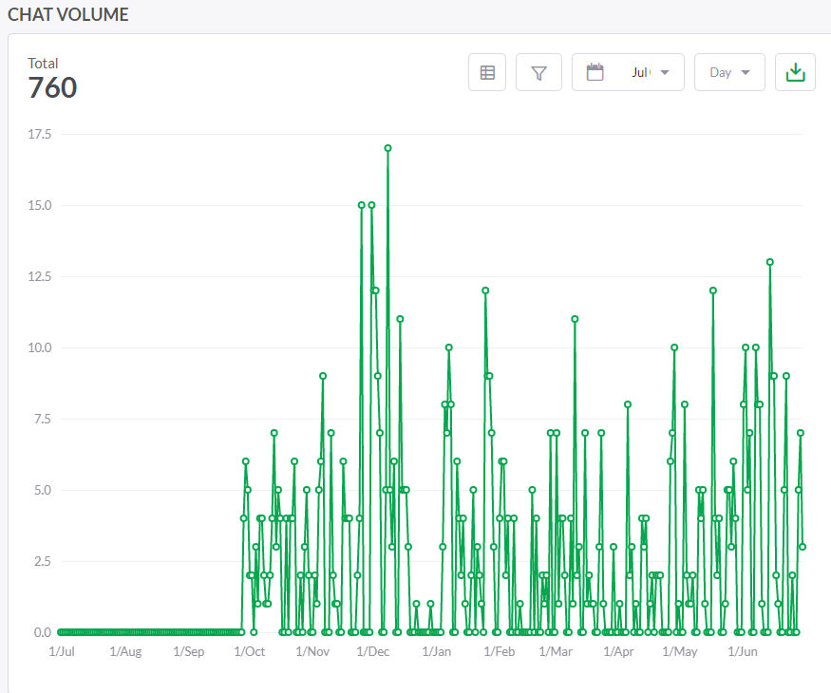

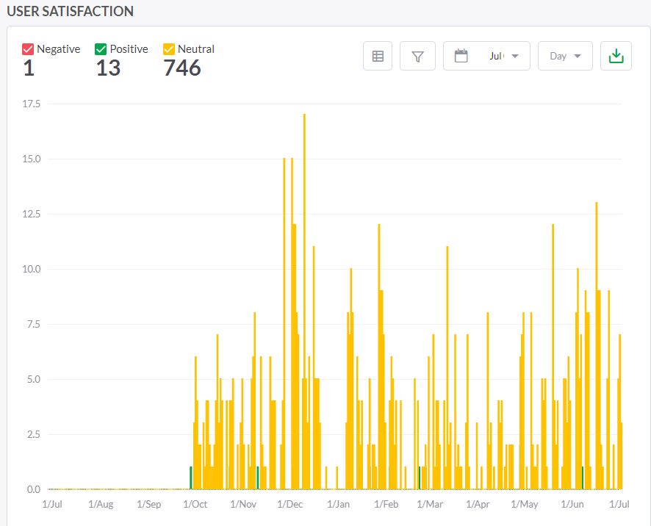
9B. What improvement plans did your program identify upon the assessment of each program? How has your program used the results of assessment to improve program learning outcomes? Please be as detailed as possible.
We see that the chat feature is actulay working for the department to provide the students support. We have also added the Zoom link for the students to drop-in for questions. A&R will also conduct a survey later for the asssessmet of outcomes as well as the collection of data. For degrees and certificates, students have completed one assessment for the outcome on how students will be able to self-assess their degree/certificate progress.

9C. Describe how the program has made use of information from the data it has from program learning outcomes in Round 4 (last cycle of the last 3 years) for continuous improvement. Include the three most significant plans for improvements as a result of the assessment process with timelines. Click here to view your Assessment Calendar
N/A

9D. How does your program ensure that students are aware of the program outcomes?
N/A
9E. Where are the program level outcomes published? If on a website, please specify the URL.
N/A

In the boxes below, add improvement actions that are directly related to Assessment. If there are no improvement actions in this area, leave blank. If you have more than one Improvement Plan, add more by copying and pasting the table below.
IMPROVEMENT ACTIONS
Program/Discipline:
Action Name:
Description:
Completion Timeline
Responsible person:

- ENGAGEMENT
10A. Discuss how staff and faculty have engaged in institutional efforts such as committees, presentations, and departmental activities. Please list the committees that full-time staff participate in.
A&R staff have joined the Classified Senate committee, participated in district and campus meetings, as well as the campus activities which have been provided by Student Services and Campus Life.
10B. Discuss how faculty and staff have engaged in community activities, partnerships and/or collaborations.
We pariticate in the Student Success Day and Student Welcome Week. Additionally, we are invited to the undocumented student trainings and the undocumented student week so that we understand and learn about the AB540 process.
10C. Discuss how classified staff are included in program training, discussions, and decision-making.
A&R staff has a monthly meeting with the student services department which is called the Student Services Council meeting. We also participlate in the district A&R training for update on the program and new state regulations. Furthermore, we also check in with our direct manager, Dean of Student Support Services, everyweek, regarding A&R work in progess and any pending decision that need to be made.
- 10D. Discuss the relationship and engagement with other student services, programs, departments, or administrative units and how these relationships support your area to meet its goals.
Admissions and records staff are working closely with other student services departments, counseling, financial aid, learning community, etc to make sure our students have receive the support that they need.

In the boxes below, add improvement actions that are directly related to Engagement. If there are no improvement actions in this area, leave blank. If you have more than one Improvement Plan, add more by copying and pasting the table below.
IMPROVEMENT ACTIONS
Discipline:
Action Name:
Description:
Completion Timeline
Responsible person:

VI. Prioritized Resource Requests
In the boxes below, add a 3-year resource requests for your program that have not been funded by existing funding sources. Work with your supervisor to estimate costs. If there are no resource requested, leave the boxes blank.

Click here to view the Resource Request Process and Timeline

Resource Category | Description/Justification | Estimated Annual Salary Costs | Estimated Annual Benefits Costs | Total  Estimated  Cost | Overall  Priority Ranking (1=Most important)
Personnel
Classified Staff | A&R Technician (Degree/Certificates & Transfer Credits)  Admissions & Records Clerk (Regular & Non-Credit) | $48,845  $ 38,772 | $10,295  $10,295 | $ 59,140  $49,067 | 1  2
Student Worker
Part Time Faculty
Professional Development | Description/Justification |  |  | Estimated Cost
Program-wide PD needed
Personal/Individual PD needed
Supplies | Description/Justification |  |  | Estimated Cost
Software (for whom or role?)
Books, Magazines, and/or Periodicals
Instructional Supplies
Non-Instructional Supplies | Printers for staff to work on campus (3) |  |  | $2,500 | 1
Technology & Equipment | Description/Justification  Before you list your technology request, click here to view the latest Technology Refresh Plan to verify whether it has already included. |  |  | Estimated Cost
New
Replacement
Facilities | Description/Justification |  |  | Estimated Cost
Classrooms
Offices
Labs
Other
Library | Description/Justification |  |  | Estimated Cost
Library materials (including streamline media needs)
Library collections
OER
Other | Description/Justification |  |  | Estimated Cost
OTHER Description

Thank you for your time and effort in completing the Program Review!
Please email the completed Program Review to your Dean or Manager by November 30, 2021.

