Berkeley City College’s mission is to provide our diverse community with
educational opportunities, promote student success, and to transform lives.

Introduction and Directions

Berkeley City College (BCC), in conjunction with the Peralta community College District, has an institutional effectiveness process which consists of the following components: a District-wide Strategic Plan which is updated every six years; Comprehensive Program Reviews (CPRs) which are completed every three years; and Annual Program Updates (APUs) which are completed in non-program review years.

TIMELINE
Annual Program Update (APU) 2022-2023 timeline has been developed for each program and services to guide through the semester. Please review and work with your Deans, Managers, Department Chairs and/or Supervisors to complete this APU.

For BCC, 2022-2023 marks a critically important year as the college is in the process of revising its Educational Master Plan (EMP) for the next 5 years (2024-2028). This college EMP process will inform the District with their planning for their Strategic Plan. This year’s APU will take an especially important role for the EMP process, carrying your analysis, planning and strategies to support our students success, retention, and equitable completion.

The APU is intended to primarily focus upon planning for the subsequent year based on the institutional priorities. While developing the College’s EMP for the next 5 years, the college and the district focused on the Vision for Success identified by the California Community College Chancellor’s office as well as Student Centered Funding Formula (SCFF) that clearly delineate the categorized outcomes that the Colleges should be focusing. Please use these foci as your reference to prioritize your department and other goals.

RESOURCE REQUEST PROCESS
In this process of making continuous quality improvement, there is an opportunity for each program, student services, and department to request resources that support achieving the stated goals. The APU process directly leads to the institutional resource allocation process and budget planning facilitated by the Institutional Planning and Allocation of Resources (IPAR) Committee for the following academic year (2023-24). The process for this can be found here (2022-23 APU Timeline). This is an opportunity for each department to request resources that will support your department goals and set outcomes.

TECHNOLOGY REQUEST
Finally, for the resource request section, please connect with your Deans, managers, and supervisors regarding your technology needs so that you can be informed about the equipment that is addressed in the BCC Technology Refresh Plan. If your requests are covered in the Refresh Plan, you do not need to request them in this APU.

If you have questions regarding other material in the Annual Program Update, please contact your Manager. If you have questions regarding data, please contact Dr. Phoumy Sayavong, Senior Researcher and Planning Analyst (psayavong@peralta.edu).

Please email the completed Annual Program Update to your Supervisor by November 30, 2022.

College Profile
Click here to view the Berkeley City College Student Demographics Dashboard.
This 2-page dashboard will provide data on the demographics of our student body from the past two years such as headcount, ethnicity, enrollment status, age group, educational goals, and majors.
College Outcomes | 2018-2019 | 2019-20 | 2020-21 | 2021-22
Full Time Equivalent Students (FTES) | 4161 | 3,931 | 3,622 | 3,259
Productivity (Avg. Goal = 17.5) | 13 | 13.2 | 13 | 10.9
Success Rate (%) | 69% | 77% | 75%* | 70%*
Degrees + Certificates Awarded (#) | 948 | 1,109 | 1,027 | 960
*Excludes “EW” grades

To view prior Program Reviews, click here. To view prior Annual Program Updates, click here.

1a. Program Description
Please verify the mission statement for your program. If your program has not created a mission statement, provide details on how your program supports and contributes to the College’s mission.
Our role is to provide a link between students’ classroom experiences to activities outside of the classroom. We aim to provide learning experiences that stimulate and encourage social, cultural, and recreational interactions. Through sponsored services, programs, and events on campus, students will have the opportunity to create meaningful experiences at our campus.

Our office provides students the tools and resources for their individual and student organization success. We encourage all of you to find experiences through our office that will challenge and supporting your learning. We want you to be part of life lessons and memories created through the programs offered to make your experiences an integral part of Berkeley City College’s educational environment.
Name(s) of member(s) completing this APU | Program | Completion Date
John Nguyen | Office of Student Activities & Campus Life | 11/30/2022
List staff names with assignments in fall 2022.
Full Time | Part Time
John Nguyen – Acting Dean of Enrollment Services | N/A

1b. Program Priorities & Goals
Based on the Vision for Success and SCFF, and your program’s mission, what are your program’s priorities and goals for 2022-23?
The office’s priorities and goals are:
- Increase extracurricular and co-curricular activities for students.
- Ensure that funds are appropriately spent.
- Increase club participation and engagement.
- Work with ASBCC to appoint students to both campus and district participatory governance.
- Create partnerships and maintain partnerships with local community organizations to increase basic needs initiatives and efforts.
- Create partnerships with local community organizations to increase civic engagement.
- Establish an annual leadership equity conference to provide tools and resources for students to become leaders in their community.

2. Student Equity, Success, & Completion
Using the data dashboards provided below, review and reflect upon the outcome trends for your program. Please also review overall BCC’s data linked here.

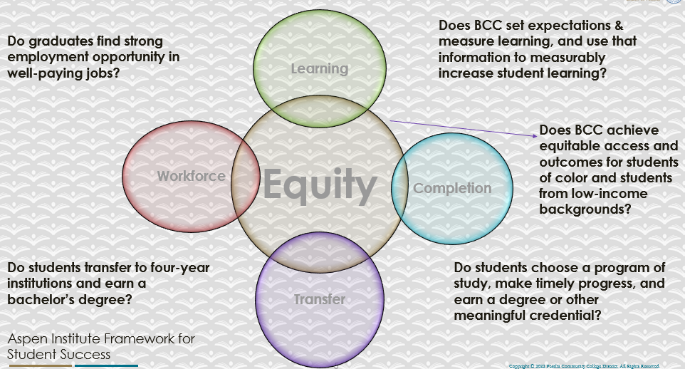

For assistance with data dashboards, contact Phoumy Sayavong at psayavong@peralta.edu
How are students doing in success and completion in your program? In comparison to the BCC overall success and completion rate, how are the students doing in your program? What are the group of students that needs more attention to achieve goals?
The students who are part of Associated Students, Student Clubs, and the Ambassador Program need to maintain a 2.0 GPA to be eligible to be part of these organizations. They are succeeding because there is a minimum requirement. In addition, they are performing well because they are the first students to learn about all the resources available on campus. The groups that do need more attention are students who are not part of campus activities on campus because they may not necessarily know about all the resources available for them.

What are key factors in your program that contributed to positive success and completion rate?
- Provide extracurricular activities for students to take part as a leader in.
- Provide clear instructions of funding requests from the Associated Students of Berkeley City College.
- Provide training for student leaders regarding the Brown Act, Robert’s Rules of Order, and leadership.
- Provide basic needs support for students including food, transportation, and resources.

What are some improvements your program can make? Identify strategies.
- Have student ambassadors and student leaders outreach to classrooms to recruit new student leaders.
- Have surveys at every event to identify trends to improve the department.
- Provide additional onboard and check-ins for student leaders.
- Partner with local organizations to identify transportation and food needs.

3a. Enrollment Trend and Productivity Dashboard
*Note that completion and retention rates are presented with the inclusion and exclusion of excused withdrawals (EW) and military withdrawals.
What are the enrollment trends in your program in the last three years (if applicable) or college?
In order to increase our enrollment, we have strategically sent emails and text messages to students to join student clubs and student government. Additionally, we have sent emails and texts to inform students about the food pantry and emergency aid support.

We also brought back in-person campus bulletin boards now that we are back on campus. We have noticed that students are more receptive to flyers with QR codes on them.

There has been an increase in student clubs, student government officers, and in-person events because we actively inform and update students about all the opportunities and resources available for them.
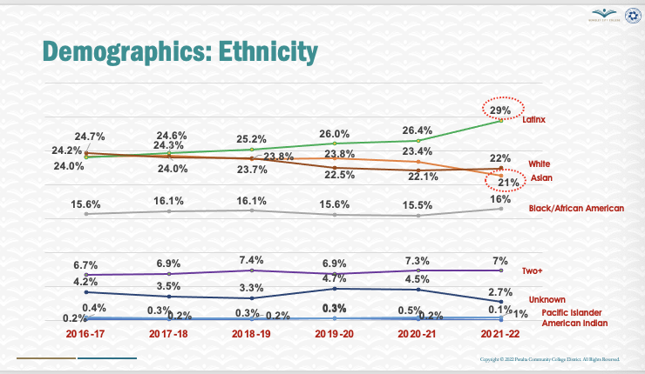
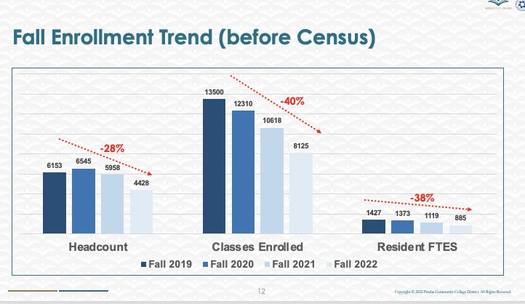
What strategies would you recommend to increase student enrollment in your program?
- Implementing Ocelot to provide responses for students during off-hours.
- Hire additional student ambassadors to provide support at the front desk.
- Identify a space for the basic needs center so that students can pick up food and find resources every day on campus.
Community Colleges are funded based on the Student Centered Funding Formula (“SCFF”) which is comprised of the following allocations:

Student Centered Funding Formula: Focus and Priorities
% Of Allocation | Categories
70%  Base Allocation: FTES (Enrollment) | - Credit FTES  - NonCredit FTES  - Special Admits (Dual Enrollment, etc.)
20%  Supplemental Allocation | - Pell Grant  - AB 540  - Adult School  - Promise Grants
10%  Student Success Allocation | - Associate Degrees  - ADTs  - 9 or more CE units  - Transfer  - Transfer level Math and English in the first year

List the Program’s progress and reflection on how to maintain or increase student enrollment. Please describe retention (i.e., remain enrolled for a full semester) and persistence (i.e., enroll in consecutive semesters) efforts.
- Provide and market Spring to Success Campaign that includes: AC Transit Bus Passes, “Free Parking” if you take 6-12 units on BCC campus, free weekly lunch meals, and food pantry access.
- Continue to use live chat feature staffed by student ambassadors to support students.
- Implement Ocelot to ensure that students are supported during campus off-hours.

Please describe your unit’s efforts in identifying Pell Grant recipients, College Promise Grant recipients, Adult Education, and AB 540 students. What processes are in place to accurately report these students each semester?

College Outcomes | 2018-2019 | 2019-2020 | 2020-21 | 2021-22
Full Time Equivalent Students (FTES) | 4,161 | 3,931 | 3,622 | 3,259
Pell Grant Recipients | 2,387 | 2,281 | 2,181 | 1,826
College Promise Grant Recipients | 4,373 | 4,143 | 4,011 | 3,500
AB 540 Students | 74 | 51 | 22 | 69

3b. Course Completion and Retention Rates Dashboard – Student Services
*Note that completion and retention rates are presented with the inclusion and exclusion of excused withdrawals (EW) and military withdrawals.

If you need more guidance with this item, click here for additional support. Click here for additional guidance for how to view and use equity data. If you would like to view BCC’s Equity Plan, click here.
On page 3 of the “Course Completion and Retention Rates by Subject” dashboard, what are the completion and retention trends by gender, age, ethnicity in your program/service area?
How can your Program improve trends over the next year?
- Administer surveys for students at every event by strategically showing a QR code during an event for the student to take a picture of during the event. The reason for this is to ensure that students can easily access the survey.
- Continue to have extracurricular programming by making it easy for students to apply for funding to organize these events.
- Increase food pantry resources on campus and finding a permanent location for the basic needs center.
- Hire additional student ambassadors to support students with questions.

What population(s) showed outcomes gains and which need more support?

Disaggregate the data and outcomes as far down as a possible then ask:
- What trends do you notice when examining course success rates for student populations by ethnicity? Which factors do you believe have the greatest impact (positive or negative) and cause variation between student course success rates in your Program? Describe some specific methods your Program is planning or implementing to address these equity gaps. How will you evaluate the efficacy of these interventions?

- How has pivoting to online instruction contributed to potential reductions in student success? Provide some specific examples of practices that staff in your Program have found ineffective in the online environment.

Please review the video from the RP Group acknowledging the interrogation De Anza Community College committed to in their analysis of course completion and success rate.
- Students who are taking excessive units on campus. Helping them find additional resources on campus so that they don’t fall behind.
- Students who are working full-time and providing extracurricular programming during the evenings.
- Students who have high financial needs and providing them with funding support.
- Providing additional support for our Black and Latinx students.

How do these outcome trends in your program compare to the college average?
- Our trends in the program are higher than the college average because the student leaders are aware of more resources on campus.

How will these outcome trends you identified in this section affect your program goals and plans for the next year and what are your strategies to shift the trend to go towards positive direction?
- We are planning to work with learning communities and running queries to identify the most disproportionately impacted student groups on campus and consistently reach out to them through email, text, and phone about the resources available on campus.

3c. Degrees and Certificates Dashboard
On page 1 of the “Degrees and Certificate Awards Trends” Dashboard, what are the award trends for your program/service area (e.g., overall, by gender, age, and ethnicity)?
On page 4, what population(s) award trends showed gains in your program and which populations need more support?

3d. Transfer Dashboard
This dashboard does not provide data by subject. Reflect on what you can do to affect student transfer. How may your Program help to support BCC student transfer? (e.g., serve on panels, strengthen GP in your dept, change curriculum, increase number of AD-Ts, etc.)
- In the past, we hosted college panels so that students can learn about different colleges. We invited alums from Berkeley City College who successfully transferred to come back and talk with students about their experience.

3e. Curriculum based on Guided Pathways
View your program through the lens of student equity outcomes.
- How is your Program making pathways for students to complete their goals?
- Continue to follow-up with students to ensure that they are meeting the minimum requirement to be part of student government, student clubs, and the student ambassador program.

4. Dual Enrollment
As continued decline in overall enrollment for college going population occurs, it is important for us to look at who will be coming to BCC in the next 5 years. Reviewing the data provide here, what strategies would your Program employ to address bringing more students to BCC?

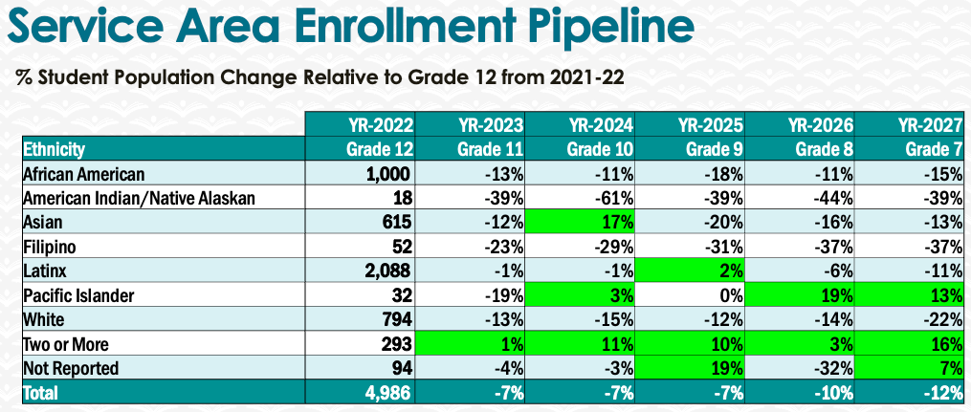
- Work with high schools to reach out to students about resources.
- Host events specifically targeted to high school students to encourage them to attend Berkeley City College.
- Run queries on students who will be coming to Berkeley City College in 5 years and ask them what they would like to see on campus.

5. Facility Utilization Needs
Assess your facility utilization for next year and indicate if the space is sufficient or not. If not, what are the needs and why? Work with your manager to check on your needs prior to responding this section.
Our space could be improved since it is difficult for students to enter the Student Activities & Campus Life Office because there is a door that deters students from entering. Fortunately we are moving to the new building where our office will be more welcoming for students.

6. Assessment
Berkeley City College is committed to a culture of assessment to improve instruction, services, and institutional planning. Findings from SLO, PLO, ALO assessments, and program review data are used to direct resources for institutional priorities that are articulated in the Educational Master Plan and BCC Strategic Plan. Due to the critical role that course and program assessments play in our institutional planning and be in compliance with the Accreditation requirements, assessments must be completed to qualify for APU resource allocation requests.
What action plans did your Program identify upon the assessment of each Service Area Outcomes (SAOs)? Please be as detailed as possible.
Service Area Outcome 1: Students will participate in programs offered by the Office of Student Activities & Campus Life.
We will strategically send emails, texts, post on websites, do classroom presentations, and post QR codes on campus about events.

Service Area Outcome 2: The Office of Student Activities and Campus Life will provide timely and personal responses to informational requests.
Provide training for Student Campus Life Assistant and Student Ambassadors to reply back to students. Also implement Ocelot to provide answers during off-hours.

Service Area Outcome 3: Students will increase their engagement and participation in activities.
Provide clear instructions for student leaders to request funding, book event spaces, and providing leadership training.

Describe the Program’s progress on the Action Plans identified for Service Area Outcomes (SAOs). Please be specific. Identify percentages towards completion of Action Plans. What Action Plans are priorities?
Service Area Outcome 1: Students will participate in programs offered by the Office of Student Activities & Campus Life.
We have started to send out marketing information for students. This has been working because many students find out about events through text.

Service Area Outcome 2: The Office of Student Activities and Campus Life will provide timely and personal responses to informational requests.
Student Assistant and Ambassadors have been providing information for students.

Service Area Outcome 3: Students will increase their engagement and participation in activities.
Students have a better understanding of our to request resources compared to pre-pandemic years because they are able to read instructions on our webpage and knowing that they can come to the Campus Life Assistant to ask for help.

Describe the status of SAO completion in Rounds 4 and 5 of the Assessment Cycle. Identify the percentages of completion. Briefly describe what needs to be done to reach 100% completion? Identify issues or concerns that may prevent your area from completing assessments of SAOs.

To assist you with this area/prompt, please review your Program’s Round 5 Tentative Plan available on One Drive, search Curricunet for assessment proposals of courses (or SAOs) that should be assessed this past year, and consult the Program’s SAO lead) and/or faculty (or staff) who were scheduled for assessments this past year.
How does your department, program, or unit ensure that students are aware of Service Area Outcomes?
They will be posted on the Student Activities & Campus Life webpage.

Where are the Service Area Outcomes published? If on a website, please specify the URL.
It is located on https://www.berkeleycitycollege.edu/campuslife/

7. Engagement
Discuss how faculty and classified staff have engaged in institutional efforts such as committees, presentations, and departmental activities. Please list the committees that full-time faculty/staff/admin participate in.
- Work with faculty to do classroom presentations.
- Work with faculty to offer extra credit for students for attending events.
- Ask classified staff to let their students know about events.

Discuss how faculty and staff have engaged in community activities, partnerships and/or collaborations.
- Faculty and staff have helped by letting their students know about events on campus.
Discuss how part-time staff members are included in program trainings, discussions, and decision-making.
- We have an open-call for everyone to participate in events including the food pantry.
- Discuss the relationship and engagement with other support services, programs, departments, or administrative units and how these relationships/collaboration support meeting your program goals.
- Continue to work with offices and departments to inform them of the events on campus.
Are there areas you feel that your department can benefit more by increasing collaboration and partnership? How?
- Learning communities and categorical programs. These students build rapport with students and we can collaborate with them since these students already have positive relationships with their respective programs.

8. Prioritized Resource Requests
During the 2021-22 Comprehensive Program Review process, you have provided your resource requests which went through the IPAR process. In this section, include resource requests from last year that are still needed and/or new resources that have emerged. Provide justifications. If there are no resource requested, leave the boxes blank.

Resource Category | Description/Justification | Estimated Cost
Personnel
Classified Staff | Student Activities & Campus Life Assistant This full-time will help with fund support such as requisitions, budget journals/transfers, and monitoring budgets. They will also help out with generating reports and assisting students. | $80,000
Student Worker
Part Time Faculty
Professional Development
Department wide PD needed
Personal/Individual PD needed
Supplies
Software (for whom or role?)
Books, Magazines, and/or Periodicals
Instructional Supplies
Non-Instructional Supplies | Outreach advertisements and materials | $10,000
Technology & Equipment
Description/Justification (Before you list your technology request, click here to view the latest Technology Refresh Plan to verify whether it has already included.)
New | 3 Surface Pro Tablet | $4,500
Replacement
Facilities
Classrooms
Offices
Labs
Other
Library
Library materials (including streamline media needs)
Library collections
OER
Other
OTHER Description

Thank you for your time and effort in completing the Annual Program Update!
Please email the completed Program Review to your Dean by November 30, 2022.

