Berkeley City College’s mission is to provide our diverse community with
educational opportunities, promote student success, and to transform lives.

Introduction and Directions

Berkeley City College (BCC), in conjunction with the Peralta community College District, has an institutional effectiveness process which consists of the following components: a District-wide Strategic Plan which is updated every six years; Comprehensive Program Reviews (CPRs) which are completed every three years; and Annual Program Updates (APUs) which are completed in non-program review years.

TIMELINE
Annual Program Update (APU) 2022-2023 timeline has been developed for each program and services to guide through the semester. Please review and work with your Deans, Managers, Department Chairs and/or Supervisors to complete this APU.

For BCC, 2022-2023 marks a critically important year as the college is in the process of revising its Educational Master Plan (EMP) for the next 5 years (2024-2028). This college EMP process will inform the District with their planning for their Strategic Plan. This year’s APU will take an especially important role for the EMP process, carrying your analysis, planning and strategies to support our students success, retention, and equitable completion.

The APU is intended to primarily focus upon planning for the subsequent year based on the institutional priorities. While developing the College’s EMP for the next 5 years, the college and the district focused on the Vision for Success identified by the California Community College Chancellor’s office as well as Student Centered Funding Formula (SCFF) that clearly delineate the categorized outcomes that the Colleges should be focusing. Please use these foci as your reference to prioritize your department and other goals.

RESOURCE REQUEST PROCESS
In this process of making continuous quality improvement, there is an opportunity for each program, student services, and department to request resources that support achieving the stated goals. The APU process directly leads to the institutional resource allocation process and budget planning facilitated by the Institutional Planning and Allocation of Resources (IPAR) Committee for the following academic year (2023-24). The process for this can be found here (2022-23 APU Timeline). This is an opportunity for each department to request resources that will support your department goals and set outcomes.

TECHNOLOGY REQUEST
Finally, for the resource request section, please connect with your Deans, managers, and supervisors regarding your technology needs so that you can be informed about the equipment that is addressed in the BCC Technology Refresh Plan. If your requests are covered in the Refresh Plan, you do not need to request them in this APU.

If you have questions regarding other material in the Annual Program Update, please contact your Manager. If you have questions regarding data, please contact Dr. Phoumy Sayavong, Senior Researcher and Planning Analyst (psayavong@peralta.edu).

Please email the completed Annual Program Update to your Supervisor by November 30, 2022.

College Profile
Click here to view the Berkeley City College Student Demographics Dashboard.
This 2-page dashboard will provide data on the demographics of our student body from the past two years such as headcount, ethnicity, enrollment status, age group, educational goals, and majors.
College Outcomes | 2018-2019 | 2019-20 | 2020-21 | 2021-22
Full Time Equivalent Students (FTES) | 4161 | 3,931 | 3,622 | 3,259
Productivity (Avg. Goal = 17.5) | 13 | 13.2 | 13 | 10.9
Success Rate (%) | 69% | 77% | 75%* | 70%*
Degrees + Certificates Awarded (#) | 948 | 1,109 | 1,027 | 960
*Excludes “EW” grades

To view prior Program Reviews, click here. To view prior Annual Program Updates, click here.

li

1a. Program Description
Please verify the mission statement for your program. If your program has not created a mission statement, provide details on how your program supports and contributes to the College’s mission.
Our mission is to provide accommodations and assistance to students with disabilities that facilitate their achieving their educational goals. We are committed to ensuring that students receive equal access to all programs and services.

Name(s) of member(s) completing this APU | Program | Completion Date
Elissa Jaw | SAS | 12/19/2022
List staff names with assignments in fall 2022.
Full Time | Part Time
Elissa Jaw  Maricela Becerra  Lynn Massey  Dolores Harshaw  Roberto Gonzalez | Bendi Yilmaz  Aidan Kyle Carter  Jessica Kumar  Jean Rowland

1b. Program Priorities & Goals
Based on the Vision for Success and SCFF, and your program’s mission, what are your program’s priorities and goals for 2022-23?
The BCC SAS program goal and top priority for 2022-23 is to introduce and reinstate Educational Assistance Courses (EAC) primarily for students with disabilities who are registered with the SAS office so that they may benefit in auxiliary support that specifically addresses barriers to learning, accessing course materials, and/or the development of job readiness skills. This goal is aligned with the Chancellor’s Vision for Success goals in that EACs will help close the equity gaps between access to resources, increase transfer, certificate and degree attainment through increasing course completion and prepare students for gainful employment.

2. Student Equity, Success, & Completion
Using the data dashboards provided below, review and reflect upon the outcome trends for your program. Please also review overall BCC’s data linked here.

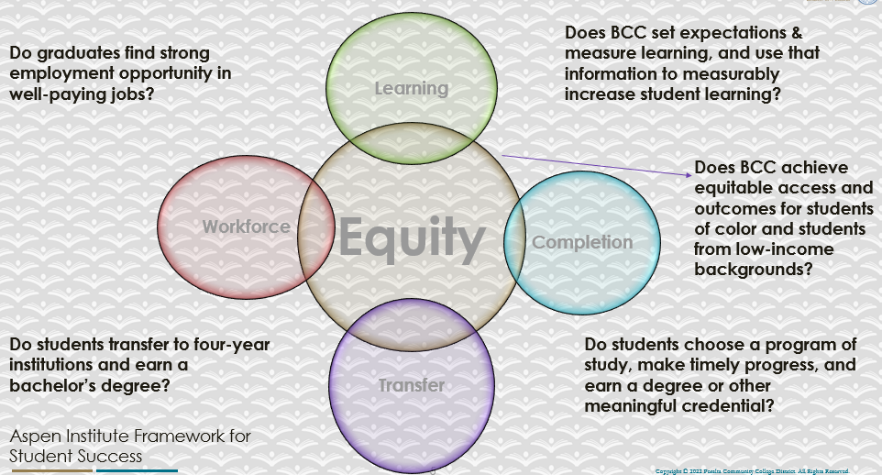

For assistance with data dashboards, contact Phoumy Sayavong at psayavong@peralta.edu
How are students doing in success and completion in your program? In comparison to the BCC overall success and completion rate, how are the students doing in your program? What are the group of students that needs more attention to achieve goals?
Including military and excused withdrawals, the data from the Power BI Tool showed that SAS students faired similarly to all students at BCC regarding student success rates (as denoted by their course completion rates) and retention rates for the past 3 academic years.

During the 2019-2020 academic year, BCC course completion rate overall was at 68%, while SAS course completion rate was slightly less at 65%. The college retention rate for this year was 88%, compared to the SAS group at 89%. In the 2020-2021 academic year, the campus completion rate was 71% while SAS had a 69% completion rate. The retention rate for this year for the college was at 86% and the BCC SAS group was at 85%. During the 2021-2022 academic year, both college and SAS group completion rates were at 68%. The retention rates for this year showed 84% for the college while SAS students were slightly higher at 86% retention.

Based on this data, the SAS student group only appears to vary within 2% of college-wide course completion and retention rates. The specific groups of students who require more attention to achieve goals are reviewed in the sections below.
What are key factors in your program that contributed to positive success and completion rate?
Over the past 2 years, the college has implemented systems and resources for students to continue coursework remotely such as providing laptop and WIFI access, financial aid resources and online student support services. The district had also purchased the Accessibility Information Management (AIM) software to support SAS programs in order to expedite classroom accommodations and disability services for students. The SAS offices throughout the district now work more collaboratively than they have done so in the past 20 years.

What are some improvements your program can make? Identify strategies.
We hope to reinstate and develop new Educational Assistance Courses (EAC) that will help support students’ ability to be self-sufficient and build study strategies in order for them to be successful in mainstream classes.

3a. Enrollment Trend and Productivity Dashboard
*Note that completion and retention rates are presented with the inclusion and exclusion of excused withdrawals (EW) and military withdrawals.
What are the enrollment trends in your program in the last three years (if applicable) or college?
Utilizing information from the CCCCO Data Mart website, SAS student enrollment trends at BCC showed an overall reduction of 27% of SAS students from 2019-2020 to 2020-2021, while in 2021-2020 academic year the total numbers only increased by 2% from the previous year. Students with learning disabilities had seen a steady decline of 3% each year 2019. Students with mobility disabilities declined by 3% between 2019-2020-to 2020-2021. Students with mental health disabilities showed an increase in enrollment between 2019-2020 and 2020-2021 academic years by 6% as did students with Attention Deficit Hyperactivity Disorder between 2020-2021 to 2021-2022 academic years. Changes in enrollment for all other disabilities only varied by 2% or less within the past 3 years.

African American students have also shown a steady yearly decline of 3% for the past 3 years. From 2020-2021 to 2021-2022 academic years, Asian and Latino students rose by 4% and 3% respectively. While Non-Hispanic students also increased by 3% from 2019-2020 to 2020-2021 academic years.

Students over 50 years of age showed the sharpest decline from 2019-2020 to 2020-2021 academic years by 4%. During the same period, student groups of 18-19 and 30-34 years of age increased by 3% each. All other age and gender groups showed a 2% or less change in enrollment over the past 3 years.

What strategies would you recommend to increase student enrollment in your program?
We hope to develop a non-credit EAC certificate that provides students job-readiness skills for entry or re-entry toward gainful employment. The CA State Department of Rehabilitation may refer their consumers to receive job preparation training through our program. This may also provide an alternate option for recent high school graduates who would like to enter the workforce and develop work-readiness training.

Community Colleges are funded based on the Student Centered Funding Formula (“SCFF”) which is comprised of the following allocations:

Student Centered Funding Formula: Focus and Priorities
% Of Allocation | Categories
70%  Base Allocation: FTES (Enrollment) | - Credit FTES  - NonCredit FTES  - Special Admits (Dual Enrollment, etc.)
20%  Supplemental Allocation | - Pell Grant  - AB 540  - Adult School  - Promise Grants
10%  Student Success Allocation | - Associate Degrees  - ADTs  - 9 or more CE units  - Transfer  - Transfer level Math and English in the first year

List the Program’s progress and reflection on how to maintain or increase student enrollment. Please describe retention (i.e., remain enrolled for a full semester) and persistence (i.e., enroll in consecutive semesters) efforts.
We would like to provide better training for students on how to access their course materials and content using assistive technology via development of EACs.

Please describe your unit’s efforts in identifying Pell Grant recipients, College Promise Grant recipients, Adult Education, and AB 540 students. What processes are in place to accurately report these students each semester?

College Outcomes | 2018-2019 | 2019-2020 | 2020-21 | 2021-22
Full Time Equivalent Students (FTES) | 4,161 | 3,931 | 3,622 | 3,259
Pell Grant Recipients | 2,387 | 2,281 | 2,181 | 1,826
College Promise Grant Recipients | 4,373 | 4,143 | 4,011 | 3,500
AB 540 Students | 74 | 51 | 22 | 69

The SAS department does not currently track Pell Grant recipients, College Promise recipients, Adult Education nor AB540 students.

3b. Course Completion and Retention Rates Dashboard – Student Services
*Note that completion and retention rates are presented with the inclusion and exclusion of excused withdrawals (EW) and military withdrawals.

If you need more guidance with this item, click here for additional support. Click here for additional guidance for how to view and use equity data. If you would like to view BCC’s Equity Plan, click here.
On page 3 of the “Course Completion and Retention Rates by Subject” dashboard, what are the completion and retention trends by gender, age, ethnicity in your program/service area?
During the 2021-2022 academic year, data from the Power BI Tool show some differences between SAS and campus-wide course completion and retention rates. The data presented includes MW and EW grades.

For gender, SAS students differ within 2% between males and female groups for both completion and retention rates. Only the unspecified (X) subgroup shows an 8% increase of course completion rate for SAS students as compared to the overall campus percentage.

For age, no data was shown for SAS students under 16 years of age. The largest differences in completion rates between SAS and campus wide students were among 16-18 year-olds (5.3% lower), 30-34 year-olds (6.2% higher), 55-64 year-olds (8.8% lower) and those 65 and older showed a 22.7% less percentage of course completions. Course retention rates were higher among SAS student between 30-34 years of age (4.2% higher) and lower by 3.3% for those 65 years or older as compared to all BCC students.

For ethnicity, SAS students who were Asian showed a 6.5% lower rate in course completion, while Caucasian students showed a 4.5% higher completion rate as compared to the overall BCC campus population. When comparing course retention rates for ethnicity, Only SAS Asian students showed a lower rate compared to BCC Asian students (6.8% lower). SAS Latino and white students were both higher that BCC students of the same ethnic category (4.2% and 3.7% higher respectively).

How can your program improve trends over the next year?
Again, this is where the development of EACs for the department may improve course completion and retention rates by providing resources that may mitigate educational barriers caused by their disabilities. Better and ease of access to lectures, text readings and ability to execute assignments is expected to increase both course retention and completion rates.

What population(s) showed outcomes gains and which need more support?

Disaggregate the data and outcomes as far down as a possible then ask:
- What trends do you notice when examining course success rates for student populations by ethnicity? Which factors do you believe have the greatest impact (positive or negative) and cause variation between student course success rates in your Program? Describe some specific methods your Program is planning or implementing to address these equity gaps. How will you evaluate the efficacy of these interventions?

- How has pivoting to online instruction contributed to potential reductions in student success? Provide some specific examples of practices that staff in your Program have found ineffective in the online environment.
Please review the video from the RP Group acknowledging the interrogation De Anza Community College committed to in their analysis of course completion and success rate.
See above for outcomes gains among ethnic populations. Based on the cited data, it appears that Asian students have lower course completion and retention rates compared to other ethnic groups and are thereby in need of more support.

How do these outcome trends in your program compare to the college average?
Historically, Asian students have not participated in SAS programs as reflective of their enrollment percentages at the campus (averaging between 21-23%).

How will these outcome trends you identified in this section affect your program goals and plans for the next year and what are your strategies to shift the trend to go towards positive direction?
SAS faces the challenge as many other programs do in providing equity among all student populations. SAS may invest in multilingual advertisement in various Asian languages around campus to inform students of the services that exist at the college and thereby increase participation in the program.

3c. Degrees and Certificates Dashboard
On page 1 of the “Degrees and Certificate Awards Trends” Dashboard, what are the award trends for your program/service area (e.g., overall, by gender, age, and ethnicity)?
The total number of degrees and certificates awarded in 2021-2022 academic year were 152. This represents a 25% increase from 2020-2021 academic year when the total number of degrees and certificates awarded was 121. The following tables display the degree and certificates awarded to SAS students over the past 2 academic years. Disaggregated data for specific demographic groups of gender, age and ethnicity are presented.

Table 1: Gender
 | 2020-2021 | 2021-2022 | % Change
Female | 74 | 104 | 41%
Male | 46 | 39 | -15%
X (unspecified) | 1 | 9 | 800%
Total | 121 | 152 | 25%

Despite upward trend for overall degree and certificates conferred, there is a notable 15% drop for males completing their educational goals between these academic years. The data also shows the disparate proportional rates of male to female degree and certificate completion.

Table 2: Age
 | 2020-2021 | 2021-2022 | % Change
<16 | 0 | 0 | 0
16-18 | 24 | 10 | -58%
19-24 | 83 | 95 | 14%
25-29 | 21 | 31 | 48%
30-34 | 12 | 22 | 83%
35-54 | 18 | 27 | 50%
55-64 | 6 | 5 | -17%
65+ | 0 | 3 | 300%

Data from Table 2 demonstrates a decrease of awards conferred for students under 18 years of age and those between 55-64 years of age. Oddly, those above 65 years of age have increased in completion of educational goals.

Table 3: Ethnicity
 | 2020-2021 | 2021-2022 | % Change
Native American | 0 | 0 | 0%
Asian American | 13 | 20 | 54%
African American | 31 | 35 | 13%
Latino | 37 | 37 | 0%
Caucasian | 24 | 44 | 83%
Multiracial | 16 | 16 | 0%
Total | 121 | 152 | 25%

Table 3 shows that the greatest increase of degree and certificate awards were among Asian and Caucasian students (54% and 83% respectively) between 2020-2021 and 2021-2022 academic years.

On page 4, what population(s) award trends showed gains in your program and which populations need more support?
Although overall degrees and certificates conferred for SAS students have increased over the past 2 academic years, degrees and certificates awarded toward male students appear to be on a downward trend. This appears to be a population in need of more support.

3d. Transfer Dashboard
This dashboard does not provide data by subject. Reflect on what you can do to affect student transfer. How may your Program help to support BCC student transfer? (e.g., serve on panels, strengthen GP in your dept, change curriculum, increase number of AD-Ts, etc.)
The main pathway toward student transfer is by way of increasing course completion and retention rates. SAS counselors currently work with every SAS student to develop a Student Educational
Plan (SEP), if not already completed by another BCC counselor.

Another way to affect student transfer is to provide better in-service training for all counselors on the specific degree programs offered by universities so that counselors may better guide students toward their desired career paths. A budget for professional development may also enable counseling staff to attend UC and CSU transfer conferences to become better acquainted with transfer guidelines and program offerings.

3e. Curriculum based on Guided Pathways
View your program through the lens of student equity outcomes.
- How is your Program making pathways for students to complete their goals?
SAS works with every student to develop SEPs or obtain their Individual Plan for Employment from their Department of Rehabilitation counselor if applicable. An EAC can be developed to address career pathway options for students with disabilities and address their specific needs for accommodations as they pursue their goals.

4. Dual Enrollment
As continued decline in overall enrollment for college going population occurs, it is important for us to look at who will be coming to BCC in the next 5 years. Reviewing the data provide here, what strategies would your Program employ to address bringing more students to BCC?

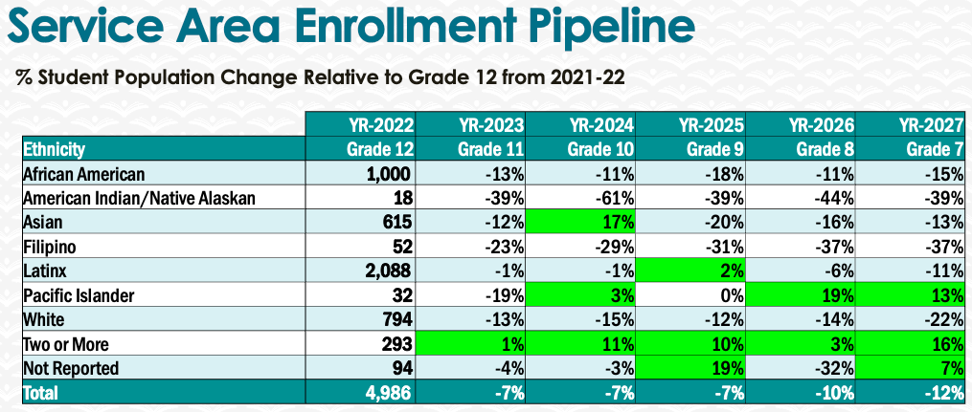
If SAS were granted additional funding to employ a full-time 1.0 FTE SAS Counselor, we would have the ability to provide more outreach activities directed towards Albany Unified, Berkeley Unified and Oakland Unified special education programs to discuss college degree and certificate options and to prepare them for receiving support services while they attend.

5. Facility Utilization Needs
Assess your facility utilization for next year and indicate if the space is sufficient or not. If not, what are the needs and why? Work with your manager to check on your needs prior to responding this section.
The current office space is NOT sufficient. SAS greatly needs a spacious and well-designed reception area. There is only one small office in which 3 front desk staff share a space and no specific check-in area for students. Students must check in with front desk staff one individual at a time in order preserve medical privacy. SAS needs a front desk counter with a separate waiting room that is not shared with general counseling staff.

6. Assessment
Berkeley City College is committed to a culture of assessment to improve instruction, services, and institutional planning. Findings from SLO, PLO, ALO assessments, and program review data are used to direct resources for institutional priorities that are articulated in the Educational Master Plan and BCC Strategic Plan. Due to the critical role that course and program assessments play in our institutional planning and to be in compliance with the Accreditation requirements, assessments must be completed to qualify for APU resource allocation requests.
What action plans did your Program identify upon the assessment of each Service Area Outcomes (SAOs)? Please be as detailed as possible.
- Faculty and staff outreach/training: SAS Staff will provide general and individualized training and information to campus administrators, faculty and staff related to serving students with disabilities.

- Customer Service: Students and instructors will report receiving effective services from SAS.

- Support Services/Student Communication: SAS will design and maintain easily accessible online and in person methods of receiving support for students with disabilities.

- SAS Students will request services in sufficient time to maximize their accommodations.

Describe the Program’s progress on the Action Plans identified for Service Area Outcomes (SAOs). Please be specific. Identify percentages towards completion of Action Plans. What Action Plans are priorities?
Describe the status of SAO completion in Rounds 4 and 5 of the Assessment Cycle. Identify the percentages of completion. Briefly describe what needs to be done to reach 100% completion? Identify issues or concerns that may prevent your area from completing assessments of SAOs.

To assist you with this area/prompt, please review your Program’s Round 5 Tentative Plan available on One Drive, search Curricunet for assessment proposals of courses (or SAOs) that should be assessed this past year, and consult the Program’s SAO lead) and/or faculty (or staff) who were scheduled for assessments this past year.
How does your department, program, or unit ensure that students are aware of Service Area Outcomes?
Where are the Service Area Outcomes published? If on a website, please specify the URL.
The Service Area Outcomes have not been published on the SAS website yet.

7. Engagement
Discuss how faculty and classified staff have engaged in institutional efforts such as committees, presentations, and departmental activities. Please list the committees that full-time faculty/staff/admin participate in.
The following are a list of faculty and classified staff participations in institutional activities.
Name | Classification | Activities
Elissa Jaw | Faculty | District DE Committee, Student Services Council, SAS Departmental Meetings, Behavioral Intervention Team, Student Club Advisor, General Counseling Meetings, Presenter for Flex Day Workshops, The Learning Center and Chair Meetings
Roberto Gonzalez | Staff | SAS Departmental Meetings, President of Classified Senate, Flex Day Presenter
Dolores Harshaw | Staff | Student Services Council, SAS Departmental Meetings, President’s Race and Equity Taskforce; Safety Committee
Lynn Massey | Staff | SAS Departmental Meetings
Maricela Becerra | Faculty | SAS Departmental Meetings, Flex Day Presentation

Discuss how faculty and staff have engaged in community activities, partnerships and/or collaborations.
SAS staff have collaborative relations with the Berkeley College Internship Program (CIP) and Department of Rehabilitation (DOR) Berkeley and Oakland Branch Offices. The SAS department has presented at CIP for their consumers regarding student services and accommodations offered by the college. SAS counselors periodically collaborate with DOR counselors and personnel on the students’/consumers’ Individual Plan for Employment or Training in order to provide academic services at the college while the students are completing their career educational goals.
Discuss how part-time staff members are included in program trainings, discussions, and decision-making.
Part-time SAS counselors and classified staff present during campus Flex Day workshops and participate in discussions during SAS and Student Services departmental meetings. SAS faculty and staff periodically complete departmental surveys for opinion or decision-making purposes.
- Discuss the relationship and engagement with other support services, programs, departments, or administrative units and how these relationships/collaboration support meeting your program goals.
- SAS works with EOPS students and validates their requirements for 3x counselor contact per semester. SAS also provides reduced course letters to EOPS so that students can take a more manageable unit load as their required by their disability accommodations. SAS also works with the Learning Resource Center (LRC) staff to provide collaborative assistance for students who have extensive learning challenges or may need extra time for tutoring services due to a disability. Many support service program counselors refer students to SAS for learning disability assessment and evaluation.
Are there areas you feel that your department can benefit more by increasing collaboration and partnership? How?
SAS counselors can provide in-service training for tutors at the LRC or on how to teach with students with various disabilities and universal design learning.

8. Prioritized Resource Requests
During the 2021-22 Comprehensive Program Review process, you have provided your resource requests which went through the IPAR process. In this section, include resource requests from last year that are still needed and/or new resources that have emerged. Provide justifications. If there are no resource requested, leave the boxes blank.

Resource Category | Description/Justification | Estimated Cost
Personnel
Classified Staff | Full-time classified staff for Alternate Media production (AMS); 1 part-time front desk clerical staff to assist with scheduling student appointments, reception and test proctoring | $130,000 AMS  $46,000 part-time clerical
Student Worker | Student Worker for clerical and front desk operations assistance | $33,000
Part Time Faculty | 2 part-time SAS counselors for a total of 30 hours/week during fall and spring semesters and 24 hours/week during summer session. | $84,000
Professional Development
Department wide PD needed | In-service trainings on disability and/or assistive technology | $3000
Personal/Individual PD needed | California Association for Postsecondary Education and Disability (CAPED) Conference | $6000
Supplies
Software (for whom or role?) | License renewals and/or new software purchases for Kurzweil, Learning Ally, Glean, OtterAI, JAWS. | $8000
Books, Magazines, and/or Periodicals | DSM-V-TR for referencing mental health disorders | $400
Instructional Supplies | Dry eraser markers; whiteboard erasers, paper; printer ink, post-its, LiveScribe SmartPen ink cartridge refills; SmartPen replacements; digital recorders | $1300
Non-Instructional Supplies | General office supplies | $600
Technology & Equipment
Description/Justification (Before you list your technology request, click here to view the latest Technology Refresh Plan to verify whether it has already included.)
New | Roger Pens/Microphone for real-time captioning for deaf or hard-of-hearing students; Omni Robot for student remote participation and attendance for disability accommodations | $4000
Replacement | Testing room cameras – Need to upgrade cameras to include audio, larger monitor for better viewing and camera coverage in testing rooms; increase video storage capacity and duration. | $2500
Facilities
Classrooms | N/A
Offices | N/A
Labs | N/A
Other | N/A
Library
Library materials (including streamline media needs) | N/A
Library collections | N/A
OER | N/A
Other
OTHER Description

Thank you for your time and effort in completing the Annual Program Update!
Please email the completed Program Review to your Dean by November 30, 2022.

