Berkeley City College’s mission is to provide our diverse community with
educational opportunities, promote student success, and to transform lives.

Introduction and Directions

Berkeley City College (BCC), in conjunction with the Peralta community College District, has an institutional effectiveness process which consists of the following components: a District-wide Strategic Plan which is updated every six years; Comprehensive Program Reviews (CPRs) which are completed every three years; and Annual Program Updates (APUs) which are completed in non-program review years.

TIMELINE
Annual Program Update (APU) 2022-2023 timeline has been developed for each program and services to guide through the semester. Please review and work with your Deans, Managers, Department Chairs and/or Supervisors to complete this APU.

For BCC, 2022-2023 marks a critically important year as the college is in the process of revising its Educational Master Plan (EMP) for the next 5 years (2024-2028). This college EMP process will inform the District with their planning for their Strategic Plan. This year’s APU will take an especially important role for the EMP process, carrying your analysis, planning and strategies to support our students success, retention, and equitable completion.

The APU is intended to primarily focus upon planning for the subsequent year based on the institutional priorities. While developing the College’s EMP for the next 5 years, the college and the district focused on the Vision for Success identified by the California Community College Chancellor’s office as well as Student Centered Funding Formula (SCFF) that clearly delineate the categorized outcomes that the Colleges should be focusing. Please use these foci as your reference to prioritize your department and other goals.

RESOURCE REQUEST PROCESS
In this process of making continuous quality improvement, there is an opportunity for each program, student services, and department to request resources that support achieving the stated goals. The APU process directly leads to the institutional resource allocation process and budget planning facilitated by the Institutional Planning and Allocation of Resources (IPAR) Committee for the following academic year (2023-24). The process for this can be found here (2022-23 APU Timeline). This is an opportunity for each department to request resources that will support your department goals and set outcomes.

TECHNOLOGY REQUEST
Finally, for the resource request section, please connect with your Deans, managers, and supervisors regarding your technology needs so that you can be informed about the equipment that is addressed in the BCC Technology Refresh Plan. If your requests are covered in the Refresh Plan, you do not need to request them in this APU.

If you have questions regarding other material in the Annual Program Update, please contact your Manager. If you have questions regarding data, please contact Dr. Phoumy Sayavong, Senior Researcher and Planning Analyst (psayavong@peralta.edu).

Please email the completed Annual Program Update to your Supervisor by November 30, 2022.

College Profile
Click here to view the Berkeley City College Student Demographics Dashboard.
This 2-page dashboard will provide data on the demographics of our student body from the past two years such as headcount, ethnicity, enrollment status, age group, educational goals, and majors.
College Outcomes | 2018-2019 | 2019-20 | 2020-21 | 2021-22
Full Time Equivalent Students (FTES) | 4161 | 3,931 | 3,622 | 3,259
Productivity (Avg. Goal = 17.5) | 13 | 13.2 | 13 | 10.9
Success Rate (%) | 69% | 77% | 75%* | 70%*
Degrees + Certificates Awarded (#) | 948 | 1,109 | 1,027 | 960
*Excludes “EW” grades

To view prior Program Reviews, click here. To view prior Annual Program Updates, click here.

1a. Program Description
Please verify the mission statement for your program. If your program has not created a mission statement, provide details on how your program supports and contributes to the College’s mission.
Berkeley City College offers a wide variety of financial aid programs and services to help you meet your educational costs. The college participates in the Federal Pell Grant Program, the Federal Supplemental Education Opportunity Grant Program (SEOG), the Federal College Work-Study Program, and the California College Promise Grant (CCPG).
Name(s) of member(s) completing this APU | Program | Completion Date
John Nguyen | Financial Aid | 11/30/2022
List staff names with assignments in fall 2022.
Full Time | Part Time
John Nguyen – Acting Dean of Enrollment Services  Andrea Williams – Out-of-Class Financial Aid Officer  Kent Nguyen – Financial Aid Specialist  Jaimie Redmon – Financial Aid Specialist | Tammie Perry – Financial Aid Senior Clerk

1b. Program Priorities & Goals
Based on the Vision for Success and SCFF, and your program’s mission, what are your program’s priorities and goals for 2022-23?
The office’s priorities and goals are:
- Increase financial aid workshops.
- Increase FAFSA completion.
- Update webpage to have most to date information.
- Have front desk staff and specialists to further support students.

2. Student Equity, Success, & Completion
Using the data dashboards provided below, review and reflect upon the outcome trends for your program. Please also review overall BCC’s data linked here.

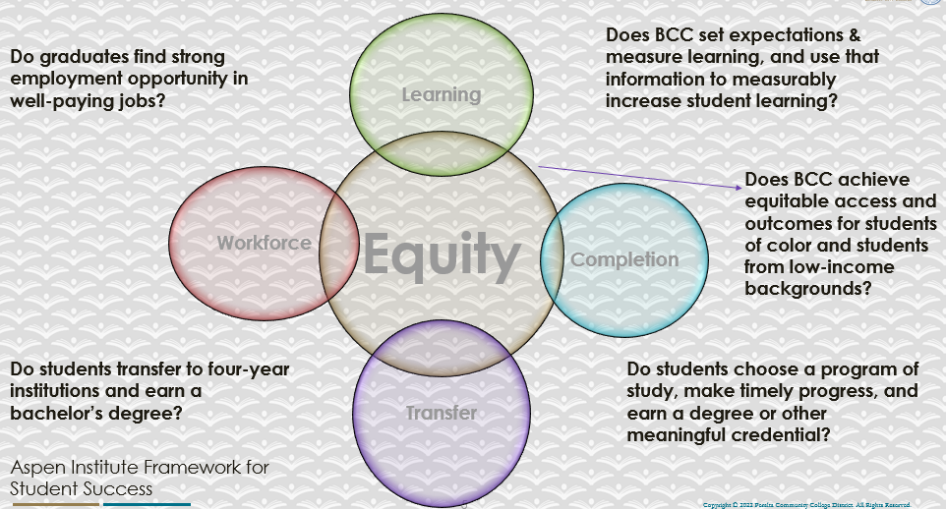

For assistance with data dashboards, contact Phoumy Sayavong at psayavong@peralta.edu
How are students doing in success and completion in your program? In comparison to the BCC overall success and completion rate, how are the students doing in your program? What are the group of students that needs more attention to achieve goals?
- Students who are receiving financial aid are doing better because their financial stress and burden are lessened.
- The group of students that need more attention to achieve goals are students who are not eligible for financial aid and need to do an appeal. We need to continue providing them with support and track their progress by referring them to the right resources.

What are key factors in your program that contributed to positive success and completion rate?
- Provide front desk support.
- Following up with student’s financial aid questions.
- Providing financial aid workshops during enrollment periods.

What are some improvements your program can make? Identify strategies.
- Hire additional staffing financial aid director, financial aid officer, and specialists for the office.
- Send messaging out to students about important deadlines and workshops through emails and texts.
- Participate by tabling at campus events.
- Participate in outreach efforts to provide financial aid information.

3a. Enrollment Trend and Productivity Dashboard
*Note that completion and retention rates are presented with the inclusion and exclusion of excused withdrawals (EW) and military withdrawals.
What are the enrollment trends in your program in the last three years (if applicable) or college?
We have noticed more students requesting for financial aid assistance; however, we are short-staffed so it is taking longer than usual. To help with this, we have additional student employees at the front desk to answer questions.
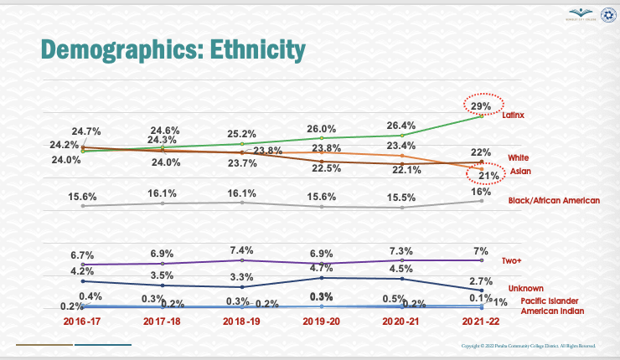
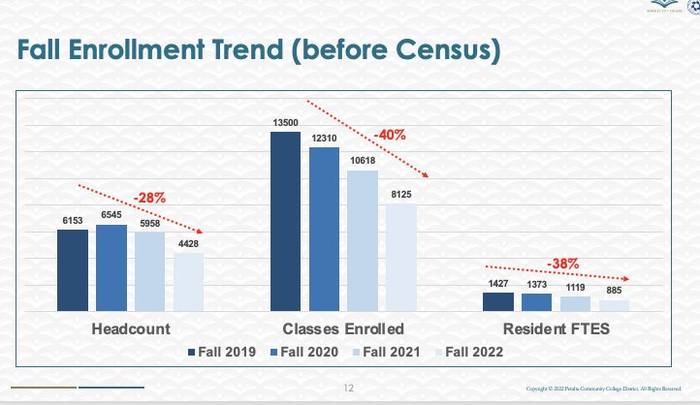
What strategies would you recommend to increase student enrollment in your program?
- Provide more signage around campus about financial aid.
- Have tablets at the front for students to receive self-help.
- Continue marketing Spring to Success for students to complete their FAFSA, CADDAA or California Promise Grant.
Community Colleges are funded based on the Student Centered Funding Formula (“SCFF”) which is comprised of the following allocations:

Student Centered Funding Formula: Focus and Priorities
% Of Allocation | Categories
70%  Base Allocation: FTES (Enrollment) | - Credit FTES  - NonCredit FTES  - Special Admits (Dual Enrollment, etc.)
20%  Supplemental Allocation | - Pell Grant  - AB 540  - Adult School  - Promise Grants
10%  Student Success Allocation | - Associate Degrees  - ADTs  - 9 or more CE units  - Transfer  - Transfer level Math and English in the first year

List the Program’s progress and reflection on how to maintain or increase student enrollment. Please describe retention (i.e., remain enrolled for a full semester) and persistence (i.e., enroll in consecutive semesters) efforts.
- Provide and market Spring to Success Campaign that includes: AC Transit Bus Passes, “Free Parking” if you take 6-12 units on BCC campus, free weekly lunch meals, and food pantry access.
- Continue to use live chat feature and Zoom staffed by financial aid staff.
- Implement Ocelot to ensure that students are supported during campus off-hours.

Please describe your unit’s efforts in identifying Pell Grant recipients, College Promise Grant recipients, Adult Education, and AB 540 students. What processes are in place to accurately report these students each semester?

College Outcomes | 2018-2019 | 2019-2020 | 2020-21 | 2021-22
Full Time Equivalent Students (FTES) | 4,161 | 3,931 | 3,622 | 3,259
Pell Grant Recipients | 2,387 | 2,281 | 2,181 | 1,826
College Promise Grant Recipients | 4,373 | 4,143 | 4,011 | 3,500
AB 540 Students | 74 | 51 | 22 | 69

3b. Course Completion and Retention Rates Dashboard – Student Services
*Note that completion and retention rates are presented with the inclusion and exclusion of excused withdrawals (EW) and military withdrawals.

If you need more guidance with this item, click here for additional support. Click here for additional guidance for how to view and use equity data. If you would like to view BCC’s Equity Plan, click here.
On page 3 of the “Course Completion and Retention Rates by Subject” dashboard, what are the completion and retention trends by gender, age, ethnicity in your program/service area?
How can your Program improve trends over the next year?
- Administer surveys for students so that financial aid can learn how to improve.
- Increase financial aid workshops and being more intentional about targeting specific groups for financial aid workshops. For example, have a financial aid workshop for undocumented students by working with the Undocumented Community Resource Center.

What population(s) showed outcomes gains and which need more support?

Disaggregate the data and outcomes as far down as a possible then ask:
- What trends do you notice when examining course success rates for student populations by ethnicity? Which factors do you believe have the greatest impact (positive or negative) and cause variation between student course success rates in your Program? Describe some specific methods your Program is planning or implementing to address these equity gaps. How will you evaluate the efficacy of these interventions?

- How has pivoting to online instruction contributed to potential reductions in student success? Provide some specific examples of practices that staff in your Program have found ineffective in the online environment.

Please review the video from the RP Group acknowledging the interrogation De Anza Community College committed to in their analysis of course completion and success rate.
- Students who are on FA Appeals. We have noticed that many students apply for FA Appeals and many of them are over 1st attempts so we need to keep track of their progress.
- Independent students: Many students apply for independence from their parents because of extenuating circumstances that makes it difficult for them to do well in their courses. We need to continue working with these students to identify resources for them to succeed.

How do these outcome trends in your program compare to the college average?
- Many students qualify for financial aid and they are less burdened because not only do they receive free fees because of Spring to Success, they are receiving additional funds to support their education.

How will these outcome trends you identified in this section affect your program goals and plans for the next year and what are your strategies to shift the trend to go towards positive direction?
- We will continue communicating with students about important deadlines and resources through multiple outlets including the website, texts, emails, and flyers on campus.
- We will also table on campus during events to inform students about financial aid.
- Make classroom presentations about financial aid resources and how to receive them.

3c. Degrees and Certificates Dashboard
On page 1 of the “Degrees and Certificate Awards Trends” Dashboard, what are the award trends for your program/service area (e.g., overall, by gender, age, and ethnicity)?
On page 4, what population(s) award trends showed gains in your program and which populations need more support?

3d. Transfer Dashboard
This dashboard does not provide data by subject. Reflect on what you can do to affect student transfer. How may your Program help to support BCC student transfer? (e.g., serve on panels, strengthen GP in your dept, change curriculum, increase number of AD-Ts, etc.)
- Provide financial aid workshops for students who are prospective transfers.
- Connect students with resources to financial aid at universities.

3e. Curriculum based on Guided Pathways
View your program through the lens of student equity outcomes.
- How is your Program making pathways for students to complete their goals?
- Follow-up with students who have completed their financial aid appeals to ensure that they are completing their goals.
- Reach out to students to attend financial aid workshops and remind them of important deadlines so that they can receive financial aid so that they do not need to worry about financial burdens.

4. Dual Enrollment
As continued decline in overall enrollment for college going population occurs, it is important for us to look at who will be coming to BCC in the next 5 years. Reviewing the data provide here, what strategies would your Program employ to address bringing more students to BCC?

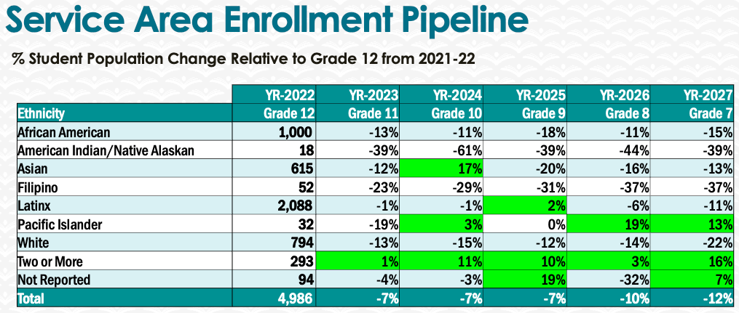
- Work with high schools and provide them with information on financial aid students are eligible for and have them make appointments with us to ensure they are ready for college.

5. Facility Utilization Needs
Assess your facility utilization for next year and indicate if the space is sufficient or not. If not, what are the needs and why? Work with your manager to check on your needs prior to responding this section.
We need to have more open spaces for students to receive financial aid support in a private setting. At the moment, students are being helped at the front desk and in the financial aid office. A bigger space with soundproof dividers will ensure student confidentiality.

6. Assessment
Berkeley City College is committed to a culture of assessment to improve instruction, services, and institutional planning. Findings from SLO, PLO, ALO assessments, and program review data are used to direct resources for institutional priorities that are articulated in the Educational Master Plan and BCC Strategic Plan. Due to the critical role that course and program assessments play in our institutional planning and be in compliance with the Accreditation requirements, assessments must be completed to qualify for APU resource allocation requests.
What action plans did your Program identify upon the assessment of each Service Area Outcomes (SAOs)? Please be as detailed as possible.
SAOS assessments are in progress.

Describe the Program’s progress on the Action Plans identified for Service Area Outcomes (SAOs). Please be specific. Identify percentages towards completion of Action Plans. What Action Plans are priorities?
SAOS assessments are in progress.

Describe the status of SAO completion in Rounds 4 and 5 of the Assessment Cycle. Identify the percentages of completion. Briefly describe what needs to be done to reach 100% completion? Identify issues or concerns that may prevent your area from completing assessments of SAOs.

To assist you with this area/prompt, please review your Program’s Round 5 Tentative Plan available on One Drive, search Curricunet for assessment proposals of courses (or SAOs) that should be assessed this past year, and consult the Program’s SAO lead) and/or faculty (or staff) who were scheduled for assessments this past year.
SAOS assessments are in progress.

How does your department, program, or unit ensure that students are aware of Service Area Outcomes?
They will be posted on the Financial Aid page.

Where are the Service Area Outcomes published? If on a website, please specify the URL.
They will be posted on the Financial Aid page.

7. Engagement
Discuss how faculty and classified staff have engaged in institutional efforts such as committees, presentations, and departmental activities. Please list the committees that full-time faculty/staff/admin participate in.
- There are collaborations with enrollment services and faculty through classroom financial aid presentations. We also participate in campus tours and participate in high school events. Additionally, financial aid participates in professional development activities.
Discuss how faculty and staff have engaged in community activities, partnerships and/or collaborations.
- Collaborate with Berkeley City College programs through tabling and outreach events.
Discuss how part-time staff members are included in program trainings, discussions, and decision-making.
- Student Services Council meetings.
- Discuss the relationship and engagement with other support services, programs, departments, or administrative units and how these relationships/collaboration support meeting your program goals.
- Continue to work with offices and departments to inform them of important deadlines.
Are there areas you feel that your department can benefit more by increasing collaboration and partnership? How?
- Working with categorical programs such as EOPS and CalWORKS where students need financial support and reach out to them to ensure that deadlines are completed.

8. Prioritized Resource Requests
During the 2021-22 Comprehensive Program Review process, you have provided your resource requests which went through the IPAR process. In this section, include resource requests from last year that are still needed and/or new resources that have emerged. Provide justifications. If there are no resource requested, leave the boxes blank.

Resource Category | Description/Justification | Estimated Cost
Personnel
Classified Staff | Increase assignment of permanent part-time Clerical II to full-time. | $64,800
Classified Staff | Financial Aid Specialist | $80,000
Classified staff | Program Services Specialist | $70,000
Student Worker | 2 FA Student Advisors | $30,000
Part Time Faculty | Financial Aid Counselor | $70,000
Professional Development
Department wide PD needed
Personal/Individual PD needed
Supplies
Software (for whom or role?)
Books, Magazines, and/or Periodicals
Instructional Supplies
Non-Instructional Supplies | Outreach advertisements and materials with BCC Financial Aid logo | $10,000
Technology & Equipment
Description/Justification (Before you list your technology request, click here to view the latest Technology Refresh Plan to verify whether it has already included.)
New | 9 Surface Pro Tablet | $13,500
Replacement | 10 Desktop including monitors, 8 laptops, and 6 scanners. | $15,000
Facilities
Classrooms
Offices
Labs
Other
Library
Library materials (including streamline media needs) | FA events set up for in-person and virtual: Projector, computer, audio, speakers, and other streamline services. | $600
Library collections
OER
Other
OTHER Description

Thank you for your time and effort in completing the Annual Program Update!
Please email the completed Program Review to your Dean by November 30, 2022.

