Berkeley City College’s mission is to provide our diverse community with
educational opportunities, promote student success, and to transform lives.

Introduction and Directions

Berkeley City College (BCC), in conjunction with the Peralta community College District, has an institutional effectiveness process which consists of the following components: a District-wide Strategic Plan which is updated every six years; Comprehensive Program Reviews (CPRs) which are completed every three years; and Annual Program Updates (APUs) which are completed in non-program review years.

TIMELINE
Annual Program Update (APU) 2022-2023 timeline has been developed for each program and services to guide through the semester. Please review and work with your Deans, Managers, Department Chairs and/or Supervisors to complete this APU.

For BCC, 2022-2023 marks a critically important year as the college is in the process of revising its Educational Master Plan (EMP) for the next 5 years (2024-2028). This college EMP process will inform the District with their planning for their Strategic Plan. This year’s APU will take an especially important role for the EMP process, carrying your analysis, planning and strategies to support our students success, retention, and equitable completion.

The APU is intended to primarily focus upon planning for the subsequent year based on the institutional priorities. While developing the College’s EMP for the next 5 years, the college and the district focused on the Vision for Success identified by the California Community College Chancellor’s office as well as Student Centered Funding Formula (SCFF) that clearly delineate the categorized outcomes that the Colleges should be focusing. Please use these foci as your reference to prioritize your department and other goals.

RESOURCE REQUEST PROCESS
In this process of making continuous quality improvement, there is an opportunity for each program, student services, and department to request resources that support achieving the stated goals. The APU process directly leads to the institutional resource allocation process and budget planning facilitated by the Institutional Planning and Allocation of Resources (IPAR) Committee for the following academic year (2023-24). The process for this can be found here (2022-23 APU Timeline). This is an opportunity for each department to request resources that will support your department goals and set outcomes.

TECHNOLOGY REQUEST
Finally, for the resource request section, please connect with your Deans, managers, and supervisors regarding your technology needs so that you can be informed about the equipment that is addressed in the BCC Technology Refresh Plan. If your requests are covered in the Refresh Plan, you do not need to request them in this APU.

If you have questions regarding other material in the Annual Program Update, please contact your Manager. If you have questions regarding data, please contact Dr. Phoumy Sayavong, Senior Researcher and Planning Analyst (psayavong@peralta.edu).

Please email the completed Annual Program Update to your Supervisor by November 30, 2022.

College Profile
Click here to view the Berkeley City College Student Demographics Dashboard.
This 2-page dashboard will provide data on the demographics of our student body from the past two years such as headcount, ethnicity, enrollment status, age group, educational goals, and majors.
College Outcomes | 2018-2019 | 2019-20 | 2020-21 | 2021-22
Full Time Equivalent Students (FTES) | 4161 | 3,931 | 3,622 | 3,259
Productivity (Avg. Goal = 17.5) | 13 | 13.2 | 13 | 10.9
Success Rate (%) | 69% | 77% | 75%* | 70%*
Degrees + Certificates Awarded (#) | 948 | 1,109 | 1,027 | 960
*Excludes “EW” grades

To view prior Program Reviews, click here. To view prior Annual Program Updates, click here.

1a. Program Description
Please verify the mission statement for your program. If your program has not created a mission statement, provide details on how your program supports and contributes to the College’s mission.
EOPS
The mission of Extended Opportunity Programs and Services (EOPS) at Berkeley City College is to provide financial and academic support to students whose educational and socioeconomic backgrounds may prevent them from successfully attending college. EOPS provides students with services including orientation, early registration, specialized counseling, academic planning, career guidance, academic progress monitoring, tutoring, book grants, transfer assistance, workshops, and special cultural awareness activities.
C.A.R.E.
The mission of Cooperative Agencies Resources for Education (CARE), a supplemental program to EOPS, is to provide academic and financial assistance to students who are single heads of household with dependent children and receive CalWORKs and or Cash Aid (TANF) benefits. CARE students receive supplemental counseling and advisement services; assistance with childcare and transportation; textbooks and school supplies; workshops, activities, or classes to enhance personal development, parenting and study skills; group support; peer networking; and information and referrals to campus and community based human services programs.

Name(s) of member(s) completing this APU | Program | Completion Date
Ramona F. Butler | EOPS/CARE | 11/28/22
List staff names with assignments in fall 2022.
Full Time | Part Time
Ramona F. Butler EOPS /CARE Coordinator
Alejandra Oseguera EOPS/ CARE Counselor

1b. Program Priorities & Goals
Based on the Vision for Success and SCFF, and your program’s mission, what are your program’s priorities and goals for 2022-23?
Due to COVID -19 shelter in place, the EOPS program participant numbers decreased considerably. While Instructional and Student services offered 100% online support, faculty and student transition was slow and steady in meeting the needs of students. We learned many valuable lessons on how to comprehensively deliver instructional and wrap around services to our students. The EOPS/CARE program is rebuilding and reimagining program success goals. Our goals for 2022-23 include.
Collaboration and Recruitment:
1) Work with other departments such as Financial Aid, Enrollment Services, UCRC, and Learning Communities, to identify eligible students for the program
Work with County representatives to identify potential students eligible for the CARE program to offer an educational alternative rather than immediate job search.
2) Update the application processes to meet the needs of today’s student, including online access. This will allow students to submit their application online, upload supporting documents, have access to check application status and schedule their mandatory EOPS/CARE new student orientation online. Paper applications will also be available to any student who prefers that method of submission.
Improve Student Success and Retention:
The need of counseling services continues to be high among students. The program continues to offer online, phone, and in person appointments. Online appointments is a very successful tool for the EOPS& CARE students as many of them work full time, are care givers, have families and other obligations that will not allow them to be on campus during counseling hours.. An additional part-time counselor is needed to meet the needs of our students.
Comprehensive Tutoring Services:
Providing comprehensive tutoring services to students in math, English, and science courses is a priority for EOPS/CARE students. Currently The Jerry L. Adams Learning Resource Center offers online tutoring. The EOPS program can provide additional tutoring services as an over-and-above service.
Employee Training and Innovation:
Attend state approved trainings for EOPS staff and faculty to ensure everyone has current information on Title 5 regulations, program activities, campus technological updates and events to identify areas of improvement. Expand out EOPS/CARE Advisory Committee, including Community Based Organizations (CBO) that have the same goals as the EOPS model

Student Engagement
Working to being students back to campus is important as many felt isolated during the pandemic. Increase efforts to encourage student engagement on campus. Develop pathways for students to become aware of BCC programs and services, engage students in campus activities, In-person workshops, cultural activities, encourage students to form / join clubs, run for student government, and encourage participation in transfer-based events and programs.

2. Student Equity, Success, & Completion
Using the data dashboards provided below, review and reflect upon the outcome trends for your program. Please also review overall BCC’s data linked here.

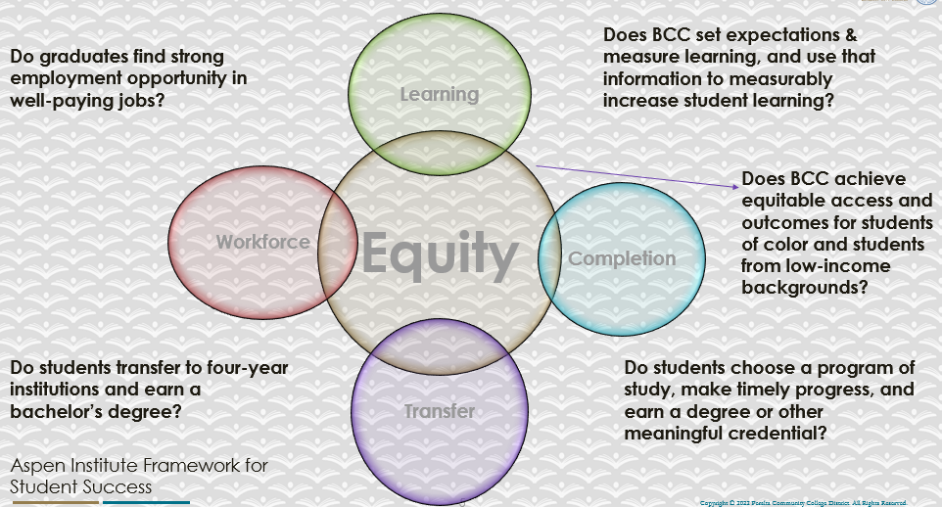

For assistance with data dashboards, contact Phoumy Sayavong at psayavong@peralta.edu
How are students doing in success and completion in your program? In comparison to the BCC overall success and completion rate, how are the students doing in your program? What are the group of students that needs more attention to achieve goals?
Prior to COVID - 19 Shelter in place the EOPS program completion success thrived. Many of our program participants were in their sophomore year as the wave of COVID hit. Since this population already experienced online instruction there was little worry to the 100% online transition.
Some of our New students were wary of 100% online instruction and how it could still benefit them in completing their educational goals. SAS students had similar experiences. Now that the college campus is open, EOPS & CARE are ready to assist students, encouraging them to experience the combination of online and in person EOPS services.
What are key factors in your program that contributed to positive success and completion rate?
Experience with online instruction allowed EOPS students to complete their educational goals during the pandemic shelter in place. A combination of continual check in from EOPS staff, mental health and wellness support from the BCC Wellness Center helped to ease tensions and offer supportive services.
What are some improvements your program can make? Identify strategies.
The EOPS program is sensitive to the needs of our students. Our program population includes SAS, ESOL, Single Parents, Returning students and more. Improvements are always a consideration, including supporting students in the navigation of online technology, using online technology and in person availability for workshops and other EOPS services.

3a. Enrollment Trend and Productivity Dashboard
*Note that completion and retention rates are presented with the inclusion and exclusion of excused withdrawals (EW) and military withdrawals.
What are the enrollment trends in your program in the last three years (if applicable) or college?
What strategies would you recommend to increase student enrollment in your program?
Community Colleges are funded based on the Student Centered Funding Formula (“SCFF”) which is comprised of the following allocations:

Student Centered Funding Formula: Focus and Priorities
% Of Allocation | Categories
70%  Base Allocation: FTES (Enrollment) | - Credit FTES  - NonCredit FTES  - Special Admits (Dual Enrollment, etc.)
20%  Supplemental Allocation | - Pell Grant  - AB 540  - Adult School  - Promise Grants
10%  Student Success Allocation | - Associate Degrees  - ADTs  - 9 or more CE units  - Transfer  - Transfer level Math and English in the first year

List the Program’s progress and reflection on how to maintain or increase student enrollment. Please describe retention (i.e., remain enrolled for a full semester) and persistence (i.e., enroll in consecutive semesters) efforts.
The EOPS & CARE programs have eligibility requirements such as California Resident (in-state fees), current FAFSA or CADAA with a zero EFC. The program works with other departments such as Financial Aid, Enrollment Services, Learning Communities and County Social Service Departments (for CARE students) to identify eligible students. The EOPS and CARE programs work to maintain enrollment by specialized counseling, mid semester check ins, and end of the semester support services, and workshops. Over and above services include, book service, academic grants, and university application fee waivers. Establishing relationships and providing advocacy for our participants helps students maintain persistence now that we are back from the COVID Pandemic shelter in place.

Please describe your unit’s efforts in identifying Pell Grant recipients, College Promise Grant recipients, Adult Education, and AB 540 students. What processes are in place to accurately report these students each semester?

College Outcomes | 2018-2019 | 2019-2020 | 2020-21 | 2021-22
Full Time Equivalent Students (FTES) | 4,161 | 3,931 | 3,622 | 3,259
Pell Grant Recipients | 2,387 | 2,281 | 2,181 | 1,826
College Promise Grant Recipients | 4,373 | 4,143 | 4,011 | 3,500
AB 540 Students | 74 | 51 | 22 | 69

The EOPS program collaborates with other departments such as Enrollment Services, Financial Aid, and Learning Communities to identify potential students who may be academically disadvantaged and income eligible. We do this by tabling at BCC events. Requesting query’s from Financial Aid and CCC apply to identify students who may be foster youth, CalWORKs eligible, CalFresh recipients. We also work with the UCRC , and the Learning Communities. Applications and brochures are posted at the counseling desk, Quick Counseling area, Welcome Desk and Library. Word of mouth from continuing students is also very helpful. All EOPS & CARE eligible students are also eligible for The tuition waiver (CCPG- A or B), Pell , SEOG, and Cal Grants.

3b. Course Completion and Retention Rates Dashboard – Student Services
*Note that completion and retention rates are presented with the inclusion and exclusion of excused withdrawals (EW) and military withdrawals.

If you need more guidance with this item, click here for additional support. Click here for additional guidance for how to view and use equity data. If you would like to view BCC’s Equity Plan, click here.
On page 3 of the “Course Completion and Retention Rates by Subject” dashboard, what are the completion and retention trends by gender, age, ethnicity in your program/service area?
The completion rates for EOPS students decreased over the years indicated 2019-2021. COVID-19 shelter in place decreased completion and retention. The move to 100% online complicated the way instruction and student services delivered curriculum and services to students. EOPS eligible students experienced the difficulties of this change and many discontinued their academic goals for the 2020-2021 fiscal year, Others EOPS student’s maintained academic excellence and were able to complete their academic goals.

How can your Program improve trends over the next year?
The EOPS and CARE programs have been able to successfully make the transition to an online/in-person model to deliver Over and above services to our program participants.
-We currently offer online, video, and in-person counseling services through ConexED.
-Mid Semester check ins are offered via zoom
-We facilitate workshops and meetings in person and on zoom simultaneously and provide light refreshments for students who attend in person.
- We continue to offer incentives for students who maintain program requirements.

What population(s) showed outcomes gains and which need more support?

Disaggregate the data and outcomes as far down as a possible then ask:
- What trends do you notice when examining course success rates for student populations by ethnicity? Which factors do you believe have the greatest impact (positive or negative) and cause variation between student course success rates in your Program? Describe some specific methods your Program is planning or implementing to address these equity gaps. How will you evaluate the efficacy of these interventions?

- How has pivoting to online instruction contributed to potential reductions in student success? Provide some specific examples of practices that staff in your Program have found ineffective in the online environment.
Please review the video from the RP Group acknowledging the interrogation De Anza Community College committed to in their analysis of course completion and success rate.
How do these outcome trends in your program compare to the college average?
How will these outcome trends you identified in this section affect your program goals and plans for the next year and what are your strategies to shift the trend to go towards positive direction?
Since COVID-19 students have adapted to the new way of delivering services and curriculum. The EOPS and CARE programs work with participants by offering both online and in-person services in a safe environment.

3c. Degrees and Certificates Dashboard
On page 1 of the “Degrees and Certificate Awards Trends” Dashboard, what are the award trends for your program/service area (e.g., overall, by gender, age, and ethnicity)?
The EOPS Program degree trends peeked, declined and finally peeked in 2019-2020. Once the pandemic transitioned us to 100% online instruction, college enrollment declined which affected the EOPS program. Online recruitment did not take the place of in-person enrollment support. The CARE program degree increased by 1.
On page 4, what population(s) award trends showed gains in your program and which populations need more support?
The EOPS and CARE programs are designed to assist educationally disadvantaged student complete their academic goals through transfer. Continual support is always our goal. The program tends to have more females. During the last 3 academic years the program issued a total of 19 degrees and Certificates 10 male and 9 female.

3d. Transfer Dashboard
This dashboard does not provide data by subject. Reflect on what you can do to affect student transfer. How may your Program help to support BCC student transfer? (e.g., serve on panels, strengthen GP in your dept, change curriculum, increase number of AD-Ts, etc.)
Although the awarded indicated in 3c are low, the EOPS and CARE programs completes almost 3 times the amounts indicated. The EOPS and CARE programs can provide “post-petition” support to our program participants who petition to make sure they have the support they need to actually complete the process of finishing required courses and issuance of their degrees & certificates.

3e. Curriculum based on Guided Pathways
View your program through the lens of student equity outcomes.
- How is your Program making pathways for students to complete their goals?
The EOPS and CARE programs use continual engagement with our program participants as a means to assist students in completing their academic goals. We use Remind Texting, and email listserv to provide program updates, campus event information, employment opportunities and general messages. The Program also provides over and above services such as video, phone and in person counseling services, academic & supply grants, and midterm progress support. EOPS/CARE staff, Admin, and community partners, facilitate workshops such as Time Management, Study Skills, Wellness and Health, Knowing your Life’s Purpose, Financial Wellness. Specialized workshops for CARE students such as Student Parent Check-in, Self-Care, Study Time is Family Time.

4. Dual Enrollment
As continued decline in overall enrollment for college going population occurs, it is important for us to look at who will be coming to BCC in the next 5 years. Reviewing the data provide here, what strategies would your Program employ to address bringing more students to BCC?

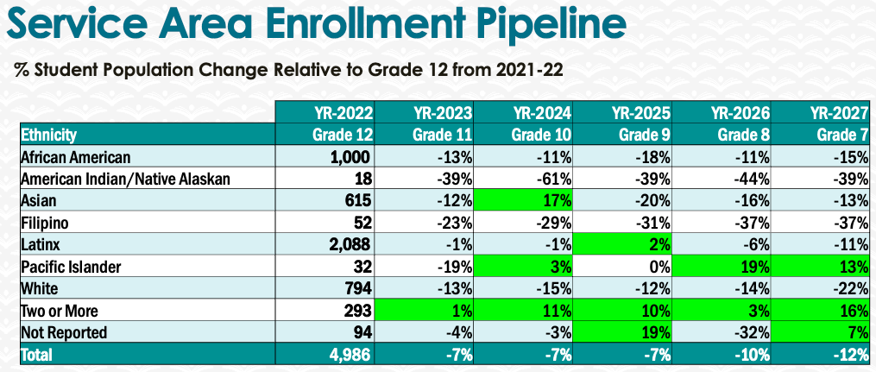
The EOPS and CARE programs require eligibility criteria that includes residency, CCPG with a zero EFC and state deemed educational disadvantage. The program offers over and above services for our student participants. Strategies to bring students to the campus include
-Working with other student services department such Enrollment Services to table at their events and speak about EOPS /CARE program eligibility and requirements. Conduct queries to identify eligible students,
- Present packets of EOPS & CARE information to faculty and speak to their students
- Send email notices to students in Counseling 24 classes regarding possible eligibility for EOPS
-Use the monitors on available floors to post EOPS recruitment information

5. Facility Utilization Needs
Assess your facility utilization for next year and indicate if the space is sufficient or not. If not, what are the needs and why? Work with your manager to check on your needs prior to responding this section.

6. Assessment
Berkeley City College is committed to a culture of assessment to improve instruction, services, and institutional planning. Findings from SLO, PLO, ALO assessments, and program review data are used to direct resources for institutional priorities that are articulated in the Educational Master Plan and BCC Strategic Plan. Due to the critical role that course and program assessments play in our institutional planning and to be in compliance with the Accreditation requirements, assessments must be completed to qualify for APU resource allocation requests.
What action plans did your Program identify upon the assessment of each Service Area Outcomes (SAOs)? Please be as detailed as possible.
Describe the Program’s progress on the Action Plans identified for Service Area Outcomes (SAOs). Please be specific. Identify percentages towards completion of Action Plans. What Action Plans are priorities?
Describe the status of SAO completion in Rounds 4 and 5 of the Assessment Cycle. Identify the percentages of completion. Briefly describe what needs to be done to reach 100% completion? Identify issues or concerns that may prevent your area from completing assessments of SAOs.

To assist you with this area/prompt, please review your Program’s Round 5 Tentative Plan available on One Drive, search Curricunet for assessment proposals of courses (or SAOs) that should be assessed this past year, and consult the Program’s SAO lead) and/or faculty (or staff) who were scheduled for assessments this past year.
How does your department, program, or unit ensure that students are aware of Service Area Outcomes?
Where are the Service Area Outcomes published? If on a website, please specify the URL.

7. Engagement
Discuss how faculty and classified staff have engaged in institutional efforts such as committees, presentations, and departmental activities. Please list the committees that full-time faculty/staff/admin participate in.
The EOPS program offer workshops to facilitate workshops and talks for program participants designed for academic achievement and success. We invite Administrators, staff, faculty and outside facilitators to speak to our students. Workshops include:
How to Write a Winning Scholarship Essay, Study skills 101, Financial Planning, Mindful Art, Self-care and mental health Strategies.
We invite other departments to come and speak to our students regarding academic success.
-SAS Department staff discuss how disabilities, diagnosed or not, can hinder academic success and how the campus accommodation services can support academic success.
Counselors facilitate workshops including, Resume Development, Dress for Success, Interviewing tips.
-Transfer Center. Staff conduct workshops on transfer opportunities and support services to assist in the process.
- Enrollment, Financial Aid, Admissions and Records. Staff support student enrollment and assist students with the necessary forms needed to make any challenge with class schedules, transcript submissions, Financial Aid disbursements (Cal Grants, Pell, SEOG and CCPG) easier to complete.

Discuss how faculty and staff have engaged in community activities, partnerships and/or collaborations.
The EOPS and CARE programs have an Advisory Committee. The committee members include faculty, staff, and CBO partners. Agenda’s include recruitment strategies, community challenges with retaining students, housing and food insecurities, etc.
Discuss how part-time staff members are included in program trainings, discussions, and decision-making.
- Discuss the relationship and engagement with other support services, programs, departments, or administrative units and how these relationships/collaboration support meeting your program goals.
Are there areas you feel that your department can benefit more by increasing collaboration and partnership? How?

8. Prioritized Resource Requests
During the 2021-22 Comprehensive Program Review process, you have provided your resource requests which went through the IPAR process. In this section, include resource requests from last year that are still needed and/or new resources that have emerged. Provide justifications. If there are no resource requested, leave the boxes blank.

Resource Category | Description/Justification | Estimated Cost
Personnel
Classified Staff | 1 Staff Assistant  1 Clerical Assistant | 55,000.00  40,000.00
Student Worker | 3 Student workers | 15,000.00
Part Time Faculty | Adjunct Counselor | 40,000.00
Professional Development
Department wide PD needed | Customer Service | $1,500.00
Personal/Individual PD needed
Supplies
Software (for whom or role?)
Books, Magazines, and/or Periodicals
Instructional Supplies
Non-Instructional Supplies
Technology & Equipment
Description/Justification (Before you list your technology request, click here to view the latest Technology Refresh Plan to verify whether it has already included.)
New
Replacement
Facilities
Classrooms
Offices
Labs
Other
Library
Library materials (including streamline media needs)
Library collections
OER
Other
OTHER Description

Thank you for your time and effort in completing the Annual Program Update!
Please email the completed Program Review to your Dean by November 30, 2022.

