Berkeley City College’s mission is to provide our diverse community with
educational opportunities, promote student success, and to transform lives.

Introduction and Directions

Berkeley City College (BCC), in conjunction with the Peralta community College District, has an institutional effectiveness process which consists of the following components: a District-wide Strategic Plan which is updated every six years; Comprehensive Program Reviews (CPRs) which are completed every three years; and Annual Program Updates (APUs) which are completed in non-program review years.

TIMELINE
Annual Program Update (APU) 2022-2023 timeline has been developed for each program and services to guide through the semester. Please review and work with your Deans, Managers, Department Chairs and/or Supervisors to complete this APU.

For BCC, 2022-2023 marks a critically important year as the college is in the process of revising its Educational Master Plan (EMP) for the next 5 years (2024-2028). This college EMP process will inform the District with their planning for their Strategic Plan. This year’s APU will take an especially important role for the EMP process, carrying your analysis, planning and strategies to support our students success, retention, and equitable completion.

The APU is intended to primarily focus upon planning for the subsequent year based on the institutional priorities. While developing the College’s EMP for the next 5 years, the college and the district focused on the Vision for Success identified by the California Community College Chancellor’s office as well as Student Centered Funding Formula (SCFF) that clearly delineate the categorized outcomes that the Colleges should be focusing. Please use these foci as your reference to prioritize your department and other goals.

RESOURCE REQUEST PROCESS
In this process of making continuous quality improvement, there is an opportunity for each program, student services, and department to request resources that support achieving the stated goals. The APU process directly leads to the institutional resource allocation process and budget planning facilitated by the Institutional Planning and Allocation of Resources (IPAR) Committee for the following academic year (2023-24). The process for this can be found here (2022-23 APU Timeline). This is an opportunity for each department to request resources that will support your department goals and set outcomes.

TECHNOLOGY REQUEST
Finally, for the resource request section, please connect with your Deans, managers, and supervisors regarding your technology needs so that you can be informed about the equipment that is addressed in the BCC Technology Refresh Plan. If your requests are covered in the Refresh Plan, you do not need to request them in this APU.

If you have questions regarding other material in the Annual Program Update, please contact your Manager. If you have questions regarding data, please contact Dr. Phoumy Sayavong, Senior Researcher and Planning Analyst (psayavong@peralta.edu).

Please email the completed Annual Program Update to your Supervisor by November 30, 2022.

College Profile
Click here to view the Berkeley City College Student Demographics Dashboard.
This 2-page dashboard will provide data on the demographics of our student body from the past two years such as headcount, ethnicity, enrollment status, age group, educational goals, and majors.
College Outcomes | 2018-2019 | 2019-20 | 2020-21 | 2021-22
Full Time Equivalent Students (FTES) | 4161 | 3,931 | 3,622 | 3,259
Productivity (Avg. Goal = 17.5) | 13 | 13.2 | 13 | 10.9
Success Rate (%) | 69% | 77% | 75%* | 70%*
Degrees + Certificates Awarded (#) | 948 | 1,109 | 1,027 | 960
*Excludes “EW” grades

To view prior Program Reviews, click here. To view prior Annual Program Updates, click here.

1a. Program Description
Please verify the mission statement for your program. If your program has not created a mission statement, provide details on how your program supports and contributes to the College’s mission.
The CalWORKs program serves students and their families by providing educational and career opportunities combined with effective academic support services that enable them to complete their educational goals, find meaningful employment, and successfully transition into the workforce. The program acts as a liaison between a student’s county of residence and college, to ensure that CalWORKs students have access to available county services and academic benefits. The program contributes towards meeting the college’s strategic planning goals of students’ equity and success.

Name(s) of member(s) completing this APU | Program | Completion Date
Ramona F. Butler | California Work Opportunity and Responsibility to Kids (CalWORKs) | 11/21/22
List staff names with assignments in fall 2022.
Full Time | Part Time
Stacey Shears, Vice President Student Services Manager  Brenda Johnson, Dean of Student Services, Director  Martin De Mucha Flores, Associate Dean of Educational Success | Ramona F, Butler, EOPS/CARE Coordinator

1b. Program Priorities & Goals
Based on the Vision for Success and SCFF, and your program’s mission, what are your program’s priorities and goals for 2022-23?
CalWORKs program goals 2022-2023:
1) Collaboration with our county partners to recruit clients into robust academic programs that will provide opportunities for student parents to complete their educational goals at Berkeley City College and successfully transition into the workforce.
2) Support all program participants during their academic career at Berkeley City College by providing student support services that foster academic excellence including:
-New/continuing student orientations that are designed to familiarize students with county regulations and expectations, academic standards, degree completion and transfer requirements.
-Provide academic and career counseling that support students to increase retention and completion through Certificate / Associate degree completion and transfer and provide referrals as needed. CalWORKs Counseling Services are essential to a student parent’s success and completion.
-Collaboration with other student service departments such as, Financial Aid, Student Accessibility Services, and the Wellness Center. Working with these departments allows the program to recognize student essentials that are outside the classroom and work to resolve roadblocks that hinder academic success and completion
- Referrals and recruitment to other student success programs, such as, EOPS/CARE, Learning Communities, and student government. These relationships give collaborative support to students and allows them to pull from campus community resources while working towards their academic goals of certificate /degree and transfer.
3) Increase employment opportunities including job readiness workshops, resume development, mock interview sessions. Provide on campus employment opportunities for students to remain in an educational environment while completing academic goals.

2. Student Equity, Success, & Completion
Using the data dashboards provided below, review and reflect upon the outcome trends for your program. Please also review overall BCC’s data linked here.

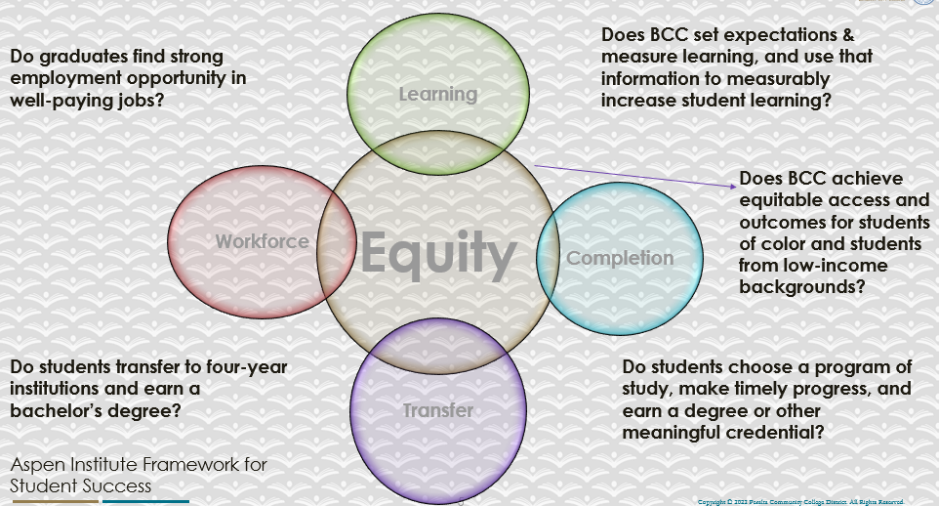

For assistance with data dashboards, contact Phoumy Sayavong at psayavong@peralta.edu
How are students doing in success and completion in your program? In comparison to the BCC overall success and completion rate, how are the students doing in your program? What are the group of students that needs more attention to achieve goals?
The CalWORKs program is a county social service program for families to who receive general and monetary assistance. We provide academic support for student parents to complete their certificate/ degree. Often academic goals are not realized or prioritized as parenting and job search is more of an immediate essential. CalWORKs students who are able to complete their academic goals of Certificate/ Associate Degree, are better prepared to realize their academic ability, and potentially receive better employment opportunities.

What are key factors in your program that contributed to positive success and completion rate?
Key factors for CalWORKs student’s to have a better success and completion rate are,
-Family support such as childcare which gives students the time to attend class and complete required assignments without the worry.
- Transportation support provides allows students to attend class and meet other needs.
- Mentorship from other CalWORKs classmates and successful graduates gives students a confidence boost by seeing others like themselves succeed academically.
-Cohort participation contributes to success and completion rates by providing academic support by creating relationships that support academic excellence.
- Student conferences designed specifically for student parents provides a space for student parents to thrive and re-energize their efforts for academic success and completion.

What are some improvements your program can make? Identify strategies.
Continued and new strategies:
-Work with the BCC Wellness center to offer workshops tailored to the needs of student parents in minoritized communities to support their experiences and efforts to continue their educational goals.
- Continue to facilitate Biweekly Student Parent check in meetings designed to address different student parent concerns such as COVID Health check in, Former CALWORKs Student Successes, Wellness checks /Needs Assessments, and Strategies for Self-Care.
- Encourage students to apply for scholarships, participate in student centered conferences to celebrate their accomplishments personally and academically.

3a. Enrollment Trend and Productivity Dashboard
*Note that completion and retention rates are presented with the inclusion and exclusion of excused withdrawals (EW) and military withdrawals.
What are the enrollment trends in your program in the last three years (if applicable) or college?
What strategies would you recommend to increase student enrollment in your program?
Student parents often have challenges in balancing academic goals / achievements and family responsibilities. County Social Services offers an opportunity for upward mobility through job training and employment search strategies. Enrollment, retention, and degree completion is the focus of the CalWORKs program. One strategy to increase enrollment is, collaboration with County Social Services to refer clients to an educational path that will provide more opportunities for professional growth, upward mobility, and employment opportunities as an alternative to an employment path that has limited options for professional growth without degree completion. Every month during the Fall and Spring semesters, The campus meets with county partners to present Berkeley City College’s certificate and degree program offerings as an alternative.

Community Colleges are funded based on the Student Centered Funding Formula (“SCFF”) which is comprised of the following allocations:

Student Centered Funding Formula: Focus and Priorities
% Of Allocation | Categories
70%  Base Allocation: FTES (Enrollment) | - Credit FTES  - NonCredit FTES  - Special Admits (Dual Enrollment, etc.)
20%  Supplemental Allocation | - Pell Grant  - AB 540  - Adult School  - Promise Grants
10%  Student Success Allocation | - Associate Degrees  - ADTs  - 9 or more CE units  - Transfer  - Transfer level Math and English in the first year

List the Program’s progress and reflection on how to maintain or increase student enrollment. Please describe retention (i.e., remain enrolled for a full semester) and persistence (i.e., enroll in consecutive semesters) efforts.
The CalWORKs program is a county social services program designed for families who receive county assistance through cash aid benefits. The premise is “Welfare to Work” and students must meet all requirements from the county first then the option of education is presented.
The college CalWORKs program works with our sister colleges and community college region, to collaborate with county social service partners to recruitment students for an educational choice rather than immediate job search. Once students are enrolled we encourage them to remain enrolled by offering incentives such as childcare support, academic grants, workshops designed for student parents. We collaborate with other campus departments such as SAS, Wellness Center to meet students where they are and reiterate that the program and the college is here to support them through their academic career.

Please describe your unit’s efforts in identifying Pell Grant recipients, College Promise Grant recipients, Adult Education, and AB 540 students. What processes are in place to accurately report these students each semester?

College Outcomes | 2018-2019 | 2019-2020 | 2020-21 | 2021-22
Full Time Equivalent Students (FTES) | 4,161 | 3,931 | 3,622 | 3,259
Pell Grant Recipients | 2,387 | 2,281 | 2,181 | 1,826
College Promise Grant Recipients | 4,373 | 4,143 | 4,011 | 3,500
AB 540 Students | 74 | 51 | 22 | 69

Students are eligible for CalWORKs through the county where they reside. The CalWORKs program partners with the enrollment and recruitment departments to identify students who may be eligible for the program. We do this by tabling at events and requesting queries through Financial Aid, and CCC apply to identify students who receive CalFresh, Medicare & Medical benefits, and CalWORKs. We also reach out to the county representatives to ask that they refer potential students to our program. Being eligible for CalWORKs benefits means students are also eligible for Cal Grants, Pell, CCPG, and SEOG grants. The program supports students with completing all the necessary forms for eligibility, tuition waivers and disbursements.

3b. Course Completion and Retention Rates Dashboard – Student Services
*Note that completion and retention rates are presented with the inclusion and exclusion of excused withdrawals (EW) and military withdrawals.

If you need more guidance with this item, click here for additional support. Click here for additional guidance for how to view and use equity data. If you would like to view BCC’s Equity Plan, click here.
On page 3 of the “Course Completion and Retention Rates by Subject” dashboard, what are the completion and retention trends by gender, age, ethnicity in your program/service area?
The CalWORKs program retention rates in 2020-21 are 87%

How can your Program improve trends over the next year?
The CalWORKs program depends on county referrals and self-identification. The program collaborates with other campus departments and county partners to recruit students.

What population(s) showed outcomes gains and which need more support?

Disaggregate the data and outcomes as far down as a possible then ask:
- What trends do you notice when examining course success rates for student populations by ethnicity? Which factors do you believe have the greatest impact (positive or negative) and cause variation between student course success rates in your Program? Describe some specific methods your Program is planning or implementing to address these equity gaps. How will you evaluate the efficacy of these interventions?

- How has pivoting to online instruction contributed to potential reductions in student success? Provide some specific examples of practices that staff in your Program have found ineffective in the online environment.
Please review the video from the RP Group acknowledging the interrogation De Anza Community College committed to in their analysis of course completion and success rate.
The CalWORKs program depends on county referral assistance and self-referral. During COVID-19 the program enrollment decreased considerably. Online instruction has not helped our success rates as student parents focus has been on family health and safety. Since COVID-19 The State and county staff have changed regulations to make it easier for students to remain on general assistance and choose an educational path. Since that time potential students enrollment is slowly increasing.
How do these outcome trends in your program compare to the college average?
CalWORKs program outcomes have decreased over the last few years like the college as a whole. Now that we are slowly and steadily increasing our enrollment so has CalWORKs enrollment. More eligible students are beginning to continue their educational path to academic success.

How will these outcome trends you identified in this section affect your program goals and plans for the next year and what are your strategies to shift the trend to go towards positive direction?
The CalWORKs program is committed to enrollment success, retention and completion. Goals are continually being evaluated and revised as needed. Our staratagies college and county collaborations continue to evolve as an educational path is realized for upward mobility and employment success.
continue

3c. Degrees and Certificates Dashboard
On page 1 of the “Degrees and Certificate Awards Trends” Dashboard, what are the award trends for your program/service area (e.g., overall, by gender, age, and ethnicity)?
No degrees have been issued for CalWORKs students

On page 4, what population(s) award trends showed gains in your program and which populations need more support?

3d. Transfer Dashboard
This dashboard does not provide data by subject. Reflect on what you can do to affect student transfer. How may your Program help to support BCC student transfer? (e.g., serve on panels, strengthen GP in your dept, change curriculum, increase number of AD-Ts, etc.)
Although the Dashboard does not reflect CalWORKs degrees have been issued students have petitioned. The CalWORKs program must work closer with students to support their academic efforts by offering wellness checks, on campus employment opportunities, over and above supplemental support services and other support services.

3e. Curriculum based on Guided Pathways
View your program through the lens of student equity outcomes.
- How is your Program making pathways for students to complete their goals?
The Berkeley City College CalWORKs program provides counseling services, specialize workshops, supplemental support services, and specializes workshops for students. The program, acts as a liaison between the college and county social service department to submit the required forms and create a pathway for goal completion.

4. Dual Enrollment
As continued decline in overall enrollment for college going population occurs, it is important for us to look at who will be coming to BCC in the next 5 years. Reviewing the data provide here, what strategies would your Program employ to address bringing more students to BCC?

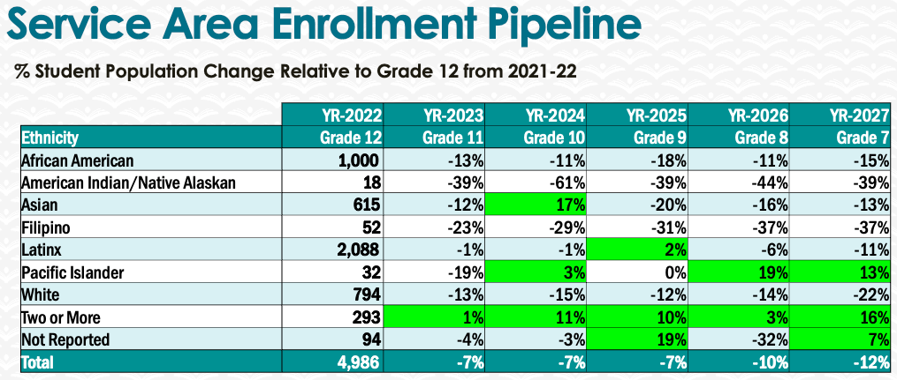
CalWORKs is a program that supports students who choose an educational pathway to employment. We work with our county representatives, community partners, and college services to recruit, enroll and support degree completion.
-Working with County representatives to encourage students to choose an educational pathway to employment by offering robust degree programs of interest
-Use CCC apply and Financial Aid to query students who may be eligible
- Offer support services such as childcare and supplemental transportation
-Provide counseling services including educational, career, and wellness checks to further assess student parent needs
-

5. Facility Utilization Needs
Assess your facility utilization for next year and indicate if the space is sufficient or not. If not, what are the needs and why? Work with your manager to check on your needs prior to responding this section.

6. Assessment
Berkeley City College is committed to a culture of assessment to improve instruction, services, and institutional planning. Findings from SLO, PLO, ALO assessments, and program review data are used to direct resources for institutional priorities that are articulated in the Educational Master Plan and BCC Strategic Plan. Due to the critical role that course and program assessments play in our institutional planning and to be in compliance with the Accreditation requirements, assessments must be completed to qualify for APU resource allocation requests.
What action plans did your Program identify upon the assessment of each Service Area Outcomes (SAOs)? Please be as detailed as possible.
Describe the Program’s progress on the Action Plans identified for Service Area Outcomes (SAOs). Please be specific. Identify percentages towards completion of Action Plans. What Action Plans are priorities?
Describe the status of SAO completion in Rounds 4 and 5 of the Assessment Cycle. Identify the percentages of completion. Briefly describe what needs to be done to reach 100% completion? Identify issues or concerns that may prevent your area from completing assessments of SAOs.

To assist you with this area/prompt, please review your Program’s Round 5 Tentative Plan available on One Drive, search Curricunet for assessment proposals of courses (or SAOs) that should be assessed this past year, and consult the Program’s SAO lead) and/or faculty (or staff) who were scheduled for assessments this past year.
How does your department, program, or unit ensure that students are aware of Service Area Outcomes?
Where are the Service Area Outcomes published? If on a website, please specify the URL.

7. Engagement
Discuss how faculty and classified staff have engaged in institutional efforts such as committees, presentations, and departmental activities. Please list the committees that full-time faculty/staff/admin participate in.
The CalWORKs program offer workshops designed specifically for student parents and the program ‘s mission of “… providing educational and career opportunities combined with effective academic support services that enable them to complete their educational goals, find meaningful employment, and successfully transition into the workforce…” Administrators, Faculty and Classified Professionals are invited to facilitate workshops and talks for program participants. Workshops include:
-Admin workshop support. Administrators are invited to facilitate workshops for participants including but not limited to, How to Write a Winning Scholarship Essay, Study skills 101, ,
-Faculty advising. Faculty members speak to students about employment opportunities in their major
- Faculty facilitated Student Parent wellness workshops. The Wellness Center facilitates workshops on self-care and mental health wellness. Wellness assessments via zoom biweekly allow students to continually express their challenges and successes. Peer 2 Peer (P2P) meetings allow student parents to train in the facilitation of wellness groups for their own families and communities
Academic and Career Counseling Services. Counselors facilitate workshops including, Resume Development, Dress for Success, Interviewing tips.
- SAS department. Department staff discuss how disabilities, diagnosed or not, can hinder academic success and how the campus accommodation services can support academic success.
-Transfer Center. Staff conduct workshops on transfer opportunities and support services to assist in the process.
- Enrollment, Financial Aid, Admissions and Records. Staff support student enrollment and assist students with the necessary forms needed to make any challenge with class schedules, transcript submissions, Financial Aid disbursements (Cal Grants, Pell, SEOG and CCPG) easier to complete.

Discuss how faculty and staff have engaged in community activities, partnerships and/or collaborations.
The CalWORKS program has an Advisory Committee. The committee members include faculty, staff, and CBO partners. Agenda’s include recruitment strategies, academic support for families, disability services, health and wellness housing and food security/insecurity, housing and more.
Discuss how part-time staff members are included in program trainings, discussions, and decision-making.
Part Time faculty members provide counseling services to CalWORKs participants by completing comprehensive Student Education Plans, facilitating workshops and providing job information to students. Part Time Coordinator provides all program operations including, hiring staff, budget operations, organizing and facilitating workshops, conferences, trainings.
- Discuss the relationship and engagement with other support services, programs, departments, or administrative units and how these relationships/collaboration support meeting your program goals.
- The CalWORKs program is committed to student achievement, success, and retention. We work with the necessary Student Services Departments to make sure that our participants are ready for their semester. We work with Enrollment Services, Student Accessibility Services, Financial Aid, Admissions and Records, to make sure all appropriate forms and documents are completed and submitted. This allows students to know the required timelines and documents needed for future submissions
- The program also works with our county partners to make sure required forms are submitted on time to continue the flow of CalWORKs academic benefits as any break in support may create an environment where a =student can decide to discontinue academic goals.
Are there areas you feel that your department can benefit more by increasing collaboration and partnership? How?

8. Prioritized Resource Requests
During the 2021-22 Comprehensive Program Review process, you have provided your resource requests which went through the IPAR process. In this section, include resource requests from last year that are still needed and/or new resources that have emerged. Provide justifications. If there are no resource requested, leave the boxes blank.

Resource Category | Description/Justification | Estimated Cost
Personnel
Classified Staff | Clerical Assistant | $35,000.00
Student Worker | 2 | 10,000.00
Part Time Faculty | 1 Adjunct Counselor  Job Developer | $40,000.00  $15,000.00
Professional Development
Department wide PD needed
Personal/Individual PD needed
Supplies
Software (for whom or role?)
Books, Magazines, and/or Periodicals
Instructional Supplies
Non-Instructional Supplies
Technology & Equipment
Description/Justification (Before you list your technology request, click here to view the latest Technology Refresh Plan to verify whether it has already included.)
New
Replacement
Facilities
Classrooms
Offices
Labs
Other
Library
Library materials (including streamline media needs)
Library collections
OER
Other
OTHER Description

Thank you for your time and effort in completing the Annual Program Update!
Please email the completed Program Review to your Dean by November 30, 2022.

