Berkeley City College’s mission is to provide our diverse community with
educational opportunities, promote student success, and to transform lives.

Introduction and Directions

Berkeley City College (BCC), in conjunction with the Peralta community College District, has an institutional effectiveness process which consists of the following components: a District-wide Strategic Plan which is updated every six years; Comprehensive Program Reviews (CPRs) which are completed every three years; and Annual Program Updates (APUs) which are completed in non-program review years.

TIMELINE
Annual Program Update (APU) 2022-2023 timeline has been developed for each program and services to guide through the semester. Please review and work with your Deans, Managers, Department Chairs and/or Supervisors to complete this APU.

For BCC, 2022-2023 marks a critically important year as the college is in the process of revising its Educational Master Plan (EMP) for the next 5 years (2024-2028). This college EMP process will inform the District with their planning for their Strategic Plan. This year’s APU will take an especially important role for the EMP process, carrying your analysis, planning and strategies to support our students success, retention, and equitable completion.

The APU is intended to primarily focus upon planning for the subsequent year based on the institutional priorities. While developing the College’s EMP for the next 5 years, the college and the district focused on the Vision for Success identified by the California Community College Chancellor’s office as well as Student Centered Funding Formula (SCFF) that clearly delineate the categorized outcomes that the Colleges should be focusing. Please use these foci as your reference to prioritize your department and other goals.

RESOURCE REQUEST
In this process of making continuous quality improvement, there is an opportunity for each program, student services, and department to request resources that support achieving the stated goals. The APU process directly leads to the institutional resource allocation process and budget planning facilitated by the Institutional Planning and Allocation of Resources (IPAR) Committee for the following academic year (2023-24). The process for this can be found here (2022-23 APU Timeline). This is an opportunity for each department to request resources that will support your department goals and set outcomes.

TECHNOLOGY REQUEST
Finally, for the resource request section, please connect with your Deans, managers, and supervisors regarding your technology needs so that you can be informed about the equipment that is addressed in the BCC Technology Refresh Plan. If your requests are covered in the Refresh Plan, you do not need to request them in this APU.

If you have questions regarding other material in the Annual Program Update, please contact your Dean or Manager. If you have questions regarding data, please contact Dr. Phoumy Sayavong, Senior Researcher and Planning Analyst (psayavong@peralta.edu).

Please email the completed Annual Program Update to your Dean by November 30, 2022.

College Profile
Click here to view the Berkeley City College Student Demographics Dashboard.
This 2-page dashboard will provide data on the demographics of our student body from the past two years such as headcount, ethnicity, enrollment status, age group, educational goals, and majors.
College Outcomes | 2018-2019 | 2019-20 | 2020-21 | 2021-22
Full Time Equivalent Students (FTES) | 4,161 | 3,931 | 3,622 | 3,259
Productivity (Avg. Goal = 17.5) | 13 | 13.2 | 13 | 10.9
Success Rate (%) | 69% | 77% | 75%* | 70%*
Degrees + Certificates Awarded (#) | 948 | 1,109 | 1,027 | 960
*Excludes “EW” grades

To view prior Program Reviews, click here. To view prior Annual Program Updates, click here.

1a. Department Description
Please verify the mission statement for your department. If your department has not created a mission statement, provide details on how your department supports and contributes to the College’s mission.
The mission of the sociology discipline at Berkeley City College is to support students in degree completion and transfer. By providing a course of study that examines the systematic study of human social institutions and social relationships, sociology courses provide both a general education in the social sciences as well as preparation for the sociology major. Students taking sociology courses will study the role of social theory, sociological research methods, social organization and structure, social stratification and hierarchies, dynamics of social change, family structures, social deviance and control, and applications to the study of specific social groups, social institutions, and social problems.
Name(s) of member(s) completing this APU | Department | Completion Date
Mark Swiencicki  Linda McAllister | Sociology | 11/27/22
List faculty names with assignments in fall 2022.
Full Time | Part Time
Linda McAllister  Mark Swiencicki | Darrol Hughes  Breanne Harris

1b. Department Priorities & Goals
Based on the Vision for Success and SCFF, and your department mission, what are your department’s priorities and goals for 2022-23?
Goal 1. Curriculum:
1: Adopt Sociology of Sexualities Course (on hold until Soc faculty at other colleges can meet)
2: Support mapping project for SOC program under Guided Pathways model.

Goal 2. Assessment:
1: Complete identified assessment activities for the discipline in the Social Sciences three year assessment schedule (underway)

Goal 3. Instruction:
1: Continue to schedule sociology courses across the schedule and across delivery methods (ongoing).
2: Recruit a pool of sociology tutors for both face to face and online classes
3: Bring our asynchronous online courses through the Peer Online Course Review badging process
4: Recruit qualified faculty to teach in our High School dual enrollment program

Goal 4. Student Success:
1: Increase Student Success and Retention in face-to-face classes (ongoing), particularly for disproportionally impacted groups.
2: Increase Student Success and Retention in online and hybrid classes (ongoing), particularly for disproportionately impacted groups.
3: Increase Students completion of Sociology ADT (ongoing), particularly for disproportionately impacted groups.

2. Student Equity, Success, & Completion
Using the data dashboards provided below, review and reflect upon the outcome trends for your department. Please also review overall BCC’s data linked here.

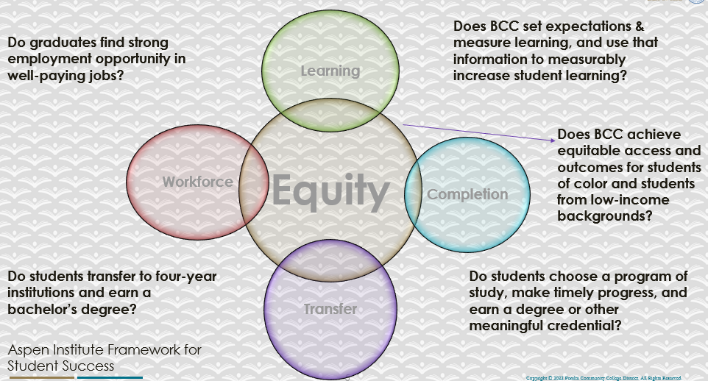

For assistance with data dashboards, contact Phoumy Sayavong at psayavong@peralta.edu
How are students doing in success and completion in your department, compared to the BCC overall success and completion rate? What are the group of students that need more attention to achieve goals?
According to 21-22 data, for
Completion: Sociology- 66% vs. BCC- 68%. So very little difference here.
Retention: Sociology- 80% vs. BCC- 84%. So very moderate deficit here.

Groups Struggling with Completion:
a) Black students – 56% (vs. all -66%)
b) 55-64 years old – 43% (vs. all - 66%)

Groups Struggling with Retention:
a) Race Unknown – 70% (vs. all -80%)
b) Black – 76% (vs. all -80%)

What do you see as key factors in your department that contributed to positive success and completion rate?
We believe lower internet access and pc availability is hurting the above mentioned students taking online courses.

What are some improvements your department can make? Identify strategies.
1) The college already offers free Chromebook loans, but students still keep taking the class on their cell phones. Our instructors will keep stressing why a pc is needed rather than just a cell phone.
2) For internet access we suggest the district subsidize internet connections for low income students.
3) for Black students, our instructors can place a link to the Umoja Program on their syllabi (and explain what it does)
4) For the 55-64 year olds, they are a tiny group, and we assume those were mostly displaced by Covid.

3a. Enrollment Trend and Productivity Dashboard
*Note that completion and retention rates are presented with the inclusion and exclusion of excused withdrawals (EW) and military withdrawals.
What were the enrollment trends in your department in the past three years?
BCC enrollment trend: from 30k – 22k (-31%)
BCC Sociology enrollment trend: from 1080 to 702 (-35%)
Our decline was only slightly lower than BCC itself.

What strategies would you recommend to increase student enrollment in your department?
1) Have instructors send emails out to past students in Intro classes encouraging them to take additional classes.
2) Experiment with different time slots to lower competition with other soc sci departments.

Community Colleges are funded based on the Student Centered Funding Formula (“SCFF”) which is comprised of the following allocations:

Student Centered Funding Formula: Focus and Priorities
% Of Allocation | Categories
70%  Base Allocation: FTES (Enrollment) | - Credit FTES  - NonCredit FTES  - Special Admits (Dual Enrollment, etc.)
20%  Supplemental Allocation | - Pell Grant  - AB 540  - Adult School  - Promise Grants
10%  Student Success Allocation | - Associate Degrees  - ADTs  - 9 or more CE units  - Transfer  - Transfer level Math and English in the first year

List the department’s progress and reflection on what is being done to maintain or increase the base level of full-time equivalent students (FTES = 12 units). Please describe retention (i.e., remain enrolled for a full semester) and persistence (i.e., enroll in consecutive semesters) efforts.
Since 2016-2017, while the college completion and retention rates have remained relatively flat, the SOC Dept. has seen an increase in both measures with a particularly positive gain from 2016-2017 to 2019-2020 in the completion rate, improving 20 points and the retention rate improving 12 points – both measure though are most likely slightly inflated for 2019-2020 due to the Military Withdrawal (MW) and Excused Withdrawal (EW) extended for the COVID crisis. With both measures increasing, and not insignificantly, SOC Dept. faculty recognize the achievement of a primary goal as outlined in the previous Program Review. Retention and completion rates across female and male students are relatively equal, both rates are even with college average. Nonbinary students show lower completion and retention. Completion and retention rates across age groups are relatively even; students in the age range of 16-29 make up the bulk of the enrollment and average around 75% in completion and around 88% in retention. Retention and completion rates for the 20 and older age group is on college average in both categories. SOC Dept. completion rate for Black/African American students is 3 points below the college average. Retention rate for Black/African American students is at the college average. The completion rate and retention rate for Hispanic/Latino student in SOC Dept. sections are both on par with the college average. Both rates show improvement for Black/African American and Hispanic/Latino completion and retention rates. The SOC Dept. concentrated on initiatives to improve completion and retention across the student body with particular attention to students from traditionally marginalized communities. The SOC Dept. will continue to strategize, develop initiatives, and pursue programs that the pay particular heed to the unique circumstances of the Black/African American and Latinx communities at BCC. SOC faculty will likewise continue to support identified student groups such as EOPS, CalWorks, Umoja, CareBCC, Veterans Affairs, etc. The completion and retention rates for special student groups, on average, run close to the college norm.

Please describe your department’s efforts in identifying Pell Grant recipients, College Promise Grant recipients, Adult Education, and AB 540 students. What processes are in place to accurately report these students each semester?

College Outcomes | 2018-2019 | 2019-2020 | 2020-21 | 2021-22
Full Time Equivalent Students (FTES) | 4,161 | 3,931 | 3,622 | 3,259
Pell Grant Recipients | 2,387 | 2,281 | 2,181 | 1,826
College Promise Grant Recipients | 4,373 | 4,143 | 4,011 | 3,500
AB 540 Students | 74 | 51 | 22 | 69

3b. Course Completion and Retention Rates Dashboard – Instruction
*Note that completion and retention rates are presented with the inclusion and exclusion of excused withdrawals (EW) and military withdrawals.

If you need more guidance with this item, click here for additional support. Click here for additional guidance for how to view and use equity data. If you would like to view BCC’s Equity Plan, click here.
On page 3 of the “Course Completion and Retention Rates by Subject” dashboard, what are the completion and retention trends by gender, age, ethnicity in your department?
Data for Sociology Dept Alone:
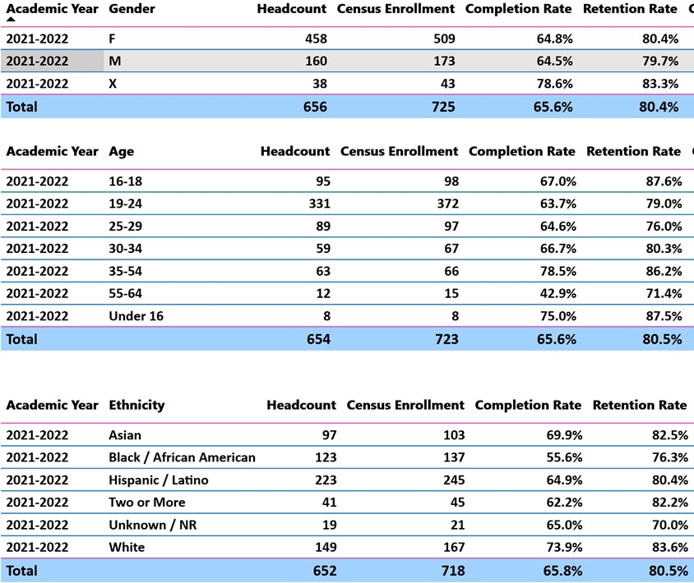

When the data are disaggregated by student ethnic groups, gender, and age, how do you plan to address them over the next year?
1) Spend more time stressing the need to use a PC or Chromebook to complete the class. We will do this by highlighting it our syllabi, and on the first day of class, and again when a student comes to us because of doing poorly and we find out they don’t have an actual pc.
2) To help our low income students who are doing poorly due to lack of broadband internet access, we will publicize where they can go to get cheap internet.
3) For our Black students, our instructors will place a link to the Umoja Program on our (and explain what it does)
4) Since a fair amount of the students who drop classes do so due to missing an exam, we will make sure to provide Canvas reminders of coming exams 2 days before the exam.

What population(s) showed outcomes gains in your discipline(s) and which need more support?
Disaggregate the data and outcomes as far down as a possible then ask:
- What trends do you notice when examining course success rates for student populations by ethnicity? Which factors do you believe have the greatest impact (positive or negative) and cause variation between student course success rates in your Program? Describe some specific methods your department is planning or implementing to address these equity gaps. How will you evaluate the efficacy of these interventions?

- How has pivoting to online instruction contributed to potential reductions in student success? Provide some specific examples of practices that faculty in your department have found ineffective in the online environment.
Please review the video from the RP Group acknowledging the interrogation De Anza Community College committed to in their analysis of course completion and success rate.
Ethnicity: sadly, by a wide margin, our African American students have the lowest success rates, with Black success rates of only 56%, vs. 66% for all BCC students). This is not a surprise because African
Americans have the 2nd highest poverty rate in the US, and the highest rate of being killed by cops and incarceration.
Since the disparity in success rates is so high, we believe more resources should be put into programs like UMOJA. Hispanic success rates are only 1 percentage point lower than the college wide average (i.e., 65% vs 66%), so it looks like most effort should go into supporting our African American students. We plan to work with the counselors to identify types of support that we can offer the aforementioned struggling students. To evaluate this we would need to compare the outcomes of Black students who did join these programs to the overall success rates of our Black students that didn’t join Umoja, or any other program the counselors recommend.
The only other trend we noticed is that students with “Two or more races” were about 3.5 percentage point behind the college average (i.e., 62.2 vs. 65.8. However, since the data doesn’t tell us who this small group is ethnically, we have no way of identifying their exact ethnicity, and thus contacting them.
The pivot to online instruction:
We believe the pivot to online education explains much of the disparity noted above, since it takes considerable economic resources to prosper in online classes, and Black students have the second highest poverty rates of all races. This is not a surprise because recent research has demonstrated that Black and Latinx students are doing much worse in online classes than other groups of students (https://www.mckinsey.com/industries/public-and-social-sector/our-insights/covid-19-and-learning-loss-disparities-grow-and-students-need-help) Unfortunately the data links provided in the APA do not allow us to see how African American success rates vary by course modality so we can only speculate.
Ineffective processes for online classes:
We have found that unlike in traditional face to face classes, we cannot simply publish exam and other important assignment dates in the syllabus, and remind them in class, so we have started sending routine announcements a day or two before each exam to remind them an exam is coming. \
We have also found that traditional grading of written work, where you write comments on their paper doesn’t work as well in an online paper, so we have started using rigorous rubrics to: 1) make crystal clear what the students need to do to succeed, and 2) this allows us to instead of writing down the same comments over and over that most students make, to concentrate more of our efforts on a higher level analysis of the students’ writing and providing ways to improve their papers.

How do these outcome trends in your department compare to the college average?
As mentioned above, Black BCC sociology students have a success rate of 56% vs. 66% for the college as a whole. .
The only other trend we noticed is that students with “Two or more races” were about 3.5 percentage point behind the college average (i.e., 62.2 vs. 65.8. However, since the data doesn’t tell us who this small group is ethnically, we have no way of identifying their exact ethnicity, and thus contacting them.

How will these outcome trends you identified in this section affect your department goals and plans for the next year and what are your strategies to shift to move the trend towards a positive direction?
Since our African American students seem to be struggling in online courses, we plan to have a good mix of both F2F and online courses in the future.

3c. Degrees and Certificates Dashboard
On page 1 of the “Degrees and Certificate Awards Trends” Dashboard, what are the award trends for your department (e.g., overall, by gender, age, and ethnicity)?
Change in numbers of AA-Ts awarded to following groups between 2017-2022:
-Gender: Females up 9% , males down 55%, X = flat

-Age:
16-18: up 2.5x (but only 4 -10);
19-24: flat (but big drop from 21 to 22).
25-29: -43%
30-34: +50%
35-54: flat
55-64: flat
65+ : only 1 in 2020
under 16: only 1 in 2020
However, it’s worth noting that nearly all our AA-Ts are going to students between 16-24 -- classic traditional students, so efforts to reach out to students of 35+ would have only a marginal impact.

-Ethnicity:
American Indians- none granted
Asians: -33% (but big drop between 2020 – 2022)
Black/African Amer: flat
Hispanic/Latino: +43% (but big drop between 2021 – 2022)
Pac Islander: only 1 in 2020
Two or more: -40%
Unknown/NR: flat (only 1 each year)
White: -33% (but big drop between 2021 – 2022)
Remarkably in 2022, Hispanics completed the most AA-Ts, with African Americans in second place.

On page 4, what population(s) award trends showed gains in your program area and which populations need more support?
AA & AAT Trends:
Gender: : Females up 9% , but males are sharply down by 41%, X up 3x. Male college attendance has been lower than females since the late 1980s, so men (especially men of color) need extra support and recruitment. On the other hand, research shows that women were hit much harder by the Covid layoffs, so this could be pushing up female increases and decreasing male rates if young men opting for the higher paying service jobs that the Covid job shortage created more than females.

Age:
1) Nearly all groups are down, or flat, except for students who are 16-18, with a whopping 2.5x increase. However, since their numbers only went from 4 -10, this doesn’t have a big impact on our huge numbers.

2) the groups experiencing the biggest drops, and needing help would be 25-34 year olds, in other words workers in their prime year. However, since our department has always had more females than males, since many females of parenting age have had to take time off work during Covid to watch their kids AATs, this could explain much of the drop.

Ethnicity: remarkably, only Hispanics experienced a big gain of 43% in AATs over this period. However, they also experienced a sharp drop between 2021 – 2022, presumably due to the need to take most of their classes online.

3d. Transfer Dashboard
This dashboard does not provide data by subject. Reflect on what you can do to affect student transfer. How may your department help to support BCC student transfer? (e.g., serve on panels, strengthen GP in your dept, change curriculum, increase number of AD-Ts, etc.)
The SOC Dept. has concentrated on initiatives to improve completion and retention across the student body with particular attention to students from traditionally marginalized communities. The SOC Dept. will continue to strategize, develop initiatives, and pursue programs that the pay particular heed to the unique circumstances of the Black/African American and Latinx communities at BCC. SOC faculty will likewise continue to support identified student groups such as EOPS, CalWorks, Umoja, CareBCC, Veterans Affairs, etc. The completion and retention rates for special student groups, on average, run close to the college norm.
SOC faculty recently revised the SOC ADT to meet the state level revisions. SOC faculty also worked on drafting and moving through the curriculum process the Law, Public Policy and Society ADT.

3e. Curriculum based on Guided Pathways
View the department’s curriculum through the lens of student equity outcomes.
- What intentional effort is your department making to create and present clear pathways for students through curriculum?
One SOC department faculty member is the Co-Coordinator for Guided Pathways and is working closely with dual enrollment for equity to identify high school on ramps, mapping the programs ADTs and reviewing curriculum for alignment with transfer pathways.

- What are your plans for revising and/or creating new pathways supported by labor market information (LMI) and student demands? Using Vision for Success and SCFF focus, please indicate rationale and how the plans directly support student success and equitable completion.
Currently working with Psychology faculty to develop a gerontology CE certificate

4. Dual Enrollment
As continued decline in overall enrollment for college going population, it is important for us to look at who will be coming to BCC in the next 5 years. Reviewing the data provide here, what strategies would your department employ to address bringing more students to BCC?

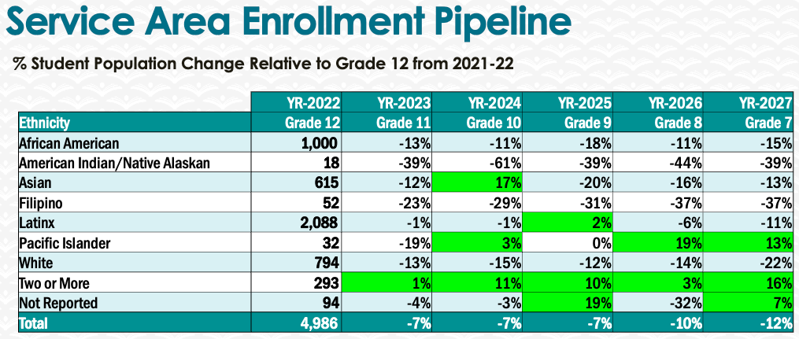
The trends suggest the only 3 increases in student groups will be “Two or More” (TOM), Pacific Islanders, and Not Reported. However, since only tiny amounts of Pac Islanders are coming to BCC, and only slightly more Not Reported, it makes more sense to concentrate on TOM students, especially since the Census shows that this is one of the fastest growing racial groups. To attract more
TOM students we would work with the counselors to find out if there are any student groups in the high schools for bi and multiracial students so we could try to directly contact the student groups to invite them to visit and enroll in BCC.

5. Facility Utilization Needs

Assess your facilities utilization (including labs, support for online learning, and other spaces) and for next year, indicate if the space is sufficient or not. If not, what are the needs and why? Work with your Dean to check on your needs prior to responding this section.
Year 1 (2022-23) | Year23 (2023-24)
1) More AV classrooms with useable whiteboard is needed.  2) Online proctoring software is needed for online exam taking.  3) Faculty need semi-professional usb microphones for lecturing in class with masks on. | 1) Sufficient AV classrooms with useable whiteboard is needed.  2) Online proctoring software is needed for online exam taking.  3) Faculty need semi-professional usb microphones, webcams, and external SSDs for creating online lectures.

6. Assessment
Berkeley City College is committed to a culture of assessment to improve instruction, services, and institutional planning. Findings from SLO, PLO, ALO assessments, and program review data are used to direct resources for areas that are institutional priorities that are articulated in the Educational Master Plan and BCC Strategic Plan.

Due to the critical role that course and program assessments play in our institutional planning and to be in compliance with the Accreditation requirements, assessments must be completed to qualify for the APU resource allocation requests.
6a. What action plans did your department identify upon the assessment of each SLOs and/or PLOs? For courses with multiple sections in the program, please list the main action plans. Please be as detailed as possible.
Soc 1:
SLO 1, Action Plan 1: come up with another real world example of functionalism in the lectures to reinforce what it involves.
SLO 1, Action Plan 2: use breakout discussions on the concepts the students struggled with to have them create a real world example for each definition.

SLO 2, Action Plan: Add a section to the term paper assignment that reminds them that a paper that turns in only half of the assigned pages will get an F, and a paper with 2/3 the required pages will get a D, and specify how long each prompt in the essay should be.

Soc 2:
SLO 1, Action Plan: : give students more practice on how each of the perspectives works by adding a group assignment that makes them explain why each of 3 quotes is an example of a particular perspective.

SLO 2, Action Plan: : switch term paper to one that only requires them to only interview 1 subject (3 subjects was too taxing for them) using the subject’s direct quotes to support their claims.

Soc 5:
SLO 1, Action Plan: to raise the percentage of Zoom discussion/classes that students have to attend in our blended courses to help students master the course concepts and definitions.

SLO 2, Action Plan: add to paper assignment a list of interview questions that they need to ask (to prevent students from getting off topic and having insufficient material/quotes to support their claims).

SOC 7:
SLO 1 Action Plan: I will have students complete a series of short writing assignments which require them to develop and maintain strict analytic focus. I've called these assignments "Article Analysis" assignments and they should help ready students for the kind of structured analysis and writing expected of larger academic projects.

SLO 2 Action Plan: Adding this to the assignment sheet: Make sure to stick to the image itself and to its particularities. Try to avoid introducing information about the painter or photographer’s life into your essay: Analyze the content that is in front of you. Removing photo of Donald Trump and adding collage by Lynn Hershman Leeson.

SOC 8:
SLO 1 Action Plan: Will add a separate page on Canvas about the media resources and their role in the course.
Will add a note about the media resources being a part of the chapter quiz in the quiz instructions.
I will add a study resource related to Foucault and controlology.
I can experiment with having the quiz unlock only after the media pages are accessed but have some concerns about the impact on students who may be locked out of taking a quiz that they otherwise could have done reasonably well on. Will connect with the Laney faculty member who teaches this course and ask them how they teach controlology. I can also connect with faculty teaching Intro to SOC and explore how much focus they are placing on theoretical paradigms outside of conflict theory/critical theory. Disciplines outside of Sociology (like Political Science) also teach Foucault so I could check in with POSCI faculty.

SLO2 Action Plan: I will look for media material that focuses on socio-economic status to include earlier in the course (we do cover this but after this assessment took place) so students can see an application beyond what is discussed in the text (which is quite theoretical). This should be something students are thinking about early in the course. I will include a focus on the micro-macro connection in my weekly announcement that describes the learning goals for the week. I can also look at how to revise an earlier discussion prompt to get students thinking about and applying the micro-macro connection before this discussion assignment.

SOC 13:
SLO 1 Action Plan: Rewrite paper objective to stress that students are being asked to take a position, and argue for that position, within the paper.
Uncouple this paper from a previous project to allow students who missed the earlier assignment to be able to complete this paper. Share out examples of model work
SLO2 Action Plan: Create a review resource of core concepts relevant to the paper. Revise paper assignment to include links to required resources

SOC 18
SLO 1 Action Plan: For the deaths myth lecture I plan to re-organize the group activity here. Students will still be assigned a myth by group and list out themes within their assigned myth but the linking of commonalities (and noting differences) across themes will be more deliberately built into the lecture that follows the activity.

I need to create a check in on the at home reading beyond just class discussion. I could create a no-credit quiz for the reading study guide or make sure there is a cross-reference from sections of the text that may be more challenging with class lecture.
SLO2 Action Plan: Set a higher standard for what target “meets” success.

SOC 120:
SLO 1 Action Plan: I will assess this SLO at a later date in the course so that I can cover more social theory before administering the outcome question and better prepare them to discuss the nuances of the relationship between social theory and methodology.
SLO2 Action Plan: I will change the research proposal such that it can be more inclusive of qualitative research methodology. Although ethnographers use qualitative methods, this point was a little confusing to students who requested to do a qualitative instead of ethnographic research proposal.

6b. Describe the department’s progress on the Actions Plans identified for course Student Learning Outcomes (SLOs). If your department offers a degree or certificate, please describe the department’s progress on the Action Plans for Program Learning Outcomes (PLOs).
The Sociology department will examine the results of the above action plans during our 2023 and 2024 assessments round.
We have not assessed program PLOS and will look for guidance from the Assessment committee on that process.

6c. Describe the status of SLO and PLO completion in Rounds 4 and 5 of the Assessment Cycle. Identify the percent of completion. Briefly describe what needs to be done to reach 100% completion. Identify issues or concerns that may prevent your department from completing assessments of SLOs and/or PLOs.
We have not completed rounds 4 and 5 of the assessment cycle.

6d. Besides your syllabi, where are the program level outcomes published? If on a website, please specify the URL.
In the Associate Degree & Certificate Programs/Course Announcements & Descriptions at
https://www.berkeleycitycollege.edu/sociology/files/2020/06/BCC-2020-2021-SOCIOLOGY-AA-T.pdf

7. Engagement
Discuss how faculty and classified staff have engaged in institutional efforts such as committees, presentations, and departmental activities. Please list the committees that full-time faculty participate in.
Swiencicki has sat on the DTC committee for the past 8 years (with 1 semester off due to a scheduling conflict), and sat on a TRC until 2019. He also taught an hour class to BCC faculty on how to create and edit professional quality course lectures in Camtasia (S21).
McAllister Activities for Sp 22 – F ’22: Curriculum Committee (Sp ’22), Faculty Senator (F ’22), Guided Pathways co-coordinator (Sp/F ’22), POCR committee (Sp/F ’22), POCR reviewer (Sp/F ’22), CIS TRC (Sp/F ’22), Educational Hiring Committee Chair (F ’22), FDIP mentor (F ’22), Honor Council (Sp ’22), Faculty Observations (F ’22), TLC Board (Sp/F ’22).
Discuss how faculty and staff have engaged in community activities, partnerships and/or collaborations.
The two FT sociology instructors meet periodically to review and update the SLOs. In term of the data
analysis, the courses are divided between the 2 FT instructors depending upon which courses they
primarily teach. The two FT faculty also meet periodically to review the courses offered, best times to offer them, and what to change or add for the future.
Discuss how adjunct faculty members are included in departmental training, discussions, and decision-making.
Adjunct faculty are invited to, and usually attend the department meetings. Adjunct faculty have also assisted in doing SLOs.
- Discuss the relationship and engagement with other support services, programs, departments, or administrative units and how these relationships/collaboration support meeting your departmental goals.
- Sociology has been actively involved with Guided Pathways and working across Academic and Career Communities that have sociology classes in their degree pathways. Sociology classes are strongly represented among our dual enrollment offerings
Are there areas you feel that your department can benefit more by increasing collaboration and partnership? How?

8. Prioritized Resource Requests
During the 2021-22 Comprehensive Program Review process, you have provided your resource requests which went through the IPAR process. In this section, include resource requests from last year that are still needed and/or new resources that have emerged. Provide justifications. If there are no resource requested, leave the boxes blank.

Resource Category | Description/Justification | Estimated Cost
Personnel
Classified Staff | We need a full-time accessibility specialist so that our online courses in particular are in compliance | ?
Student Worker
Part Time Faculty
Professional Development
Department wide PD needed
Personal/Individual PD needed
Supplies
Software (for whom or role?) | Camtasia Studio for Swiencicki(usually BCC gets site license)
Books, Magazines, and/or Periodicals
Instructional Supplies
Non-Instructional Supplies
Technology & Equipment
Description/Justification (Before you list your technology request, click here to view the latest Technology Refresh Plan to verify whether it has already included.)
New | 2 USB Microphones for lecturing in class with mask on. (for Swiencicki and McAllister) | $200
Replacement
Facilities
Classrooms
Offices
Labs
Other
Library
Library materials (including streamline media needs)
Library collections
OER
Other
OTHER Description

Thank you for your time and effort in completing the Annual Program Update!
Please email the completed Program Review to your Dean by November 30, 2022

