Berkeley City College’s mission is to provide our diverse community with
educational opportunities, promote student success, and to transform lives.

Introduction and Directions

Berkeley City College (BCC), in conjunction with the Peralta community College District, has an institutional effectiveness process which consists of the following components: a District-wide Strategic Plan which is updated every six years; Comprehensive Program Reviews (CPRs) which are completed every three years; and Annual Program Updates (APUs) which are completed in non-program review years.

TIMELINE
Annual Program Update (APU) 2022-2023 timeline has been developed for each program and services to guide through the semester. Please review and work with your Deans, Managers, Department Chairs and/or Supervisors to complete this APU.

For BCC, 2022-2023 marks a critically important year as the college is in the process of revising its Educational Master Plan (EMP) for the next 5 years (2024-2028). This college EMP process will inform the District with their planning for their Strategic Plan. This year’s APU will take an especially important role for the EMP process, carrying your analysis, planning and strategies to support our students success, retention, and equitable completion.

The APU is intended to primarily focus upon planning for the subsequent year based on the institutional priorities. While developing the College’s EMP for the next 5 years, the college and the district focused on the Vision for Success identified by the California Community College Chancellor’s office as well as Student Centered Funding Formula (SCFF) that clearly delineate the categorized outcomes that the Colleges should be focusing. Please use these foci as your reference to prioritize your department and other goals.

RESOURCE REQUEST
In this process of making continuous quality improvement, there is an opportunity for each program, student services, and department to request resources that support achieving the stated goals. The APU process directly leads to the institutional resource allocation process and budget planning facilitated by the Institutional Planning and Allocation of Resources (IPAR) Committee for the following academic year (2023-24). The process for this can be found here (2022-23 APU Timeline). This is an opportunity for each department to request resources that will support your department goals and set outcomes.

TECHNOLOGY REQUEST
Finally, for the resource request section, please connect with your Deans, managers, and supervisors regarding your technology needs so that you can be informed about the equipment that is addressed in the BCC Technology Refresh Plan. If your requests are covered in the Refresh Plan, you do not need to request them in this APU.

If you have questions regarding other material in the Annual Program Update, please contact your Dean or Manager. If you have questions regarding data, please contact Dr. Phoumy Sayavong, Senior Researcher and Planning Analyst (psayavong@peralta.edu).

Please email the completed Annual Program Update to your Dean by November 30, 2022.

College Profile
Click here to view the Berkeley City College Student Demographics Dashboard.
This 2-page dashboard will provide data on the demographics of our student body from the past two years such as headcount, ethnicity, enrollment status, age group, educational goals, and majors.
College Outcomes | 2018-2019 | 2019-20 | 2020-21 | 2021-22
Full Time Equivalent Students (FTES) | 4,161 | 3,931 | 3,622 | 3,259
Productivity (Avg. Goal = 17.5) | 13 | 13.2 | 13 | 10.9
Success Rate (%) | 69% | 77% | 75%* | 70%*
Degrees + Certificates Awarded (#) | 948 | 1,109 | 1,027 | 960
*Excludes “EW” grades

To view prior Program Reviews, click here. To view prior Annual Program Updates, click here.

1a. Department Description
Please verify the mission statement for your department. If your department has not created a mission statement, provide details on how your department supports and contributes to the College’s mission.
In addition to the college mission, the focus of the Psychology discipline is threefold, to support critical thinking, analysis, and application of major psychological theories and concepts, and prepare students planning to successfully transfer into the psychology major.

Our psychology courses engage in the scientific study of human behavior and mental processes. Psychology students study the nature of consciousness, the development of the individual, basic processes of perception, learning, memory, cognition, and motivation; the relationship of behavior to physiology and health; and the nature of psychological disorders and how psychologists attempt to improve the quality of people’s lives.

In addition, to supporting increased understanding of the human condition, our own behavior as well as that of others, our Psychology courses fulfill general education requirements in area D (social sciences) and in area E (Lifelong Learning) at California State Universities. We have an AA-T in Psychology and our Psychology 1 class has consistently been included as a Learning Community core course.

Ultimately, our courses support the College Mission of promoting student success and transfer.

Name(s) of member(s) completing this APU | Department | Completion Date
Melina Bersamin | Psychology | 11/15/22
List faculty names with assignments in fall 2022.
Full Time | Part Time
Melina Bersamin | Rima Najm-Brisco  Christopher Gade  Jennifer Yu  Gerald Williams

1b. Department Priorities & Goals
Based on the Vision for Success and SCFF, and your department mission, what are your department’s priorities and goals for 2022-23?
The psychology program is prioritizing three goals for the upcoming year. First, to increase the number of students who transfer to a four-year college, second to close equity gaps, and to finalize and advertise the psychology pathway maps to support students understanding of the necessary steps/classes for admission to CSU and UC.

2. Student Equity, Success, & Completion
Using the data dashboards provided below, review and reflect upon the outcome trends for your department. Please also review overall BCC’s data linked here.

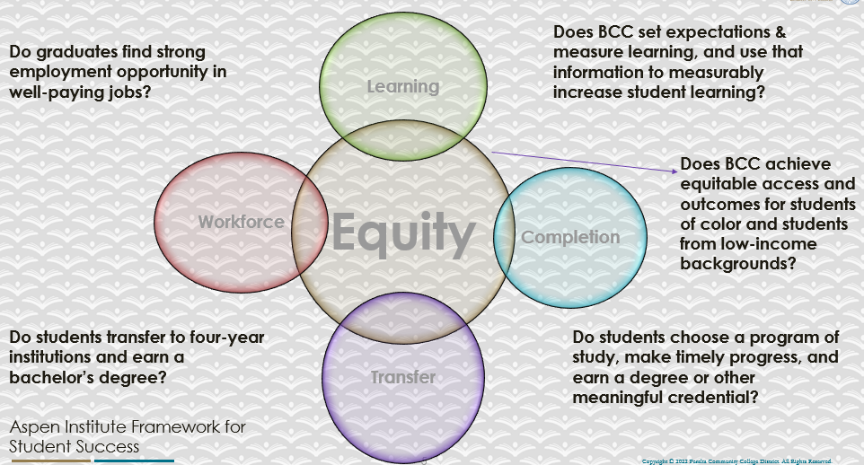

For assistance with data dashboards, contact Phoumy Sayavong at psayavong@peralta.edu
How are students doing in success and completion in your department, compared to the BCC overall success and completion rate? What are the group of students that need more attention to achieve goals?
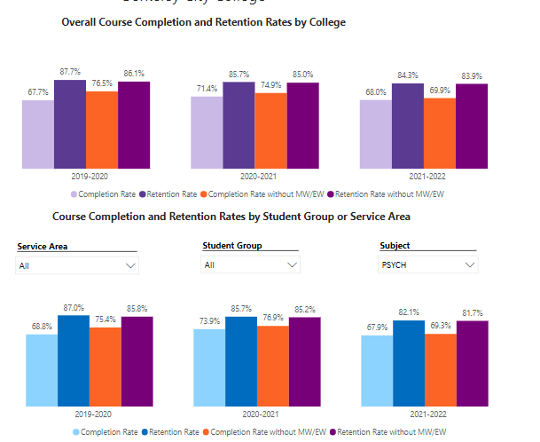
As noted above, in general the Psychology completion and retention rates in line with the collegewide rates. Looking at 21-22, you see that the completion rate is 68% campus-wide, and 67.9% for psychology. The retention rate for the same year was 84.3% campus-wide and 82.1% for psychology. This 2.2% difference might be due to lower completion and retention rates among Black, Hispanic, and Pacific Islander students. As noted below, their retention rates range between 70 and 76% but when you look at the college as a whole, these numbers are higher and range between 76 and 81%. A similar pattern emerges when you look at completion rates suggesting that these are the groups that need the most support.

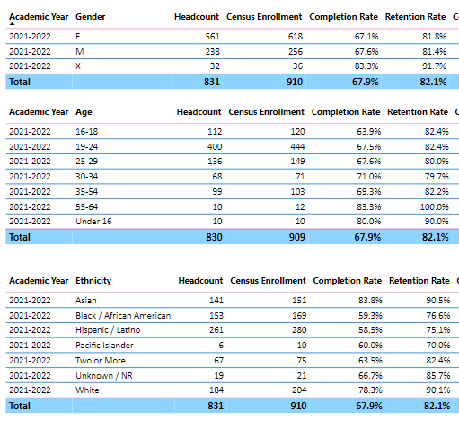
What do you see as key factors in your department that contributed to positive success and completion rate?
- We created a program map for students that was shared out to students in several psychology classes.
- Courses make a concerted effort to link theories and concepts to concrete applications in the student’s world (e.g. from study habits to policy implications)
- Many faculty are flexible and creating opportunities for students to make-up work
- Students were given the option in several classes to visit a psychology class at UCB.

What are some improvements your department can make? Identify strategies.
- We developed an Introductory to Biological Psychology course that will remove hidden pre-recs from the student pathway and reduce the number of courses a student needs for transfer to UCB. However, we need to be able to staff the course which means finding more faculty who can teach it. This course might lead to retention of students as they are not discouraged by the course sequence and number of classes needed to complete the major.
- Build out collaborations with UCB and CSU EB so students can visit the campus and sample psychology courses.
- Embed counselors into the classroom the week the schedule opens so students have increased exposure and opportunity to effectively plan next steps.

3a. Enrollment Trend and Productivity Dashboard
*Note that completion and retention rates are presented with the inclusion and exclusion of excused withdrawals (EW) and military withdrawals.
What were the enrollment trends in your department in the past three years?
 | Productivity | 2019/20 | 2020/21 | 2021/22 | FTES | 2019/20 | 2020/21 | 2021/22
Psych 1A | Productivity | 17.2 | 15.4 | 13.7 | FTES | 62.02 | 55.34 | 43.7
PSYCH 21 | Productivity | 16 | 14.5 | 15.4 | FTES | 48 | 37.82 | 30.7
Psych 6 | Productivity | 17.5 | 14.7 | 12.7 | FTES | 10.5 | 8.8 | 7.6
Psych 28 | Productivity | 17.5 | 16.8 | 11.5 | FTES | 3.5 | 6.7 | 6.7

There have been significant declines in enrollment over the past three years across courses within the psychology discipline. I am unsure why productivity has declined yet FTES has gone up for Psych 28. This is not surprising as this course is a required course for the Psych AA-T.

What strategies would you recommend to increase student enrollment in your department?
- Embedded counselors to attend classes as soon as the class schedule comes out and then again towards the end of the semester.
- Increased marketing of the psychology pathway map
- Host school wide events that highlight the program, transfer and career opporutnities.

Community Colleges are funded based on the Student Centered Funding Formula (“SCFF”) which is comprised of the following allocations:

Student Centered Funding Formula: Focus and Priorities
% Of Allocation | Categories
70%  Base Allocation: FTES (Enrollment) | - Credit FTES  - NonCredit FTES  - Special Admits (Dual Enrollment, etc.)
20%  Supplemental Allocation | - Pell Grant  - AB 540  - Adult School  - Promise Grants
10%  Student Success Allocation | - Associate Degrees  - ADTs  - 9 or more CE units  - Transfer  - Transfer level Math and English in the first year

List the department’s progress and reflection on what is being done to maintain or increase the base level of full-time equivalent students (FTES = 12 units). Please describe retention (i.e., remain enrolled for a full semester) and persistence (i.e., enroll in consecutive semesters) efforts.
We continue to schedule courses that are responsive to student need including both in-person, on-line and hybrid. Additionally, in-person classes are scheduled at various times of day. It is unclear whether introducing night in-person classes would support persistence. We are also trying to work more closely with counseling to support students developing an education plan but also actively planning at the close of one semester for the next. With regard to retention, we have not had a tutoring program for psychology for several years. When the new tutoring program was developed, students who had been interested in being tutors indicated that it was not worthwhile to participate in the class to be a tutor. It may be worthwhile to revisit this model to increase tutoring for the psychology program. Last but not least, retention would be increased through school/program activities that promote connectedness such as the psychology club, or psychology-related events.
Please describe your department’s efforts in identifying Pell Grant recipients, College Promise Grant recipients, Adult Education, and AB 540 students. What processes are in place to accurately report these students each semester?

College Outcomes | 2018-2019 | 2019-2020 | 2020-21 | 2021-22
Full Time Equivalent Students (FTES) | 4,161 | 3,931 | 3,622 | 3,259
Pell Grant Recipients | 2,387 | 2,281 | 2,181 | 1,826
College Promise Grant Recipients | 4,373 | 4,143 | 4,011 | 3,500
AB 540 Students | 74 | 51 | 22 | 69

There have been no efforts that I am aware of around identifying these students. I would be interested in hearing from the college why this is necessary information at the department level. How might this information be used to support persistence and retention?

3b. Course Completion and Retention Rates Dashboard – Instruction
*Note that completion and retention rates are presented with the inclusion and exclusion of excused withdrawals (EW) and military withdrawals.

If you need more guidance with this item, click here for additional support. Click here for additional guidance for how to view and use equity data. If you would like to view BCC’s Equity Plan, click here.
On page 3 of the “Course Completion and Retention Rates by Subject” dashboard, what are the completion and retention trends by gender, age, ethnicity in your department?
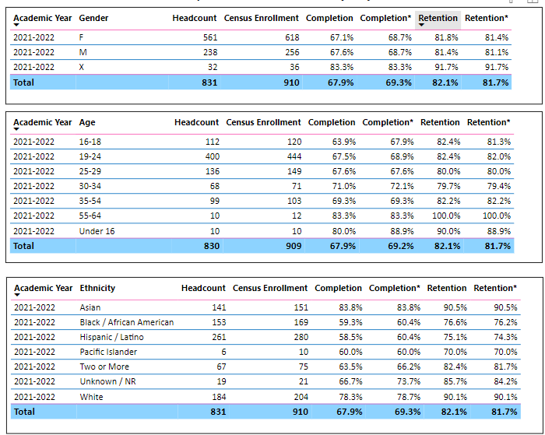

When the data are disaggregated by student ethnic groups, gender, and age, how do you plan to address them over the next year?
There do not appear to be significant differences by gender. Differences, however, do emerge by age. Specifically, older students are more likely to complete, with the one exception being students under 16. However, this is a small number of students (n = 10) who have the highest rates of completion. With regards to retention, rates range between 79.7% - 100%. However, in general retention hovers around 81%. I won’t speculate on these trends given the somewhat arbitrary nature of the age groupings. The most meaningful data from this chart is that there is some evidence that our older students, who have been stigmatized as being technologically challenged, are succeeding.
Unfortunately, there are still significant differences in completion and retention by ethnicity. Asians and White students have the highest rates and Black and Hispanic students have the lowest rates. This trend has not changed in the six years that I have been here. Now that students are more comfortable with zoom, perhaps we should continue subject specific on-line tutoring. An issue that emerges is students are hesitant to participate due to time constraints, timing issues, and on the tutor’s side, having to take a class. The first two could be addressed through embedded tutoring. Faculty are tracking 150+ students, it would be worthwhile to identify strategies on how to identify students early and provide support that are both time sensitive and time efficient. Starfish was a start, what other programs that integrate with canvas might support this process? I continue to believe that developing community between student will lead to increased social capital that will support student success.
.

What population(s) showed outcomes gains in your discipline(s) and which need more support?

Disaggregate the data and outcomes as far down as a possible then ask:
- What trends do you notice when examining course success rates for student populations by ethnicity? Which factors do you believe have the greatest impact (positive or negative) and cause variation between student course success rates in your Program? Describe some specific methods your department is planning or implementing to address these equity gaps. How will you evaluate the efficacy of these interventions?

- How has pivoting to online instruction contributed to potential reductions in student success? Provide some specific examples of practices that faculty in your department have found ineffective in the online environment.
Please review the video from the RP Group acknowledging the interrogation De Anza Community College committed to in their analysis of course completion and success rate.
*Discussion of ethnic differences noted above. I can only speculate as to what factors have to greatest impact, positive or negative. Given that the trends are similar at the program and college level, I would argue that structural inequities around poverty contribute to the differences we see. Within the psychology department we have not yet created a plan of action to address these inequities. A starting point might be to work with affinity group clubs to host tutoring sessions or recruit from different affinity groups. Alternatively, it we can identify student positions that support the major (e.g. such as Support Inc), are paid, and provide training/work experience opportunities, this could create increased feelings of inclusion, self-efficacy, reinforce course content, reduce time spent off campus at a different position, and ultimately support success. Early identification of students who are doing poorly and clearly defined support/resources that do not increase faculty workload is another area of growth. For example, we could create an internal policy whereby students who fail following the first midterm are encouraged to attend an office hour and create a plan of action to improve their performance. We could measure success through an increase in performance from the first to the second midterm at the student level and comparing scores between those who attended office hours and those who did not.

* More data is needed to answer this question. Some students are thriving with on-line instruction. They can take a course asynchronously, don’t have to worry about parking or work/child care schedules. Other students purposefully sign up for in-person classes as they need an in-person experience for motivation. And to complicate matters further, some students sign-up for whatever class is available even though a different modality would serve them best. Looking specifically at Psych 1A (and using the age category to find the percentages) we see that the completion rate for on-line classes is 68.3% and for on line it is 64.3%. It is hard to make comparisons for other classes as most other classes were taught solely on-line. But again, without knowing more, it is unclear what drives this difference: instructor, student-level characteristics, fewer opportunities to check-in/reminders.

How do these outcome trends in your department compare to the college average?
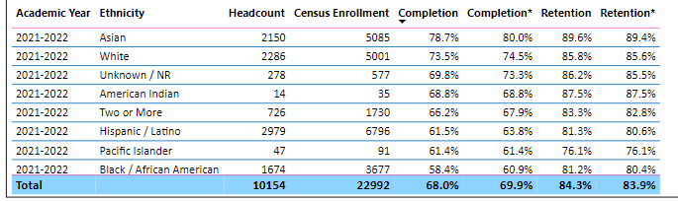
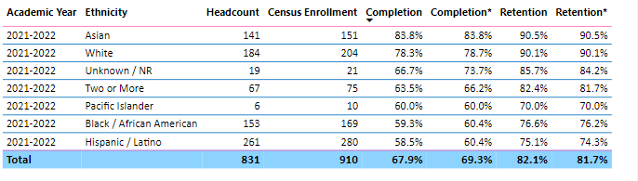
The first table is college wide rates and the second is specific to the psychology department. You can see that in general the trends are similar with one notable difference, among Hispanic/Latino students in psychology completion rates are the lowest where as for the college, the lowest rates are among Black students.
How will these outcome trends you identified in this section affect your department goals and plans for the next year and what are your strategies to shift to move the trend towards a positive direction?
- Identify ways of providing additional services and resources to Black and Hispanic students
- Create and market services in culturally appropriate ways to support Black and Hispanic success
- Identify a successful tutoring strategy to both recruit student tutors and ensure students are taking advantage of tutoring.

3c. Degrees and Certificates Dashboard
On page 1 of the “Degrees and Certificate Awards Trends” Dashboard, what are the award trends for your department (e.g., overall, by gender, age, and ethnicity)?
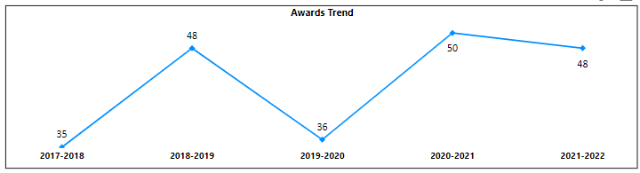
Looking at the degrees awarded, 22% were Asian, 10% Black, 27% Hispanic, 8% 2+, 31% White. However, without knowing how many were on track to graduate that year, it is challenging to interpret these numbers by subpopulations without identifying a relevant denoninator. However, since 2017 we are seeing a sustainted rate of about 48 graduates per year, with 2019/2020 (Covid) being an exception.
On page 4, what population(s) award trends showed gains in your program area and which populations need more support?
Across most subgroups you see a dip in 2019 and 2020, likely a result of the pandemic. Veterans, low income, and foster students are the students who appear to need the most support and whose rates are decreasing or low relative to other groups.

3d. Transfer Dashboard
This dashboard does not provide data by subject. Reflect on what you can do to affect student transfer. How may your department help to support BCC student transfer? (e.g., serve on panels, strengthen GP in your dept, change curriculum, increase number of AD-Ts, etc.)
At the macro level: Create a culture by which there are daily events on campus that link students to career interests (panels with different industry leaders, alumni to talk about career and transfer, UCB and CSU professors sharing out what they teach, workshops on transfer, etc). I think that we should develop a vibrant college hour that students make their way to BCC at lunch knowing that there will be some resource to take advantage of that will support their future. I would suggest that every department is responsible for 5 days of college hour programming a semester.

3e. Curriculum based on Guided Pathways
View the department’s curriculum through the lens of student equity outcomes.
- What intentional effort is your department making to create and present clear pathways for students through curriculum?
      - Several years ago we identified a class, BIO 1A, that was adding additional classes (3) to students who wanted to transfer to UC Berkeley in Psychology. Through creating Psych 61 we are making the pathway much easier and students only have to take one class. The course is now approved to meet area B2 in the CSU Breadth pathway and I believe the class will go through IGETC review this December.
      - We worked closely with a counselor to develop a pathway map for students wishing to transfer to a CSU or UCB. In our pathway map we have provided “signposts” for events, activities, and resources students should take advantage based on their current unit status. However, this pathway map is still in draft form and needs to be finalized, approved (though I am not sure who would do this), and distributed to students outside of my classes.
- What are your plans for revising and/or creating new pathways supported by labor market information (LMI) and student demands? Using Vision for Success and SCFF focus, please indicate rationale and how the plans directly support student success and equitable completion.
      - The field of gerontology is growing and the demand for workers that support caregiving, admin, and social work among those 65 and up is increasing as the baby boomer population ages. I have been talking to Linda McAllister about developing a new AA and/or certificate in gerontology. This would provide students with the skills necessary to gain employment or transfer to a 4-year institution. This certificate would entail developing some new classes, but also incorporating current classes such as Developmental Psychology, Social Work, and Death and Dying.

4. Dual Enrollment
As continued decline in overall enrollment for college going population, it is important for us to look at who will be coming to BCC in the next 5 years. Reviewing the data provide here, what strategies would your department employ to address bringing more students to BCC?
- Work with local high schools and present the BCC option beginning in 9th grade. This would be presentations aimed at parents as well
- Work directly with Puente and Umoja. BCC Umoja students could “host” a Berkeley high student for a class and a tour of the campus and a visit to the Umoja space.
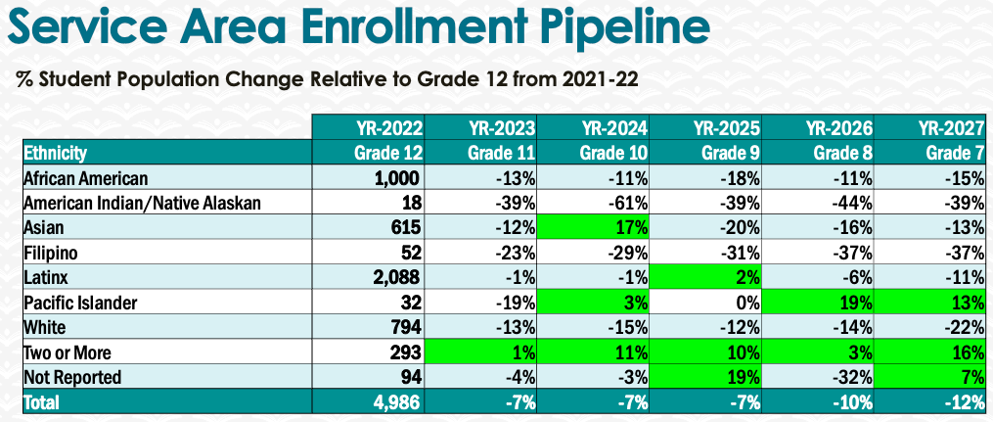

5. Facility Utilization Needs

Assess your facilities utilization (including labs, support for online learning, and other spaces) and for next year, indicate if the space is sufficient or not. If not, what are the needs and why? Work with your Dean to check on your needs prior to responding this section.
I would recommend purchasing a program such as respondus to reduce cheating while taking an exam in on-line classes. It would be helpful to have more computer labs for students to take exams. Additionally, it would be worthwhile to invest in a testing center where make-up exams can be proctored.

6. Assessment
Berkeley City College is committed to a culture of assessment to improve instruction, services, and institutional planning. Findings from SLO, PLO, ALO assessments, and program review data are used to direct resources for areas that are institutional priorities that are articulated in the Educational Master Plan and BCC Strategic Plan.

Due to the critical role that course and program assessments play in our institutional planning and to be in compliance with the Accreditation requirements, assessments must be completed to qualify for the APU resource allocation requests.
6a. What action plans did your department identify upon the assessment of each SLOs and/or PLOs? For courses with multiple sections in the program, please list the main action plans. Please be as detailed as possible.
Assessment is not a department wide activity. A culture of assessment needs to be developed whereby part-timers and full-timers work together to craft assessment tools, collect and analyze data, and review results as a team. Unfortunately, there is little incentive for part-timers to participate in this process and thus there has not been the opportunity at the program level to close the loop. There are few opportunities to collaborate on assessment and work as a unit and this is an area of need in order to collectively improve our courses. An action plan that could be implemented through FIG or other funding might include: 1. Creating a shared rubric, 2. Train all instructors on using the rubric, 3. Include rubric in canvas so it can be easily incorporated into all courses 4. When instructors are assigned courses, assessment requirements and action plan for that semester are discussed as well (though I don’t know if this might be a union issue).
6b. Describe the department’s progress on the Actions Plans identified for course Student Learning Outcomes (SLOs). If your department offers a degree or certificate, please describe the department’s progress on the Action Plans for Program Learning Outcomes (PLOs).
There has been little progress since last year other than the SLOs are now consistent across all classes. A key action area identified through the assessment was to: 1. Increase class discussion and activities, which has been challenging in the last year due to an increase in asynchronous teaching. This action item may need to be reconfigured given the increase in on-line teaching. 2. Increase student collaboration. Similarly, instructors may need to identify strategies to support this process in an on-line setting. After much reflection, there needs to be increased communication and participation around assessment activities in order to evaluate and adjust teaching strategies and consider programmatic changes. Specifically, I must develop a more detailed action plan moving forward and share this information with all part-time instructors.

6c. Describe the status of SLO and PLO completion in Rounds 4 and 5 of the Assessment Cycle. Identify the percent of completion. Briefly describe what needs to be done to reach 100% completion. Identify issues or concerns that may prevent your department from completing assessments of SLOs and/or PLOs.
In Spring 22 data was collected for Psych 28 (100% of classes (n = 2) submitted data. However, no data was collected for psych 21. This data is still in the process of being analyzed. Psych 21 will now be assessed in fall of 23.

Assessment plan for the next cycle:
spring 22 | fall 22 | spring 23 | fall 2023
Psych 21 | X | Psych 1 | Psych 21
Psych 28 | X | Psych 6 | X

6d. Besides your syllabi, where are the program level outcomes published? If on a website, please specify the URL.
Just the syllabi.

7. Engagement
Discuss how faculty and classified staff have engaged in institutional efforts such as committees, presentations, and departmental activities. Please list the committees that full-time faculty participate in.
I am currently participating in the following committees:
- Co-lead for Guided Pathways
- Distance Education Committee Members
- Psychology Club Faculty Advisor
- Chair of Hiring Committee for Psychology Instructor Position
Discuss how faculty and staff have engaged in community activities, partnerships and/or collaborations.
I collaborated with Olivia Owens (Counseling Intern and UCB Liaison) on the following activities:
- A BCC alum and current UCB student spoke to psychology classes about her experience transferring and experience at UCB
- Olivia Owens coordinated with UCB faculty to invite BCC students to attend a class at UCB. While a small number of psychology students attended (N = 7). The response was quite positive as illustrated by this student evaluation:
“I thought that the psychology class was an amazing experience. I personally have not gone to a university at all, so beyond the fascinating source material the class environment itself was something that I learned about. From the way lectures work, to how you get student interaction in such large lecture halls, and the overall expectations when it comes to note taking and such, it was eye-opening. However, I did find it just a bit hard to follow the source material at first because I realized that the lecture material was meant to be taught over a course of numerous classes, and attending just that one class didn't mean much for me at that point. Overall I think that this was an amazing opportunity for those that wish to transfer to a UC or any large campus, and I would like for there to be clearer guidelines on what to expect in the class.”
Discuss how adjunct faculty members are included in departmental training, discussions, and decision-making.
This is an area that needs to be developed. While part-time faculty are made aware of various initiatives and opportunities (ABCD course, FIGS, Leadership positions), there is very little participation in our department. This is not surprising given that many adjunct faculty are teaching in at least 2 other institutions, not including Peralta. I will look to other departments to examine how they are including adjunct faculty in department discussions and decision-making.
- Discuss the relationship and engagement with other support services, programs, departments, or administrative units and how these relationships/collaboration support meeting your departmental goals.
- I have been working closely with counseling at various points throughout the year to 1: Bring in counselors to discuss the psychology pathway to CSUs and UCs. One counselor came in last year to present in three different classes. Students found it very helpful even though some of them were not psych majors. 2: Through Skyler Barton, I worked with Olivia Owens to further the relationship between BCC and UCB.
Are there areas you feel that your department can benefit more by increasing collaboration and partnership? How?
Through the guided pathways model, I think it would be beneficial to host cross-program events that focus on career, transfer, or even general lectures on how to approach a current event using lenses from different disciplines. What is needed to make this happen? Like student clubs, perhaps faculty could apply for funds to host these events. These funds could be used to a) pay for food (incentives for students to attend), and b) adjunct faculty participation.

8. Prioritized Resource Requests
During the 2021-22 Comprehensive Program Review process, you have provided your resource requests which went through the IPAR process. In this section, include resource requests from last year that are still needed and/or new resources that have emerged. Provide justifications. If there are no resource requested, leave the boxes blank.

Resource Category | Description/Justification | Estimated Cost
Personnel
Classified Staff
Student Worker
Part Time Faculty | In order to engage adjunct faculty in the assessment process it is necessary to build in PD that supports the process of assessment, implementation and re-evaluation. More importantly, adjunct faculty need to be paid for their time.  Training on making courses accessible.  Stipends to participate in activities that build interest in the psychology program at BCC | $8,000- $10,000
Professional Development
Department wide PD needed
Personal/Individual PD needed
Supplies
Software (for whom or role?) | Respondus lock-down or other software to prevent cheating.  Continued licensing of Snagit and Camtasia to enable hybrid and online course video lectures.  Continued support for Canvas Studio for closed caption services and the archiving of multimedia material.  Continued subscription to other software such as Turnitin and other LTIs commonly used by faculty. | $4,000
Books, Magazines, and/or Periodicals
Instructional Supplies
Non-Instructional Supplies
Technology & Equipment
Description/Justification (Before you list your technology request, click here to view the latest Technology Refresh Plan to verify whether it has already included.)
New
Replacement
Facilities
Classrooms
Offices
Labs
Other
Library
Library materials (including streamline media needs)
Library collections | Access to the New York Times
OER
Other
OTHER Description | Money to pay outside speakers. For example, through various connections a faculty member knows someone who participated in the Stanford Prison Experiment, a seminal study in the field of psychology. To bring in researchers, clinicians, policy makers who have a connection to psychology would inspire students. | $1000

Thank you for your time and effort in completing the Annual Program Update!
Please email the completed Program Review to your Dean by November 30, 2022

