Berkeley City College’s mission is to provide our diverse community with
educational opportunities, promote student success, and to transform lives.

Introduction and Directions

Berkeley City College (BCC), in conjunction with the Peralta community College District, has an institutional effectiveness process which consists of the following components: a District-wide Strategic Plan which is updated every six years; Comprehensive Program Reviews (CPRs) which are completed every three years; and Annual Program Updates (APUs) which are completed in non-program review years.

TIMELINE
Annual Program Update (APU) 2022-2023 timeline has been developed for each program and services to guide through the semester. Please review and work with your Deans, Managers, Department Chairs and/or Supervisors to complete this APU.

For BCC, 2022-2023 marks a critically important year as the college is in the process of revising its Educational Master Plan (EMP) for the next 5 years (2024-2028). This college EMP process will inform the District with their planning for their Strategic Plan. This year’s APU will take an especially important role for the EMP process, carrying your analysis, planning and strategies to support our students success, retention, and equitable completion.

The APU is intended to primarily focus upon planning for the subsequent year based on the institutional priorities. While developing the College’s EMP for the next 5 years, the college and the district focused on the Vision for Success identified by the California Community College Chancellor’s office as well as Student Centered Funding Formula (SCFF) that clearly delineate the categorized outcomes that the Colleges should be focusing. Please use these foci as your reference to prioritize your department and other goals.

RESOURCE REQUEST
In this process of making continuous quality improvement, there is an opportunity for each program, student services, and department to request resources that support achieving the stated goals. The APU process directly leads to the institutional resource allocation process and budget planning facilitated by the Institutional Planning and Allocation of Resources (IPAR) Committee for the following academic year (2023-24). The process for this can be found here (2022-23 APU Timeline). This is an opportunity for each department to request resources that will support your department goals and set outcomes.

TECHNOLOGY REQUEST
Finally, for the resource request section, please connect with your Deans, managers, and supervisors regarding your technology needs so that you can be informed about the equipment that is addressed in the BCC Technology Refresh Plan. If your requests are covered in the Refresh Plan, you do not need to request them in this APU.

If you have questions regarding other material in the Annual Program Update, please contact your Dean or Manager. If you have questions regarding data, please contact Dr. Phoumy Sayavong, Senior Researcher and Planning Analyst (psayavong@peralta.edu).

Please email the completed Annual Program Update to your Dean by November 30, 2022.

College Profile
Click here to view the Berkeley City College Student Demographics Dashboard.
This 2-page dashboard will provide data on the demographics of our student body from the past two years such as headcount, ethnicity, enrollment status, age group, educational goals, and majors.
College Outcomes | 2018-2019 | 2019-20 | 2020-21 | 2021-22
Full Time Equivalent Students (FTES) | 4,161 | 3,931 | 3,622 | 3,259
Productivity (Avg. Goal = 17.5) | 13 | 13.2 | 13 | 10.9
Success Rate (%) | 69% | 77% | 75%* | 70%*
Degrees + Certificates Awarded (#) | 948 | 1,109 | 1,027 | 960
*Excludes “EW” grades

To view prior Program Reviews, click here. To view prior Annual Program Updates, click here.

1a. Department Description
Please verify the mission statement for your department. If your department has not created a mission statement, provide details on how your department supports and contributes to the College’s mission.
The mission of the Modern Languages program is to provide courses leading to the following: an Associate of Arts degree in Spanish and a certificate of completion Spanish; transfer to a university; the general requirements for the A.A. and A.S. degrees or transfer; and lifelong learning.

Name(s) of member(s) completing this APU | Department | Completion Date
Fabián Banga  Juan Miranda | Modern Languages | 12/01/22
List faculty names with assignments in fall 2022.
Full Time | Part Time
Fabián Banga | Michael Arrigo – (French)  Ana Belén Redondo Campillos – (Spanish)  Anne McCormick – (French - Spanish)  Juan Miranda – (Spanish)  Diego Panasiti – (Spanish)  Patricia Jorgensen – (Spanish)

1b. Department Priorities & Goals
Based on the Vision for Success and SCFF, and your department mission, what are your department’s priorities and goals for 2022-23?
The department’s priorities and goals for 2022-23 are as follows:

- Continue developing and implementing assessment processes
- Peer Online Course Review (POCR) all our courses in Spanish and French
- Have all our instructors teaching online become certified reviewers
- Continue offering (based on students’ demand) and assessing: Arabic, French and Spanish
- Expand French course offerings to keep up with demand made by students.
- Help to BCC to become a Certified POCR Campus

2. Student Equity, Success, & Completion
Using the data dashboards provided below, review and reflect upon the outcome trends for your department. Please also review overall BCC’s data linked here.

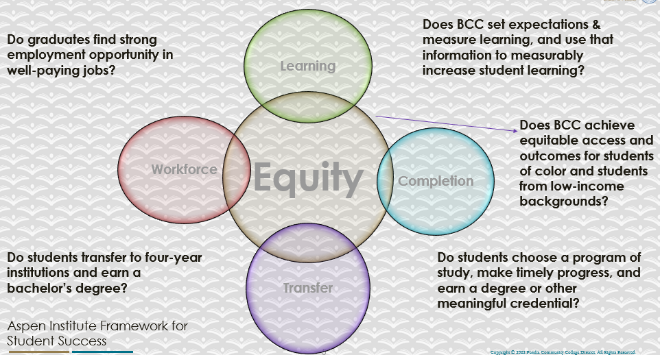

For assistance with data dashboards, contact Phoumy Sayavong at psayavong@peralta.edu

How are students doing in success and completion in your department, compared to the BCC overall success and completion rate? What are the group of students that need more attention to achieve goals?
As me mentioned in our last year APU, the critical need of having not only the right technology but also the appropriate conditions and preparation for taking online classes has affected two student populations that historically have clear socioeconomic disadvantages, the population of Hispanic/ Latino/a and Black /African American. From APU 2021-22: “Not only the anecdotal experience seen by the professors of the department when giving classes, supports this assumption, but also concrete data provides numbers that sustain this hypothesis.”
Even though the retention and completion are higher in some populations, completion is approximately 10% lower than the average of the campus. Furthermore, in 2019-2020, during the most difficult period of the pandemic, completion in Black / African Americans was almost 20% lower than the average. (See previous APUs)
The recommendation is identical to previous programs reviews:
“The achievement gap of African American and Hispanic students on campus is irrefutable; and continues to be unresolved. Resources are needed to help these students and other students in similar situations by offering more tutoring, more support in the use of technology and helping students to acquire these technologies. The department could not even use the language lab during the pandemic. Transformation of the lab by using virtual technologies is imperative. However, if students are not familiar with these technologies or simply do not have access to them, the lab's transformation will not help these populations.
Unfortunately, the emphasis on productivity does not help disadvantaged populations. The increase in students in classes offers an excellent result in productivity but significantly disadvantages underprivileged students who require more attention from instructors. It is not surprising, in this context, that if the level of productivity has improved significantly in the last semesters, completion and retention has not been favorable with groups with socio-economic needs. Furthermore, problems in these areas (completion and retention) have exacerbated.”

What do you see as key factors in your department that contributed to positive success and completion rate?
The department offers different modalities to accommodate different preferences and schedules. But the modality that has been most successful is that of 100% online and asynchronous classes. All online and asynchronous classes were filled before the semester started. The department has implemented online and asynchronous classes this year at all levels. In our next year we will be able to verify if this modality, which is the most requested by students, was successful in its retention and complied.
What are some improvements your department can make? Identify strategies.
The department will continue with the development of the virtual laboratory and will evaluate the enrollment trends and modalities. Sporting students at the beginning of the semester seems critical to student success. For this, resources are necessary, whether they are technological or support, such as counselors, especially for high school students.

3a. Enrollment Trend and Productivity Dashboard
*Note that completion and retention rates are presented with the inclusion and exclusion of excused withdrawals (EW) and military withdrawals.
What were the enrollment trends in your department in the past three years?
Enrollment has dropped significantly due to the pandemic, a factor that has impacted the entire country.

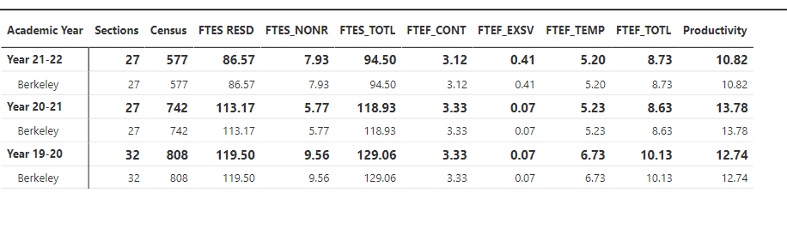

On the other hand, we can see a tendency to recover if we consider the last 4 semesters.

Only Fall:
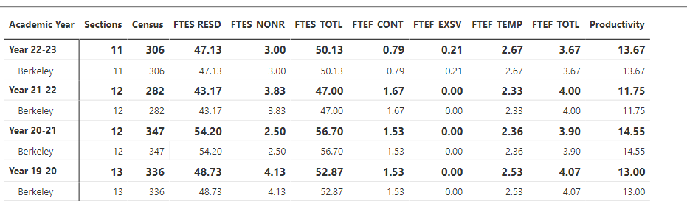

What strategies would you recommend to increase student enrollment in your department?
Increase the support and offer of asynchronous online classes. On the other hand, the training of teachers in this new methodology is essential. This training can be achieved in the direct training of teachers (POCR workshops, peer assessment) and the evaluation of courses methodically and periodically.

Community Colleges are funded based on the Student Centered Funding Formula (“SCFF”) which is comprised of the following allocations:

Student Centered Funding Formula: Focus and Priorities
% Of Allocation | Categories
70%  Base Allocation: FTES (Enrollment) | - Credit FTES  - NonCredit FTES  - Special Admits (Dual Enrollment, etc.)
20%  Supplemental Allocation | - Pell Grant  - AB 540  - Adult School  - Promise Grants
10%  Student Success Allocation | - Associate Degrees  - ADTs  - 9 or more CE units  - Transfer  - Transfer level Math and English in the first year

List the department’s progress and reflection on what is being done to maintain or increase the base level of full-time equivalent students (FTES = 12 units). Please describe retention (i.e., remain enrolled for a full semester) and persistence (i.e., enroll in consecutive semesters) efforts.
The department continues to offer classes at all levels, including combining multiple sections into a single course to maintain productivity. This effort is more difficult for instructors. These courses have multiple preps but the compensation of a single class to the instructor since these combined sections are offered individually. On the other hand, the effort has shown excellent levels of retention and completion. See 3B courses like 2B. This trend becomes much more evident this year as we have a second generation of online students in these sections.

Please describe your department’s efforts in identifying Pell Grant recipients, College Promise Grant recipients, Adult Education, and AB 540 students. What processes are in place to accurately report these students each semester?

College Outcomes | 2018-2019 | 2019-2020 | 2020-21 | 2021-22
Full Time Equivalent Students (FTES) | 4,161 | 3,931 | 3,622 | 3,259
Pell Grant Recipients | 2,387 | 2,281 | 2,181 | 1,826
College Promise Grant Recipients | 4,373 | 4,143 | 4,011 | 3,500
AB 540 Students | 74 | 51 | 22 | 69

None. The department must work in these areas.

3b. Course Completion and Retenton Rates Dashboard – Instruction
*Note that completion and retention rates are presented with the inclusion and exclusion of excused withdrawals (EW) and military withdrawals.

If you need more guidance with this item, click here for additional support. Click here for additional guidance for how to view and use equity data. If you would like to view BCC’s Equity Plan, click here.
On page 3 of the “Course Completion and Retention Rates by Subject” dashboard, what are the completion and retention trends by gender, age, ethnicity in your department?
BCC:
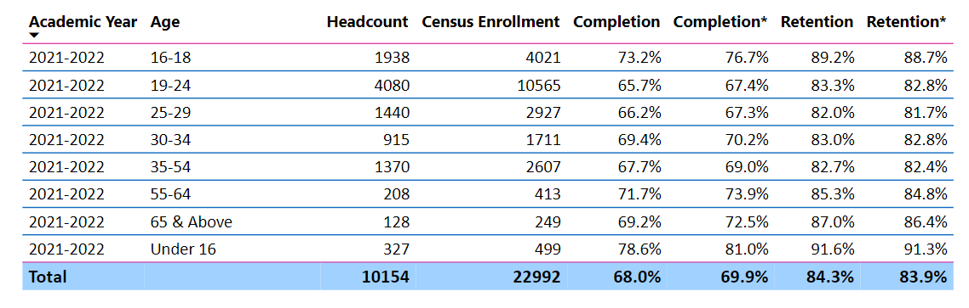

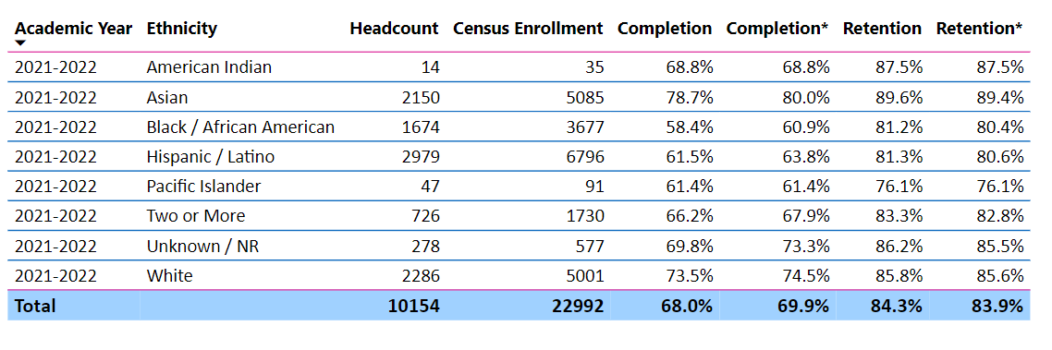

ML:
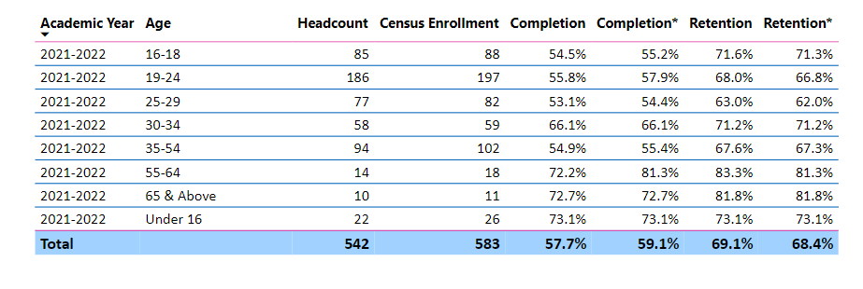

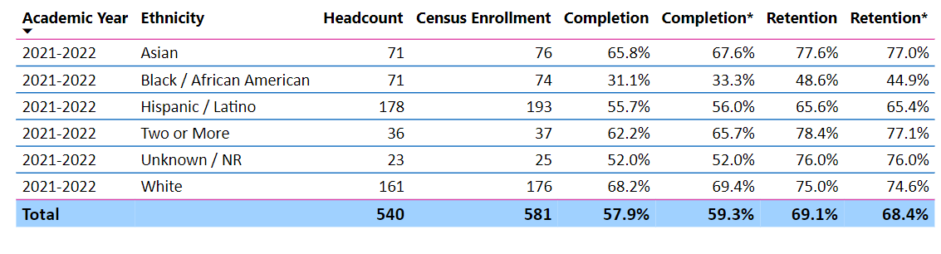

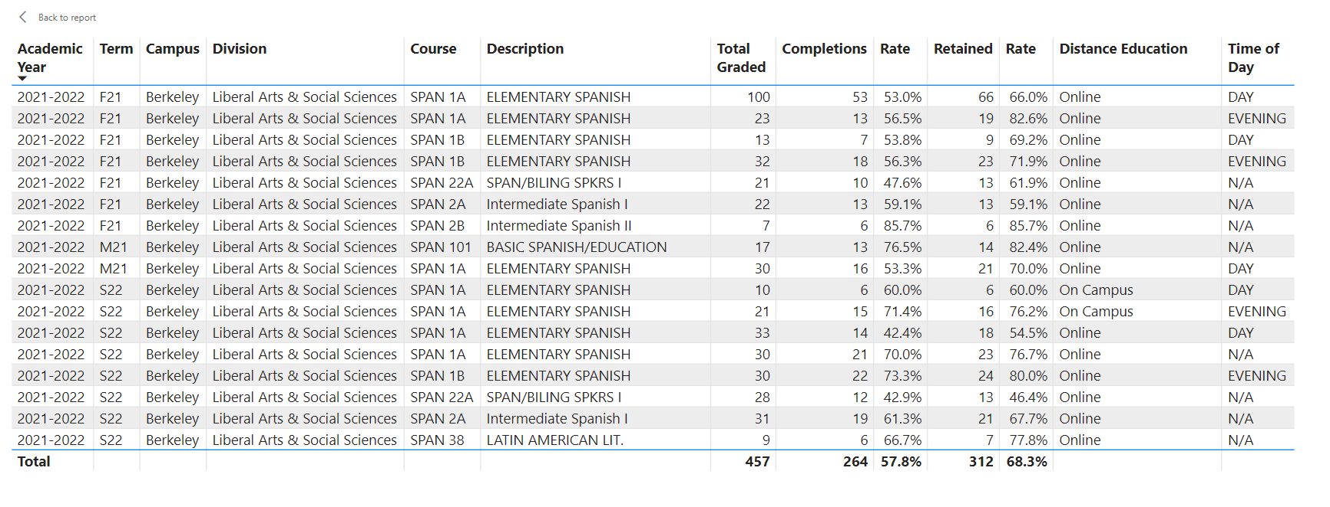
When the data are disaggregated by student ethnic groups, gender, and age, how do you plan to address them over the next year?
As we have previously mentioned, the groups that need the most support are Hispanic/Latino/a students and African American students. This issue was already stated in the previous program review (2019-20):

“This is a problem that not only affects these students but our whole campus and nation. “The persistence of the educational achievement gap imposes on the United States the economic equivalent of a permanent national recession’ (McKinsey & Company 2009, 6).
[…]
On average, black and Latino students are roughly two to three years of learning behind white students of the same age. This racial gap exists regardless of how it is measured, including both achievement (e.g., test score) and attainment (e.g., graduation rate) measures. Taking the average National Assessment of Educational Progress” (McKinsey & Company 2009, 9)
McKinsey & Company. 2009. The Economic Impact of the Achievement Gap in America’s Schools: Summary of Findings. http://dropoutprevention.org/wp-content/uploads/2015/07/ACHIEVEMENT_GAP_REPORT_20090512.pdf.

The Modern Language Department will continue helping these students’ providing tutors, classroom and pedagogical techniques, special attention to students in need but this issue transcends our department and needs the attention of the whole campus.

In any case, trying to solve this problem from the perspective of a single department is an irresponsible attitude since it requires a response from the entire educational community of the university. Counselors who understand the problem of the community, counselors specialized in high school students, for example, can help solve this problem.

What population(s) showed outcomes gains in your discipline(s) and which need more support?

Disaggregate the data and outcomes as far down as a possible then ask:
- What trends do you notice when examining course success rates for student populations by ethnicity? Which factors do you believe have the greatest impact (positive or negative) and cause variation between student course success rates in your Program? Describe some specific methods your department is planning or implementing to address these equity gaps. How will you evaluate the efficacy of these interventions?

- How has pivoting to online instruction contributed to potential reductions in student success? Provide some specific examples of practices that faculty in your department have found ineffective in the online environment.
Please review the video from the RP Group acknowledging the interrogation De Anza Community College committed to in their analysis of course completion and success rate.
A significant phenomenon is that retention and completion are lower in women. This phenomenon occurs during the pandemic, and it remains to be seen whether it will continue in the future. This is the first time we see this discrepancy. It is possible that this occurs since many women are the only support in the homes. But more data is needed to analyze this phenomenon and not improvise in an anecdotal way. We also see in the data lower retention and completion in students aged 16-18. Something that is at odds with the retention seen on campus. The question is if this issue is related to the pandemic or will continue in future years. Analyzing one class specifically, Spanish 22A, it has been found that a considerable percentage of high school students take the class and then drop out. The students are all from high schools and data has been preserved in order to identify which high school they come from.

How do these outcome trends in your department compare to the college average?
As we have already explained, in the case of high school students, retention and completion is much lower in the department than in the rest of the campus.

How will these outcome trends you identified in this section affect your department goals and plans for the next year and what are your strategies to shift to move the trend towards a positive direction?
It directly affects the retention, compilation, and success of the department-wide assessment. The department is evaluating how to collaborate with the broader campus in deploying expert high school counselors who can identify failing students early in the semester and intervene appropriately in the early stages.

The language department has an element that distinguishes it from many other departments. His language classes cover the college and high school language requirements. That makes it an attractive solution for high schools that don't offer languages. What is not taken into account is the rigor and demand that a language class has at the university. Many students, especially native students, have never been exposed to advanced language classes where elements such as critical thinking, or advanced elements of syntax study, are a fundamental factor in passing the class.

3c. Degrees and Certificates Dashboard
On page 1 of the “Degrees and Certificate Awards Trends” Dashboard, what are the award trends for your department (e.g., overall, by gender, age, and ethnicity)?
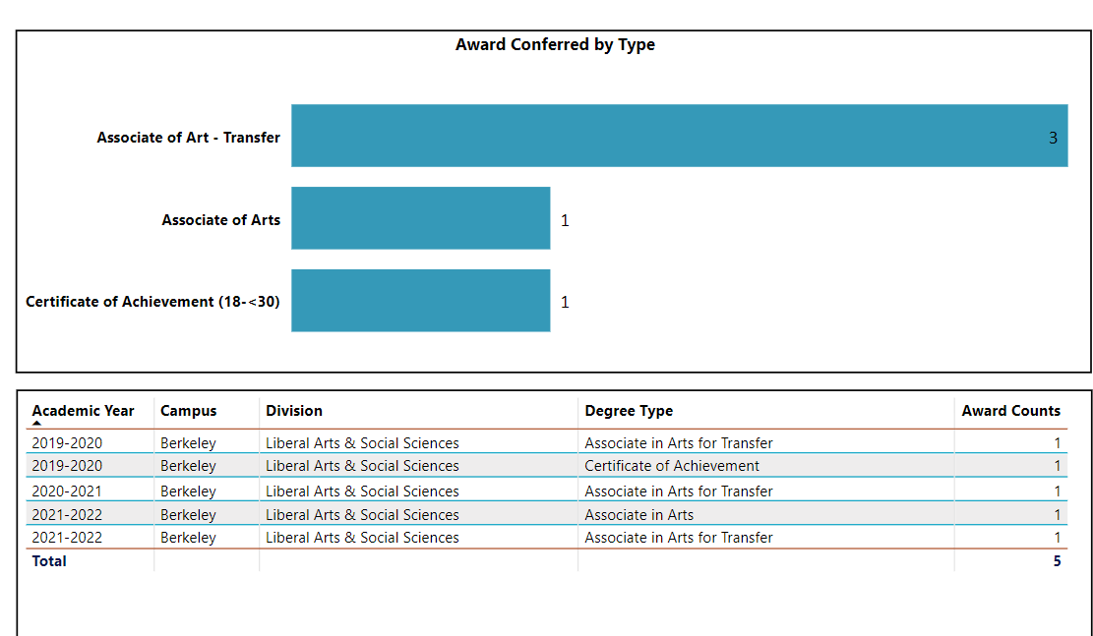

On page 4, what population(s) award trends showed gains in your program area and which populations need more support?
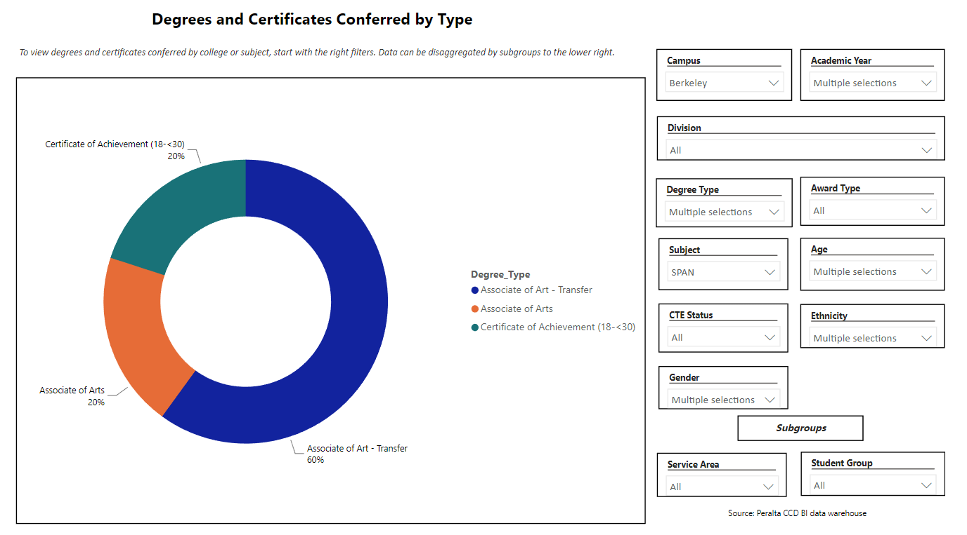
The number of diplomas is too low to see a clear trend.

3d. Transfer Dashboard
This dashboard does not provide data by subject. Reflect on what you can do to affect student transfer. How may your department help to support BCC student transfer? (e.g., serve on panels, strengthen GP in your dept, change curriculum, increase number of AD-Ts, etc.)
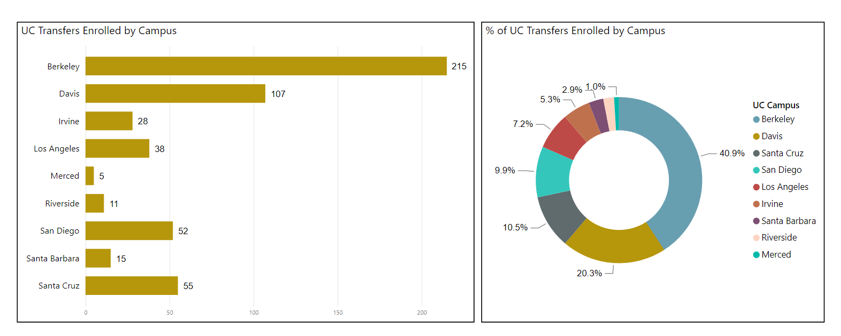
Per the data we see in student evaluations, consistently 75% of our students who take language classes (such as 1A and 1B), take these classes for a degree requirement (for BCC or other institutions) or as an elective. 1As and 1Bs represent approximately 70% + of the classes offered in the Department. Almost 900 students have transferred to UC from BCC in the last 3 years. The department has the function of offering classes to achieve the Language other than English requirement for students who do not have a proficiency equivalent to two years of high school courses in the same language.

Continuing to offer these classes, in an affordable way (OERs) and at various times/days (Online Ed), is one of the main goals of the department. These goals benefit our entire population but especially students who transfer to other institutions.

3e. Curriculum based on Guided Pathways
View the department’s curriculum through the lens of student equity outcomes.
- What intentional effort is your department making to create and present clear pathways for students through curriculum?
The Modern Language Department is actively participating in the guided pathway effort to continue offering the language classes that are relevant to the pathway that requires our classes.

Furthermore, courses required to complete AAT, Certificates or AA are offered every semester. In the last 4 years, all levels of Spanish have been offered, alternating some advanced classes so that students can complete their diplomas.

- What are your plans for revising and/or creating new pathways supported by labor market information (LMI) and student demands? Using Vision for Success and SCFF focus, please indicate rationale and how the plans directly support student success and equitable completion.
n/a ?

4. Dual Enrollment
As continued decline in overall enrollment for college going population, it is important for us to look at who will be coming to BCC in the next 5 years. Reviewing the data provide here, what strategies would your department employ to address bringing more students to BCC?

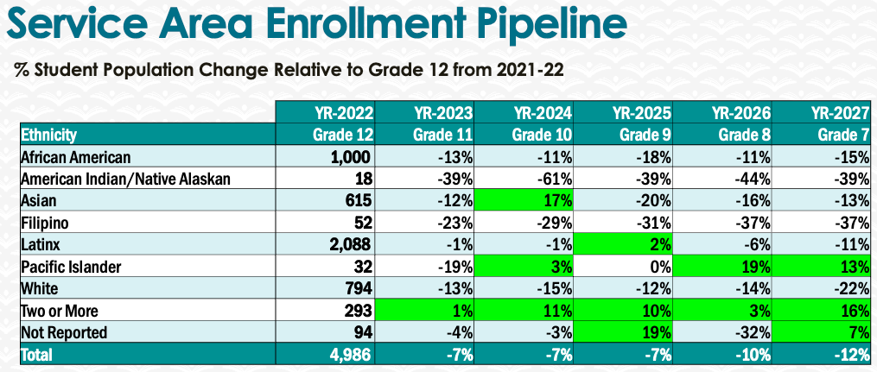
It is important to understand that it is difficult to influence student enrollment, since student enrollment is affected by factors outside our department: transfer rates, the economic situation of the country, general enrollment, etc.

However, student support, use of OER materials to reduce cost to students, asynchronous online courses (which are very popular), and a strong tutoring center will not only attract more students, but help with other issues such as retention, completion, and success. The department will continue to work in this area as before.

The department could expand the offering of courses not intended for transfer students, but rather for students who want to simply learn a foreign language. For this, the department needs to increase the number of classes it offers; something that until now has been constrained by budget cuts.

5. Facility Utilization Needs

Assess your facilities utilization (including labs, support for online learning, and other spaces) and for next year, indicate if the space is sufficient or not. If not, what are the needs and why? Work with your Dean to check on your needs prior to responding this section.
It will take us more than one academic year to fully develop a virtual language lab. For the physical facilities, current facilities such as language lab and classrooms work well for the department.

6. Assessment
Berkeley City College is committed to a culture of assessment to improve instruction, services, and institutional planning. Findings from SLO, PLO, ALO assessments, and program review data are used to direct resources for areas that are institutional priorities that are articulated in the Educational Master Plan and BCC Strategic Plan.

Due to the critical role that course, and program assessments play in our institutional planning and to be in compliance with the Accreditation requirements, assessments must be completed to qualify for the APU resource allocation requests.
6a. What action plans did your department identify upon the assessment of each SLOs and/or PLOs? For courses with multiple sections in the program, please list the main action plans. Please be as detailed as possible.
Upon the assessment of each SLO of beginning language classes:
SLO 1 (Demonstrate competency at the beginning high level (per ACTFL guidelines) in reading, writing, listening, and speaking.)

Our department action plan is (1) to revise the amount of oral work and create more opportunities for practice and pronunciation, (2) to consult teaching and learning experts about oral teaching methods in asynchronous classes to help students have more opportunities to practice their oral skills, and (3) to disaggregate SLO data by gender, race, and ethnicity to see if our department action plans are responding to underserved students.

SLO 2 (Students present on a cultural aspect they are passionate about, and they must juxtapose that research onto its impact on a Spanish-speaking country or Spanish-speaking community in the US.)

Our department action plan is (1) to state goals or objective of assignments/activities more explicitly, and create a comparison activity, where students have to talk about both criteria, (2) to collect more/different assessment data to be more accurate, and help students have a deeper cultural understanding, and (3) to disaggregate SLO data by gender, race, and ethnicity to see if our department action plans are responding to underserved students. Furthermore, our departments’ SLOs include cultural and historical understanding of the targeted language and communities in the U.S. to evaluate values, behaviors, and worldviews in light of new cultural knowledge about the targeted language.

Our Department PLOs align with ACTFL proficiency guidelines of reading, writing, listening, and speaking in foreign language instruction. The mission of the Modern Languages program is to provide courses leading to the following: an Associate of Arts degree in Spanish and a certificate of completion Spanish; transfer to a university; the general requirements for the A.A. and A.S. degrees or transfer; and lifelong learning.

6b. Describe the department’s progress on the Actions Plans identified for course Student Learning Outcomes (SLOs). If your department offers a degree or certificate, please describe the department’s progress on the Action Plans for Program Learning Outcomes (PLOs).
The Modern Languages Department action plan is to complete the SLO Assessment of all classes offered. Currently, by following previous actions plans, we have developed an assessment template for beginning language classes, and a more automatized template for instructors to ease the process of SLO assessment. Currently, most classes that required assessment have been assessed in 2022, and our assessment representative had sent information on assessment workshops for all faculty to become aware and more familiar about the process, while striving for student success and a higher completion rate.

With our current action plan, we believe that by becoming more familiar, and conduction SLO assessments regularly, as well as designing templates to conduct PLOs, there will be an impact in our current PLOs completion rates, and our student's success rate as well.

6c. Describe the status of SLO and PLO completion in Rounds 4 and 5 of the Assessment Cycle. Identify the percent of completion. Briefly describe what needs to be done to reach 100% completion. Identify issues or concerns that may prevent your department from completing assessments of SLOs and/or PLOs.
Currently, our SLO completion rate for 2022 is higher than 60%, an important increment from the two previous years; and, with our current action plan, we look forward to reaching 90% to 100% by the end of the 2022/23 school year. To reach 100% we need the collaboration of Part-time faculty to assess their courses, which they are not required, and it must be conducted in a voluntary basis. We are currently in dialogue to design a plan to provide certain types of rewards to encourage Part-time faculty to conduct SLO, and PLO Assessments of their classes; consequently, helping us reach the ultimate goal of 100% completion.

6d. Besides your syllabi, where are the program level outcomes published? If on a website, please specify the URL.
https://www.berkeleycitycollege.edu/languages/

(In progress)

7. Engagement
Discuss how faculty and classified staff have engaged in institutional efforts such as committees, presentations, and departmental activities. Please list the committees that full-time faculty participate in.
Fabian Banga: Chairs Council, Curriculum Committee
Anne McCormick: Academic Senate
Juan Miranda (PT): Assessment Committee

Discuss how faculty and staff have engaged in community activities, partnerships and/or collaborations.
Professor Fabian Banga is member at the of The Modern Language Association of America, and of the Committee on Community Colleges 2019–22; and Chair of this committee 2021–22. Working through June 2025, the Committee on Community Colleges will consider a range of issues that affect modern language teachers in two-year colleges, e.g., conditions of employment, staffing, curriculum, articulation with secondary schools and four-year institutions, the preparation and recruitment of faculty, and the encouragement of scholarship about teaching in the community college.

Discuss how adjunct faculty members are included in departmental training, discussions, and decision-making.
Adjunct professors actively participate in department and curriculum decisions at regular departmental meetings. Professor Anne McCormick is the lead faculty in French and represents the department in the Academic Senate. Professor Juan Miranda is also the department's representative on the Assessment Committee.

- Discuss the relationship and engagement with other support services, programs, departments, or administrative units and how these relationships/collaboration support meeting your departmental goals.
The department regularly supports the efforts of the LRC in the area of tutoring and the Counseling Department in advising students in areas that are relevant to languages. This relationship and support between units is vital since mutual support benefits both the department and the LRC reciprocally.

Are there areas you feel that your department can benefit more by increasing collaboration and partnership? How?
The department can continue offering important support in tutoring areas and in collaborating with the campus in implementing a High School student support center/advising/assisting.

8. Prioritized Resource Requests
During the 2021-22 Comprehensive Program Review process, you have provided your resource requests which went through the IPAR process. In this section, include resource requests from last year that are still needed and/or new resources that have emerged. Provide justifications. If there are no resources requested, leave the boxes blank.

Resource Category | Description/Justification | Estimated Cost
Personnel
Classified Staff
Student Worker
Part Time Faculty
Professional Development
Department wide PD needed
Personal/Individual PD needed
Supplies
Software (for whom or role?)
Books, Magazines, and/or Periodicals
Instructional Supplies
Non-Instructional Supplies
Technology & Equipment
Description/Justification (Before you list your technology request, click here to view the latest Technology Refresh Plan to verify whether it has already included.)
New
Replacement
Facilities
Classrooms
Offices
Labs
Other
Library
Library materials (including streamline media needs)
Library collections
OER
Other
OTHER Description

Thank you for your time and effort in completing the Annual Program Update!
Please email the completed Program Review to your Dean by November 30, 2022

