Berkeley City College’s mission is to provide our diverse community with
educational opportunities, promote student success, and to transform lives.

Introduction and Directions

Berkeley City College (BCC), in conjunction with the Peralta community College District, has an institutional effectiveness process which consists of the following components: a District-wide Strategic Plan which is updated every six years; Comprehensive Program Reviews (CPRs) which are completed every three years; and Annual Program Updates (APUs) which are completed in non-program review years.

TIMELINE
Annual Program Update (APU) 2022-2023 timeline has been developed for each program and services to guide through the semester. Please review and work with your Deans, Managers, Department Chairs and/or Supervisors to complete this APU.

For BCC, 2022-2023 marks a critically important year as the college is in the process of revising its Educational Master Plan (EMP) for the next 5 years (2024-2028). This college EMP process will inform the District with their planning for their Strategic Plan. This year’s APU will take an especially important role for the EMP process, carrying your analysis, planning and strategies to support our students success, retention, and equitable completion.

The APU is intended to primarily focus upon planning for the subsequent year based on the institutional priorities. While developing the College’s EMP for the next 5 years, the college and the district focused on the Vision for Success identified by the California Community College Chancellor’s office as well as Student Centered Funding Formula (SCFF) that clearly delineate the categorized outcomes that the Colleges should be focusing. Please use these foci as your reference to prioritize your department and other goals.

RESOURCE REQUEST
In this process of making continuous quality improvement, there is an opportunity for each program, student services, and department to request resources that support achieving the stated goals. The APU process directly leads to the institutional resource allocation process and budget planning facilitated by the Institutional Planning and Allocation of Resources (IPAR) Committee for the following academic year (2023-24). The process for this can be found here (2022-23 APU Timeline). This is an opportunity for each department to request resources that will support your department goals and set outcomes.

TECHNOLOGY REQUEST
Finally, for the resource request section, please connect with your Deans, managers, and supervisors regarding your technology needs so that you can be informed about the equipment that is addressed in the BCC Technology Refresh Plan. If your requests are covered in the Refresh Plan, you do not need to request them in this APU.

If you have questions regarding other material in the Annual Program Update, please contact your Dean or Manager. If you have questions regarding data, please contact Dr. Phoumy Sayavong, Senior Researcher and Planning Analyst (psayavong@peralta.edu).

Please email the completed Annual Program Update to your Dean by November 30, 2022.

College Profile
Click here to view the Berkeley City College Student Demographics Dashboard.
This 2-page dashboard will provide data on the demographics of our student body from the past two years such as headcount, ethnicity, enrollment status, age group, educational goals, and majors.
College Outcomes | 2018-2019 | 2019-20 | 2020-21 | 2021-22
Full Time Equivalent Students (FTES) | 4,161 | 3,931 | 3,622 | 3,259
Productivity (Avg. Goal = 17.5) | 13 | 13.2 | 13 | 10.9
Success Rate (%) | 69% | 77% | 75%* | 70%*
Degrees + Certificates Awarded (#) | 948 | 1,109 | 1,027 | 960
*Excludes “EW” grades

To view prior Program Reviews, click here. To view prior Annual Program Updates, click here.

1a. Department Description
Please verify the mission statement for your department. If your department has not created a mission statement, provide details on how your department supports and contributes to the College’s mission.
Berkeley City College’s mission is to provide our diverse community with educational opportunities, promote student success, and to transform lives. The college achieves its mission through instruction, student support and learning resources which enable its students to earn associate degrees and certificates, and to attain college competency, careers, transfer, and skills for lifelong success.

The Multimedia Department designs its instruction with career in mind so students can gain employment. Along that career-building path, we encourage completion of certificates and degrees so that they may transfer to a 4-year or can be more appealing to local tech market employers. Our curriculum focuses on technical skills, communication, collaboration, and aesthetics so they may be competitive in the job market.
With gainful employment, our diverse student body is empowered with more options throughout life.

Name(s) of member(s) completing this APU | Department | Completion Date
Justin Hoffman, Dru Kim, Mary Clarke Miller | Multimedia | November 2022
List faculty names with assignments in fall 2022.
Full Time | Part Time
Justin Hoffman  Mary Clarke-Miller  Rachel Mercy Simpson ( on reduced load) | Michel Bohbot  Phillip Campbell  Chris Carter  Steven Castro  Joshua Dickinson  Mark Frey  Lana Greenberg  Berwyn Hutcherson  Carlo Kamin  Patrick Kenney  Dru Kim  Natalie Newman  Jason Nou  Richard O'Connell  Matthew Olson  Tressa Pack  Hemil Patel  George Peterson  Chris Platz  Joanna Ruckman  Tyrone Shieszler  Matthew Silverberg  Dennis Spencer  Pam Stalker  Liliana Valezquez  Becca Wolff  Bijan Yashar  Pat Miller  Matthew Albinson

1b. Department Priorities & Goals
Based on the Vision for Success and SCFF, and your department mission, what are your department’s priorities and goals for 2022-23?
The program goals we listed in our 2021-22 program review align with the “Vision for Success” and SCFF. They are as follows:

- Continue Outreach initiatives and highlight partnerships to increase visibility of programs.
- Revise curriculum for Mobile + Web AA and Digital Imaging AA, adding electives that would engage a wider variety of students, while promoting diversity in curriculum.
- Revise curriculum to align courses with OEI-CVC and OER standards and develop online tools. Increase number of instructors preparing for POCER review and aligning courses.
- Increase career dialogue and outreach to industry organizations to grow board members, industry, feedback, potential internships and apprenticeships.
- Continue to fully assess course SLOs and program PLOs
- Increase completion rates for Hispanic/Latino and African-American students.

2. Student Equity, Success, & Completion
Using the data dashboards provided below, review and reflect upon the outcome trends for your department. Please also review overall BCC’s data linked here.

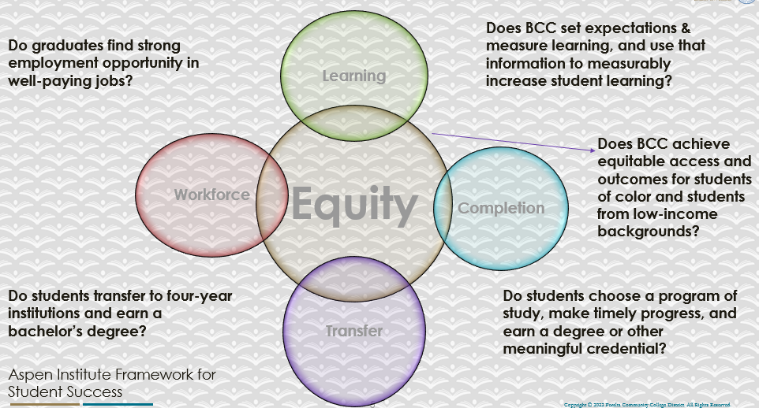

For assistance with data dashboards, contact Phoumy Sayavong at psayavong@peralta.edu
How are students doing in success and completion in your department, compared to the BCC overall success and completion rate? What are the group of students that need more attention to achieve goals?
When compared to the college, MMART students are performing higher in completion and retention. In addition, when other programs are struggling for enrollment, MMART is experiencing growth from Fall 2021 to Spring 2022.

Below is a chart of MMART, Peralta, and BCC in regards to drops.

 | 2018-19 | 2019-20 | 2020-21 | 2021-22
PCCD | 52,300 | 51,199 | 46,400 | 41,600 | 20% drop
BCC | 12,400 | 12,300 | 11,500 | 9,700 | 23% drop
MMART | 2945 | 2929 | 2772 | 2652 | .9% drop

Below is a chart for the completion and retention of BCC and MMART students for the 2021-2022 School year.

 | COMPLETION / RETENTION COMPARISON
 | COMPLETION | RETENTION
BCC OVERALL | 70.00% | 84.00%
MMART | 74% | 86%

Below is a completion and retention chart by semester:

ALL STUDENTS
 | CENSUS | COMPLETION | COMP.TOTAL | RENTENTION | RENT.TOTAL
FALL 2021 | 1373 | 71% | 972 | 83% | 1144
SPRING 2022 | 1121 | 77% | 868 | 89% | 1001
SUMMER 2022 | 158 | 72% | 113 | 86% | 135
TOTAL | 2652 | 74% | 1953 | 86% | 2280

Low completion and retention for Hispanic/Latino and African American student represents the lowest retention and completion for all of Berkeley City College as a whole. MMART can improve our outcomes for the African American and Hispanic/Latino student populations. MMART will make this an agenda item to discuss for the next department meeting.

MMART African American Student Populations below:

 | AFRICAN AMERICAN STUDENTS
 | CENSUS | COMPLETION | TOTAL COMPLETERS | RETENTION | TOTAL RENTENTION
FALL 2021 | 173 | 63% | 109 | 77% | 134
SPRING 2022 | 162 | 73% | 118 | 87% | 140
SUMMER 2022 | 11 | 27% | 3 | 55% | 6
TOTAL | 346 | 66% | 230 | 81% | 280

MMART Latino/Hispanic Student populations below:

 | HISPANIC LATINO STUDENTS
 | CENSUS | COMPLETION | TOTAL COMPLETERS | RETENTION | TOTAL RENTENTION
SPRING 2022 | 230 | 81% | 185 | 91% | 210
FALL 2022 | 355 | 70% | 250 | 83% | 294
SUMMER 2022 | 28 | 69% | 19 | 86% | 25
TOTAL | 613 | 74% | 454 | 86% | 529

What do you see as key factors in your department that contributed to positive success and completion rate?
Key factors for positive success are the commitment of faculty to providing supportive, inclusive, and accessible course content. Faculty work diligently to support students and support the college. MMART faculty and strand leads focus closely on career education needs. MMART faculty provide students the relevant career skills for emerging job market trends. Support within the classroom and dedication to delivering content provide an attractive professional and educational environment. Animation and Game Design will begin to pilot expanding LRC resources with embedded tutors and meet up times for small group support.

What are some improvements your department can make? Identify strategies.
Most importantly, the district and school need a dedicated budget towards social media and other forms of digital outreach where each department can oversee the content promoting our courses, etc. We anticipate that this shift towards a bulk of digital marketing rather than just print will have a huge impact on our registration, especially as there are more online modalities opening our market to students that do not live in the immediate area.

All our digital marketing has been run on our own by teachers who have used their unpaid time and own funds to create paid ads so official monetary support is needed.

3a. Enrollment Trend and Productivity Dashboard
*Note that completion and retention rates are presented with the inclusion and exclusion of excused withdrawals (EW) and military withdrawals.
What were the enrollment trends in your department in the past three years?
The pandemic lowered enrollment totals across Peralta over the past three years. When MMART is compared to large programs at Berkeley City College, MMART has demonstrated minimal losses in enrollment. With enrollment down across the campus, MMART enrollment is currently growing. In Fall 2022, MMART has the strongest productivity among large departments at Berkeley City College. There is
an anomaly where the noncredit courses that are mirrored are not included in the productivity chart in BI tools.

The BI tools report lists number of students enrolled in classes upwards to 40 but in mirrored classes if there is a 50/50 split only the credit students are counted in the productivity please see linked spreadsheet
mmart fall22.xlsx
highlighted in green the enrolled numbers at census and red the productivity not reflecting those numbers.

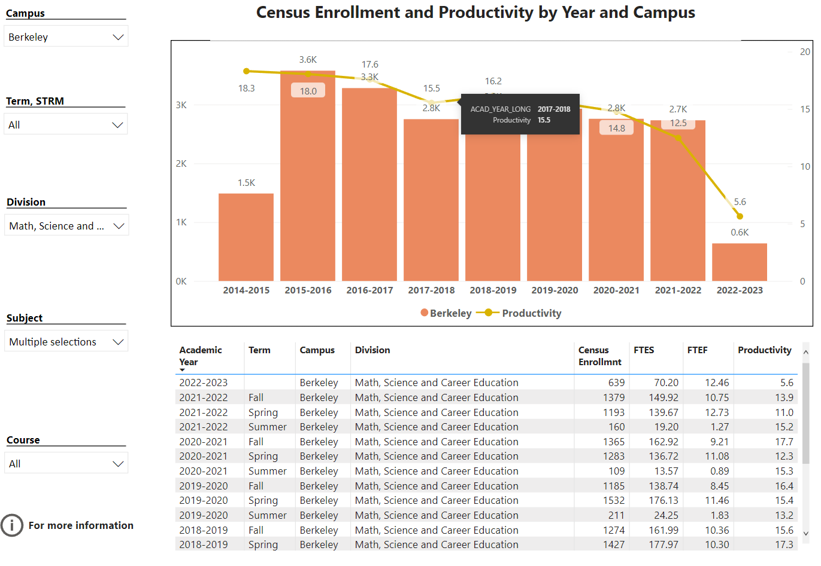

The above is the combined numbers for mmart for all strands. Our productivity numbers are incorrect as they do not reflect the noncredit students.

Here is a comparison chart of productivity for Fall 2022 among large departments at Berkeley City College.

 | MMART | ENGL | MATH | BUS/CIS/ECON | BIOL/CHEM
CENSUS FALL ‘22 | 1706 | 1598 | 1232 | 824 | 709
SECTIONS | 58 | 61 | 44 | 34 | 29
PRODUCTIVITY | 17.5 | 12.6 | 14.4 | 13.5 | 13.45

What strategies would you recommend to increase student enrollment in your department?
We recommend increasing the amount of part time faculty and funding to support social media marketing and career pathway outreach. Social media outreach has been a successful start with the social media coordinator position. We need additional funding to continue this program and grow the social media reach.

We recommend supporting faculty to receive relevant CE certifications or additional academic studies in related disciplines. Lastly, we recommend continued support of the newest versions of software and technology resources to provide students with relevant, career focused learning opportunities.

Strong growth in dual enrollment necessitates increased support of dual enrollment students. We recommend increased tutors to pilot LRC tutors, in-classroom tutoring initiatives, accessibility support, and online material development.

For the strands that are experiencing large growth numbers we would request additional ftef so that students can complete their degrees in a more timely manner – students cannot enroll when classes are full which puts them behind in their path to completion and in juxtaposition higher end classes have been cut when they don’t fill. We have been forced to choose what classes run leaving students without the opportunity to take classes to complete degrees. In Animation and Game and Mobile and Video we are trying to offer multiple classes at the beginning level to increase enrollment in later classes and would like to increase ftef for the earlier classes but not cut the higher end classes so that students see there is a path – more training for counseling would also help – some student SEPs do not take into account the rotation of classes and some students miss taking classes in fall that are not offered in spring.

Community Colleges are funded based on the Student Centered Funding Formula (“SCFF”) which is comprised of the following allocations:

Student Centered Funding Formula: Focus and Priorities
% Of Allocation | Categories
70%  Base Allocation: FTES (Enrollment) | - Credit FTES  - NonCredit FTES  - Special Admits (Dual Enrollment, etc.)
20%  Supplemental Allocation | - Pell Grant  - AB 540  - Adult School  - Promise Grants
10%  Student Success Allocation | - Associate Degrees  - ADTs  - 9 or more CE units  - Transfer  - Transfer level Math and English in the first year

List the department’s progress and reflection on what is being done to maintain or increase the base level of full-time equivalent students (FTES = 12 units). Please describe retention (i.e., remain enrolled for a full semester) and persistence (i.e., enroll in consecutive semesters) efforts.
MMART is heavily focused on Career Technical education, with Mary Clarke Miller leading CE for Berkeley City College. Providing career focused courses with instructors experienced in the disciplines provides students the motivation to continue their studies for the goal of career opportunities.

The Animation group have reintroduced field trips for students in classes and started up again the animation club and are hosting external nonprofits in animation to introduce students to global animation to invigorate the students, the MMART show case returned in spring and an Animation portfolio show spring of last year and plan to repeat this coming spring we are encouraging students to participate and be proud of the work they are producing and highlight internally and externally the work of the students – the MMART showcase showed Video and Digital imaging work and the Animation and Game Show represented the Game students play testing their games demonstrations of Mocap and facial tracking and character sculptures and examples of animation and virtual production work. As we move forward we will be inviting industry to participate and review student work in the portfolio show. We opened the show to the high school students and will look for a more structured call out to our feeder schools for spring.

Mobile and Web has begun discussions with Meta, Google, Coursera and other education partners to grow CE curriculum tied to industry. Post pandemic Mobile and Web has begun to create on site career opportunities. This semester, Mobile and Web organized opportunites for students to shadow executives at Credit Karma during an open house.

Digital Imaging re-opened the print room after the passing of Joe Doyle last Fall 21. Currently Digital Imaging and Mobile and Web are having conversations with the Art Department for collaborative curriculum that can lead to transfer and career opportunities. Digital Imaging is discussing revitalizing the Digital Imaging Club and looking for times, space, and opportunities to create art shows.

In addition, in order to grow FTES, Multimedia Arts has strong outreach for dual enrollment pathways with High schools in the Eastbay. Continued support of our Highschool partners, supports a greater mission of Technology Advocacy, growing community interest for enrollment.

Please describe your department’s efforts in identifying Pell Grant recipients, College Promise Grant recipients, Adult Education, and AB 540 students. What processes are in place to accurately report these students each semester?

College Outcomes | 2018-2019 | 2019-2020 | 2020-21 | 2021-22
Full Time Equivalent Students (FTES) | 4,161 | 3,931 | 3,622 | 3,259
Pell Grant Recipients | 2,387 | 2,281 | 2,181 | 1,826
College Promise Grant Recipients | 4,373 | 4,143 | 4,011 | 3,500
AB 540 Students | 74 | 51 | 22 | 69

We do not have data concerning which of our students are Pell Grant or Promise Grant recipients. We do not know the processes for accurately reporting (or in any way reporting) these students each semester.

3b. Course Completion and Retention Rates Dashboard – Instruction
*Note that completion and retention rates are presented with the inclusion and exclusion of excused withdrawals (EW) and military withdrawals.

If you need more guidance with this item, click here for additional support. Click here for additional guidance for how to view and use equity data. If you would like to view BCC’s Equity Plan, click here.
On page 3 of the “Course Completion and Retention Rates by Subject” dashboard, what are the completion and retention trends by gender, age, ethnicity in your department?
The data below demonstrates that MMART is above the BCC Average for completion and retention. We believe that Multimedia Arts can increase these numbers with additional instructional support for growing classrooms and instructional support. Many of our courses require significant individual attention to grow confidence and success of the course material.

 | COMPLETION / RETENTION COMPARISON
 | COMPLETION | RETENTION
BCC OVERALL | 70.00% | 84.00%
MMART | 74% | 86%

When the data are disaggregated by student ethnic groups, gender, and age, how do you plan to address them over the next year?
Low enrollment for Hispanic/Latino and African American student represents the lowest retention and completion for all of Berkeley City College. We have been addressing this challenge by trying to increase diversity of classroom instructors and support staff. In addition, we will be discussing this challenge at the department meetings and advisory board meetings to formulate an improvement plan.
We plan to utilize the LAEP program to help our students participate in internal and external internships to increase diversity in the field. We are working to employ more black and brown students into the tutor roles to highlight their success and be role models for all students. Mary worked with the BLAC (Building Leaders and Creators), internship program last summer and we had two students picked for a 12 week paid internship for advertising agencies in SF – students then spoke to classes about their experience this fall. Hope to continue this in summer 23. One female student was hired as a technical Artist for Halon Entertainment for 60K plus, others are working as interns for smaller companies, or starting their own businesses.
The multimedia showcase in Spring 2022 attracted 100+ students and over 40 Video alumni who attended the screening as well as the mixer after the show – where students met and discussed career and education options with MMart Video alumni. One of the post event discussions entailed support and resources for POCs breaking into professional filmmaking. A LatinX video student was nominated as a semi-finalist for the Jack Kempe Cook scholarship. From 2020-2021 four Video students won EMMY scholarships including LatinX students. African American and LatinX students video students won Peralta Multimedia Emerging Filmmaker and Community Service scholarships.
Video Instructors include African Americans (3) in each area of the discipline: video production, sound design and editing. We also have three Asian Instructors, a Pacific Islander and 3 Caucasian instructors. We would benefit from hiring LatinX instructors. All video Teaching Assistants have been people of color for the past 3 years with the majority being LatinX and the others predominantly African American.

What population(s) showed outcomes gains in your discipline(s) and which need more support?

Disaggregate the data and outcomes as far down as a possible then ask:
- What trends do you notice when examining course success rates for student populations by ethnicity? Which factors do you believe have the greatest impact (positive or negative) and cause variation between student course success rates in your Program? Describe some specific methods your department is planning or implementing to address these equity gaps. How will you evaluate the efficacy of these interventions?

- How has pivoting to online instruction contributed to potential reductions in student success? Provide some specific examples of practices that faculty in your department have found ineffective in the online environment.
Please review the video from the RP Group acknowledging the interrogation De Anza Community College committed to in their analysis of course completion and success rate.
The lowest retention and completion area is the African American population. We have seen positive gains for this community when comparing Fall 2021 with Spring 2022. Although, we still need to keep a focus to achieve equitable completion and retention results.

 | AFRICAN AMERICAN STUDENTS
 | COMPLETION | RETENTION
FALL 2021 | 63% | 77%
SPRING 2022 | 73% | 87%

Multimedia Arts has received a strong positive response for online instruction. Completion and retention numbers have increased as students have become more familiar with the modality. We have noticed that online instruction struggles if faculty do not create online communities and do not share strong course materials/tutorials. As an outcome of the pandemic, distance education seems to be a strong area for enrollment growth nationally and at Berkeley City College.

Here is the data comparing the completion and retention of online courses for BCC and MMART. Faculty have been encouraged at the growth in retention and completion numbers of Distance Education courses.

 | DISTANCE EDUCATION
 | COMPLETION | RETENTION
MMART | 70% | 83%
BCC | 66% | 84%

For course offerings in the strand of Mobile + Web Design, the online learning modality is an important node of learning. Educational offerings via other universities, colleges, and career learning platforms mimic the online modality of learning. Online learning increases accessibility for students to gain career skills and level up knowledge while multitasking their current careers. The strategic thinking and problem solving manifested while taking an online course simulates future career environments.

Our students have expressed appreciation for options of online as well as async modalities, the use of Canvas shells to collect lesson plan materials, and LRC tutors. They have been vocal that they would like to see Hyflex modality in the spring as some are not sure they want to return F2F yet. As we only offer one section of a given course, they do not have an option of either/or.
We have already seen that online classes are filling faster than the F2F. Students need more support as they struggle with the material. We will encourage students to make use of the F2F labs in the spring and continue to direct them to the LRC. We will continue to build resources into the classes and work with teachers to further scaffold the lesson materials.
In Animation and Game the students have been utilizing the course materials and student lounge to ask questions – we had a reduction in tutors to support classes due to now in fall 22 classes all filling to max. by census there was an adjustment but still high numbers across all classes – in animation and Game we are looking to hire a couple of students to support in the LRC we also through herff were able to purchase 10 mac laptops and 3 pc laptops which the LRC has agreed to have on hand for students to utilize -this will encourage more students to return to the college. I continue to work with the faculty in animation and Game to create robust online resources – we a have found in animation and game that online Sync is better for students as we can still then have group discussions and share out work in progress. We continue to have issues with students accessing software at the start of the semester they put off downloading and or acquiring adobe suite or Maya or unreal – hopefully by setting up the LRC with the software it will be smoother start. And encourage more face to face meetings at the start of the semester to assist students.

How do these outcome trends in your department compare to the college average?
MMART has been performing higher than the college for completion and retention among the African American student population.

Below are the totals of African American Students within MMART

 | AFRICAN AMERICAN STUDENTS
MMART | COMPLETION | RETENTION
FALL 2021 | 63% | 77%
SPRING 2022 | 73% | 87%

Below are the retention and completion totals from the college:

 | AFRICAN AMERICAN STUDENTS
BCC | COMPLETION | RETENTION
FALL 2021 | 61% | 80%
SPRING 2022 | 59% | 80%

How will these outcome trends you identified in this section affect your department goals and plans for the next year and what are your strategies to shift to move the trend towards a positive direction?
We will review and assess our current outcomes to refine and build on the success. With current positive outcomes, we will continue to support and advocate for our current plan. In the coming semester our focus it to create strong assessment practices for the future.

We are continuing to follow the current plan as we move into 2023-24.

Year 1 (2021-22) | Year 2 (2022-23) | Year 3 (2023-24)
Add additional support to the LRC and embed tutors in the F2F labs for the Spring 2022.  Review some of the high-tech courses and see where additional support can be added.  Spring 2022: build a social media campaign to encourage students to petition for degrees and certificates.  Set up a completion workshop for MMART students to see what certificates they may have or about to complete. We are still unable to plan properly as we have no data on where students are on their educational journey.  We need access to the student transcripts to view progress. | Introduce Hyflex options for classes at minimum F2F with Sync online option.  If we have access to a degree audit, we will plan a campaign around students completing certificates and degrees and use for scheduling purposes so that students can complete.  Use the Film festival to celebrate students' academic and creative achievements – list all student who have completed certificates /degrees in the past year as part of the program. Some students do not bother to petition for their degrees. This will give them the opportunity to do so and be recognized by their peers, where we can also highlight in social media.  Work on developing new curriculum for Mobile + Web Design and assessing current Mobile and Web Courses. Work on building career education pathways and attempting to secure CCAP from high school partners.  Digital Imaging is working on upgrading curriculum and collaborating with curriculum leading to careers and transfer. Working on building career education pathways and growing dual enrollment partnerships.  Work on developing and polishing a 4-year degree submission. (working in partnership with 6 colleges to develop virtual production certificates, aa degree and 4 year degree hosted by one of the 6 colleges)  We need access to the student transcripts to view progress | Animation and Game will Continue to expand Hyflex with Sync online option. Building out facilities to support heavy render applications and providing students a state of the art environement for learning animation and game design material.  Video will continue to advance the Film Festival and production resources to support career growth in Film Production.  Mobile and Web will finalize the implementation of new career oriented curriculum partnering with collaborative curriculum partners within BCC and beyond. Growing Tech Advocacy work of faculty that are industry professionals and students growing technology careers.  Digital Imaging will implement new curriculum with partners within BCC and provide state of the art digital imaging opportunities that support careers and transfer.

3c. Degrees and Certificates Dashboard
On page 4, what population(s) award trends showed gains in your program area and which populations need more support?
Below are the degree award trends since 2018

 | DEGREE TRENDS
 | Total | Associates of Arts | Associate of Science | Certificate of Proficiency
2018-2019 | 60 | 17 | 8 | 22
2019-2020 | 43 | 14 | 6 | 17
2020-2021 | 21 | 8 | 6 | 8
2021-2022 | 41 | 12 | 12 | 1

The breakdown of awards by ethnicity:

 | DEGREE TRENDS
 | Asian | African American | Hispanic/Latino | White
2018-2019 | 17 | 2 | 11 | 25
2019-2020 | 11 | 2 | 8 | 21
2020-2021 | 7 | 3 | 7 | 2
2021-2022 | 14 | 3 | 13 | 8

Our degree award totals had a large dip during covid, although are still low. There are a significant number of students that qualify for awards. This is an area where administration and/or counseling could really make an impact on campus. Faculty do not have access to raw data on courses completed, it is hard to do a deep assessment of completion obstacles. We may pilot a process that was developed by HUSV and reach out to students and ask them to complete spreadsheets listing what classes they have taken and self report on certificates and degree – while MMART is much Larger than HUSV it is worth trying as the degree audit system is still not ready and it provides an opportunity for chairs and leads to connect with students we have been waiting on the degree audit for 7+ years as SWP is funded on completion. Animation and Game will start the pilot and work with Melina from HUSV on template, while this process is manual it is better than no data. A quick survey of students tells me they are not up to speed on petitioning for certificates and degrees and tend to leave it all to the end which eventually will impact our numbers and “points system” Only Transfer students reliably petition as it affects their status when they do transfer. We will set up a mechanism for transfer to Virtual production degree when that happens- we have no other options currently for transfer degrees unless we can build a partnership with santa monica community college and their degree program in interaction Design. The Graphic Design transfer program was put on hold at csu.
For past year.
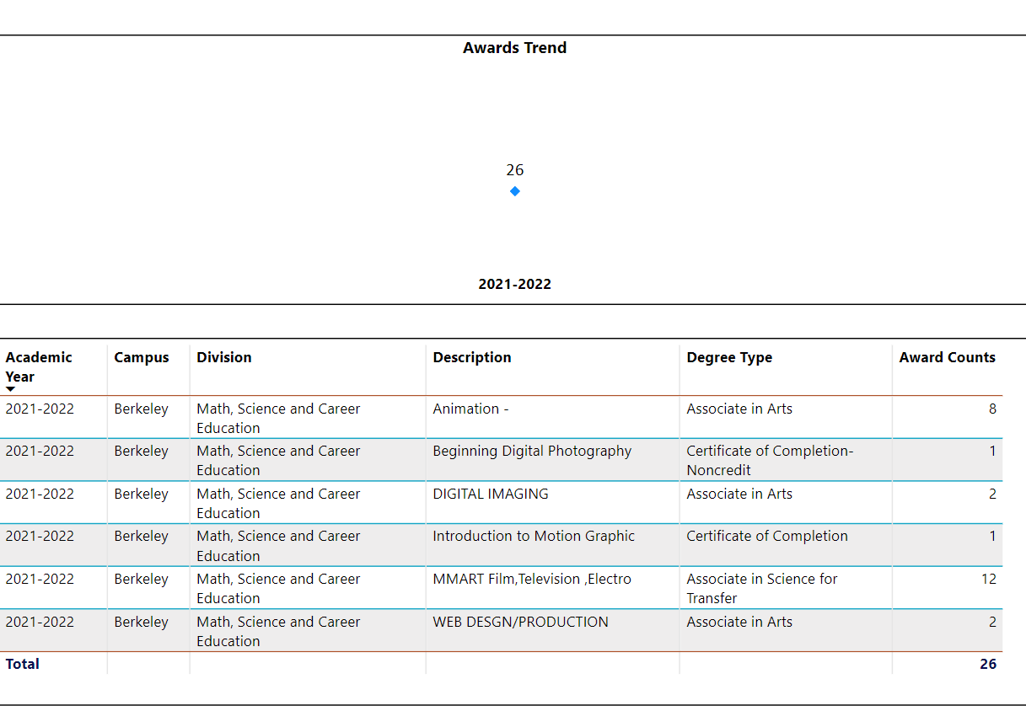

3d. Transfer Dashboard
This dashboard does not provide data by subject. Reflect on what you can do to affect student transfer. How may your department help to support BCC student transfer? (e.g., serve on panels, strengthen GP in your dept, change curriculum, increase number of AD-Ts, etc.)
Additional dual enrollment course offerings will stimulate the largest increase of data points for student transfers. Additional support for the high school students taking Berkeley City College courses will create exposure for transfer opportunities. Successful completion of college courses via Berkeley City College will provide the needed confidence of Highschool students to apply and enroll to transfer institutions. Mary is part of the GP group and advocating for inclusion into the liberal studies options. Animation History and Contemporary Photographers are both now part of humanities alone with movies to multimedia, they help to provide options to students who are maybe not sure of the path they want to follow – most of the mmart curriculum is now approved by UC as elective choices along will all are approved by CSU. Mary has been working with Joseph to articulate classes into specific programs at local CSU and Uc;’s for direct articulation – it is a slow process. As mentioned above we have the only transfer degree currently available. We are still very much career focused.

3e. Curriculum based on Guided Pathways
View the department’s curriculum through the lens of student equity outcomes.
- What intentional effort is your department making to create and present clear pathways for students through curriculum?
We are currently focusing on assessment, advisory board meetings, and updating curriculum to meet industry needs. MMART is following the directive of the CE committee to reach out to industry, and clearly define in demand skills.
In Animation and Video we are working on a model curriculum that will be shared amongst initially 6 colleges that are part of the Virtual production academy – the model curriculum will be streamlining SLOs and providing opportunity for students to take courses across the 6 colleges we will be working on Articulation agreements and Mou is in process. Another step is for Peralta to be a teaching college for cvc and we will be working on getting courses POCR reviewed and badged for CVC once Peralta becomes a teaching college it will be an easier process for students to sign up for classes.

- What are your plans for revising and/or creating new pathways supported by labor market information (LMI) and student demands? Using Vision for Success and SCFF focus, please indicate rationale and how the plans directly support student success and equitable completion.
Addressed in the answer above.
Based on the LMI data coming in for Games and Virtual production we are developing 3 total certificates a fundamentals certificate for Virtual production fundamentals and then two next level certificates for the hands on video camera production side of virtual production and one for technical artist – both will lead into a bachelors degree that we have submitted an interest form for as part of the 6 college collective academy. We have great interest from industry and they are getting excited about what we are doing as they see the opportunity for increasing diversity within the field. WE are currently working with the advisory committee for Virtual production which includes game and video and visual effects companies to develop internship opportunities for students. We hope to be able to use the new LAEP program to encourage more companies to create internships for our students.

Mobile and Web and Digital Imaging are growing Data Design curriculum and career ec

4. Dual Enrollment
As continued decline in overall enrollment for college going population, it is important for us to look at who will be coming to BCC in the next 5 years. Reviewing the data provide here, what strategies would your department employ to address bringing more students to BCC?

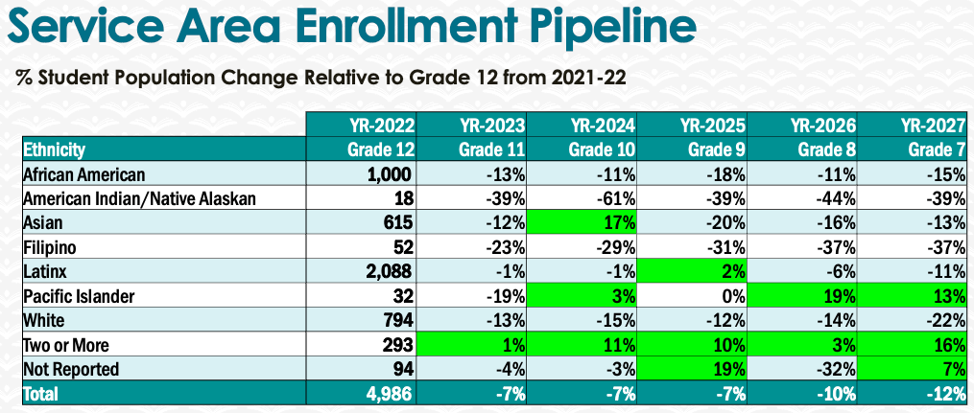
Multimedia Arts enrollment is currently on an upward growth curve. This is due to our identification of supporting career needs and dual enrollment partners as mentioned above.
AS we work towards preparing more courses for POCR review we aim to get courses badged and offered on the CVC website which once we are a teaching college also help to push enrollment up.

5. Facility Utilization Needs

Assess your facilities utilization (including labs, support for online learning, and other spaces) and for next year, indicate if the space is sufficient or not. If not, what are the needs and why? Work with your Dean to check on your needs prior to responding this section.
Continuation of our current technology refresh and infrastructure plan.

Year 1 (2021-22) | Year 2 (2022-23) | Year 3 (2023-24)
-We have no space for 30 part-time faculty as there is one office with 2 FT and one coordinator which leaves one computer for PT (30). There is a need for more space for rotating PT faculty or reorganization of existing space with new furniture. Needed Technology supplies support for Part time faculty to support their distance education and the creation of online materials for classroom instruction.  - Create a teaching room for teaching online or review with a portable cart system to teach online in classrooms. This portable solution uses a 360 camera, microphone, a visual display(monitor) and speakers.  Ideally, there would be several mobile carts available. Both Room 227 and Room 324 labs have reached the end of their life span and urgently need to be updated. Currently, we are two years behind the scheduled refresh plan.  For Room 324 – computers need to be able to handle the growing needs of the software and outfitted with a minimum of i7 core, 64gigs of memory and an equivalent to a 3090 graphics card. (Full spec to be provided later).  The video lab also needs 27-inch iMacs with Retina 5K displays; 3.6GHz 10-core 10th-generation Intel Core i9 processor, Turbo Boost up to 5.0GHz. 64GB 2666MHz DDR4 memory. Radeon Pro 5700 XT with 16GB of GDDR6 memory 8TB SSD storage. We have experienced issues with visual effects/motion graphics where the computers are unable to handle the projects.  The computer in the video studio Rm 218 needs to be updated. A PC laptop for motion capture needs to be purchased. The two laptops we have used for Demo and VR had to be loaned out to faculty and now need to be replaced as they have become outdated  -We recommend the continuation of Splashtop subscription for the college to provide flexibility to students.  -A larger lab space than 324 is needed: we have crammed 40 computers into that space, and it is not ADA compliant  Students also use this workspace on non-computer tasks for Design Thinking / Game Design / Experimental Animation / 2D animation. Therefore, we need a space that can have tables and computers for student group work. The ideal would be similar to the room used for writing workshops where there is space around the computer lab for students to work.  -An ongoing annual budget of 3k to maintain and repair existing video production gear.  Need air purifiers for 218, 227 because of demographic of student participation and classroom usage. | Set up of labs based on refresh plan – hope is to have computers ordered and installed summer 2022. Keep some of the PCs to be used as a render farm – Students can use splash top to login to use.  Wish for larger lab for 324 – it is the smallest computer lab in the college.  Facilities in general  All Labs including video studio should have dimmable lighting – request was submitted for last lighting update but did not happen. The current solution is to have some lights unscrewed - it does not work when trying to project and have students take notes. Plus, fluorescent's cause headaches for faculty and students.  The video studio is too dim, but the lighting also causes headaches and is not bright enough for notetaking. Likewise, a dimmer lighting system is best.  For Animation and Game, we need computer updates for room 324 which also services CIS  We need computers with min 64 gig ram. 1 tb SSD hard drive, graphics card equivalent to 3090 NVidia card 12 Gb– and min i7 core / AMD Ryzen 9 5950X 16 core 72 mb cache  Animation would like 41 Cintiqs for 2D animation and drawing classes – but 324 is small and needs room for 2 monitors set up. It would also be beneficial to all animation and game classes, but we would need a bigger space.  The video studio in Room 218 is a very small space to accommodate active 30+ students with film gear. Our AV equipment room has always been too small for our storage needs. With the expansion of our lending library in Fall 2020 to include 100 more checkout video kits (a huge step in equity for us), more teaching and storage space will be crucial as we transition back to F2F modality.  Print Lab – There needs to be a swipe card reader installed for students to pay for prints to keep all funds together for purchasing of paper and ink.  Faculty coordinator stipend for development of marketing plan for CE departments. $6K/faculty/1 semester.  Joint project w/Business - Total: $6000  Faculty stipend to develop Social Media Marketing Certificate w/Business Dept.. $1950/1 semester – Total: $2000  Student workers from MMART department for development of marketing plan for BCC CE programs. 8hrs/wk/1 semester/student worker. Total: $2280  Taxes and Benefits for MMART faculty stipends – Total: $576  5 embedded tutors over 2 semester specifically for F22/S23 MMART dual enrollment classes ( approximately 57 hrs/tutor/semester at $16.32) Total $9344  Spring ‘23 MMARTs Festival outreach and paid marketing event costs and needs – Total: $5000 | The advent of virtual production is very exciting as a growing industry where we see the intersection of our Animation, Game, Motion Graphics and Video Arts disciplines. To update our offerings to the industry job market, we would like to add a video LED wall for Virtual production as part of an Apprenticeship program incorporating animation/game and video.  Additional small Lab outside of college that is 24/7 accessible. Or an IA to montior a lab in the college and assist students for 40 hrs per week  Additional studio/Photography room set up for backdrops and still photography/mocap/video to hold 30 people – perhaps with a side windowed room between rooms for half computer lab.  Additional Studio space to be flexed between video and animation for Real time capture and motion graphics.

6. Assessment
Berkeley City College is committed to a culture of assessment to improve instruction, services, and institutional planning. Findings from SLO, PLO, ALO assessments, and program review data are used to direct resources for areas that are institutional priorities that are articulated in the Educational Master Plan and BCC Strategic Plan.

Due to the critical role that course, and program assessments play in our institutional planning and to be following the Accreditation requirements, assessments must be completed to qualify for the APU resource allocation requests.
6a. What action plans did your department identify upon the assessment of each SLOs and/or PLOs? For courses with multiple sections in the program, please list the main action plans. Please be as detailed as possible.
Multimedia Arts is starting to incorporate assessment more fully into our courses. As most of our teachers had to pivot to online teaching to accommodate the pandemic, the bulk of their time has gone to transitioning and improving their lessons to this modality. In some cases, teachers have had to re-work online lesson plans for hybrid modality where there is F2F and online class time. This has left very little time for uncompensated part-timers (94% of our faculty) to tackle assessment with the additional time burden of adapting for course trajectory.

6b. Describe the department’s progress on the Actions Plans identified for course Student Learning Outcomes (SLOs). If your department offers a degree or certificate, please describe the department’s progress on the Action Plans for Program Learning Outcomes (PLOs).
Some of our courses embed assessment within the Canvas rubric where students can see where they stand in achieving outcomes. They are also published in course syllabi which is reviewed at the beginning of the semester with students.

6c. Describe the status of SLO and PLO completion in Rounds 4 and 5 of the Assessment Cycle. Identify the percent of completion. Briefly describe what needs to be done to reach 100% completion. Identify issues or concerns that may prevent your department from completing assessments of SLOs and/or PLOs.
6d. Besides your syllabi, where are the program level outcomes published? If on a website, please specify the URL.
BCC Multimedia department page (catalog is attached on the website) and on Canvas.

7. Engagement
Discuss how faculty and classified staff have engaged in institutional efforts such as committees, presentations, and departmental activities. Please list the committees that full-time faculty participate in.
Mary and Justin attend the local CE Committee meetings. Justin and Dru attend Chairs council. Mary is currently Chair of CE committee, Technology committee, participates in Academic Senate, Curriculum Committee, Round Table, Distance Education Committee, Library OER and District CE. Natalie was a student worker coordinator, attended Earn and Learn, and Alumni Network committees. Justin represents the Union for BCC and the State committee for online teaching and accessibility. Mary and Natalie were DE coaches from Fall 2020 through Spring 2021. Both of them are also POCR reviewers.
Natalie and Lana Greenberg run seasonal social media campaigns to promote department enrollment, student community and retention, plus the college in general. Research and analytics are used to design these campaigns.
Discuss how faculty and staff have engaged in community activities, partnerships and/or collaborations.
Mary works with Siggraph nonprofit group, Unreal Academic partnership, working collaboratively with Ohlone, Laney to build up awareness of Media in the bay Area. Mary also working with Marin college, skyline, La Canada college on a VR apprenticeship development.
Justin has been completing outreach with high schools, local tech companies, and developing dual enrollment opportunities.
Rachel has worked with local film festivals which have gone dark over the past 2 years due to the pandemic – but we hope it will start up again. Now that she is part-time, we will need to see how that can be maintained.
Natalie maintains ties with colleagues and alumni at MasterClass, Amazon International, Apple and Sephora for leads on internships, employment and advisory board members.

Our faculty in MMART work at prestigious industry institutions providing vidal feedback of industry trends, community events, and needs.
Discuss how adjunct faculty members are included in departmental training, discussions, and decision-making.
We hold department meetings to support teacher needs and the latest administrative developments.
- Discuss the relationship and engagement with other support services, programs, departments, or administrative units and how these relationships/collaboration support meeting your departmental goals.
- SAS – MMART works closely with this department due to the wide range of spectrum students taking our programs.
Are there areas you feel that your department can benefit more by increasing collaboration and partnership? How?
In the current SWP funding model, MMART is proposing a position for a faculty member to support career outreach to engage in partnerships with local industry leaders.

8. Prioritized Resource Requests
During the 2021-22 Comprehensive Program Review process, you have provided your resource requests which went through the IPAR process. In this section, include resource requests from last year that are still needed and/or new resources that have emerged. Provide justifications. If there are no resource requested, leave the boxes blank.

Resource Category | Description/Justification | Estimated Cost
Personnel
Classified Staff | Yr 1=1 full time IA to cover Print , labs and Video check out  Yr 2=additional IA for total of 2 to cover Print/video and Animation and Game needs | 58K
Student Worker | Yr 1=50K  Yr 2=55k  Yr 3=55K
Part Time Faculty | Yr 1= + 4 to maintain courses F2F and replace 2 FT faculty Coordinator role  Yr 3=coordinator role to support department as a whole  Assessment stipends to faculty – 250 per course – 10 courses per semester – every semester for 3 years | 12k + benefits  12k + benefits  5k per year for 3 years
Full Time Faculty | Yr 1 = Replace Digital Design FT faculty  Yr= 2 Animation/Game faculty member and for the next 3 years add to the strands so that each has 2 FT faculty – Animation – video-mobile and web are both growing.  Yr 3 – 2nd Mobile + Web Instructor | 70k + benefits  70k + benefits  70k + benefits
Professional Development
Department wide PD needed | Yr 1= Pocr training / HyFlex training / Grading for equity  Yr 2= same as above  Yr 3=same as above | 15K
Personal/Individual PD needed | Yr 1= certification for Protools 1 teacher  Workshop or certification in Livestream methods  Yr 2=certification for Unreal 2 teachers  Yr 3=certification for 3D Tools 2 teachers (Zbrush / Substance) | 2k  3K  4k  4k
Supplies
Software (for whom or role?) | Yr2 = Cinema 4D + Zbrush +redshift+red giant – 41 licenses @ 199 per unit due July 1st  Toon Boom and Storyboard pro  Writer Duet screenplay software/celtx  Avid ProTools audio software (estimate is non-partnership price)  Gopro subscription 150X8  Yr 3= Writer Duet screenplay software/celtx  Avid ProTools audio software  Cinema 4D  ToonBoom  Gopro subscription 150X8 | $8,159  $13,006  $3Kceltx  $9protools$1200  Same as above
Books, Magazines, and/or Periodicals
Instructional Supplies | Yr 1= iPads for digital whiteboards for all modalities plus pencil and cover (=34*$1,200K*1.1) still requesting  Yr 2= Ipads if funding not available for year 1  Yr 3=supplement instructional supplies | $40,800  $20K
Non-Instructional Supplies
Technology & Equipment
Description/Justification (Before you list your technology request, click here to view the latest Technology Refresh Plan to verify whether it has already included.)
New | Yr 1= IPAD for Live Link facial capture 25 units + pencil +cover 1,008 received 3 ipads and purchased camera for virtual production – could use a body suite holder for facial camera (iphone)  Yr 2= additional and updated photography equipment  40 Cintq 24” Wacom tablet screens - $2500 per unit  Web continued request for mobile laptop lab to increase flexibility for course schedule. 40 laptops and cart.  Yr 3= update certain video equipment to stay at par industry developments | $25,200  2500  40k  100k  100K laptops  50K cart  $30K
Replacement | Yr 1= pdate 40 computers in 227 lab (=6758*40*1.1)  Room 324 update 36 PCs 64 gig ram. 1 tb SSD hard drive, graphics card equivalent to 3090 NVidia card 12 Gb– and min i7 core / AMD Ryzen 9 5950X 16 core 72 mb cache  2 game pc laptops for Dual enrollment events and vr ready – 5K per piece – teachers have borrowed for past 2 years – should be on the refresh list.  photography equipment  Yr 2= photography equipment  printers  Yr 3= video equipment | $300K  $240K  10K  $3K  $30K  $15K
Facilities
Classrooms | New larger video sound stage/photo/virtual production studio that can more safely accommodate 30 students with teacher, student workers and full gear set ups. | $800K
Offices | Need additional space for 33 pt faculty
Labs | MMART has two labs that are part of the refresh plan.  Yr 3= EditStock for media for editing courses | $4K
Other
Library
Library materials (including streamline media needs)
Library collections
OER | Any OER used needs to be compliant for ADA – need funds to remediate texts and Scripts
Other
OTHER Description

Thank you for your time and effort in completing the Annual Program Update!
Please email the completed Program Review to your Dean by November 30, 2022

