Berkeley City College’s mission is to provide our diverse community with
educational opportunities, promote student success, and to transform lives.

Introduction and Directions

Berkeley City College (BCC), in conjunction with the Peralta community College District, has an institutional effectiveness process which consists of the following components: a District-wide Strategic Plan which is updated every six years; Comprehensive Program Reviews (CPRs) which are completed every three years; and Annual Program Updates (APUs) which are completed in non-program review years.

TIMELINE
Annual Program Update (APU) 2022-2023 timeline has been developed for each program and services to guide through the semester. Please review and work with your Deans, Managers, Department Chairs and/or Supervisors to complete this APU.

For BCC, 2022-2023 marks a critically important year as the college is in the process of revising its Educational Master Plan (EMP) for the next 5 years (2024-2028). This college EMP process will inform the District with their planning for their Strategic Plan. This year’s APU will take an especially important role for the EMP process, carrying your analysis, planning and strategies to support our students success, retention, and equitable completion.

The APU is intended to primarily focus upon planning for the subsequent year based on the institutional priorities. While developing the College’s EMP for the next 5 years, the college and the district focused on the Vision for Success identified by the California Community College Chancellor’s office as well as Student Centered Funding Formula (SCFF) that clearly delineate the categorized outcomes that the Colleges should be focusing. Please use these foci as your reference to prioritize your department and other goals.

RESOURCE REQUEST
In this process of making continuous quality improvement, there is an opportunity for each program, student services, and department to request resources that support achieving the stated goals. The APU process directly leads to the institutional resource allocation process and budget planning facilitated by the Institutional Planning and Allocation of Resources (IPAR) Committee for the following academic year (2023-24). The process for this can be found here (2022-23 APU Timeline). This is an opportunity for each department to request resources that will support your department goals and set outcomes.

TECHNOLOGY REQUEST
Finally, for the resource request section, please connect with your Deans, managers, and supervisors regarding your technology needs so that you can be informed about the equipment that is addressed in the BCC Technology Refresh Plan. If your requests are covered in the Refresh Plan, you do not need to request them in this APU.

If you have questions regarding other material in the Annual Program Update, please contact your Dean or Manager. If you have questions regarding data, please contact Dr. Phoumy Sayavong, Senior Researcher and Planning Analyst (psayavong@peralta.edu).

Please email the completed Annual Program Update to your Dean by November 30, 2022.

College Profile
Click here to view the Berkeley City College Student Demographics Dashboard.
This 2-page dashboard will provide data on the demographics of our student body from the past two years such as headcount, ethnicity, enrollment status, age group, educational goals, and majors.
College Outcomes | 2018-2019 | 2019-20 | 2020-21 | 2021-22
Full Time Equivalent Students (FTES) | 4,161 | 3,931 | 3,622 | 3,259
Productivity (Avg. Goal = 17.5) | 13 | 13.2 | 13 | 10.9
Success Rate (%) | 69% | 77% | 75%* | 70%*
Degrees + Certificates Awarded (#) | 948 | 1,109 | 1,027 | 960
*Excludes “EW” grades

To view prior Program Reviews, click here. To view prior Annual Program Updates, click here.

1a. Department Description
Please verify the mission statement for your department. If your department has not created a mission statement, provide details on how your department supports and contributes to the College’s mission.
Our mission in the Berkeley City College Mathematics Department is to ensure that every student graduates, transfers or progresses into a career as a disciplined, literate and ethical individual, proficient at using mathematics and quantitative reasoning appropriately to analyze and solve complex problems in the real world.
Berkeley City College offers an extensive list of math courses in a variety of formats and times throughout the day to help fit the life and learning styles of all our students.
We are very pleased to offer the Associate in Science Degree for Transfer (AS-T). Upon completion of the AS-T in mathematics, students may transfer to California State University (CSU) system. Completion of the sequence of math courses in the AS-T satisfies the math requirements for transfer to the University of California system (UC) into the mathematics major.

Name(s) of member(s) completing this APU | Department | Completion Date
Claudia Abadia | Math
List faculty names with assignments in fall 2022.
Full Time | Part Time
Claudia Abadia  Kelly Pernell  Rick Wing  Mark Rinker  Shawn McDougal  Mike Orkin  Dmitriy Zhiv | Latha Gopinath  Fan Ching Kuo  Gaston Sanchez Trujillo  Chunfang Zhang  Mike Valdez  Naima Azgui  Elisabeth Chemouni  Lloyd Bland  Arash Farahmand  Yevgeniy Russakovskii  Preston Smith  David Powell

1b. Department Priorities & Goals
Based on the Vision for Success and SCFF, and your department mission, what are your department’s priorities and goals for 2022-23?
The mission of the BCC Math department for 2022-23 is to increase minority student enrollment to improve the and close the equity gap among our student population. We also strive to increase the number of students that pass transfer level math during their first year of community college as per AB705 and the student-centered funding formula.

2. Student Equity, Success, & Completion
Using the data dashboards provided below, review and reflect upon the outcome trends for your department. Please also review overall BCC’s data linked here.

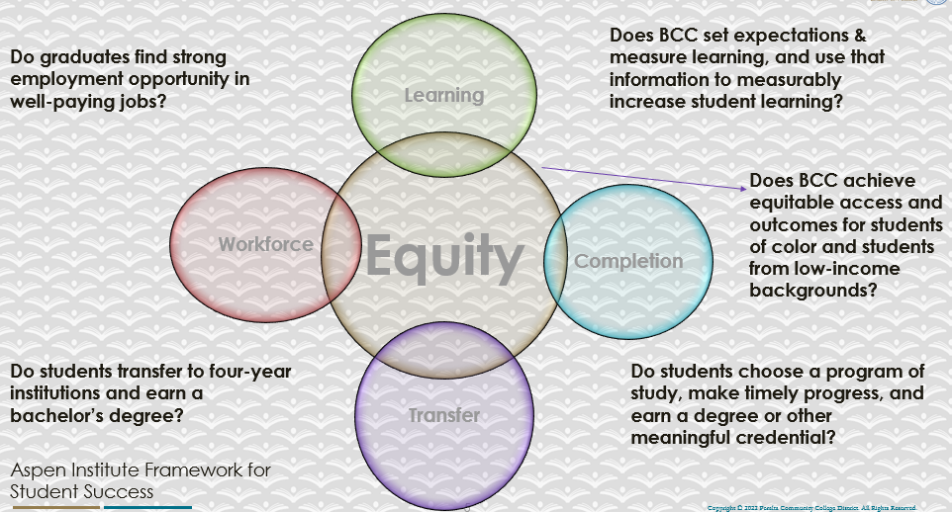

For assistance with data dashboards, contact Phoumy Sayavong at psayavong@peralta.edu
How are students doing in success and completion in your department, compared to the BCC overall success and completion rate? What are the group of students that need more attention to achieve goals?
Math students at BCC perform similarly to the overall school rates but are slightly due to the loss of basic skills level math classes (impact of AB705 implementation). We have lower completion and retention rates with Pacific Islander, Latinx , and African American/Black students. We also notice this trend with non-binary students and students of ages 19-24.
What do you see as key factors in your department that contributed to positive success and completion rate?
A key factor that contributed to the positive success and completion rate was the implementation of AB705 and the support classes we offered in Pre-Calculus, Statistics and Trigonometry.

What are some improvements your department can make? Identify strategies.
Some strategies that the math department can implement are to develop more culturally relevant teaching I.e. develop contextualized social justice examples in class. Another strategy the department can consider is adopting equity grading practices like no late penalties, raising the grading floor to 50%, mastery level grading and staggered testing dates.

3a. Enrollment Trend and Productivity Dashboard
*Note that completion and retention rates are presented with the inclusion and exclusion of excused withdrawals (EW) and military withdrawals.
What were the enrollment trends in your department in the past three years?
2019-2020: 15.6 (Math) 14.9 (BCC)
2020-2021: 15.5 (Math) 14.2 (BCC)
2021-2022: 12.4 (Math) 11.9 (BCC)
Due to Covid and the migration to in-person instruction, enrollment has dropped a bit. The math department’s productivity is slightly higher than the college average.

What strategies would you recommend to increase student enrollment in your department?
I recommend we increase the number of dual enrollment courses we offer in Math at BCC. I also recommend that we survey our students to see which modality they prefer for instruction (face-to-face, synchronous zoom, asynchronous and hybrid).

Community Colleges are funded based on the Student Centered Funding Formula (“SCFF”) which is comprised of the following allocations:

Student Centered Funding Formula: Focus and Priorities
% Of Allocation | Categories
70%  Base Allocation: FTES (Enrollment) | - Credit FTES  - NonCredit FTES  - Special Admits (Dual Enrollment, etc.)
20%  Supplemental Allocation | - Pell Grant  - AB 540  - Adult School  - Promise Grants
10%  Student Success Allocation | - Associate Degrees  - ADTs  - 9 or more CE units  - Transfer  - Transfer level Math and English in the first year

List the department’s progress and reflection on what is being done to maintain or increase the base level of full-time equivalent students (FTES = 12 units). Please describe retention (i.e., remain enrolled for a full semester) and persistence (i.e., enroll in consecutive semesters) efforts.
The math department is trying to increase FTES by offering courses in all modalities to meet student demand. We continue to offer transfer level classes with and without support sections to be AB705 compliant. We offer dual enrollment classes with OSA, Life Academy and Berkeley High School. We have also connected with Berkeley Adult School and in the future hope to have a better collaboration (worked with Midhun Joseph).
Please describe your department’s efforts in identifying Pell Grant recipients, College Promise Grant recipients, Adult Education, and AB 540 students. What processes are in place to accurately report these students each semester?

College Outcomes | 2018-2019 | 2019-2020 | 2020-21 | 2021-22
Full Time Equivalent Students (FTES) | 4,161 | 3,931 | 3,622 | 3,259
Pell Grant Recipients | 2,387 | 2,281 | 2,181 | 1,826
College Promise Grant Recipients | 4,373 | 4,143 | 4,011 | 3,500
AB 540 Students | 74 | 51 | 22 | 69

Math faculty have no way of identifying Pell Grant recipients, Promise Grant recipients, Adult Education students or AB540 students. The only way a faculty member could know this type of information is if a student voluntarily shares this with a faculty member.

3b. Course Completion and Retention Rates Dashboard – Instruction
*Note that completion and retention rates are presented with the inclusion and exclusion of excused withdrawals (EW) and military withdrawals.

If you need more guidance with this item, click here for additional support. Click here for additional guidance for how to view and use equity data. If you would like to view BCC’s Equity Plan, click here.
On page 3 of the “Course Completion and Retention Rates by Subject” dashboard, what are the completion and retention trends by gender, age, ethnicity in your department?
Disaggregating completion rates reveals a striking and consistent disparity between Asian students and Black/African American and Hispanic/Latino students. Effective Fall 2019 the Math department offers support courses for Pre-Calculus, Statistics and Trigonometry. The intention of these support courses is to increase success rates and completion rates in these courses as mandated by the state. Math will also have a few sections that will be linked to learning communities like Umoja. The support that learning community students receive will help improve completion rates. Faculty members are participating in a grant that will look at implementing equity grading strategies.

When the data are disaggregated by student ethnic groups, gender, and age, how do you plan to address them over the next year?
Some strategies that the math department can implement are to develop more culturally relevant teaching I.e. develop contextualized social justice examples in class. Another strategy the department can consider is adopting equity grading practices like no late penalties, raising the grading floor to 50%, mastery level grading and staggered testing dates.

What population(s) showed outcomes gains in your discipline(s) and which need more support?

Disaggregate the data and outcomes as far down as a possible then ask:
- What trends do you notice when examining course success rates for student populations by ethnicity? Which factors do you believe have the greatest impact (positive or negative) and cause variation between student course success rates in your Program? Describe some specific methods your department is planning or implementing to address these equity gaps. How will you evaluate the efficacy of these interventions?

- How has pivoting to online instruction contributed to potential reductions in student success? Provide some specific examples of practices that faculty in your department have found ineffective in the online environment.
Please review the video from the RP Group acknowledging the interrogation De Anza Community College committed to in their analysis of course completion and success rate.
The student populations that need the most help and support has consistently been our students of color (Latinx, African American/Black, Pacific Islander)

How do these outcome trends in your department compare to the college average?
The math department outcome trends are slightly lower than the overall college rates. This could be a result of the more technical subject matter.

How will these outcome trends you identified in this section affect your department goals and plans for the next year and what are your strategies to shift to move the trend towards a positive direction?
Some of the strategies the math department plans to implement are to seek professional development opportunities (individual and department) to work with at risk student populations, redesign and refine the support classes by updating the support materials,
increase dual enrollment by reaching out to neighboring schools or community organizations and by offering courses in various modalities, also establishing a percentage baseline of face-to-face offerings based on student demand not district or college request.

3c. Degrees and Certificates Dashboard
On page 1 of the “Degrees and Certificate Awards Trends” Dashboard, what are the award trends for your department (e.g., overall, by gender, age, and ethnicity)?
There don’t seem to be any identifiable trends. Hopefully with the updated Math ADT (more electives added) more students will opt to earn a Math ADT.
On page 4, what population(s) award trends showed gains in your program area and which populations need more support?
Veterans, Adult Ed and CTE showed overall improvement. Low-income students and DSPS students need more support. Overall, the trend seems to be declining for all student groups.

3d. Transfer Dashboard
This dashboard does not provide data by subject. Reflect on what you can do to affect student transfer. How may your department help to support BCC student transfer? (e.g., serve on panels, strengthen GP in your dept, change curriculum, increase number of AD-Ts, etc.)
Our department can support student transfer by ensuring that we offer transfer level classes in various modalities since the majority of our certificates and degrees require math.

3e. Curriculum based on Guided Pathways
View the department’s curriculum through the lens of student equity outcomes.
- What intentional effort is your department making to create and present clear pathways for students through curriculum?
We have two distinct pathways in the math department, BSTEM and Liberal Arts. We are working with other departments to make sure that we offer the courses that they need for their prerequisites.

- What are your plans for revising and/or creating new pathways supported by labor market information (LMI) and student demands? Using Vision for Success and SCFF focus, please indicate rationale and how the plans directly support student success and equitable completion.
The math department needs to continue offering transfer level classes with support. Faculty need professional development to teach in a more equitable manner. The department needs to investigate working with other 4-year institutions to form clear transfer pathways or certificates that lead to employment.

4. Dual Enrollment
As continued decline in overall enrollment for college going population, it is important for us to look at who will be coming to BCC in the next 5 years. Reviewing the data provide here, what strategies would your department employ to address bringing more students to BCC?

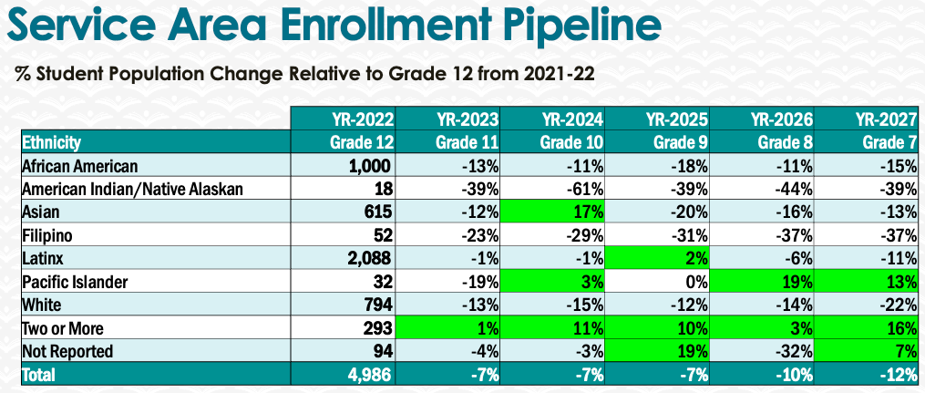
We need to continue our work with our community partners that ask us to offer DE courses. We need to work with Berkeley Adult School and consider offering Math 203 or Math 206. We need to be more visible in the Berkeley community. The department should consider offering Geometry to attract high school students to BCC. The math department needs to develop an academic boot camp that offers a math review to help students be prepared for college level math.

5. Facility Utilization Needs

Assess your facilities utilization (including labs, support for online learning, and other spaces) and for next year, indicate if the space is sufficient or not. If not, what are the needs and why? Work with your Dean to check on your needs prior to responding this section.
The math department would benefit from having a math computer lab to support online learning. The department would also benefit from having more office space for part-time faculty. Currently all part timers share one desk in room 355.

6. Assessment
Berkeley City College is committed to a culture of assessment to improve instruction, services, and institutional planning. Findings from SLO, PLO, ALO assessments, and program review data are used to direct resources for areas that are institutional priorities that are articulated in the Educational Master Plan and BCC Strategic Plan.

Due to the critical role that course and program assessments play in our institutional planning and to be in compliance with the Accreditation requirements, assessments must be completed to qualify for the APU resource allocation requests.
6a. What action plans did your department identify upon the assessment of each SLOs and/or PLOs? For courses with multiple sections in the program, please list the main action plans. Please be as detailed as possible.
Math 1: Recommend Instructors that teach this class to implement active learning with supervised classwork to do a word problem to calculate interest compounded annually, monthly and continuously

Math 13: Recommend Instructors that teach Math 13 to implement active learning instead of lecture in teaching how to convert information presented in words to mathematical symbols and do a short review of tables and graphs during first few meetings

Math 50: Recommend instructors that teach this class to dedicate first few classes for algebra review

Math 213: Assign more exercises where students practice differentiating between two different types of probability exercises: one regarding the value of a quantitative variable and the other regarding the mean of a quantitative variable.

Math 215: Recommend Instructors that teach this class to implement active learning with supervised classwork to do a word problem to calculate interest compounded annually, monthly and continuously.

6b. Describe the department’s progress on the Actions Plans identified for course Student Learning Outcomes (SLOs). If your department offers a degree or certificate, please describe the department’s progress on the Action Plans for Program Learning Outcomes (PLOs).
We are making ok progress. We are working on equity grants for Pre-Calculus and Calculus. We need to bring faculty together to remind them of their action plans for their courses.

6c. Describe the status of SLO and PLO completion in Rounds 4 and 5 of the Assessment Cycle. Identify the percent of completion. Briefly describe what needs to be done to reach 100% completion. Identify issues or concerns that may prevent your department from completing assessments of SLOs and/or PLOs.
Round 4 completion rate is 100%

Round 5
We are assessing Math 1, Math 3A-3F, and Math 215 this Fall 2022. We will review data Spring 2023. Math 13/213 Fall 2023
16A was evaluated in Spring 2022 and the data is in curricunet.
50 was assessed but it is not in curricunet yet

Curricunet training is a big impediment. More training is needed.
6d. Besides your syllabi, where are the program level outcomes published? If on a website, please specify the URL.
Our SLOs are on the department webpage: https://www.berkeleycitycollege.edu/math/student-learning-outcomes/
Our PLOs are listed on the AST degree page: https://www.berkeleycitycollege.edu/math/associate-in-science-for-transfer-as-t-degree-in-mathematics/

7. Engagement
Discuss how faculty and classified staff have engaged in institutional efforts such as committees, presentations, and departmental activities. Please list the committees that full-time faculty participate in.
Claudia Abadia serves as department chair and is the chair of the department chair council. She attends the academic senate, college roundtable and any other committee meeting where her attendance is required/requested. Kelly Pernell serves as the secretary of the academic senate and is the college Assessment coordinator. Mark Rinker is on the academic senate as the senator for the math department. Dmitriy Zhiv serves on the curriculum committee and is the liaison for the department. Claudia Abadia and Michael Orkin serve on the faculty advisory support team for tutoring.
Discuss how faculty and staff have engaged in community activities, partnerships and/or collaborations.
The math department offers dual enrollment courses in collaboration with Life Academy, Oakland School for the Arts and Berkeley High School.
Discuss how adjunct faculty members are included in departmental training, discussions, and decision-making.
Adjunct faculty are included in trainings, discussions and the decision-making process. All are invited to training and department meetings.
- Discuss the relationship and engagement with other support services, programs, departments, or administrative units and how these relationships/collaboration support meeting your departmental goals.
- Math needs to increase their collaborations with the LRC. The goal is for the department to take ownership of math tutoring. Math supports other support services like DSS.
Are there areas you feel that your department can benefit more by increasing collaboration and partnership? How?
Math can benefit by increasing their collaboration with other departments like computer science, education and other STEM disciplines. Math and computer science can collaborate on developing a data science certificate or program. Math and education can work together to ensure that education 18 aligns with math 18 which is no longer taught at BCC. Math can support other STEM disciplines by ensuring that we regularly offer the right classes that serve as prerequisites (Math 3A-3C for Physics 4A-4C).

8. Prioritized Resource Requests
During the 2021-22 Comprehensive Program Review process, you have provided your resource requests which went through the IPAR process. In this section, include resource requests from last year that are still needed and/or new resources that have emerged. Provide justifications. If there are no resource requested, leave the boxes blank.

Resource Category | Description/Justification | Estimated Cost
Personnel
Classified Staff
Student Worker
Part Time Faculty
Professional Development
Department wide PD needed
Personal/Individual PD needed
Supplies
Software (for whom or role?)
Books, Magazines, and/or Periodicals
Instructional Supplies | Need supply budget especially as we increase the number of in person sections. | Amount to be determined by Vincent Koo
Non-Instructional Supplies | Printer supplies and technology supplies (cables, adapters, flash drives and portable hard drives) | Amount to be determined by Joe Bay and Vincent Koo
Technology & Equipment
Description/Justification (Before you list your technology request, click here to view the latest Technology Refresh Plan to verify whether it has already included.)
New
Replacement
Facilities
Classrooms
Offices
Labs
Other
Library
Library materials (including streamline media needs)
Library collections
OER
Other
OTHER Description

Thank you for your time and effort in completing the Annual Program Update!
Please email the completed Program Review to your Dean by November 30, 2022

