Berkeley City College’s mission is to provide our diverse community with
educational opportunities, promote student success, and to transform lives.

Introduction and Directions

Berkeley City College (BCC), in conjunction with the Peralta community College District, has an institutional effectiveness process which consists of the following components: a District-wide Strategic Plan which is updated every six years; Comprehensive Program Reviews (CPRs) which are completed every three years; and Annual Program Updates (APUs) which are completed in non-program review years.

TIMELINE
Annual Program Update (APU) 2022-2023 timeline has been developed for each program and services to guide through the semester. Please review and work with your Deans, Managers, Department Chairs and/or Supervisors to complete this APU.

For BCC, 2022-2023 marks a critically important year as the college is in the process of revising its Educational Master Plan (EMP) for the next 5 years (2024-2028). This college EMP process will inform the District with their planning for their Strategic Plan. This year’s APU will take an especially important role for the EMP process, carrying your analysis, planning and strategies to support our students success, retention, and equitable completion.

The APU is intended to primarily focus upon planning for the subsequent year based on the institutional priorities. While developing the College’s EMP for the next 5 years, the college and the district focused on the Vision for Success identified by the California Community College Chancellor’s office as well as Student Centered Funding Formula (SCFF) that clearly delineate the categorized outcomes that the Colleges should be focusing. Please use these foci as your reference to prioritize your department and other goals.

RESOURCE REQUEST
In this process of making continuous quality improvement, there is an opportunity for each program, student services, and department to request resources that support achieving the stated goals. The APU process directly leads to the institutional resource allocation process and budget planning facilitated by the Institutional Planning and Allocation of Resources (IPAR) Committee for the following academic year (2023-24). The process for this can be found here (2022-23 APU Timeline). This is an opportunity for each department to request resources that will support your department goals and set outcomes.

TECHNOLOGY REQUEST
Finally, for the resource request section, please connect with your Deans, managers, and supervisors regarding your technology needs so that you can be informed about the equipment that is addressed in the BCC Technology Refresh Plan. If your requests are covered in the Refresh Plan, you do not need to request them in this APU.

If you have questions regarding other material in the Annual Program Update, please contact your Dean or Manager. If you have questions regarding data, please contact Dr. Phoumy Sayavong, Senior Researcher and Planning Analyst (psayavong@peralta.edu).

Please email the completed Annual Program Update to your Dean by November 30, 2022.

College Profile
Click here to view the Berkeley City College Student Demographics Dashboard.
This 2-page dashboard will provide data on the demographics of our student body from the past two years such as headcount, ethnicity, enrollment status, age group, educational goals, and majors.
College Outcomes | 2018-2019 | 2019-20 | 2020-21 | 2021-22
Full Time Equivalent Students (FTES) | 4,161 | 3,931 | 3,622 | 3,259
Productivity (Avg. Goal = 17.5) | 13 | 13.2 | 13 | 10.9
Success Rate (%) | 69% | 77% | 75%* | 70%*
Degrees + Certificates Awarded (#) | 948 | 1,109 | 1,027 | 960
*Excludes “EW” grades

To view prior Program Reviews, click here. To view prior Annual Program Updates, click here.

1a. Department Description
Please verify the mission statement for your department. If your department has not created a mission statement, provide details on how your department supports and contributes to the College’s mission.
The primary mission of the Berkeley City College Library is to promote student success and equity by providing access to space and resources needed to complete studies and supporting the curriculum and information needs of the diverse Berkeley City College community. This mission is met by providing physical and remote access to quality diverse print, electronic, and multimedia resources, services, and instruction. Consistent with the mission and institutional outcomes of Berkeley City College, the library faculty and staff strive to promote information competency, critical thinking, lifelong learning, and academic success. They do so by making available to Berkeley City College students faculty and staff the resources needed to conduct research related to their curriculum and endeavors and by promoting the information competency skills needed to successfully retrieve information through instructional support.

Name(s) of member(s) completing this APU | Department | Completion Date
Heather Dodge, Jenny Yap, Joshua Boatright, Patrick Wallace | Library | 11/29/2022
List faculty names with assignments in fall 2022.
Full Time | Part Time
Joshua Boatright, Jenny Yap, Heather Dodge, Patrick Wallace (CLASSIFIED) | Suzanne Allison, Annemarie Meyer, Linda Jolivet, Justine Rea, Allison Greene (CLASSIFIED)

1b. Department Priorities & Goals
Based on the Vision for Success and SCFF, and your department mission, what are your department’s priorities and goals for 2022-23?
- Expand the library’s physical footprint to accommodate different modes of studying and programming—increase study rooms, improve facilities to accommodate personal devices (electrical outlets, wifi, etc)
- Increase the visibility of library services through programming and instruction
- Increase access to digital and physical resources by implementing a reserve textbook module in Alma and a digital textbook reserves module (Alma-D)
- Expand staffing to include an additional FT librarian who supports equity, access, and inclusion activities.
- Expand staffing to include a FT Senior Library Technician to support our existing library facility, expanded library footprint, and the additional technology lending program
- Stabilize and expand the library’s budget for databases, books/e-books, and technology accessing all available resources to the library (Fund 1, lottery funds, Measure G, and Higher Education Emergency Relief Funds)

2. Student Equity, Success, & Completion
Using the data dashboards provided below, review and reflect upon the outcome trends for your department. Please also review overall BCC’s data linked here.

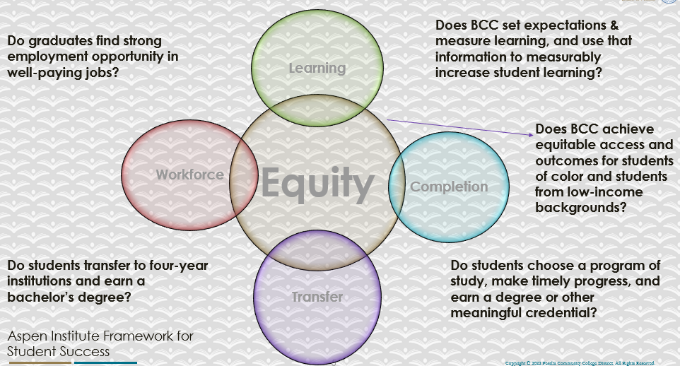

For assistance with data dashboards, contact Phoumy Sayavong at psayavong@peralta.edu
How are students doing in success and completion in your department, compared to the BCC overall success and completion rate? What are the group of students that need more attention to achieve goals?
In LIS 85 (our only course with data) our completion rates averaged 76% over the last three years in comparison to 69% as a college averages. However, those rates were lower for males, and African American students with males sometimes dipping as low as 53% completion and AfAm males dipping as low as 33%. Thus, African American males will continue to be the target population to support in LIS classes.

What do you see as key factors in your department that contributed to positive success and completion rate?
Overall, the library supports success and completion across the entire college through the following:
- Providing spaces for study and supportive staff to assist students
- Collections that support the college’s curriculum, both physical and digital
- Instruction, in the form of library orientations and reference interactions, to support student research
- Providing chromebooks and other instructional technology that supports student success in online and in person courses
Specific to LIS 85:
- Re-designed online courses that integrate more personalized and humanistic content such as videos featuring LIS instructors, a liquid syllabus, and a communications calendar to ensure students are informed of important deadlines
- Additional avenues for student support such as office hours in person and online and expanded availability of librarians both online in LibChat and in person.

What are some improvements your department can make? Identify strategies.
More support for students of color and students experiencing mental health challenges:
- Consider offering a hybrid LIS 85 section to the learning communities
- Work closely with UMOJA and Puente support staff to ensure students understand the requirements of an 8-week course.
- Require students enrolled in a learning community to attend office hours within the first two weeks of class

3a. Enrollment Trend and Productivity Dashboard
*Note that completion and retention rates are presented with the inclusion and exclusion of excused withdrawals (EW) and military withdrawals.
What were the enrollment trends in your department in the past three years?
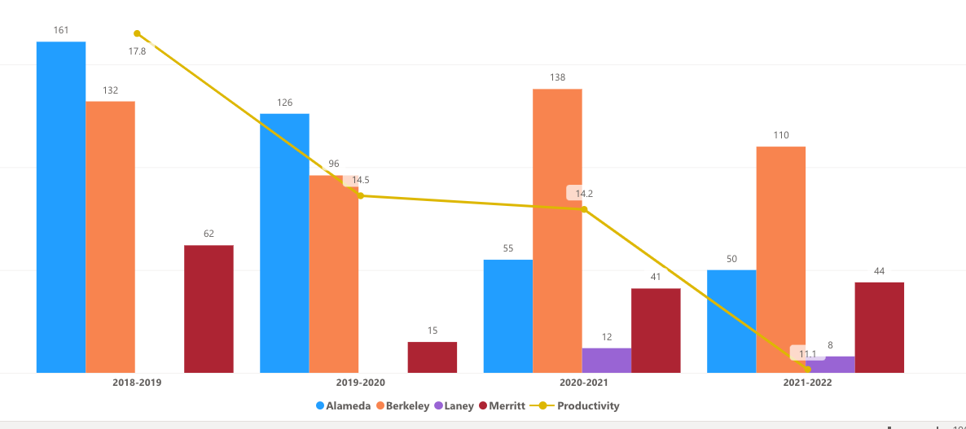
As has been the trend across the college(s), enrollment has fallen slightly in our LIS sections, with a momentary recoup of students in 2020-21. However, this remains on par with other departments in the college and since only Merritt and BCC offer LIS 85, it is still important that we continue to offer the same amount of sections/courses.
What strategies would you recommend to increase student enrollment in your department?
Every term we advertise via the counselors and in Spring the LIS 85 course is part of the Society of Scholars and other learning communities cohort classes. In addition, we advertise on our website, through social media, in classes we visit, and via physical flyers on campus.
Beyond this, it’s not clear how much more we could do to increase enrollment.

Community Colleges are funded based on the Student Centered Funding Formula (“SCFF”) which is comprised of the following allocations:

Student Centered Funding Formula: Focus and Priorities
% Of Allocation | Categories
70%  Base Allocation: FTES (Enrollment) | - Credit FTES  - NonCredit FTES  - Special Admits (Dual Enrollment, etc.)
20%  Supplemental Allocation | - Pell Grant  - AB 540  - Adult School  - Promise Grants
10%  Student Success Allocation | - Associate Degrees  - ADTs  - 9 or more CE units  - Transfer  - Transfer level Math and English in the first year

List the department’s progress and reflection on what is being done to maintain or increase the base level of full-time equivalent students (FTES = 12 units). Please describe retention (i.e., remain enrolled for a full semester) and persistence (i.e., enroll in consecutive semesters) efforts.
LIS Courses
-partnering with the counselors and learning communities to offer an LIS 85 section specifically designed for learning communities students
-offering a new non-credit LIS 500 certificate in research skills and advertising this via the counselors and through social media
Library
-providing technology to students for the duration of their time at BCC, including chromebooks and hotspots
-encouraging student use of the library by expanding resources such as wireless printing (soon to be free printing), self-service room booking, expanding digital textbook lending, and leading Zero Textbook Cost efforts on campus to ensure faculty understand the financial and other implications of using high cost textbooks.
Please describe your department’s efforts in identifying Pell Grant recipients, College Promise Grant recipients, Adult Education, and AB 540 students. What processes are in place to accurately report these students each semester?

College Outcomes | 2018-2019 | 2019-2020 | 2020-21 | 2021-22
Full Time Equivalent Students (FTES) | 4,161 | 3,931 | 3,622 | 3,259
Pell Grant Recipients | 2,387 | 2,281 | 2,181 | 1,826
College Promise Grant Recipients | 4,373 | 4,143 | 4,011 | 3,500
AB 540 Students | 74 | 51 | 22 | 69

We don’t have a process in place. This information should be available to the college researcher but isn’t readily available to our LIS instructors.

3b. Course Completion and Retention Rates Dashboard – Instruction
*Note that completion and retention rates are presented with the inclusion and exclusion of excused withdrawals (EW) and military withdrawals.

If you need more guidance with this item, click here for additional support. Click here for additional guidance for how to view and use equity data. If you would like to view BCC’s Equity Plan, click here.
On page 3 of the “Course Completion and Retention Rates by Subject” dashboard, what are the completion and retention trends by gender, age, ethnicity in your department?
https://usc-word-edit.officeapps.live.com/ Using the link to the left, it’s clear that the LIS 85 class has consistent retention and completion rates between 60-80% across all genders, ages, and ethnicities, except for African Americans, specifically males, where the completion rates hover between 50-60%, unacceptably low.

When the data are disaggregated by student ethnic groups, gender, and age, how do you plan to address them over the next year?
Starting this spring, in our UMOJA/Puente section of LIS 85, we plan to institute mandatory office hours for all students with at least two office hours for each student to ensure that they are on the right track. In addition, the instructor will work closely with the UMOJA and Puente coordinators to schedule in person time for students to get one-on-one help. Contract grading will go into place in week #2 in the UMOJA/Puente section to ensure that students do not fall behind.

What population(s) showed outcomes gains in your discipline(s) and which need more support?

Disaggregate the data and outcomes as far down as a possible then ask:
- What trends do you notice when examining course success rates for student populations by ethnicity? Which factors do you believe have the greatest impact (positive or negative) and cause variation between student course success rates in your Program? Describe some specific methods your department is planning or implementing to address these equity gaps. How will you evaluate the efficacy of these interventions?

- How has pivoting to online instruction contributed to potential reductions in student success? Provide some specific examples of practices that faculty in your department have found ineffective in the online environment.
Please review the video from the RP Group acknowledging the interrogation De Anza Community College committed to in their analysis of course completion and success rate.
Please see information above about support for African American students.

How do these outcome trends in your department compare to the college average?
We are below the college average, however, considering that one full section of our LIS class is AfrAm we have a larger sample size than a typical BCC course.

How will these outcome trends you identified in this section affect your department goals and plans for the next year and what are your strategies to shift to move the trend towards a positive direction?
See above.

3c. Degrees and Certificates Dashboard
On page 1 of the “Degrees and Certificate Awards Trends” Dashboard, what are the award trends for your department (e.g., overall, by gender, age, and ethnicity)?
N/A
On page 4, what population(s) award trends showed gains in your program area and which populations need more support?
N/A

3d. Transfer Dashboard
This dashboard does not provide data by subject. Reflect on what you can do to affect student transfer. How may your department help to support BCC student transfer? (e.g., serve on panels, strengthen GP in your dept, change curriculum, increase number of AD-Ts, etc.)
N/A

3e. Curriculum based on Guided Pathways
View the department’s curriculum through the lens of student equity outcomes.
- What intentional effort is your department making to create and present clear pathways for students through curriculum?
We recently created an LIS 500 non-credit research skills certificate. 22-23 is the first year it is offered so we don’t have enough data to present at this moment.

- What are your plans for revising and/or creating new pathways supported by labor market information (LMI) and student demands? Using Vision for Success and SCFF focus, please indicate rationale and how the plans directly support student success and equitable completion.
We recently created an LIS 500 non-credit research skills certificate. 22-23 is the first year it is offered so we don’t have enough data to present at this moment.

4. Dual Enrollment
As continued decline in overall enrollment for college going population, it is important for us to look at who will be coming to BCC in the next 5 years. Reviewing the data provide here, what strategies would your department employ to address bringing more students to BCC?

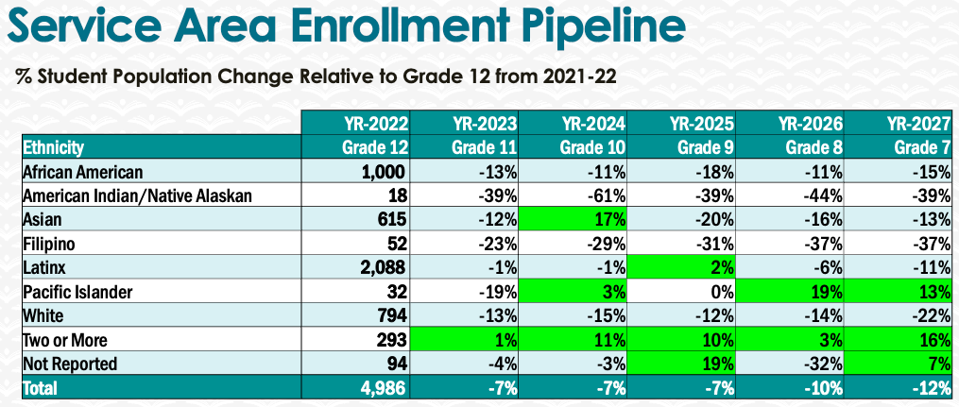
The library continues to be the hub of equity on campus and we will expand programming that braids together our academic disciplines, special populations, and the library’s resources. Programs such as our plants in the library (collaboration with the biology department), Don’t Judge a Book art exhibit (collaboration with the Art department), and rotating book displays that feature student interests and clubs, are all examples of how the library is expanding active and passive programming to students.

In addition, we are making printing free, students can self-reserve study rooms, and we provide a host of lendable technology.

In addition, the LIS 85 class is an excellent dual-enrollment class that can support students as they transition to college-level research courses across the disciplines.

5. Facility Utilization Needs

Assess your facilities utilization (including labs, support for online learning, and other spaces) and for next year, indicate if the space is sufficient or not. If not, what are the needs and why? Work with your Dean to check on your needs prior to responding this section.
If we look at data from the last time we evaluated our space needs in pre-COVID times, you will see that demands on the library’s space have increased year over year. COVID 19 has changed how students see the campus and this is the first semester (FA 22) that we are fully operational as a library. Space needs are changing to include the following activities:
-more private areas to Zoom with instructors, taking synchronous online Zoom classes, and participate in online learning activities
-space to accommodate technology lending and staff to support these activities, including staff to support and trouble-shoot student technology issues
-better and stronger network wifi to ensure that we have ample broadband internet to accommodate student needs for streaming videos, creating content, and video conferencing
-open computer labs with software such as Adobe Photoshop and other specialized software that is specific to courses (MMART, CIS, ART, etc). And staffing to support the use of these software and spaces
 | AY 16/17 | AY 17/18
Gate Count (Fall) | 66973 | 69248
Reserve textbook checkouts | 28193 | 21962
Reference transactions | 1183 | 1350
Circulating books checkouts | 2727 | 4854
Research workshops | 100 | 126
Students in workshops/orientations | 3025 | 3654

6. Assessment
Berkeley City College is committed to a culture of assessment to improve instruction, services, and institutional planning. Findings from SLO, PLO, ALO assessments, and program review data are used to direct resources for areas that are institutional priorities that are articulated in the Educational Master Plan and BCC Strategic Plan.

Due to the critical role that course and program assessments play in our institutional planning and to be in compliance with the Accreditation requirements, assessments must be completed to qualify for the APU resource allocation requests.
6a. What action plans did your department identify upon the assessment of each SLOs and/or PLOs? For courses with multiple sections in the program, please list the main action plans. Please be as detailed as possible.
Please see this document for our SLO assessment data for LIS 85. Action Plan Report 9_9_22.xlsx

6b. Describe the department’s progress on the Actions Plans identified for course Student Learning Outcomes (SLOs). If your department offers a degree or certificate, please describe the department’s progress on the Action Plans for Program Learning Outcomes (PLOs).
-more explicit instructions and example assignments have been incorporated into LIS 85
-one instructor uses a communications calendar to communicate with students in a consistent and regular way and tracks student log-ins to Canvas. If a student doesn’t log-in over the span of 3 days this student is contacted to ensure they are still on track for course completion.

6c. Describe the status of SLO and PLO completion in Rounds 4 and 5 of the Assessment Cycle. Identify the percent of completion. Briefly describe what needs to be done to reach 100% completion. Identify issues or concerns that may prevent your department from completing assessments of SLOs and/or PLOs.
100% of sections of LIS 85 were assessed.

6d. Besides your syllabi, where are the program level outcomes published? If on a website, please specify the URL.
We only offer one course. So there are no program outcomes.

6 (A). Assessment
Berkeley City College is committed to a culture of assessment to improve instruction, services, and institutional planning. Findings from SLO, PLO, ALO assessments, and program review data are used to direct resources for institutional priorities that are articulated in the Educational Master Plan and BCC Strategic Plan. Due to the critical role that course and program assessments play in our institutional planning and to be in compliance with the Accreditation requirements, assessments must be completed to qualify for APU resource allocation requests.
What action plans did your Program identify upon the assessment of each Service Area Outcomes (SAOs)? Please be as detailed as possible.
Please see this document for SAO assessment. SAO Survey Notes and action plan.docx

Describe the Program’s progress on the Action Plans identified for Service Area Outcomes (SAOs). Please be specific. Identify percentages towards completion of Action Plans. What Action Plans are priorities?
-we are increasing programming to promote the library’s services
-we are making strides to implement PrimoOne search and expand digital textbook lending
-we are ensuring adequate access to technology lending

Describe the status of SAO completion in Rounds 4 and 5 of the Assessment Cycle. Identify the percentages of completion. Briefly describe what needs to be done to reach 100% completion? Identify issues or concerns that may prevent your area from completing assessments of SAOs.

To assist you with this area/prompt, please review your Program’s Round 5 Tentative Plan available on One Drive, search Curricunet for assessment proposals of courses (or SAOs) that should be assessed this past year, and consult the Program’s SAO lead) and/or faculty (or staff) who were scheduled for assessments this past year.
See the action plan above.
How does your department, program, or unit ensure that students are aware of Service Area Outcomes?
We meet each semester during Flex Day to review our progress on our SAOs.

Where are the Service Area Outcomes published? If on a website, please specify the URL.
https://www.berkeleycitycollege.edu/library/stafffaculty/library-documents/

7. Engagement
Discuss how faculty and classified staff have engaged in institutional efforts such as committees, presentations, and departmental activities. Please list the committees that full-time faculty participate in.
Committees: professional development (chair), academic senate, affordable educational materials (chair), facilities, technology, integrated planning council, distance education, classified senate, department chairs council.
Initiatives: Guided Pathways, POCR review, CCLI, CL-EAR committee of the CCL, ASCCC OERI regional lead, OERI college liaison
Discuss how faculty and staff have engaged in community activities, partnerships and/or collaborations.
Faculty and staff are ACTIVELY engaged across campus. Our Principal Library Tech has partnered with local cultural venues to establish a program of lending museum passes. We also engage in programming across college departments and are pursuing a possible speakers series with Berkeley High and the Berkeley Public Library in Spring. The library has also partnered with the art and science departments on programming in the library and will continue to do more in the future.
Discuss how adjunct faculty members are included in departmental training, discussions, and decision-making.
Part-time faculty and staff are integral to our library. Librarian Annemarie Meyer is spearheading our digital textbook reserves program and has made vital changes to our library services platform, Alma. Suzanne Allison acts as our programming librarian, setting up book displays and creating cross-disicpline programs such as our plants in the library program with the biology department. Part-time staff Allison Greene created our library stamp card program, is responsible for seasonal decorations in the library, and is our library ambassador to many, many students. See above for contributions from our Prinicipal Library Tech, an essential staff member to the BCC library.
- Discuss the relationship and engagement with other support services, programs, departments, or administrative units and how these relationships/collaboration support meeting your departmental goals.
- See above.
Are there areas you feel that your department can benefit more by increasing collaboration and partnership? How?
We need funds to continue to offer our programming such as the plant event, snacks and other support during finals weeks, and other programming to bring students into the library and back to campus. Currently, library staff pays out of pocket for certain supplies.

8. Prioritized Resource Requests
During the 2021-22 Comprehensive Program Review process, you have provided your resource requests which went through the IPAR process. In this section, include resource requests from last year that are still needed and/or new resources that have emerged. Provide justifications. If there are no resource requested, leave the boxes blank.

NONE OF OUR PREVIOUS RESOURCE REQUESTS WERE MET. SEE REQUESTS BELOW.

Resource Category | Description/Justification | Estimated Cost
Personnel
Classified Staff | FT Senior Library Tech: needed to ensure smooth operations at the library (all other Peralta colleges have 2 f/t classified professionals). Previously requested on numerous APUs/CPRs. | $63,000
Student Worker | 1.75 Student workers: to meet the additional safety needs put on us by COVID 19 | $37,000
Part Time Faculty | Sufficient budget to cover 1.5 PT faculty | $120,000
Professional Development
Department wide PD needed | -Conference/training to support new library services platform (Ex Libris Knowledge Days) $1,000 x two personnel | $4,000
Personal/Individual PD needed
Supplies
Software (for whom or role?) | $60,000 yr for additional databases, including eBooks, that would support STEM, CTE, and streaming media areas (Science Direct, Web of Knowledge, Diversity+, Swank, Kanopy) | $60,000
Books, Magazines, and/or Periodicals | 20,000 stable book purchasing budget to ensure the currency of the digital and physical library collection | $20,000
Instructional Supplies
Non-Instructional Supplies | Furniture refresh needed in the library to replace stained upholstery Increased budget for book processing supplies: book tape, bar codes, to match our increase in technology lending Additional funds for color printing to promote library services | $26,000
Technology & Equipment
Description/Justification (Before you list your technology request, click here to view the latest Technology Refresh Plan to verify whether it has already included.)
New | High tech scanner for our digital textbook project | $5,000
Replacement | Replacement for our two OLD AS DIRT library security gates. | $20,000
Facilities
Classrooms | Staffed LAB for makers space and MMART technology | $65,000
Offices | Office for additional Library Tech | $20,000
Labs | REPLACEMENT LAB FOR ROOM 125 | $65,000
Other | 5 additional study rooms | $20.000
Library
Library materials (including streamline media needs) | See above
Library collections | See above
OER
Other
OTHER Description

Thank you for your time and effort in completing the Annual Program Update!
Please email the completed Program Review to your Dean by November 30, 2022

