Berkeley City College’s mission is to provide our diverse community with
educational opportunities, promote student success, and to transform lives.

Introduction and Directions

Berkeley City College (BCC), in conjunction with the Peralta community College District, has an institutional effectiveness process which consists of the following components: a District-wide Strategic Plan which is updated every six years; Comprehensive Program Reviews (CPRs) which are completed every three years; and Annual Program Updates (APUs) which are completed in non-program review years.

TIMELINE
Annual Program Update (APU) 2022-2023 timeline has been developed for each program and services to guide through the semester. Please review and work with your Deans, Managers, Department Chairs and/or Supervisors to complete this APU.

For BCC, 2022-2023 marks a critically important year as the college is in the process of revising its Educational Master Plan (EMP) for the next 5 years (2024-2028). This college EMP process will inform the District with their planning for their Strategic Plan. This year’s APU will take an especially important role for the EMP process, carrying your analysis, planning and strategies to support our students success, retention, and equitable completion.

The APU is intended to primarily focus upon planning for the subsequent year based on the institutional priorities. While developing the College’s EMP for the next 5 years, the college and the district focused on the Vision for Success identified by the California Community College Chancellor’s office as well as Student Centered Funding Formula (SCFF) that clearly delineate the categorized outcomes that the Colleges should be focusing. Please use these foci as your reference to prioritize your department and other goals.

RESOURCE REQUEST
In this process of making continuous quality improvement, there is an opportunity for each program, student services, and department to request resources that support achieving the stated goals. The APU process directly leads to the institutional resource allocation process and budget planning facilitated by the Institutional Planning and Allocation of Resources (IPAR) Committee for the following academic year (2023-24). The process for this can be found here (2022-23 APU Timeline). This is an opportunity for each department to request resources that will support your department goals and set outcomes.

TECHNOLOGY REQUEST
Finally, for the resource request section, please connect with your Deans, managers, and supervisors regarding your technology needs so that you can be informed about the equipment that is addressed in the BCC Technology Refresh Plan. If your requests are covered in the Refresh Plan, you do not need to request them in this APU.

If you have questions regarding other material in the Annual Program Update, please contact your Dean or Manager. If you have questions regarding data, please contact Dr. Phoumy Sayavong, Senior Researcher and Planning Analyst (psayavong@peralta.edu).

Please email the completed Annual Program Update to your Dean by November 30, 2022.

College Profile
Click here to view the Berkeley City College Student Demographics Dashboard.
This 2-page dashboard will provide data on the demographics of our student body from the past two years such as headcount, ethnicity, enrollment status, age group, educational goals, and majors.
College Outcomes | 2018-2019 | 2019-20 | 2020-21 | 2021-22
Full Time Equivalent Students (FTES) | 4,161 | 3,931 | 3,622 | 3,259
Productivity (Avg. Goal = 17.5) | 13 | 13.2 | 13 | 10.9
Success Rate (%) | 69% | 77% | 75%* | 70%*
Degrees + Certificates Awarded (#) | 948 | 1,109 | 1,027 | 960
*Excludes “EW” grades

To view prior Program Reviews, click here. To view prior Annual Program Updates, click here.

1a. Department Description
Please verify the mission statement for your department. If your department has not created a mission statement, provide details on how your department supports and contributes to the College’s mission.
We are an interdisciplinary, multifaceted program that offers classes in African American Studies, Asian American Studies, Mexican/Latin American Studies, and Ethnic Studies.
Ethnic Studies was born out of struggle, through the efforts of student and community-based activism. We continually honor this legacy, in and out of the classroom, and take great pride in developing socially-conscious scholars.
Ethnic Studies at Berkeley City College emphasizes intersectional, relational, and decolonial approaches to the study of race, ethnicity, and indigeneity, within and beyond what is presently the United States.
Our students are motivated and engaged, and drawn to our program out of an interest in social justice and racial equity.

Name(s) of member(s) completing this APU | Department | Completion Date
Alejandro Wolbert Perez | Social Science | 11/30/22
List faculty names with assignments in fall 2022.
Full Time | Part Time
Jimmy Crutison
Jeffrey Ow

1b. Department Priorities & Goals
Based on the Vision for Success and SCFF, and your department mission, what are your department’s priorities and goals for 2022-23?
Priorities and goals of the program in Ethnic Studies include:
- Ensure ETHST + classes meet Area F transfer requirements
- Expand course offerings in ETHST +
- Increase completion and transfer rates of students
- Build student-to-faculty mentor pipeline
- Explore the possibility of offering a degree and/or certificate in ETHST+

2. Student Equity, Success, & Completion
Using the data dashboards provided below, review and reflect upon the outcome trends for your department. Please also review overall BCC’s data linked here.

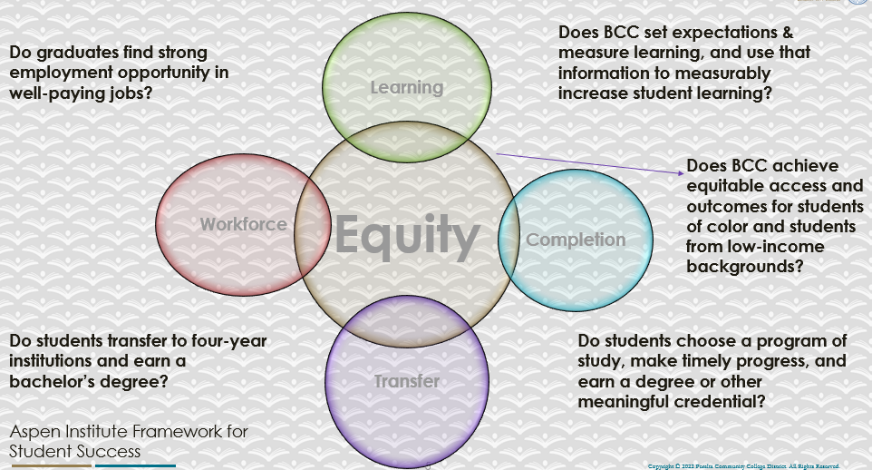

For assistance with data dashboards, contact Phoumy Sayavong at psayavong@peralta.edu
How are students doing in success and completion in your department, compared to the BCC overall success and completion rate? What are the group of students that need more attention to achieve goals?
Enrollment and productivity across ETHST + dropped year-to-year from 2020-2021 to 2021-2022. It should be noted that this coincided with the COVID 19 pandemic.
Enrollment went from 456 to 396 students, and productivity went from 15.2 to 13.3 during this time.

Curiously, when we aggregate the data by discipline, we find that students taking classes in African American Studies experienced the greatest drop in productivity, from 16.2 to 11.8, as the enrollment declined, from 162 to 118. Ethnic Studies, and Mexican and Latin American Studies enrollment and productivity also followed these trends, with enrollment going from 185 to 156 and 30 to 28, and productivity dropping from 15.4 to 13.0 and from 15.0 to 14.0, in ETHST and MLAT, respectively.
In contrast, students taking Asian American Studies increased, from 79 to 96, as the productivity also grew, from 13.2 to 16.0.

Overall, student completion at 68.6% and retention at 80.7% in ETHST + are slightly better than the
average completion of 68.0% and retention of 84.3% at Berkeley City College. We did examine completion and retention on a year by year basis across ethnic groups, across gender, and by age. As per college trends overall, the majority of our students fall into the 19-24 cohort, with the second largest number comprised of 16-18 year olds. While overall enrollment and the concomitant completion and retention rates trended downward. However, white students as a group increased their enrollment across the Ethnic Studies program, jumping from 35 to 56, yet their completion and retention rates both fell by a considerable percentage over the three years, from 66.7% and 84.8% completion and retention during the 2019-2020 academic year, to 45.6% and 60.7% in 2021-2022.

What do you see as key factors in your department that contributed to positive success and completion rate?
Current research (Dee & Penner, 2017) points to the importance of a culturally-relevant ethnic studies curriculum in supporting students, in particular students-of-color. As Berkeley City College is a majority ‘minority’ campus, it stands to reason that our students benefit from the coursework and instructors who reflect their experiences and communities.

See Dee, T. S., & Penner, E. K. (2017). The Causal Effects of Cultural Relevance: Evidence from an Ethnic Studies Curriculum. American Educational Research Journal, 54(1), 127–166. http://www.jstor.org/stable/44245373

What are some improvements your department can make? Identify strategies.
Culturally-relevant pedagogy and instruction is central to our mission and the work of equity across the institution. In supporting these program, department, and college goals we can continue to

- Develop and expand course offerings that reflect a culturally-relevant pedagogy and decenter whiteness, work that should not be limited to the program in Ethnic Studies

- Support hiring practices and policies to recruit part-time and full-time instructors grounded in intersectional, decolonial, and anti-racist approaches towards education, with an emphasis upon naming specific experiences, interests, areas of expertise and/or community involvement;

- Ensure that instructors are not perpetuating a hostile or harmful environment for students-of-color

3a. Enrollment Trend and Productivity Dashboard
*Note that completion and retention rates are presented with the inclusion and exclusion of excused withdrawals (EW) and military withdrawals.
What were the enrollment trends in your department in the past three years?
While enrollment dropped over the previous three academic years, from 434 in 2019-2020 to 398 students in 2021-2022, curiously enough enrollment bumped upward, slightly in 2020-2021, to 456. We hypothesize the year-to-year decrease reflects the limited and changing options i.e. lower number of classes offered in Ethnic Studies, with the uncertainty of returning to face-to-face instruction, in the context of the ongoing COVID 19 pandemic.

What strategies would you recommend to increase student enrollment in your department?
We recognize that our lower enrollments lead to a limited course selection, and less available sections within those offerings. For Ethnic Studies + to grow, it will require an expansion of classes across each area, with targeted recruitment efforts made with community partnerships (such as via Berkeley High). The CSU transfer requirement will undoubtably boost enrollment, as well as insuring that ETHST + classes are linked with BCC’s learning communities.

Community Colleges are funded based on the Student Centered Funding Formula (“SCFF”) which is comprised of the following allocations:

Student Centered Funding Formula: Focus and Priorities
% Of Allocation | Categories
70%  Base Allocation: FTES (Enrollment) | - Credit FTES  - NonCredit FTES  - Special Admits (Dual Enrollment, etc.)
20%  Supplemental Allocation | - Pell Grant  - AB 540  - Adult School  - Promise Grants
10%  Student Success Allocation | - Associate Degrees  - ADTs  - 9 or more CE units  - Transfer  - Transfer level Math and English in the first year

List the department’s progress and reflection on what is being done to maintain or increase the base level of full-time equivalent students (FTES = 12 units). Please describe retention (i.e., remain enrolled for a full semester) and persistence (i.e., enroll in consecutive semesters) efforts.
The program in Ethnic Studies emphasizes decolonial, intersectional, and relational approaches to the field, in our pedagogy, including course design and materials, as we view education as a means to our collective liberation. Our efforts towards retention and persistence stem from this perspective, as we seek to create a space welcoming and supportive of our students across their experiences and backgrounds. Instructors in ETHST + speak to the social and affective domain, i.e. creating a sense of community and supporting students’ interpersonal and emotional needs, as important to these goals.

Please describe your department’s efforts in identifying Pell Grant recipients, College Promise Grant recipients, Adult Education, and AB 540 students. What processes are in place to accurately report these students each semester?

College Outcomes | 2018-2019 | 2019-2020 | 2020-21 | 2021-22
Full Time Equivalent Students (FTES) | 4,161 | 3,931 | 3,622 | 3,259
Pell Grant Recipients | 2,387 | 2,281 | 2,181 | 1,826
College Promise Grant Recipients | 4,373 | 4,143 | 4,011 | 3,500
AB 540 Students | 74 | 51 | 22 | 69

3b. Course Completion and Retention Rates Dashboard – Instruction
*Note that completion and retention rates are presented with the inclusion and exclusion of excused withdrawals (EW) and military withdrawals.

If you need more guidance with this item, click here for additional support. Click here for additional guidance for how to view and use equity data. If you would like to view BCC’s Equity Plan, click here.
On page 3 of the “Course Completion and Retention Rates by Subject” dashboard, what are the completion and retention trends by gender, age, ethnicity in your department?
Course completion and retention across the previous three years rates reflect national trends in higher education. That is, overall, there is a pandemic-related decrease in numbers as well as completion and retention rates. Once aggregated, we find that students who identify as female outnumber and outperform those identified as male; those who are gender-nonconforming, identified as X, represent a small but steadily growing population of our students. Completion and retention rates across gender categories remain almost identical when compared year-to-year, 2021-2022 to 2020-2021.

Across age we find the majority of our students in the 19-24 cohort, followed by those in the 16-18 group as of 2021-2022. The 16-18 group appears to be the fastest growing category, as the 25-29 group surpassed their numbers in prior years. This trend is one we expect to continue, especially as dual enrollment continues to expand. However, we also feel it important to keep a place open for those students 25 and older, including the ‘lifelong learners’ who are not necessarily supported in current funding models.

When aggregated by race, the completion rates of white students dropped the most during the three year time span, in spite of their enrollment increasing.

When the data are disaggregated by student ethnic groups, gender, and age, how do you plan to
address them over the next year?
The 16-18 group is the fastest growing population enrolled in ETHST + classes, a trend we expect to continue going forward. We expect to support this progress through continuing existing partnerships, and developing new ones in the area of dual enrollment. At the same time, we recognize an underserved community of learners in the 25 and above category.

Male students, especially men-of-color, remain underrepresented in higher education at BCC as across the nation. This has substantial and long-term implications which are not solely the providence of BCC. However, again, this category represents an area of untapped potential for recruitment and opportunity. Too, while small in number, non-gender conforming students are a population that is increasing in number and will merit increased awareness and attention.

The 18-24 aged population of Black and Latinx Californians in college is disproportionately low; of those who do attend higher education, the majority are in community colleges. Our enrollment, retention, and completion rates, while respectable, do not reflect nor address the full potential of these populations. This appears to be the greatest sources of untapped potential in recruitment, retention, and completion.

What population(s) showed outcomes gains in your discipline(s) and which need more support?

Disaggregate the data and outcomes as far down as a possible then ask:
- What trends do you notice when examining course success rates for student populations by ethnicity? Which factors do you believe have the greatest impact (positive or negative) and cause variation between student course success rates in your Program? Describe some specific methods your department is planning or implementing to address these equity gaps. How will you evaluate the efficacy of these interventions?

- How has pivoting to online instruction contributed to potential reductions in student success? Provide some specific examples of practices that faculty in your department have found ineffective in the online environment.
Please review the video from the RP Group acknowledging the interrogation De Anza Community College committed to in their analysis of course completion and success rate.
In thinking of the COVID-era shift towards online instruction, students appear to stay away rather than attempt and risk an unsuccessful outcome. At the same time, an expansion of online options has led to greater opportunities and flexibility for students. For example, when offered in person, ETHST 2 struggled to make. While the shift to online happened to coincide with the total shutdown of in-person instruction, the increased enrollment has led to the course being offered online for alternating semesters since 2020.

That said, without other options (hybrid, in-person), all students who are enrolled in an online class do not necessarily do so voluntarily. Among the challenges around access the college has made strides in providing laptops and instructional onboarding (FAQs, how-tos). However, the online format has presented a challenge towards the communal and social aspects of the college experience—among the very things that serve the goals of retention and completion, by way of community-building. Too, the online format by design relies upon the textual and written word as a primary means of interaction, such as in an asynchronous class, or discussion and lecture via Zoom during synchronous meetings. Where the face-to-face modality allows for scaffolding and support, not to mention contextual clues in interpersonal interaction, these are difficult if not impossible to replicate even in the most efficient online setting.

How do these outcome trends in your department compare to the college average?
The program as a whole trends positively, when compared to the college average.

In thinking of the COVID-era shift towards online instruction, students appear to stay away rather than attempt and risk an unsuccessful outcome. At the same time, an expansion of online options has led to greater opportunities and flexibility for students. For example, when offered in person, ETHST 2 struggled to make. While the shift to online happened to coincide with the total shutdown of in-person instruction, the increased enrollment has led to the course being offered online for alternating semesters since 2020.

How will these outcome trends you identified in this section affect your department goals and plans for the next year and what are your strategies to shift to move the trend towards a positive direction?
One positive aspect of the shifting trends in lower enrollment has been smaller class sizes. This appears to have been a net positive, and could be part of a viable strategy towards continual improvement around completion and retention.

It is imperative that ETHST + offers sections across modalities, and that the modalities align with instructor abilities and expertise. Towards this end, the program has begun recruiting a range of potential instructors to complement our existing faculty members. At the present, should one of our PT AFRAM or ASAME instructors become unavailable (either in the case of an emergency, or, more likely, a scheduling conflict), we do not have an alternate who meets the discipline’s MQs.

Finally, aligning ETHST + courses with learning communities should offer mutual support towards these goals.

3c. Degrees and Certificates Dashboard
On page 1 of the “Degrees and Certificate Awards Trends” Dashboard, what are the award trends for your department (e.g., overall, by gender, age, and ethnicity)?
n/a

ETHST+ does not current offer a degree or certificate.

On page 4, what population(s) award trends showed gains in your program area and which populations need more support?

3d. Transfer Dashboard
This dashboard does not provide data by subject. Reflect on what you can do to affect student transfer. How may your department help to support BCC student transfer? (e.g., serve on panels, strengthen GP in your dept, change curriculum, increase number of AD-Ts, etc.)
Following recent legislative success in expanding Ethnic Studies across California, we have moved to update the majority of ETHST + courses in order to meet Area F transfer requirements. This will be an important step in support students interested in transferring.

3e. Curriculum based on Guided Pathways
View the department’s curriculum through the lens of student equity outcomes.
- What intentional effort is your department making to create and present clear pathways for students through curriculum?
ETHST+ curriculum remains limited, and concentrated around foundational (“Introduction to ___”) course offerings. Within this, we offer a focused and well-curated pathway for students to meet their transfer requirement. However, further expansion of the program and movement towards certificates and/or a degree will necessitate the growth of class offerings.

- What are your plans for revising and/or creating new pathways supported by labor market information (LMI) and student demands? Using Vision for Success and SCFF focus, please indicate rationale and how the plans directly support student success and equitable completion.
While students do not necessarily enter BCC with an interest in Ethnic Studies +, they tend to view the classes offered in our program positively, and report generally positive experiences. This suggests an opportunity to scale up in order to meet student demands (or interest), while at the same time incorporating curriculum that will support students on transfer and career paths.

4. Dual Enrollment
As continued decline in overall enrollment for college going population, it is important for us to look at who will be coming to BCC in the next 5 years. Reviewing the data provide here, what strategies would your department employ to address bringing more students to BCC?

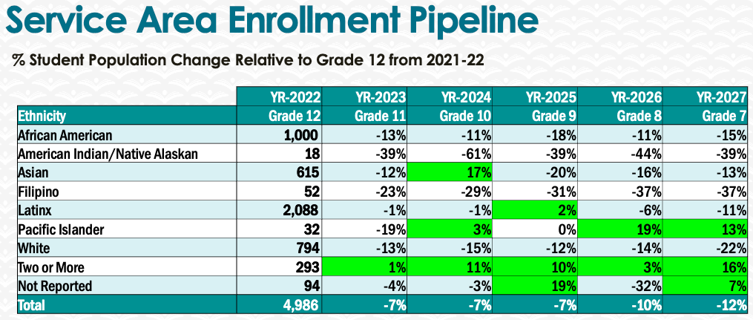
It is unclear if these trends are local, across the district, or statewide. What we do recognize, however, is the equity gap that exists between high school graduates and the population who enters college. As the vast majority of African American and Latinx college students attend community college, there appears room for growing and, as importantly, sustaining high school-to-college pipelines that are specifically focused upon these populations, while recognizing the myriad challenges and demands upon this group. Reduced or free tuition increases access, but does not pay the bills or cover the rent, especially in the SF Bay Area. Support above and beyond what is conventionally offered may help position college enrollment as a more attractive alternative to workforce entry.

5. Facility Utilization Needs

Assess your facilities utilization (including labs, support for online learning, and other spaces) and for next year, indicate if the space is sufficient or not. If not, what are the needs and why? Work with your Dean to check on your needs prior to responding this section.
Social science faculty members utilize the larger classrooms at 2050 Center St. (rooms 422-424) as well as several of the rooms located in the basement of main campus. Many classrooms in 2050 Center Street do not have usable whiteboard space if the projector/screen are also in use that impacts our delivery of instruction.

In keeping with a pedagogical praxis of inclusivity, ETHST+ courses emphasize classroom discussions. An ideal classroom would have the space and/or ability to be converted into a discussion ‘in the round,’ as well as allowing for multiple breakout groups.
In collaboration colleagues in Humanities offering film classes, we collectively need updated and wider film screening facilities (devoted library room with staffing) and technology (computers with DVD players, headphones) for our film studies courses. At the minimum we recommend a dedicated classroom for courses that rely/utilize media.

6. Assessment
Berkeley City College is committed to a culture of assessment to improve instruction, services, and institutional planning. Findings from SLO, PLO, ALO assessments, and program review data are used to direct resources for areas that are institutional priorities that are articulated in the Educational Master Plan and BCC Strategic Plan.

Due to the critical role that course and program assessments play in our institutional planning and to be in compliance with the Accreditation requirements, assessments must be completed to qualify for the APU resource allocation requests.
6a. What action plans did your department identify upon the assessment of each SLOs and/or PLOs? For courses with multiple sections in the program, please list the main action plans. Please be as detailed as possible.
ETHST 1 and ETHST 2 were last assessed in Spring 2020. MLAT 30A was assessed in Fall 2020. ASAME 11 was assessed in Fall 2021.
Assessment made based upon student responses to discussion prompts reflective of course materials, to provide in effect a pre- and post-test. Student demonstrated growth and improvement in all three SLO areas, in the context of the assessment. Assessment of SLO as initially planned involved pre-/post- group demonstration of competencies. Separating out descriptive and evaluative aspects of SLO may help provide more details.

6b. Describe the department’s progress on the Actions Plans identified for course Student Learning Outcomes (SLOs). If your department offers a degree or certificate, please describe the department’s progress on the Action Plans for Program Learning Outcomes (PLOs).
Action plans suggest revisiting criteria in the assessments, with a more focused set of measurements as tied to the SLOs. Following the revisions of the course outlines this will continue.

6c. Describe the status of SLO and PLO completion in Rounds 4 and 5 of the Assessment Cycle. Identify the percent of completion. Briefly describe what needs to be done to reach 100% completion. Identify issues or concerns that may prevent your department from completing assessments of SLOs and/or PLOs.
Assessments of ETHST 1, ETHST 2, MLAT 30A, and ASAME 11 were completed during the last cycle, and are scheduled for assessments starting Spring 2023.

6d. Besides your syllabi, where are the program level outcomes published? If on a website, please specify the URL.

7. Engagement
Discuss how faculty and classified staff have engaged in institutional efforts such as committees, presentations, and departmental activities. Please list the committees that full-time faculty participate in.
Ethnic Studies + faculty are engaged to the extent possible in departmental, campus, and district activities. The FT ES instructor serves as the Coordinator for the district’s Faculty Diversity Internship Program. Other service projects include
Participation as a faculty representative on the President’s Task Force on Equity & Racial Justice;
External member on the Tenure Review Committee in Art, and as part of the Communication search committee in the Humanities Department;
Scholarship reviewer, for BCC’s Dreamers’ scholarship and PCCD’s PACLA scholarship;
Presentations on diversity, equity, inclusion, and anti-racist hiring practices and policies, to BCC and District academic senates, as part of a working-group;
Facilitating a faculty reading seminar at BCC organized around race, coloniality, and abolition, as part of a Guided Pathways-sponsored initiative.
organizing, moderating, and/or speaking at events and programs, including documentary presentations, student-focused panel on careers in the community college, and a conversation around abolitionist pedagogies.
Discuss how faculty and staff have engaged in community activities, partnerships and/or collaborations.
Faculty involvement with the greater SF Bay Area community includes outreach and partnership development with area colleges, primarily through the FDIP Coordinator position, as well as more specific partnerships with area Ethnic Studies + programs to support instructional, staffing, and mentorship in the field.
Other areas of involvement include but are not limited to
serving as the external member on the dissertation advisory committee of Calvin Monroe, through the Kalamanovitz School of Education, St. Mary’s College. (Prior to receiving his doctorate, Dr. Monroe participated in FDIP and taught at BCC.)
sharing expertise in Ethnic Studies in support of K-12 level curriculum revisions with Art in Action, a Bay Area-based arts education program.
And presenting annually at the National Association for Chicana and Chicano Studies academic conference, as well as other academic and community-based forums.
Discuss how adjunct faculty members are included in departmental training, discussions, and decision-making.
Part-time faculty members are invited and encouraged to participate in department and program trainings, discussions, and their feedback is solicited to a reasonable extent possible. Part time faculty are supported as well in their career goals and pedagogical development.
- Discuss the relationship and engagement with other support services, programs, departments, or administrative units and how these relationships/collaboration support meeting your departmental goals.
- ETHST+ maintains active partnerships with the learning communities, academic counselors, and specific student resource centers. These relationships ensure that our communities of interest are aware of our offerings, enroll in our classes, and are supported throughout their educational experiences.
Are there areas you feel that your department can benefit more by increasing collaboration and partnership? How?
There is always room for improvement and expansion, and the program could certainly continue to benefit through increased, continual collaboration and partnerships. Furthermore, there are student populations who we do not directly recruit, through active partnerships, who nonetheless represent active members of our community.

8. Prioritized Resource Requests
During the 2021-22 Comprehensive Program Review process, you have provided your resource requests which went through the IPAR process. In this section, include resource requests from last year that are still needed and/or new resources that have emerged. Provide justifications. If there are no resource requested, leave the boxes blank.

Resource Category | Description/Justification | Estimated Cost
Personnel
Classified Staff
Student Worker
Part Time Faculty | Accessible Materials Officer – Assisting in creation/conversion of accessible materials for distance ed.
Professional Development
Department wide PD needed
Personal/Individual PD needed
Supplies
Software (for whom or role?)
Books, Magazines, and/or Periodicals
Instructional Supplies
Non-Instructional Supplies
Technology & Equipment
Description/Justification (Before you list your technology request, click here to view the latest Technology Refresh Plan to verify whether it has already included.)
New
Replacement
Facilities
Classrooms
Offices
Labs
Other
Library
Library materials (including streamline media needs)
Library collections
OER
Other
OTHER Description

Thank you for your time and effort in completing the Annual Program Update!
Please email the completed Program Review to your Dean by November 30, 2022

