Berkeley City College’s mission is to provide our diverse community with
educational opportunities, promote student success, and to transform lives.

Introduction and Directions

Berkeley City College (BCC), in conjunction with the Peralta community College District, has an institutional effectiveness process which consists of the following components: a District-wide Strategic Plan which is updated every six years; Comprehensive Program Reviews (CPRs) which are completed every three years; and Annual Program Updates (APUs) which are completed in non-program review years.

TIMELINE
Annual Program Update (APU) 2022-2023 timeline has been developed for each program and services to guide through the semester. Please review and work with your Deans, Managers, Department Chairs and/or Supervisors to complete this APU.

For BCC, 2022-2023 marks a critically important year as the college is in the process of revising its Educational Master Plan (EMP) for the next 5 years (2024-2028). This college EMP process will inform the District with their planning for their Strategic Plan. This year’s APU will take an especially important role for the EMP process, carrying your analysis, planning and strategies to support our students success, retention, and equitable completion.

The APU is intended to primarily focus upon planning for the subsequent year based on the institutional priorities. While developing the College’s EMP for the next 5 years, the college and the district focused on the Vision for Success identified by the California Community College Chancellor’s office as well as Student Centered Funding Formula (SCFF) that clearly delineate the categorized outcomes that the Colleges should be focusing. Please use these foci as your reference to prioritize your department and other goals.

RESOURCE REQUEST
In this process of making continuous quality improvement, there is an opportunity for each program, student services, and department to request resources that support achieving the stated goals. The APU process directly leads to the institutional resource allocation process and budget planning facilitated by the Institutional Planning and Allocation of Resources (IPAR) Committee for the following academic year (2023-24). The process for this can be found here (2022-23 APU Timeline). This is an opportunity for each department to request resources that will support your department goals and set outcomes.

TECHNOLOGY REQUEST
Finally, for the resource request section, please connect with your Deans, managers, and supervisors regarding your technology needs so that you can be informed about the equipment that is addressed in the BCC Technology Refresh Plan. If your requests are covered in the Refresh Plan, you do not need to request them in this APU.

If you have questions regarding other material in the Annual Program Update, please contact your Dean or Manager. If you have questions regarding data, please contact Dr. Phoumy Sayavong, Senior Researcher and Planning Analyst (psayavong@peralta.edu).

Please email the completed Annual Program Update to your Dean by November 30, 2022.

College Profile
Click here to view the Berkeley City College Student Demographics Dashboard.
This 2-page dashboard will provide data on the demographics of our student body from the past two years such as headcount, ethnicity, enrollment status, age group, educational goals, and majors.
College Outcomes | 2018-2019 | 2019-20 | 2020-21 | 2021-22
Full Time Equivalent Students (FTES) | 4,161 | 3,931 | 3,622 | 3,259
Productivity (Avg. Goal = 17.5) | 13 | 13.2 | 13 | 10.9
Success Rate (%) | 69% | 77% | 75%* | 70%*
Degrees + Certificates Awarded (#) | 948 | 1,109 | 1,027 | 960
*Excludes “EW” grades

To view prior Program Reviews, click here. To view prior Annual Program Updates, click here.

1a. Department Description
Please verify the mission statement for your department. If your department has not created a mission statement, provide details on how your department supports and contributes to the College’s mission.
The ESOL Program at Berkeley City College provides foundational skills in English for a diverse community, addressing the needs of international students, immigrants who have recently arrived in the Bay area, and multilingual students who have received some previous education in the U.S. The goal of the program is to prepare students for success in transfer and vocational courses and/or immediate employment advancement and meaningful participation in American life.

Name(s) of member(s) completing this APU | Department | Completion Date
Gabriel Winer  Sepi Hosseini | ESOL | November 30, 2022
List faculty names with assignments in fall 2022.
Full Time | Part Time
Laurie Brion  Gabriel Winer | Sepi Hosseini  Osa Kauffman  Jim Seger  Olga Lewis

1b. Department Priorities & Goals
Based on the Vision for Success and SCFF, and your department mission, what are your department’s priorities and goals for 2022-23?
Increase completion rates for Black and Latinx students.
Continue to recruit and support non-credit students from the community.
Work toward joining ESOL with Guided Pathways.
Expand course offerings of intermediate level classes.
Evaluate the appropriate balance of online and F2F offerings in light of our current student population needs.
Increase student self-advocacy and access to student services.

2. Student Equity, Success, & Completion
Using the data dashboards provided below, review and reflect upon the outcome trends for your department. Please also review overall BCC’s data linked here.

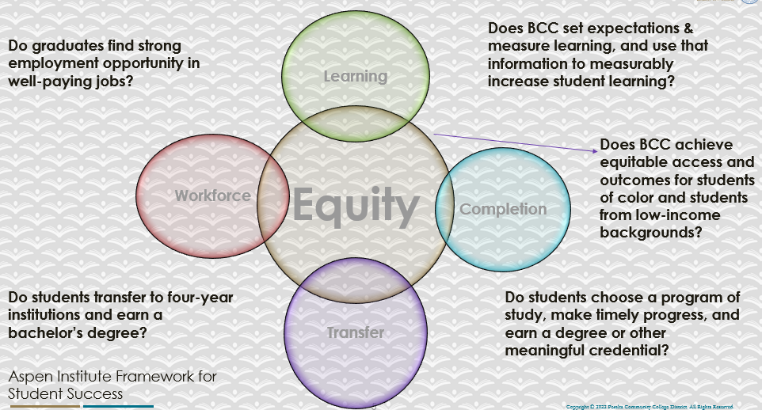

For assistance with data dashboards, contact Phoumy Sayavong at psayavong@peralta.edu
How are students doing in success and completion in your department, compared to the BCC overall success and completion rate? What are the group of students that need more attention to achieve goals?
While completion rates in the school as a whole have remained relatively stable since 2018, the ESOL completion rate has steadily dropped from 83.6% in 2018-2019 to 59.9% in 2021-2022.
As detailed in the 2022 Comprehensive Program Review, it’s crucial to disaggregate student data by residency in order to see a more accurate picture of which groups need more attention: international students achieve completion at higher rates than local students, presumably because of socioeconomic factors and/or because of their overall statistically higher level of previous postsecondary education. Local Latinx students are currently the group that needs the most support.
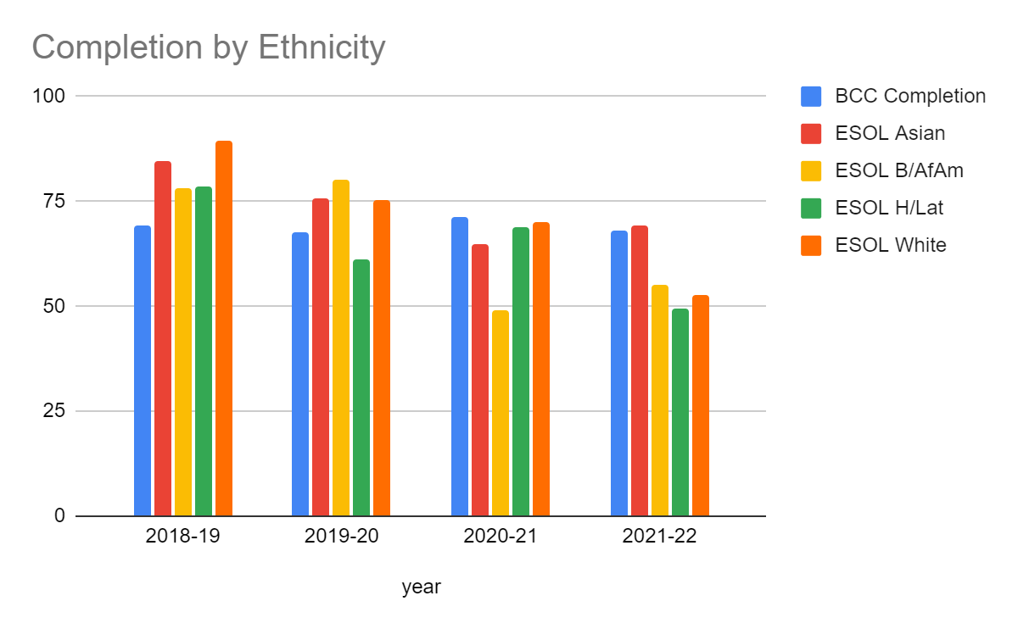
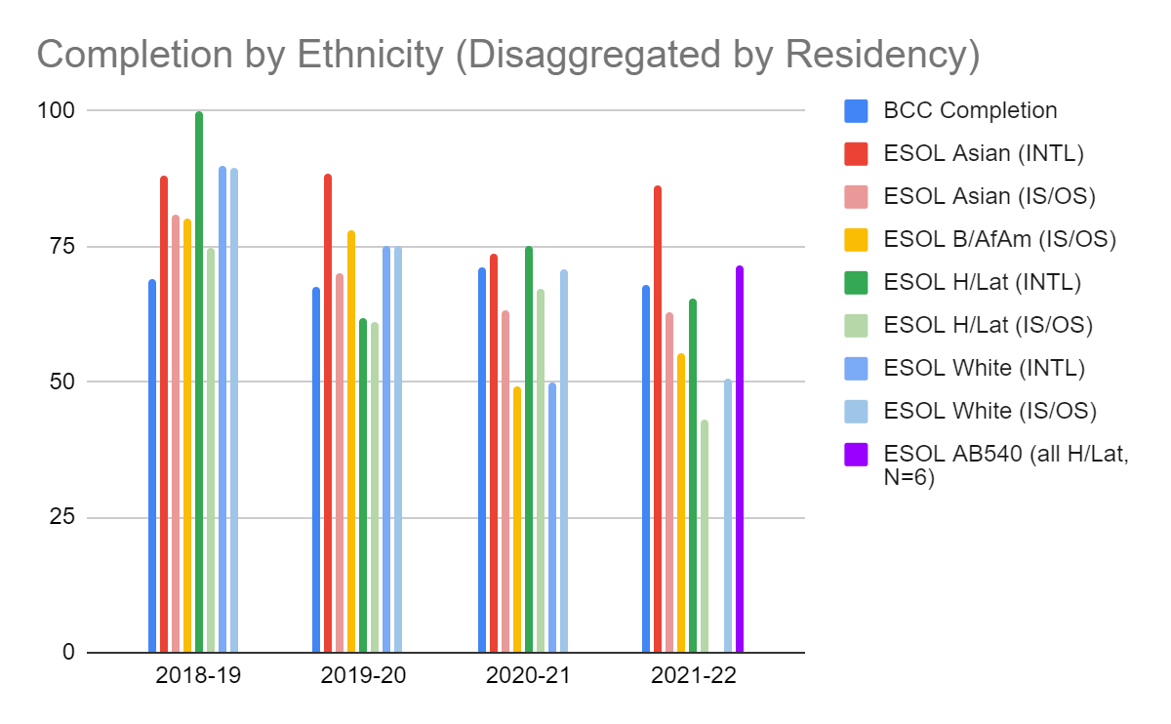

What do you see as key factors in your department that contributed to positive success and completion rate?
To the extent that students were succeeding, they were supported by faculty collaboration and a solid curriculum structure.
What are some improvements your department can make? Identify strategies.
One improvement our department can make is to offer more face-to-face classes, which we believe is the modality that most promotes student success. We attribute the decrease in the completion rate to the change in instructional modality as a result of the COVID-19 pandemic. Online technology is often not accessible to many members of the ESOL population.

Another potential improvement is to offer lower-level classes. Because of the current unavailability of lower-level classes at BCC, many students who test at a low level are placed in high-intermediate and advanced classes. Our theory is that this contributes to a lower completion rate.

3a. Enrollment Trend and Productivity Dashboard
*Note that completion and retention rates are presented with the inclusion and exclusion of excused withdrawals (EW) and military withdrawals.
What were the enrollment trends in your department in the past three years?
Enrollment dropped precipitously along with the college as a whole, but that trend reversed this fall, and our enrollment is much higher than previously.

What strategies would you recommend to increase student enrollment in your department?
Critical need #1: improve the BCC website and the accessibility of CCCApply.
Critical need #2: continue to streamline the placement/orientation process.

Community Colleges are funded based on the Student Centered Funding Formula (“SCFF”) which is comprised of the following allocations:

Student Centered Funding Formula: Focus and Priorities
% Of Allocation | Categories
70%  Base Allocation: FTES (Enrollment) | - Credit FTES  - NonCredit FTES  - Special Admits (Dual Enrollment, etc.)
20%  Supplemental Allocation | - Pell Grant  - AB 540  - Adult School  - Promise Grants
10%  Student Success Allocation | - Associate Degrees  - ADTs  - 9 or more CE units  - Transfer  - Transfer level Math and English in the first year

List the department’s progress and reflection on what is being done to maintain or increase the base level of full-time equivalent students (FTES = 12 units). Please describe retention (i.e., remain enrolled for a full semester) and persistence (i.e., enroll in consecutive semesters) efforts.
The department has engaged in significant efforts to streamline the intake process through Guided Self Placement and advising. We have also worked toward equitable standards-based grading practices, and have revised course outlines to remove hard prerequisites, thus removing barriers to both initial enrollment and persistence.

Please describe your department’s efforts in identifying Pell Grant recipients, College Promise Grant recipients, Adult Education, and AB 540 students. What processes are in place to accurately report these students each semester?

College Outcomes | 2018-2019 | 2019-2020 | 2020-21 | 2021-22
Full Time Equivalent Students (FTES) | 4,161 | 3,931 | 3,622 | 3,259
Pell Grant Recipients | 2,387 | 2,281 | 2,181 | 1,826
College Promise Grant Recipients | 4,373 | 4,143 | 4,011 | 3,500
AB 540 Students | 74 | 51 | 22 | 69

Although this is typically a college-level function rather than a department-level function, it’s very helpful when we receive information about overall numbers and disaggregated outcomes for these groups. We will continue to review the BI Tool Data Dashboards and consider at each juncture how we can contribute to equitable outcomes for these populations. Notably, the AB540 students were counted for the first time (see purple column in above chart of completion disaggregated by residency) in 2021-22. They achieved completion in ESOL classes at a rate higher than that of BCC students as a whole. There were only 6 individuals in this count, so it may not be statistically significant, but portends well.

3b. Course Completion and Retention Rates Dashboard – Instruction
*Note that completion and retention rates are presented with the inclusion and exclusion of excused withdrawals (EW) and military withdrawals.

If you need more guidance with this item, click here for additional support. Click here for additional guidance for how to view and use equity data. If you would like to view BCC’s Equity Plan, click here.
On page 3 of the “Course Completion and Retention Rates by Subject” dashboard, what are the completion and retention trends by gender, age, ethnicity in your department?
Gender: Women have a bit higher completion and retention rates than men. Women’s completion rate is 61.9%. Men’s completion rate is 52.8%/ Women’s retention rate is 90.5%. Men’s retention rate is 87.0%.
Age: Completion rates range from 55.7% to 66.7% with the highest completion rate among the youngest and the oldest age groups.
Ethnicity: Asian students have the highest completion rates (69.3%), while Hispanic/Latino students have the lowest completion and rates (49.3%). There is smaller range of retention rate with Asians at 94% and White at 87.2%.

When the data are disaggregated by student ethnic groups, gender, and age, how do you plan to address them over the next year?
Continue to learn about and implement evidence-based effective practices that are resulting in improved outcomes across the state, such as collaboration with student services, comprehensive advising, eliminating unnecessary prerequisites and other structural barriers.

What population(s) showed outcomes gains in your discipline(s) and which need more support?

Disaggregate the data and outcomes as far down as a possible then ask:
- What trends do you notice when examining course success rates for student populations by ethnicity? Which factors do you believe have the greatest impact (positive or negative) and cause variation between student course success rates in your Program? Describe some specific methods your department is planning or implementing to address these equity gaps. How will you evaluate the efficacy of these interventions?

- How has pivoting to online instruction contributed to potential reductions in student success? Provide some specific examples of practices that faculty in your department have found ineffective in the online environment.
Please review the video from the RP Group acknowledging the interrogation De Anza Community College committed to in their analysis of course completion and success rate.
While completion rates in the school as a whole have remained relatively stable since 2018, the ESOL completion rate has steadily dropped from 83.6% in 2018-2019 to 59.9% in 2021-2022.
As detailed in the 2022 Comprehensive Program Review, it’s crucial to disaggregate student data by residency in order to see a more accurate picture of which groups need more attention: international students achieve completion at higher rates than local students, presumably because of socioeconomic factors and/or because of their overall statistically higher level of previous postsecondary education. Local Latinx students are currently the group that needs the most support.

How do these outcome trends in your department compare to the college average?
Before the pandemic, ESOL students of every ethnicity group had better outcomes than the college average. More recently it has varied, with international Asian students still exceeding the overall rate, but local Latinx students completing at the lowest levels.

How will these outcome trends you identified in this section affect your department goals and plans for the next year and what are your strategies to shift to move the trend towards a positive direction?
Continue to learn about and implement evidence-based effective practices that are resulting in improved outcomes across the state, such as collaboration with student services, comprehensive advising, eliminating unnecessary prerequisites and other structural barriers.

3c. Degrees and Certificates Dashboard
On page 1 of the “Degrees and Certificate Awards Trends” Dashboard, what are the award trends for your department (e.g., overall, by gender, age, and ethnicity)?
Over time the overall number of degrees and certificates awarded has steadily decreased from 57 in 2017-2018 to 12 in 2021-2022. This is likely due to the overall decrease in enrollment as well as the reduction in contact during COVID with counselors and other faculty who normally inform and support students in obtaining certificates.
Gender: In 2017-2018, certificates awarded were split equally between men and women. In following years, women have made of majority of awardees ranging from 68% to 92%.
Age: No significant trends were identified based on age.
Race: No significant trends were identified based on race.
*Note: One would have to take these trends as a percentage of overall enrollment demographics in the ESOL department to identify inequities based on gender, age or race.
On page 4, what population(s) award trends showed gains in your program area and which populations need more support?
(Can’t filter to just ESOL. Filtered by Liberal Studies & Language Arts Division)
DSPS showed gains from 22.73% in 2019-2020 to 40.91% in 2021-2022.
Adult ed dropped from 80% to 20%, which could indicate a greater need for support.
Low-income: 2019-2020 --> 30%, 2020-2021 --> 39%, 2021-2022 --> 32 would also benefit from support.

3d. Transfer Dashboard
This dashboard does not provide data by subject. Reflect on what you can do to affect student transfer. How may your department help to support BCC student transfer? (e.g., serve on panels, strengthen GP in your dept, change curriculum, increase number of AD-Ts, etc.)
Developing Guided Pathways certificate programs and associated OER materials

3e. Curriculum based on Guided Pathways
View the department’s curriculum through the lens of student equity outcomes.
- What intentional effort is your department making to create and present clear pathways for students through curriculum?
Developing Guided Pathways certificate programs and associated OER materials

- What are your plans for revising and/or creating new pathways supported by labor market information (LMI) and student demands? Using Vision for Success and SCFF focus, please indicate rationale and how the plans directly support student success and equitable completion.
Developing Guided Pathways certificate programs and associated OER materials
An emergent strategy strongly promoted by research and policy groups is creating certificate programs combining advanced ESOL with high-impact GE courses that fulfill requirements for multiple degrees. A frequently showcased example of this is Cypress College's guided pathways ESL certificate programs. At the RP Group’s Strengthening Student Success Conference, Cypress College described their exemplary work in AB 705 And ESL: Opportunities into and beyond the Goal of Transfer-Level Composition. Laney College has also developed a set of interdisciplinary certificates. They align with Guided Pathways Principles, AB 705 goals, the Student Centered Funding Formula, and state and national research.

4. Dual Enrollment
As continued decline in overall enrollment for college-going population, it is important for us to look at who will be coming to BCC in the next 5 years. Reviewing the data provided here, what strategies would your department employ to address bringing more students to BCC?

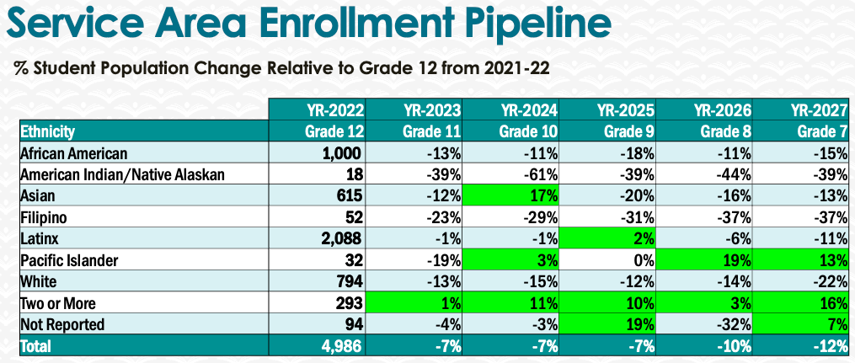
In order to increase high school dual enrollment with the college, we should encourage partnerships with local high schools by maintaining relationships with high school counselors and administrators and doing classroom outreach. High school students should also be encouraged to take summer classes at Berkeley City College.

5. Facility Utilization Needs

Assess your facilities utilization (including labs, support for online learning, and other spaces) and for next year, indicate if the space is sufficient or not. If not, what are the needs and why? Work with your dean to check on your needs prior to responding to this section.
Use of the Modern Language classroom (212) has been greatly beneficial for instruction, as the room allows students to move around, change desk configurations, and collaborate comfortably and effectively.
The only problem is that the computer is attached to the wall, forcing the instructor to teach from a far corner, facing away from their students. Joe Bay has set up a temporary solution with a laptop on a cart, but it will be removed next semester. An articulated arm would solve this problem.

6. Assessment
Berkeley City College is committed to a culture of assessment to improve instruction, services, and institutional planning. Findings from SLO, PLO, ALO assessments, and program review data are used to direct resources for areas that are institutional priorities that are articulated in the Educational Master Plan and BCC Strategic Plan.

Due to the critical role that course and program assessments play in our institutional planning and to be in compliance with the Accreditation requirements, assessments must be completed to qualify for the APU resource allocation requests.
6a. What action plans did your department identify upon the assessment of each SLOs and/or PLOs? For courses with multiple sections in the program, please list the main action plans. Please be as detailed as possible.
READING AND WRITING COURSES, ROUND 4:

Clarity and Style and Mechanics and Usage.
- Provide instruction in most frequent mechanical errors. Teach proofreading skills so students can find and correct errors in writing.
- While grammar is not a main focus of the course, instructors may provide general mechanical error feedback so that the student is aware of their trouble spots.
- Recommend grammar course for students whose grammar significantly impacts comprehensibility of writing.
Multiple Perspectives
- Build rationale with students for addressing multiple perspectives. Discuss how it strengthens writing and makes it more persuasive.
- Share rubric with students. Review multiple perspectives requirement.
- Analyze models of successful and unsuccessful examples multiple perspectives in writing.
- Guided activity in identifying and responding to an opposing perspective.

Reading Comprehension
- Emphasize strategies to mitigate language vocabulary and structure weaknesses, such as pre-reading, and guessing vocabulary from context.

READING AND WRITING COURSES ROUND 5

Increase student collaboration and/or peer review:
- Scaffold essay assignments by introducing them as a partner/group activity
- Continue in-person and online peer review
Increase guidance for students as they work on assignments: Have students write the in-class essays in class
Provide models of strong student work:
- Provide more models of summary-response essays for analysis
- Move the mock scoring session earlier in the semester so students have a clearer vision of successful research papers
Revise activities leading up to and/or supporting assignment/activities
- Formatting
  - Review rubric
  - Analyze examples
  - Error correction exercises
  - Peer review
  - Include instructional materials online (videos, examples, quizzes, etc.)
- Reading comprehension: Emphasize reading strategies such as pre-reading, guessing vocabulary from context, identifying point of view, tone, purpose, major vs. minor details etc.
- Incorporate student services, e.g.:
  - Guest speakers (e.g. counselors)
  - Use Canvas to highlight/link to services
  - Contact assignments: students explore and report on campus resources
  - Announcements

LISTENING AND SPEAKING COURSES, ROUND 4:

- Continue teaching active listening and the basic practices of conflict resolution. Students seemed to engage more with each other because they had the pragmatic tools and meaningful reason to do so.
- Share this rubric with students at the beginning of the class and ask students to pay attention to a particular area when they are working in small groups. I will also develop an assessment using a conversation about a course theme and ask students to consider ways that they would apply the active listening which we do in service of mediation to active listening and turn taking in a conversation about a theme/listening activity.
- Introduce and spend more time practicing question formation and intonation, past tense ed, and review some of the different tense forms, especially as they relate to the kinds of story telling that they will be doing. This isn’t a grammar class, but to the extent that I can highlight different grammar forms that may be common to certain kinds of pragmatic features, this could be helpful.
- Choose a few additional themes to cover during the semester: climate change, social media, resilience, stereotype threat and pull out target vocabulary. In general, I need to develop additional materials or a system to learn, remember, practice vocabulary, so it is not so random. Identify target vocabulary from the mediation materials--(especially related to needs and emotions)
- SLO1: Reinforce target vocabulary through additional practice (quizzes, and other in-class and online exercises). Include more practice in the areas listed in the pronunciation section of the rubric (phonemes, word and phrasal stress, reductions, intonation, pacing, cadence and linking).
- SLO2 and SLO3: Develop materials/ exercises for pragmatics practice, particularly in the areas of “backchanneling”, follow-up questions, following a thread for an extended period and asking comprehension questions for misunderstandings.
- Share our ESOL Listening/Speaking rubric with students.
- Develop materials/exercises for pragmatics practice, particularly in the areas of “backchanneling”, follow-up questions and verbal acknowledgement of partner’s ideas.
- Develop materials for final past tense -ed pronunciation.
- Reinforce target vocabulary through additional practice (quizzes, and other in-class and online exercises).
- Include more practice in the areas listed in the pronunciation section of the rubric (phonemes, word and phrasal stress, reductions, intonation, pacing, cadene and linking).

GRAMMAR COURSES, ROUND 4:

- Provide more opportunities for students to practice freewriting using the grammar studied in class
- Develop a universal rubric covering the listed areas
- Revamp the regularly used textbook and adopt the new OER
- Expose students to correct examples of correct writing
- Explore OER resources as an alternative source of materials and grammar topics.
- Develop materials/exercises that target the Past Perfect and how this tense relates to other verb tenses.
- Develop materials/exercises in which Past perfect and the Past perfect progressive are used in various contexts and situations in order to clarify when each tense is used.
- Include more practice with various verb tenses when using the Active/Passive voice. In general, students understand the concept of active/passive voice. However, the challenge is using the correct grammatical form in different verb tenses.
- Reinforce all grammar topics taught in this course though other activities such as creating dialogues for students to practice speaking with other classmates, quizzes, writing exercises, and other online activities.

6b. Describe the department’s progress on the Actions Plans identified for course Student Learning Outcomes (SLOs). If your department offers a degree or certificate, please describe the department’s progress on the Action Plans for Program Learning Outcomes (PLOs).
Based on the round 4 SLO assessments action plans at the department level, the department has revised SLOs for listening and speaking. Whereas, in round 4 there were three SLOs, we have eliminated redundancy and reduced the number of SLOs to two.
Action plans for Program Learning Outcomes are in progress.

6c. Describe the status of SLO and PLO completion in Rounds 4 and 5 of the Assessment Cycle. Identify the percent of completion. Briefly describe what needs to be done to reach 100% completion. Identify issues or concerns that may prevent your department from completing assessments of SLOs and/or PLOs.
- Round 4: 100% completion of assessment of SLOs
- Round 5: In progress. 100% completion of assessment of reading and writing SLOs. Other subject areas are scheduled to be assessed over this and future semesters.
6d. Besides your syllabi, where are the program level outcomes published? If on a website, please specify the URL.
https://www.berkeleycitycollege.edu/esl/ (See left tab “Program and Course Student Learning Outcomes” --> https://docs.google.com/document/d/1FtfoKTQ62AhLseIGajoarwW3tD4n15fEt_rE3X_wxSI/edit?usp=sharing)

7. Engagement
1. Discuss how faculty and classified staff have engaged in institutional efforts such as committees, presentations, and departmental activities. Please list the committees that full-time faculty participate in.
ESOL instructors continued to collaborate to improve our ability to foster student success. We also continued to share materials, participate in collaborative assessment, and work on various continuing department projects such as building a districtwide Guided Self Placement tool and revising course outlines.
Full-time faculty serve on Department Chairs Council, Peralta ESOL Advisory Committee, Tenure Review Facilitator, Guided Self-Placement Task Force, serve as scholarship readers, and are working on a book for the ASCCC OERI. Adjunct faculty participate in inquiry groups, serve as liaison to Assessment Committee, and share materials as partners in collaboration. As part of the process of developing ESOL Guided Pathways certificates of achievement, ESOL faculty have worked with lead faculty from disciplines across the school and counselors to identify appropriate courses to include.

2. Discuss how faculty and staff have engaged in community activities, partnerships and/or collaborations.
ESOL faculty have worked with outreach/liaisons to Berkeley Adult School, Berkeley High School, and Berkeley Technical High School.
3. Discuss how adjunct faculty members are included in departmental training, discussions, and decision-making.
Adjunct faculty participate fully in collaborative assessments, inquiry, and planning.
- Discuss the relationship and engagement with other support services, programs, departments, or administrative units and how these relationships/collaboration support meeting your departmental goals.
The ESOL department works closely with the International Office, the Undocumented Community Resource Center, counseling, Transitions Liaison, the Learning Resources Center, and the Teaching and Learning Center.
5. Are there areas you feel that your department can benefit more by increasing collaboration and partnership? How?
Inquiry groups and other communities of practice, particularly among faculty teaching different sections of the same class. As Guided Pathways develops, it will be crucial for all disciplines to collaborate. Assessment could be more meaningful and effective if it were done collectively. All these activities should be a priority for the college to fund.

8. Prioritized Resource Requests
During the 2021-22 Comprehensive Program Review process, you have provided your resource requests which went through the IPAR process. In this section, include resource requests from last year that are still needed and/or new resources that have emerged. Provide justifications. If there are no resource requested, leave the boxes blank.

Resource Category | Description/Justification | Estimated Cost
Personnel
Classified Staff
Student Worker
Part Time Faculty | In order to add the long-sought level 2 classes, which should be ready to offer in Fall 2023, we will need additional FTEF. The new courses are  - 252/512 Reading & Writing 2 (6 units/ 0.4 FTEF)  - 262/562 Listening & Speaking 2 (4 units/ 0.3 FTEF)  - 272/572 Grammar 2 (4 units/ 0.3 FTEF)  We are down to the absolute minimum of our level 3 and 4 classes, so it is not an option to cancel those in order to provide sections of level 2. Here are some possible options for adding level 2:  - Add one section of 252/552 (6 units/ 0.4 FTEF)  - Add one each of 252 to day and evening (12 units/ 0.8 FTEF)  - Add one 252/512 and one 262/562 (10 units/ 0.7 FTEF)  - Add one of each: 252/512, 262/562, and 272/572 (14 units, 1.0 FTEF
Professional Development
Department wide PD needed | Collaboration, develop materials, mentor new teachers
Personal/Individual PD needed | conferences
Supplies
Software (for whom or role?)
Books, Magazines, and/or Periodicals
Instructional Supplies
Non-Instructional Supplies
Technology & Equipment
Description/Justification (Before you list your technology request, click here to view the latest Technology Refresh Plan to verify whether it has already included.)
New | Articulated arm for computer
Replacement
Facilities
Classrooms
Offices
Labs
Other
Library
Library materials (including streamline media needs)
Library collections
OER
Other
OTHER Description

Thank you for your time and effort in completing the Annual Program Update!
Please email the completed Program Review to your Dean by November 30, 2022

