Berkeley City College’s mission is to provide our diverse community with
educational opportunities, promote student success, and to transform lives.

Introduction and Directions

Berkeley City College (BCC), in conjunction with the Peralta Community College District, has an institutional effectiveness process, which consists of the following components: a District-wide Strategic Plan which is updated every six years; Comprehensive Program Reviews (CPRs) which are completed every three years; and Annual Program Updates (APUs) which are completed in non-program review years.

TIMELINE
Annual Program Update (APU) 2022-2023 timeline has been developed for each program and services to guide through the semester. Please review and work with your Deans, Managers, Department Chairs and/or Supervisors to complete this APU.

For BCC, 2022-2023 marks a critically important year as the college is in the process of revising its Educational Master Plan (EMP) for the next 5 years (2024-2028). This college EMP process will inform the District with their planning for their Strategic Plan. This year’s APU will take an especially important role for the EMP process, carrying your analysis, planning and strategies to support our students success, retention, and equitable completion.

The APU is intended to primarily focus upon planning for the subsequent year based on the institutional priorities. While developing the College’s EMP for the next 5 years, the college and the district focused on the Vision for Success identified by the California Community College Chancellor’s office as well as Student Centered Funding Formula (SCFF) that clearly delineate the categorized outcomes that the Colleges should be focusing. Please use these foci as your reference to prioritize your department and other goals.

RESOURCE REQUEST
In this process of making continuous quality improvement, there is an opportunity for each program, student services, and department to request resources that support achieving the stated goals. The APU process directly leads to the institutional resource allocation process and budget planning facilitated by the Institutional Planning and Allocation of Resources (IPAR) Committee for the following academic year (2023-24). The process for this can be found here (2022-23 APU Timeline). This is an opportunity for each department to request resources that will support your department goals and set outcomes.

TECHNOLOGY REQUEST
Finally, for the resource request section, please connect with your Deans, managers, and supervisors regarding your technology needs so that you can be informed about the equipment that is addressed in the BCC Technology Refresh Plan. If your requests are covered in the Refresh Plan, you do not need to request them in this APU.

If you have questions regarding other material in the Annual Program Update, please contact your Dean or Manager. If you have questions regarding data, please contact Dr. Phoumy Sayavong, Senior Researcher and Planning Analyst (psayavong@peralta.edu).

Please email the completed Annual Program Update to your Dean by November 30, 2022.

College Profile
Click here to view the Berkeley City College Student Demographics Dashboard.
This 2-page dashboard will provide data on the demographics of our student body from the past two years such as headcount, ethnicity, enrollment status, age group, educational goals, and majors.

College Outcomes | 2018-2019 | 2019-20 | 2020-21 | 2021-22
Full Time Equivalent Students (FTES) | 4,161 | 3,931 | 3,622 | 3,259
Productivity (Avg. Goal = 17.5) | 13 | 13.2 | 13 | 10.9
Success Rate (%) | 69% | 77% | 75%* | 70%*
Degrees + Certificates Awarded (#) | 948 | 1,109 | 1,027 | 960
*Excludes “EW” grades

To view prior Program Reviews, click here. To view prior Annual Program Updates, click here.

1a. Department Description
Please verify the mission statement for your department. If your department has not created a mission statement, provide details on how your department supports and contributes to the College’s mission.
The Education Teacher Preparation Program’s mission is to create exceptional teachers. We collaborate to promote, advance, and sustain a quality teacher education program. We are committed to increasing the number of students from diverse backgrounds and facilitating their success by providing high quality academic training along with academic support, integrated with multiple early field experiences and early employment. The Education Teacher Preparation Program faculty are committed to the following:
- recruiting a diverse population of students who are interested in teaching and transforming these students into exceptional teachers
- providing support for students to enter a career, teaching in either early childhood education, transitional kindergarten, K-12 classrooms, two- or four-year colleges, or career education (CE) programs and helping students find the educational and career pathways appropriate to their individual interests
- providing the mentoring, tutoring, and other resources to ensure students’ success in attaining the permits, certificates, degrees, and/or teaching credentials they need to enter or increase their position in a career in education
- providing exceptional training, giving future teachers the skills and values to work with a diverse student body, including students who have special needs or who are English language learners.

Name(s) of member(s) completing this APU | Department | Completion Date
Joya L. Chavarin, Ed.D., Jorge Wahner | Education Teacher Preparation Program | November 30, 2022
List faculty names with assignments in fall 2022.
Full Time | Part Time
There are no full-time faculty in this program. A 0.5 FTEF Education full-time faculty member is listed in error. The referenced person is contractually a 100% full-time faculty member in the English Department | Tracey Black, Ed.D.  Iris Bradford, M.Ed.  Joya Chavarin, Ed.D.  Michelle Espino, M.Ed  Tasha Henneman, Ed.D.  Bianca Lorenz, M.Ed.  Velma Robinson, M.Ed.  Jorge Wahner, M.Ed.

1b. Department Priorities & Goals
Based on the Vision for Success and SCFF, and your department mission, what are your department’s priorities and goals for 2022-23?
The Education Program department’s priorities and goals for 2022-23 is to increase student success and decrease the achievement gap in alignment with our program mission, Vision for Success, SCFF, as well as BCC’s Guided Pathways and Equity Agenda by:
- Increasing the number of students that acquire program certificates, degrees, and industry recognized certifications for an in-demand job. This increase is necessary to meet local, regional, and statewide workforce demands, as analyzed by the Centers of Excellence LMI data
- Increasing the number of program students transferring annually to CSU and UC
- Increasing academic embedded supports to ensure program certificates and degrees are achieved in 60-units so that more students reach their educational goals sooner and at less cost to them.
- Increasing the number of program students employed by BCC’s Youth Apprenticeship, Early Educator Apprenticeship, and Expanded Learning Apprenticeship industry partnerships. The Apprenticeship Programs ensure Education Program students are employed in their field of study with embedded supports and guaranteed wage increases at each completion point (i.e., certificates, AA, BA).

2. Student Equity, Success, & Completion
Using the data dashboards provided below, review and reflect upon the outcome trends for your department. Please also review overall BCC’s data linked here.

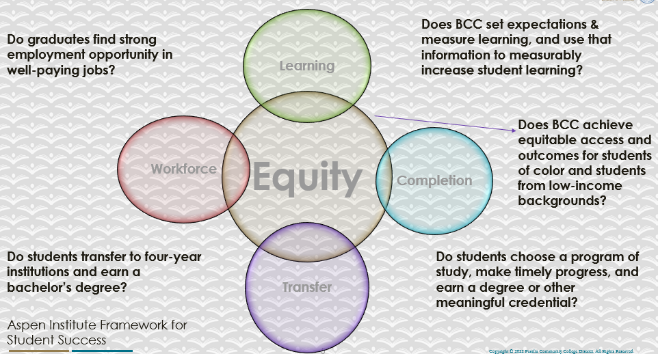

For assistance with data dashboards, contact Phoumy Sayavong at psayavong@peralta.edu
How are students doing in success and completion in your department, compared to the BCC overall success and completion rate? What are the group of students that need more attention to achieve goals?
The students in the Education program have a higher success and completion rate compared to the BCC’s overall success and completion rate (e.g., 76% vs. 70%). Although higher success than BCC’s overall rate, Black/African American group of students need more attention to achieve goals.
What do you see as key factors in your department that contributed to positive success and completion rate?
Key factors that contributed to positive success and completion rates is the opportunity for the Education Program faculty to participate in a Community of Practice (CoP) funded by Strong Workforce Program (SWP) funds. Each faculty member who participated received an individual data snapshot of their overall course success and completion rate. Faculty were able to reflect on their own positive success and completion rate (as well as areas of improvement) within the context of overall program data and BCC’s rates.
What are some improvements your department can make? Identify strategies.
Identifying that the majority of the Education Program classes are online, improvements are needed to ensure course access and content accessibility. Professional development training in Peer Online Course Review (POCR) and Peralta’s Online Equity Tool are recommended next step strategies.

3a. Enrollment Trend and Productivity Dashboard
*Note that completion and retention rates are presented with the inclusion and exclusion of excused withdrawals (EW) and military withdrawals.
What were the enrollment trends in your department in the past three years?
While enrollment for BCC, as a whole, was reduced by 20.53% from 2017-18 to 2020-21, the enrollment in the Education Teacher Preparation Program increased 64% from 2017-18 to 2020-21 and is one of the fastest growing programs at Berkeley City College:

BCC College Outcomes | 2018-2019 | 2019-2020 | 2020-21 | 2021-2022
Full Time Equivalent Students (FTES) | 3,864 | 3,696 | 3,290 | 2398
Efficiency | 13 | 13.2 | 14.3 | 11.89
(Productivity; avg faculty-student ratio)

EDUC/CHDEV Enrollment Outcomes | 2018-2019 | 2019-2020 | 2020-21 | 2021-2022
Full Time Equivalent Students (FTES) | 196 | 213 | 289 | 294
Efficiency | 14.10 | 13.56 | 13.38 | 13.0
(Productivity; avg faculty-student ratio)

Productivity rates did not increase or decrease in a statistically significant way. Productivity/average faculty-student ratio decreased when class sizes decreased due to the COVID-19 Pandemic in 2020.
What strategies would you recommend to increase student enrollment in your department?
We recommend the following to increase student enrollment in the Education Program:
- Engage in pre-enrollment activities, including marketing, recruitment, and participation in campus high-yield events (i.e., express registration days, etc.); initial enrollment activities, including program counseling, orientation and registration supports; continued enrollment, including instruction, success supports, student services, and financial aid; and post enrollment activities, including transition/transfer supports, alumni engagement, and lifelong learning
- Stay abreast in research, current trends and practices to ensure program alignment with market demand, instructional delivery modalities and students’ expressed preferences, learning styles
- Ensure the quality of teaching and learning, including curriculum relevance and continued alignment with student goals
- Engage in professional development to consistently improve pedagogy to foster student learning and provide experiential learning opportunities utilizing required course materials
- Participate in program promotion through word-of-mouth, student and alumni success stories, learner outcomes, and as program faculty content experts
- Recruit through prospective student connections and relationships, participation in enrollment and outreach campus events, creation of test-drive opportunities (i.e., summer bridge, iDecide, dual enrollment), and outreach database of post-admit contacts and re-recruit stop-outs
- Prioritize student success by personalizing the experience through early academic feedback, knowledge of student services and supports, and frequent faculty/student interactions, especially in online courses, and assessing equity and other data in order to shift pedagogy to improve student success
- Increase the assurance of a welcoming and inclusive classroom environment, fostering academic and social integration, timely turnaround (i.e., rosters, grades, assessments), effective/holistic advising, academic mentoring, and career and advanced education coaching
Community Colleges are funded based on the Student Centered Funding Formula (“SCFF”) which is comprised of the following allocations:

Student Centered Funding Formula: Focus and Priorities
% Of Allocation | Categories
70%  Base Allocation: FTES (Enrollment) | - Credit FTES  - NonCredit FTES  - Special Admits (Dual Enrollment, etc.)
20%  Supplemental Allocation | - Pell Grant  - AB 540  - Adult School  - Promise Grants
10%  Student Success Allocation | - Associate Degrees  - ADTs  - 9 or more CE units  - Transfer  - Transfer level Math and English in the first year

List the department’s progress and reflection on what is being done to maintain or increase the base level of full-time equivalent students (FTES = 12 units). Please describe retention (i.e., remain enrolled for a full semester) and persistence (i.e., enroll in consecutive semesters) efforts.
The CHDEV/EDUC retention rate is 90.3%. Faculty work hard to encourage students to enroll in the consecutive semester. Program coordinator(s) present on what courses are being offered and when to check in with a BCC counselor, including overview of BCC student support services that is also embedded into course Canvas shells.

Please describe your department’s efforts in identifying Pell Grant recipients, College Promise Grant recipients, Adult Education, and AB 540 students. What processes are in place to accurately report these students each semester?

College Outcomes | 2018-2019 | 2019-2020 | 2020-21 | 2021-22
Full Time Equivalent Students (FTES) | 4,161 | 3,931 | 3,622 | 3,259
Pell Grant Recipients | 2,387 | 2,281 | 2,181 | 1,826
College Promise Grant Recipients | 4,373 | 4,143 | 4,011 | 3,500
AB 540 Students | 74 | 51 | 22 | 69

Our Apprentice enrolled students are Head Start and CalWORKs parents who qualify for the Pell grant. I am not sure how to ensure accurate reporting of referenced students besides recommending that ALL enrolled program students apply for the FAFSA and select Berkeley City College to receive their information. If there is something more our program can do to ensure accurate reporting of these students each semester, please advise and we will update processes accordingly.

3b. Course Completion and Retention Rates Dashboard – Instruction
*Note that completion and retention rates are presented with the inclusion and exclusion of excused withdrawals (EW) and military withdrawals.

If you need more guidance with this item, click here for additional support. Click here for additional guidance for how to view and use equity data. If you would like to view BCC’s Equity Plan, click here.
On page 3 of the “Course Completion and Retention Rates by Subject” dashboard, what are the completion and retention trends by gender, age, ethnicity in your department?
In terms of gender, the completion and retention rates for students in BCC EDUC/CHDEV classes were similar for females, males and others (completion 76.5%, 77.0%, 85.1% respectively, and retention 86.5%, 88.1%, 87.2%).

Students were retained in all age groups at rates between 88.9% and 93.3%. Completion rates varied by age distribution, with the highest rate for students under 16 (88.4%), those 65 and above (80.7%) and those 16-18 (78.6%). Students who fared the worst were those in the largest groups, 19-24 year olds (71.5%) and 25-29 (72.2%); since between them, these groups comprise approximately of the overall population, this is noteworthy.

Retention rates disaggregated by ethnicity were as follows:
Retention | 2019-2020 |  | 2020-2021 |  | 2021-2022
Am Indian | NR |  | NR |  | NR
Asian | 94.4% |  | 94.1% |  | 93.8%
Black/ African American | 80.3% |  | 87.9% |  | 87.5%
Hispanic/ Latino | 84.0% |  | 81.2% |  | 84.8%
Pacific Islander | NR |  | NR |  | NR
2 or more | 81.8% |  | 73.3% |  | 93.9%
unknown | NR |  | 90.0% |  | 100%
Completion rates disaggregated by retention were as follows:
Completion | 2019-2020 |  | 2020-2021 |  | 2021-2022
Am Indian | NR |  | NR |  | NR
Asian | 94.4% |  | 94.4% |  | 75%
Black/ African American | 80.3% |  | 72.4% |  | 63.8%
Hispanic/ Latino | 80.0% |  | 70.3% |  | 76.8%
Pacific Islander | NR |  | NR |  | NR
2 or more | 81.8% |  | 66.7% |  | 72.7%
unknown | NR |  | 70.0% |  | 100%
white | 89.7% |  | 81.9% |  | 86.3%
Retention rates increased in three ethnic groups and decreased in two between 2021-22. Completion rates increased in four ethnic groups and decreased in two during that period.
When the data are disaggregated by student ethnic groups, gender, and age, how do you plan to address them over the next year?
Year 1 (2021-22) |  | Year 2 (2022-23) |  | Year 3 (2023-24)
There has been a 64% enrollment increase since 2017 despite the college’s overall enrollment decline. We plan to build program capacity through hiring a full-time instructor. |  | We need to increase capacity to ensure guaranteed transfer w/BA plus credential option pathway (2+2+1) (i.e., 2 years of Community College, 2 years of a BA program, and 1 year of a Credential Program). We would like to develop a BA program if there is an opportunity through CCCCO. |  | A full-time instructor will enhance our 2+2+1 pathway and ensure students can attain degrees and transfer without exceeding 60 units (and 120 units for their BA if there’s an opportunity to create a BA degree through CCCCO).
What population(s) showed outcomes gains in your discipline(s) and which need more support?

Disaggregate the data and outcomes as far down as a possible then ask:
- What trends do you notice when examining course success rates for student populations by ethnicity? Which factors do you believe have the greatest impact (positive or negative) and cause variation between student course success rates in your Program? Describe some specific methods your department is planning or implementing to address these equity gaps. How will you evaluate the efficacy of these interventions?

- How has pivoting to online instruction contributed to potential reductions in student success? Provide some specific examples of practices that faculty in your department have found ineffective in the online environment.
Please review the video from the RP Group acknowledging the interrogation De Anza Community College committed to in their analysis of course completion and success rate.
How do these outcome trends in your department compare to the college average?
An analysis of the Power BI tool reflects increased enrollment, higher retention, and completion rates than the college average, most notably for Hispanic/Latino students. There is still much work to do to ensure the retention and completion success of historically minoritized students.

How will these outcome trends you identified in this section affect your department goals and plans for the next year and what are your strategies to shift to move the trend towards a positive direction?

Year 1 (2021-2022) | Year 2 (2022-2023) | Year 3 (2023-2024)
No impact on department goals and plans to use student data to engage all faculty in professional development opportunities and program action planning to ensure students are aware of and able to access internal and external student support services. | Continue to use student data to engage all faculty in professional development opportunities and program action planning to ensure all enrolled students are aware of and able to access internal and external student support services. | Identify gaps and lessons learned for on-going quality improvement and monitoring using outcome trends identified in this section.

3c. Degrees and Certificates Dashboard
On page 1 of the “Degrees and Certificate Awards Trends” Dashboard, what are the award trends for your department (e.g., overall, by gender, age, and ethnicity)?
Currently the internal data tracking system is missing critical milestones and accomplishments for Education Program Students. An analysis of the data on the Power BI dashboard does not reflect significant progress for the Education Program Department. CCCCO Datamart, however, reflects 2018-2021 “Program Awards Summary” a little more accurately than our internal data reporting systems (see: Summary Report below). However, there is still much work to do to ensure Education Program data validity.

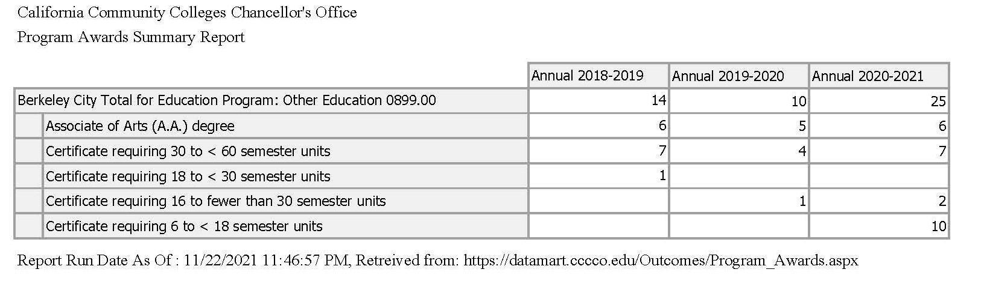
Increasing the review of Education Program data collection & processing activities to validate data integrity with a focus on successfully capturing SCFF outcomes is a priority.

On page 4, what population(s) award trends showed gains in your program area and which populations need more support?

The distribution of students, in terms of ethnicity, in Education Program Awards is as follows:
 | 18-19 | 19-20 | 20-21
Am Indian | NR | NR | NR
Asian | 3 | 2 | 2
Black/ African American | 3 | 1 | 7
Hispanic/ Latino | 2 | 2 | 10
Pacific Islander | NR | NR | NR
2 or more | 1 | NR | 2
unknown | NR | 1 | 2
white | 5 | 4 | 2

The two groups not represented (American Indian and Pacific Islander) have relatively small populations at the College.

How do these outcome trends compare to the college average?
It is worth noting that the group of students receiving the most Program Awards in the Education Program is Hispanic/Latino students, one of the DI populations.

3d. Transfer Dashboard
This dashboard does not provide data by subject. Reflect on what you can do to affect student transfer. How may your department help to support BCC student transfer? (e.g., serve on panels, strengthen GP in your dept, change curriculum, increase number of AD-Ts, etc.)
The following four program certificates and degrees are intentionally designed for a guaranteed transfer with a BA plus credential option (2+2+1) (i.e., two years of Community College, two years of a BA program, and one year of a Credential Program), so that students can take all four plus IGETC for a total of 60 units, meeting the completion metric for certificates and degrees:
- School Readiness Certificate of Proficiency
- Teacher’s Aide Certificate of Achievement
- Liberal Studies - Teacher Preparation A.A.
- Child and Adolescent Development AA-T (new)
The intentionally designed degrees and certificates allow students to attain more than one, and possibly, all four certificates and degrees (and two industry recognized certificates issued by the California Commission on Teacher Credentialing) without exceeding 60 units. Furthermore, this program design allows for all enrolled students to meet all the Student-Centered Funding Formula metrics and will accomplish the following:
- Increase the number of students that acquire program certificates, degrees, and industry recognized certifications for an in-demand job. This increase is necessary to meet local, regional, and statewide workforce demands, as validated by the Centers of Excellence LMI data
- Increase the number of program students transferring annually to CSU and UC
- Increase academic embedded supports to ensure program certificates and degrees are achieved in 60 units so that more students reach their educational goals sooner and at less cost to them.
In the past, the two AA programs cited above did not exist or needed significant revamping. Therefore, students who were actually enrolled in our program ended up receiving AA degrees in Liberal Arts from other disciplines instead of from education in order to meet their end goal of attaining a BA degree, which would then allow them to qualify to enroll in a credential program. For this reason, our program does not reflect the actual enrollment and completion metrics. The new Liberal Studies - Teacher Preparation A.A. and Child and Adolescent Development AA-T alleviates this problem.

3e. Curriculum based on Guided Pathways
View the department’s curriculum through the lens of student equity outcomes.
- What intentional effort is your department making to create and present clear pathways for students through curriculum?
- Increase the quality of teaching and learning, including culturally responsive curriculum construction and continued alignment with employment demands and student goals, by making adjustments to lessons plans and assignments based on student assessment outcomes
- Engage in professional development to consistently improve pedagogy to foster student engagement, provide experiential learning opportunities, and utilize required course materials to increase student engagement
- Increase the assurance of best practices in creating a welcoming and inclusive classroom environment, fostering academic and social integration
- What are your plans for revising and/or creating new pathways supported by labor market information (LMI) and student demands? Using Vision for Success and SCFF focus, please indicate rationale and how the plans directly support student success and equitable completion.
The LMI data reveals a high need for teachers working with children with special needs. The plan is to create a 48-unit Child and Adolescent Certificate of Achievement. The unit requirement fulfills paraprofessional course requirements in lieu of the paraprofessional test. The 48-units will also be stackable to the both the Liberal Studies A.A. and Child and Adolescent AA-T

4. Dual Enrollment
As continued decline in overall enrollment for college going population, it is important for us to look at who will be coming to BCC in the next 5 years. Reviewing the data provide here, what strategies would your department employ to address bringing more students to BCC?

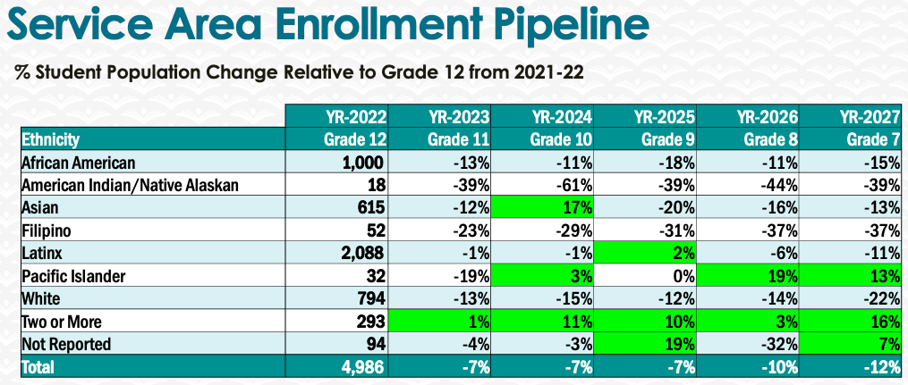
Strategies our program will employ to address bringing more students to BCC includes collaborative efforts to develop culturally relevant and responsive program outreach materials to engage potential students’ and their families; Improve program website and user-friendliness of course sequencing via accessible program mapping software; Present about our program to industry partners and aligned high school pathway stakeholders.

5. Facility Utilization Needs

Assess your facilities utilization (including labs, support for online learning, and other spaces) and for next year, indicate if the space is sufficient or not. If not, what are the needs and why? Work with your Dean to check on your needs prior to responding this section.
We will need an Education Program office space (and phone) for next academic year and will work collaboratively with the chair and dean to address expressed facility utilization needs.

6. Assessment
Berkeley City College is committed to a culture of assessment to improve instruction, services, and institutional planning. Findings from SLO, PLO, ALO assessments, and program review data are used to direct resources for areas that are institutional priorities that are articulated in the Educational Master Plan and BCC Strategic Plan.

Due to the critical role that course and program assessments play in our institutional planning and to be in compliance with the Accreditation requirements, assessments must be completed to qualify for the APU resource allocation requests.
6a. What action plans did your department identify upon the assessment of each SLOs and/or PLOs? For courses with multiple sections in the program, please list the main action plans. Please be as detailed as possible.
Program faculty identified the need to continue focusing on students’ reading and writing, while introducing strategies to increase students reading, writing, and critical thinking skills. Continue to have whole class, small group, and pair-share discussions, which promote student’s comprehension of their reading material and help them form their own opinions about various social factors and the effect of those factors on student performance. We also identified the need to update all program courses to align with new state regulatory requirements, and to choose OER materials when available in further efforts to decrease costs for students.

6b. Describe the department’s progress on the Actions Plans identified for course Student Learning Outcomes (SLOs). If your department offers a degree or certificate, please describe the department’s progress on the Action Plans for Program Learning Outcomes (PLOs).
Assessment in the past three years has been very informal; thus, it is a high priority in the Education Teacher Preparation Program, as explained in 9A. We have been assigned a schedule for the next three years.
6c. Describe the status of SLO and PLO completion in Rounds 4 and 5 of the Assessment Cycle. Identify the percent of completion. Briefly describe what needs to be done to reach 100% completion. Identify issues or concerns that may prevent your department from completing assessments of SLOs and/or PLOs.
The Education Program curriculum is being updated to align to the new state regulatory mandates. At the moment, our priority is to update the program outlines to align to the new state regulatory mandates and along with this to update our SLOs. One of the barriers in accomplishing this in a timely manner is that we do not have a full-time faculty member in the Education Teacher Preparation Program that could oversee academic quality and program effectiveness through regular assessment of learning outcomes for all program courses, certificates, and degrees. This is especially important in light of the State’s ever-changing regulations and mandates.
6d. Besides your syllabi, where are the program level outcomes published? If on a website, please specify the URL.
On the Education Teacher Preparation Program website under the degrees and certificate tab links: https://www.berkeleycitycollege.edu/education-programs/program-degrees-and-certificates/

7. Engagement
Discuss how faculty and classified staff have engaged in institutional efforts such as committees, presentations, and departmental activities. Please list the committees that full-time faculty participate in.
We have no full-time faculty or staff. Part-time faculty participate in Academic Senate, Dual Enrollment for Equity, Guided Pathways, Curriculum Committee, Career Education Committee, and College Roundtable
Discuss how faculty and staff have engaged in community activities, partnerships and/or collaborations.
The Program Coordinator participates in CA Commission on Teacher Credentialing (Invitation Only) Advisory Workgroup; she is also an Associate of CA Community College Teacher Education Programs (ACCCTEP) board member, BACCC Apprenticeship Advisory Board member, ECE/EDU Apprenticeship Advisor, and Youth and Early Educator Apprenticeship Program partner.
All part-time faculty work in industry -- City of Oakland Head Start, YMCA of the East Bay, Oakland Unified School District, UC Berkeley Early Childhood Education Programs -- and stay abreast of current research, trends, and practices for the Education workforce.
Discuss how adjunct faculty members are included in departmental training, discussions, and decision-making.
All adjunct faculty participate in a program workgroup to
- increase enrollment student success, completion, and retention of Education Program students
- decrease the achievement/opportunity gap in alignment with BCC’s Strategic plan, Guided Pathways, and Equity Agenda
- increase the quality of teaching and learning, including culturally responsive curriculum construction and continued alignment with employment demands and student goals
- participate in professional development to consistently improve pedagogy to foster student engagement, provide experiential learning opportunities, use required course materials appropriately, and meet our SLOs effectively ensure a welcoming and inclusive class environment, fostering academic and social integration
- Discuss the relationship and engagement with other support services, programs, departments, or administrative units and how these relationships/collaboration support meeting your departmental goals.
- Despite limitations of part-time faculty availability to attend meetings during the day, program faculty continue to engage positively with other support services, programs and departments. Specifically, counseling, career and transfer center, EOPS/CalWorks, Learning Resource Center (LRC), and Student Accessibility Services (SAS) to facilitate student access and success. Links to other referenced support services, programs and resources are also embedded in course Canvas shells.
Are there areas you feel that your department can benefit more by increasing collaboration and partnership? How?
The increase in internal collaboration and partnership with financial aid for our enrolled apprenticeship students to access Learning-Aligned Employment Program (LAEP) funds, as well as accessible CalWorks, EOPS, Career Transfer Center and LRC services will increase completion and matriculation success for program students. Understanding how to access services for non-traditional students working full-time and taking classes online at night would benefit our program faculty who meet with students in the evening. Increasing efforts to internally collaborate and partner to address the needs of non-traditional students and part-time faculty would benefit our program. A few examples include automated online forms in need of signatures (i.e., subwaiver, certificates, degrees, etc.), evening and weekend student services availability (i.e, counseling, enrollment, financial aid, student accessibility services, etc.), and professional development for part-time faculty in the evening and/or weekend.

8. Prioritized Resource Requests
During the 2021-22 Comprehensive Program Review process, you have provided your resource requests which went through the IPAR process. In this section, include resource requests from last year that are still needed and/or new resources that have emerged. Provide justifications. If there are no resource requested, leave the boxes blank.

Resource Category | Description/Justification | Estimated Cost
Personnel
Classified Staff | Part-time Success Coordinator for Dual Enrollment and Non-Traditional Student Apprentices to ensure 2+2+1 success | $65,000.00
Student Worker | Embedded tutors for dual enrollment and Non-Traditional Student Apprentices (1202.36 per semester) | $24,259.92 per yr
Part Time Faculty
Professional Development
Department wide PD needed | Professional development to learn how to use Peer Online Course Review (POCR) and Online equity tool training for all EDUC/CHDEV faculty  Faculty Community of Practice Participation to meet and engage regularly, including committee work. SWP covers 6 faculty and need to add two more ($2000 per semester stipend for each part-time faculty) | $2500.00  $4000.00
Personal/Individual PD needed | Being able to take advantage of professional development opportunities both internally and externally for the Education Program Coordinator to continue supporting EDUC/CHDEV faculty to continue growing professionally | $1000.00
Supplies
Software (for whom or role?)
Books, Magazines, and/or Periodicals
Instructional Supplies
Non-Instructional Supplies
Technology & Equipment
Description/Justification (Before you list your technology request, click here to view the latest Technology Refresh Plan to verify whether it has already included.)
New | All Education faculty are in need of new laptops as the system updates are no longer effective in resolving glitches resulting from old operating systems. Estimate $1000 each part time faculty member inclusive of educational software needs | $9000.00
Replacement
Facilities
Classrooms
Offices
Labs
Other
Library
Library materials (including streamline media needs)
Library collections
OER
Other
OTHER Description

Thank you for your time and effort in completing the Annual Program Update!
Please email the completed Program Review to your Dean by November 30, 2022

