Berkeley City College’s mission is to provide our diverse community with
educational opportunities, promote student success, and to transform lives.

Introduction and Directions

Berkeley City College (BCC), in conjunction with the Peralta community College District, has an institutional effectiveness process which consists of the following components: a District-wide Strategic Plan which is updated every six years; Comprehensive Program Reviews (CPRs) which are completed every three years; and Annual Program Updates (APUs) which are completed in non-program review years.

TIMELINE
Annual Program Update (APU) 2022-2023 timeline has been developed for each program and services to guide through the semester. Please review and work with your Deans, Managers, Department Chairs and/or Supervisors to complete this APU.

For BCC, 2022-2023 marks a critically important year as the college is in the process of revising its Educational Master Plan (EMP) for the next 5 years (2024-2028). This college EMP process will inform the District with their planning for their Strategic Plan. This year’s APU will take an especially important role for the EMP process, carrying your analysis, planning and strategies to support our students success, retention, and equitable completion.

The APU is intended to primarily focus upon planning for the subsequent year based on the institutional priorities. While developing the College’s EMP for the next 5 years, the college and the district focused on the Vision for Success identified by the California Community College Chancellor’s office as well as Student Centered Funding Formula (SCFF) that clearly delineate the categorized outcomes that the Colleges should be focusing. Please use these foci as your reference to prioritize your department and other goals.

RESOURCE REQUEST
In this process of making continuous quality improvement, there is an opportunity for each program, student services, and department to request resources that support achieving the stated goals. The APU process directly leads to the institutional resource allocation process and budget planning facilitated by the Institutional Planning and Allocation of Resources (IPAR) Committee for the following academic year (2023-24). The process for this can be found here (2022-23 APU Timeline). This is an opportunity for each department to request resources that will support your department goals and set outcomes.

TECHNOLOGY REQUEST
Finally, for the resource request section, please connect with your Deans, managers, and supervisors regarding your technology needs so that you can be informed about the equipment that is addressed in the BCC Technology Refresh Plan. If your requests are covered in the Refresh Plan, you do not need to request them in this APU.

If you have questions regarding other material in the Annual Program Update, please contact your Dean or Manager. If you have questions regarding data, please contact Dr. Phoumy Sayavong, Senior Researcher and Planning Analyst (psayavong@peralta.edu).

Please email the completed Annual Program Update to your Dean by November 30, 2022.

College Profile
Click here to view the Berkeley City College Student Demographics Dashboard.
This 2-page dashboard will provide data on the demographics of our student body from the past two years such as headcount, ethnicity, enrollment status, age group, educational goals, and majors.
College Outcomes | 2018-2019 | 2019-20 | 2020-21 | 2021-22
Full Time Equivalent Students (FTES) | 4,161 | 3,931 | 3,622 | 3,259
Productivity (Avg. Goal = 17.5) | 13 | 13.2 | 13 | 10.9
Success Rate (%) | 69% | 77% | 75%* | 70%*
Degrees + Certificates Awarded (#) | 948 | 1,109 | 1,027 | 960
*Excludes “EW” grades

To view prior Program Reviews, click here. To view prior Annual Program Updates, click here.

1a. Department Description
Please verify the mission statement for your department. If your department has not created a mission statement, provide details on how your department supports and contributes to the College’s mission.
The mission of the program is to educate students so that they can compete and perform successfully in today’s ever-changing global business environment. Students in this program will acquire computer application, programming, and technical knowledge and skills needed for initial employment, skill upgrades, career advancement, and career changes as well as the undergraduate courses needed to move into four-year computer science or other related degree programs that have similar goals.

Name(s) of member(s) completing this APU | Department | Completion Date
Paramsothy Thananjeyan | Comp. Information Systems | November 30, 2022
List faculty names with assignments in fall 2022.
Full Time | Part Time
Paramsothy Thananjeyan  Vladeta Djukich  Benjamin Allen | Michael Seidel

1b. Department Priorities & Goals
Based on the Vision for Success and SCFF, and your department mission, what are your department’s priorities and goals for 2022-23?
Create a CS program and move CIS courses and certificates to the CS program, update courses as necessary.

Deactivate CIS – Web Programming certificates and courses.

Create a new Data Science course and a certificate program.

Hire more part-time CIS faculty.

2. Student Equity, Success, & Completion
Using the data dashboards provided below, review and reflect upon the outcome trends for your department. Please also review overall BCC’s data linked here.

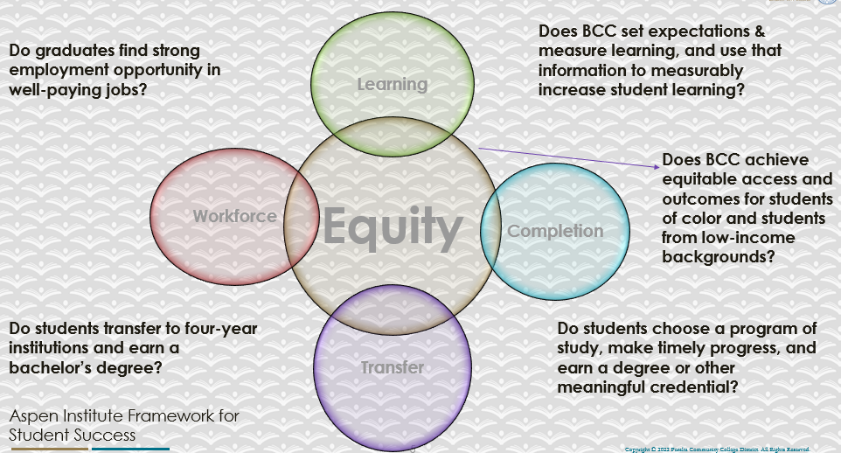

For assistance with data dashboards, contact Phoumy Sayavong at psayavong@peralta.edu
How are students doing in success and completion in your department, compared to the BCC overall success and completion rate? What are the group of students that need more attention to achieve goals?
Completion Rate:
2019 – 2020 CIS – 56.1% (BCC – 67.7%)
2020 – 2021 CIS – 63.6% (BCC – 71.4%)
2021 – 2022 CIS – 58.3% (BCC – 68.3%)

Retention Rate:
2019 – 2020 CIS – 82.4% (BCC – 87.7%)
2020 – 2021 CIS – 82.7% (BCC – 85.7%)
2021 – 2022 CIS – 80.0% (BCC – 84.3%)

Overall, CIS completion and retentions rates are lower than BCC averages.

All three years completion rates for females are higher than males.

Nearly 78+% of the students taking CIS courses are less than 29 years, with mostly below 24 years.

Completion and retention rates are generally higher for White and Asian students and lower for Black and Hispanic students.

What do you see as key factors in your department that contributed to positive success and completion rate?
It seems that CIS courses are generally more challenging compared to other courses in other departments.

What are some improvements your department can make? Identify strategies.
More student focused help and a good background knowledge of Mathematics are helpful in increasing completion and retention rates.

Supporting programs such as tutoring services and cohort support should be provided.

3a. Enrollment Trend and Productivity Dashboard
*Note that completion and retention rates are presented with the inclusion and exclusion of excused withdrawals (EW) and military withdrawals.
What were the enrollment trends in your department in the past three years?
CIS Enrollment and productivity for the last three years:
2019-2020 = 745 (CIS Productivity = 15.9 – BCC Productivity = 14.9)
2020 – 2021 = 612 (CIS Productivity = 16.0 – BCC Productivity = 14.2)
2021-2022 = 524 (CIS Productivity =13.4 – BCC Productivity = 11.2)

Data shows that productivity of CIS is slightly larger compared to BCC average. Overall, enrollments have decreased in 2019-20 compared to previous years and the productivity has decreased from 15.9 to 13.4. The decrease in enrollment may be due to the pandemic as all courses have been changed to online or synchronous online offerings. Also, we have not significantly increased or decreased the number of courses offered during this period.

Most courses except CIS 1 and CIS 42A/B generally tend to have high productivity.

What strategies would you recommend to increase student enrollment in your department?
I am not sure if there is anything we can do in short-term to increase productivity dramatically. Long term, we need to find qualified instructors and offer all courses in a predictable sequence.

Hire regular embedded and LRC tutors for all CIS classes.

Department has no resources to any public enrollment and marketing activities. We hope to corporate and coordinate with CTE activities.
Community Colleges are funded based on the Student Centered Funding Formula (“SCFF”) which is comprised of the following allocations:

Student Centered Funding Formula: Focus and Priorities
% Of Allocation | Categories
70%  Base Allocation: FTES (Enrollment) | - Credit FTES  - NonCredit FTES  - Special Admits (Dual Enrollment, etc.)
20%  Supplemental Allocation | - Pell Grant  - AB 540  - Adult School  - Promise Grants
10%  Student Success Allocation | - Associate Degrees  - ADTs  - 9 or more CE units  - Transfer  - Transfer level Math and English in the first year

List the department’s progress and reflection on what is being done to maintain or increase the base level of full-time equivalent students (FTES = 12 units). Please describe retention (i.e., remain enrolled for a full semester) and persistence (i.e., enroll in consecutive semesters) efforts.
We have returned all classes to face-to-face classes. However, the current enrollment trends in community colleges have been significantly lower and our enrollment trends seem to correlate with the general enrollment trends.

Please describe your department’s efforts in identifying Pell Grant recipients, College Promise Grant recipients, Adult Education, and AB 540 students. What processes are in place to accurately report these students each semester?

College Outcomes | 2018-2019 | 2019-2020 | 2020-21 | 2021-22
Full Time Equivalent Students (FTES) | 4,161 | 3,931 | 3,622 | 3,259
Pell Grant Recipients | 2,387 | 2,281 | 2,181 | 1,826
College Promise Grant Recipients | 4,373 | 4,143 | 4,011 | 3,500
AB 540 Students | 74 | 51 | 22 | 69

More institutional support would be needed for a small department to undertake such activities. Presently 2 FT instructors are teaching above their maximum contract load. One FT instructor in on a reduced load for the past few years.

College does not provide any information to the department on any Grant recipients or other information.

3b. Course Completion and Retention Rates Dashboard – Instruction
*Note that completion and retention rates are presented with the inclusion and exclusion of excused withdrawals (EW) and military withdrawals.

If you need more guidance with this item, click here for additional support. Click here for additional guidance for how to view and use equity data. If you would like to view BCC’s Equity Plan, click here.
On page 3 of the “Course Completion and Retention Rates by Subject” dashboard, what are the completion and retention trends by gender, age, ethnicity in your department?
This summary is presented for the whole period between 2019 to 2022.
- Male/Female/Other:
Completion(%) Retention(%)
2019-2021 2020-2021 2021-2022 2019-2020 2020-2021 2021-2022
Male: 64.9 68.2 69.6 86.0 83.0 87.1
Female: 63.7 68.6 66.4 85.1 83.1 81.6
Other: 50.7 67.2 78.9 84.5 82.2 90.2

The lower completion and retention rates were observed between 2019 to 2022 are somewhat mixed and does not show any pattern.
- Ethnic groups:
Completion(%) Retention(%)
2019-2021 2020-2021 2021-2022 2019-2020 2020-2021 2021-2022
American Indian:
30.0 84.0 70 93.3
Asian:
75.6 77.7 74.0 89.4 87.7 85.6
Black/African American:
56.2 58.3 65.0 84.0 78.8 84,7
Hispano/Latino:
55.1 61.8 67.2 82.2 79.3 83.3
Pacific Islander:
45.5 54.5 35.5 72.7 81.8 47.1
Two or more:
54.0 64.7 67.0 86.0 78.9 81.1
Unknown:
54.8 76.8 76.9 81.8 86.2 85.9
White:
63.0 68.9 63.5 82.6 83.4 83.9
The completion rates consistently increased for Black/African American and Hispano/Latino students between 2019 to 2022. The others are mixed and do not show any consistent trends.
- Age groups:
Completion(%) Retention(%)
2019-2021 2020-2021 2021-2022 2019-2020 2020-2021 2021-2022
Under 16: 87.8 80.4 82.8 92.7 84.6 89.7
16-18: 76.5 72.5 77.4 91.0 83.3 86.3
19-24: 64.0 69.4 64.6 86.1 81.1 82.4
25-29: 64.4 67.5 66.1 86.7 83.0 84.6
30-34: 62.0 67.9 66.7 81.6 79.7 84.7
35-54: 58.1 65.2 72.0 84.7 77.3 85.9
55-64: 52.1 63.6 60.9 84.5 75.0 85.5
Above 64 59.5 50.0 57.9 75.7 84.3 68.4
The highest completion and retention rates were observed for younger students (16-18 and under 16) and gradually decreases for older students.

Although smaller in sample size under 16 shows the highest completion and retention rates.

When the data are disaggregated by student ethnic groups, gender, and age, how do you plan to address them over the next year?
Supporting programs such as tutoring services and cohort support should be provided to age groups under 16 and 16-18, as the students, may need additional counseling and educational programs to guide through the transfer process and career pathways. Tutoring services should be provided to Black/African American and Hispanic/Latino students as both groups received the lower completion rates. It seems that there is an equity gap between the course completion and course retention of the Black/African American and Hispanic/Latino students compared to White and Asian populations in our discipline

We hope to corporate and coordinate with collegewide activities.

What population(s) showed outcomes gains in your discipline(s) and which need more support?

Disaggregate the data and outcomes as far down as a possible then ask:
- What trends do you notice when examining course success rates for student populations by ethnicity? Which factors do you believe have the greatest impact (positive or negative) and cause variation between student course success rates in your Program? Describe some specific methods your department is planning or implementing to address these equity gaps. How will you evaluate the efficacy of these interventions?

- How has pivoting to online instruction contributed to potential reductions in student success? Provide some specific examples of practices that faculty in your department have found ineffective in the online environment.
Please review the video from the RP Group acknowledging the interrogation De Anza Community College committed to in their analysis of course completion and success rate.
I am expecting that since the administrators have asked us to watch this video (so far 94 views since it was published, including all the Peralta chairs who may watched it), that they are going to take serious steps towards equity. This leaves me with hope that the administrators are serious in committing the resources that are need to reach the goals instead of forcing more responsibilities on the few fulltime faculty.

How do these outcome trends in your department compare to the college average?
No comparisons were made.

How will these outcome trends you identified in this section affect your department goals and plans for the next year and what are your strategies to shift to move the trend towards a positive direction?
No explicit plans and goals at this time. I am hoping that I can hire more faculty and expect that the administrators can help with actual money and resources to create and implement the goals.

3c. Degrees and Certificates Dashboard
On page 1 of the “Degrees and Certificate Awards Trends” Dashboard, what are the award trends for your department (e.g., overall, by gender, age, and ethnicity)?
Total number of certificate (CA plus CC): 2 in 2019, 1 in 2020, and 5 in 2022
Unfortunately, the numbers are too small to make any meaningful comparison across different categories.
On page 4, what population(s) award trends showed gains in your program area and which populations need more support?
The numbers are too small to make any meaningful comparison across different categories.

3d. Transfer Dashboard
This dashboard does not provide data by subject. Reflect on what you can do to affect student transfer. How may your department help to support BCC student transfer? (e.g., serve on panels, strengthen GP in your dept, change curriculum, increase number of AD-Ts, etc.)
Unable to reflect on data that is not given.

3e. Curriculum based on Guided Pathways
View the department’s curriculum through the lens of student equity outcomes.
- What intentional effort is your department making to create and present clear pathways for students through curriculum?
We have worked with the CTE groups and Guided Pathways to create a clear mapping that identifies the path for successfully complete the certificates.

I hope the college counselors understand the pathways and the course offered at BCC and provide meaningful support to students.

- What are your plans for revising and/or creating new pathways supported by labor market information (LMI) and student demands? Using Vision for Success and SCFF focus, please indicate rationale and how the plans directly support student success and equitable completion.
We have reviewed the LMI market and are hoping to update the courses and certificates.

CIS department has plans to continue the current CIS coordinator positions to make sure that we work with our advisory committee, CTE, and Guided Pathways and have our courses meet the current industry and transfer requirements.

4. Dual Enrollment
As continued decline in overall enrollment for college going population, it is important for us to look at who will be coming to BCC in the next 5 years. Reviewing the data provide here, what strategies would your department employ to address bringing more students to BCC?

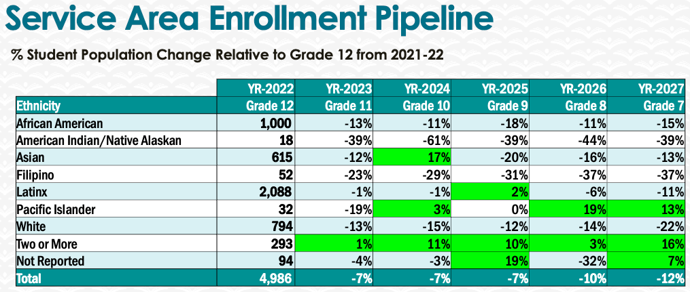
We are hoping to reduce our courses to make sure that we offer the most important courses that meet the labor market and transfer needs.

We will cancel offering low productive and unessential low-level classes.

5. Facility Utilization Needs

Assess your facilities utilization (including labs, support for online learning, and other spaces) and for next year, indicate if the space is sufficient or not. If not, what are the needs and why? Work with your Dean to check on your needs prior to responding this section.
We do not anticipate any need for additional labs at this time. We request that labs 312, 323, and 324 are given priority for CIS courses. We hope that the lab computers and equipment will be updated on their regular cycle.

Online tutoring help will be needed if we propose to offer more online courses.

We will need help to create online courses that meet the State requirements.

6. Assessment
Berkeley City College is committed to a culture of assessment to improve instruction, services, and institutional planning. Findings from SLO, PLO, ALO assessments, and program review data are used to direct resources for areas that are institutional priorities that are articulated in the Educational Master Plan and BCC Strategic Plan.

Due to the critical role that course and program assessments play in our institutional planning and to be in compliance with the Accreditation requirements, assessments must be completed to qualify for the APU resource allocation requests.
6a. What action plans did your department identify upon the assessment of each SLOs and/or PLOs? For courses with multiple sections in the program, please list the main action plans. Please be as detailed as possible.
The department is currently starting the current assessment cycle and faculty members are reviewing and updating the student learning outcomes and program outcomes. The department chair will begin to review the program outcomes upon discussion with the assessment liaison.

To be continued in Spring 2023. Ongoing.

6b. Describe the department’s progress on the Actions Plans identified for course Student Learning Outcomes (SLOs). If your department offers a degree or certificate, please describe the department’s progress on the Action Plans for Program Learning Outcomes (PLOs).
All courses and certificates are being reviewed. To be continued and completed in Spring 2023. Ongoing.

6c. Describe the status of SLO and PLO completion in Rounds 4 and 5 of the Assessment Cycle. Identify the percent of completion. Briefly describe what needs to be done to reach 100% completion. Identify issues or concerns that may prevent your department from completing assessments of SLOs and/or PLOs.
All courses and certificated are being reviewed and are being updated.

6d. Besides your syllabi, where are the program level outcomes published? If on a website, please specify the URL.
None except description of courses and certificates.

7. Engagement
Discuss how faculty and classified staff have engaged in institutional efforts such as committees, presentations, and departmental activities. Please list the committees that full-time faculty participate in.
P. Thananjeyan – Chair, Chairs Council, CTE, Guided Pathways, hiring committees, faculty assessment committees, TRC committees.
B, Allen – Curriculum committee.
C. Vladeta Djukich – None.
Discuss how faculty and staff have engaged in community activities, partnerships and/or collaborations.
Collaborate with UC Berkeley to offer the Data 8 course at BCC and create a Data Science program.
Discuss how adjunct faculty members are included in departmental training, discussions, and decision-making.
We have only one active part-time faculty and we collaborate and coordinate with him in all curriculum activities.
- Discuss the relationship and engagement with other support services, programs, departments, or administrative units and how these relationships/collaboration support meeting your departmental goals.
- Regular communications with other services, departments, and administrative units on an as-needed basis.
Are there areas you feel that your department can benefit more by increasing collaboration and partnership? How?
It will be helpful provided we have more instructors to participate.

8. Prioritized Resource Requests
During the 2021-22 Comprehensive Program Review process, you have provided your resource requests which went through the IPAR process. In this section, include resource requests from last year that are still needed and/or new resources that have emerged. Provide justifications. If there are no resource requested, leave the boxes blank.

Resource Category | Description/Justification | Estimated Cost
Personnel
Classified Staff | CIS/CTE Coordinator | $ 15,000
Student Worker | Embedded and LRC tutors | $ 30,000
Part Time Faculty | At least 2-3 part-time faculty | $ 75,000
Professional Development
Department wide PD needed | Course and certificate updates and assessments. | $ 10,000
Personal/Individual PD needed | Conferences and memberships | $ 2,000
Supplies
Software (for whom or role?) | Robotic software | $ 500
Books, Magazines, and/or Periodicals
Instructional Supplies | Update robotics supplies | $ 10,000
Non-Instructional Supplies | Supplies | $ 4,000
Technology & Equipment
Description/Justification (Before you list your technology request, click here to view the latest Technology Refresh Plan to verify whether it has already included.)
New
Replacement
Facilities
Classrooms
Offices
Labs
Other
Library
Library materials (including streamline media needs)
Library collections
OER
Other
OTHER Description | Dimmable lights focusing on the Whiteboard for rooms 312 and 323 so that whiteboard and projects can be used simultaneously, while the ceiling lights are turned off. | $ ???

Thank you for your time and effort in completing the Annual Program Update!
Please email the completed Program Review to your Dean by November 30, 2022

