Berkeley City College’s mission is to provide our diverse community with
educational opportunities, promote student success, and to transform lives.

Introduction and Directions

Berkeley City College (BCC), in conjunction with the Peralta community College District, has an institutional effectiveness process which consists of the following components: a District-wide Strategic Plan which is updated every six years; Comprehensive Program Reviews (CPRs) which are completed every three years; and Annual Program Updates (APUs) which are completed in non-program review years.

TIMELINE
Annual Program Update (APU) 2022-2023 timeline has been developed for each program and services to guide through the semester. Please review and work with your Deans, Managers, Department Chairs and/or Supervisors to complete this APU.

For BCC, 2022-2023 marks a critically important year as the college is in the process of revising its Educational Master Plan (EMP) for the next 5 years (2024-2028). This college EMP process will inform the District with their planning for their Strategic Plan. This year’s APU will take an especially important role for the EMP process, carrying your analysis, planning and strategies to support our students success, retention, and equitable completion.

The APU is intended to primarily focus upon planning for the subsequent year based on the institutional priorities. While developing the College’s EMP for the next 5 years, the college and the district focused on the Vision for Success identified by the California Community College Chancellor’s office as well as Student Centered Funding Formula (SCFF) that clearly delineate the categorized outcomes that the Colleges should be focusing. Please use these foci as your reference to prioritize your department and other goals.

RESOURCE REQUEST
In this process of making continuous quality improvement, there is an opportunity for each program, student services, and department to request resources that support achieving the stated goals. The APU process directly leads to the institutional resource allocation process and budget planning facilitated by the Institutional Planning and Allocation of Resources (IPAR) Committee for the following academic year (2023-24). The process for this can be found here (2022-23 APU Timeline). This is an opportunity for each department to request resources that will support your department goals and set outcomes.

TECHNOLOGY REQUEST
Finally, for the resource request section, please connect with your Deans, managers, and supervisors regarding your technology needs so that you can be informed about the equipment that is addressed in the BCC Technology Refresh Plan. If your requests are covered in the Refresh Plan, you do not need to request them in this APU.

If you have questions regarding other material in the Annual Program Update, please contact your Dean or Manager. If you have questions regarding data, please contact Dr. Phoumy Sayavong, Senior Researcher and Planning Analyst (psayavong@peralta.edu).

Please email the completed Annual Program Update to your Dean by November 30, 2022.

College Profile
Click here to view the Berkeley City College Student Demographics Dashboard.
This 2-page dashboard will provide data on the demographics of our student body from the past two years such as headcount, ethnicity, enrollment status, age group, educational goals, and majors.
College Outcomes | 2018-2019 | 2019-20 | 2020-21 | 2021-22
Full Time Equivalent Students (FTES) | 4,161 | 3,931 | 3,622 | 3,259
Productivity (Avg. Goal = 17.5) | 13 | 13.2 | 13 | 10.9
Success Rate (%) | 69% | 77% | 75%* | 70%*
Degrees + Certificates Awarded (#) | 948 | 1,109 | 1,027 | 960
*Excludes “EW” grades

To view prior Program Reviews, click here. To view prior Annual Program Updates, click here.

1a. Department Description
Please verify the mission statement for your department. If your department has not created a mission statement, provide details on how your department supports and contributes to the College’s mission.
The mission of the business program is to educate students so they can compete and perform successfully in today’s ever-changing global business environment. This requires not only job specific technical skills but also more general skills. Students in this program will acquire the knowledge and skills needed for initial employment, skill upgrades, career advancement, and career changes as well as the undergraduate courses needed to move into four-year business degree programs that have similar goals.

Name(s) of member(s) completing this APU | Department | Completion Date
Paramsothy Thananjeyan | Business | 11/30/2022
List faculty names with assignments in fall 2022.
Full Time | Part Time
Leonard Chung  Peter DuBois | Drew Braithwaite  Rabab Chowdhury  Tracy Coleman  Sharon Garrett  Darrell Gualco  Malkiat Sandhu  Cindy Turner

1b. Department Priorities & Goals
Based on the Vision for Success and SCFF, and your department mission, what are your department’s priorities and goals for 2022-23?
1. Review of all business classes, degrees, certificates, and programs.
2. Create Certificate of Achievement/Proficiency in Business and curriculum design new business/data science courses/certificates.
3. Complete identified assessment activities for the discipline in the Business three-year assessment schedule.
4. Continue to schedule business courses across the schedule and across delivery methods.
5. Develop a discipline specific tutor training program (ongoing).
6. Map Business program under Guided Pathways model.
7. Increase student success and retention in face-to-faces day and evening classes.
8. Increase student success and retention in online and hybrid classes.

2. Student Equity, Success, & Completion
Using the data dashboards provided below, review and reflect upon the outcome trends for your department. Please also review overall BCC’s data linked here.

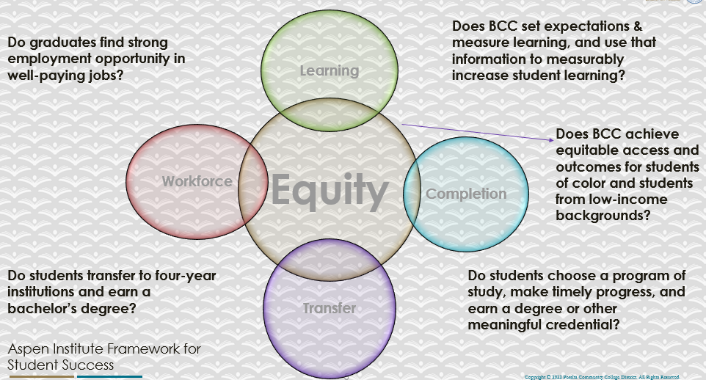

For assistance with data dashboards, contact Phoumy Sayavong at psayavong@peralta.edu
How are students doing in success and completion in your department, compared to the BCC overall success and completion rate? What are the group of students that need more attention to achieve goals?
Based on 2022 to 2022 data, for
Completion: Business – 68% vs. BCC – 66%. Very little difference.
Retention: Business – 80% vs. BCC – 84%. Moderate deficit here.

Groups Struggling with Completion:
Black/African American students – 51% vs. overall 67%.
Race Unknown – 40% vs overall 67%.

Groups Struggling with Retention:
Black/African American – 66% vs overall 80%
Race Unknown – 60% vs overall 80%

What do you see as key factors in your department that contributed to positive success and completion rate?
Technology – internet access and availability of hardware/software for online and hybrid classes.

What are some improvements your department can make? Identify strategies.
Internet access – district to subsidize for better internet connections with stronger signal for low-income students.
Further promote the free Chromebook loaner program specifically to new students as some students still utilize their cell phones to attend online and hybrid classes and provide temporary access to Chromebooks as some may need to repair their existing personal computers during regular semester.

3a. Enrollment Trend and Productivity Dashboard
*Note that completion and retention rates are presented with the inclusion and exclusion of excused withdrawals (EW) and military withdrawals.
What were the enrollment trends in your department in the past three years?
Enrollment: 376 to 330 (-12%)
BCC: 31K to 22K (-31%)
Decline slightly lower than overall.
What strategies would you recommend to increase student enrollment in your department?
Course scheduling – experiment with different time slots to reduce competition with other colleges.
Marketing - Department to contact former and current students to encourage them to enroll in additional classes.

Community Colleges are funded based on the Student Centered Funding Formula (“SCFF”) which is comprised of the following allocations:

Student Centered Funding Formula: Focus and Priorities
% Of Allocation | Categories
70%  Base Allocation: FTES (Enrollment) | - Credit FTES  - NonCredit FTES  - Special Admits (Dual Enrollment, etc.)
20%  Supplemental Allocation | - Pell Grant  - AB 540  - Adult School  - Promise Grants
10%  Student Success Allocation | - Associate Degrees  - ADTs  - 9 or more CE units  - Transfer  - Transfer level Math and English in the first year

List the department’s progress and reflection on what is being done to maintain or increase the base level of full-time equivalent students (FTES = 12 units). Please describe retention (i.e., remain enrolled for a full semester) and persistence (i.e., enroll in consecutive semesters) efforts.
As indicated in the data, for 2021 to 2022, retention and completion rates across female and male students are relatively equal, both rates are even with college average. Completion and retention rates across age groups are relatively even except for students in the age range of 19-24 make up the bulk of the enrollment and average around 66% in completion and around 75% in retention. Retention and completion rates for the 24 and older age group is on college average in both categories. The Business department completion rate for Black/African American students is below the college average. Retention rate for Black/African American students is lower than the college average. The completion rate and retention rate for Hispanic/Latino student, the largest group in 2021, Business Dept. sections, are both on par with the college average. The Business department has concentrated on initiatives to improve completion and retention across the student body with particular attention to students from traditionally marginalized communities. The department will continue to strategize, develop initiatives, and pursue programs that the pay particular heed to the unique circumstances of the Black/African American at BCC. Business faculty will likewise continue to support identified student groups such as EOPS, CalWORKs, Umoja, CareBCC, Veterans Affairs, etc. The completion and retention rates for special student groups, on average, run close to the overall college norm.

Please describe your department’s efforts in identifying Pell Grant recipients, College Promise Grant recipients, Adult Education, and AB 540 students. What processes are in place to accurately report these students each semester?

College Outcomes | 2018-2019 | 2019-2020 | 2020-21 | 2021-22
Full Time Equivalent Students (FTES) | 4,161 | 3,931 | 3,622 | 3,259
Pell Grant Recipients | 2,387 | 2,281 | 2,181 | 1,826
College Promise Grant Recipients | 4,373 | 4,143 | 4,011 | 3,500
AB 540 Students | 74 | 51 | 22 | 69

TBA

3b. Course Completion and Retention Rates Dashboard – Instruction
*Note that completion and retention rates are presented with the inclusion and exclusion of excused withdrawals (EW) and military withdrawals.

If you need more guidance with this item, click here for additional support. Click here for additional guidance for how to view and use equity data. If you would like to view BCC’s Equity Plan, click here.
On page 3 of the “Course Completion and Retention Rates by Subject” dashboard, what are the completion and retention trends by gender, age, ethnicity in your department?
Data for the Business Department as shown on page 3:

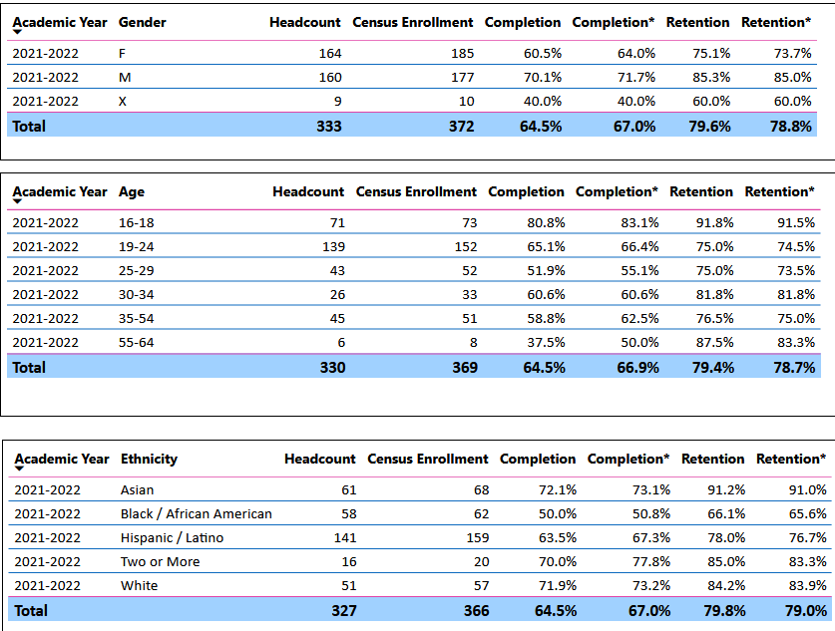

When the data are disaggregated by student ethnic groups, gender, and age, how do you plan to address them over the next year?
Allocate sufficient time on the first day of class to inform students the need to use a personal computer or the loaner Chromebook to complete the class.
To assist our low-income students who are doing poorly because of lack of internet access, encourage the students to search for free or affordable internet access.
Send exam reminders three days before scheduled exam using Canvas mail to avoid the need to drop a class because of missed exam/s.

What population(s) showed outcomes gains in your discipline(s) and which need more support?

Disaggregate the data and outcomes as far down as a possible then ask:
- What trends do you notice when examining course success rates for student populations by ethnicity? Which factors do you believe have the greatest impact (positive or negative) and cause variation between student course success rates in your Program? Describe some specific methods your department is planning or implementing to address these equity gaps. How will you evaluate the efficacy of these interventions?

- How has pivoting to online instruction contributed to potential reductions in student success? Provide some specific examples of practices that faculty in your department have found ineffective in the online environment.
Please review the video from the RP Group acknowledging the interrogation De Anza Community College committed to in their analysis of course completion and success rate.
The data indicated that Black/African American students have the lowest success rates, 51% vs 66% for all BCC students with highest at 78% for the Two or More category, and with retention 66% vs 80% for all students whereas the highest retention rate is at 91%. Since the disparity in success rates is relatively high, more resources should be put into programs like UMOJA. It looks like most effort should go into supporting our Black/African American students. More work should be done with the counselors to identify types of support that we can offer the aforementioned struggling students. To evaluate this, we would need to compare the outcomes of Black/African American students who did join these programs to the overall success rates of our Black/African American students that didn’t join Umoja, or any other program the counselors recommend.
How do these outcome trends in your department compare to the college average?
As stated previously, Black/African American students have a success rate of 50% vs 66% for the college as a whole. The second lowest group, Hispanic/Latino group is 1.3% higher than the overall rate. The unknown race group, also the smallest group, has the lowest rate of 40% vs 66% for all, since the data does not show who this small group is ethnically, there is no way to identify the 9 students.

How will these outcome trends you identified in this section affect your department goals and plans for the next year and what are your strategies to shift to move the trend towards a positive direction?
The department should offer a good mix of face-to-face, hybrid, and online courses in the future to suit the needs of students struggling in online courses.

3c. Degrees and Certificates Dashboard
On page 1 of the “Degrees and Certificate Awards Trends” Dashboard, what are the award trends for your department (e.g., overall, by gender, age, and ethnicity)?
Change in numbers of awards between 2017 to 2022:

Awards: from 54 in 2017 to 64 in 2021: up 10% overall

Awards: from 67 in 2020 to 64 in 2021: down 4%

Gender: Females down 7%, Male up 4%, X = +1 person

Age Group: 2020 to 2021

16 to 18: down 21%
19 to 24: down 21%
25 to 29: up 35%
30 to 34: up 80%
35 to 54: down 25%
55 to 64: down 33%
65 & higher: none
Under 16: none

Ethnicity:2020 to 2021

American Indian: None
Asian: down 12%
Black/African American: down 71% (big drop in 2021)
Hispanic/Latino: flat
Pacific Islander: flat
Two or More: down 67%
Unknown: flat
White: down 70% (big drop in 2021)

On page 4, what population(s) award trends showed gains in your program area and which populations need more support?
Gains:
DSPS: 28% to 35%
Foster Youth: 18% to 35%
CTE: 27% to 44%
Adult Ed: 22% to 54%

Need more support:
Low Income: 37% to 31%
Veterans: 37% to 33%

Gender:
Female 64% in 2021, 61% in 2020
Male 32% in 2021, 36% in 2020

Female increases and male decreases.

Age group:
19 to 24: 718 in 2020, 617 in 2021 slight decrease

Ethnicity:
Highest: Hispanic/Latino 32% in 2020, 30% in 2021 highest group for two years
Lowest: Pacific Islander 0% in 2020, 0% in 2021 no increase or decrease

3d. Transfer Dashboard
This dashboard does not provide data by subject. Reflect on what you can do to affect student transfer. How may your department help to support BCC student transfer? (e.g., serve on panels, strengthen GP in your dept, change curriculum, increase number of AD-Ts, etc.)
The Business department has concentrated on initiatives to improve completion and retention across the student body with particular attention to students from traditionally marginalized communities. The department will continue to strategize, develop initiatives, and pursue programs that the pay particular heed to the unique circumstances of the Black/African American at BCC. Business faculty will likewise continue to support identified student groups such as EOPS, CalWORKs, Umoja, CareBCC, Veterans Affairs, etc. The completion and retention rates for special student groups, on average, run relatively close to the college norm.

3e. Curriculum based on Guided Pathways
View the department’s curriculum through the lens of student equity outcomes.
- What intentional effort is your department making to create and present clear pathways for students through curriculum?
Improve enrollment.

- What are your plans for revising and/or creating new pathways supported by labor market information (LMI) and student demands? Using Vision for Success and SCFF focus, please indicate rationale and how the plans directly support student success and equitable completion.
Complete mapping of the guided pathways for the business department.

4. Dual Enrollment
As continued decline in overall enrollment for college going population, it is important for us to look at who will be coming to BCC in the next 5 years. Reviewing the data provide here, what strategies would your department employ to address bringing more students to BCC?

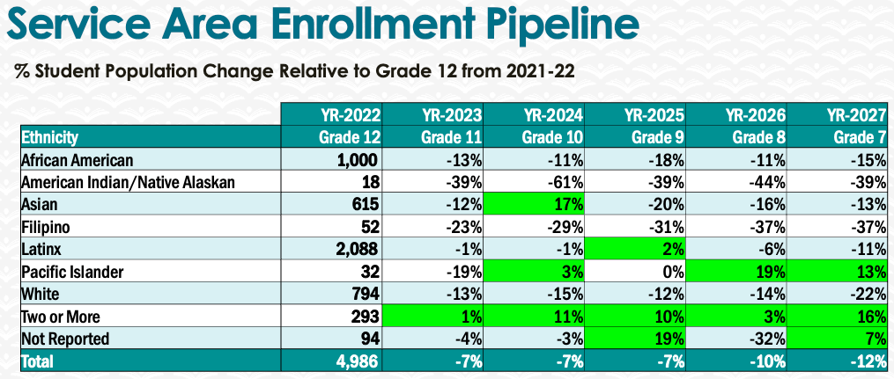
Dual enrollment:
Offer additional business classes for high school students after consulting with their counselors.
Create short business certificates for high school students.
Additional resources to help recruit faculty members to teach the additional courses.

5. Facility Utilization Needs

Assess your facilities utilization (including labs, support for online learning, and other spaces) and for next year, indicate if the space is sufficient or not. If not, what are the needs and why? Work with your Dean to check on your needs prior to responding this section.
Fully functional smart classrooms are necessary in order for the department to offer face-to-face and hybrid courses. Mini or USB microphones for lecturing in class with masks on. Webcams, document cameras, external SSD drives for storing and presenting lectures and class materials, proper lighting, and faster laptops for renderings are needed for faculty members for recording lectures and preparing documents.

6. Assessment
Berkeley City College is committed to a culture of assessment to improve instruction, services, and institutional planning. Findings from SLO, PLO, ALO assessments, and program review data are used to direct resources for areas that are institutional priorities that are articulated in the Educational Master Plan and BCC Strategic Plan.

Due to the critical role that course and program assessments play in our institutional planning and to be in compliance with the Accreditation requirements, assessments must be completed to qualify for the APU resource allocation requests.
6a. What action plans did your department identify upon the assessment of each SLOs and/or PLOs? For courses with multiple sections in the program, please list the main action plans. Please be as detailed as possible.
Department Chair to review the completed SLO reports and identify the action plans as needed.

6b. Describe the department’s progress on the Actions Plans identified for course Student Learning Outcomes (SLOs). If your department offers a degree or certificate, please describe the department’s progress on the Action Plans for Program Learning Outcomes (PLOs).
Assessment plans are being developed by the assessment liaison for the 2023 and 2024 assessments round.

6c. Describe the status of SLO and PLO completion in Rounds 4 and 5 of the Assessment Cycle. Identify the percent of completion. Briefly describe what needs to be done to reach 100% completion. Identify issues or concerns that may prevent your department from completing assessments of SLOs and/or PLOs.
Assessment for round 4 is ongoing and is being planned by the assessment liaison.

6d. Besides your syllabi, where are the program level outcomes published? If on a website, please specify the URL.
PLOs to be reviewed by the department chair.

7. Engagement
Discuss how faculty and classified staff have engaged in institutional efforts such as committees, presentations, and departmental activities. Please list the committees that full-time faculty participate in.
Business faculty members have sat on TRC committee, Assessment committee, Curriculum Committee, and Academic Senate.
Discuss how faculty and staff have engaged in community activities, partnerships and/or collaborations.
A Business department coordinator was hired in 2022 to coordinate community activities.
Discuss how adjunct faculty members are included in departmental training, discussions, and decision-making.
Full time and adjunct faculty members are regularly invited to and usually attend the department meetings. Adjunct faculty members have actively assisted in reviewing SLOs for the department.
- Discuss the relationship and engagement with other support services, programs, departments, or administrative units and how these relationships/collaboration support meeting your departmental goals.
Department chair has worked closely with the Guided Pathways program. The Guided Pathways program is designed to improve our level of AA-Ts and AS-Ts and shorten the period of time students need to attend to get an Associate Degree for transfer.
Are there areas you feel that your department can benefit more by increasing collaboration and partnership? How?
Counseling department: continue to maintain close relationship with our counselors to gain first-hand knowledge issues and needs of our new students.

8. Prioritized Resource Requests
During the 2021-22 Comprehensive Program Review process, you have provided your resource requests which went through the IPAR process. In this section, include resource requests from last year that are still needed and/or new resources that have emerged. Provide justifications. If there are no resource requested, leave the boxes blank.

Resource Category | Description/Justification | Estimated Cost
Personnel
Classified Staff
Student Worker | Tutors | $5,000
Part Time Faculty | Part time faculty members – dual enrollment | TBA
Professional Development
Department wide PD needed
Personal/Individual PD needed
Supplies
Software (for whom or role?) | Camtasia Studio for faculty members who record their own lectures. | College site license
Books, Magazines, and/or Periodicals | Latest edition of accounting textbooks on reserve in the library | $600
Instructional Supplies | SSD hard-drive/storage devices for presenting lectures | $700
Non-Instructional Supplies | Office supplies – faculty and tutors | $3,000
Technology & Equipment
Description/Justification (Before you list your technology request, click here to view the latest Technology Refresh Plan to verify whether it has already included.)
New | Faster personal computer for rendering videos. | BCC
Replacement
Facilities
Classrooms
Offices
Labs
Other
Library
Library materials (including streamline media needs)
Library collections
OER
Other
OTHER Description

Thank you for your time and effort in completing the Annual Program Update!
Please email the completed Program Review to your Dean by November 30, 2022

