Berkeley City College’s mission is to provide our diverse community with
educational opportunities, promote student success, and to transform lives.

Introduction and Directions

Berkeley City College (BCC), in conjunction with the Peralta community College District, has an institutional effectiveness process which consists of the following components: a District-wide Strategic Plan which is updated every six years; Comprehensive Program Reviews (CPRs) which are completed every three years; and Annual Program Updates (APUs) which are completed in non-program review years.

TIMELINE
Annual Program Update (APU) 2022-2023 timeline has been developed for each program and services to guide through the semester. Please review and work with your Deans, Managers, Department Chairs and/or Supervisors to complete this APU.

For BCC, 2022-2023 marks a critically important year as the college is in the process of revising its Educational Master Plan (EMP) for the next 5 years (2024-2028). This college EMP process will inform the District with their planning for their Strategic Plan. This year’s APU will take an especially important role for the EMP process, carrying your analysis, planning and strategies to support our students success, retention, and equitable completion.

The APU is intended to primarily focus upon planning for the subsequent year based on the institutional priorities. While developing the College’s EMP for the next 5 years, the college and the district focused on the Vision for Success identified by the California Community College Chancellor’s office as well as Student Centered Funding Formula (SCFF) that clearly delineate the categorized outcomes that the Colleges should be focusing. Please use these foci as your reference to prioritize your department and other goals.

RESOURCE REQUEST
In this process of making continuous quality improvement, there is an opportunity for each program, student services, and department to request resources that support achieving the stated goals. The APU process directly leads to the institutional resource allocation process and budget planning facilitated by the Institutional Planning and Allocation of Resources (IPAR) Committee for the following academic year (2023-24). The process for this can be found here (2022-23 APU Timeline). This is an opportunity for each department to request resources that will support your department goals and set outcomes.

TECHNOLOGY REQUEST
Finally, for the resource request section, please connect with your Deans, managers, and supervisors regarding your technology needs so that you can be informed about the equipment that is addressed in the BCC Technology Refresh Plan. If your requests are covered in the Refresh Plan, you do not need to request them in this APU.

If you have questions regarding other material in the Annual Program Update, please contact your Dean or Manager. If you have questions regarding data, please contact Dr. Phoumy Sayavong, Senior Researcher and Planning Analyst (psayavong@peralta.edu).

Please email the completed Annual Program Update to your Dean by November 30, 2022.

College Profile
Click here to view the Berkeley City College Student Demographics Dashboard.
This 2-page dashboard will provide data on the demographics of our student body from the past two years such as headcount, ethnicity, enrollment status, age group, educational goals, and majors.
College Outcomes | 2018-2019 | 2019-20 | 2020-21 | 2021-22
Full Time Equivalent Students (FTES) | 4,161 | 3,931 | 3,622 | 3,259
Productivity (Avg. Goal = 17.5) | 13 | 13.2 | 13 | 10.9
Success Rate (%) | 69% | 77% | 75%* | 70%*
Degrees + Certificates Awarded (#) | 948 | 1,109 | 1,027 | 960
*Excludes “EW” grades

To view prior Program Reviews, click here. To view prior Annual Program Updates, click here.

1a. Department Description
Please verify the mission statement for your department. If your department has not created a mission statement, provide details on how your department supports and contributes to the College’s mission.
The most important goal for Astronomy, is to provide students with the knowledge and skills they will need in order to perform successfully in the next stage of their careers, whether that stage involves transfer to a 4-year institution, entering a professional program of study such as nursing, or entering the workplace in a specialized field such as biotechnology. Another important goal is to build steppingstones to science in order to make careers in science accessible to students who have little or no background in science and math but who have been excited by the news and the potential of interesting jobs in biotechnology and other science related fields,

Name(s) of member(s) completing this APU | Department | Completion Date
Pieter de Haan | Science
List faculty names with assignments in fall 2022.
Full Time | Part Time
None | Matthew Fillingim

1b. Department Priorities & Goals
Based on the Vision for Success and SCFF, and your department mission, what are your department’s priorities and goals for 2022-23?
The Science department is looking for OER textbooks for the students. BIOL0-1A and 1B are using OPENSTAX books, the BIOL-10 is slowly moving to the OPENSTAX book. Organic Chemistry and Astronomy are also looking for this opportunity for the students.
We are also working on more AS-T degrees. Environmental Sciences will be launched in the Fall of 2023. Geography AD-T will probably launch in the Spring of 2024 together with the Physics AS-T degree. We implemented special learning techniques to close the equity gaps in our biology courses.

2. Student Equity, Success, & Completion
Using the data dashboards provided below, review and reflect upon the outcome trends for your department. Please also review overall BCC’s data linked here.

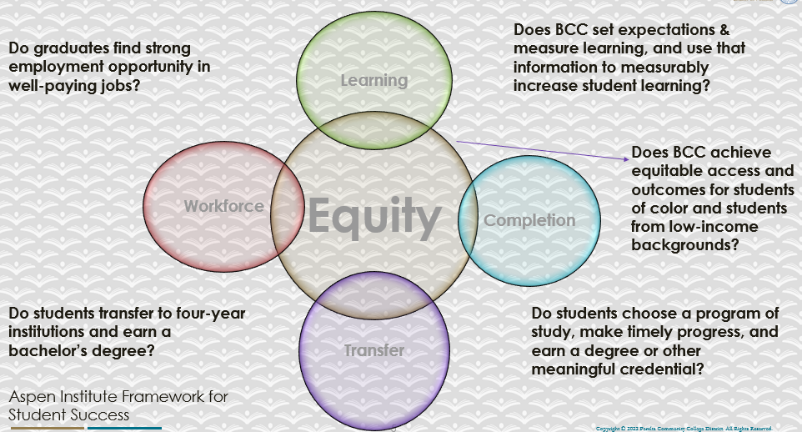

For assistance with data dashboards, contact Phoumy Sayavong at psayavong@peralta.edu
How are students doing in success and completion in your department, compared to the BCC overall success and completion rate? What are the group of students that need more attention to achieve goals?
Success and Completion rates for ASTR are much higher than the College rates.

What do you see as key factors in your department that contributed to positive success and completion rate?
In the major Biology courses, we are using teaching techniques we learned at the FLOSS workshops to decrease the equity gap. It seems to work!
What are some improvements your department can make? Identify strategies.
We always can improve our strategies by fine tuning our teaching techniques.

3a. Enrollment Trend and Productivity Dashboard
*Note that completion and retention rates are presented with the inclusion and exclusion of excused withdrawals (EW) and military withdrawals.
What were the enrollment trends in your department in the past three years?
In Astronomy we see a declining enrollment. The reason for this declining enrollment is the new Math prerequisites for Astronomy.

What strategies would you recommend to increase student enrollment in your department?
We should revisit the prerequisites for this course and see if it is necessary.

Community Colleges are funded based on the Student Centered Funding Formula (“SCFF”) which is comprised of the following allocations:

Student Centered Funding Formula: Focus and Priorities
% Of Allocation | Categories
70%  Base Allocation: FTES (Enrollment) | - Credit FTES  - NonCredit FTES  - Special Admits (Dual Enrollment, etc.)
20%  Supplemental Allocation | - Pell Grant  - AB 540  - Adult School  - Promise Grants
10%  Student Success Allocation | - Associate Degrees  - ADTs  - 9 or more CE units  - Transfer  - Transfer level Math and English in the first year

List the department’s progress and reflection on what is being done to maintain or increase the base level of full-time equivalent students (FTES = 12 units). Please describe retention (i.e., remain enrolled for a full semester) and persistence (i.e., enroll in consecutive semesters) efforts.
We are looking in Summer dual enrollment possibilities. We are also looking at NonCredit courses.

Please describe your department’s efforts in identifying Pell Grant recipients, College Promise Grant recipients, Adult Education, and AB 540 students. What processes are in place to accurately report these students each semester?

College Outcomes | 2018-2019 | 2019-2020 | 2020-21 | 2021-22
Full Time Equivalent Students (FTES) | 4,161 | 3,931 | 3,622 | 3,259
Pell Grant Recipients | 2,387 | 2,281 | 2,181 | 1,826
College Promise Grant Recipients | 4,373 | 4,143 | 4,011 | 3,500
AB 540 Students | 74 | 51 | 22 | 69

N/A I don’t understand this process. Who is reporting to whom?

3b. Course Completion and Retention Rates Dashboard – Instruction
*Note that completion and retention rates are presented with the inclusion and exclusion of excused withdrawals (EW) and military withdrawals.

If you need more guidance with this item, click here for additional support. Click here for additional guidance for how to view and use equity data. If you would like to view BCC’s Equity Plan, click here.
On page 3 of the “Course Completion and Retention Rates by Subject” dashboard, what are the completion and retention trends by gender, age, ethnicity in your department?
The average completion rate for Astronomy is 86.9% in 2019-2020 and 2020-2021 there were more females enrolled than males. In 2021-2022 the enrollment of females and males was the same. The completion rate for both sexes is decreasing, and the difference between Female and Male is stays the same e.g., 96.6% Males 87.5% Females in 2019-2020 to 84.0% Males and 75.0% Females in 2021-2022.
Age: Over the last three years the age groups fluctuated.
Ethnicity: A large decrease in completion of the Asian population is seen from 92.6% to 76.9% over the last 2 years. In 2019-2020 no Asian population was reported. For the African American population, we see an increase from 75.0% to 80.0% for completion. For the Hispanic population we see a decrease in completion from 95.7% to 69.2%. The white population slightly decreased in completion rate over the last 3 years from 96.2% to 92.3%.

When the data are disaggregated by student ethnic groups, gender, and age, how do you plan to address them over the next year?
After fine tuning of our equity reducing learning techniques in Biology, we are planning workshops in our department

What population(s) showed outcomes gains in your discipline(s) and which need more support?

Disaggregate the data and outcomes as far down as a possible then ask:
- What trends do you notice when examining course success rates for student populations by ethnicity? Which factors do you believe have the greatest impact (positive or negative) and cause variation between student course success rates in your Program? Describe some specific methods your department is planning or implementing to address these equity gaps. How will you evaluate the efficacy of these interventions?

- How has pivoting to online instruction contributed to potential reductions in student success? Provide some specific examples of practices that faculty in your department have found ineffective in the online environment.
Please review the video from the RP Group acknowledging the interrogation De Anza Community College committed to in their analysis of course completion and success rate.
Astronomy is a lecture course without labs. The overall completion and retention rate is high and the enrollment in this course is also high.

How do these outcome trends in your department compare to the college average?
The enrollment of this course and productivity is so much higher than the college average

How will these outcome trends you identified in this section affect your department goals and plans for the next year and what are your strategies to shift to move the trend towards a positive direction?
We are looking for a balance between online and in person classes. Eventually, all lab classes will be back in the classroom.

3c. Degrees and Certificates Dashboard
On page 1 of the “Degrees and Certificate Awards Trends” Dashboard, what are the award trends for your department (e.g., overall, by gender, age, and ethnicity)?
Astronomy has no degrees or awards. It is part of the GE requirement.

On page 4, what population(s) award trends showed gains in your program area and which populations need more support?
Astronomy is looking at free textbooks.

3d. Transfer Dashboard
This dashboard does not provide data by subject. Reflect on what you can do to affect student transfer. How may your department help to support BCC student transfer? (e.g., serve on panels, strengthen GP in your dept, change curriculum, increase number of AD-Ts, etc.)
The Department is looking at more AD-T degrees. See Biology, Physics and Geography

3e. Curriculum based on Guided Pathways
View the department’s curriculum through the lens of student equity outcomes.
- What intentional effort is your department making to create and present clear pathways for students through curriculum?
With the increase in our AS-T and AD-T programs we make it easier for the students to follow pathways.

- What are your plans for revising and/or creating new pathways supported by labor market information (LMI) and student demands? Using Vision for Success and SCFF focus, please indicate rationale and how the plans directly support student success and equitable completion.
With the launch of the Environmental Science and the geography program we heard from the students. A lot of students these days would love to study more in the environmental sciences and remote sensing areas.

4. Dual Enrollment
As continued decline in overall enrollment for college going population, it is important for us to look at who will be coming to BCC in the next 5 years. Reviewing the data provide here, what strategies would your department employ to address bringing more students to BCC?

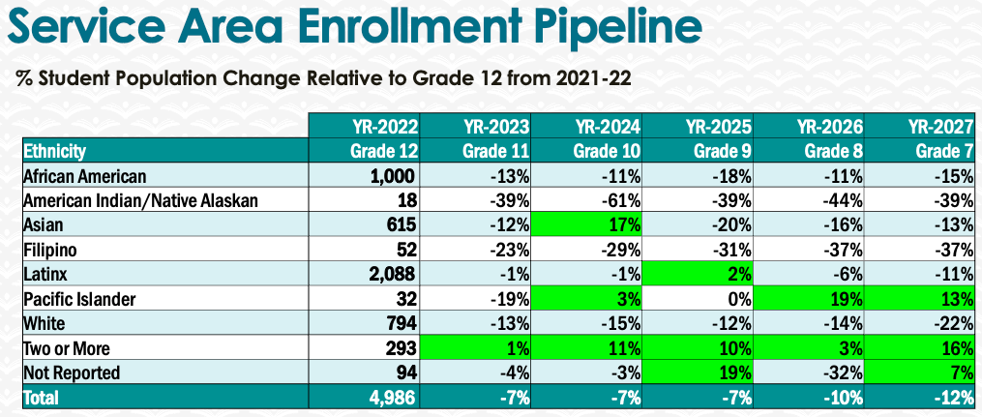
From this data we can see a decline in High School students. We as a department should go into the high schools to talk about the benefits of taking science courses at BCC.

5. Facility Utilization Needs

Assess your facilities utilization (including labs, support for online learning, and other spaces) and for next year, indicate if the space is sufficient or not. If not, what are the needs and why? Work with your Dean to check on your needs prior to responding this section.
N/A

6. Assessment
Berkeley City College is committed to a culture of assessment to improve instruction, services, and institutional planning. Findings from SLO, PLO, ALO assessments, and program review data are used to direct resources for areas that are institutional priorities that are articulated in the Educational Master Plan and BCC Strategic Plan.

Due to the critical role that course and program assessments play in our institutional planning and to be in compliance with the Accreditation requirements, assessments must be completed to qualify for the APU resource allocation requests.
6a. What action plans did your department identify upon the assessment of each SLOs and/or PLOs? For courses with multiple sections in the program, please list the main action plans. Please be as detailed as possible.
Action Plans for SLO1: Demonstrate knowledge of the fundamental forces and processes that shape planets, stars, star systems, galaxies, and the universe, and how we can learn about these objects from astronomical observations.
Action plans:
-Incorporated several new questions from a newly released test bank associated with the textbook.
-Increased discussion of tides, comets and asteroids, the difference between low and high mass star evolution, and different types of nebula is warranted based on learning gaps.
-Implement weekly check-ins with each student either via email or over Zoom to encourage students to keep on track and to address any issues in students' academic (or otherwise) lives.
-I am an occasional participant in astronomy teaching/education discussion groups. Over the past semester and a half, much of the discussion has focused on how instructors can effectively transition their face-to-face courses to online/virtual courses. These discussions have helped give me ideas (and will hopefully continue to give me ideas) on how to keep students engaged - including weekly check-ins for asynchronous online courses.
Action Plans for SLO2: Demonstrate knowledge of the origin, evolution, and main properties of objects in the Solar System, stars (including the Sun), galaxies (including the Milky Way), and the universe.
Action Plans:
- The action plans are similar for SLO1

6b. Describe the department’s progress on the Actions Plans identified for course Student Learning Outcomes (SLOs). If your department offers a degree or certificate, please describe the department’s progress on the Action Plans for Program Learning Outcomes (PLOs).
This course is not part of a degree or program.

6c. Describe the status of SLO and PLO completion in Rounds 4 and 5 of the Assessment Cycle. Identify the percent of completion. Briefly describe what needs to be done to reach 100% completion. Identify issues or concerns that may prevent your department from completing assessments of SLOs and/or PLOs.
ASTR will be assessed again during Fall 2023

6d. Besides your syllabi, where are the program level outcomes published? If on a website, please specify the URL.
The course action plans for ASTR are posted in curricunet:
https://peralta.curricunet.com/Form/Module/Index/4365
And
https://peralta.curricunet.com/Form/Module/Index/4371

7. Engagement
Discuss how faculty and classified staff have engaged in institutional efforts such as committees, presentations, and departmental activities. Please list the committees that full-time faculty participate in.
Science Faculty are engaged in the following committees:
Academic Senate
Assessment Committee
Chair Committee
Department Meetings
Facility Committee
Guided Pathway Committee
Hiring Committees
Roundtable
Tech Committee
Discuss how faculty and staff have engaged in community activities, partnerships and/or collaborations.
The faculty reported during the department meetings about the different committees.
Discuss how adjunct faculty members are included in departmental training, discussions, and decision-making.
If adjunct faculty are present at the department meetings, they are included in department training, discussions, and decision making. Julia Chang will take on the assessment liaison job for our department.
- Discuss the relationship and engagement with other support services, programs, departments, or administrative units and how these relationships/collaboration support meeting your departmental goals.
The Science department is a large department with many different disciplines (Astronomy, Biology, Biotechnology, Chemistry, Geography, Geology, Physics, and Physical Sciences) that use the tutor services in the LRC. Some faculty hold their office hours in this space for a more relaxed atmosphere.
Are there areas you feel that your department can benefit more by increasing collaboration and partnership? How?
We are in contact with Multimedia Arts to promote our programs (advertising)

8. Prioritized Resource Requests
During the 2021-22 Comprehensive Program Review process, you have provided your resource requests which went through the IPAR process. In this section, include resource requests from last year that are still needed and/or new resources that have emerged. Provide justifications. If there are no resource requested, leave the boxes blank.

Resource Category | Description/Justification | Estimated Cost
Personnel
Classified Staff
Student Worker
Part Time Faculty
Professional Development
Department wide PD needed
Personal/Individual PD needed
Supplies
Software (for whom or role?)
Books, Magazines, and/or Periodicals
Instructional Supplies
Non-Instructional Supplies
Technology & Equipment
Description/Justification (Before you list your technology request, click here to view the latest Technology Refresh Plan to verify whether it has already included.)
New
Replacement
Facilities
Classrooms
Offices
Labs
Other
Library
Library materials (including streamline media needs)
Library collections
OER
Other
OTHER Description

Thank you for your time and effort in completing the Annual Program Update!
Please email the completed Program Review to your Dean by November 30, 2022

