Berkeley City College’s mission is to provide our diverse community with
educational opportunities, promote student success, and to transform lives.

Introduction and Directions

Berkeley City College (BCC), in conjunction with the Peralta community College District, has an institutional effectiveness process which consists of the following components: a District-wide Strategic Plan which is updated every six years; Comprehensive Program Reviews (CPRs) which are completed every three years; and Annual Program Updates (APUs) which are completed in non-program review years.

TIMELINE
Annual Program Update (APU) 2022-2023 timeline has been developed for each program and services to guide through the semester. Please review and work with your Deans, Managers, Department Chairs and/or Supervisors to complete this APU.

For BCC, 2022-2023 marks a critically important year as the college is in the process of revising its Educational Master Plan (EMP) for the next 5 years (2024-2028). This college EMP process will inform the District with their planning for their Strategic Plan. This year’s APU will take an especially important role for the EMP process, carrying your analysis, planning and strategies to support our students success, retention, and equitable completion.

The APU is intended to primarily focus upon planning for the subsequent year based on the institutional priorities. While developing the College’s EMP for the next 5 years, the college and the district focused on the Vision for Success identified by the California Community College Chancellor’s office as well as Student Centered Funding Formula (SCFF) that clearly delineate the categorized outcomes that the Colleges should be focusing. Please use these foci as your reference to prioritize your department and other goals.

RESOURCE REQUEST PROCESS
In this process of making continuous quality improvement, there is an opportunity for each program, student services, and department to request resources that support achieving the stated goals. The APU process directly leads to the institutional resource allocation process and budget planning facilitated by the Institutional Planning and Allocation of Resources (IPAR) Committee for the following academic year (2023-24). The process for this can be found here (2022-23 APU Timeline). This is an opportunity for each department to request resources that will support your department goals and set outcomes.

TECHNOLOGY REQUEST
Finally, for the resource request section, please connect with your Deans, managers, and supervisors regarding your technology needs so that you can be informed about the equipment that is addressed in the BCC Technology Refresh Plan. If your requests are covered in the Refresh Plan, you do not need to request them in this APU.

If you have questions regarding other material in the Annual Program Update, please contact your Manager. If you have questions regarding data, please contact Dr. Phoumy Sayavong, Senior Researcher and Planning Analyst (psayavong@peralta.edu).

Please email the completed Annual Program Update to your Supervisor by November 30, 2022.

College Profile
Click here to view the Berkeley City College Student Demographics Dashboard.
This 2-page dashboard will provide data on the demographics of our student body from the past two years such as headcount, ethnicity, enrollment status, age group, educational goals, and majors.
College Outcomes | 2018-2019 | 2019-20 | 2020-21 | 2021-22
Full Time Equivalent Students (FTES) | 4161 | 3,931 | 3,622 | 3,259
Productivity (Avg. Goal = 17.5) | 13 | 13.2 | 13 | 10.9
Success Rate (%) | 69% | 77% | 75%* | 70%*
Degrees + Certificates Awarded (#) | 948 | 1,109 | 1,027 | 960
*Excludes “EW” grades

To view prior Program Reviews, click here. To view prior Annual Program Updates, click here.

1a. Program Description
Please verify the mission statement for your program. If your program has not created a mission statement, provide details on how your program supports and contributes to the College’s mission.
Name(s) of member(s) completing this APU | Program | Completion Date
Dr. Jenny Gough | American Sign Language | November 23, 2022
List staff names with assignments in fall 2022.
Full Time | Part Time
Dr. Jenny Gough & Iva Ikeda | N/A

1b. Program Priorities & Goals
Based on the Vision for Success and SCFF, and your program’s mission, what are your program’s priorities and goals for 2022-23?
Our program’s mission supports and aims to increase degree and certificate attainment and reduce the individual courses in one semester and put two classes in one semester as a fast track such as, classifiers level 1 and classifiers level 2 courses in one semester instead of classifiers 1 course in the fall and classifiers level 2 course in the spring.

2. Student Equity, Success, & Completion
Using the data dashboards provided below, review and reflect upon the outcome trends for your program. Please also review overall BCC’s data linked here.

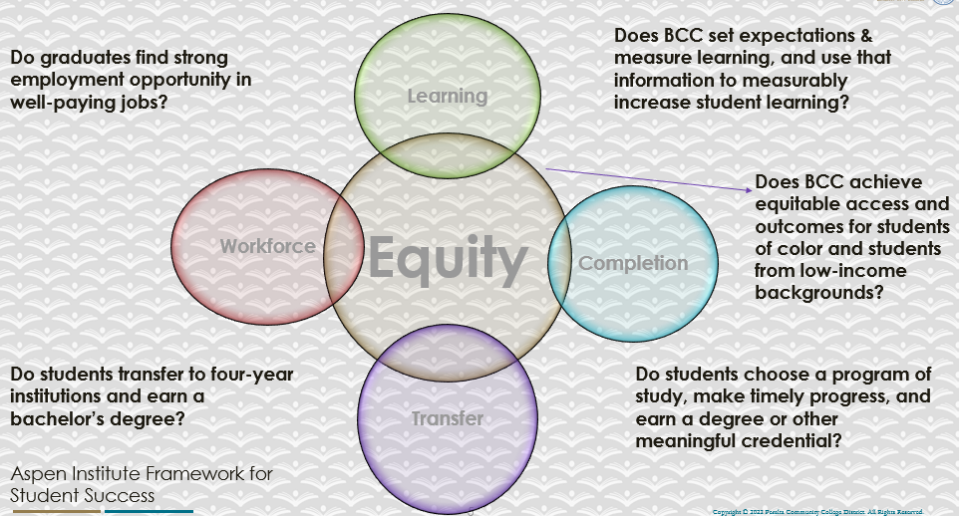

For assistance with data dashboards, contact Phoumy Sayavong at psayavong@peralta.edu
How are students doing in success and completion in your program? In comparison to the BCC overall success and completion rate, how are the students doing in your program? What are the group of students that needs more attention to achieve goals?
1. Course Completion and Retention Rates Dashboard- Instruction
There are 1-2% decrease significant changes. Course Completion-72% and Retention Rates-78% by ASL from all data is 72& and above.

2.
- Female students- 75% completion rate and 80%- retention rate
- Age- 30-34- 88% completion rate and 92% retention rate
- 79.2%- white completion rate and 85.5% retention rate
- 78.8%- Asian completion rate and 84.8% retention rate
- 75%- two or more completion rate and 77.3% retention rate

3. We need to invest other ethnicity and diverse students to achieve goals such as Hispanic/Latino and Black/African American. They both are 61% average for the completion rate and 70% retention rate. Also, we need to focus on X gender students since the data shown 53.6% completion rate and 64.3% retention rate.

What are key factors in your program that contributed to positive success and completion rate?
The highest percent of students who are:
- Female students- 75% completion rate and 80%- retention rate
- Age- 30-34- 88% completion rate and 92% retention rate
- 79.2%- white completion rate and 85.5% retention rate
- 78.8%- Asian completion rate and 84.8% retention rate
- 75%- two or more completion rate and 77.3% retention rate

What are some improvements your program can make? Identify strategies.
We need to invest other ethnicity and diverse students to achieve goals such as Hispanic/Latino and Black/African American. They both are 61% average for the completion rate and 70% retention rate. Also, we need to focus on X gender students since the data shown 53.6% completion rate and 64.3% retention rate.

Identify strategies:

- Recruiting high school students such as partnership with the dual program
- Expand ASL 50 courses since we have high # of enrollment of students
- Course planning strategy such as placing two courses into one semester instead of one course for the fall and another one for the spring (for example, fingerspelling level 1 and fingerspelling level 2). It may provide the motivation for students to complete the courses on time within two years instead of more than two years for the certificate or AA degree.
- Our current instructors who are part time, they all are white instructors. We need to hire diverse instructors such as x gender, Hispanic, black and other diverse instructors. This way we can have them as students’ role models and create this as positive environment for students to come in and learn the sign language.

3a. Enrollment Trend and Productivity Dashboard
*Note that completion and retention rates are presented with the inclusion and exclusion of excused withdrawals (EW) and military withdrawals.
What are the enrollment trends in your program in the last three years (if applicable) or college?
In the last three years the enrollment based on all data is decreased from 224 (year: 2018-2019) to 144 (year: 2021-2022). Total is 80 census enrollments decreased. The productivity based on all data is decreased from 12.8 (year: 2018-2019) to 10.2 (year: 2021-2022.) Total: 2.6 productivity decreased.

Note here: Will you add the new column of original # of enrollment students from day 1 of school starts to the day of census report? This way we can have better feeling with the # of enrollments increase or decrease and rationales for students to drop the course(s).

What strategies would you recommend to increase student enrollment in your program?
-Expand the partnership with dual programs and expand the ASL 50 courses.
-Expand instructors that are diverse. We have part time instructors who are white. We need diverse instructors to reflect their role models to our diverse students.
-Revisit the courses planning by placing our courses into one semester instead of each course for each semester (for example, classifiers level one- Fall semester and classifiers level two- Spring semester. Place them in one semester and squeeze them into 8 weeks course for each course).
-We possibly create new courses to meet students’ desire under our ASL program
-We maintain with the online courses and some of them face to face to meet all students’ educational needs

Community Colleges are funded based on the Student Centered Funding Formula (“SCFF”) which is comprised of the following allocations:

Student Centered Funding Formula: Focus and Priorities
% Of Allocation | Categories
70%  Base Allocation: FTES (Enrollment) | - Credit FTES  - NonCredit FTES  - Special Admits (Dual Enrollment, etc.)
20%  Supplemental Allocation | - Pell Grant  - AB 540  - Adult School  - Promise Grants
10%  Student Success Allocation | - Associate Degrees  - ADTs  - 9 or more CE units  - Transfer  - Transfer level Math and English in the first year

List the Program’s progress and reflection on how to maintain or increase student enrollment. Please describe retention (i.e., remain enrolled for a full semester) and persistence (i.e., enroll in consecutive semesters) efforts.
-Partnership with dual programs (special admits)
-Expand ASL 50 courses (online and face to face)
-Possible create new courses that suit our community’s needs.
-Revisit the courses planning and promote students to graduate on time within two years instead of more than two years to earn their certificate or A.A. degree.

This way we can get the good number of enrollment courses for a full semester.

Please describe your unit’s efforts in identifying Pell Grant recipients, College Promise Grant recipients, Adult Education, and AB 540 students. What processes are in place to accurately report these students each semester?

College Outcomes | 2018-2019 | 2019-2020 | 2020-21 | 2021-22
Full Time Equivalent Students (FTES) | 4,161 | 3,931 | 3,622 | 3,259
Pell Grant Recipients | 2,387 | 2,281 | 2,181 | 1,826
College Promise Grant Recipients | 4,373 | 4,143 | 4,011 | 3,500
AB 540 Students | 74 | 51 | 22 | 69

3b. Course Completion and Retention Rates Dashboard – Student Services
*Note that completion and retention rates are presented with the inclusion and exclusion of excused withdrawals (EW) and military withdrawals.

If you need more guidance with this item, click here for additional support. Click here for additional guidance for how to view and use equity data. If you would like to view BCC’s Equity Plan, click here.
On page 3 of the “Course Completion and Retention Rates by Subject” dashboard, what are the completion and retention trends by gender, age, ethnicity in your program/service area?
The highest percent of students who are:
- Female students- 75% completion rate and 80%- retention rate
- Age- 30-34- 88% completion rate and 92% retention rate
- 79.2%- white completion rate and 85.5% retention rate
- 78.8%- Asian completion rate and 84.8% retention rate
- 75%- two or more races completion rate and 77.3% retention rate

How can your Program improve trends over the next year?
- Recruit the other race students than white, Asian and two or more races
- Encourage them to complete courses on time
- Expand the part time diverse instructors
- Partnership with high schools
- Provide our supports to students other than white, Asian and two or more races
- Hire diverse part-time instructors to meet students’ educational needs and their potential role models.

What population(s) showed outcomes gains and which need more support?

Disaggregate the data and outcomes as far down as a possible then ask:
- What trends do you notice when examining course success rates for student populations by ethnicity? Which factors do you believe have the greatest impact (positive or negative) and cause variation between student course success rates in your Program? Describe some specific methods your Program is planning or implementing to address these equity gaps. How will you evaluate the efficacy of these interventions?

- How has pivoting to online instruction contributed to potential reductions in student success? Provide some specific examples of practices that staff in your Program have found ineffective in the online environment.
Please review the video from the RP Group acknowledging the interrogation De Anza Community College committed to in their analysis of course completion and success rate.
White, Asian and more than two races shown high percent succeed to complete the courses and retention rate.

Hispanic/Latino/a and Black/African American students shown at little above than 50% of succussed to complete the course and retention rates. That’s half of them succeed in our courses instead of all of them. I can see that we have white instructors who are part-time instructors and we have lack of diverse with their multicultural experiences and backgrounds instructors that reflect our students and lack of role models. I believe that our curriculum needs to show diverse backgrounds and better support system for them to succeed in class. In addition, our syllabus will need to modify to student friendly where they all can feel welcome and drive through our classes.

How do these outcome trends in your program compare to the college average?
The outcome trends compare to the college average from three years ago to present have slowly decreased.

For instance, the completion* for the Berkeley Community College from 78.5% (year: 2019-2020) to 71.6% (year: 2021-2022) and for retention* from 86.1% (2019-2020) to 69.9% (2021-2022). Total: completion rate decreased 6.6% and retention* decreased 2.2%

Our ASL program has shown slowly decreased. For instance, the completion* 76.5% (year: 2019-2020) to 69.9% (year: 2021-2022) and for retention* from 86.1% (2019-2020) to 83.9% (2021-2022) completion rate decreased 6.6% and retention* decreased 2.2%.

Berkeley City College and our ASL program are in similar average percentage of completion* and retention.

How will these outcome trends you identified in this section affect your program goals and plans for the next year and what are your strategies to shift the trend to go towards positive direction?
- Develop and modify the courses from face to face to online/hybrid courses for specific ASL courses
- Continue with embedded and LRC tutoring service for ASL students
- Partnership with high schools
- Hire more part time diverse Instructor(s)

3c. Degrees and Certificates Dashboard
On page 1 of the “Degrees and Certificate Awards Trends” Dashboard, what are the award trends for your program/service area (e.g., overall, by gender, age, and ethnicity)?
The award trends for ASL have decreased from 9 (year: 2019-2020) to 13 (year: 2020-2021) to 5 (year: 2021-2022).

Degrees & Certificates Conferred

Ethnicity:
Hispanic/Latino 30%
Asian 25%
White 21%
Black/African American 15%

Gender-
F- 61.8%
M- 36.1&
X-2.18%

Age
High percent- 19-24 years old
On page 4, what population(s) award trends showed gains in your program and which populations need more support?
Young age of 19-24 is very high # of students and # of women students are very high. Black/African American, Asian, Hispanic/Latino/a, two or more than races, and NR- they all need support from our system. We have low % of X gender students.

3d. Transfer Dashboard
This dashboard does not provide data by subject. Reflect on what you can do to affect student transfer. How may your Program help to support BCC student transfer? (e.g., serve on panels, strengthen GP in your dept, change curriculum, increase number of AD-Ts, etc.)
Our ASL department can offer panels, and work with counselor to hire coordinator or specialist to explain about university’ service.

3e. Curriculum based on Guided Pathways
View your program through the lens of student equity outcomes.
- How is your Program making pathways for students to complete their goals?
- Modify our curriculum, syllabus and support students to complete their goals.

4. Dual Enrollment
As continued decline in overall enrollment for college going population occurs, it is important for us to look at who will be coming to BCC in the next 5 years. Reviewing the data provide here, what strategies would your Program employ to address bringing more students to BCC?

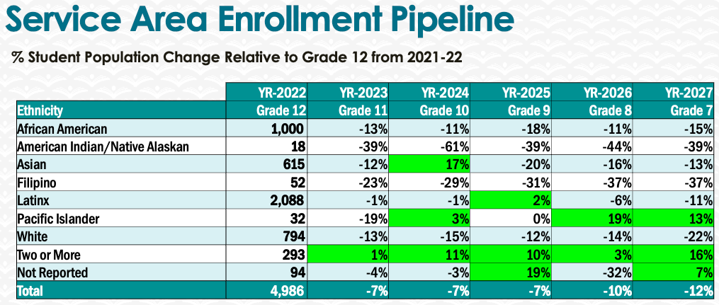

5. Facility Utilization Needs
Assess your facility utilization for next year and indicate if the space is sufficient or not. If not, what are the needs and why? Work with your manager to check on your needs prior to responding this section.
ASL classrooms- Deaf friendly
ASL labs
ASL LRC & embedded tutoring service

6. Assessment
Berkeley City College is committed to a culture of assessment to improve instruction, services, and institutional planning. Findings from SLO, PLO, ALO assessments, and program review data are used to direct resources for institutional priorities that are articulated in the Educational Master Plan and BCC Strategic Plan. Due to the critical role that course and program assessments play in our institutional planning and to be in compliance with the Accreditation requirements, assessments must be completed to qualify for APU resource allocation requests.
What action plans did your Program identify upon the assessment of each Service Area Outcomes (SAOs)? Please be as detailed as possible.
COVID-19 disruption (from in-person to OL conversion). ASL 50-53, ASL 55A & ASL 55B, ASL 202A and 202B, ASL 200 A & B, ASL 57 and ASL 464- Some of them are canceled due to low enrollment # of students. Some of the courses are online or face-to-face. The assessment needs to clean, and we will submit all of ASL 50 and 51. I completed some of them, and some are working in progress.

Describe the Program’s progress on the Action Plans identified for Service Area Outcomes (SAOs). Please be specific. Identify percentages towards completion of Action Plans. What Action Plans are priorities?
The progress with this program and Action Plans- the goal is to complete them and upload them with the template ready for instructors to submit them on time.
Also, the assessments are instructor-friendly in design and easy for them to calculate, write the report, and upload to it Curricunet. The priority goal of the Action Plans is to submit all of them every semester.

Describe the status of SAO completion in Rounds 4 and 5 of the Assessment Cycle. Identify the percentages of completion. Briefly describe what needs to be done to reach 100% completion? Identify issues or concerns that may prevent your area from completing assessments of SAOs.

The goal is complete 100% and the committees’ comments regarding the result of assessments slow the progress down. If they accept the result of assessments, then the template for feeding the assessments will be on time instead of overwhelming with other assessments.

How does your department, program, or unit ensure that students are aware of Service Area Outcomes?
Our department and program are designing the SLOs that match to our ASL curriculum and assessments that apply to students’ learning. It will lead the outcome of SLOs.

Where are the Service Area Outcomes published? If on a website, please specify the URL.
- https://www.actfl.org/sites/default/files/publications/standards/World-ReadinessStandardsforLearningLanguages.pdf
- https://aslta.org/wp-content/uploads/2014/07/National_ASL_Standards.pdf
- https://www.gallaudet.edu/Documents/ASL-Standards/K-12-ASL-Content-Standard.pdf
- https://www.lulu.com/shop/kim-brown-kurz/shop/kim-brown-kurz/learning-outcomes-for-american-sign-language-skills-levels-1-4/ebook/product-14npm7d5.html?page=1&pageSize=4

7. Engagement
Discuss how faculty and classified staff have engaged in institutional efforts such as committees, presentations, and departmental activities. Please list the committees that full-time faculty/staff/admin participate in.
Faculty and staff have engaged with committees, Academic Senate, Department Chair Council, and Assessment Committee.
Discuss how faculty and staff have engaged in community activities, partnerships and/or collaborations.
Faculty and staff have engaged in community activities such as American Sign Language Association of the Deaf, Conference of Interpreter Trainers, Registry of Interpreters for the Deaf (RID), ACTFL, NorCal RID, Bay Area ASLTA, and webinars/professional development trainings/conferences.
Discuss how part-time staff members are included in program trainings, discussions, and decision-making.
We attended department meetings, discussed about ASL classes, programs, students and the decision making. We also attended professional development trainings that benefited our program by revisiting our curriculum, materials, and goals.
- Discuss the relationship and engagement with other support services, programs, departments, or administrative units and how these relationships/collaboration support meeting your program goals.
- Department and administrative units- continue to support our program by providing our needs such as computers/laptops, ipads, studio room, ASL lab, high quality of interpreters, professional development trainings and continue to support our ASL classes.
Are there areas you feel that your department can benefit more by increasing collaboration and partnership? How?
-Dual program with High School for ASL 50 classes
-Partnership with community- police, firemen, EMT, and non-signers (parents who have Deaf child).
8. Prioritized Resource Requests
During the 2021-22 Comprehensive Program Review process, you have provided your resource requests which went through the IPAR process. In this section, include resource requests from last year that are still needed and/or new resources that have emerged. Provide justifications. If there are no resource requested, leave the boxes blank.

Resource Category | Description/Justification | Estimated Cost
Personnel
Classified Staff
Student Worker | LRC Tutor and Embedded Tutor for ASL department | 16,000 a year
Part Time Faculty
Professional Development
Department wide PD needed
Personal/Individual PD needed
Supplies
Software (for whom or role?)
Books, Magazines, and/or Periodicals
Instructional Supplies | Yr 1=  6 Digital Tablet Drawing Pen Tablets  4 Video Conference Lighting for Remote Working  2 Ipad pro  2 Apple Pencils  2 Dry-erase whiteboards  Yr 2=  6 Digital Tablet Drawing Pen Tablets  4 Video Conference Lighting for Remote Working  2 Ipad pro  2 Apple Pencils  2 Dry-erase whiteboards  Yr 3=  6 Digital Tablet Drawing Pen Tablets  4 Video Conference Lighting for Remote Working  2 Ipad pro  2 Apple Pencils  2 Dry-erase whiteboards | $600 ($100 each tablet)  $200 ($50 each lighting)  $2,500 ($1,250 each ipad pro) $200 ($100 each pencil  $70 ($35 each board)
Non-Instructional Supplies
Technology & Equipment
Description/Justification (Before you list your technology request, click here to view the latest Technology Refresh Plan to verify whether it has already included.)
New
Replacement
Facilities
Classrooms
Offices
Labs
Other
Library
Library materials (including streamline media needs) | 8 Signing Naturally Unit 1-6 video library subscirption  8 Signing Naturally Unit 7-12 video library subscritpion  10 Signing Naturally Unit 1-6 workbooks  6 Signing Naturally Unit 7-12 workbooks | $560 ($35 subscription per year)  $1360 work ooks ($85 per book)
Library collections
OER
Other
OTHER Description

Thank you for your time and effort in completing the Annual Program Update!
Please email the completed Program Review to your Dean by November 30, 2022.

