Berkeley City College’s mission is to provide our diverse community with
educational opportunities, promote student success, and to transform lives.

Introduction and Directions

Berkeley City College (BCC), in conjunction with the Peralta community College District, has an institutional effectiveness process which consists of the following components: a District-wide Strategic Plan which is updated every six years; Comprehensive Program Reviews (CPRs) which are completed every three years; and Annual Program Updates (APUs) which are completed in non-program review years.

TIMELINE
Annual Program Update (APU) 2022-2023 timeline has been developed for each program and services to guide through the semester. Please review and work with your Deans, Managers, Department Chairs and/or Supervisors to complete this APU.

For BCC, 2022-2023 marks a critically important year as the college is in the process of revising its Educational Master Plan (EMP) for the next 5 years (2024-2028). This college EMP process will inform the District with their planning for their Strategic Plan. This year’s APU will take an especially important role for the EMP process, carrying your analysis, planning and strategies to support our students success, retention, and equitable completion.

The APU is intended to primarily focus upon planning for the subsequent year based on the institutional priorities. While developing the College’s EMP for the next 5 years, the college and the district focused on the Vision for Success identified by the California Community College Chancellor’s office as well as Student Centered Funding Formula (SCFF) that clearly delineate the categorized outcomes that the Colleges should be focusing. Please use these foci as your reference to prioritize your department and other goals.

RESOURCE REQUEST
In this process of making continuous quality improvement, there is an opportunity for each program, student services, and department to request resources that support achieving the stated goals. The APU process directly leads to the institutional resource allocation process and budget planning facilitated by the Institutional Planning and Allocation of Resources (IPAR) Committee for the following academic year (2023-24). The process for this can be found here (2022-23 APU Timeline). This is an opportunity for each department to request resources that will support your department goals and set outcomes.

TECHNOLOGY REQUEST
Finally, for the resource request section, please connect with your Deans, managers, and supervisors regarding your technology needs so that you can be informed about the equipment that is addressed in the BCC Technology Refresh Plan. If your requests are covered in the Refresh Plan, you do not need to request them in this APU.

If you have questions regarding other material in the Annual Program Update, please contact your Dean or Manager. If you have questions regarding data, please contact Dr. Phoumy Sayavong, Senior Researcher and Planning Analyst (psayavong@peralta.edu).

Please email the completed Annual Program Update to your Dean by November 30, 2022.

College Profile
Click here to view the Berkeley City College Student Demographics Dashboard.
This 2-page dashboard will provide data on the demographics of our student body from the past two years such as headcount, ethnicity, enrollment status, age group, educational goals, and majors.
College Outcomes | 2018-2019 | 2019-20 | 2020-21 | 2021-22
Full Time Equivalent Students (FTES) | 4,161 | 3,931 | 3,622 | 3,259
Productivity (Avg. Goal = 17.5) | 13 | 13.2 | 13 | 10.9
Success Rate (%) | 69% | 77% | 75%* | 70%*
Degrees + Certificates Awarded (#) | 948 | 1,109 | 1,027 | 960
*Excludes “EW” grades

To view prior Program Reviews, click here. To view prior Annual Program Updates, click here.

1a. Department Description
Please verify the mission statement for your department. If your department has not created a mission statement, provide details on how your department supports and contributes to the College’s mission.
The philosophy program advances the mission of BCC in a few different ways.

First, it prepares students to transfer to a four year institution as a philosophy major. It does this by introducing students to the main questions within the major branches of philosophy, including metaphysics, epistemology, political theory, aesthetics, ethics, and logic; and by developing the critical thinking skills necessary for tackling those philosophical questions.

Second, philosophy courses provide ways for students to meet general education requirements for transfer and for associate degrees.

Name(s) of member(s) completing this APU | Department | Completion Date
Ari Krupnick | Arts and Cultural Studies | 11/30/22
List faculty names with assignments in fall 2022.
Full Time | Part Time
Ari Krupnick | Marc Lispi, Eric Gerlach

1b. Department Priorities & Goals
Based on the Vision for Success and SCFF, and your department mission, what are your department’s priorities and goals for 2022-23?
- Grow enrollment in philosophy courses
- Improve completion and retention rates (without changing academic standards), especially for disproportionately impacted students.
- Get more courses badged through POCR process

2. Student Equity, Success, & Completion
Using the data dashboards provided below, review and reflect upon the outcome trends for your department. Please also review overall BCC’s data linked here.

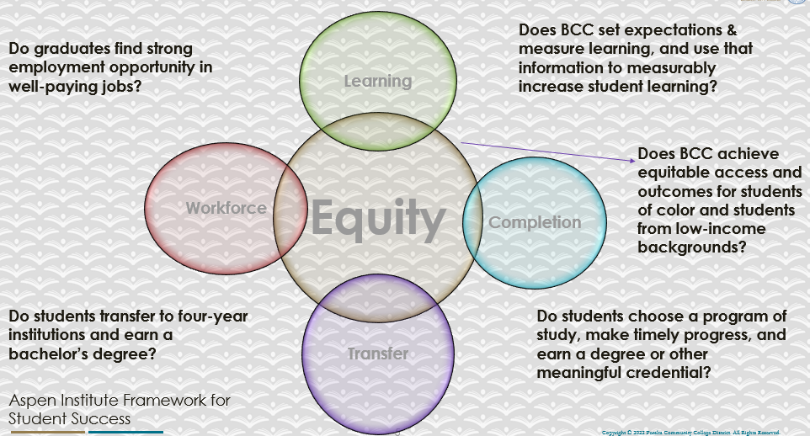

For assistance with data dashboards, contact Phoumy Sayavong at psayavong@peralta.edu
How are students doing in success and completion in your department, compared to the BCC overall success and completion rate? What are the group of students that need more attention to achieve goals?
Overall, the completion rate for philosophy courses is similar to the overall completion rate for courses across the college, although it was several points lower in both 19-20 and 21-22. The groups of students with the lowest completion rates relative to others are the Black/African American students and the Hispanic/Latino students.

What do you see as key factors in your department that contributed to positive success and completion rate?
Our instructors are dedicated, and are passionate about what they teach.

What are some improvements your department can make? Identify strategies.
We can improve online instruction. Various best practices, such as “humanizing” online learning and creating more “instructor presence” in an online class, helps all students engage with the course and complete it successfully, especially disproportionately impacted students.

3a. Enrollment Trend and Productivity Dashboard
*Note that completion and retention rates are presented with the inclusion and exclusion of excused withdrawals (EW) and military withdrawals.
What were the enrollment trends in your department in the past three years?
Enrollment has declined each of the past three years.

What strategies would you recommend to increase student enrollment in your department?
Put more courses through our POCR process to have them appear as badged courses on the CVC exchange. Improve quality of instruction, especially online instruction.

Community Colleges are funded based on the Student Centered Funding Formula (“SCFF”) which is comprised of the following allocations:

Student Centered Funding Formula: Focus and Priorities
% Of Allocation | Categories
70%  Base Allocation: FTES (Enrollment) | - Credit FTES  - NonCredit FTES  - Special Admits (Dual Enrollment, etc.)
20%  Supplemental Allocation | - Pell Grant  - AB 540  - Adult School  - Promise Grants
10%  Student Success Allocation | - Associate Degrees  - ADTs  - 9 or more CE units  - Transfer  - Transfer level Math and English in the first year

List the department’s progress and reflection on what is being done to maintain or increase the base level of full-time equivalent students (FTES = 12 units). Please describe retention (i.e., remain enrolled for a full semester) and persistence (i.e., enroll in consecutive semesters) efforts.
In terms of retention, instructors in the philosophy program make extra effort to ensure their presence is felt in the first weeks of the course (especially in an online environment), and they are compassionate instructors that reach out to struggling students and are generous in allowing them ways to catch up if they fall behind. In terms of persistence, philosophy instructors always announce to their current students what philosophy courses are available to them the next semester.

We also have a clear pathway to an ADT degree in philosophy, and ensure that our courses articulate with the most popular UC and CSU schools for transferring philosophy majors. Thus, philosophy students know that their coursework is advancing them towards their ultimate goal.

Please describe your department’s efforts in identifying Pell Grant recipients, College Promise Grant recipients, Adult Education, and AB 540 students. What processes are in place to accurately report these students each semester?

College Outcomes | 2018-2019 | 2019-2020 | 2020-21 | 2021-22
Full Time Equivalent Students (FTES) | 4,161 | 3,931 | 3,622 | 3,259
Pell Grant Recipients | 2,387 | 2,281 | 2,181 | 1,826
College Promise Grant Recipients | 4,373 | 4,143 | 4,011 | 3,500
AB 540 Students | 74 | 51 | 22 | 69

Does this question apply to the philosophy program? I don’t see how it does.

3b. Course Completion and Retention Rates Dashboard – Instruction
*Note that completion and retention rates are presented with the inclusion and exclusion of excused withdrawals (EW) and military withdrawals.

If you need more guidance with this item, click here for additional support. Click here for additional guidance for how to view and use equity data. If you would like to view BCC’s Equity Plan, click here.
On page 3 of the “Course Completion and Retention Rates by Subject” dashboard, what are the completion and retention trends by gender, age, ethnicity in your department?
19-20:
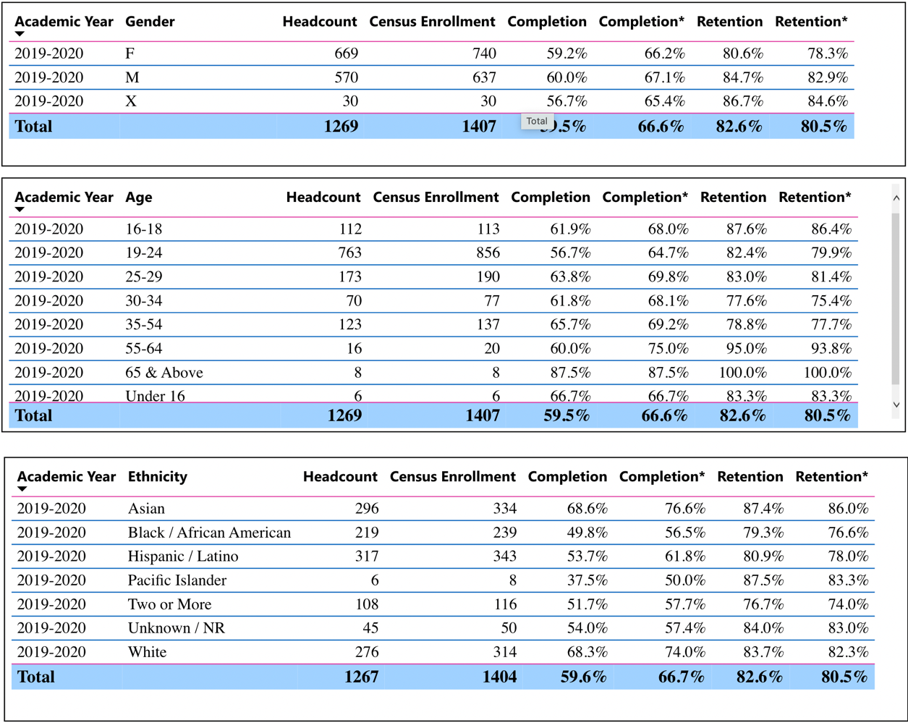

20-21:

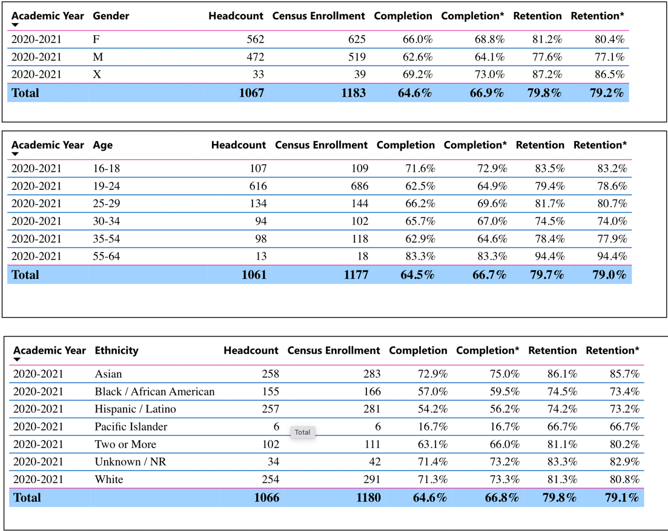

21-22:

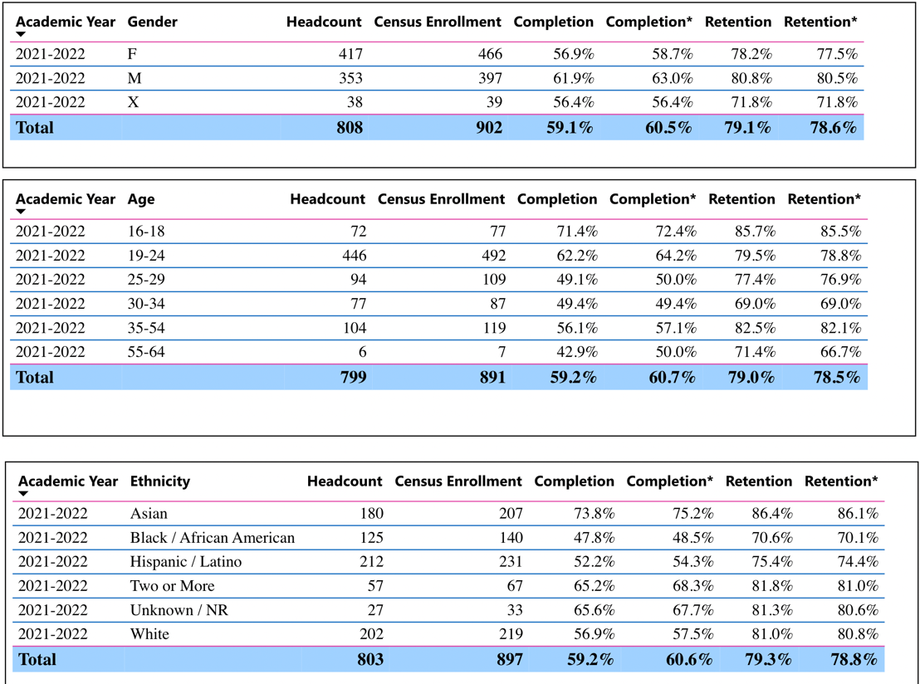

When the data are disaggregated by student ethnic groups, gender, and age, how do you plan to address them over the next year?
The most noticeable aspect of the data included above is that the completion and retention rates for Black/African American and Hispanic/Latino students is meaningfully lower than the completion and retention rates for other ethnic groups (specifically White and Asian students).
As mentioned above, one way to address this would be to increase the quality of online instruction (where most classes have been held the past few years), specifically by “humanizing” our online courses, so that they include increased instructor presence and a greater focus on community building. This practice helps all students, but particularly underserved students. Our FT instructor is enrolled in a 4 week @ONE course starting on 4/1/23 titled `Humanizing Online Teaching and Learning’, and he can share what he learns with the other philosophy instructors.

What population(s) showed outcomes gains in your discipline(s) and which need more support?

Disaggregate the data and outcomes as far down as a possible then ask:
- What trends do you notice when examining course success rates for student populations by ethnicity? Which factors do you believe have the greatest impact (positive or negative) and cause variation between student course success rates in your Program? Describe some specific methods your department is planning or implementing to address these equity gaps. How will you evaluate the efficacy of these interventions?

- How has pivoting to online instruction contributed to potential reductions in student success? Provide some specific examples of practices that faculty in your department have found ineffective in the online environment.
Please review the video from the RP Group acknowledging the interrogation De Anza Community College committed to in their analysis of course completion and success rate.
In terms of how we plan to address equity gaps, see the answer above. We would evaluate the efficacy of the suggested intervention by checking completion and retention rates after the intervention is implemented.

How do these outcome trends in your department compare to the college average?
There are no noticeable trends in the outcomes. There is some movement in certain groups year to year, but not in a consistent direction.

How will these outcome trends you identified in this section affect your department goals and plans for the next year and what are your strategies to shift to move the trend towards a positive direction?
See answers above.

3c. Degrees and Certificates Dashboard
On page 1 of the “Degrees and Certificate Awards Trends” Dashboard, what are the award trends for your department (e.g., overall, by gender, age, and ethnicity)?
There are too few awards of the philosophy ADT to discuss trends by group. Overall, except for a large jump in 19-20, the number of philosophy ADTs awarded has stayed at 1-2 per year.

On page 4, what population(s) award trends showed gains in your program area and which populations need more support?
Not applicable. See answer to previous question.

3d. Transfer Dashboard
This dashboard does not provide data by subject. Reflect on what you can do to affect student transfer. How may your department help to support BCC student transfer? (e.g., serve on panels, strengthen GP in your dept, change curriculum, increase number of AD-Ts, etc.)
We already have the Philosophy ADT. We can maintain and potentially increase articulation agreements with UC and CSU philosophy programs, and ensure philosophy courses satisfy as many UC/CSU general education requirements as possible.

3e. Curriculum based on Guided Pathways
View the department’s curriculum through the lens of student equity outcomes.
- What intentional effort is your department making to create and present clear pathways for students through curriculum?
We completed a complete program map for the Philosophy ADT---including specific recommendations for completing all GE requirements---but there is no public place to post this information where students would easily find it.

- What are your plans for revising and/or creating new pathways supported by labor market information (LMI) and student demands? Using Vision for Success and SCFF focus, please indicate rationale and how the plans directly support student success and equitable completion.
Not applicable.

4. Dual Enrollment
As continued decline in overall enrollment for college going population, it is important for us to look at who will be coming to BCC in the next 5 years. Reviewing the data provide here, what strategies would your department employ to address bringing more students to BCC?

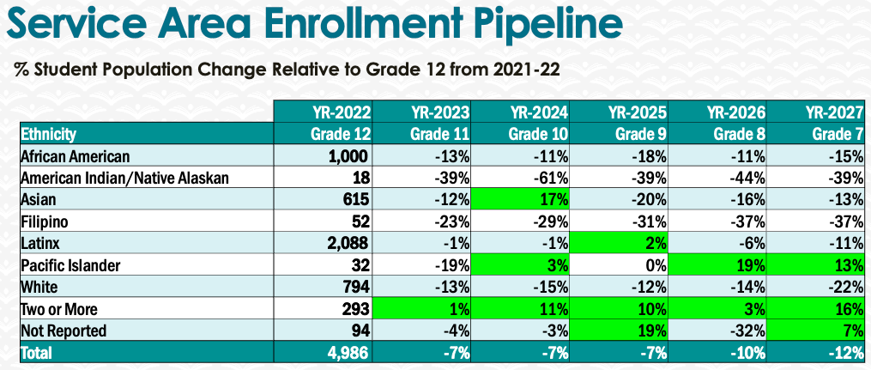
I’m not sure what the philosophy program specifically can do to bring more students to BCC. If the question is specifically about increasing dual enrollment, the philosophy program is willing to offer courses on a high-school campus, or teach a class of high-school students at BCC. My understanding is that the high-schools and the BCC administration are the ones who actually decide what courses would actually get selected for something like that.

5. Facility Utilization Needs

Assess your facilities utilization (including labs, support for online learning, and other spaces) and for next year, indicate if the space is sufficient or not. If not, what are the needs and why? Work with your Dean to check on your needs prior to responding this section.
Facilities are adequate for the philosophy program.

6. Assessment
Berkeley City College is committed to a culture of assessment to improve instruction, services, and institutional planning. Findings from SLO, PLO, ALO assessments, and program review data are used to direct resources for areas that are institutional priorities that are articulated in the Educational Master Plan and BCC Strategic Plan.

Due to the critical role that course and program assessments play in our institutional planning and to be in compliance with the Accreditation requirements, assessments must be completed to qualify for the APU resource allocation requests.
6a. What action plans did your department identify upon the assessment of each SLOs and/or PLOs? For courses with multiple sections in the program, please list the main action plans. Please be as detailed as possible.
PHIL 001 is the most heavily scheduled course in the philosophy program. Both SLOs for that course were assessed in Fall 2020.

The main action plans for SLO 1 were:
- Rather than having students write 3 significant papers (3-5 pages), have smaller written assignments each week where students can build proficiency in expository writing and in argument analysis, before trying their hand at a larger paper at the end of the semester.
- Use quizzes as a way for students to check their understanding of an argument before attempting to write about that argument.
- Use more specific rubrics to provide feedback on weekly writing assignments.
- Ideally, strong student work from previous semesters would be provided for every assignment where students are tasked with reconstructing or evaluating an argument.
- I would like to try covering fewer topics over the course of the semester, building in more activities for each topic that is covered. Hopefully this will yield a deeper understanding of the topics that are covered. I worry that, at the current pace, a number of students are left with a too superficial grasp of the theories/arguments under discussion (and this ultimately shows up in their papers).
The main action plans for SLO 2 were:
- While, overall, no significant learning gaps were identified, there were still some modules where the students struggled with the quiz more than usual, e.g., the quiz for Module 5. In those cases, it would likely help to provide more supporting material leading up to the quiz, such as instructor-written text to go along with each reading in the module that provides context and guidance for the student as they head into the reading, and more videos breaking down the readings.

The program outcomes for the Philosophy ADT have not been assessed. There are too few completers to provide data for such an assessment.
6b. Describe the department’s progress on the Actions Plans identified for course Student Learning Outcomes (SLOs). If your department offers a degree or certificate, please describe the department’s progress on the Action Plans for Program Learning Outcomes (PLOs).
For SLO 1 from PHIL 001, action plans 1, 2, and 3 have been implemented. Action plans 4 and 5 are in progress. For SLO 2, action plan 1 is in progress.

6c. Describe the status of SLO and PLO completion in Rounds 4 and 5 of the Assessment Cycle. Identify the percent of completion. Briefly describe what needs to be done to reach 100% completion. Identify issues or concerns that may prevent your department from completing assessments of SLOs and/or PLOs.
Assessment for round 5 is 40% complete. To get to 100%, PHIL 010, 016, 020A, 020B, 035, and 037 would have to be assessed. 020A is scheduled to be assessed this semester, and 020B and 035 are scheduled to be assessed next semester. 010, 016 and 037 have not been scheduled recently, and therefore have not been assessed. Lack of consistent scheduling for all courses is one obstacle to completing assessments.

6d. Besides your syllabi, where are the program level outcomes published? If on a website, please specify the URL.
PLOs for the Philosophy ADT are listed in the college catalog.

7. Engagement
Discuss how faculty and classified staff have engaged in institutional efforts such as committees, presentations, and departmental activities. Please list the committees that full-time faculty participate in.
Our FT faculty member has served as Chair of the Curriculum Committee for the past several years; served as faculty liaison for Guided Pathways for two semesters; and recently served on a hiring committee for Education.
Discuss how faculty and staff have engaged in community activities, partnerships and/or collaborations.
Our PT instructor Marc Lispi serves as faculty advisor to the Students for Social Change Club, and has scheduled a number of guest speakers for the campus community. In the past year, this has included, Olúfẹ́mi Táíwò on his book Elite Capture; Sam Mitrani on the historical origins of the police in the U.S.; Dr. Suzuki on the politics of public health during the Pandemic; Rory Fanning on military recruitment in the U.S. and a couple others.

Discuss how adjunct faculty members are included in departmental training, discussions, and decision-making.
Adjunct faculty are consulted before we make any significant updates to curriculum, such as changing SLOs or PLOs, or degree requirements. Our part-timers are also encouraged to complete SLO assessment on the sections they teach, and to develop and implement action plans based on those assessments. Adjuncts are also always encouraged to attend and participate in department meetings.

- Discuss the relationship and engagement with other support services, programs, departments, or administrative units and how these relationships/collaboration support meeting your departmental goals.
- Some philosophy courses are included in degrees and certificates outside of the philosophy program, which assists with our goal to increase enrollment in philosophy courses. For instance, PHIL 031A (as a required course) and PHIL 010 (as an elective) are included in the new cross-disciplinary Law, Public Policy, and Society AD-T. PHIL 011 is set to be included (as an elective) in the Data Analytics certificate which is currently in development. Our FT instructor has also recently reached out to Math and CS faculty to speak with them about recommending PHIL 011 (formal logic) to their students, and for their support for a sabbatical project which would make that course easier/more convenient for students to take.
Are there areas you feel that your department can benefit more by increasing collaboration and partnership? How?
PHIL 011 (formal logic) is a course that a lot of students who wouldn’t normally think of taking a philosophy class could benefit from, namely, math and computer science/programming students. The philosophy program would benefit from students in those areas being more aware of this course and how it could serve them. I’d like to increase collaboration with Math and CS around that course.

8. Prioritized Resource Requests
During the 2021-22 Comprehensive Program Review process, you have provided your resource requests which went through the IPAR process. In this section, include resource requests from last year that are still needed and/or new resources that have emerged. Provide justifications. If there are no resource requested, leave the boxes blank.

Resource Category | Description/Justification | Estimated Cost
Personnel
Classified Staff | Accessibility expert to help with section 508 compliance
Student Worker
Part Time Faculty
Professional Development
Department wide PD needed | PD courses relating to online instruction, such as those offered by @ONE | $300
Personal/Individual PD needed
Supplies
Software (for whom or role?)
Books, Magazines, and/or Periodicals
Instructional Supplies
Non-Instructional Supplies
Technology & Equipment
Description/Justification (Before you list your technology request, click here to view the latest Technology Refresh Plan to verify whether it has already included.)
New
Replacement
Facilities
Classrooms
Offices | Private, quiet spaces for prepping and meeting with students
Labs
Other
Library
Library materials (including streamline media needs)
Library collections
OER | Accessibility remediation for OER
Other
OTHER Description

Thank you for your time and effort in completing the Annual Program Update!
Please email the completed Program Review to your Dean by November 30, 2022

