Berkeley City College’s mission is to provide our diverse community with
educational opportunities, promote student success, and to transform lives.

Introduction and Directions

Berkeley City College (BCC), in conjunction with the Peralta community College District, has an institutional effectiveness process which consists of the following components: a District-wide Strategic Plan which is updated every six years; Comprehensive Program Reviews (CPRs) which are completed every three years; and Annual Program Updates (APUs) which are completed in non-program review years.

TIMELINE
Annual Program Update (APU) 2022-2023 timeline has been developed for each program and services to guide through the semester. Please review and work with your Deans, Managers, Department Chairs and/or Supervisors to complete this APU.

For BCC, 2022-2023 marks a critically important year as the college is in the process of revising its Educational Master Plan (EMP) for the next 5 years (2024-2028). This college EMP process will inform the District with their planning for their Strategic Plan. This year’s APU will take an especially important role for the EMP process, carrying your analysis, planning and strategies to support our students success, retention, and equitable completion.

The APU is intended to primarily focus upon planning for the subsequent year based on the institutional priorities. While developing the College’s EMP for the next 5 years, the college and the district focused on the Vision for Success identified by the California Community College Chancellor’s office as well as Student Centered Funding Formula (SCFF) that clearly delineate the categorized outcomes that the Colleges should be focusing. Please use these foci as your reference to prioritize your department and other goals.

RESOURCE REQUEST
In this process of making continuous quality improvement, there is an opportunity for each program, student services, and department to request resources that support achieving the stated goals. The APU process directly leads to the institutional resource allocation process and budget planning facilitated by the Institutional Planning and Allocation of Resources (IPAR) Committee for the following academic year (2023-24). The process for this can be found here (2022-23 APU Timeline). This is an opportunity for each department to request resources that will support your department goals and set outcomes.

TECHNOLOGY REQUEST
Finally, for the resource request section, please connect with your Deans, managers, and supervisors regarding your technology needs so that you can be informed about the equipment that is addressed in the BCC Technology Refresh Plan. If your requests are covered in the Refresh Plan, you do not need to request them in this APU.

If you have questions regarding other material in the Annual Program Update, please contact your Dean or Manager. If you have questions regarding data, please contact Dr. Phoumy Sayavong, Senior Researcher and Planning Analyst (psayavong@peralta.edu).

Please email the completed Annual Program Update to your Dean by November 30, 2022.

College Profile
Click here to view the Berkeley City College Student Demographics Dashboard.
This 2-page dashboard will provide data on the demographics of our student body from the past two years such as headcount, ethnicity, enrollment status, age group, educational goals, and majors.
College Outcomes | 2018-2019 | 2019-20 | 2020-21 | 2021-22
Full Time Equivalent Students (FTES) | 4,161 | 3,931 | 3,622 | 3,259
Productivity (Avg. Goal = 17.5) | 13 | 13.2 | 13 | 10.9
Success Rate (%) | 69% | 77% | 75%* | 70%*
Degrees + Certificates Awarded (#) | 948 | 1,109 | 1,027 | 960
*Excludes “EW” grades

To view prior Program Reviews, click here. To view prior Annual Program Updates, click here.

1a. Department Description
Please verify the mission statement for your department. If your department has not created a mission statement, provide details on how your department supports and contributes to the College’s mission.
Humanities courses at BCC explore ways of thinking, being, and living in a global, transnational and interdisciplinary perspective by guiding student learning in an historically grounded and critically engaged approach to a variety of subjects. Comprising disciplines concerned with human thought, creativity, and experience, courses in the Humanities allow students to study foundations in personal and community values, cultural views, religious beliefs, and aesthetic practices (including film and other arts) and theories.

Name(s) of member(s) completing this APU | Department | Completion Date
Dylan Eret, Laura Ruberto | Arts and Cultural Studies/ Humanities | 11/30/22
List faculty names with assignments in fall 2022.
Full Time | Part Time
Dylan Eret  Laura Ruberto | Avy Valladares  Shawn Doubiago

1b. Department Priorities & Goals
Based on the Vision for Success and SCFF, and your department mission, what are your department’s priorities and goals for 2022-23?
- To see the Film Studies AA degree approved and ready to be implemented in Fall 2023.
- To increase student retention and success and thus enrollment.

2. Student Equity, Success, & Completion
Using the data dashboards provided below, review and reflect upon the outcome trends for your department. Please also review overall BCC’s data linked here.

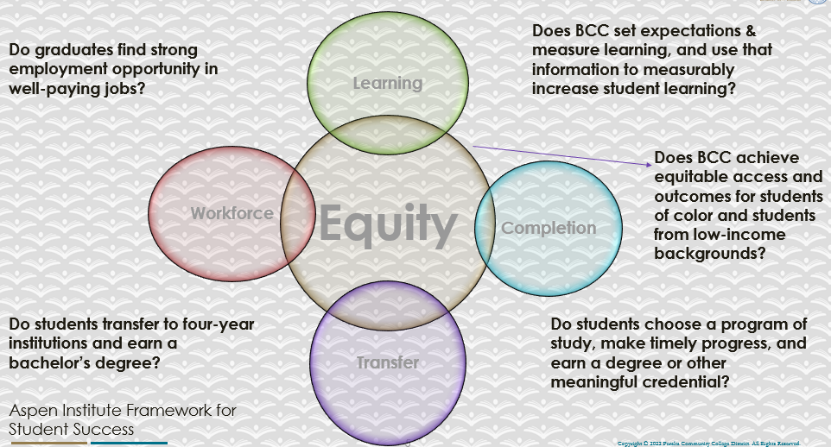

For assistance with data dashboards, contact Phoumy Sayavong at psayavong@peralta.edu
How are students doing in success and completion in your department, compared to the BCC overall success and completion rate? What are the group of students that need more attention to achieve goals?
The completion rates (without MW/EW) for Humanities are 2.9% above the college average (87.2%). The retention rates (without MW/EW) are 3.0% above the college average, even across most student groups (86.9%).

What do you see as key factors in your department that contributed to positive success and completion rate?
We work closely each semester to diversify our course offerings through the scheduling process, adapt our pedagogies to fit the modality of a particular course, and experiment with methods of engagement to keep students on track when disruptions arise within each course (staying compassionate whenever we can).

What are some improvements your department can make? Identify strategies.
- Assist our faculty in their preferred teaching practices: support face-to-face learning outside the classroom, guest lectures, collaborative teaching, and other experimental approaches to teaching.
- Submit courses for POCR review.

3a. Enrollment Trend and Productivity Dashboard
*Note that completion and retention rates are presented with the inclusion and exclusion of excused withdrawals (EW) and military withdrawals.
What were the enrollment trends in your department in the past three years?
What are your enrollment trends in the past three years?
Our productivity has fallen since the beginning of the pandemic: from 14.5 2019-2020 to 11.3 2021-2022. Our productivity seems to be higher in Summer and Fall. These changes likely have more to do with the changing enrollments trends between FTF and online courses during the pandemic.
What strategies would you recommend to increase student enrollment in your department?
- Create an advertising campaign for our programs and courses (especially for in-person courses).
- Work with Learning Communities and local high schools to match students to our courses.
- Develop new courses and make sure we offer courses at different times and modalities.
- Increase course offerings in Fall to account for higher enrollment.
- Get courses POCR approved.

Community Colleges are funded based on the Student Centered Funding Formula (“SCFF”) which is comprised of the following allocations:

Student Centered Funding Formula: Focus and Priorities
% Of Allocation | Categories
70%  Base Allocation: FTES (Enrollment) | - Credit FTES  - NonCredit FTES  - Special Admits (Dual Enrollment, etc.)
20%  Supplemental Allocation | - Pell Grant  - AB 540  - Adult School  - Promise Grants
10%  Student Success Allocation | - Associate Degrees  - ADTs  - 9 or more CE units  - Transfer  - Transfer level Math and English in the first year

List the department’s progress and reflection on what is being done to maintain or increase the base level of full-time equivalent students (FTES = 12 units). Please describe retention (i.e., remain enrolled for a full semester) and persistence (i.e., enroll in consecutive semesters) efforts.
Please describe your department’s efforts in identifying Pell Grant recipients, College Promise Grant recipients, Adult Education, and AB 540 students. What processes are in place to accurately report these students each semester?

College Outcomes | 2018-2019 | 2019-2020 | 2020-21 | 2021-22
Full Time Equivalent Students (FTES) | 4,161 | 3,931 | 3,622 | 3,259
Pell Grant Recipients | 2,387 | 2,281 | 2,181 | 1,826
College Promise Grant Recipients | 4,373 | 4,143 | 4,011 | 3,500
AB 540 Students | 74 | 51 | 22 | 69

3b. Course Completion and Retention Rates Dashboard – Instruction
*Note that completion and retention rates are presented with the inclusion and exclusion of excused withdrawals (EW) and military withdrawals.

If you need more guidance with this item, click here for additional support. Click here for additional guidance for how to view and use equity data. If you would like to view BCC’s Equity Plan, click here.
On page 3 of the “Course Completion and Retention Rates by Subject” dashboard, what are the completion and retention trends by gender, age, ethnicity in your department?
Our course completion rates (without MW/EW) are about 3% greater than the college average across these categories.

When the data are disaggregated by student ethnic groups, gender, and age, how do you plan to address them over the next year?
Depending on the course or modality, we plan to work on improving the completion and retention rates for African-American and Latinx students.

What population(s) showed outcomes gains in your discipline(s) and which need more support?

Disaggregate the data and outcomes as far down as a possible then ask:
- What trends do you notice when examining course success rates for student populations by ethnicity? Which factors do you believe have the greatest impact (positive or negative) and cause variation between student course success rates in your Program? Describe some specific methods your department is planning or implementing to address these equity gaps. How will you evaluate the efficacy of these interventions?

- How has pivoting to online instruction contributed to potential reductions in student success? Provide some specific examples of practices that faculty in your department have found ineffective in the online environment.
Please review the video from the RP Group acknowledging the interrogation De Anza Community College committed to in their analysis of course completion and success rate.
How do these outcome trends in your department compare to the college average?
How will these outcome trends you identified in this section affect your department goals and plans for the next year and what are your strategies to shift to move the trend towards a positive direction?

3c. Degrees and Certificates Dashboard
On page 1 of the “Degrees and Certificate Awards Trends” Dashboard, what are the award trends for your department (e.g., overall, by gender, age, and ethnicity)?
NA

On page 4, what population(s) award trends showed gains in your program area and which populations need more support?
NA

3d. Transfer Dashboard
This dashboard does not provide data by subject. Reflect on what you can do to affect student transfer. How may your department help to support BCC student transfer? (e.g., serve on panels, strengthen GP in your dept, change curriculum, increase number of AD-Ts, etc.)
Humanities faculty regularly support transfer through informal mentoring of students, bringing graduate students and faculty from four-year universities into our classrooms, bringing students to UCB on course-related field studies, reading student’s transfer application essays, among other ways.

3e. Curriculum based on Guided Pathways
View the department’s curriculum through the lens of student equity outcomes.
- What intentional effort is your department making to create and present clear pathways for students through curriculum?
Our faculty work with the GP (ACC) program to help implement clear paths for our students. We have created an AA in Film Studies, integrating all the film studies courses in Humanities and across the college.

- What are your plans for revising and/or creating new pathways supported by labor market information (LMI) and student demands? Using Vision for Success and SCFF focus, please indicate rationale and how the plans directly support student success and equitable completion.
NA

4. Dual Enrollment
As continued decline in overall enrollment for college going population, it is important for us to look at who will be coming to BCC in the next 5 years. Reviewing the data provide here, what strategies would your department employ to address bringing more students to BCC?

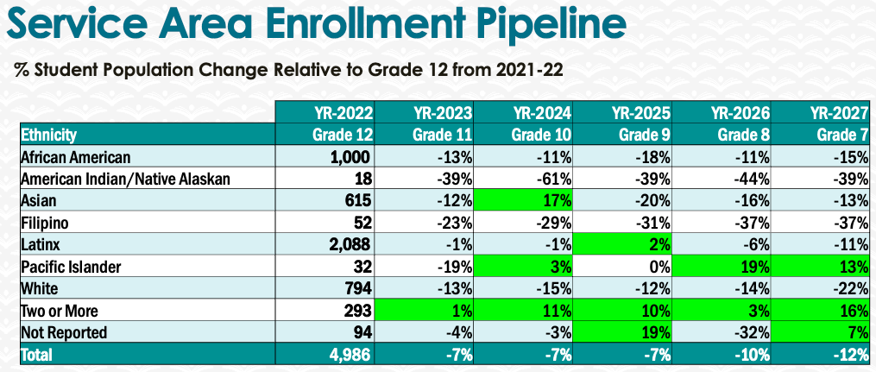

5. Facility Utilization Needs

Assess your facilities utilization (including labs, support for online learning, and other spaces) and for next year, indicate if the space is sufficient or not. If not, what are the needs and why? Work with your Dean to check on your needs prior to responding this section.
- We need updated classroom space that is current with modern technology needs.
- We need quiet, private instructor office space for prepping, grading, and meeting with students
- We need a dedicated classroom space specific to Humanities courses (both in-person and online) that meet for special events, guest lectures, or workshops, ideally 1-2 days/times per month.

6. Assessment
Berkeley City College is committed to a culture of assessment to improve instruction, services, and institutional planning. Findings from SLO, PLO, ALO assessments, and program review data are used to direct resources for areas that are institutional priorities that are articulated in the Educational Master Plan and BCC Strategic Plan.

Due to the critical role that course and program assessments play in our institutional planning and to be in compliance with the Accreditation requirements, assessments must be completed to qualify for the APU resource allocation requests.
6a. What action plans did your department identify upon the assessment of each SLOs and/or PLOs? For courses with multiple sections in the program, please list the main action plans. Please be as detailed as possible.
By and large our assessments of SLOs show that we are successful in having students reach course SLOs. Action plans tend to include continuing to work with colleagues to consider new and dynamic teaching models, including field trips and guest lectures. We also need to continue to work with BCC’s library and the DE program to further develop our courses.

6b. Describe the department’s progress on the Actions Plans identified for course Student Learning Outcomes (SLOs). If your department offers a degree or certificate, please describe the department’s progress on the Action Plans for Program Learning Outcomes (PLOs).
We do not have immediate plans for assessing the Liberal Arts AA degree. We need to work with other programs and departments to do this.

6c. Describe the status of SLO and PLO completion in Rounds 4 and 5 of the Assessment Cycle. Identify the percent of completion. Briefly describe what needs to be done to reach 100% completion. Identify issues or concerns that may prevent your department from completing assessments of SLOs and/or PLOs.
Please review the SLO and PLO spreadsheets housed and managed by the Assessment committee at BCC.

6d. Besides your syllabi, where are the program level outcomes published? If on a website, please specify the URL.
https://www.berkeleycitycollege.edu/slo/student-learning-outcomes/

7. Engagement
Discuss how faculty and classified staff have engaged in institutional efforts such as committees, presentations, and departmental activities. Please list the committees that full-time faculty participate in.
Laura Ruberto is on the Guided Pathways/Academic and Career Pathways committee; Laura recently stepped down as the TLC Faculty Coordinator and will be the assessment liaison for the ACS department in Spring 2023.
Both Dylan Eret and Laura Ruberto regularly participate in Arts and Cultural Studies Department meetings and related work.
Discuss how faculty and staff have engaged in community activities, partnerships and/or collaborations.
We connect our students to local museums and other institutions to encourage learning that moves beyond the classroom and community-building among students taking face-to-face courses (and getting students to experience learning outside their homes for online courses). We work with those places to offer discounted or free admission to students.
Discuss how adjunct faculty members are included in departmental training, discussions, and decision-making.
We regularly connect with all faculty teaching Humanities, involve them in assessment, curriculum development, and decision-making at all levels. We meet in-person and on Zoom.
- Discuss the relationship and engagement with other support services, programs, departments, or administrative units and how these relationships/collaboration support meeting your departmental goals.
- We especially connect with counselors as much as possible so that they are aware of our courses and work we are doing.
Are there areas you feel that your department can benefit more by increasing collaboration and partnership? How?
Yes—a directed, advertising campaign supporting our courses and other GE courses like ours.

Before the pandemic we had a developing relationship with the Berkeley Pacific Film Archive and Museum – our students were able to attend screenings and events for free. This program fell apart during the pandemic but it would be useful if we could have administrative assistance in restarting it.

8. Prioritized Resource Requests
During the 2021-22 Comprehensive Program Review process, you have provided your resource requests which went through the IPAR process. In this section, include resource requests from last year that are still needed and/or new resources that have emerged. Provide justifications. If there are no resource requested, leave the boxes blank.

Resource Category | Description/Justification | Estimated Cost
Personnel
Classified Staff | accessibility expert to help with section 508 compliance  Marketing expert to create and implement a marketing plan for our programs (We have had versions of this request on our APUs for at least 12 years without being fulfilled.)
Student Worker | Tutors to help students become stronger readers and critical thinkers for our humanities-content focused courses
Part Time Faculty | More part-time faculty for substitutes and/or course teaching needs
Professional Development
Department wide PD needed | To help develop dynamic teaching approaches online and face-to-face
Personal/Individual PD needed | Increase number of sabbaticals; increase funding for association memberships and conference travel
Supplies
Software (for whom or role?)
Books, Magazines, and/or Periodicals | A budget for books and media, including streaming services for videos
Instructional Supplies | On-going
Non-Instructional Supplies | On-going
Technology & Equipment
Description/Justification (Before you list your technology request, click here to view the latest Technology Refresh Plan to verify whether it has already included.)
New
Replacement | Full time faculty need computer refreshes more frequently than in past years; part-time faculty need laptops and other technology just like full-timers do.  (We have had versions of these requests on our APUs for at least 12 years, without being fulfilled)
Facilities
Classrooms | Updated classroom space with better sound and projection; dedicated classroom/lab for specified time (1-2 times per month) for a variety of Humanities online courses that meet for special projects, guest lectures, and workshops. (We have had versions of these requests on our APUs for at least 12 years.)
Offices | Private, quiet, faculty office space for prepping, grading and meeting with students. (We have had versions of these requests on our APUs for at least 12 years, without being fulfilled.)
Labs
Other
Library
Library materials (including streamline media needs) | High quality video streaming services
Library collections | Textbooks purchased  Humanities-focused books purchased
OER | On-going assistance finding these sources
Other
OTHER Description | Funds to support guest speakers in our classrooms and/or programs and to support classroom field studies  (We have had versions of these requests on our APUs for at least 12 years, without ever being fulfilled.)

Thank you for your time and effort in completing the Annual Program Update!
Please email the completed Program Review to your Dean by November 30, 2022

