Berkeley City College’s mission is to provide our diverse community with
educational opportunities, promote student success, and to transform lives.

Introduction and Directions

Berkeley City College (BCC), in conjunction with the Peralta community College District, has an institutional effectiveness process which consists of the following components: a District-wide Strategic Plan which is updated every six years; Comprehensive Program Reviews (CPRs) which are completed every three years; and Annual Program Updates (APUs) which are completed in non-program review years.

TIMELINE
Annual Program Update (APU) 2022-2023 timeline has been developed for each program and services to guide through the semester. Please review and work with your Deans, Managers, Department Chairs and/or Supervisors to complete this APU.

For BCC, 2022-2023 marks a critically important year as the college is in the process of revising its Educational Master Plan (EMP) for the next 5 years (2024-2028). This college EMP process will inform the District with their planning for their Strategic Plan. This year’s APU will take an especially important role for the EMP process, carrying your analysis, planning and strategies to support our students success, retention, and equitable completion.

The APU is intended to primarily focus upon planning for the subsequent year based on the institutional priorities. While developing the College’s EMP for the next 5 years, the college and the district focused on the Vision for Success identified by the California Community College Chancellor’s office as well as Student Centered Funding Formula (SCFF) that clearly delineate the categorized outcomes that the Colleges should be focusing. Please use these foci as your reference to prioritize your department and other goals.

RESOURCE REQUEST
In this process of making continuous quality improvement, there is an opportunity for each program, student services, and department to request resources that support achieving the stated goals. The APU process directly leads to the institutional resource allocation process and budget planning facilitated by the Institutional Planning and Allocation of Resources (IPAR) Committee for the following academic year (2023-24). The process for this can be found here (2022-23 APU Timeline). This is an opportunity for each department to request resources that will support your department goals and set outcomes.

TECHNOLOGY REQUEST
Finally, for the resource request section, please connect with your Deans, managers, and supervisors regarding your technology needs so that you can be informed about the equipment that is addressed in the BCC Technology Refresh Plan. If your requests are covered in the Refresh Plan, you do not need to request them in this APU.

If you have questions regarding other material in the Annual Program Update, please contact your Dean or Manager. If you have questions regarding data, please contact Dr. Phoumy Sayavong, Senior Researcher and Planning Analyst (psayavong@peralta.edu).

Please email the completed Annual Program Update to your Dean by November 30, 2022.

College Profile
Click here to view the Berkeley City College Student Demographics Dashboard.
This 2-page dashboard will provide data on the demographics of our student body from the past two years such as headcount, ethnicity, enrollment status, age group, educational goals, and majors.
College Outcomes | 2018-2019 | 2019-20 | 2020-21 | 2021-22
Full Time Equivalent Students (FTES) | 4,161 | 3,931 | 3,622 | 3,259
Productivity (Avg. Goal = 17.5) | 13 | 13.2 | 13 | 10.9
Success Rate (%) | 69% | 77% | 75%* | 70%*
Degrees + Certificates Awarded (#) | 948 | 1,109 | 1,027 | 960
*Excludes “EW” grades

To view prior Program Reviews, click here. To view prior Annual Program Updates, click here.

1a. Department Description
Please verify the mission statement for your department. If your department has not created a mission statement, provide details on how your department supports and contributes to the College’s mission.
In addition to the mission of the Social Sciences Department, the mission of the History discipline at Berkeley City College is for students to think critically and deeply about the historical processes that have shaped, and continue to shape, the world we live in.

Through Berkeley City College history courses, we undertake a critical analysis of ourselves and society through examinations of the historical forces that create change over time and define the contemporary moment. Our field of inquiry goes beyond the facts of history, to encompass questions of identity, knowledge, consciousness, “truth”, and meaning. At the same time, we provide students with critical thinking, reading, and writing skills that have applications well beyond the discipline.

History courses at Berkeley City College fulfill general education requirements, as well as the American Cultures requirement at UC and the United States History, Constitution, and American Ideals requirement at California State Universities. History classes meet both transfer and degree completion requirements. We have an AA-T in History and our classes are requirements in several Learning Communities, and support the AD-T degrees in Elementary Teacher Education and Political Science, as well as the AA degree in Global Studies. The BCC History program is well known for being incredibly diverse in the classes it offers and has one of the largest catalogs of History classes in the Peralta District.

The History discipline, through its course offerings and contribution towards degree completion and transfer, supports the College Mission in promoting student success, providing our diverse community with educational opportunities and transforming lives.

Name(s) of member(s) completing this APU | Department | Completion Date
Tim Rose | History | 11/30/22
List faculty names with assignments in fall 2022.
Full Time | Part Time
Tim Rose | Richard Kim  Robert Michael Noonan  Jennifer Helton

1b. Department Priorities & Goals
Based on the Vision for Success and SCFF, and your department mission, what are your department’s priorities and goals for 2022-23?
- Move at least two classes onto the CVC-OEI platform.
- Work with Guided Pathways program to build degree completion.
- Collaborate with the Counseling Department to attract more history majors and guide students toward degree completion.
- Maintain up-to-date curriculum in Curriqunet and consider curriculum growth as warranted.
- Assess courses as schedule through the SLO and section aggregate stages of the process.
- Develop a post-pandemic schedule that takes into account new trends for student demand.
- Through the faculty new-hire prioritization process, request an additional full-time history instructor.
- Bring the current history instructors together more frequently for check-in meetings.
- Use course assessment, instructor evaluation, and collaborative process among history faculty to ensure high quality instruction.

2. Student Equity, Success, & Completion
Using the data dashboards provided below, review and reflect upon the outcome trends for your department. Please also review overall BCC’s data linked here.

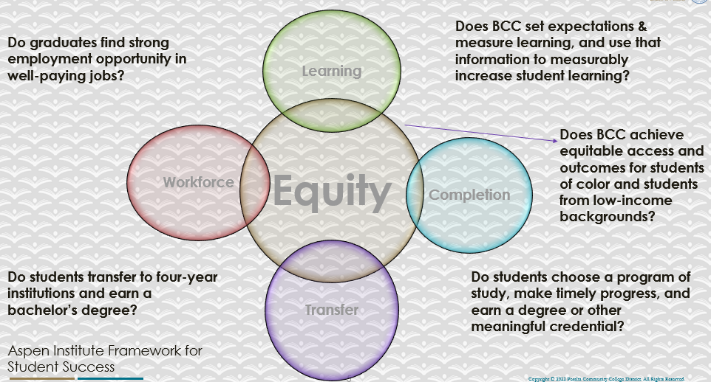

For assistance with data dashboards, contact Phoumy Sayavong at psayavong@peralta.edu
How are students doing in success and completion in your department, compared to the BCC overall success and completion rate? What are the group of students that need more attention to achieve goals?
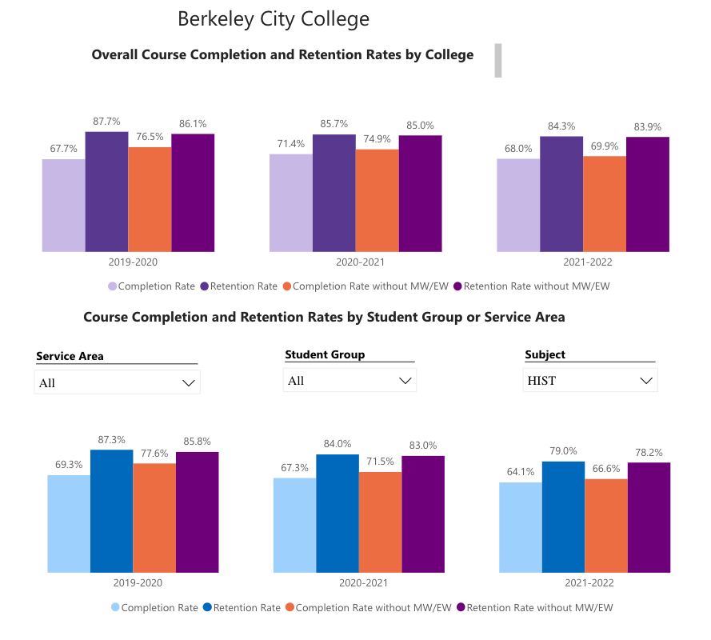

Completion and Retention General Trend:
The completion rate in history sections remains lower than the college-wide average. The academic year 2021-2022 showed the most significant decline in completion in comparison to the college-wide average in recent years; in 2019-2020, history section showed a higher completion rate than the college average, yet in 2021-2022, the split between history sections completion rate and the college average showed a 3% gap with history below the college average. Likewise, the retention rate in history sections that once matched the college average (academic year 2019-2020) has dropped below college average by slightly more than 5 percentage points. Overall, comparing completion and retention between 2019-2020 and 2021-2022 in history sections, there has been a decline in both categories. There was a five percent drop in completion (with MW/EW factored in) and an eight percent drop in retention (with MW/EW factored in). Scheduling may have played a modest role in the dropping completion and retention rates. Sections offered as 8-week terms tend to have lower completion and retention rates. Likewise, the trend for many history sections when offered online has been slightly lower completion and retention. Lingering disruptions from the pandemic might also have played a role in declining success metrics.

Success and retention rates might also be improved by better college-entry support for students. A high proportion of student who take history classes do not appear prepared to perform at college-level in terms of reading, writing, and study skills.

What do you see as key factors in your department that contributed to positive success and completion rate?
The strength of the history department lies in its faculty. The department has maintained a core of instructors over the past decade; all of whom have extensive experience teaching in community colleges and universities. All instructors in the history department have gone through the evaluation process in the past two years and all received excellent peer reviews and superlative student evaluations.

What are some improvements your department can make? Identify strategies.
The immediate goal is to move online history classes through the POCR process and receive CVC-OEI “badging.”

3a. Enrollment Trend and Productivity Dashboard
*Note that completion and retention rates are presented with the inclusion and exclusion of excused withdrawals (EW) and military withdrawals.
What were the enrollment trends in your department in the past three years?
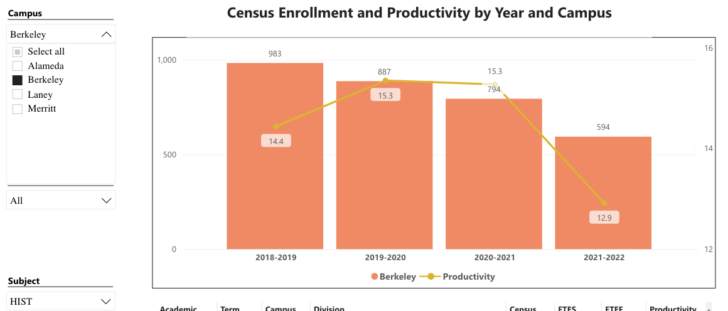
The three-year trend has been bad in all ways: history enrollments have dropped by roughly thirty-three percent; the productivity rate has dropped by 2.4. These are troubling numbers. But we might also note that a similar trend appears across the history programs in the PCCD.

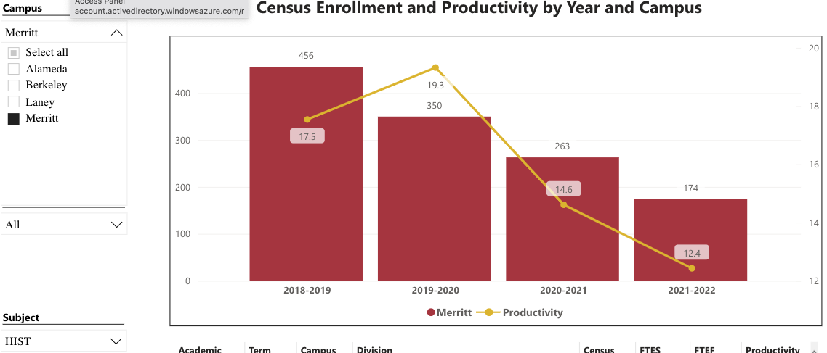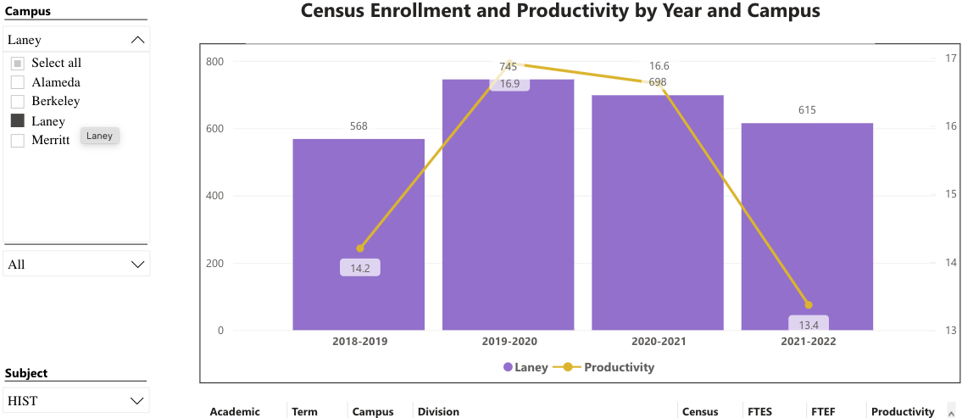

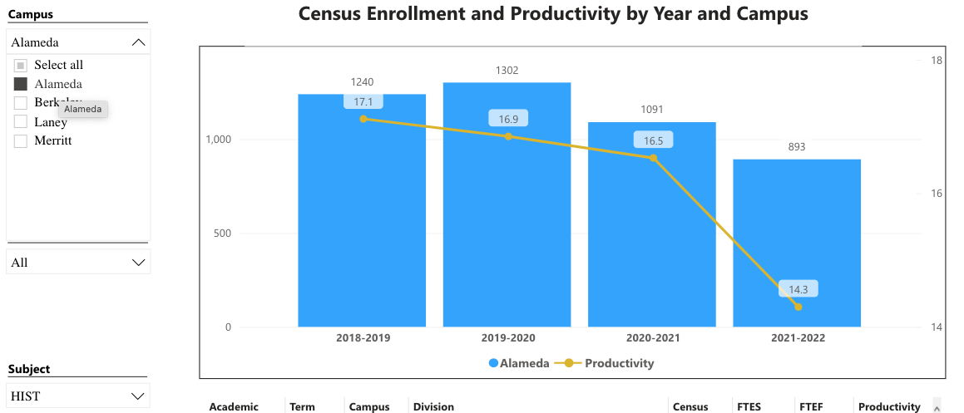

What strategies would you recommend to increase student enrollment in your department?
- Continue to build the Guided Pathways project to maintain enrollment.
- Increase contract education offerings at BYMCA and other local institutions.
- Improve/increase advertising of the college in Berkeley, Albany, Kensington, El Cerrito.
- Promote BCC courses at UC Berkeley.
- Expand the summer schedule where possible.
- College to hire a fulltime electronic media/website administrator to work with history instructors in building and maintaining attractive, current, and detailed departmental and faculty webpages.

Community Colleges are funded based on the Student Centered Funding Formula (“SCFF”) which is comprised of the following allocations:

Student Centered Funding Formula: Focus and Priorities
% Of Allocation | Categories
70%  Base Allocation: FTES (Enrollment) | - Credit FTES  - NonCredit FTES  - Special Admits (Dual Enrollment, etc.)
20%  Supplemental Allocation | - Pell Grant  - AB 540  - Adult School  - Promise Grants
10%  Student Success Allocation | - Associate Degrees  - ADTs  - 9 or more CE units  - Transfer  - Transfer level Math and English in the first year

List the department’s progress and reflection on what is being done to maintain or increase the base level of full-time equivalent students (FTES = 12 units). Please describe retention (i.e., remain enrolled for a full semester) and persistence (i.e., enroll in consecutive semesters) efforts.
To maintain or increase the base level of full-time equivalent students the History Department has worked to build schedules to fit student demand – as in various online modalities and day/time options. It is clear that coming out of the pandemic, demand for online classes has dramatically increased compared to pre-2020 enrollment figures. For retention and student support, the History Department utilized tutors in 2020-2022 in far greater numbers than previous years. History Department faculty concluded that having tutors available in the LRC and embedded in classes made little noticeable difference in retention. But this is an option that should be more fully explored going forward. For persistence, the History Department has schedule sequential classes, such as HIST 2A & HIST 2B and HIST 3A & HIST 3B, in fall and then spring terms in order to have more coherency in the schedule and a recommended sequence built into the program for history majors.

Please describe your department’s efforts in identifying Pell Grant recipients, College Promise Grant recipients, Adult Education, and AB 540 students. What processes are in place to accurately report these students each semester?

College Outcomes | 2018-2019 | 2019-2020 | 2020-21 | 2021-22
Full Time Equivalent Students (FTES) | 4,161 | 3,931 | 3,622 | 3,259
Pell Grant Recipients | 2,387 | 2,281 | 2,181 | 1,826
College Promise Grant Recipients | 4,373 | 4,143 | 4,011 | 3,500
AB 540 Students | 74 | 51 | 22 | 69

Faculty in the History Dept. have not been identifying any of these student groups.

3b. Course Completion and Retention Rates Dashboard – Instruction
*Note that completion and retention rates are presented with the inclusion and exclusion of excused withdrawals (EW) and military withdrawals.

If you need more guidance with this item, click here for additional support. Click here for additional guidance for how to view and use equity data. If you would like to view BCC’s Equity Plan, click here.
On page 3 of the “Course Completion and Retention Rates by Subject” dashboard, what are the completion and retention trends by gender, age, ethnicity in your department?
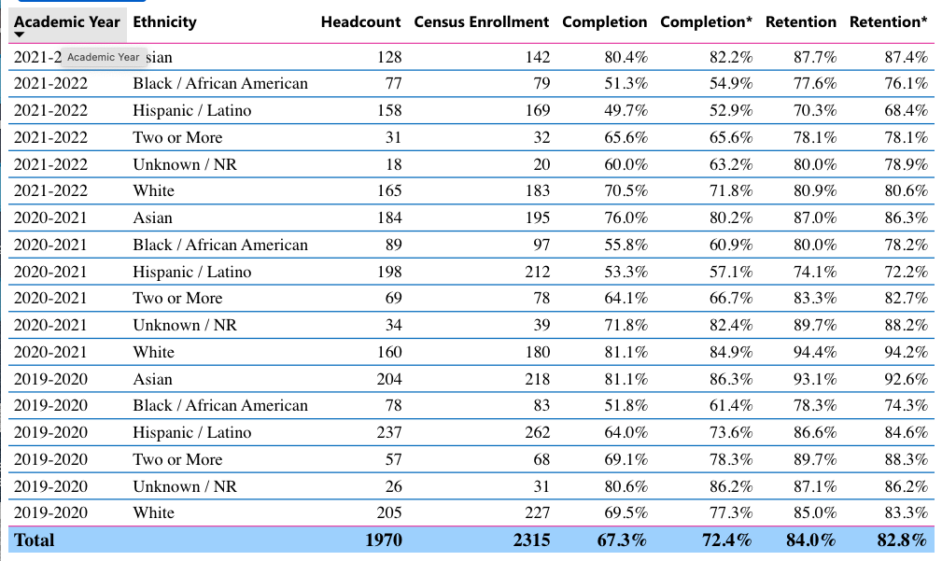
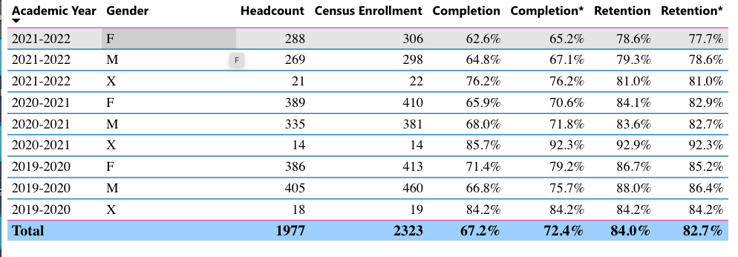
When the data are disaggregated by student When the data are disaggregated by student ethnic groups, gender, and age, how do you plan to address them over the next year?
It would be helpful to know the college’s plan for addressing this data. Then the History Dept. can coordinate its approach to meet the college’s plans and goals.

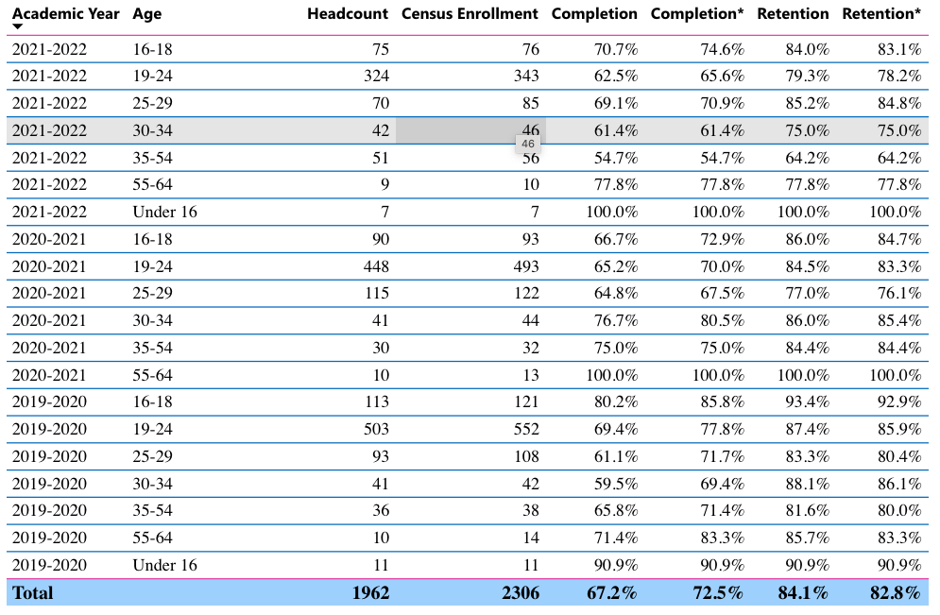

What population(s) showed outcomes gains in your discipline(s) and which need more support?

Disaggregate the data and outcomes as far down as a possible then ask:
- What trends do you notice when examining course success rates for student populations by ethnicity? Which factors do you believe have the greatest impact (positive or negative) and cause variation between student course success rates in your Program? Describe some specific methods your department is planning or implementing to address these equity gaps. How will you evaluate the efficacy of these interventions?

- How has pivoting to online instruction contributed to potential reductions in student success? Provide some specific examples of practices that faculty in your department have found ineffective in the online environment.
Please review the video from the RP Group acknowledging the interrogation De Anza Community College committed to in their analysis of course completion and success rate.
In terms of success rates of African Americans and Latinx students, disaggregated data show a downward trend in the past year for the History Department. The History Department faculty do not believe that they have requisite data to explain this trend. More student resources for basic skills would no doubt be helpful in addressing equity gaps for ethnic groups.

The History Department faculty would like to know what plans or programs the college is using or implementing to address equity gaps. Perhaps clearer information from the college might allow the History Department better understand where it fits into these plans or programs or how it might support the college’s initiatives.
The History Department does offer a Society of Scholars (Umoja/Puente) cohort class each semester. This relationship between Umoja and the History Department has proven successful in recent years in a number of ways.

How do these outcome trends in your department compare to the college average?
The most noticeable trend regarding success rate by ethnicity shows up in the relatively poor numbers for Black/African America students; below college average. At least in a small way, considering the collaboration between the History Department and the Society of Scholar program (Puente) in regularly offering a learning community HIST 7B, some ground will be made in attending to the unique conditions of the group. In the grander scheme, however, more attention needs to be paid to the success of Black/African America and Hispanic/Latinx students who enroll in history section. The enrollment figures of both groups are consistent with the enrollment of each group college-wide. So, the issue is not in attracting Black/African America and Hispanic/Latinx students to History section, the issue is making sure the outcome is successful.
While the rates generally mirror the overall rates of the college, the History Department must take strides to bolster completion and retention for this student group. History sections likewise did relatively poorly in guiding Hispanic/Latinx students to course completion. In general, Hispanic/Latinx student completion and retention rates in History sections concur with the college-wide rates of the group, but History sections did not fare well in terms of completion and retention in 2021-2022. During this academic year, obviously affected by the pandemic, completion and retention of Hispanic/Latinx sagged dramatically. This trend is particularly troubling in light of the fact that more Hispanic/Latinx students enroll in History sections than any other ethnic group.

How will these outcome trends you identified in this section affect your department goals and plans for the next year and what are your strategies to shift to move the trend towards a positive direction?
The History Department would like to work collaboratively with the college to develop strategies to push the needle, so to speak, in a positive direction.

3c. Degrees and Certificates Dashboard
On page 1 of the “Degrees and Certificate Awards Trends” Dashboard, what are the award trends for your department (e.g., overall, by gender, age, and ethnicity)?
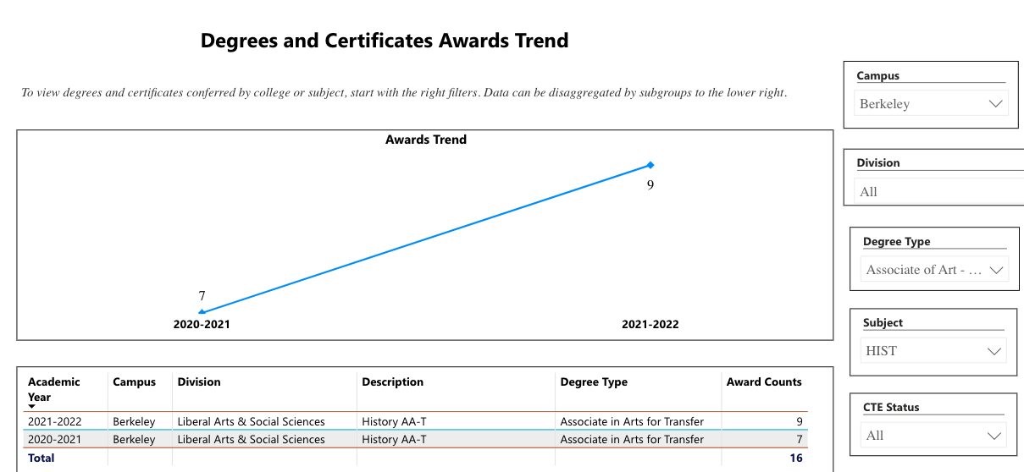
Degrees (AA-T) History – Berkeley City College

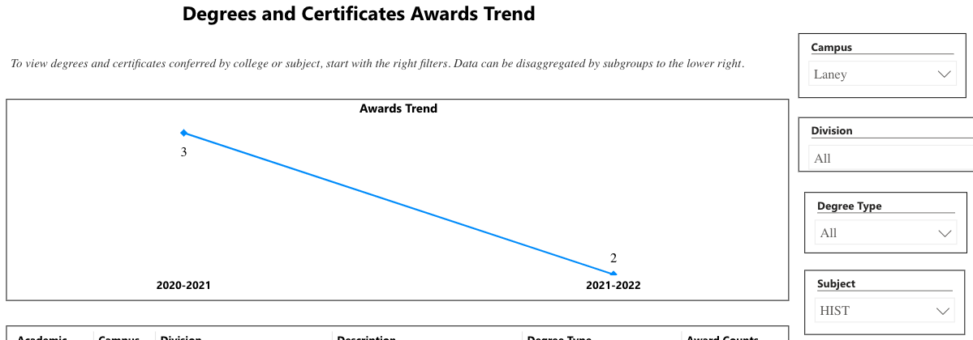
Degrees (AA-T) History – Laney College

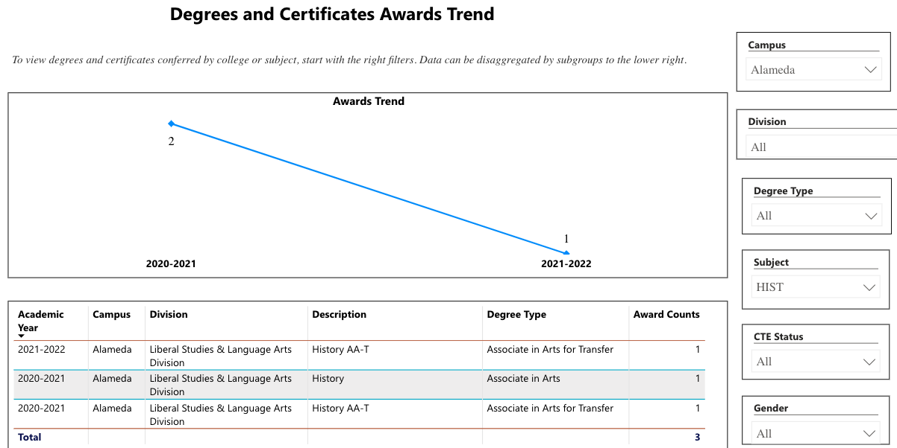
Degrees (AA-T) History – College of Alameda

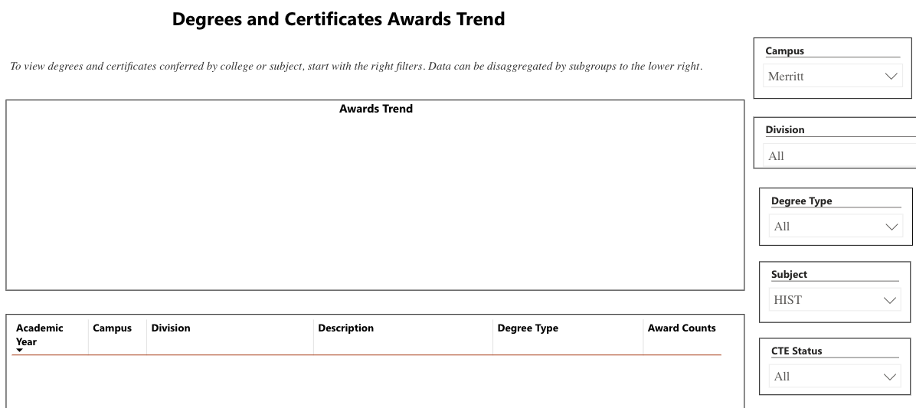
Degrees (AA-T) History – Merritt College

While the Berkeley City College History Department only awarded nine AA-Ts in 2021-2022, that accounted for three-fourths of all History AA-Ts awarded in the Peralta District. Awarded degrees also increased at BCC by nearly 30% 2020-2021 to 2021-2022. It’s tough to boast about nine degrees, but we’re well above the district average in History AA-Ts.
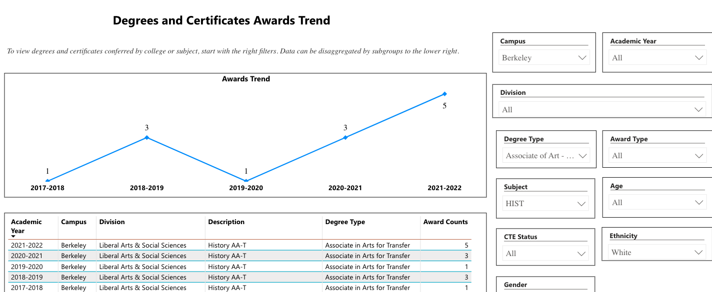
Five out of nine AA-Ts awarded in 2021-2022 went white students; two were awarded to Latinx students; and one to a Black student.

History Department faculty will make greater efforts to encourage students to major in History and to earn a History AA-T.
History courses also support the Liberal Arts/Social Sciences degree.

On page 4, what population(s) award trends showed gains in your program area and which populations need more support?
Latinx and Black students need more support.

3d. Transfer Dashboard
This dashboard does not provide data by subject. Reflect on what you can do to affect student transfer. How may your department help to support BCC student transfer? (e.g., serve on panels, strengthen GP in your dept, change curriculum, increase number of AD-Ts, etc.)
Build guided pathways will be a priority. Continue to provide faculty advising for students moving toward transfer.

3e. Curriculum based on Guided Pathways
View the department’s curriculum through the lens of student equity outcomes.
- What intentional effort is your department making to create and present clear pathways for students through curriculum?
The History Department has focused its curriculum on transfer level courses and courses that fulfill degree requirements at transfer institutions. Curriculum in the History Department is aligned with CSU and UC degrees.

- What are your plans for revising and/or creating new pathways supported by labor market information (LMI) and student demands? Using Vision for Success and SCFF focus, please indicate rationale and how the plans directly support student success and equitable completion.
N/A

4. Dual Enrollment
As continued decline in overall enrollment for college going population, it is important for us to look at who will be coming to BCC in the next 5 years. Reviewing the data provide here, what strategies would your department employ to address bringing more students to BCC?

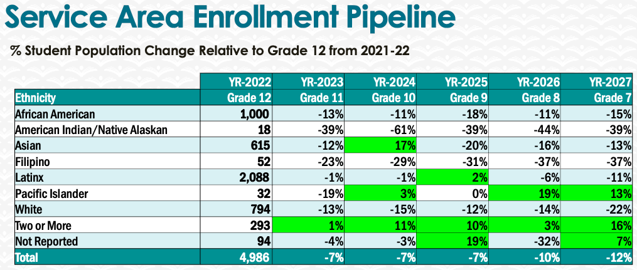
History Department faculty look forward to working with the college to address filling the student enrollment “pipeline” in the coming academic years.

5. Facility Utilization Needs

Assess your facilities utilization (including labs, support for online learning, and other spaces) and for next year, indicate if the space is sufficient or not. If not, what are the needs and why? Work with your Dean to check on your needs prior to responding this section.
Utilization of classrooms for class meetings. No associated labs. Increased faculty office space could be useful for mentoring students in the program.

6. Assessment
Berkeley City College is committed to a culture of assessment to improve instruction, services, and institutional planning. Findings from SLO, PLO, ALO assessments, and program review data are used to direct resources for areas that are institutional priorities that are articulated in the Educational Master Plan and BCC Strategic Plan.

Due to the critical role that course and program assessments play in our institutional planning and to be in compliance with the Accreditation requirements, assessments must be completed to qualify for the APU resource allocation requests.
6a. What action plans did your department identify upon the assessment of each SLOs and/or PLOs? For courses with multiple sections in the program, please list the main action plans. Please be as detailed as possible.
Completed SLO Assessment Round 4 – Through Level 2 (Section Aggregate):
HIST 2A
HIST 2B
HIST 7A
HIST 7B
HIST 21

Partially Completed SLO Assessment Round 4 – Through Level 1 (SLOs):
HIST 19

Assessment Plan Fall 2021 – Fall 2023

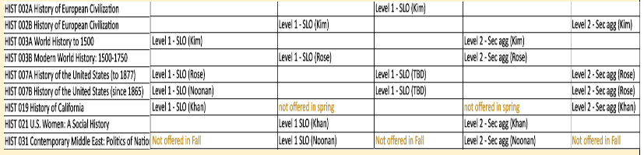

6b. Describe the department’s progress on the Actions Plans identified for course Student Learning Outcomes (SLOs). If your department offers a degree or certificate, please describe the department’s progress on the Action Plans for Program Learning Outcomes (PLOs).
In the period 2021-2022, identified as Round 4 of assessment at BCC, the History Department did well in assessing almost all of its regularly offered courses up to the section aggregate stage. Over the past three years a number of faculty members worked to create rubrics for assessing particular course SLOs. We will need to organize the department to do likewise for Program Outcomes. As of yet, the Department has not taken significant measures to collectively work through assessment. Program Outcomes will be assessed in the coming cycle.

Upon successful completion of this program, students will be able to:
- Demonstrate knowledge of the historical process within particular fields of history and effectively link historical cause and effect.
- Apply historical methodology and critical thinking in order to analyze primary and secondary sources and historical arguments.
- Interpret the diverse historical forces which have shaped the past and inform the content of the present.
All section aggregates included the following actions:
- State goals or objective of assignments/activities more explicitly
- Revise content of assignment/activities/readings
- Increase guidance for students as they work on assignments

6c. Describe the status of SLO and PLO completion in Rounds 4 and 5 of the Assessment Cycle. Identify the percent of completion. Briefly describe what needs to be done to reach 100% completion. Identify issues or concerns that may prevent your department from completing assessments of SLOs and/or PLOs.
The History Department has done well in meeting completion goals for SLOs. But PLOs are a different matter. We have not assessed PLOs recently.

6d. Besides your syllabi, where are the program level outcomes published? If on a website, please specify the URL.
Learning outcomes are posted on every syllabus; all Canvas pages associated with history classes; and the department’s webpage.

History Department PLOs are published on the department’s webpage
https://www.berkeleycitycollege.edu/history/

7. Engagement
Discuss how faculty and classified staff have engaged in institutional efforts such as committees, presentations, and departmental activities. Please list the committees that full-time faculty participate in.
Tim Rose (since fall 2021):
- Chair of Chairs Council
- Department Chair – Social Sciences
- Lead Faculty – History
- Roundtable for Planning and Budgeting
- Integrated Planning Committee
- Academic Senate (non-voting member)
- HUSV Leadership Team
- Psychology Instructor Search Committee
- Career Education Committee
- Tutoring Stakeholders Taskforce
- Website Revisions Taskforce
- Participatory Governance Retreat
- PGM update taskforce
- Faculty New-Hire Prioritization Taskforce
- IPC Governance Charge Revision Taskforce
- Program Review Revision Taskforce
Richard Kim
- Assessment Liaison for Social Science Department
Discuss how faculty and staff have engaged in community activities, partnerships and/or collaborations.
Tim Rose: CE HUSV and CHDEV/EDUC Advisory Board Meeting Participant; scheduling dual enrollment and contract education classes for Social Sciences.
Discuss how adjunct faculty members are included in departmental training, discussions, and decision-making.
All history department adjuncts are encouraged to attend professional development events during flex days. All adjuncts participate in Social Science Department meetings. Richard Kim and Jennifer Helton have contributed to assessing courses that fell in the recent course assessment cycle.
- Discuss the relationship and engagement with other support services, programs, departments, or administrative units and how these relationships/collaboration support meeting your departmental goals.
- The History Department collaborates with other disciplines within the Social Sciences in terms of curriculum and scheduling (frequently) and pedagogy (occasionally). The Department coordinates goals with the Counseling Department as well as the Society of Scholars Program, library, Student Accessibility Services, BCC’s Transfer Center, and Veterans Affairs.
Are there areas you feel that your department can benefit more by increasing collaboration and partnership? How?
Sure. To be discussed.

8. Prioritized Resource Requests
During the 2021-22 Comprehensive Program Review process, you have provided your resource requests which went through the IPAR process. In this section, include resource requests from last year that are still needed and/or new resources that have emerged. Provide justifications. If there are no resource requested, leave the boxes blank.

Resource Category | Description/Justification | Estimated Cost
Personnel
Classified Staff | Accessible Materials Officer – Assisting in creation/conversion of accessible materials for distance ed. | N/A
Student Worker
Part Time Faculty
Professional Development
Department wide PD needed
Personal/Individual PD needed
Supplies
Software (for whom or role?) | Continued licensing of Snagit and Camtasia to enable hybrid and online course video lectures.  Continued support for Canvas Studio for closed caption services and the archiving of multimedia material.  Continued subscription to other software such as Turnitin and other LTIs commonly used by faculty. | N/A
Books, Magazines, and/or Periodicals | Continue subscription to New York Times online. | N/A
Instructional Supplies
Non-Instructional Supplies
Technology & Equipment
Description/Justification (Before you list your technology request, click here to view the latest Technology Refresh Plan to verify whether it has already included.)
New | Continued refresh of full-time faculty computers at regular intervals. | N/A
Replacement
Facilities
Classrooms
Offices
Labs
Other
Library
Library materials (including streamline media needs) | Kanopy streaming is an essential multimedia platform for our instructional needs. | N/A
Library collections
OER | Continue support for OER and Affordable Learning Materials program. | N/A
Other
OTHER Description | Support for POCR (Peer Online Course) reviewers and those having their courses reviewed.  Accessible materials support. | N/A

Thank you for your time and effort in completing the Annual Program Update!
Please email the completed Program Review to your Dean by November 30, 2022

