Berkeley City College’s mission is to provide our diverse community with
educational opportunities, promote student success, and to transform lives.

Introduction and Directions

Berkeley City College (BCC), in conjunction with the Peralta community College District, has an institutional effectiveness process which consists of the following components: a District-wide Strategic Plan which is updated every six years; Comprehensive Program Reviews (CPRs) which are completed every three years; and Annual Program Updates (APUs) which are completed in non-program review years.

TIMELINE
Annual Program Update (APU) 2022-2023 timeline has been developed for each program and services to guide through the semester. Please review and work with your Deans, Managers, Department Chairs and/or Supervisors to complete this APU.

For BCC, 2022-2023 marks a critically important year as the college is in the process of revising its Educational Master Plan (EMP) for the next 5 years (2024-2028). This college EMP process will inform the District with their planning for their Strategic Plan. This year’s APU will take an especially important role for the EMP process, carrying your analysis, planning and strategies to support our students success, retention, and equitable completion.

The APU is intended to primarily focus upon planning for the subsequent year based on the institutional priorities. While developing the College’s EMP for the next 5 years, the college and the district focused on the Vision for Success identified by the California Community College Chancellor’s office as well as Student Centered Funding Formula (SCFF) that clearly delineate the categorized outcomes that the Colleges should be focusing. Please use these foci as your reference to prioritize your department and other goals.

RESOURCE REQUEST
In this process of making continuous quality improvement, there is an opportunity for each program, student services, and department to request resources that support achieving the stated goals. The APU process directly leads to the institutional resource allocation process and budget planning facilitated by the Institutional Planning and Allocation of Resources (IPAR) Committee for the following academic year (2023-24). The process for this can be found here (2022-23 APU Timeline). This is an opportunity for each department to request resources that will support your department goals and set outcomes.

TECHNOLOGY REQUEST
Finally, for the resource request section, please connect with your Deans, managers, and supervisors regarding your technology needs so that you can be informed about the equipment that is addressed in the BCC Technology Refresh Plan. If your requests are covered in the Refresh Plan, you do not need to request them in this APU.

If you have questions regarding other material in the Annual Program Update, please contact your Dean or Manager. If you have questions regarding data, please contact Dr. Phoumy Sayavong, Senior Researcher and Planning Analyst (psayavong@peralta.edu).

Please email the completed Annual Program Update to your Dean by November 30, 2022.

College Profile
Click here to view the Berkeley City College Student Demographics Dashboard.
This 2-page dashboard will provide data on the demographics of our student body from the past two years such as headcount, ethnicity, enrollment status, age group, educational goals, and majors.
College Outcomes | 2018-2019 | 2019-20 | 2020-21 | 2021-22
Full Time Equivalent Students (FTES) | 4,161 | 3,931 | 3,622 | 3,259
Productivity (Avg. Goal = 17.5) | 13 | 13.2 | 13 | 10.9
Success Rate (%) | 69% | 77% | 75%* | 70%*
Degrees + Certificates Awarded (#) | 948 | 1,109 | 1,027 | 960
*Excludes “EW” grades

To view prior Program Reviews, click here. To view prior Annual Program Updates, click here.

1a. Department Description
Please verify the mission statement for your department. If your department has not created a mission statement, provide details on how your department supports and contributes to the College’s mission.
The mission of the Economics department at Berkeley City College is to prepare and support students for degree completion and transfer. The courses in the Economics discipline focus on how societies, individuals, and firms utilize scarce resources in order to satisfy unlimited wants. This study encompasses both the study of rational choice at the firm and individual level, as well as analysis of how those interrelated actions affect the overall economy in the aggregate. Students will be able to apply the basic economic concepts discussed in the discipline to past and present events.

Name(s) of member(s) completing this APU | Department | Completion Date
Chris Bernard | Economics | 11/30/22
List faculty names with assignments in fall 2022.
Full Time | Part Time
Chris Bernard | Darrell Gualco  Malkiat Sandhu

1b. Department Priorities & Goals
Based on the Vision for Success and SCFF, and your department mission, what are your department’s priorities and goals for 2022-23?
The goal of the Economics department at Berkeley City College is to prepare and support students for degree completion and transfer. These goals will help increase degree and certificate attainment. Additionally, they will increase transfers to 4-year universities. The economics department is also actively trying to reduce equity gaps in completion rates and contribute towards to one of the American Economics Association’s initiatives that works towards increasing diversity in the economics profession.

2. Student Equity, Success, & Completion
Using the data dashboards provided below, review and reflect upon the outcome trends for your department. Please also review overall BCC’s data linked here.

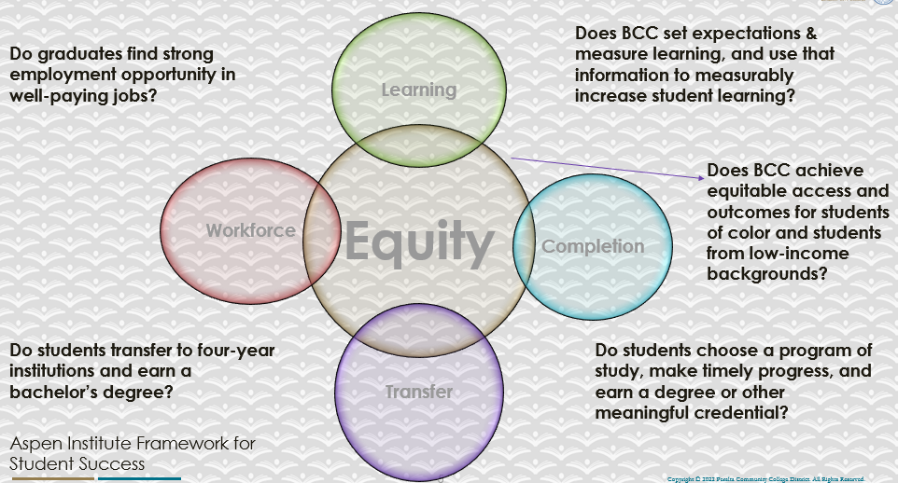

For assistance with data dashboards, contact Phoumy Sayavong at psayavong@peralta.edu
How are students doing in success and completion in your department, compared to the BCC overall success and completion rate? What are the group of students that need more attention to achieve goals?
[All data referenced excludes MW and EW grades]

The overall completion rate in economics courses is higher than BCC (73.0% v. 69.9%). The overall retention rate in economics is higher than BCC (86.2% v. 83.9%).

The completion rate has increased every year over the last 3 academic years (AY19-20: 69.9%; AY20-21: 70.5%; AY21-22: 73%). Retention rates have increased as well (AY19-20: 82.1%; AY20-21: 82.1%; AY21-22: 86.2%).

What do you see as key factors in your department that contributed to positive success and completion rate?
Students have been asking for tutoring in economics. Since last year, tutors in economics have been made available.

What are some improvements your department can make? Identify strategies.
Get tutors implemented earlier in the semester. It is difficult getting new tutors set up in the fall semester. These issues are not as relevant in the spring semester as the tutors tend to rollover from the fall and have completed paperwork and training.

3a. Enrollment Trend and Productivity Dashboard
*Note that completion and retention rates are presented with the inclusion and exclusion of excused withdrawals (EW) and military withdrawals.
What were the enrollment trends in your department in the past three years?
Between AY18-19 and AY20-21, economics averaged over 550 students. Productivity was never below 14.8. In AY21-22, enrollment dropped to 382 and productivity dropped to 12.7. It is unclear how much of this impact was due to effects of the pandemic.

What strategies would you recommend to increase student enrollment in your department?
Work with other disciplines and promote the interdisciplinary aspects of economics. Economics is now included in an Academic Career Community with other social sciences so this could help with this aspect of recruiting. We need to find the proper blend of face-to-face, online synchronous, online asynchronous, and hybrid offerings.

Community Colleges are funded based on the Student Centered Funding Formula (“SCFF”) which is comprised of the following allocations:

Student Centered Funding Formula: Focus and Priorities
% Of Allocation | Categories
70%  Base Allocation: FTES (Enrollment) | - Credit FTES  - NonCredit FTES  - Special Admits (Dual Enrollment, etc.)
20%  Supplemental Allocation | - Pell Grant  - AB 540  - Adult School  - Promise Grants
10%  Student Success Allocation | - Associate Degrees  - ADTs  - 9 or more CE units  - Transfer  - Transfer level Math and English in the first year

List the department’s progress and reflection on what is being done to maintain or increase the base level of full-time equivalent students (FTES = 12 units). Please describe retention (i.e., remain enrolled for a full semester) and persistence (i.e., enroll in consecutive semesters) efforts.
Economics is included in the Academic and Career Community with other social sciences to highlight the interdisciplinary aspect of the discipline. Students are encouraged to take both Econ 1 and Econ 2. Economics courses have been included as elective options in newly created degrees and certificates that are moving through the curriculum process.

Please describe your department’s efforts in identifying Pell Grant recipients, College Promise Grant recipients, Adult Education, and AB 540 students. What processes are in place to accurately report these students each semester?

College Outcomes | 2018-2019 | 2019-2020 | 2020-21 | 2021-22
Full Time Equivalent Students (FTES) | 4,161 | 3,931 | 3,622 | 3,259
Pell Grant Recipients | 2,387 | 2,281 | 2,181 | 1,826
College Promise Grant Recipients | 4,373 | 4,143 | 4,011 | 3,500
AB 540 Students | 74 | 51 | 22 | 69

3b. Course Completion and Retention Rates Dashboard – Instruction
*Note that completion and retention rates are presented with the inclusion and exclusion of excused withdrawals (EW) and military withdrawals.

If you need more guidance with this item, click here for additional support. Click here for additional guidance for how to view and use equity data. If you would like to view BCC’s Equity Plan, click here.
On page 3 of the “Course Completion and Retention Rates by Subject” dashboard, what are the completion and retention trends by gender, age, ethnicity in your department?
For AY21-22, the completion rate for students in economics courses was 73%. For the same year, the retention rate was 86.2%.

In AY21-22, students over 25 have lower completion rates than the general completion rate and retention rate for economics. This age group represents a little more a quarter of students taking economics courses (108/391).

In AY21-22 Hispanic/Latino and Black/African American students had lower completion rates and retention rates than the completion rate and retention rates for students taking economics courses. (Hispanic/Latino student completion rate: 63.5%, retention rate: 81.2%; and Black/African American student completion rate: 50%, retention rate: 76.1%).

Here is a summary completion rates for students who identify as Black/African American, Hispanic/Latino, and Two or More over the last 3 years.

Economics Course Completion Rates
 | AY19-20  Completion Rate | AY20-21  Completion Rate | AY21-22  Completion Rate
Black/African American | 41.2% | 58.0% | 50.0%
Hispanic / Latino | 67.5% | 69.9% | 63.5%
Two of More | 71.4% | 51.2% | 58.6%
Overall | 69.9% | 70.5% | 73.0%

And here is a breakdown of retention rates for students who identify as Black/African American, Hispanic/Latino, and Two or More over the last 3 years:

Economics Course Retention Rates
 | AY19-20 | AY20-21 | AY21-22
Black/African American | 68.60% | 76.00% | 76.10%
Hispanic / Latino | 81.70% | 83.50% | 81.20%
Two of More | 77.60% | 63.40% | 82.80%
Overall | 82.10% | 82.10% | 86.20%

The gaps in retention rates are not as large as the gaps in completion rates.

When the data are disaggregated by student ethnic groups, gender, and age, how do you plan to address them over the next year?
Recruit Hispanic/Latino and Black/African American students as tutors in the LRC and as embedded tutors.

What population(s) showed outcomes gains in your discipline(s) and which need more support?

Disaggregate the data and outcomes as far down as a possible then ask:
- What trends do you notice when examining course success rates for student populations by ethnicity? Which factors do you believe have the greatest impact (positive or negative) and cause variation between student course success rates in your Program? Describe some specific methods your department is planning or implementing to address these equity gaps. How will you evaluate the efficacy of these interventions?

- How has pivoting to online instruction contributed to potential reductions in student success? Provide some specific examples of practices that faculty in your department have found ineffective in the online environment.
Please review the video from the RP Group acknowledging the interrogation De Anza Community College committed to in their analysis of course completion and success rate.
Online instruction has created opportunities to increase student success while simultaneously creating reductions in student success. Our department is offering hybrid, face-to-face, and online courses to find the right blend of offerings.

Testing in an online setting is difficult given the temptation that students may feel to use cheating for hire services. This is a problem that could be addressed by creating a testing center at the college. Teaching online presents new opportunities for faculty to experiment with practices that can improve completion. Focused trainings and appropriate trainings are necessary to promote the promise suggested by the data below.

Online courses present interesting data for completion and retention in economics courses.

Economics Course Completion Rates by Modality
 | AY19-20 | AY20-21 | AY21-22
Synchronous | N/A | 77.2% | 76.1%
Asynchronous | 61.2% | 44.8% | 63.2%
Overall | 69.9% | 70.5% | 73.0%

Economics Course Retention Rates by Modality
 | AY19-20 | AY20-21 | AY21-22
Synchronous | N/A | 84.10% | 87.60%
Asynchronous | 61.20% | 74.30% | 83.20%
Overall | 82.10% | 82.10% | 86.20%

In economics, asynchronous online courses have a lower completion rate than the general completion rate and lower completion rates that hybrid and synchronous modalities. Synchronous online courses completion rates are equal to or above the completion rate for economics in general. Given the differences between asynchronous and synchronous courses, it appears that there needs to be focus on how to improve results in asynchronous courses. This can be accomplished on two fronts. First, students need to be prepared to take an asynchronous class and understand the need to be organized. Second, instructors of asynchronous online courses should be encouraged to go through online training courses and eventually Peer Online Course Review.

It would be nice to get data on the hybrid modality. This modality should be further explored and sections should continue to be offered in this modality.

The statistics for BCC present the following data:

BCC Completion Rates by Modality
 | AY19-20 | AY20-21 | AY21-22
Synchronous | 78.00% | 75.10% | 69.30%
Asynchronous | 74.90% | 74.50% | 70.40%
Overall (all modalities) | 76.50% | 74.90% | 69.90%

BCC Retention Rates by Modality
 | AY19-20 | AY20-21 | AY21-22
Synchronous | 90.00% | 85.50% | 84.40%
Asynchronous | 82.90% | 84.30% | 83.10%
Overall (all modalities) | 86.10% | 85.00% | 83.90%

It warrants mentioning that both asynchronous and synchronous completion and retention rates are equal to or exceed the collegewide completion and retention rates. This suggests opportunities for online offerings that can help students complete their degrees and certificates.

How do these outcome trends in your department compare to the college average?
The completion rate for economics courses offered synchronously are similar or exceed the completion rate for synchronous courses offered at the college. Economics courses offered asynchronously have a lower completion rate than the college.

How will these outcome trends you identified in this section affect your department goals and plans for the next year and what are your strategies to shift to move the trend towards a positive direction?
Synchronous online course offerings seem to produce positive student outcomes and should continue to be offered. Gaps in asynchronous could be addressed by offering online pedagogy training and encouraging faculty to take ABCDs of Online Teaching at BCC and begin to work on getting a course through POCR.

3c. Degrees and Certificates Dashboard
On page 1 of the “Degrees and Certificate Awards Trends” Dashboard, what are the award trends for your department (e.g., overall, by gender, age, and ethnicity)?
AA-Ts awarded at BCC has hovered between 21 and 23 degrees awarded over the last 5 years. These are awarded pretty evenly between males and females. Asian students have earned about half of the degrees awarded over the same time period.

Transfers to UC campuses are listed below:

BCC to UC Transfers by Major in Economics
 | AY15-16 | AY16-17 | AY17-18 | AY18-19 | AY19-20 | AY20-21 | AY21-22
UCB | 3 | 5 | 6 | 8 | 8 | 3 | 6
UCD | 4 | 2 | 8 | 10 | 9 | 7 | 2
UCI | 1 | 1 | 0 | 1 | 1 | 0 | 0
UCLA | 1 | 2 | 0 | 0 | 0 | 3 | 2
UCR | 0 | 0 | 0 | 0 | 0 | 1 | 1
UCSB | 1 | 3 | 2 | 2 | 3 | 1 | 0
UCSC | 1 | 0 | 0 | 3 | 0 | 1 | 1
UCSD | 8 | 5 | 4 | 6 | 6 | 9 | 7
Grand Total | 19 | 18 | 20 | 30 | 27 | 25 | 19

It is expected that many BCC students transfer to UC Davis and UC Berkeley as they are the closest UC campuses. What is interesting is that UC San Diego was the highest transfer college in AY21-22 and has consistently been a frequent location for BCC transfer students.
(Data: https://www.universityofcalifornia.edu/about-us/information-center/transfers-major)

It is possible that some students who transfer to UC also earn an AA-T from BCC. However, there is not 100% overlap. For example, in AY18-19, 20 students received AA-Ts and 30 students transferred to UC campuses. But in AY 19-20, 27 students received AA-Ts and 27 students transferred to UC.

On page 4, what population(s) award trends showed gains in your program area and which populations need more support?
White students saw an increase from 1 student in AY17-18 to 7 students in AY21-22. Other ethnicities have remained relatively stable. Black/African American have averaged about 2 degrees per year.

3d. Transfer Dashboard
This dashboard does not provide data by subject. Reflect on what you can do to affect student transfer. How may your department help to support BCC student transfer? (e.g., serve on panels, strengthen GP in your dept, change curriculum, increase number of AD-Ts, etc.)
Our department has invited transfer students to present in class and share their experiences after transfer. The economics curriculum was just updated to reflect recommendations from the UC Economics Transfer Pathway to recommend that students take “single variable calculus sequence for STEM majors to keep their options as open as possible for undergraduate and graduate school alternatives.” We have also updated the curriculum to include more electives to satisfy the degree requirements. Previously, only accounting courses were included. Now we’ve included more math classes, economics, and business courses so as to provide multiple paths for students to earn the degree.

By expanding options and pathways to obtain an economics AA-T, it is hoped that all students who transfer to UC campuses will also earn an AA-T.

3e. Curriculum based on Guided Pathways
View the department’s curriculum through the lens of student equity outcomes.
- What intentional effort is your department making to create and present clear pathways for students through curriculum?
The economics curriculum was just updated to reflect recommendations from the UC Economics Transfer Pathway to recommend that students take “single variable calculus sequence for STEM majors to keep their options as open as possible for undergraduate and graduate school alternatives.” We have also updated the curriculum to include more electives to satisfy the degree requirements. Previously, only accounting courses were included. Now we’ve included more math classes, economics, and business courses so as to provide multiple paths for students to earn the degree.
- What are your plans for revising and/or creating new pathways supported by labor market information (LMI) and student demands? Using Vision for Success and SCFF focus, please indicate rationale and how the plans directly support student success and equitable completion.
See above.

4. Dual Enrollment
As continued decline in overall enrollment for college going population, it is important for us to look at who will be coming to BCC in the next 5 years. Reviewing the data provide here, what strategies would your department employ to address bringing more students to BCC?

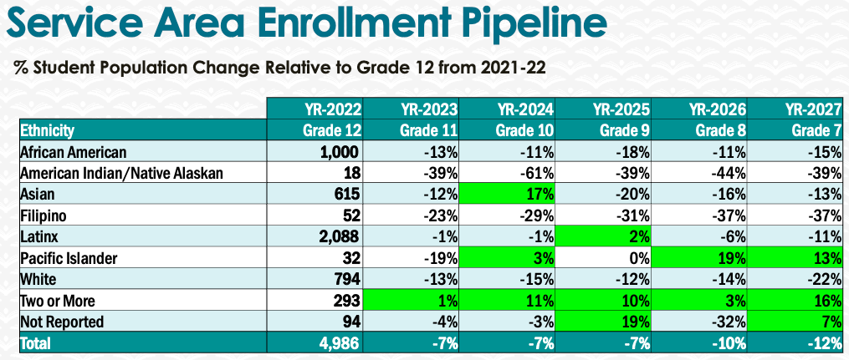
Many high school students are required to take a semester economics course in order to graduate from high school. We should actively promote taking community college courses as a way to build up units while paying the lower per-unit price at BCC. This allows students flexibility in choosing majors and low stakes opportunity to learn about various areas of study. A former high school student ended up taking a gap year after earning two years’ worth of college credits. Even though he took time off, he did not fall behind his peers. This could be a way to advertise to students.

5. Facility Utilization Needs

Assess your facilities utilization (including labs, support for online learning, and other spaces) and for next year, indicate if the space is sufficient or not. If not, what are the needs and why? Work with your Dean to check on your needs prior to responding this section.
The college needs a testing center. It has always been difficult to schedule make up exams and coordinate student and faculty schedules. Now, with the proliferation of online courses and increased acts of academic dishonesty in online exams, a testing center would provide a more secure way of ensuring that the person taking the assessment is the student in the course.

Support to make online materials accessible is necessary.

Stipends for faculty to build POCR aligned asynchronous online courses will help faculty create more engaging courses and provide training to ensure that faculty are having appropriate levels of student contact during the semester.

6. Assessment
Berkeley City College is committed to a culture of assessment to improve instruction, services, and institutional planning. Findings from SLO, PLO, ALO assessments, and program review data are used to direct resources for areas that are institutional priorities that are articulated in the Educational Master Plan and BCC Strategic Plan.

Due to the critical role that course and program assessments play in our institutional planning and to be in compliance with the Accreditation requirements, assessments must be completed to qualify for the APU resource allocation requests.
6a. What action plans did your department identify upon the assessment of each SLOs and/or PLOs? For courses with multiple sections in the program, please list the main action plans. Please be as detailed as possible.
In progress.

6b. Describe the department’s progress on the Actions Plans identified for course Student Learning Outcomes (SLOs). If your department offers a degree or certificate, please describe the department’s progress on the Action Plans for Program Learning Outcomes (PLOs).
Ongoing. Will updated SLOs. Reviewed Economics ADT and updated PLOs.

6c. Describe the status of SLO and PLO completion in Rounds 4 and 5 of the Assessment Cycle. Identify the percent of completion. Briefly describe what needs to be done to reach 100% completion. Identify issues or concerns that may prevent your department from completing assessments of SLOs and/or PLOs.
In progress.

6d. Besides your syllabi, where are the program level outcomes published? If on a website, please specify the URL.
Updating department webpage. Ongoing.

7. Engagement
Discuss how faculty and classified staff have engaged in institutional efforts such as committees, presentations, and departmental activities. Please list the committees that full-time faculty participate in.
Chris Bernard – Peer Online Course Review Lead; Distance Education Committee Co-Chair; Curriculum Committee; Guided Pathways Facilitator; Accessible Education Resource Committee;
Discuss how faculty and staff have engaged in community activities, partnerships and/or collaborations.
Working with faculty at UC Berkeley to develop Data Analysis course and program.
Discuss how adjunct faculty members are included in departmental training, discussions, and decision-making.
Faculty members, full-time and adjunct, regularly participate in flex day activities, TLC activities, and department meetings.
- Discuss the relationship and engagement with other support services, programs, departments, or administrative units and how these relationships/collaboration support meeting your departmental goals.
- Communicate regularly with other departments in the social science to work on course offerings and other areas that overlap.
Are there areas you feel that your department can benefit more by increasing collaboration and partnership? How?
Find more opportunities for interdisciplinary connection. This may be more viable as the Academic and Career Communities are built out.

8. Prioritized Resource Requests
During the 2021-22 Comprehensive Program Review process, you have provided your resource requests which went through the IPAR process. In this section, include resource requests from last year that are still needed and/or new resources that have emerged. Provide justifications. If there are no resource requested, leave the boxes blank.

Resource Category | Description/Justification | Estimated Cost
Personnel
Classified Staff | Full-Time Web Content Developer  Technology Specialist for Accessibility and Compliance | $90,000  $90,000
Student Worker | Tutors (embedded and LRC) | $15,000
Part Time Faculty
Professional Development
Department wide PD needed
Personal/Individual PD needed
Supplies
Software (for whom or role?)
Books, Magazines, and/or Periodicals
Instructional Supplies | General Office Supplies | $4,000
Non-Instructional Supplies
Technology & Equipment
Description/Justification (Before you list your technology request, click here to view the latest Technology Refresh Plan to verify whether it has already included.)
New
Replacement
Facilities
Classrooms
Offices
Labs
Other | Testing Center
Library
Library materials (including streamline media needs)
Library collections
OER
Other
OTHER Description

Thank you for your time and effort in completing the Annual Program Update!
Please email the completed Program Review to your Dean by November 30, 2022

