Berkeley City College’s mission is to provide our diverse community with
educational opportunities, promote student success, and to transform lives.

Introduction and Directions

Berkeley City College (BCC), in conjunction with the Peralta community College District, has an institutional effectiveness process which consists of the following components: a District-wide Strategic Plan which is updated every six years; Comprehensive Program Reviews (CPRs) which are completed every three years; and Annual Program Updates (APUs) which are completed in non-program review years.

TIMELINE
Annual Program Update (APU) 2022-2023 timeline has been developed for each program and services to guide through the semester. Please review and work with your Deans, Managers, Department Chairs and/or Supervisors to complete this APU.

For BCC, 2022-2023 marks a critically important year as the college is in the process of revising its Educational Master Plan (EMP) for the next 5 years (2024-2028). This college EMP process will inform the District with their planning for their Strategic Plan. This year’s APU will take an especially important role for the EMP process, carrying your analysis, planning and strategies to support our students success, retention, and equitable completion.

The APU is intended to primarily focus upon planning for the subsequent year based on the institutional priorities. While developing the College’s EMP for the next 5 years, the college and the district focused on the Vision for Success identified by the California Community College Chancellor’s office as well as Student Centered Funding Formula (SCFF) that clearly delineate the categorized outcomes that the Colleges should be focusing. Please use these foci as your reference to prioritize your department and other goals.

RESOURCE REQUEST
In this process of making continuous quality improvement, there is an opportunity for each program, student services, and department to request resources that support achieving the stated goals. The APU process directly leads to the institutional resource allocation process and budget planning facilitated by the Institutional Planning and Allocation of Resources (IPAR) Committee for the following academic year (2023-24). The process for this can be found here (2022-23 APU Timeline). This is an opportunity for each department to request resources that will support your department goals and set outcomes.

TECHNOLOGY REQUEST
Finally, for the resource request section, please connect with your Deans, managers, and supervisors regarding your technology needs so that you can be informed about the equipment that is addressed in the BCC Technology Refresh Plan. If your requests are covered in the Refresh Plan, you do not need to request them in this APU.

If you have questions regarding other material in the Annual Program Update, please contact your Dean or Manager. If you have questions regarding data, please contact Dr. Phoumy Sayavong, Senior Researcher and Planning Analyst (psayavong@peralta.edu).

Please email the completed Annual Program Update to your Dean by November 30, 2022.

College Profile
Click here to view the Berkeley City College Student Demographics Dashboard.
This 2-page dashboard will provide data on the demographics of our student body from the past two years such as headcount, ethnicity, enrollment status, age group, educational goals, and majors.
College Outcomes | 2018-2019 | 2019-20 | 2020-21 | 2021-22
Full Time Equivalent Students (FTES) | 4,161 | 3,931 | 3,622 | 3,259
Productivity (Avg. Goal = 17.5) | 13 | 13.2 | 13 | 10.9
Success Rate (%) | 69% | 77% | 75%* | 70%*
Degrees + Certificates Awarded (#) | 948 | 1,109 | 1,027 | 960
*Excludes “EW” grades

To view prior Program Reviews, click here. To view prior Annual Program Updates, click here.

1a. Department Description
Please verify the mission statement for your department. If your department has not created a mission statement, provide details on how your department supports and contributes to the College’s mission.
The Associate in Arts in Communication for Transfer Degree is designed to prepare students to complete the baccalaureate degree in communication upon transferring into the CSU system. Communication skills are essential to forming and maintaining personal relationships, acquiring and excelling in a job,
and relating to the world around us. Through the study and practice of interpersonal, professional, and inter-cultural communication skills, students will learn how their perceptions and self-esteem affect their interactions with others. Beyond this, students will improve their abilities to speak, write, and present information effectively, whether in face-to-face interactions or in public or mass-media settings.

Name(s) of member(s) completing this APU | Department | Completion Date
Cora Leighton | Arts and Cultural Studies | 11/22/22
List faculty names with assignments in fall 2022.
Full Time | Part Time
Cora Leighton  Alex Mata (spring 23 start) | Allen Conkle  Deborah Farris  Kyle Johnson  Pati Shojaee  Jennifer Zenovich

1b. Department Priorities & Goals
Based on the Vision for Success and SCFF, and your department mission, what are your department’s priorities and goals for 2022-23?
- Having just hired a second FT instructor, our goals for the next year are as follows:
- Grow our enrollment
- Participate in the California Virtual Campus via Peer Online Course Review to get as many courses as possible Badged.
- Diversify our offerings
- Continue to improve our completion and retention rates particularly for disproportionately impacted students.

2. Student Equity, Success, & Completion
Using the data dashboards provided below, review and reflect upon the outcome trends for your department. Please also review overall BCC’s data linked here.

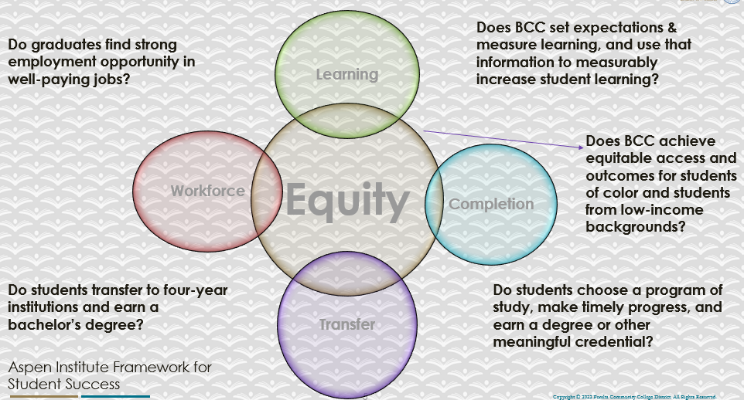

For assistance with data dashboards, contact Phoumy Sayavong at psayavong@peralta.edu
How are students doing in success and completion in your department, compared to the BCC overall success and completion rate? What are the group of students that need more attention to achieve goals?
Our success and completion rates are higher than the college average.

The group that needs the most attention is the Latinx students.

What do you see as key factors in your department that contributed to positive success and completion rate?
Our instructors participated in a year long workshop focusing on equity and online success. This helped our success rates with Black men, as seen by our 4% increased completion rates. We also participate in learning communities. Lastly, we have started participating in the CVC POCR badging process which has proven to be effective for equity success in online classes.

What are some improvements your department can make? Identify strategies.
Our department has just hired a second FT instructor who is Latinx. This will help improve the diversity of our faculty. We will continue to participate in Learning Communities as well as the Peralta Equity Program.

One aspect of equity that is missing from these stats is accessibility. Support for accessibility remediation is vital is we truly want to increase equity.

3a. Enrollment Trend and Productivity Dashboard
*Note that completion and retention rates are presented with the inclusion and exclusion of excused withdrawals (EW) and military withdrawals.
What were the enrollment trends in your department in the past three years?
Our enrollment has declined in keeping with the collegewide and national trends.

What strategies would you recommend to increase student enrollment in your department?
We recommend increasing our online offerings as students continue to indicate (by enrollment) hat they want online courses. Additionally, we recommend pursuing HyFlex classes as that will give students the flexibility they want.

Community Colleges are funded based on the Student Centered Funding Formula (“SCFF”) which is comprised of the following allocations:

Student Centered Funding Formula: Focus and Priorities
% Of Allocation | Categories
70%  Base Allocation: FTES (Enrollment) | - Credit FTES  - NonCredit FTES  - Special Admits (Dual Enrollment, etc.)
20%  Supplemental Allocation | - Pell Grant  - AB 540  - Adult School  - Promise Grants
10%  Student Success Allocation | - Associate Degrees  - ADTs  - 9 or more CE units  - Transfer  - Transfer level Math and English in the first year

List the department’s progress and reflection on what is being done to maintain or increase the base level of full-time equivalent students (FTES = 12 units). Please describe retention (i.e., remain enrolled for a full semester) and persistence (i.e., enroll in consecutive semesters) efforts.
We continue to offer courses in all modalities, and have been working with the Office of instruction to offer dynamically dated course. Additionally, we have been participating in the CVC POCR review process to increase our high quality online offerings.

Please describe your department’s efforts in identifying Pell Grant recipients, College Promise Grant recipients, Adult Education, and AB 540 students. What processes are in place to accurately report these students each semester?

College Outcomes | 2018-2019 | 2019-2020 | 2020-21 | 2021-22
Full Time Equivalent Students (FTES) | 4,161 | 3,931 | 3,622 | 3,259
Pell Grant Recipients | 2,387 | 2,281 | 2,181 | 1,826
College Promise Grant Recipients | 4,373 | 4,143 | 4,011 | 3,500
AB 540 Students | 74 | 51 | 22 | 69

This is the job of the administration, not faculty. We participate in Learning Communities and continue to try to add Dual Enrollment to our offerings.

Additional administrative support is needed for “accurate reporting.”

3b. Course Completion and Retention Rates Dashboard – Instruction
*Note that completion and retention rates are presented with the inclusion and exclusion of excused withdrawals (EW) and military withdrawals.

If you need more guidance with this item, click here for additional support. Click here for additional guidance for how to view and use equity data. If you would like to view BCC’s Equity Plan, click here.
On page 3 of the “Course Completion and Retention Rates by Subject” dashboard, what are the completion and retention trends by gender, age, ethnicity in your department?
Our success and completion rates are higher than the college average.

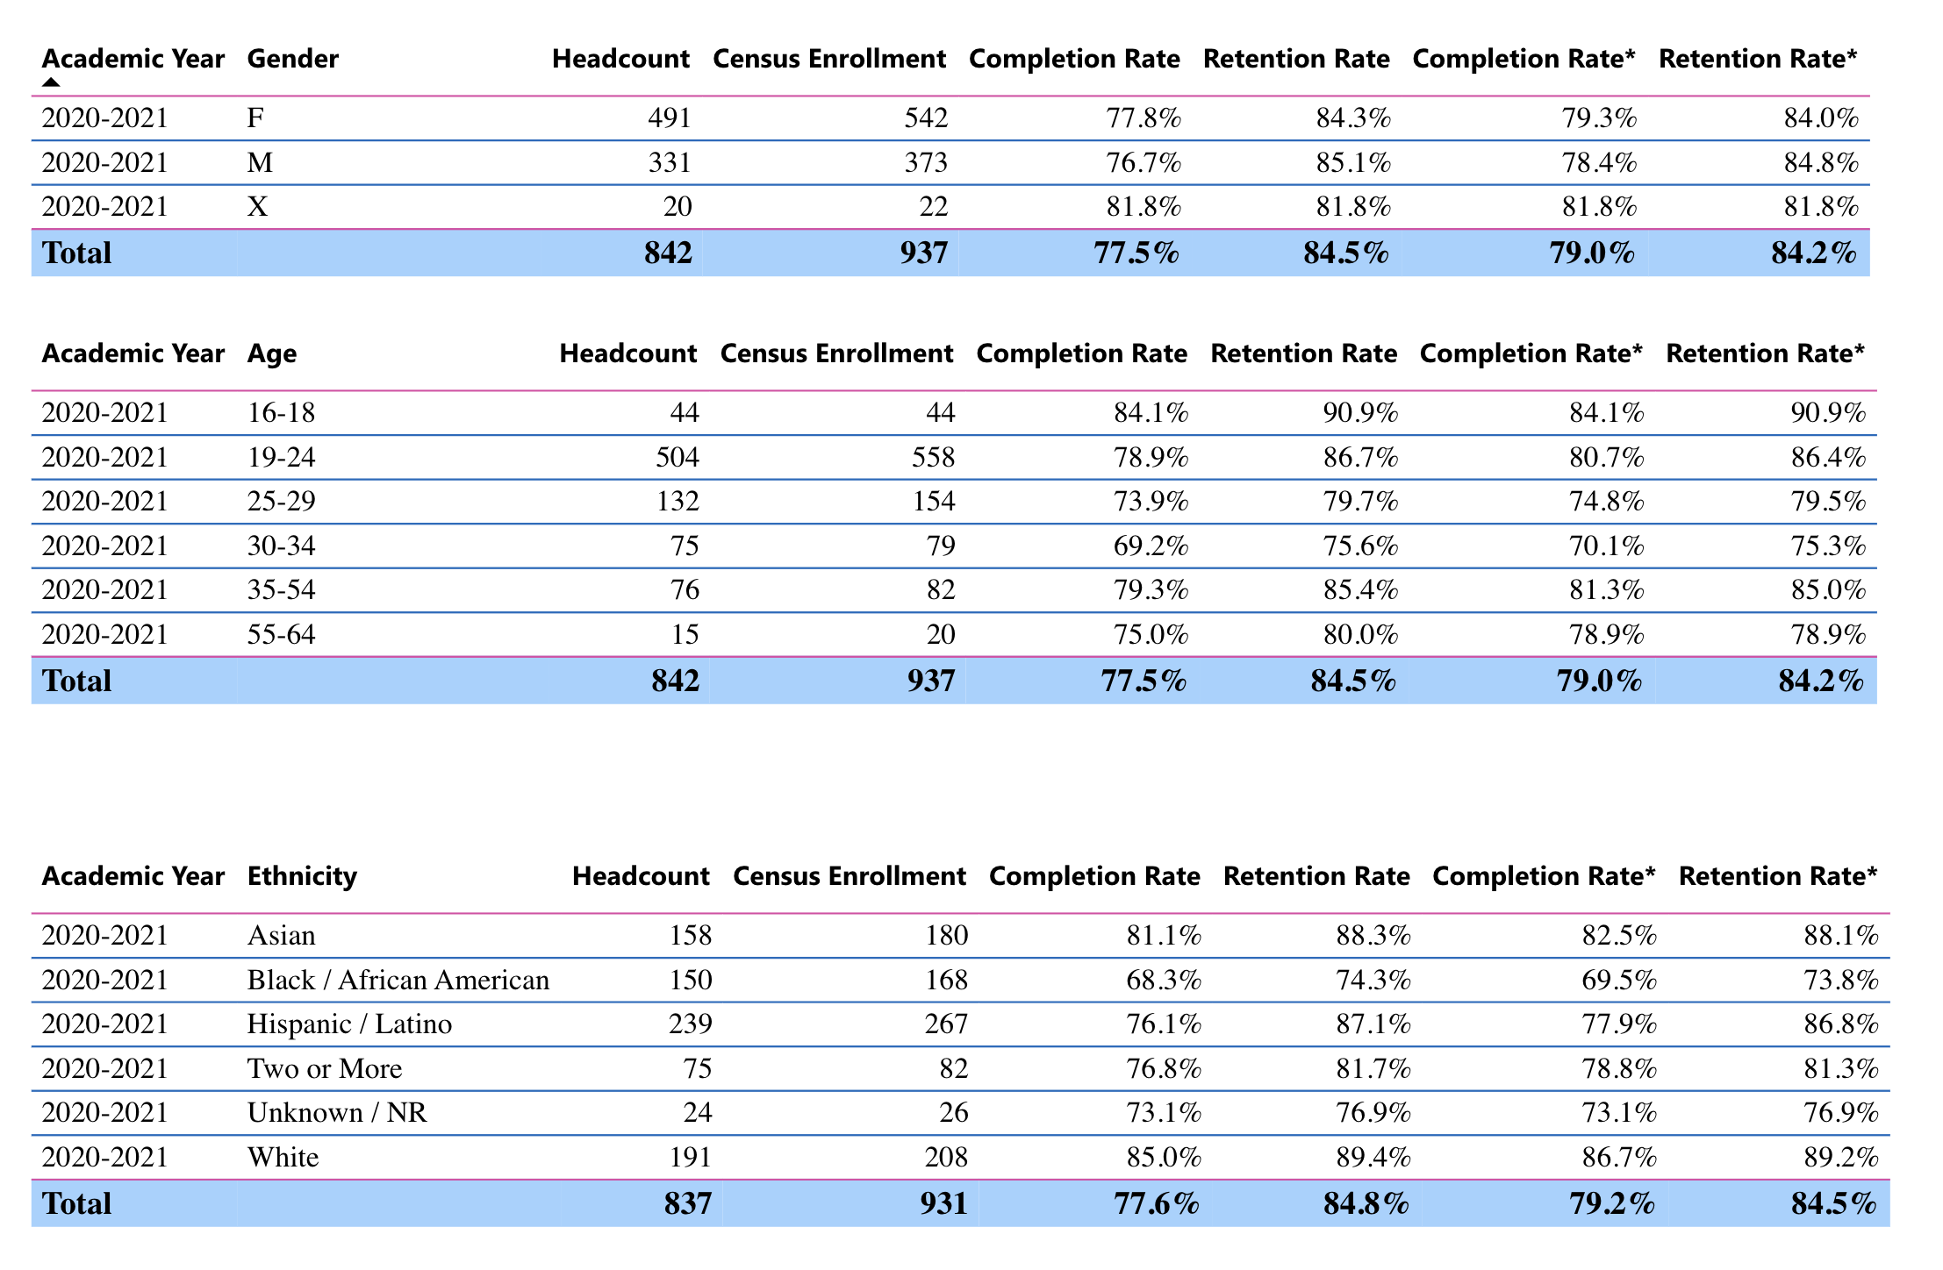

When the data are disaggregated by student ethnic groups, gender, and age, how do you plan to address them over the next year?
We have been and will continue to do the following:
- Participate in low-cost and zero cost textbook efforts (all of our courses are ZTC)
- Participate in Learning communities
- Participate in the POCR process to badge all of our online courses
- Complete the Peralta Equity Training.
- Participate when possible in the FDIP.
- Increase the accessibility of all of our materials.
- Professional development via the TLC and at Communication specific conferences.
- Encourage the development of HyFlex courses.
What population(s) showed outcomes gains in your discipline(s) and which need more support?

Disaggregate the data and outcomes as far down as a possible then ask:
- What trends do you notice when examining course success rates for student populations by ethnicity? Which factors do you believe have the greatest impact (positive or negative) and cause variation between student course success rates in your Program? Describe some specific methods your department is planning or implementing to address these equity gaps. How will you evaluate the efficacy of these interventions?

- How has pivoting to online instruction contributed to potential reductions in student success? Provide some specific examples of practices that faculty in your department have found ineffective in the online environment.
Please review the video from the RP Group acknowledging the interrogation De Anza Community College committed to in their analysis of course completion and success rate.
Black students showed gains, but Latinx students showed decline. It’s very hard to explain these changes other than anecdotally. In that regard, most research shows that disproportionately impacted students (particularly black and brown students) have been most impacted by the pandemic in all areas.

Students who have families or care for elderly parents will have the hardest time coming to campus for class. They also are most impacted by the digital divide. Although we have been doing our best to get free laptops and hot spots to these students, they would most benefit from more flexible learning options like online asynchronous and HyFlex classes.

How do these outcome trends in your department compare to the college average?
Our enrollment rates and productivity is slightly higher than the college average, but reflective of the steep decline.

How will these outcome trends you identified in this section affect your department goals and plans for the next year and what are your strategies to shift to move the trend towards a positive direction?
They won’t change our goals because we are always focused on increasing enrollment, and success rates.

3c. Degrees and Certificates Dashboard
On page 1 of the “Degrees and Certificate Awards Trends” Dashboard, what are the award trends for your department (e.g., overall, by gender, age, and ethnicity)?
Our degree awards numbers have remained consistent and are the HIGHEST for the any Communications Program in the district.
On page 4, what population(s) award trends showed gains in your program area and which populations need more support?
The numbers in this discipline are too low to show trends.

3d. Transfer Dashboard
This dashboard does not provide data by subject. Reflect on what you can do to affect student transfer. How may your department help to support BCC student transfer? (e.g., serve on panels, strengthen GP in your dept, change curriculum, increase number of AD-Ts, etc.)
Faculty advising was an extremely successful program (and relates to GP) that helped Communication Students transfer. Communication is a difficult subject in terms of transfer because they are a number of directions one can pursue. Students need help from communication faculty experts who know the nuances of the discipline. Unfortunately Faculty advising was defunded. We recommend funding this successful program.

3e. Curriculum based on Guided Pathways
View the department’s curriculum through the lens of student equity outcomes.
- What intentional effort is your department making to create and present clear pathways for students through curriculum?
We have been participating in GP and as a course required for transfer, we remain an important discipline for all students.
- What are your plans for revising and/or creating new pathways supported by labor market information (LMI) and student demands? Using Vision for Success and SCFF focus, please indicate rationale and how the plans directly support student success and equitable completion.
We are not a CTE program so we do not have labor market information. That said, communication is the number one more desirable workplace entry skill. Therefore, continuing to develop courses for students with communication anxiety utilizing our soon to be communication lab will be key.

4. Dual Enrollment
As continued decline in overall enrollment for college going population, it is important for us to look at who will be coming to BCC in the next 5 years. Reviewing the data provide here, what strategies would your department employ to address bringing more students to BCC?

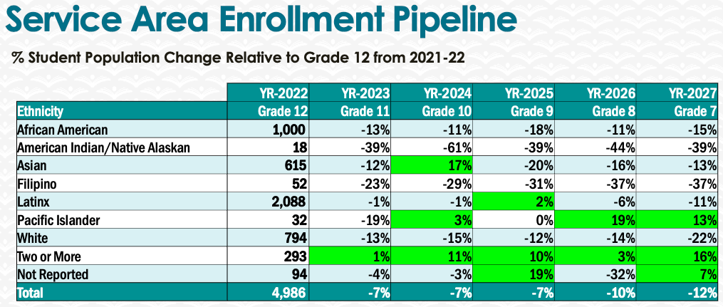
We continue to try to add dual enrollment courses in Communication but have been having staffing issues.

5. Facility Utilization Needs

Assess your facilities utilization (including labs, support for online learning, and other spaces) and for next year, indicate if the space is sufficient or not. If not, what are the needs and why? Work with your Dean to check on your needs prior to responding this section.
Yes, the space is sufficient but we would like to develop more HyFlex capable classrooms.

6. Assessment
Berkeley City College is committed to a culture of assessment to improve instruction, services, and institutional planning. Findings from SLO, PLO, ALO assessments, and program review data are used to direct resources for areas that are institutional priorities that are articulated in the Educational Master Plan and BCC Strategic Plan.

Due to the critical role that course and program assessments play in our institutional planning and to be in compliance with the Accreditation requirements, assessments must be completed to qualify for the APU resource allocation requests.
6a. What action plans did your department identify upon the assessment of each SLOs and/or PLOs? For courses with multiple sections in the program, please list the main action plans. Please be as detailed as possible.
Most recent action plans include using non-graded speaking activities to encourage students with High Communication anxiety as well as helping students learn to cite (via embedded training).

Unfortunately, due to the former assessment chair rejecting our assessment submissions, we did not complete the last round of assessment (2018-2021). We have been working with the new assessment chair to make the process easier and have hope that we can continue to assess our program as we did between 2012 and 2018.
6b. Describe the department’s progress on the Actions Plans identified for course Student Learning Outcomes (SLOs). If your department offers a degree or certificate, please describe the department’s progress on the Action Plans for Program Learning Outcomes (PLOs).
Having assessed our courses three times in the last decade, we have made a lot of progress in improving our curriculum. Our focus continues to be on diversifying our offerings online, as well as working to help students with high communication anxiety.
6c. Describe the status of SLO and PLO completion in Rounds 4 and 5 of the Assessment Cycle. Identify the percent of completion. Briefly describe what needs to be done to reach 100% completion. Identify issues or concerns that may prevent your department from completing assessments of SLOs and/or PLOs.
After completing 3 rounds of assessment for each course in our discipline, the assessment chair stopped accepting our assessment submissions. We have continued to complete the assessments, but have been unable to submit them into Curricunet.

Recently, we have been working with the new assessment chair to help instructors to use Canvas to collect data, as well as simplify the process of submitting analysis into Curricunet.
6d. Besides your syllabi, where are the program level outcomes published? If on a website, please specify the URL.
PLO’s are located in the catalog, https://www.berkeleycitycollege.edu/menu-links/files/2022/11/BCC-Catalog-22-23Addendumv2.pdf

7. Engagement
Discuss how faculty and classified staff have engaged in institutional efforts such as committees, presentations, and departmental activities. Please list the committees that full-time faculty participate in.
Our full-time faculty member is currently the Distance Education coordinator and therefore sits on almost every committee.
Discuss how faculty and staff have engaged in community activities, partnerships and/or collaborations.
Our FT faculty recently earned a Masters in Instructional Technology, presented at the Online Teaching Conference and is active in the educational technology listserv.
Discuss how adjunct faculty members are included in departmental training, discussions, and decision-making.
Adjunct faculty are always encouraged to attend and participate in department meetings. They are included in assessment action plans, and recently we conducted a FT interview workshop.
- Discuss the relationship and engagement with other support services, programs, departments, or administrative units and how these relationships/collaboration support meeting your departmental goals.
As a part of a multi-discipline department, we are naturally collaborative. We have also been working extensively with the Laney and COA Communication faculty in developing consistent Communication offerings.
We are a part of the Gender studies certificate and continue to work with other departments in Distance Education and Curriculum.
5. Are there areas you feel that your department can benefit more by increasing collaboration and partnership? How?
N/A

8. Prioritized Resource Requests
During the 2021-22 Comprehensive Program Review process, you have provided your resource requests which went through the IPAR process. In this section, include resource requests from last year that are still needed and/or new resources that have emerged. Provide justifications. If there are no resource requested, leave the boxes blank.

Resource Category | Description/Justification | Estimated Cost
Personnel
Classified Staff | accessibility expert to help with section 508 compliance
Student Worker
Part Time Faculty
Professional Development
Department wide PD needed
Personal/Individual PD needed
Supplies
Software (for whom or role?)
Books, Magazines, and/or Periodicals
Instructional Supplies
Non-Instructional Supplies
Technology & Equipment
Description/Justification (Before you list your technology request, click here to view the latest Technology Refresh Plan to verify whether it has already included.)
New | Updated laptops for part-timers teaching, and our new FT faculty
Replacement
Facilities
Classrooms | HyFlex capable classrooms
Offices | Private, quiet spaces for prepping and meeting with students
Labs
Other
Library
Library materials (including streamline media needs) | More options for Kanopy
Library collections
OER | Accessibility remediation for OER
Other
OTHER Description

Thank you for your time and effort in completing the Annual Program Update!
Please email the completed Program Review to your Dean by November 30, 2022

