Berkeley City College’s mission is to provide our diverse community with
educational opportunities, promote student success, and to transform lives.

Introduction and Directions

Berkeley City College (BCC), in conjunction with the Peralta community College District, has an institutional effectiveness process which consists of the following components: a District-wide Strategic Plan which is updated every six years; Comprehensive Program Reviews (CPRs) which are completed every three years; and Annual Program Updates (APUs) which are completed in non-program review years.

TIMELINE
Annual Program Update (APU) 2022-2023 timeline has been developed for each program and services to guide through the semester. Please review and work with your Deans, Managers, Department Chairs and/or Supervisors to complete this APU.

For BCC, 2022-2023 marks a critically important year as the college is in the process of revising its Educational Master Plan (EMP) for the next 5 years (2024-2028). This college EMP process will inform the District with their planning for their Strategic Plan. This year’s APU will take an especially important role for the EMP process, carrying your analysis, planning and strategies to support our students success, retention, and equitable completion.

The APU is intended to primarily focus upon planning for the subsequent year based on the institutional priorities. While developing the College’s EMP for the next 5 years, the college and the district focused on the Vision for Success identified by the California Community College Chancellor’s office as well as Student Centered Funding Formula (SCFF) that clearly delineate the categorized outcomes that the Colleges should be focusing. Please use these foci as your reference to prioritize your department and other goals.

RESOURCE REQUEST
In this process of making continuous quality improvement, there is an opportunity for each program, student services, and department to request resources that support achieving the stated goals. The APU process directly leads to the institutional resource allocation process and budget planning facilitated by the Institutional Planning and Allocation of Resources (IPAR) Committee for the following academic year (2023-24). The process for this can be found here (2022-23 APU Timeline). This is an opportunity for each department to request resources that will support your department goals and set outcomes.

TECHNOLOGY REQUEST
Finally, for the resource request section, please connect with your Deans, managers, and supervisors regarding your technology needs so that you can be informed about the equipment that is addressed in the BCC Technology Refresh Plan. If your requests are covered in the Refresh Plan, you do not need to request them in this APU.

If you have questions regarding other material in the Annual Program Update, please contact your Dean or Manager. If you have questions regarding data, please contact Dr. Phoumy Sayavong, Senior Researcher and Planning Analyst (psayavong@peralta.edu).

Please email the completed Annual Program Update to your Dean by November 30, 2022.

College Profile
Click here to view the Berkeley City College Student Demographics Dashboard.
This 2-page dashboard will provide data on the demographics of our student body from the past two years such as headcount, ethnicity, enrollment status, age group, educational goals, and majors.
College Outcomes | 2018-2019 | 2019-20 | 2020-21 | 2021-22
Full Time Equivalent Students (FTES) | 4,161 | 3,931 | 3,622 | 3,259
Productivity (Avg. Goal = 17.5) | 13 | 13.2 | 13 | 10.9
Success Rate (%) | 69% | 77% | 75%* | 70%*
Degrees + Certificates Awarded (#) | 948 | 1,109 | 1,027 | 960
*Excludes “EW” grades

To view prior Program Reviews, click here. To view prior Annual Program Updates, click here.

1a. Department Description
Please verify the mission statement for your department. If your department has not created a mission statement, provide details on how your department supports and contributes to the College’s mission.
The Art program is a dynamic and influential presence at Berkeley City College. Involving both the history of art and studio art practice, the degrees available are interdisciplinary and reflect the evolving market trends and current educational models of the interrelationship between Fine Art, Multimedia, archival work, and critical theory.
Each pathway in Art (ADT’s and certificates) is distinctly different from the other Peralta Colleges and tailored to create strong academic, career, and transfer preparation for students. The Art program at Berkeley City College is grounded in an emphasis on community, self-expression, and self-reflection that is integrated into the necessary skills of problem solving and visual thinking that are part of the liberal arts experience.

The Art program’s culture of innovation is apparent in the mission to provide courses that lead to the following:
AA-T in Art History
AA-T in Studio Arts
Associate of Arts degree in Fine Arts
Certificate of Completion in Figure Studies
Certificate in Public Arts (undergoing updates to greater reflect the needs of the community)
Careers in arts related fields or transfer to 4-year programs,
Basic courses for the BCC Multimedia Program
General requirements for the A.A. and A.S. degrees or transfer (GE and IGETC) and the AA in Liberal Arts and Arts and Humanities

Name(s) of member(s) completing this APU | Department | Completion Date
Jennifer Braman  Lisa Crallé  Carolyn Martin | Arts and Cultural Studies | 11/18/2022
List faculty names with assignments in fall 2022.
Full Time | Part Time
Jennifer Braman  Lisa Crallé  Carolyn Martin | Ashley Gardini  Dru Kim  James Linnehan  Sharon Siskin

1b. Department Priorities & Goals
Based on the Vision for Success and SCFF, and your department mission, what are your department’s priorities and goals for 2022-23?
- Ongoing commitment to the community as evidenced through course offerings in multiple modalities
- Grow enrollment by diversifying course offerings with the addition of watercolor painting, comics and zines course to greater reflect community interest.
- Commitment to increased synergy with Mobile Web and Digital Imaging program in enhancing cross listed course offerings and sharing the courses in a Graphic Design AA-T
- Diversify current offerings to encourage greater participation and reflection among students in the program – this means more non-western and contemporary art history course offerings and the aforementioned Zines course.
- Improve facilities to better accommodate the desired enrollment of 40 students per Studio Art course – particularly in light of disabilities and the flawed productivity calculation.
- Develop and re-brand the Public Art certificate – to include high school partnerships.
- Work with administration to ensure that art history courses are prioritized in classrooms equipped with recently upgraded projectors that support the required visual media used in every class session.
- Acquire tools to gather data on students that transfer to 4-year private art colleges with or without degrees.
- Increase transfer degrees (Graphic Design) and create accurate tracking of degree completers.
- Investigate non-degree classes as it relates to enrollment
- Strengthen relationships with local art institutions, and other communities on campus such as STEAM based organizations.

2. Student Equity, Success, & Completion
Using the data dashboards provided below, review and reflect upon the outcome trends for your department. Please also review overall BCC’s data linked here.

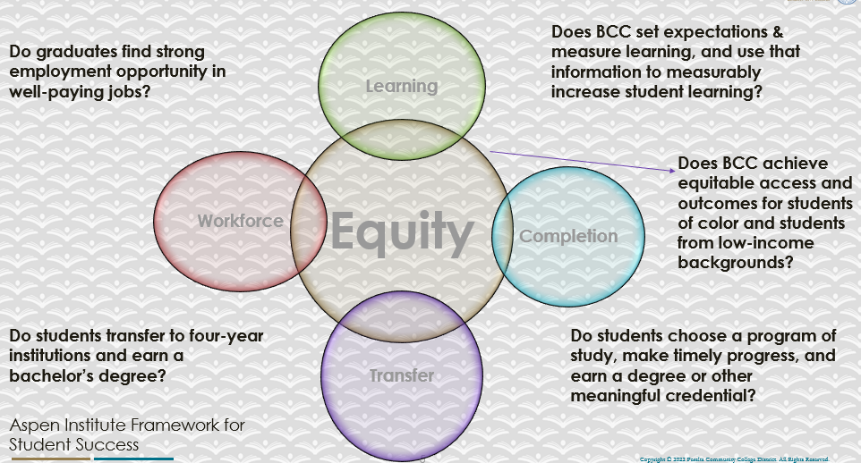

For assistance with data dashboards, contact Phoumy Sayavong at psayavong@peralta.edu
How are students doing in success and completion in your department, compared to the BCC overall success and completion rate? What are the group of students that need more attention to achieve goals?
- Our success and completion rates are higher than the college average.
- Overall, the art program enrollment mirrors the downward trend for Peralta Colleges as a whole and BCC. However, the art program productivity is consistently greater than BCC as a whole
- Additionally, the art program enjoys having enrollment that far exceeds the other Peralta college’s art programs for the past two years.
- Generally, unlike the other colleges, the BCC art program has a larger population of students in the 16-29 age groups (the school this is similar to our data is Alameda. These groups also exceed the overall BCC averages.
- Overall EOPS students, while a small group of Asian, Hispanic, Black students is 80% and above in completion and retention.
- Umoja rate are consistent with the college
- Despite the low completion rate for Pacific Islanders, there is a 90% retention rate.
- Art preforms well in all student groups, however that needs the most attention is Black/African American.
What do you see as key factors in your department that contributed to positive success and completion rate?
Art is a strong vehicle to express identity and there is faculty commitment to introducing students to a diverse array of international and domestic artists that represent all social and ethnic groups.

What are some improvements your department can make? Identify strategies.
- Recruit diverse array of faculty to fill in for the part time faculty that have left BCC during the pandemic.
- Create studio art classes that have obvious career skills embedded, such as the AA-T in graphic design, zine creation, etc.
- Forge partnerships in learning communities where appropriate.
- Add additional non-western art history courses: Latin, Asian

3a. Enrollment Trend and Productivity Dashboard
*Note that completion and retention rates are presented with the inclusion and exclusion of excused withdrawals (EW) and military withdrawals.
What were the enrollment trends in your department in the past three years?
- Our enrollment has declined in keeping with the collegewide and national trends.
- The art program has more women students than male, and the women have a higher completion/retention rate.
- Overall, concerning success rates for specific ethnicities, similar to strong productivity, the art program has stronger overall completion and retention rates than the college.
- All completion / retention rates are 70% or better.
- Generally, unlike the other colleges, the BCC art program has a larger population of students in the 16-29 age groups. These groups also exceed the overall BCC averages.

What strategies would you recommend to increase student enrollment in your department?
We recommend maintaining a balance of course modalities for studio art courses as reflected by student demand. Art History retention appears to be stronger in online courses.
Community Colleges are funded based on the Student Centered Funding Formula (“SCFF”) which is comprised of the following allocations:

Student Centered Funding Formula: Focus and Priorities
% Of Allocation | Categories
70%  Base Allocation: FTES (Enrollment) | - Credit FTES  - NonCredit FTES  - Special Admits (Dual Enrollment, etc.)
20%  Supplemental Allocation | - Pell Grant  - AB 540  - Adult School  - Promise Grants
10%  Student Success Allocation | - Associate Degrees  - ADTs  - 9 or more CE units  - Transfer  - Transfer level Math and English in the first year

List the department’s progress and reflection on what is being done to maintain or increase the base level of full-time equivalent students (FTES = 12 units). Please describe retention (i.e., remain enrolled for a full semester) and persistence (i.e., enroll in consecutive semesters) efforts.
- We continue to offer courses in all modalities, and are experimenting with offering a dynamically dated course.
- There is success with synchronous evening courses
- Schedule planning involves student polls and offering degree pipelines with course offerings each semester
Please describe your department’s efforts in identifying Pell Grant recipients, College Promise Grant recipients, Adult Education, and AB 540 students. What processes are in place to accurately report these students each semester?

College Outcomes | 2018-2019 | 2019-2020 | 2020-21 | 2021-22
Full Time Equivalent Students (FTES) | 4,161 | 3,931 | 3,622 | 3,259
Pell Grant Recipients | 2,387 | 2,281 | 2,181 | 1,826
College Promise Grant Recipients | 4,373 | 4,143 | 4,011 | 3,500
AB 540 Students | 74 | 51 | 22 | 69

Administrative support is needed for accurate reporting and data analysis.

3b. Course Completion and Retention Rates Dashboard – Instruction
*Note that completion and retention rates are presented with the inclusion and exclusion of excused withdrawals (EW) and military withdrawals.

If you need more guidance with this item, click here for additional support. Click here for additional guidance for how to view and use equity data. If you would like to view BCC’s Equity Plan, click here.
On page 3 of the “Course Completion and Retention Rates by Subject” dashboard, what are the completion and retention trends by gender, age, ethnicity in your department?
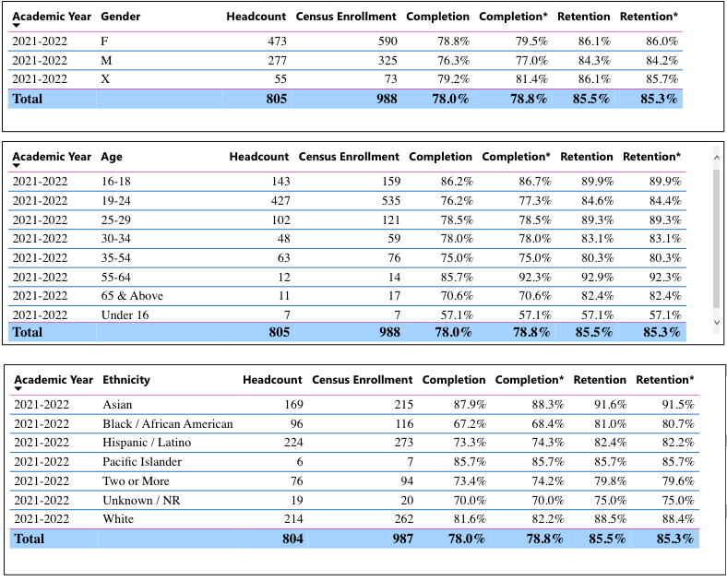

When the data are disaggregated by student ethnic groups, gender, and age, how do you plan to address them over the next year?
- Work with administration in responding to the data as it relates to course planning and adding dual enrollment and learning community partnerships
The Art program continues to offer courses in all modalities, and is experimenting with offering a dynamically dated course in SP22
- Continue to offer synchronous evening courses – as there is high retention and interest
What population(s) showed outcomes gains in your discipline(s) and which need more support?

Disaggregate the data and outcomes as far down as a possible then ask:
- What trends do you notice when examining course success rates for student populations by ethnicity? Which factors do you believe have the greatest impact (positive or negative) and cause variation between student course success rates in your Program? Describe some specific methods your department is planning or implementing to address these equity gaps. How will you evaluate the efficacy of these interventions?

- How has pivoting to online instruction contributed to potential reductions in student success? Provide some specific examples of practices that faculty in your department have found ineffective in the online environment.
Please review the video from the RP Group acknowledging the interrogation De Anza Community College committed to in their analysis of course completion and success rate.
- There is great strength with Asian and Pacific Islander retention
- Hispanic/Latino retention/completion rates are in a similar upward trend.
- Umoja rates are consistent with the college
- Despite the low completion rate for Black African American students, there is a strong retention rate.
How do these outcome trends in your department compare to the college average?
Art Program enrollment rates and productivity is somewhat higher than the college average, but reflective of the overall decline.

How will these outcome trends you identified in this section affect your department goals and plans for the next year and what are your strategies to shift to move the trend towards a positive direction?
Focus on the addition of Dual Enrollment courses and maintain our focus on student success rates.

3c. Degrees and Certificates Dashboard
On page 1 of the “Degrees and Certificate Awards Trends” Dashboard, what are the award trends for your department (e.g., overall, by gender, age, and ethnicity)?
BCC art degree awards numbers have increased and are the highest for the any art program in the district. BCC 13; COA 8; Laney 5; Merritt 1

On page 4, what population(s) award trends showed gains in your program area and which populations need more support?
No data populated on this page

3d. Transfer Dashboard
This dashboard does not provide data by subject. Reflect on what you can do to affect student transfer. How may your department help to support BCC student transfer? (e.g., serve on panels, strengthen GP in your dept, change curriculum, increase number of AD-Ts, etc.)
We need data for the students that transfer to private schools – and those that transfer to private schools such as California College of the Arts often leave without a degree. We need to capture these students.

3e. Curriculum based on Guided Pathways
View the department’s curriculum through the lens of student equity outcomes.
- What intentional effort is your department making to create and present clear pathways for students through curriculum?
- Lead Studio art faculty have had substantive dialogue in the Guided Pathways committee meetings.
- Flow charts have been created for how a student can move through career and transfer at BCC
- What are your plans for revising and/or creating new pathways supported by labor market information (LMI) and student demands? Using Vision for Success and SCFF focus, please indicate rationale and how the plans directly support student success and equitable completion.
- Creating panel discussions with community leaders in the arts and former students to discuss career pathways in the arts.
- Curriculum development with Mobile Web and Digital Imaging

4. Dual Enrollment
As continued decline in overall enrollment for college going population, it is important for us to look at who will be coming to BCC in the next 5 years. Reviewing the data provide here, what strategies would your department employ to address bringing more students to BCC?

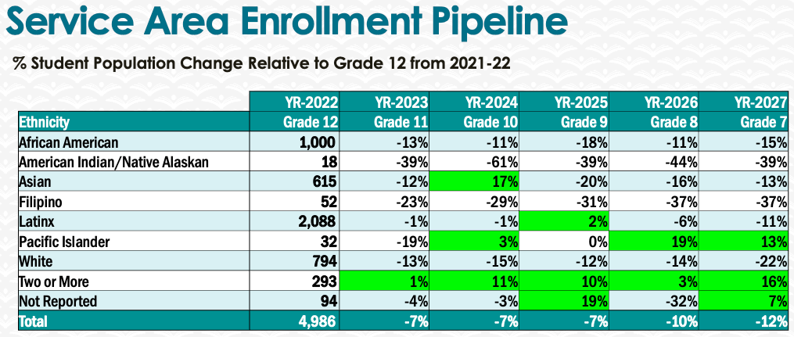
- Increasing partnerships with local high schools for studio art and art history.
- Foster the unique ability of studio arts to create unparalleled space for creating community.
- Focus not only the courses dedicated at the high schools, but also encourage high school student enrollment in the courses offered at BCC to create a dynamic mix of students.

5. Facility Utilization Needs

Assess your facilities utilization (including labs, support for online learning, and other spaces) and for next year, indicate if the space is sufficient or not. If not, what are the needs and why? Work with your Dean to check on your needs prior to responding this section.
- ADA compliant classrooms that are aligned with enrollment demands and the productivity calculation demands.
- Wall repair on the 4th floor in between the classroom 411 and 413 that is used for student exhibition
- Work with administration to ensure that art history courses are prioritized in classrooms equipped with recently upgraded projectors that support the required visual media used in every class session.

6. Assessment
Berkeley City College is committed to a culture of assessment to improve instruction, services, and institutional planning. Findings from SLO, PLO, ALO assessments, and program review data are used to direct resources for areas that are institutional priorities that are articulated in the Educational Master Plan and BCC Strategic Plan.

Due to the critical role that course and program assessments play in our institutional planning and to be in compliance with the Accreditation requirements, assessments must be completed to qualify for the APU resource allocation requests.
6a. What action plans did your department identify upon the assessment of each SLOs and/or PLOs? For courses with multiple sections in the program, please list the main action plans. Please be as detailed as possible.
Our department will have an assessment coordinator after 3-year absence, so hopefully the process will become streamlined and we can continue to assess the Art program courses

6b. Describe the department’s progress on the Actions Plans identified for course Student Learning Outcomes (SLOs). If your department offers a degree or certificate, please describe the department’s progress on the Action Plans for Program Learning Outcomes (PLOs).
Assessment continues. Program focus continues to be on diversifying our offerings as it relates to modality, as well as working to clarify occupation outcomes for art degrees

6c. Describe the status of SLO and PLO completion in Rounds 4 and 5 of the Assessment Cycle. Identify the percent of completion. Briefly describe what needs to be done to reach 100% completion. Identify issues or concerns that may prevent your department from completing assessments of SLOs and/or PLOs.
See above
6d. Besides your syllabi, where are the program level outcomes published? If on a website, please specify the URL.
PLO’s are located in the catalog, https://www.berkeleycitycollege.edu/menu-links/files/2022/11/BCC-Catalog-22-23Addendumv2.pdf

7. Engagement
Discuss how faculty and classified staff have engaged in institutional efforts such as committees, presentations, and departmental activities. Please list the committees that full-time faculty participate in.
- Full time art faculty are represented on Academic Senate, Chairs council, Roundtable, and affordable education materials committee
- A full time Art faculty member is the TRC coordinator
- Studio Art faculty host a year end art exhibition of student work
- Full time faculty manage the art gallery located in the tutoring center
- Full time faculty curate the art for public viewing on the 4th floor and throughout the campus
Discuss how faculty and staff have engaged in community activities, partnerships and/or collaborations.
- Full time faculty hosts an Artists Lecture Series for students that features local artists
- Full time faculty maintains an active Instagram account that features student artwork and course offerings of the Art Department. – it currently has 600+ friends that are current and former students and Bay Area arts organizations.
- Full time faculty have art exhibitions, international conference participation, and are visiting faculty at university undergraduate and graduate programs.
Discuss how adjunct faculty members are included in departmental training, discussions, and decision-making.
- Adjunct faculty are included in regular program meetings.
- Adjunct faculty were mentored for job placement – this includes review of materials and recommendation letters, and links to fellowships and open positions.
- Discuss the relationship and engagement with other support services, programs, departments, or administrative units and how these relationships/collaboration support meeting your departmental goals.
- The art program works collaboratively with the other programs in the department and also maintains close contact with the 3 other art programs in the district.
Are there areas you feel that your department can benefit more by increasing collaboration and partnership? How?
N/A

8. Prioritized Resource Requests
During the 2021-22 Comprehensive Program Review process, you have provided your resource requests which went through the IPAR process. In this section, include resource requests from last year that are still needed and/or new resources that have emerged. Provide justifications. If there are no resource requested, leave the boxes blank.

Resource Category | Description/Justification | Estimated Cost
Personnel
Classified Staff | accessibility expert to help with section 508 compliance
Student Worker | N/A
Part Time Faculty | - Art history instructor – with specialty in Asian art  - Studio art instructor – with specialty in anatomy
Professional Development
Department wide PD needed
Personal/Individual PD needed | Sabbaticals and general prof. development funds
Supplies
Software (for whom or role?) | Adobe Suite for illustration and zine classes: Illustrator, Photoshop, InDesign these are mandatory for all students enrolled in art classes
Books, Magazines, and/or Periodicals | - Purchase the Image of the Black in Western Art collection  - Library of Art books: Van Gogh Drawings,  - Digital subscriptions: Drawing Magazines and Art in America  - Continued publications that are provided as previously mentioned
Instructional Supplies | - Easels, drawing horses, taborets, drawing-boards, light-tables, cutting-mats.  - Faculty supplies to make class samples  - Portable whiteboard/ chalkboard (not fixed to wall)
Non-Instructional Supplies | - Locking cabinet for bones & fragile props  - Locking display case for library books (wall-mounted)  - Signage for rooms (411A, 411B, 413A, 413B)
Technology & Equipment
Description/Justification (Before you list your technology request, click here to view the latest Technology Refresh Plan to verify whether it has already included.)
New | - High resolution projector for Studio art classrooms (411, 413)  - designated Art History classroom(s) with upgraded projector that can also be used by other Humanities courses such as film  - In studio art labs: Xerox machine for room 411. Year 2  - 30 digital tablets (Wacom or iPad) and styli | $6000+
Replacement
Facilities
Classrooms | New facilities are necessary for student and instructor classroom safety, enhanced course offerings, and student enrollment that exceeds the physical space of the room when easels, drawing horses, and taboret’s that each student uses are present. | $6000+
Offices | - Egronmic chairs  - Air purifier  - Private, quiet spaces for prepping and meeting with students
Labs
Other
Library
Library materials (including streamline media needs) | - Maintain suscription to Artstor, Jstor, and Kanopy
Library collections | - Multiple copies of textbooks that art history instructors use in their courses.  - Expansion of the collection of arts related monographs that reflect a selection of artists that are queer, women, and people of color.  - Purchase the Image of the Black in Western Art collection
OER | Accessibility remediation for OER
Other
OTHER Description

Thank you for your time and effort in completing the Annual Program Update!
Please email the completed Program Review to your Dean by November 30, 2022

